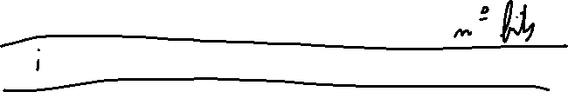

193,0.0.127 193.0.0.128

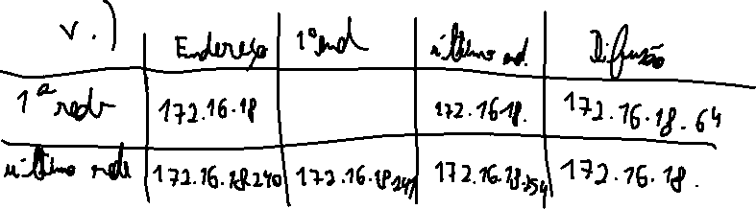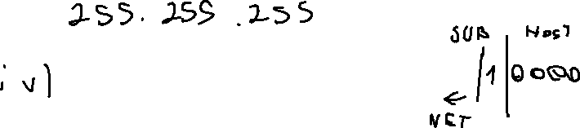

172.16.18.239

172.16.18.238

172.16.18.224

172.16.18.225

