Name: Hrushikesh Joshi
Roll No: 20ME02002

Results:
- Fixed-Fixed

Enter the value of Modulus of Elasticity of material in Pa: 1
Enter value of area moment of inertia of beam column: 1
Enter length of beam column: 1
First Boundary Condition
Press 1 for Fixed
Press 2 for hinged
Press 3 for guided
Enter the first Boundary condition: 1
Second boundary condition:
Press 1 for Fixed
Press 2 for hinged
Press 3 for guided
Press 4 for Free
Enter the second boundary condition: 1
enter number of terms you want: 10
Matrix R:
[ 0, 1, 0, 1]
[ K, 0, 1, 0]
[ sin(K), cos(K), 1, 1]
[K*cos(K), -K*sin(K), 1, 0]

Determinant of R is
K - 2*K*cos(K) + K*cos(K)^2 + K*sin(K)^2 - K^2*sin(K)

The first n positive roots are:
6.2832 8.9868 12.5664 15.4505 18.8496 21.8082 25.1327 28.1324 31.4159 34.4415

The admissible Function is:
a1*x^2*(x - 1)^2 + a2*x^3*(x - 1)^2 + a3*x^4*(x - 1)^2 + a4*x^5*(x - 1)^2 + a5*x^6*(x - 1)^2 + a6*x^7*(x - 1)^2 + a7*x^8*(x - 1)^2 + a8*x^9*(x - 1)^2 + a9*x^10*(x - 1)^2 + a10*x^11*(x - 1)^2

The energy method solution
1.0e+03 *

0.0395 0.0808 0.1579 0.2387 0.3567 0.4795 0.7267 0.9525 2.5692 3.4052

The eigenvalue solution
1.0e+03 *

0.0395 0.0808 0.1579 0.2387 0.3553 0.4756 0.6317 0.7914 0.9870 1.1862

the error percentage
-0.0000 -0.0000 -0.0002 -0.0014 -0.3790 -0.8119 -13.0848 -16.9083 -61.5849 -65.1646

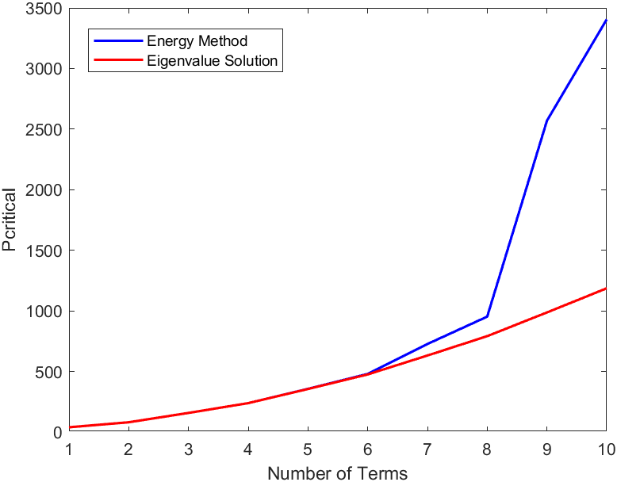

- Fixed-Free

Enter the value of Modulus of Elasticity of material in Pa: 1
Enter value of area moment of inertia of beam column: 1
Enter length of beam column: 1
First Boundary Condition
Press 1 for Fixed
Press 2 for hinged
Press 3 for guided
Enter the first Boundary condition: 1
Second boundary condition:
Press 1 for Fixed
Press 2 for hinged
Press 3 for guided
Press 4 for Free
Enter the second boundary condition: 2
enter number of terms you want: 10
Matrix R:
[ 0, 1, 0, 1]
[ K, 0, 1, 0]
[ sin(K), cos(K), 1, 1]
[-K^2*sin(K), -K^2*cos(K), 0, 0]

Determinant of R is
K^2*(sin(K) - K*cos(K))

The first n positive roots are:
4.4934 7.7253 10.9041 14.0662 17.2208 20.3713 23.5195 26.6661 29.8116 32.9564

The admissible Function is:
a1*x^2*(x - 1) + a2*x^3*(x - 1) + a3*x^4*(x - 1) + a4*x^5*(x - 1) + a5*x^6*(x - 1) + a6*x^7*(x - 1) + a7*x^8*(x - 1) + a8*x^9*(x - 1) + a9*x^10*(x - 1) + a10*x^11*(x - 1)

The energy method solution
1.0e+03 *

0.0202 0.0597 0.1189 0.1979 0.2974 0.4262 0.6219 1.0316 2.1707 8.4955

The eigenvalue solution
1.0e+03 *

0.0202 0.0597 0.1189 0.1979 0.2966 0.4150 0.5532 0.7111 0.8887 1.0861

the error percentage
-0.0000 -0.0000 -0.0001 -0.0118 -0.2730 -2.6195 -11.0590 -31.0719 -59.0586 -87.2153

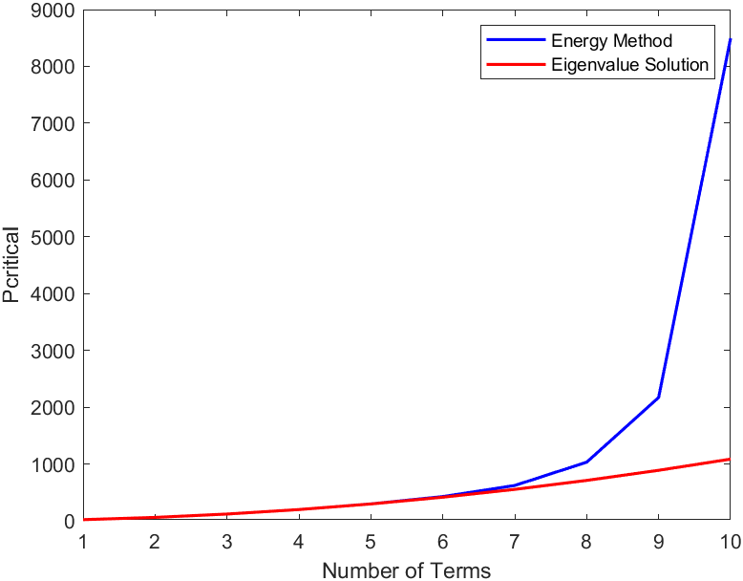

- Fixed Guided

Enter the value of Modulus of Elasticity of material in Pa: 1
Enter value of area moment of inertia of beam column: 1
Enter length of beam column: 1
First Boundary Condition
Press 1 for Fixed
Press 2 for hinged
Press 3 for guided
Enter the first Boundary condition: 1
Second boundary condition:
Press 1 for Fixed
Press 2 for hinged
Press 3 for guided
Press 4 for Free
Enter the second boundary condition: 3
enter number of terms you want: 10
Matrix R:
[ 0, 1, 0, 1]
[ K, 0, 1, 0]
[K*cos(K), -K*sin(K), 1, 0]
[ 0, 0, K^2, 0]

Determinant of R is
K^4*sin(K)

The first n positive roots are:
3.1416 6.2832 9.4248 12.5664 15.7080 18.8496 21.9911 25.1327 28.2743 31.4159

The admissible Function is:
a2*(cos(pi*x) - 1)^2 - a3*(cos(pi*x) - 1)^3 + a4*(cos(pi*x) - 1)^4 - a5*(cos(pi*x) - 1)^5 + a6*(cos(pi*x) - 1)^6 - a7*(cos(pi*x) - 1)^7 + a8*(cos(pi*x) - 1)^8 - a9*(cos(pi*x) - 1)^9 + a10*(cos(pi*x) - 1)^10 - a1*(cos(pi*x) - 1)

The energy method solution
9.8696 39.4784 88.8264 157.9137 246.7401 355.3058 483.6106 631.6547 799.4380 986.9604

The eigenvalue solution
9.8696 39.4784 88.8264 157.9137 246.7401 355.3058 483.6106 631.6547 799.4380 986.9604

the error percentage
1.0e-13 *

0 0 0 0 0.2304 0.3200 0.3526 0.1800 0.2844 0.2304

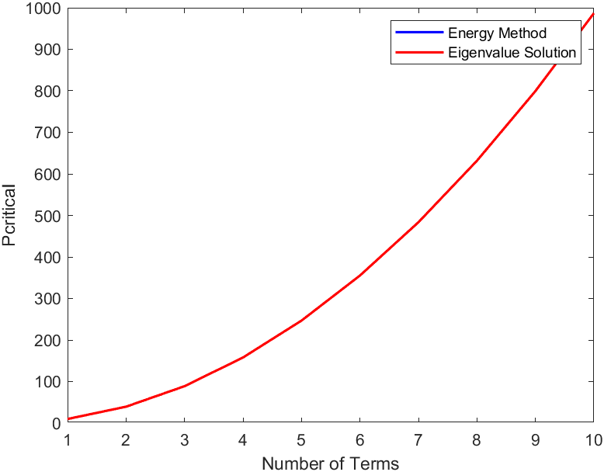

The code works in a generalized way as seen above. First, the eigenvalue problem is solved then the problem is solved using energy method for n terms, where n is specified by the user.

Based on the comparison of results, accurate values are obtained initially, then the error blows up. The greater the number of terms is demanded by the user the more degree of accuracy is achieved. trigonometric functions as admissible functions yielded better results.

The user can input any number of terms as desired with any combination of valid boundary conditions. In case an invalid boundary condition is input, the user is asked to reinput a valid one.

Enter the value of Modulus of Elasticity of material in Pa: 1
Enter value of area moment of inertia of beam column: 1
Enter length of beam column: 1
First Boundary Condition
Press 1 for Fixed
Press 2 for hinged
Press 3 for guided
Enter the first Boundary condition: 2
Second boundary condition:
Press 1 for Fixed
Press 2 for hinged
Press 3 for guided
Press 4 for Free
Enter the second boundary condition: 4
Invalid Boundary Condition, Please input again
First Boundary Condition
Press 1 for Fixed
Press 2 for hinged
Press 3 for guided
Enter the first Boundary condition:

The code

clear;
clc;
E = input('Enter the value of Modulus of Elasticity of material in Pa: ');
I = input('Enter value of area moment of intertia of beam column: ');
L= input('Enter length of beam column: ');
invalidCondition = true; %flag for the invalid condition
while invalidCondition
flag_1=true;
fprintf('First Boundary Condition \n Press 1 for Fixed \n Press 2 for hinged \n Press 3 for guided \n');
BC1 = input('Enter the first Boundary condition: ');
fprintf('Second boundary condition: \n Press 1 for Fixed \n Press 2 for hinged \n Press 3 for guided \n Press 4 for Free \n');
BC2 = input('Enter the second boundary condition: ');

if (BC1 == 3 || BC1 == 2) && BC2 == 4
fprintf('Invalid Boundary Condition, Please input again\n');
else
invalidCondition = false; % Set the flag to exit the loop
end
end
n=input("enter number of terms you want: ");
%**********************Solves the Eigenvalue problem************************
syms A B C D K x;
l=1;
assume(K~=0);
%charachteristic equation
y(x)= A*sin(K*x) + B*cos(K*x) + C*x + D;
%derivatives up to the third one
dy_dx=diff(y,x);
d2y_dx2=diff(y,x,2);
d3y_dx3=diff(y,x,3);
% BCs according to the applied boundary conditions
if BC1==1 && BC2==1
bc1=y;
bc2=dy_dx;
bc3=y;
bc4=dy_dx;
ig=2*pi;
elseif BC1==1 && BC2==2
bc1=y;
bc2=dy_dx;
bc3=y;
bc4=d2y_dx2;
ig=4;
elseif BC1==1 && BC2==3
bc1=y;
bc2=dy_dx;
bc3=dy_dx;
bc4=d3y_dx3+(K^2)*dy_dx;
ig=pi;
elseif BC1==1 && BC2==4
bc1=y;
bc2=dy_dx;
bc3=d2y_dx2;
bc4=d3y_dx3+(K^2)*dy_dx;
ig=pi/2;
elseif BC1==2 && BC2==1
bc1=y;
bc2=d2y_dx2;
bc3=y;
bc4=dy_dx;
ig=2*pi;
elseif BC1==2 && BC2==2
bc1=y;
bc2=d2y_dx2;
bc3=y;
bc4=d2y_dx2;
ig=pi;
elseif BC1==2 && BC2==3
bc1=y;
bc2=d2y_dx2;
bc3=dy_dx;
bc4=d3y_dx3+(K^2)*dy_dx;
ig=pi/2;
elseif BC1==3 && BC2==1
bc1=dy_dx;
bc2=d3y_dx3+(K^2)*dy_dx;
bc3=y;
bc4=dy_dx;
ig=pi;
elseif BC1==3 && BC2==2
bc1=dy_dx;
bc2=d3y_dx3+(K^2)*dy_dx;
bc3=y;
bc4=d2y_dx2;
ig=pi/2;
elseif BC1==3 && BC2==3
bc1=dy_dx;
bc2=d3y_dx3+(K^2)*dy_dx;
bc3=dy_dx;
bc4=d3y_dx3+(K^2)*dy_dx;
ig=0;
end
%making equations out of the boundary conditions
e1=subs(bc1,0)==0;
e2=subs(bc2,x,0)==0;
e3=subs(bc3,x,l)==0;
e4=subs(bc4,x,l)==0;
%Converting the equations into the form Rx=q
eqns=[e1,e2,e3,e4];
vars=[A B C D];
[R,q]=equationsToMatrix(eqns,vars);
% Display the matrix R
disp('Matrix R:');
disp(R);
%calculate the determinant of R
detR=det(R);
disp('Deternminant of R is');
disp(detR);
%convert the matlab equation from symbolic to numeric;
f=matlabFunction(detR);
%find the first n roots of the equation
roots_found = zeros(1, n);
for i = 1:n
if i==1
initial_guess=ig;
else
initial_guess=roots_found(i-1)+pi;
end
% Find the roots one by one starting from an initial guess
roots_found(i) = fzero(f, initial_guess);
end
disp("The first 5 positive roots are:");
disp(roots_found);
P_sol=zeros(1,n);
for i=1:n
P_sol(i)=(roots_found(i))^2*(E*I)/L^2;
end
%*****************************ENERGY METHOD***************************
sym_vars = sym('a', [1 n]); % Creating an array of symbolic variables a1,a2,a3....an;
syms x P;
phi_x=0;
%declaring amissible functions for respective BCs
if BC1==1 && BC2==1
for i=1:n
term=sym_vars(i)*(x^(i+1))*(x-L)^2;
phi_x=phi_x+term;
end
elseif BC1==1 && BC2==2
for i=1:n
term=sym_vars(i)*(x^(i+1))*(x-L);
phi_x=phi_x+term;
end
elseif BC1==1 && BC2==3
for i=1:n
%term=sym_vars(i)*(x^(i+1))*(x-3*L/2)^i;
term=sym_vars(i)*(1-cos(pi*x/L))^i;
phi_x=phi_x+term;
end
elseif BC1==1 && BC2==4
for i=1:n
term=sym_vars(i)*(x^(i+1));
phi_x=phi_x+term;
end
elseif BC1==2 && BC2==1
for i=1:n
term=sym_vars(i)*(x)*(x-L)^(i+1);
phi_x=phi_x+term;
end
elseif BC1==2 && BC2==2
for i=1:n
term=sym_vars(i)*(x^(i))*(x-L);
phi_x=phi_x+term;
end
elseif BC1==2 && BC2==3
for i=1:n
term=sym_vars(i)*((x)*(x-2*L))^i;
phi_x=phi_x+term;
end
elseif BC1==3 && BC2==1
for i=1:n
term=sym_vars(i)*(cos(pi*x/L)+1)^i;
phi_x=phi_x+term;
end
elseif BC1==3 && BC2==2
for i=1:n
term=sym_vars(i)*((x-L)*(x+L))^i;
phi_x=phi_x+term;
end
elseif BC1==3 && BC2==3
for i=1:n
term=sym_vars(i)*((x)^(i+1))*(2*x-3*L);
phi_x=phi_x+term;
end
end
disp(phi_x);

dphi_dx=diff(phi_x,x);
d2phi_dx2=diff(phi_x,x,2);
U=((E*I)/2)*int((d2phi_dx2)^2,x,0,L);
W=(P/2)*int((dphi_dx)^2,x,0,L);
PI=U-W; %computing total potential
disp(PI);
eqns = cell(1, n);

for i = 1:n
eqns{i} = diff(PI, sym_vars(i)) == 0;
end

disp(eqns(1));
[V,w]=equationsToMatrix(eqns,sym_vars);
det_V=det(V);
display(det_V);
P_sol_EM=solve(det_V==0,P);
P_num_EM=double(P_sol_EM);
fprintf("The energy method solution \n");
P_num=zeros(1,n);
for i=1:n
P_num(i)=P_num_EM(i);
end
P_num_sort=sort(P_num);
disp(P_num_sort);
fprintf("The eigenvalue solution \n")
disp(P_sol);
error=zeros(1,n);
for i=1:n
error(i)=((P_sol(i)-P_num_sort(i))/(P_num_sort(i)))*100;
end
fprintf("the error percentage \n");
disp(error);

