Catfish Grow-Out Data Management System (CGDMS) - Requirements Document

# Executive Summ6ry

The Catfish Grow-Out Data Management System (CGDMS) is designed to revolutionize catfish farming operations by providing a comprehensive digital platform for data management, performance tracking, and decision-making. This document outlines the functional and non-functional requirements for CGDMS, ensuring a robust, scalable, and user-friendly system that supports eﬃcient farm management from fingerling stocking to harvest.

# Introduction

The CGDMS aims to digitize and streamline the management of catfish farming operations. The system will support daily data collection, performance tracking, and staff workload monitoring, enabling farm managers to make data-driven decisions and optimize farm productivity.

# System Objectives

Track daily feed intake, medication, temperature, and environmental parameters.

Record and analyze fish performance per pond and across ponds. Monitor Level of Effort (LOE) per cadre of staff.

Provide traceability from stocking to harvest. Generate reports and dashboards for farm operations.

 Support role-based access control for different users (technician, supervisor, manager, admin).

# Scope

CGDMS will cover the following key areas of catfish farming operations:  Pond and Batch Management

 Daily Feed Intake Logging

 Medication and Case Management  Environmental Monitoring

 Staff Workload (LOE) Tracking

 Fish Performance Tracking  Reporting and Dashboards

 Security and Access Control

# St6keholders

 F6rm M6n6gers: Oversee overall farm operations, analyze data, and make strategic decisions.

 Supervisors: Manage daily activities, assign tasks, and monitor staff performance.

 Technici6ns: Record daily data, perform farm tasks, and report incidents.

 Administr6tors: Manage user accounts, system configurations, and data integrity.

# Function6l Requirements

## Pond & B6tch M6n6gement

 FR-001: The system shall allow creation and management of pond records, including unique identifiers, capacity, and location.

 FR-002: The system shall enable stocking of fingerlings and recording of source, number, and average weight per batch.

 FR-003: The system shall support transfer of fish between ponds, updating relevant records accordingly.

## D6ily Feed Int6ke

 FR-004: The system shall allow logging of feed type, brand, quantity, time, and method for each feeding session.

 FR-005: The system shall support multiple feeding sessions per day per pond.

 FR-006: The system shall link feed records to specific ponds and responsible staff members.

## Medic6tion & C6se M6n6gement

 FR-007: The system shall enable recording of diagnosis, treatment, drug type, and dosage for fish health issues.

 FR-008: The system shall allow logging of mortalities, injuries, or stress incidents with detailed descriptions.

 FR-009: The system shall support attachment of supporting documents (e.g., photos, lab results) to case records.

## Environment6l Monitoring

 FR-010: The system shall capture daily water temperature, pH, dissolved oxygen (DO), and ammonia levels per pond.

 FR-011: The system shall correlate environmental conditions with fish performance data.

## St6ff Worklo6d (LOE) Tr6cking

 FR-012: The system shall allow assignment and recording of tasks for each staff member.

 FR-013: The system shall track hours worked per activity (e.g., feeding, cleaning, medication, supervision).

 FR-014: The system shall generate monthly LOE summaries by staff cadre.

## Fish Perform6nce Tr6cking

 FR-015: The system shall monitor growth rate, survival, and biomass per pond and across ponds.

 FR-016: The system shall calculate key performance indicators (KPIs) such as Feed Conversion Ratio (FCR), Average Daily Weight Gain (ADWG), and Survival

Rate (%).

 FR-017: The system shall enable comparison of fish performance across different ponds and batches.

## Reporting & D6shbo6rds

 FR-018: The system shall provide a daily operational dashboard displaying feeding, medication, and environmental data.

 FR-019: The system shall generate fish growth charts and performance reports.

 FR-020: The system shall generate staff LOE heatmaps.

 FR-021: The system shall support export of reports to Excel and PDF formats.

## Security & Access Control

 FR-022: The system shall implement role-based access control (Admin, Farm Manager, Supervisor, Technician).

 FR-023: The system shall use secure authentication (e.g., JWT-based).

 FR-024: The system shall maintain a full audit trail for all critical operations.

# Non-Function6l Requirements

NFR-001 - Sc6l6bility: The system shall support operations from a small farm (20 ponds) to multi-farm operations (>100 ponds).

NFR-002 - Perform6nce: API response times shall be less than 1 second for standard queries.

NFR-003 - Av6il6bility: The system shall maintain a minimum uptime of 99.5%.

 NFR-004 - B6ckup & Recovery: The system shall support daily full backups and hourly transaction log archiving.

 NFR-005 - D6t6 Retention: The system shall retain a minimum of 5 years of records.

 NFR-006 - Security: The system shall implement TLS/SSL encryption, hashed passwords, and audit logging.

 NFR-007 - Us6bility: The system shall provide a mobile-friendly interface (PWA) for data entry on tablets/phones.

# Softw6re Requirements

 B6ckend: Java 17 LTS, Spring Boot 3.x (Spring Data JPA, Spring Security, Validation, Scheduler), PostgreSQL 15/16, OpenAPI (Swagger UI), Maven 3.9+, JWT/OAuth2, Docker 24+

 Frontend: ReactJS 18+, TypeScript 5+, Material UI or TailwindCSS + Recharts, React Router 6+, Axios or React Query, React Hook Form + Yup/Zod, Export to

Excel (xlsx), PDF

 Reporting & An6lytics: Apache POI / JasperReports, Grafana/Metabase

# H6rdw6re Requirements

## Sm6ll F6rm Setup (≤30 concurrent users, ≤20 ponds)

 Server: 8 vCPU, 16‒32 GB RAM, 1 TB SSD

 B6ckup: External HDD (2‒4 TB)

 UPS: 1.5‒2.0 kVA

 Network: Gigabit LAN, Internet ≥ 10 Mbps

## Client Devices

 T6blets/Phones: Android 10+, 4 GB RAM

 Desktop (M6n6gers): 8‒16 GB RAM, 1080p monitor

# User Stories

## ADMIN Role

 US-ADMIN-001 - M6n6ge Users & Roles: As an Admin, I want to create, update, and deactivate user accounts, assign roles (Admin or User) to staff, and reset passwords and manage login access, so that I can control system access and user permissions.

 US-ADMIN-002 - Oversee Ponds & B6tches: As an Admin, I want to create new ponds and update pond capacity/location, register new batches of fingerlings

stocked into a pond, and reassign fish from one pond to another when transferring, so that I can manage the physical and biological assets of the farm.

 US-ADMIN-003 - Monitor D6ily Oper6tions: As an Admin, I want to view all feed logs, medication logs, and environmental data across ponds, approve or reject records submitted by Users (quality control), and access dashboards showing farm-wide performance (FCR, ADWG, survival rates), so that I can ensure data accuracy and monitor overall farm health.

 US-ADMIN-004 - M6n6ge St6ff T6sks & LOE: As an Admin, I want to assign daily/weekly tasks to staff members and review LOE reports per cadre (technician, supervisor, etc.), and generate monthly utilization and productivity reports, so that I can manage staff workload and evaluate productivity.

 US-ADMIN-005 - Gener6te Reports: As an Admin, I want to export fish performance trends (Excel) and view traceability reports (from fingerling stocking

* grow-out), so that I can analyze historical data and ensure compliance.

## USER Role (Technici6n / Supervisor)

 US-USER-001 - Log D6ily Activities: As a User, I want to record feed intake per pond and per batch (time, feed type, quantity), enter medication given (disease, drug, dosage, administered by), and capture water quality data (temperature, pH, dissolved oxygen), so that I can accurately log daily farm activities.

 US-USER-002 - Tr6ck Fish Perform6nce: As a User, I want to update fish weight and count during sampling or harvest, and record mortalities and incidents (disease, injury, escape), and compare growth trends across ponds, so that I can monitor fish health and growth.

 US-USER-003 - M6n6ge T6sks & LOE: As a User, I want to log hours spent on assigned tasks (feeding, cleaning, treatment, harvesting), submit LOE records linked to cadre and pond, and receive task assignments from ADMIN, so that I can track my work and contribute to LOE reporting.

 US-USER-004 - View Limited D6shbo6rds: As a User, I want to see pond-level feed and medication history, view my own task performance records, and track real-time water quality data for assigned ponds, so that I can monitor my assigned areas and tasks.

# Accept6nce Criteri6

 AC-001: The system shall successfully record and retrieve daily feed, medication, and environmental logs.

 AC-002: The system shall accurately track fish performance per pond and across ponds.

 AC-003: The system shall correctly calculate FCR, ADWG, and Survival Rate.

 AC-004: The system shall display role-based dashboards for technicians, supervisors, and managers with relevant information.

 AC-005: The system shall allow export of reports in Excel format.

 AC-006: The system shall pass verified data security and recovery tests.

# Gloss6ry

CGDMS: Catfish Grow-Out Data Management System

FCR: Feed Conversion Ratio ADWG: Average Daily Weight Gain LOE: Level of Effort

KPI: Key Performance Indicator PWA: Progressive Web Application JWT: JSON Web Token

TLS/SSL: Transport Layer Security/Secure Sockets Layer

# Future Enh6ncements

 Integration with IoT sensors for automated environmental data collection.  Predictive analytics for disease outbreaks and growth optimization.

 Financial tracking and reporting modules.

 Mobile application for oﬄine data entry.

 Advanced AI-driven recommendations for feed and medication.

# Appendices

 Original Requirements Document (CGDMS_Requirement.docx)

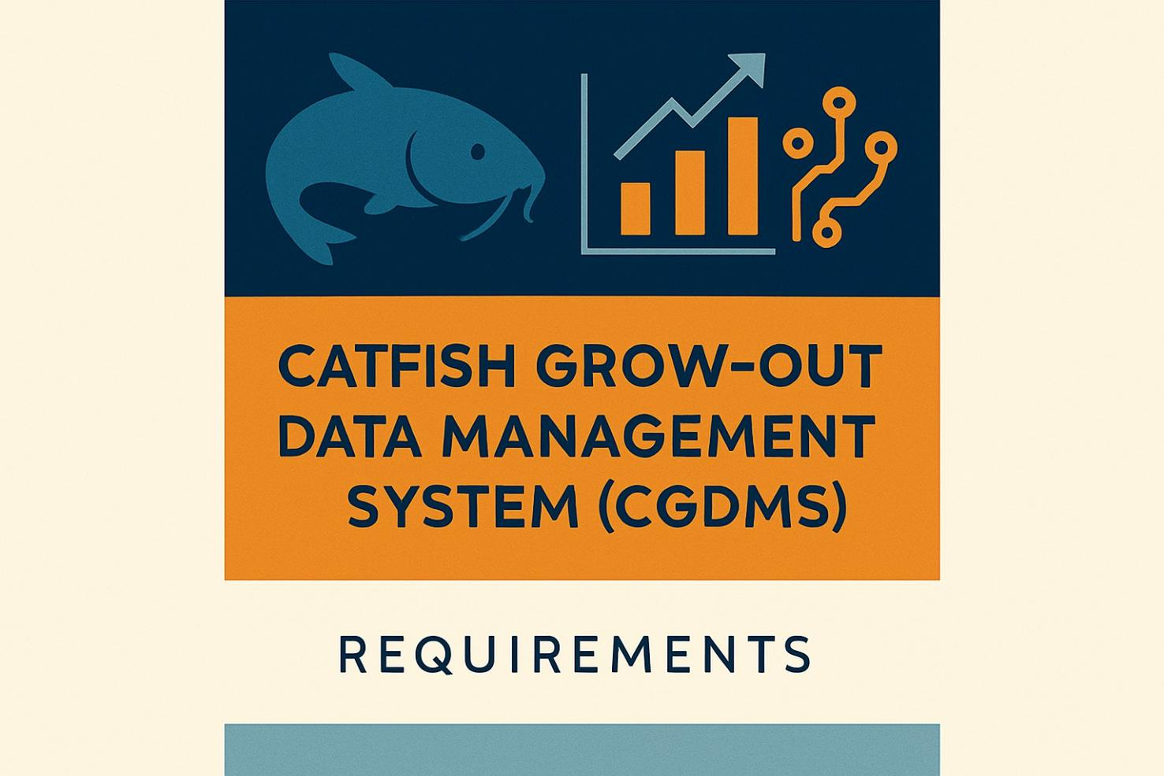

# System Architecture

Below is a high-level overview of the CGDMS system architecture:

