CYBEXHARK
Project Title | Cybexhark

Proponents:
Name/Designation | Signature | Date
Joshua A. Mendoza  Homepage/Shop/Admin |  | April 11, 2025
Steven Craig Cadampog  Faq/Contact us |  | April 11, 2025
Rexille D. Ceniza  User Dashboard/Flowchart |  | April 11, 2025
Fietz Gerald T. Gahator  Services/About us |  | April 11, 2025

Project Description
At Cybexhark in Mandaue City, we offer a comprehensive scope of premium supplements designed to support every aspect of your fitness journey. From beginners taking their first steps to seasoned athletes pushing their llimits, we have the nutritional support you need to achieve goals.
Project Scope
From weightlifting belts and gloves and supplements to, gym bag, ropes, our wide-reaching inventory ensures you have all the necessary supporting items for a comfortable and effective workout.
System Users:
System Admin (Web & App)
- In progress
- Buy & remove item

Customer (Web & App)
- Access the Homepage, FAQ, Shop, Services, Contact, and User dashboard
- Send Messages by Email

Limitation
IOS & Android is not supported for mobile application. The system will only work with windows PC Chrome.

Timeline/milestone
Activity | Date Started | Date of Completion | Remarks
Homepage | 3/23/25 | - | In progress
Shop/Cart/Checkout/Payment | 3/22/25 | - | In progress
Admin Dashboard | 3/29/25 | - | In progress
User Dashboard | 4/11/25 | - | In progress
LOGIN | 2/29/25 |  | In progress
SIGNUP | 2/29/25 |  | In progress

Risk/s
Risk | Description
Lack of Time | System approval will not be determined and so with the making and completion of the system.
Lack of Skills | The proponents may not have enough knowledge in making the system.
Errors | Errors may occur on the process

Alternative Solution
- Manage and utilize the time efficiently. Set priorities in making the system better.
- Do research and watch online programming tutorials for additional ideas in making the system.
- Experiment and understand codes using AI tools.
- Research tutorials about Web and Software Application.
- Download templates, study and experiment in making the system.
- Analyze the data flow and gather information in order to check a possible way to make the system better.

Advantages
- Accessible so it is convenient for users.
- Less storage and fast browsing experience since it has less features.
- Increase interaction between students and school staff.
- Provides personalized notification based on student status and relevant deadlines.
- Wide range of singleplayer games created from any developers whether popular company or small indies.

System Flowchart (WEB & APP)
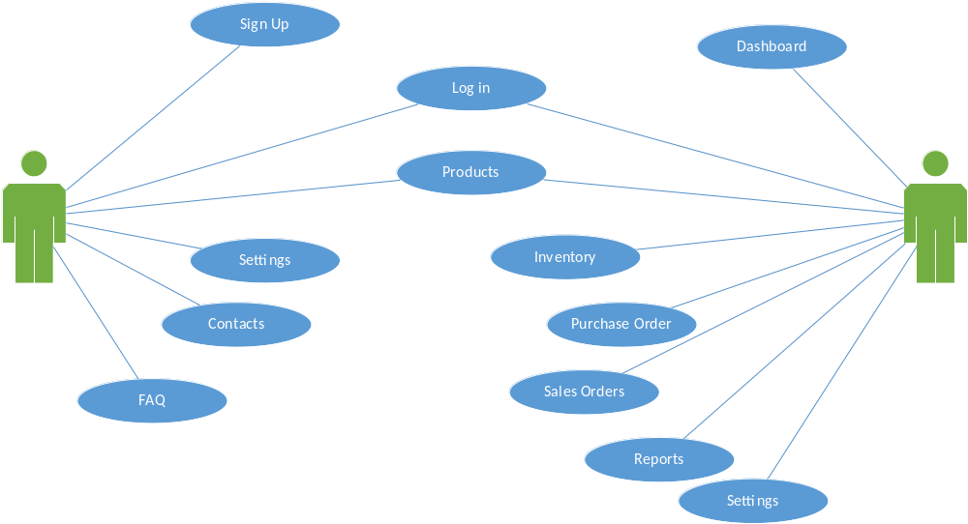
Approved by:

Name | Signature | Date
Mr. Donald M. Francisco  IT Department Head Subject Instructor |  | March 18, 2021
Mr. Roy L. Imperial, MSIT
College Dean
ACLC College of Mandaue

