Accessible Chennai - Wireframe Design

**TEAM NAME : ALGONEX**

**TEAMMATES :**

**ROLL NO NAME CLASS**

**24UAD146 JOSHUA MELVIN K AI&DS - ‘A’**

**24UAD145 JOSHPIN KAYALVIZHI A AI&DS - ‘A’**

**24UCS143 JEREMIAH JEFRY G CSE - ‘A’**

**24UAD158 MANIKANDAN K AI&DS - ‘A’**

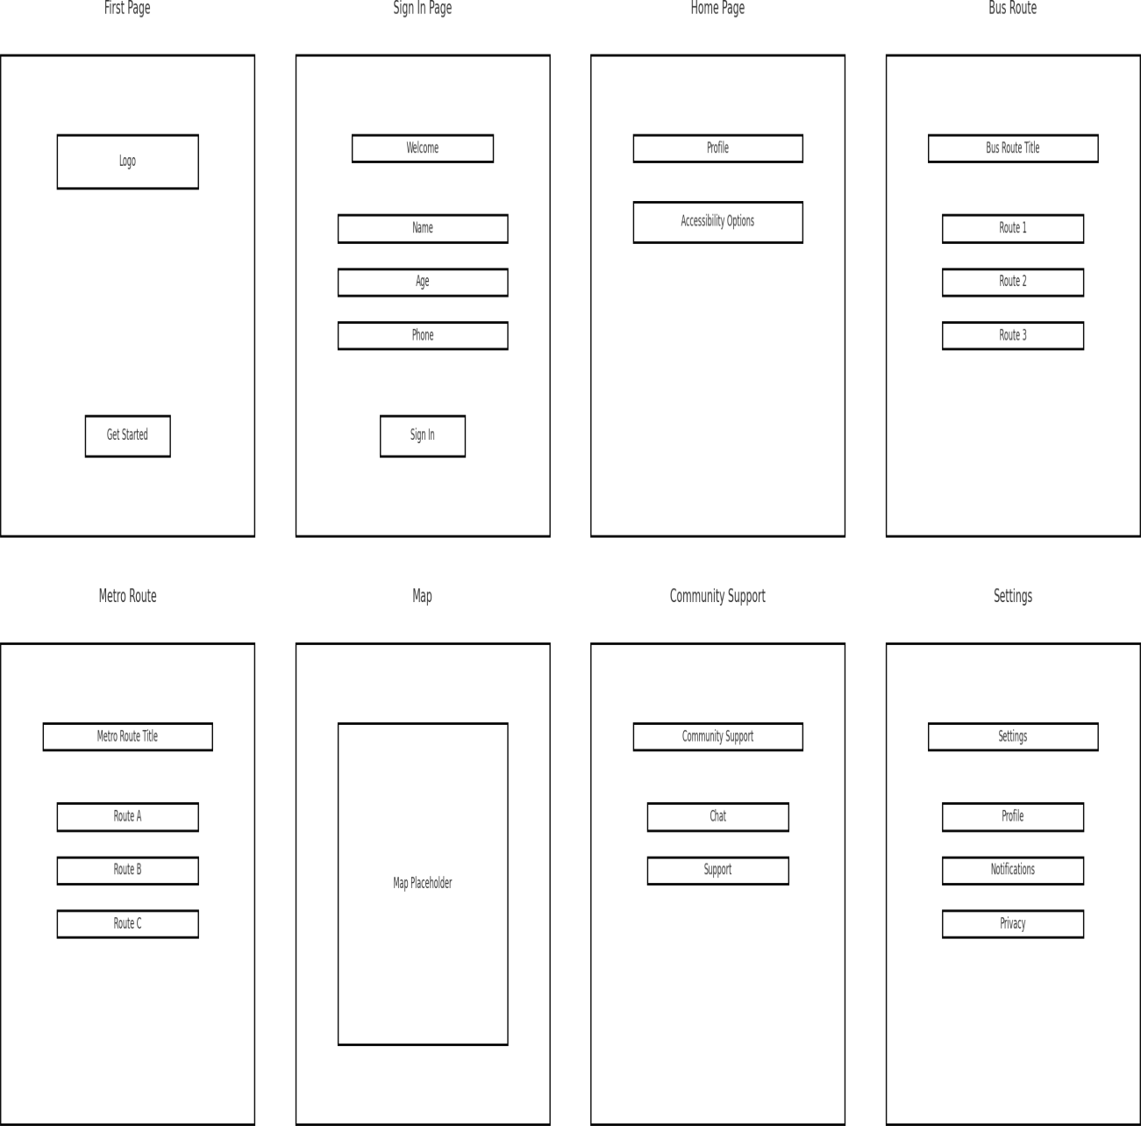

**Research References**

Government of Tamil Nadu – Transport Department. Chennai Metro Rail Accessibility Features. Retrieved from: https://chennaimetrorail.org

Ministry of Housing and Urban Affairs, Govt. of India. Accessible India Campaign (Sugamya Bharat Abhiyan). Retrieved from: https://accessibleindia.gov.in

Google Maps Help. Use Accessible Transit Routes. Retrieved from: https://support.google.com/maps/answer/6352292

Be My Eyes. Connecting Blind and Low-Vision People with Volunteers. Retrieved from: [https://www.bemyeyes.com](http://www.bemyeyes.com/)

Moovit App. Chennai Public Transit Navigation. Retrieved from: https://moovitapp.com WHO. World Report on Disability. World Health Organization, 2011.

Description :

Project Description :

Title: Accessible Chennai – Inclusive Urban Mobility System

The project aims to design and prototype a digital platform that improves urban mobility for Persons with Disabilities (PwD) in Chennai. Public transport in metropolitan areas like Chennai often lacks adequate accessibility features, making it difficult for differently-abled citizens to travel independently and safely.

To address this challenge, the project introduces “Accessible Chennai”, a user-centered solution that integrates accessibility features into a mobile/web interface. The system is designed using Figma to provide a prototype of an application that:

Assists PwD in planning accessible routes across buses, metro, and local trains.

Provides real-time alerts on disruptions, lift/escalator availability, and traffic conditions.

Supports multi-language accessibility (English & Tamil) for inclusivity.

Offers community-driven feedback, allowing users to report inaccessible locations and suggest improvements.

Ensures universal design principles, including large text, voice assistance, color contrast, and icon-based navigation.

The prototype demonstrates a practical, scalable approach to making Chennai’s public transport more inclusive, aligning with SDG Goal 11 – Sustainable Cities and Communities.

Figma Prototype Link:

<https://www.figma.com/proto/PtST8uWCRreW3xvD4t1Xcd/Accessible-Chennai?node-id=0-1&t=B3yfOGUrqp85ZJJM-1>