Technical Analysis Using R
  - Preliminary Stage • Assignment 2
Student: Joseph Tenneti
Student ID: 664427006
Course: BDA400 — Data Science Tools and Techniques
GitHub repository:
https://github.com/JOSHXAVIOR/TechnicalAnalysis

1. Purpose and project structure
This project establishes a reproducible R workflow that reads a stock portfolio, downloads daily historical stock data, computes descriptive price statistics and a moving average, and displays the results. The scripts separate installation, reusable functions, display utilities and execution. The repository should contain one subdirectory for each course assignment.
TechnicalAnalysis/
README.md
Assignment2/
Assignment2.Rproj
portfolio.txt
01_setup.R
02_functions.R
03_display.R
04_run_analysis.R
05_check_statistics.R
JosephTenneti_BDA400_A02.docx
output/ (created when the analysis runs)

2. GitHub account and repository
Sign in to GitHub, or create and verify an account. Choose New repository, enter TechnicalAnalysis, select the visibility required by the instructor, and create the repository. If it is private, grant the instructor access. Upload the extracted README.md and Assignment2 folder using Add file → Upload files, then commit. Keep the directory structure rather than uploading only the ZIP. Open the repository after upload and verify that the Word report, portfolio and R scripts are visible. Copy its real URL onto the cover page.
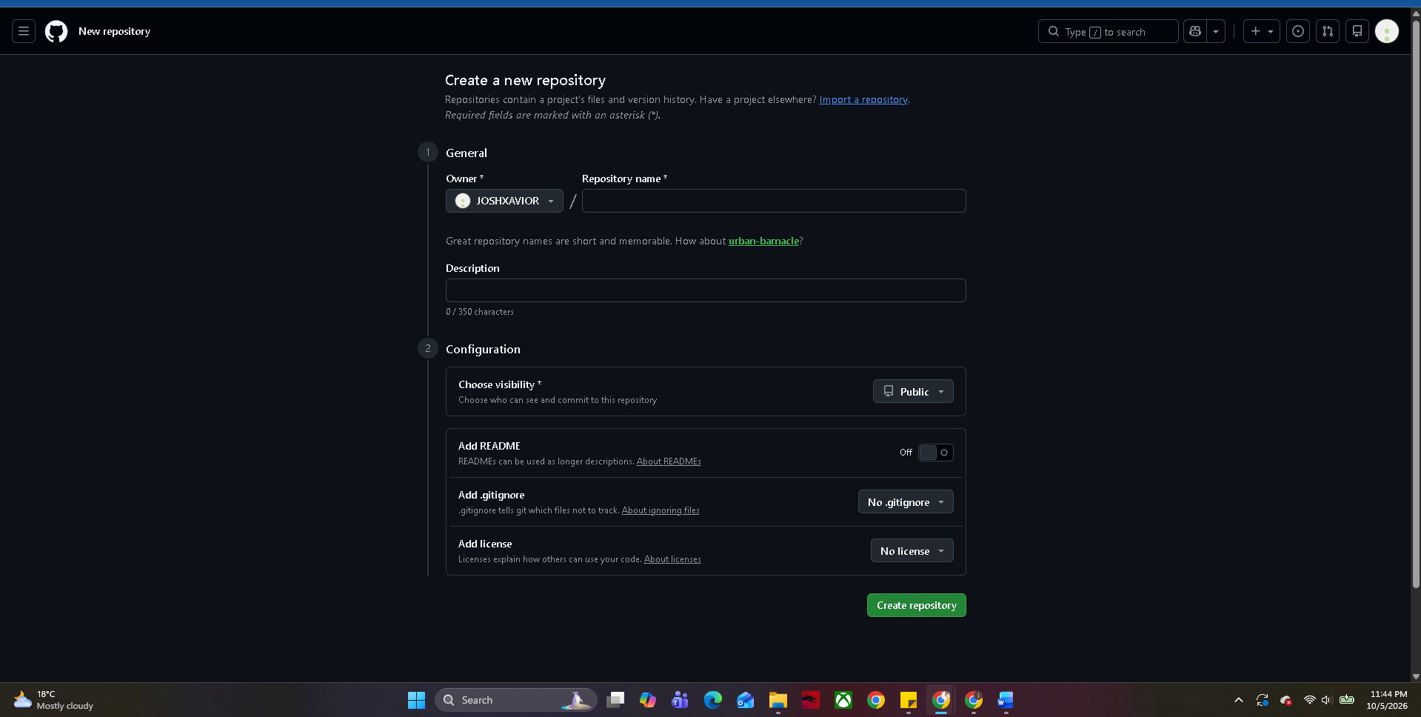

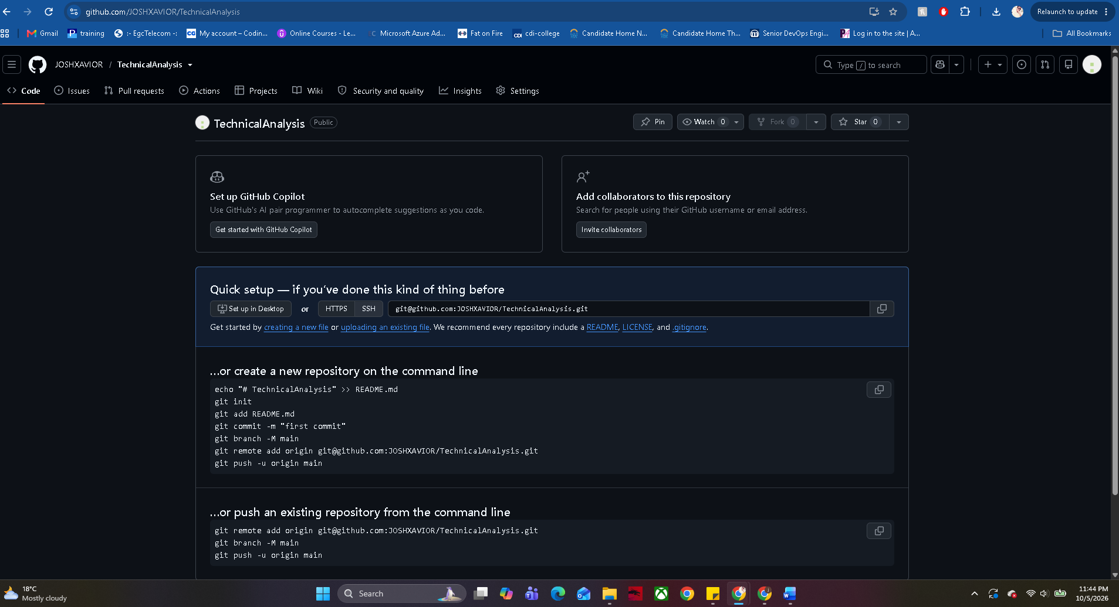

3. Install R and RStudio
Download R for your operating system from CRAN, run the installer and finish installation. Install R before RStudio. Download the free RStudio Desktop installer from Posit and complete setup. Open RStudio and confirm that its console starts R. Extract this package and open Assignment2.Rproj to set the working directory to the assignment folder. In the console, run R.version.string and getwd() to verify the runtime and project location. Record the actual installed versions, rather than assuming a version.
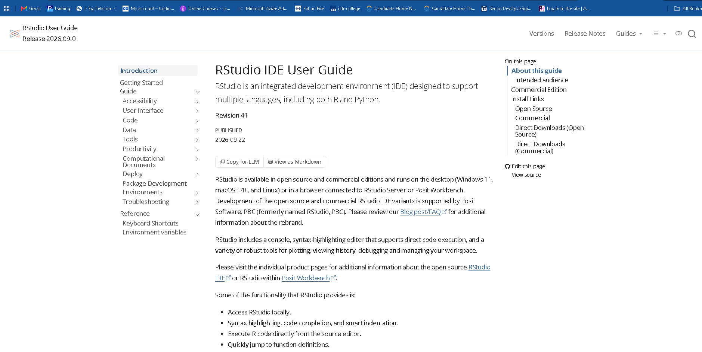

4. Package installation and configuration
Run the setup script once. It checks for quantmod, TTR, xts and zoo and installs only missing packages from CRAN. quantmod supplies stock download and OHLCV accessors; TTR supplies SMA; xts and zoo support the indexed time series returned by the download. Namespace-qualified calls make dependencies explicit. The setup script prints installed package versions and session details.
source("01_setup.R")
source("05_check_statistics.R")
source("04_run_analysis.R")
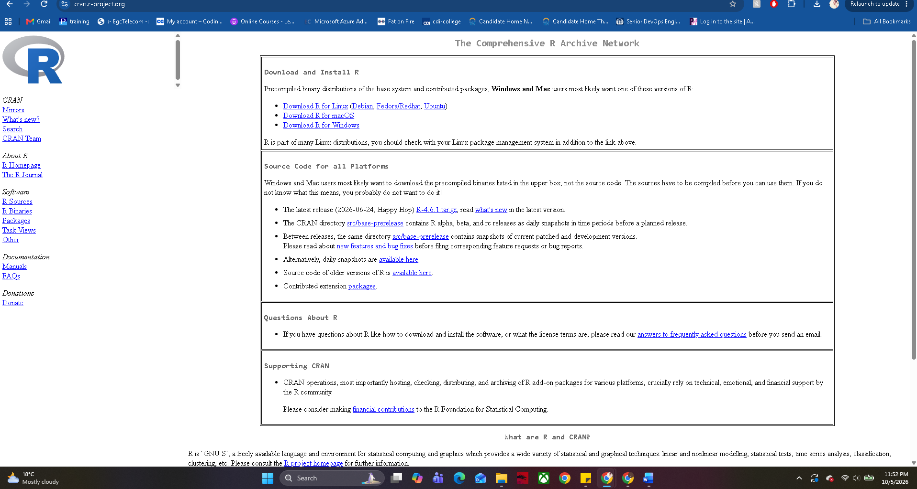

5. Portfolio and analysis settings
portfolio.txt contains five stock symbols, one per line: AAPL, MSFT, GOOGL, AMZN and NVDA. These are example US-listed technology companies chosen for a consistent USD comparison. The portfolio is a watchlist; no investment weights are specified. The fixed requested period begins 1 January 2025 and ends before 1 January 2026. Actual start and end observations depend on trading days. The moving-average window is 20 valid trading observations.
AAPL
MSFT
GOOGL
AMZN
NVDA
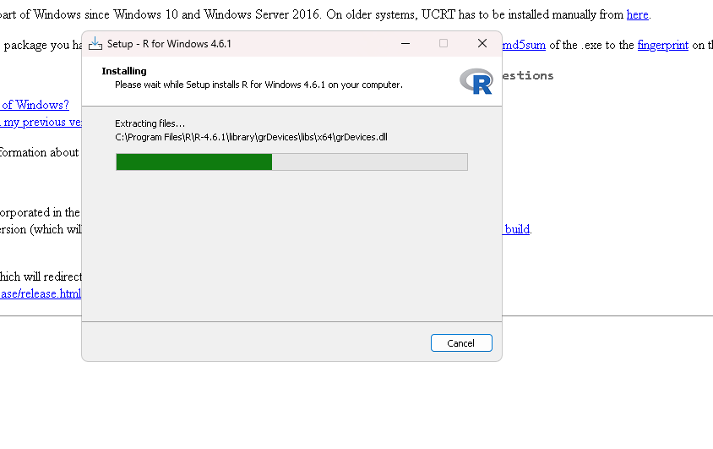

6. Import function: load_stock_data()
The function checks the portfolio path and date range, removes blank lines, ignores comment lines beginning with #, standardizes symbols to uppercase and removes duplicate symbols. For each symbol it calls quantmod::getSymbols with Yahoo as the source and auto.assign = FALSE. Each returned time series is converted to an independent data frame with Date, Open, High, Low, Close, Volume and Adjusted columns. Frames are sorted by date and duplicate dates are removed. The named list allows stocks[["AAPL"]] to retrieve the AAPL data frame without creating uncontrolled global variables.
Individual download errors are recorded and reported while successful stocks remain available. If every download fails, execution stops. Partial success must be corrected before submission: inspect output/download_failures.csv, check internet access and symbols, and rerun. No sample data silently replace failed market downloads.

7. Statistics: calculate_statistics()
The function uses adjusted prices for mean, median, sample standard deviation and SMA. Adjustment helps account for splits and distributions, although vendor revisions can change results. It returns a summary data frame and a copy of the stock data frame containing the SMA series. The first 19 valid observations have no 20-observation SMA because the full window is not available.
Statistic | Definition and interpretation
Mean | Arithmetic average of valid adjusted prices.
Median | Middle adjusted price after sorting; averages the two middle values for even sample sizes.
Mode | Most frequent price rounded to cents. Return every tied mode; all-unique prices produce No mode. Base R mode() is not a statistical-mode function.
Standard deviation | Sample dispersion of price levels, using denominator n−1. Returns NA with only one observation. This is not daily-return volatility.
Moving average | Trailing arithmetic mean of 20 valid adjusted-price observations. Missing prices are excluded, so the window describes valid observations, not 20 calendar days.
Non-finite adjusted prices are excluded and counted. A positive integer window and sorted dates are required. If there are too few valid prices for the window, SMA remains NA; an entirely missing price series is rejected.

8. Display functions and exported results
display_stock_data() prints each symbol, row count, first and last six observations, and structure. display_statistics() combines the per-stock summaries. plot_stock_data() exports a price-and-SMA PNG for each stock plus a normalized comparison chart. The main script writes one CSV per stock, statistics.csv, download_failures.csv, analysis_objects.rds and session_info.txt to output/.
The individual charts show adjusted prices and their moving average in USD. The comparison chart joins the series on common trading dates, removes incomplete rows, and divides each price by its first value on that shared date, multiplying by 100. This compares relative movement without confusing different price levels or starting dates. Tables communicate exact values, line charts show trends, and candlestick charts with volume are another common display for OHLC data. The supplied implementation uses tables and line charts.

9. Actual results and interpretation — complete after execution
[Insert two generated PNG charts here. State the observed start/end dates and valid observation counts. Compare means and medians within each stock, describe the price relative to its 20-observation SMA, and explain the normalized comparison. Avoid interpreting larger price-level SD as proof of greater investment risk.]
Results are descriptive and depend on the downloaded period. The SMA summarizes recent price levels; it does not predict future prices. Historical price analysis alone does not establish a trading strategy or financial recommendation.

10. Verification and limitations
The package includes 05_check_statistics.R with a known-price example: 1, 2, 2, 3. Expected mean = 2, median = 2, mode = 2, sample SD = √(2/3), and a two-observation SMA = NA, 1.5, 2, 2.5. Additional checks cover tied modes and all-unique values. Run these checks after installing dependencies and capture the successful result.
Preparation validation: deliverable files and DOCX/ZIP structure were inspected. R was not available in the preparation environment, so no R execution, stock-download success, actual statistics or local installation is claimed. The supplied checks remain to be run in RStudio. Installation and GitHub screenshots must come from the student’s actual workflow. Yahoo availability, rate limits and package changes may affect downloads; preserve session_info.txt and the downloaded CSVs for reproducibility.

