**PRODUCT SALES ANALYSIS**

Phase 5: Project Documentation & Submission

**DOCUMENTATION**

**Project Objective:**

The objective of the project is to perform a comprehensive sales analysis for a product or set of products. The analysis aims to provide insights into the performance of the product(s) in the market, identify trends, and make datadriven decisions to optimize sales and increase revenue

**Design Thinking Process:**

1. **Empathize:**

Understand the target audience: Identify the key stakeholders, such as sales teams, marketing, and executives.

Gather user stories: Collect input from various departments to understand their data needs and pain points.Define:

1. **Define:**

Define project scope: Clearly outline the products to be analyzed and the specific objectives of the analysis, such as improving sales, understanding customer behavior, or forecasting demand.

Create user personas: Develop profiles for different user groups, considering their roles and specific requirements.

1. **Ideate:**

Brainstorm data sources: Identify the data sources necessary for the analysis, including sales data, customer data, market trends, and competitor information.

Generate potential analysis methods: Explore different data analysis techniques, such as regression analysis, time series analysis, and clustering.

1. **Prototype:**

Design data collection and storage: Plan how to collect, store, and update the data needed for the analysis. Consider data warehousing, ETL (Extract, Transform, Load) processes, and data pipelines.

Choose analytics tools and technologies: Select the appropriate software and tools for data analysis, visualization, and reporting.

1. **Test:**

Validate data sources: Ensure the data collected is accurate, complete, and relevant to the analysis objectives.

Test analysis methods: Apply the selected data analysis techniques and validate their effectiveness in generating insights.

1. **Implement:**

Build the analysis framework: Develop the analysis models, algorithms, and dashboards required for the project.

Integrate data sources: Implement data pipelines and connections to extract, transform, and load data for analysis.

**Development Phases:**

1. **Data Collection:**

Gather relevant data from various sources, including internal databases, external APIs, market research reports, and social media platforms.

Ensure data quality, accuracy, and consistency through data cleansing and validation processes.

1. **Data Preprocessing:**

Clean, transform, and prepare the data for analysis. This may involve handling missing values, data normalization, and feature engineering.

1. **Data Analysis:**

Apply statistical and machine learning techniques to analyze the data.Identify trends, patterns, and correlations within the COVID-19 data.

Generate visualizations, such as maps, charts, and graphs, to convey the insights effectively.

1. **Exploratory Data Analysis (EDA):**

Perform EDA to gain initial insights into the data. Visualize the data and identify patterns, trends, and outliers.

1. **Data Visualization:**

Create interactive and informative data visualizations, such as dashboards or reports, to communicate insights effectively to stakeholders.

1. **Interpretation and Insights:**

Interpret the results of the analysis and draw actionable insights from the data.

Identify key findings, trends, and opportunities for improving sales strategies.

1. **Recommendations:**

Provide recommendations and strategies based on the analysis results. These recommendations should be aligned with the project's objectives and user needs.

1. **Implementation and Monitoring:**

Implement the recommended strategies, and continuously monitor and evaluate their impact on product sales.

Use feedback loops to make necessary adjustments and improvements.

1. **Reporting:**

Create comprehensive reports that summarize the analysis, insights, recommendations, and the ongoing performance of the product sales.

**Analysis Objectives:**

The analysis objectives in a product sales analysis typically include:

1. **Sales Performance Assessment:**

Evaluate the historical sales performance of a product or a set of products.

1. **Sales Forecasting:**

Predict future sales trends to support inventory management and demand planning.

1. **Customer Segmentation:**

Identify and categorize customers based on their purchase behavior and preferences.

1. **Market Trends Analysis:**

Examine market trends, competitor performance, and external factors affecting sales.

1. **Product and Pricing Optimization:**

Determine which products are most profitable and optimize pricing strategies.

**Data Collection Process:**

To achieve these objectives, data collection is crucial:

1. **Internal Sales Data:**

Gather sales data from the organization's databases, including sales transactions, order history, product information, and customer details.

1. **External Data Sources:**

Access external data, such as market research reports, industry benchmarks, and competitor data. This can provide context for the analysis.

1. **Customer Data:**

Collect customer information, purchase history, and demographics to segment and understand the customer base.

1. **Marketing and Promotion Data:**

Include data on marketing campaigns, promotions, and advertising efforts to assess their impact on sales.

1. **Economic and Seasonal Data:**

Incorporate data on economic indicators, seasons, and holidays that may influence sales.

1. **Product Data:**

Collect detailed information on the products being analyzed, including attributes, features, and pricing.

1. **Data Cleaning and Integration:**

Clean and integrate data to ensure consistency and accuracy

**Data Visualization Using IBM Cognos:**

IBM Cognos is a powerful business intelligence and data visualization tool that can be used for creating insightful dashboards and reports. Here's how it can be used:

1. **Data Preparation:**

In IBM Cognos, import and prepare the integrated data from various sources. Cleanse and format the data as needed.

1. **Dashboard Creation:**

Build interactive dashboards that showcase key performance indicators (KPIs) related to sales, customer segments, and product performance. Include charts, tables, and graphs to visualize data.

1. **Sales Trends Analysis:**

Create line charts to visualize historical sales data, making it easy to identify trends, seasonality, and patterns. Use filters to allow users to drill down into specific time periods or product categories.

1. **Customer Segmentation:**

Generate pie charts, bar charts, or heat maps to display customer segmentation results. Visualize customer behavior, preferences, and purchase patterns to tailor marketing efforts.

1. **Market Trends and Competitor Analysis:**

Utilize charts and graphs to present market trends, competitor performance, and external factors that impact sales. Comparing your sales data with industry benchmarks can be particularly insightful.

1. **Pricing and Product Optimization:**

Use scatter plots or sensitivity analysis charts to display pricing strategies and product profitability

**Derived Actionable Insights:**

Once you've collected and visualized the data, you can derive actionable insights to make informed decisions. For example:

1. **High-performing products:**

Identify which products are top sellers and focus marketing efforts on promoting them further.

1. **Customer segments:**

Tailor marketing campaigns to specific customer segments to maximize sales.

1. **Inventory management:**

Use forecasting to optimize inventory levels and avoid overstock or stockouts.

1. **Pricing adjustments:**

Analyze the impact of pricing changes on sales and adjust pricing strategies accordingly.

1. **Sales team performance:**

Recognize top-performing sales teams and provide training or incentives to underperforming teams.

1. **Expansion opportunities:**

Identify regions or markets with growth potential and plan expansion strategies.

1. **Customer engagement:**

Improve customer engagement and loyalty by understanding their preferences and behavior.

**Insights from product sales analysis can significantly guide inventory management and marketing strategies. Here's how:**

**Inventory Management:**

**Sales Revenue:**

**Product-wise Sales Revenue:**

Product 1 sales revenue: $60.1 million

Product 2 sales revenue: $62.1 million

Product 3 sales revenue: $78.4 million

Product 4 sales revenue: $36.8 million

**Ranking of Products by Sales Revenue:**

Notably, Product 3 emerges as the frontrunner in sales revenue, achieving a remarkable $78.4 million.

In contrast, Product 4 lags behind with the lowest sales revenue of $36.8 million.

**Sales Quantity:**

**Product-wise Sales Quantity:**

Product 1 sales quantity: Approximately 60,000,000 units

Product 2 sales quantity: Approximately 62,000,000 units

Product 3 sales quantity: Approximately 80,000,000 units

Product 4 sales quantity: Approximately 40,000,000 units

**Ranking of Products by Sales Quantity:**

Product 3 dominates in sales quantity, with a staggering estimated 80,000,000 units sold.

Conversely, Product 4 resides at the bottom of the list, with roughly 40,000,000 units sold.

**Sales Revenue Fluctuations:**

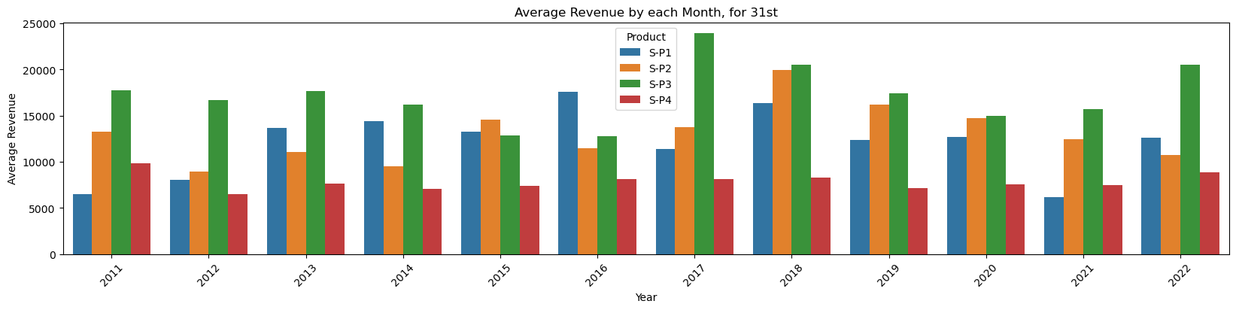

**Sales Revenue on July 7, 2020:**

A significant milestone occurred on July 7, 2020, as sales revenue notably exceeded $20,000.

**Sales Revenue After 2 Years (July 7, 2022):**

Surprisingly, a sharp decline was witnessed two years later, in July 7, 2022, as the sales revenue dropped to below $10,000.

**Notable Sales Revenue Figures:**

On June 1, 2019, the sales revenue was recorded at $6,000.

By June 3, 2019, an increase to $10,000 was observed.

It is intriguing to note that sales revenue remained constant on October 2 in both 2017 and 2019.

**Peak Sales Revenue:**

A noteworthy trend emerged in the years 2018, 2013, and 2020 when sales revenue reached its zenith at $25,000.

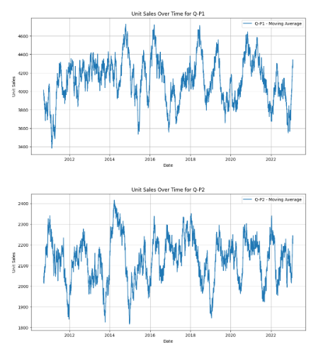

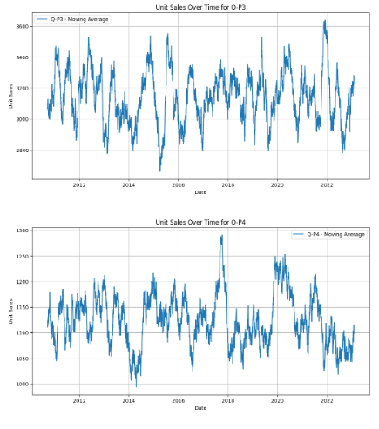

**Marketing Strategies:**

**Product 3 Maximization:** Focus marketing efforts on Product 3 since it generates the highest sales revenue and quantity. Run targeted marketing campaigns, promotions, and product enhancements to maintain its strong position.

**Product 4 Improvement**: Develop strategies to boost sales for Product 4, such as product redesign, repositioning, or targeted promotions to increase demand.

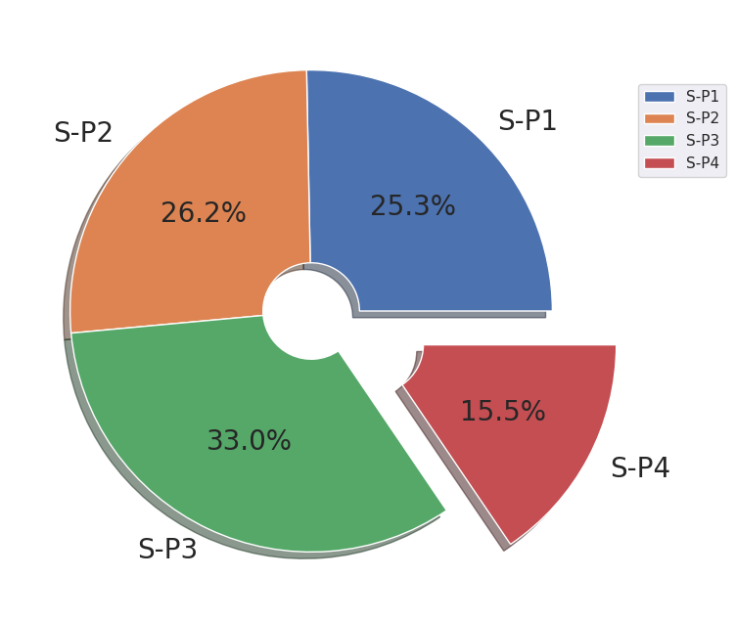

**Revenue Recovery Plan:** To address the decline from 2020 to 2022, create a comprehensive revenue recovery plan. This might include expanding the product line, launching new marketing campaigns, and identifying cost-saving measures.

**Seasonal and Date-Specific Campaigns:** Utilize insights from date-specific sales fluctuations. Plan marketing campaigns around these dates to capture the spike in revenue.

**Customer Segmentation:** Analyze customer demographics and behavior to identify the most profitable customer segments. Tailor marketing messages and channels to reach these segments effectively.

**SUBMISSIONS**

**Provide instructions on how to replicate the analysis and generate visualizations using IBM Cognos**

1. Signup and open IBM Cognos with credentials
2. Activate free trial for IBM Cognos
3. Then Launch IBM Cognos
4. Create new template by importing dataset.csv
5. The row and column data are imported and listed
6. Create new layout for your requirements
7. By selecting the necessary and required Data and apply on the respective visualizations template like , bar chart, graph and etc…
8. Write a text if you needed and placed in layout
9. Finally export it

**Examples:**



