**A Project Report on**

**Pharmacy Management System**

Submitted in partial fulfillment of the requirement of

**Project - II (BEG374CO)**

of Bachelors of Computer Engineering

**Submitted to**



Purbanchal University

Biratnagar, Nepal

**Submitted by**

Binu Sapkota

Manisha Gaire

Roshan Kumar Mahato

**Project Supervisor**

Ashim KC

**KANTIPUR CITY COLLEGE**

Putalisadak, Kathmandu

August 1, 2020

**A Project Report on**

**Pharmacy Management System**

Submitted in partial fulfillment of the requirement of

**Project - II (BEG374CO)**

of Bachelors of Computer Engineering

**Submitted to**



Purbanchal University

Biratnagar, Nepal

**Submitted by**

Binu Sapkota

Manisha Gaire

Roshan Kumar Mahato

**KANTIPUR CITY COLLEGE**

Putalisadak, Kathmandu

August 1, 2020

Certificate of Project Approval

It is hereby informed that the topic selected by

Binu Sapkota

Manisha Gaire

Roshan Kumar Mahato

of Bachelors of Computer Engineering, 5th Semester has been found suitable for the fulfillment of their academic course Project II and meets all the requirements defined by Purbanchal University, Biratnagar, Nepal. The department has approved the following topic and supervisor for the aforementioned candidates.

**Topic approved: Pharmacy Management System**

|  |  |
| --- | --- |
| ———————————————  Ashim KC  Project Supervisor  Kantipur City College | .———————————————  External Examiner  Purbanchal University |

Acknowledgements

We are thankful to everyone for the help, support and guidance we have received while completing this project.

Firstly, we would like to express our special thanks of gratitude to our supervisor Mr. Ashim KC for guiding us during our project. Every time we encountered a problem in the project, Mr. KC was always available to guide us towards the solution.

We would also like to thank our Deputy Head of Department Mr. Subash Rajkarnikar, Project Coordinator Mr. Bikash Neupane and Deputy Project Coordinator Mr. Ramesh Parajuli for their immense help at various stages of the project.

Finally, we would like to thank our family, friends and teachers for their valuable suggestions, encouragement and support. Without their guidance, it would not have been possible to complete the project. We genuinely appreciate their help and support.

Binu Sapkota

Manisha Gaire

Roshan Kumar Mahato

Abstract

Pharmacy Management System is a web application that can be used for the sales management and billing of medicines in a pharmacy. This application stores the details about medicines, their prices, the quantity that is remaining in the store as well as records about any alternative medicines that work exactly the same. This makes it easy for the cashier to search for the medicine that the customer requires. The system also provides retail store functions such as checkout and billing. The application is developed using HTML, CSS, JavaScript for frontend and PHP and MySQL database for backend.

Table of Contents

1 Introduction 9

1.1 Project Introduction 9

1.2 Problem Statement 9

1.3 Objectives 9

1.4 Significance of the Project 10

1.5 Project Features 10

1.6 Assignment of Roles and Responsibilities 10

1.7 Document Organization 11

2 Existing Systems Review 12

2.1 NepMeds 12

2.2 Swasthya 12

2.3 ePharmacy 12

3 System Analysis 13

3.1 System Development Model 13

3.2 Requirements Specifications 13

3.2.1 Functional Requirements 13

3.2.2 Non-functional Requirements 14

3.3 Feasibility Study 15

3.3.1 Technical Feasibility 15

3.3.2 Operational Feasibility 15

3.3.3 Economic Feasibility 15

3.3.4 Ethical Feasibility 15

3.3.5 Schedule Feasibility 15

4 System Design 17

4.1 Context Diagram 17

4.2 Data Flow Diagram 17

4.3 Use Case Diagram 18

4.4 Entity Relationship Diagram 19

4.5 Data Dictionary 20

4.6 UI/UX Mechanisms 22

5 System Development and Implementation 23

5.1 Programming Platform 23

5.2 Operating Environment 23

5.3 Testing and Debugging 24

5.4 Implementation and Result Analysis 25

6 Conclusion, Limitations and Future Enhancements 26

6.1 Conclusion 26

6.2 Limitations 26

6.3 Future Enhancements 26

List of Figures

Figure 3.1: Project Planned Schedule Gantt Chart 16

Figure 4.1: Context Diagram (Level 0 DFD) 17

Figure 4.2: Level 1 DFD 17

Figure 4.3: Use Case Diagram 18

Figure 4.4: Entity Relationship Diagram 19

Figure 6.1: Screenshot 1: Cashier View 28

Figure 6.2: Screenshot 2: Manager view 28

Figure 6.3: Project Completion Gantt Chart 29

List of Tables

Table 3‑1: Functional Requirements 13

Table 4‑1: Data Dictionary 20

Table 5‑1: Test Cases 24

Abbreviations

PMS Pharmacy Management System

KCC Kantipur City College

PU Purbanchal University

HTML HyperText Markup Language

CSS Cascaded Style Sheets

JS JavaScript

PHP PHP: Hypertext Preprocessor

SQL Structured Query Language

DBMS Database Management System

DFD Data Flow Diagram

ERD Entity Relationship Diagram

# Introduction

## Project Introduction

Pharmacy stores sell medicines such as tables, syrups, creams, gels, ointments as well as other products such as masks, gloves, medical instruments, sanitizers, and mineral water as well. Generally, in a pharmacy, the customer is not allowed to come inside the store, and most products are stored behind the counter. The customer either brings a doctor’s prescription and the cashier gives the required medicines, or the customer asks for whatever medicine that they want. For certain medicines, extra permission may be needed because of the ability of drug abuse. Hence, Pharmacy Management System does not allow the customers to directly select and order the medicines. Instead, the cashier (or the manager) sells the product and enters the sales data into the system and the system generates the receipt and decreases the amount of sold quantity from the sold product’s stock.

## Problem Statement

In pharmacy stores, people come to buy different kinds of medicines. Different doctors may give prescription of different brand medicines for the same diagnosis, however they all work the same. Sometimes the exact kind of medicine that the customer is looking for may not be available, however it is possible that some other medicine that works the same is available. It is very difficult to remember all the names of the medicines exactly and it is a sensitive issue as a small mistake can be very dangerous to someone’s health. Hence, there is need of a computerized system to store details about medicines and alternatives if they are not available.

## Objectives

The objectives of Pharmacy Management System are:

* To store information about the medicines and other alternatives that work exactly the same.
* To store information about the daily sales of medicines and store receipts.
* To allow simple inventory management and quickly find out which products are out of stock or going out of stock.

## Significance of the Project

Once completed, the system will provide a lot of value to various pharmacies and medical stores. It will make it convenient to manage the sales of medicines. This will be useful for pharmacies to store records of day-to-day transactions and also make it easier for cashiers to quickly find the products that the customers are looking for.

## Project Features

Some of the features in Pharmacy Management System are:

* Registration and login system for cashiers and managers.
* Ability to assign administrator (manager) privileges to a regular (cashier) user.
* Management of medicine categories such as tablets, syrups, etc.
* Management of generic names of medicines.
* Management of medicines with their prices, stock and default quantity.
* Search in all medicines or list medicines by category and search.
* Sales management and checkout system.
* Sales history and ability to view past receipts.

## Assignment of Roles and Responsibilities

We assigned the roles and responsibilities equally among all members of the group. There are various phases during the project such as analysis, coding, testing, debugging, documentation etc. The coding phase itself involves frontend and backend development as well as data entry. The team members shall share all the work and will regularly communicate with each other for the successful completion of the project.

## Document Organization

Documentation is an important part of any software project. It informs both software developers and users. The documentation for Pharmacy Management System was developed throughout the life cycle of the project. The documentation has been separated into the following 6 chapters.

**Introduction**: This chapter provides a brief overview of the project, its objectives and features.

**Literature Review**: This chapter explores some existing solutions in the market that are similar to the project and describes their shortcomings.

**System Analysis**: This chapter includes the overall analysis of the system, such as its requirements and feasibility.

**System Design**: The design of the system includes various diagrams that model the system and the user interface.

**System Development and Implementation**: In this chapter, the coding process and the testing process of the system are discussed.

**Conclusion, Limitations and Future Enhancements**: This chapter includes some concluding remarks, the limitations of the project and some possible improvements for the future.

# Existing Systems Review

While conducting research for the development process, we came across some systems having similar functionality as that of our proposed system. We list a few of those systems along with their features and limitations.

## NepMeds

NepMeds is an ecommerce site that offers medicines and health-based products. It is available as a web application at <https://www.nepmeds.com.np> and also provides mobile apps. It is an online store that lets customers order their required medicines and other products and delivers it to them.

## Swasthya

Swasthya is another ecommerce site that sells medicines and other health-based products. It is a web application available at <https://swasthya.com.np>. Customers can browse and order products online and get them delivered throughout Kathmandu Valley.

## ePharmacy

ePharmacy is an online pharmacy that is also similar to the previously mentioned systems. It is a web application available at <https://epharmacy.com.np>.

All the systems mentioned above are online medical/pharmacy stores based on ecommerce sites. These systems allow the customer to order medicines or other products online and get them delivered to their location. However, our proposed system is for the internal use of the pharmacy and customers do not directly interact with the system.

# System Analysis

## System Development Model

The system will be developed using the Waterfall model. This model was chosen because the project is small in size and the development team size is small as well. The requirements are already known and are not expected to change in the future.

Work on the project documentation will be carried out side by side during the system development process, and documentation will be integrated at the project completion stage. Additionally, some of the tests will be carried out during the coding process and some after the coding has been completed.

## Requirements Specifications

Before embarking upon the project, requirements were gathered from various places, including students, teachers, departments and college administration. Some of the most common requirements are described below.

### Functional Requirements

Table ‑1: Functional Requirements

|  |  |
| --- | --- |
| **No.** | **Requirement Name** |
| 1 | Add a new regular user to the system (registration). |
| 2 | Log in to the system with an existing user account (login). |
| 3 | Manage users by assigning/removing manager status from user account as well as delete existing user accounts. |
| 4 | Add, edit or remove categories. |
| 5 | Add, edit or remove generic names. |
| 6 | Add, edit or remove medicines or other products. |
| 7 | Search for medicines or other products. |
| 8 | List and search medicines or other products by category. |
| 9 | View details for a single medicine or product. |
| 10 | Add a certain quantity of medicine to current sale order. |
| 11 | Complete the checkout of the current sale order. |
| 12 | View the history of all the sales. |
| 13 | View the receipt of a past sale. |

### Non-functional Requirements

In addition to the functional requirements, there are various other requirements that deal with issues such as usability, reliability, availability, performance, security etc. Some of them are listed below:

* As the system will be viewed not only on desktops or laptops but also on mobile devices, the website needs to be responsive at all screen sizes.
* Only the admin user should be able to access some pages such as the management of users, categories, generic names and products.

## Feasibility Study

The feasibility study for the project involved studying whether the project is feasible technically, economically, ethically and how to complete the project within the scheduled deadline.

### Technical Feasibility

Technically, it is possible to design this system as a web application. The backend is a MySQL database which will be accessed using PHP. The frontend will be designed in HTML, CSS and JavaScript. Additional libraries like Bootstrap, jQuery, DataTables etc. will be used to provide additional features.

### Operational Feasibility

Operational feasibility is a measure of how well the system solves the problems and how it satisfies the requirements identified in the analysis. This project is definitely able to satisfy all the requirements.

### Economic Feasibility

The project does not require any special costs to develop. For the user, the only investment required is a laptop or a desktop to run the web application and a server to host it. Hence, the system is economically feasible.

### Ethical Feasibility

This project is ethically feasible as any immoral, unethical or criminal activity cannot be possible with appropriate security mechanisms. The role-based authentication system ensures that only managers (admin users) will be able to view a certain page or carry out a certain action.

### Schedule Feasibility

The project will be completed according to a planned schedule. The planned schedule is displayed in the form of a Gantt chart.

|  |  |  |  |  |  |  |  |  |  |  |  |  |  |  |
| --- | --- | --- | --- | --- | --- | --- | --- | --- | --- | --- | --- | --- | --- | --- |
| Week | 1 | 2 | 3 | 4 | 5 | 6 | 7 | 8 | 9 | 10 | 11 | 12 | 13 | 14 |
| Requirements Gathering |  |  |  |  |  |  |  |  |  |  |  |  |  |  |
| System Analysis |  |  |  |  |  |  |  |  |  |  |  |  |  |  |
| System Design |  |  |  |  |  |  |  |  |  |  |  |  |  |  |
| Coding |  |  |  |  |  |  |  |  |  |  |  |  |  |  |
| Testing / Debugging |  |  |  |  |  |  |  |  |  |  |  |  |  |  |
| Documentation |  |  |  |  |  |  |  |  |  |  |  |  |  |  |

Figure .: Project Planned Schedule Gantt Chart

# System Design

## Context Diagram

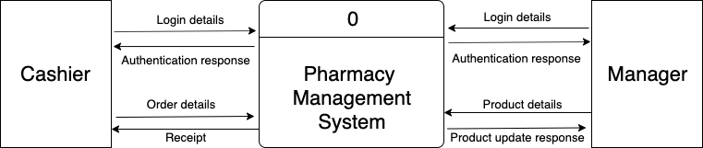

Figure .: Context Diagram (Level 0 DFD)

## Data Flow Diagram

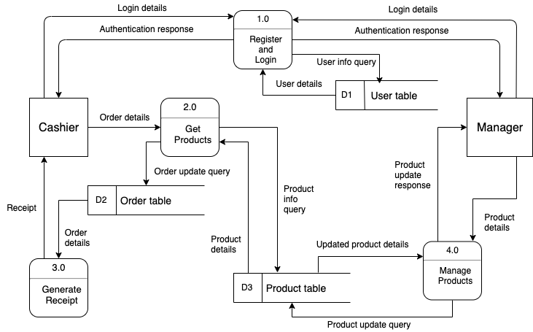

Figure .: Level 1 DFD

## Use Case Diagram

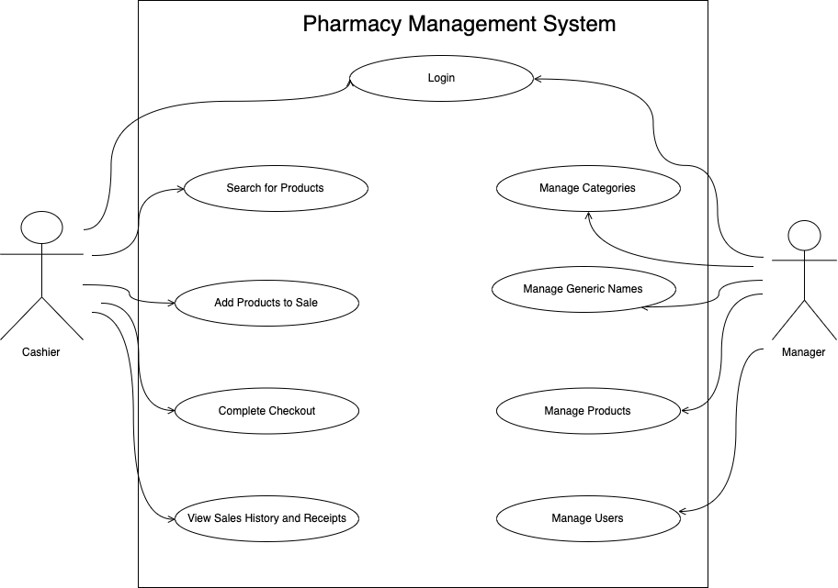

Figure .: Use Case Diagram

## Entity Relationship Diagram

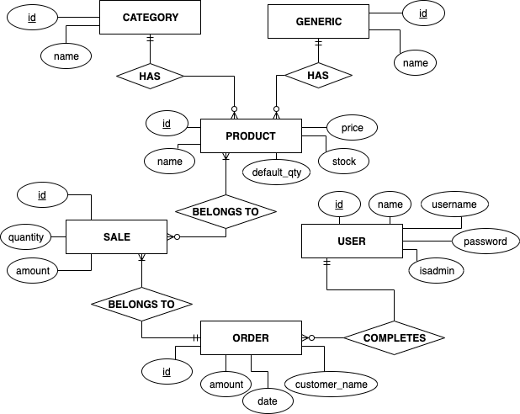

Figure .: Entity Relationship Diagram

## Data Dictionary

The following table lists all the fields stored in the various tables, their data types and short descriptions.

Table ‑1: Data Dictionary

|  |  |  |  |
| --- | --- | --- | --- |
| **Table** | **Field** | **Data Type** | **Description** |
| users | id | INTEGER | Primary key |
| users | name | VARCHAR(255) | User’s name |
| users | username | VARCHAR(255) | User’s username |
| users | password | VARCHAR(255) | User’s password |
| users | isadmin | INTEGER | 0 for regular user and 1 for admin user |
| categories | id | INTEGER | Primary key |
| categories | name | VARCHAR(255) | Category name |
| generics | id | INTEGER | Primary key |
| generics | name | VARCHAR(255) | Generic name |
| products | id | INTEGER | Primary key |
| products | category_id | INTEGER | Foreign key to categories |
| products | generic_id | INTEGER | Foreign key to products |
| products | name | VARCHAR(255) | Product name |
| products | price | DECIMAL(10, 2) | Product price |
| products | stock | INTEGER | Available quantity in stock |
| products | default_qty | INTEGER | Default quantity that is generally sold (e.g. 1 strip may have 10/12 tablets) |
| orders | id | INTEGER | Primary key |
| orders | customer_name | VARCHAR(255) | Customer name |
| orders | date | TIMESTAMP | Date and time of sale completion |
| orders | cashier_id | INTEGER | Foreign key to users |
| orders | amount | DECIMAL(10, 2) | Total amount |
| sales | id | INTEGER | Primary key |
| sales | product_id | INTEGER | Foreign key to products |
| sales | quantity | INTEGER | Quantity of the product |
| sales | amount | DECIMAL(10, 2) | Price of the product |
| sales | order_id | INTEGER | Foreign key to orders |

## UI/UX Mechanisms

The project is based on a web application so the UI will be in the form of a web site. There will be a sidebar menu that provides dropdown menus to access various pages in the website. The links on the menu will be shown according to the authorization level of the current user. We make use of buttons, form elements, tables and graphics to provide a smooth user experience. If there is a long list of items to be displayed, we use pagination system so that only 10 items are displayed at one time.

# System Development and Implementation

## Programming Platform

The web application requires the following tools to function:

* Web server (e.g., Apache)
* PHP
* MySQL

The following libraries were used:

* Bootstrap for responsive web pages
* AdminKit for the admin/sidebar theme
* jQuery for interactivity
* Select2 for searchable text box
* DataTables for pagination, searching and sorting for large tables

We also used the following tools and software during the development and documentation process:

* Visual Studio Code for text editing
* Google Chrome for running, testing and debugging
* Microsoft Word for documentation
* draw.io to generate diagrams

## Operating Environment

The application requires a HTTP Web Server (e.g., Apache), a MySQL server and a PHP interpreter on the server side.

On the client side, a web browser (e.g., Firefox, Chrome) is required to use the application. The application can be accessed from desktops, laptops, tablets or smartphones on any platform provide it can access the internet.

## Testing and Debugging

Table 5‑1: Test Cases

|  |  |  |  |
| --- | --- | --- | --- |
| **No.** | **Test Case** | **Expected Outcome** | **Actual Result** |
| 1 | Provide empty or invalid registration details | Should display error message | PASS |
| 2 | Provide empty or invalid registration details | Should display error message | PASS |
| 3 | Provide correct registration details | Should display success message and redirect to login | PASS |
| 4 | Provide correct registration details | Should display success message and redirect to dashboard | PASS |
| 5 | Add a product to the current sale | Product stock should be decreased by given quantity | FAIL |
| 6 | Remove a product from the current sale | Product stock should be increased by given quantity | FAIL |
| 7 | Search for a product | Should display product information and list of alternative products | PASS |
| 8 | View a receipt from the sales history | Details of that order including all products and total amount must be displayed | PASS |
| 9 | Delete (Cancel) a sale from the sales history | Product quantities should be added back and database updated | FAIL |
| 10 | Add a product to the current sale | Product stock should be decreased by given quantity | PASS |
| 11 | Remove a product from the current sale | Product stock should be increased by given quantity | PASS |
| 12 | Delete (Cancel) a sale from the sales history | Product quantities should be added back and database updated | PASS |

## Implementation and Result Analysis

The coding and testing process was completed successfully and the software behaves as desired. All the objectives of the project were met and we were able to provide all necessary features in the system.

Due to external issues, there was some difference with the time schedule specified in the analysis phase. The project completion Gantt chart is provided as an appendix in Appendix 2.

# Conclusion, Limitations and Future Enhancements

## Conclusion

The analysis, design, coding and testing phases of the project were completed successfully. All the requirements set out during the initial stage of the project were met. The end result of the project is a completely usable and working system.

A few problems were encountered while completing the project. The project was very challenging and offered the chance to learn new programming techniques, tools and frameworks. Overall, the project was beneficial for all team members.

## Limitations

Some of the limitations that exist in the project are:

* Product pictures are not provided.
* Location of product in store rack is not available.

## Future Enhancements

We will add the following features in the next version of the system:

* Add pictures of products so that they are easily recognizable.
* Add the physical location of the product in the store: e.g., the product is in the 3rd and 4th rows of 5th column of the left side rack. This will help the cashier to quicky find products.

References

Duckett, Jon. *HTML & CSS: Design and Build Websites*. John Wiley & Sons, Inc., 2015.

Welling, Luke and Laura Thomson. *PHP and MySQL Web Development*. Sams 2003.

Bootstrap 5 Documentation. https://getbootstrap.com/docs/5.0/getting-started/introduction/

Appendix 1: Screenshots

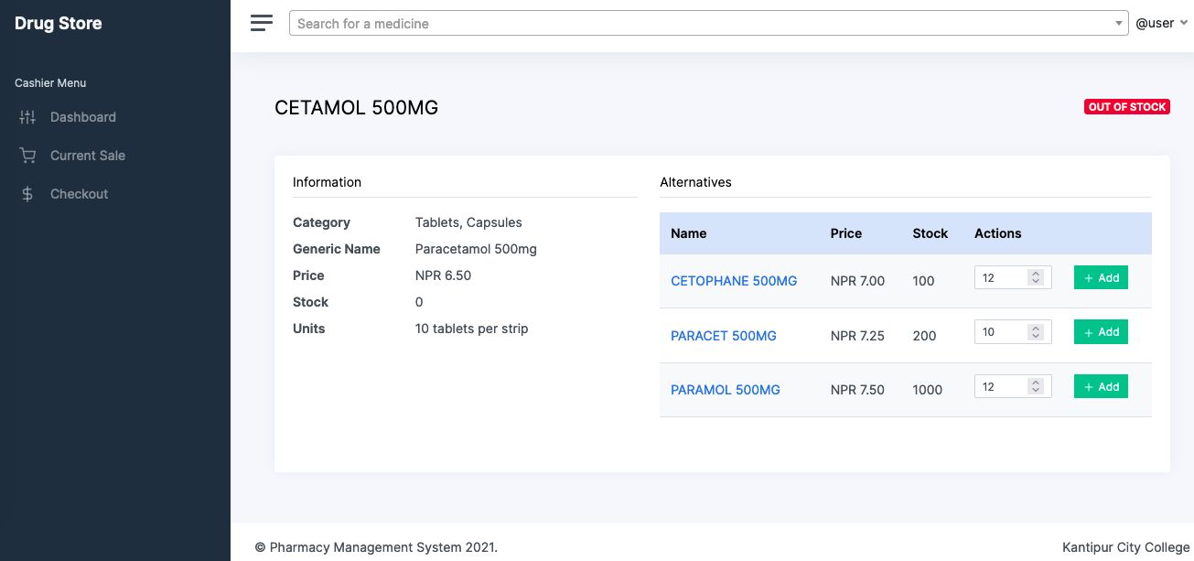

Figure 6.1: Screenshot 1: Cashier View

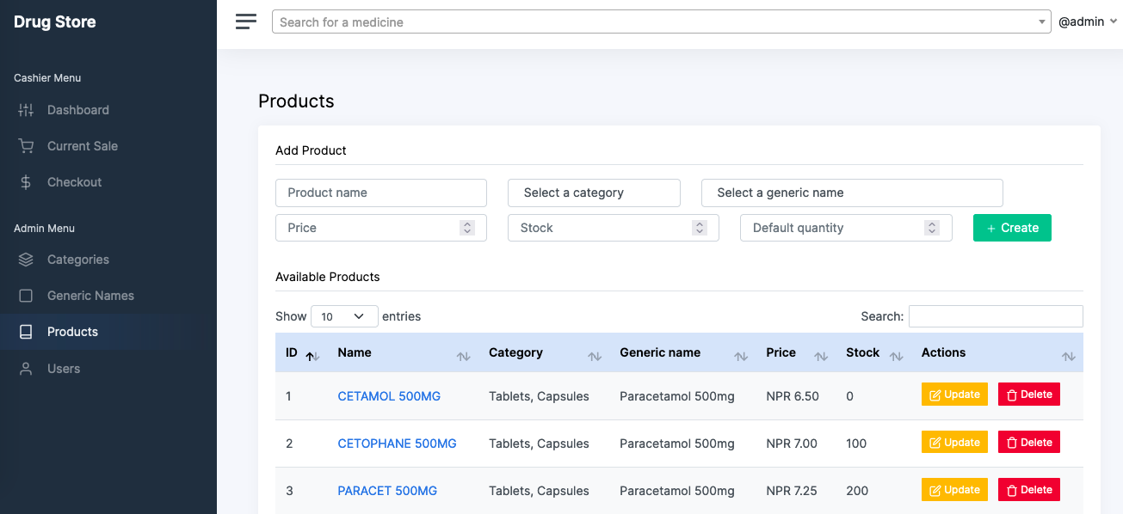

Figure 6.2: Screenshot 2: Manager view

Appendix 2: Project Completion Gantt Chart

|  |  |  |  |  |  |  |  |  |  |  |  |  |  |  |
| --- | --- | --- | --- | --- | --- | --- | --- | --- | --- | --- | --- | --- | --- | --- |
| Week | 1 | 2 | 3 | 4 | 5 | 6 | 7 | 8 | 9 | 10 | 11 | 12 | 13 | 14 |
| Requirements Gathering |  |  |  |  |  |  |  |  |  |  |  |  |  |  |
| System Analysis |  |  |  |  |  |  |  |  |  |  |  |  |  |  |
| System Design |  |  |  |  |  |  |  |  |  |  |  |  |  |  |
| Coding |  |  |  |  |  |  |  |  |  |  |  |  |  |  |
| Testing / Debugging |  |  |  |  |  |  |  |  |  |  |  |  |  |  |
| Documentation |  |  |  |  |  |  |  |  |  |  |  |  |  |  |

Figure 6.3: Project Completion Gantt Chart