**Q1**

**Write a Calculator Program**

**take 2 numbers and return + * - /**

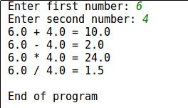

**********************************************************

**Q2**

**Write a program that reads 2 students’ information about math exam.**

* + For each student read: his name, id, and grade.
* Print the students.
* Print the grades average.

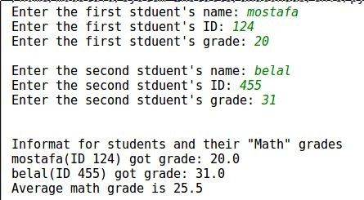

**********************************************************

**Q3**

**Swapping 2 numbers!**

**********************************************************

**Q4**

**Print current date and time in Python 🡪 Print time only**

**Given 8 integers, find the sum of those in even places and the sum of those in odd places.**

* + Note: Even place means the 2nd, 4th, 6th or 8th numbers, odd places are the 1st, 3rd, 5th and 7th numbers.
* **Input**: 11 2 7 9 12 -8 3 -1
* **Output**: 2 33
* Example Explanation:
  + 2 + 9 + (-8) + (-1) = 2 for the even places
  + 11 + 7 + 12 + 3 = 33 for the odd places

**********************************************************

**Q5**

**Write a Python program that accepts a word from the user and reverse it.**

example

enter a word: Abcd.

Reversed: dcbA

**********************************************************

**Q6**

**Write a Python program to parse a string to Float or Integer.**

 

*********************************************************

Write a Python program to get the Python version you are using.

********************************************************

**Q7**

**Write a Python program to print the calendar of a given month and year.**

Note: Use 'calendar' module

********************************************************

**Q8**

**Convert two lists into a dictionary.**

keys = ['Ten', 'Twenty', 'Thirty']

values = [10, 20, 30]

*******************************************************

**Q9**

**Return a new sorted set of identical items from a given two set.**

set1 = {10, 20, 30, 40, 50}

set2 = {30, 40, 50, 60, 70}

********************************************************

**Q 10**

**Counts the number of occurrences of item 50 from a tuple.**

tuple1 = (50, 10, 60, 70, 50)

*******************************************************

**Q 11**

**Remove empty strings and numbers from the list.**

list1 = [9,"I’m", "", " learning ", " python ", "", " at ITI"]

********************************************************

**Q 12**

**Guess the output of this program:**

# print("The best among you is the one who doesn’t harm others with his tongue and hands.")

* The best among you is the one who doesn’t harm others with his tongue and hands.
* Empty Output
* Error

That was comment

******************************************************

str1 = 'mostafa'

print(str1 + 3 * 'saad')

* Error
* mostafasaadsaadsaad
* mostafasaadsaad
* mostafa saad saad saad

********************************************************

str = 'Moustafa'

len = len(str)

str = str * 2 * len

print(len(str))

* Error
* 128
* 256
* 64

*******************************************************