**PROGRAM DESCRIPTIONS**

*Monday - Friday*

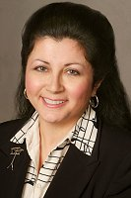**CLASSICAL MUSIC WITH** [**LAURA CARLO**](http://www.wgbh.org/995/carlo_laura.cfm)  
*Weekdays 5am-10am*  
  
Wake up your day the right way with one of Boston’s most beloved morning personalities, bringing you great classical music selections designed to fit in to your busy morning routine, along with timely news, weather, and sports updates. At 8:30, every morning, Boston Pops conductor [Keith Lockhart](http://www.wgbh.org/programs/Backstage-With-Brian-Bell-268/episodes/Boston-Pops-Conductor-Keith-Lockhart-29058) joins Laura for [Keith’s Classical Corner](http://www.wgbh.org/programs/Keiths-Classical-Corner-1038), his classical pick of the day.   
  
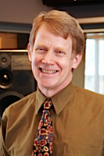**CLASSICAL MUSIC WITH** [**ALAN MCLELLAN**](http://www.wgbh.org/995/mclellan_alan.cfm)  
*Weekdays 10am-2pm*

“The best part of my job is introducing listeners to the fabulous wealth of music and music-makers in the Boston area,” says Alan, who’ll now get the chance to do just that as he takes over the midday classical airwaves in the Hub of the Universe. And every day at noon, Alan opens the ***Café Europa*** a daily visit to a great European musical capital to hear some of the world’s finest ensembles captured in concert…a great lunchtime listening companion!  
  
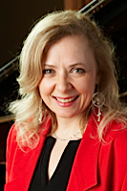**CLASSICAL MUSIC WITH** [**CATHY FULLER**](http://www.wgbh.org/995/fuller_cathy.cfm)  
*Weekdays 2pm-7pm*

Now, more listeners than ever before can hear the warmth, wit, and incredible musical knowledge of Cathy Fuller, who takes over the afternoon shift on Classical New England. Whether you’re on your way home from work, picking up the kids, or getting ready for dinner, you can rely on Cathy for a little stimulating conversation, and lots of glorious music…including ***Drive Time Live***…our new Friday afternoon “commuter concerts” from our Fraser Performance Studio.

****[**PERFORMANCE TODAY**](http://performancetoday.publicradio.org/)  
*Weekdays 7-9pm*  
*Performance Today* features timely concert recordings that can't be heard anywhere else, recent performances by the great artists of our time and by the next generation of classical artists, from concert halls around the globe. Hosted by Fred Child, the show includes interviews and performances from studios, festivals and concert stages around the country, along with classical music news and features, including the popular “Piano Puzzler” with composer Bruce Adolphe, and “Top Score,” with video gamer Emily Reese.  
  
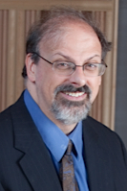**CLASSICAL MUSIC WITH** [**JAMES DAVID JACOBS**](http://www.wgbh.org/995/jacobs.cfm)  
*Monday-Thursday 9pm -1 am*

Classical music evenings have a brand-new sound in Boston, as James David Jacobs takes over the nighttime mic with a unique blend of music old, new, and unexpected, and guaranteed to be an ideal late-night companion. Wind down your day with JDJ!

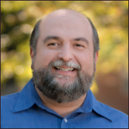[**CONCIERTO**](http://www.concierto.org/)  
*Fridays 9pm – 1 am*

Classical New England sets a new tone for the weekend with the introduction of *Concierto*, the nation’s first bilingual (Spanish and English) classical music program.  Hosted by [**Frank Dominguez**](http://www.concierto.org/blog/item/982-frank-dominguez), the program focuses particularly on Latin American and Spanish composers and musicians.  You’ll hear works from composers like Enrique Granados and Fernando Sor, as well as performances from such greats as Plácido Domingo, Manuel Barrueco, and Gustavo Dudamel.

*Weekends*

**IN PERFORMANCE WITH CATHY FULLER**  
*Saturday Mornings at 6am*

From intimate solo recitals to blazing orchestral showpieces, Cathy Fuller shares the excitement of live music-making in Boston and beyond, all captured in concert by WGBH engineers.

**CLASSICAL MUSIC WITH JAMES DAVID JACOBS**  
*Saturday Mornings, 7am-noon*  
  
From the gentle sounds of the time-honored birdcalls to the strains of Bach, Beethoven, Bernstein and beyond, James David Jacobs offers a unique Saturday morning blend of music that both feeds the soul and stirs the brain.  Including, at 9 am, [***Classics for Kids.***](http://www.classicalkids.org)Every week, classical music's great composers come to life as host **Naomi Lewin** tells their stories in an engaging and entertaining way. Hear all of our children’s programming on our Kids Classical Channel too: [www.classicalkids.org](http://www.classicalkids.org)

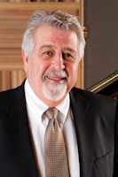**CLASSICAL MUSIC WITH** [**RAY BROWN**](http://www.wgbh.org/995/brown_ray.cfm)  
*Saturdays 12pm - 5pm*

Whether you’re catching up on errands or relaxing around the house, Ray Brown’s friendly manner and his unique mix of music makes him the ideal Saturday companion.

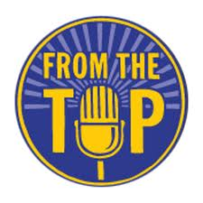[**FROM THE TOP**](http://www.fromthetop.org/)  
*Saturdays at 5pm*

Produced in association with WGBH, **From the Top,** hosted by [Christopher O'Riley](http://www.fromthetop.org/node/108) is public radio's preeminent showcase for America’s best young musicians. Each week, hear compelling performances and stories from a diverse group of young people who pursue life with passion, determination, and joy.

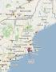[**NEW ENGLAND SUMMER FESTIVALS**](http://www.wgbh.org/programs/New-England-Summer-Festivals-1502)

*Saturdays at 6pm*

*Sundays at noon*  
  
What would summer in New England be without its music festivals?  Each week, we’ll “hit the road” to share with you the places, the personalities, and most importantly, the great performances from the region’s first-class summer music festivals...including the Rockport Chamber Music Festival, Bay Chamber Concerts in Maine, Monadnock Music in New Hampshire, the Newport Chamber Music Festival, and many more!

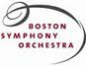[**BOSTON SYMPHONY ORCHESTRA**](http://www.wgbh.org/995/bso.cfm)*Saturdays 7pm-10pm*  
*Sundays 1pm-3pm*

The longest continuous relationship between an orchestra and a broadcaster in the nation just got better, with more opportunities than ever before to hear the Boston Symphony, the Boston Pops and Tanglewood concerts on the radio, online and all over New England. [Ron Della Chiesa](http://www.wgbh.org/995/della_chiesa_ron.cfm) is back to host our 60th Anniversary season of BSO broadcasts that features live concerts from Symphony Hall on Saturday night, and repeats of the program on Sunday afternoons! Each broadcast will be available for on-demand listening, too, via the [Classical New England](http://www.classicalnewengland.org) website.

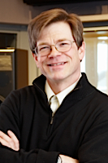[**BSO ON RECORD**](http://www.wgbh.org/topics/BSO-on-Record-243)  
*Saturdays at 10pm*  
  
Your Saturday nights with the “Aristocrat of Orchestras” continues with **The BSO on Record,** an encyclopedic journey with host and producer **Brian Bell** through the rich recording archives of the Boston Symphony Orchestra, from 1917 to the present.

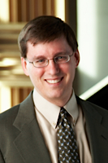**THE** [**BACH HOUR**](http://www.wgbh.org/articles/About-The-Bach-Hour-451) **WITH BRIAN MCCREATH**  
*Sundays at 6am and 5pm*  
J.S. Bach's music offers the experience of both the foundation of classical music and an intimate window on the human condition.  For over 40 years, Bach’s sacred vocal works have had a presence on Boston’s radio airwaves, and that continues each week with [**Brian McCreath**](http://www.wgbh.org/995/mccreath_brian.cfm) in an exploration of those masterpieces, along with the instrumental works and more by this iconic composer.  
  
  
****[**BAROQUE IN BOSTON**](http://www.wgbh.org/programs/programDetail.cfm?programid=1503) **WITH LAURA CARLO**  
*Sundays 7am-11am*

Laura Carlo wakes up Boston for one more day now, with a new show that explores and celebrates the richness and diversity of Boston’s early music scene. *Baroque in Boston* is centered on just that, with enough room on either side of the genre to accommodate Renaissance *bransles* to the sturdy New England melodies of William Billings.  With plenty of music by Bach and his contemporaries in between.  Spend your Sunday mornings with Laura Carlo and *Baroque in Boston* - a new New England tradition!

**LIVE FROM FRASER**  
*Sundays at 11am*

Be they International touring artists, promising prodigies from our conservatories, or front-rank ensembles from Boston and New England, classical musicians of every stripe beat a bath to our state-of-the-art Fraser Performance Studio, for an hour of in-depth conversation and passionate music-making. **Cathy Fuller** is your host.

**SUNDAY CONCERT**  
*Sundays 3pm-5pm*

The Handel & Haydn Society, Boston Baroque, the Boston Philharmonic, the Discovery Ensemble, Emmanuel Music, A Far Cry, and the New England Conservatory Symphony are among the major ensembles captured live in concert and presented for your listening enjoyment every Sunday afternoon.

****[**ARIAS & BARCAROLLES**](http://www.wgbh.org/programs/Arias-and-Barcarolles-1515) **WITH CATHY FULLER**  
*Sundays at 6pm*

*“You know, I liked that last piece you played; it's got a theme. I like music with a theme, not all them Arias and Barcarolles.”  -* Dwight D. Eisenhower, speaking to Leonard Bernstein after a White House concert, 1960.  
  
Leonard Bernstein was so taken by President Eisenhower’s remark that 30 years later, he produced a song-cycle called *Arias and Barcarolles,* with a theme Bernstein described as “The politics of love.” Similarly inspired, **Cathy Fuller** lends her voice to the weekend with a program devoted to an exploration of song - and the art of the vocal recital.  Perhaps with a Barcarolle or two!  
  
  
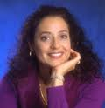[**NPR WORLD OF OPERA**](http://www.npr.org/programs/world-of-opera/)  
*Sundays at 6:30 pm*

Host [**Lisa Simeone**](http://www.npr.org/people/2101205/lisa-simeone) brings listeners compelling performances from top American and international opera companies. Each week Lisa brings you a full-length opera captured from some of the most storied companies around the world, including the Vienna State Opera, Bayreuth, Glyndebourne, Washington National Opera, Glimmerglass, New York City Opera, Paris National Opera and more.                              

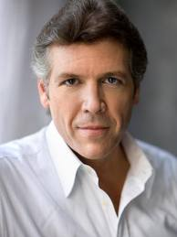[**SONG OF AMERICA**](http://www.songofamerica.net/cgi-bin/iowa/home/index.html)  
*Sundays at 10pm*  
  
***Song of America*** explores the history of American culture through the eyes of our poets and the ears of our composers. Developed and hosted by baritone **Thomas Hampson**, the series treats American classic song – poetry set to music by American composers – as a vibrant diary of the American experience. Each program focuses on a particular topic that sheds light on a larger theme in American history, and includes songs drawn from archival and modern recordings, plus stories and insights from Mr. Hampson about the people and events that inspired those songs.   
  
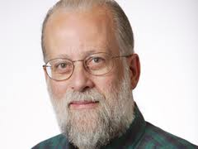[**PIPEDREAMS**](http://pipedreams.publicradio.org/)  
*Sundays 11pm-1am*  
  
Hosted by **Michael Barone**, *Pipedreams* is a two-hour program dedicated to organ music performance.  Each week the show is themed around a performer, composer, organ, organ maker or venue.  Listen closely, as many Boston-area organs and organists are regularly featured on the show!