Salesforce Applicant Portal
Process & Training Documentation



Table of Contents

Salesforce Recruiting – Portal Hiring Manager 3
New Job Requisition 5
Approved Job Requisition 8

Salesforce Recruiting – Portal Hiring Manager
Your manager requests a login for you in the portal production environment.

  - Login using the following URL https://wgbh.secure.force.com/openpositions
  - User name xxxx_xxxx@wgbh.org - your password should be emailed to you once you are set up in the production system.
  - Click on the url in the email and it will allow you to change from the system generated password to your own unique password, you will be required to set up a security question and response.
  - You are not required to log in behind the firewall using VPN.
  - Be sure you are utilizing one of the following browsers.
Mozilla Firefox version 3.6.x | Salesforce.com recommends using Firefox for best performance. For configuration recommendations, see Configuring Firefox.
Microsoft® Internet Explorer versions 6.0, 7.0, and 8.0 | Salesforce.com strongly recommends using Internet Explorer version 8.0 over versions 6.0 and 7.0. Apply all Microsoft® hotfixes. For configuration recommendations, see Configuring Internet Explorer.
Apple® Safari version 5.0.x | Supported on Windows XP and Mac OS X version 10.4 and later. There are no configuration recommendations for Safari.

Follow these steps if you have forgotten your password:
- Attempt to log in with your username and a dummy password.
- Click Forgot your password?
- Correctly enter your username and click Continue. A message will automatically be sent to your email address.
- Click the link provided in that message, correctly answer your password question, and click Continue.
- A temporary password will be automatically sent to your email address. Click the link to log in using that temporary password.
- When prompted, enter a new password.
You may need to activate your computer to successfully log in to Salesforce.com whenever your password is changed or reset, or when you log in from a computer you have not used to access Salesforce.com before. Activating your computer allows Salesforce.com to verify your identity and prevent unauthorized access. To activate your computer:
- When prompted on the login page, click the Send Activation Link button. Salesforce.com sends an activation email to the email address specified on your Salesforce.com user record.
- When you receive the activation email, copy and paste the activation link into your browser.
- The activation link included in the email is available for you to copy and paste into your browser up to 24 hours from the time you clicked the Send Activation Link button. After 24 hours, the activation link expires, and you must repeat the activation process to log in.
Password policies determine how many failed logins are allowed, for WGBH you may attempt to login up to 5 times before you are locked out. Your login screen should appear as shown below.
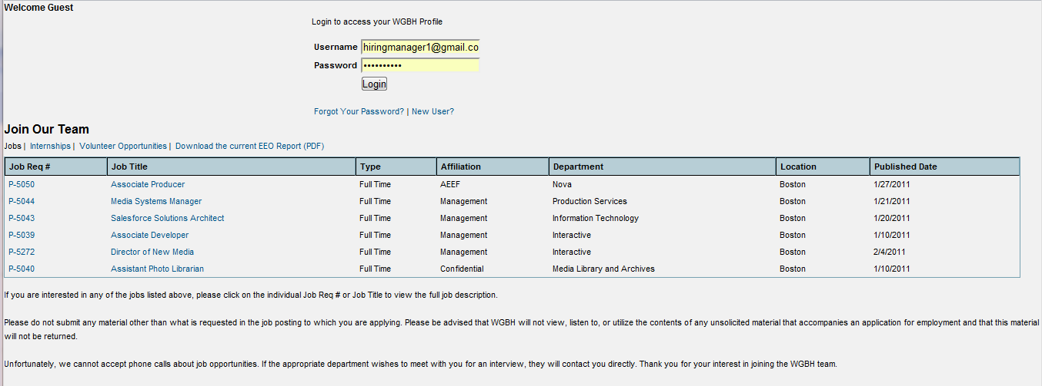
The Job details will show on the WGBH site and the potential job applicants will click into the Apply Button.
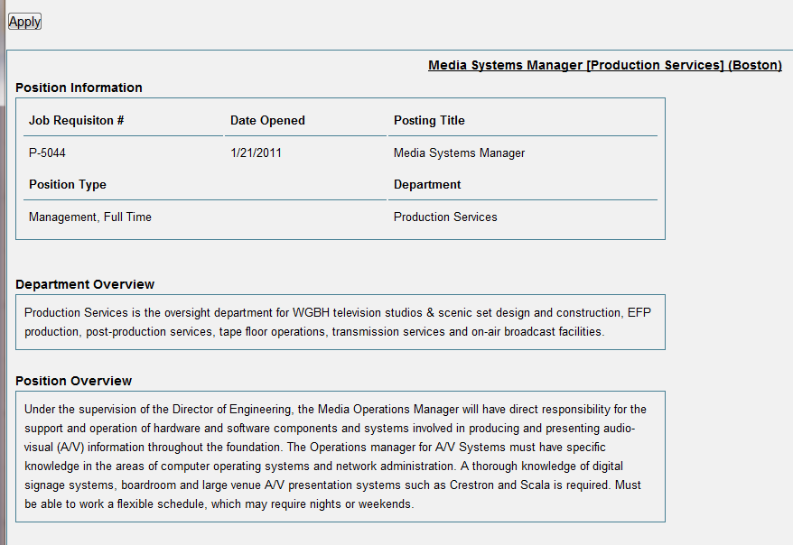

New Job Requisition
Once you have logged into Salesforce please click into the Home, Candidate, Job Applications, Job Requisitions, Reviews or Open Positions tab, users on the WGBH site will be able to click into a Job Title to review the open position and apply, click into the home tab or Create new job requisition. On the left is your search bar where you can view your most recent items.
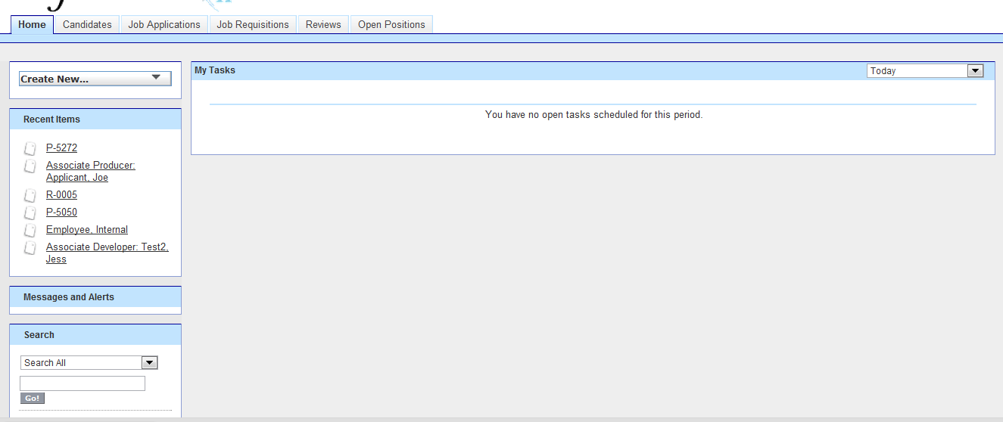
Click into ‘Create New’ drop down and select create a new Job Requisition or Click into the Job Requisition tab and click into New. The window will open for creation of a new Job Requisition, when complete hit Save.
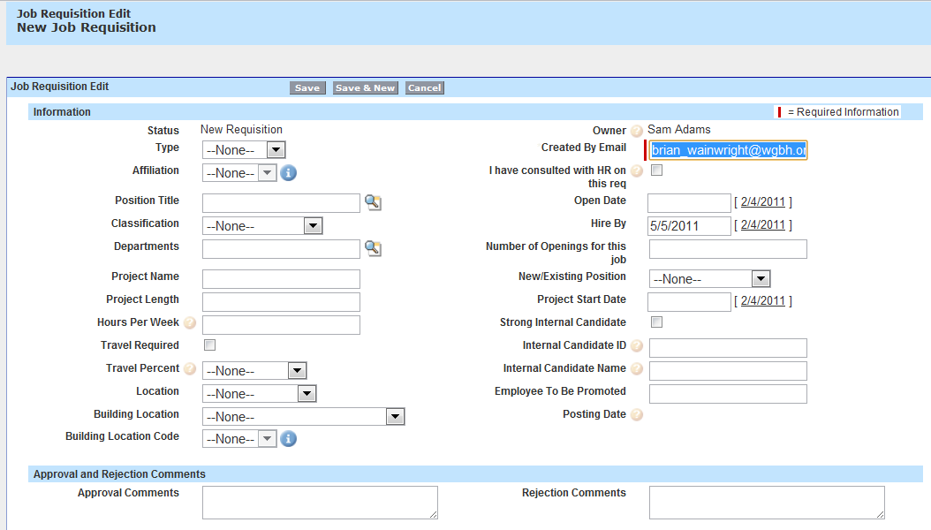
- Enter the Type (Full or Part Time)
- Based on the type you will select the appropriate Affiliation; AEEF, Confidential, Management, NABET
- Enter the Position Title, if you do not know the name of the position click into the Magnifying glass which is a look up field. In the search box enter the first letter of the position with a wild card search A* or a short version of the position title i.e. Director* and hit Go!, the result will show on the screen in the look up box, click into the title and it will populate in the field.
- Magnifying Glass is a Look Up Icon. You can use * as a wildcard search. Job titles are pulled from Lawson the WGBH financial system of record.
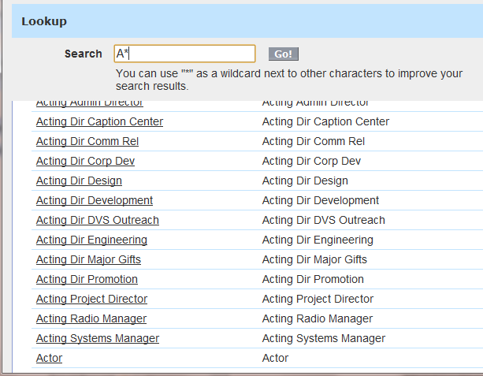
- Enter the Classification; Staff, Project Contract, Temporary, Co-op
- Enter the Department, if you do not know the name of the department please click into the Look up field.
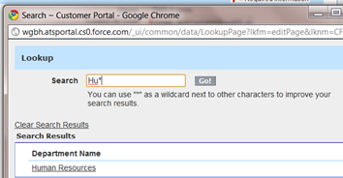
- Enter a project name if applicable.
- Enter the Hours per Week (this is the number of hours of work per position).
- If travel is required with the position please check the box.
- Select the percentage of travel required for the position; <10, <25, <50, Road Warrior
- Select the work Location; Boston, Los Angeles, New York, Greenfields, Cape & Islands
- Select the building location; Rhode Island, Carolina, Boston (Guest Street), PA, CT, California, Cape & Islands, LA, NY, MA, Nova NY, Springfield
- Select the building location code, this is dependent on the value you select from the prior building location field.
- Enter the email of who created the job requisition
- Check the box if you have consulted with HR regarding this position.
- Enter the open and hire by dates, you can click on the current date or click into the white space and it will open a calendar and you can select the date, month and year.
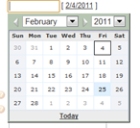
- Enter the number of openings for this position.
- Select whether it is a new or existing position.
- Enter the project start date if applicable.
- If there is a strong internal candidate please check the box.
- Enter the Internal Candidate ID (ID default is usually the Last Name in all Caps plus the first initial of the first name i.e. JONESS
- Enter the name of the person being considered for the position.
- Save the job requisition.
- Scroll down the page and add in any questions that should appear on the web site which are related to this position. Once you have completed the questions review for accuracy and completeness and Save. 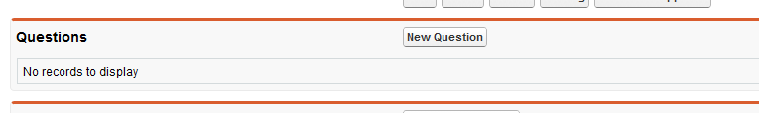

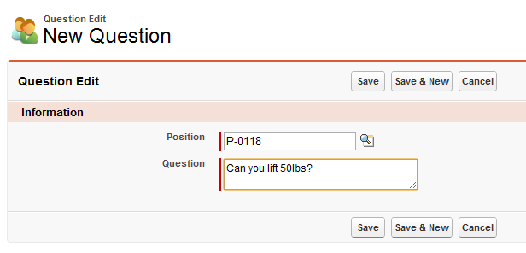
- When the requisition is complete please “Submit for approval”.
- Posting date is a view only field, Human Resources will update this field.
- Salary range will be populated directly from Lawson.

Approved Job Requisition

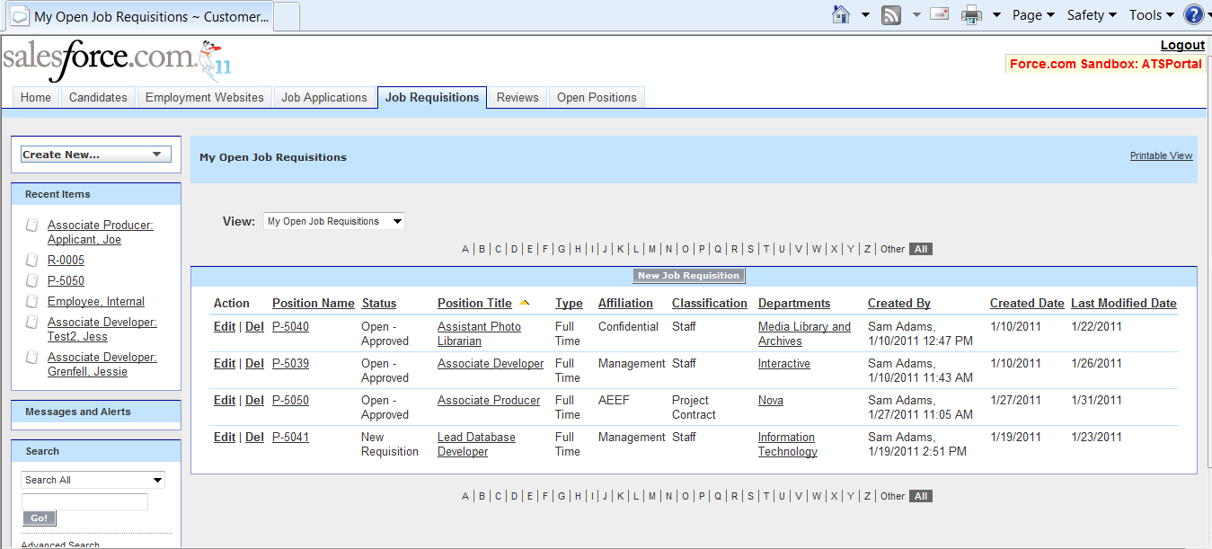

- The person who owns the job requisition will receive an email that it has been approved or rejected.
- Once approved and active, the job requisition is posted on the WGBH site.
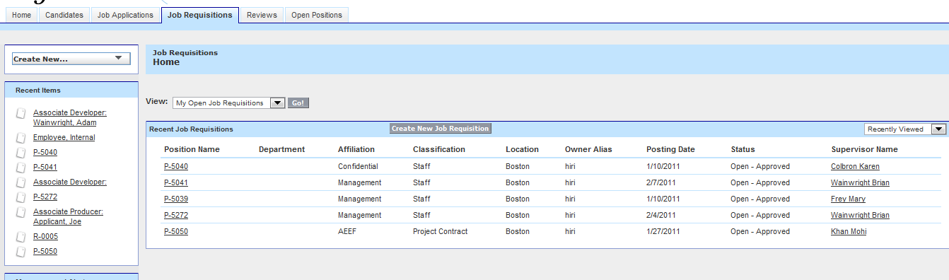
- Candidates apply for the open job requisition, they must create a profile on the WGBH site and submit a cover letter and resume.
- Their information is captured as a new or updated job applicant.
- Click into the name of the Candidate. 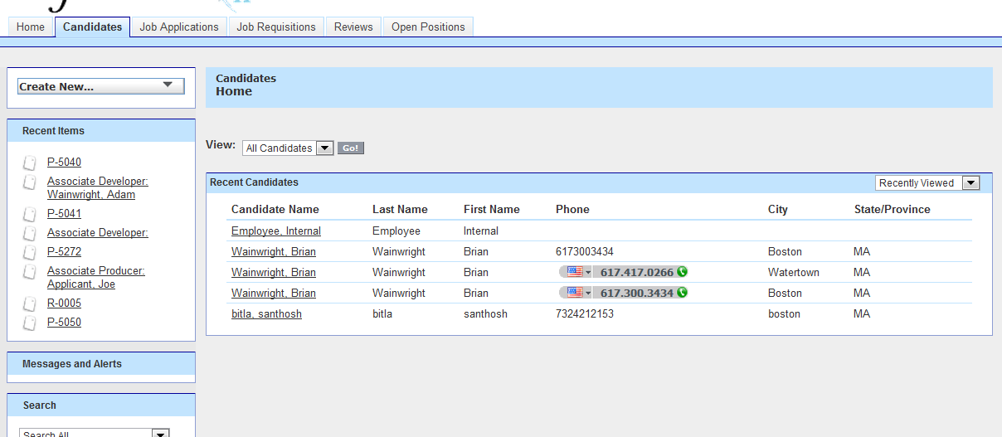

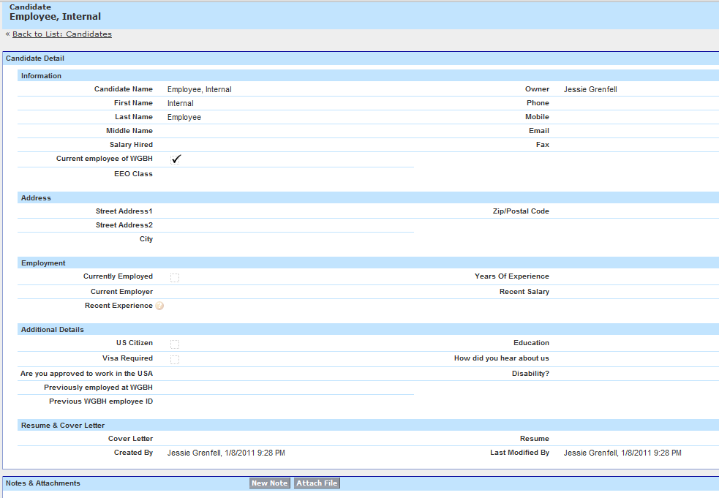

- The candidates resume and cover letter are attached and show in the candidate detail. Scroll down to the bottom of the page and view the job the applicant applied for and click into the View Action to review the resume and cover letter.
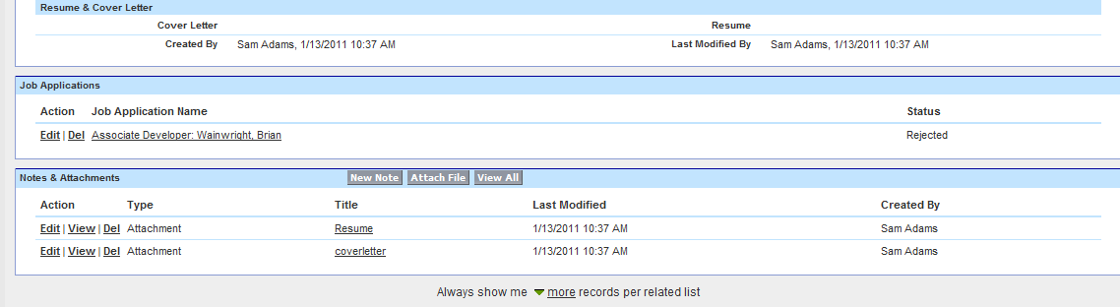
- Interviews are conducted, you can check on the position to see how many people have interviewed for the position and the ratings on the position by clicking in the Job Applicants tab and selecting the View: All Job Applicants. 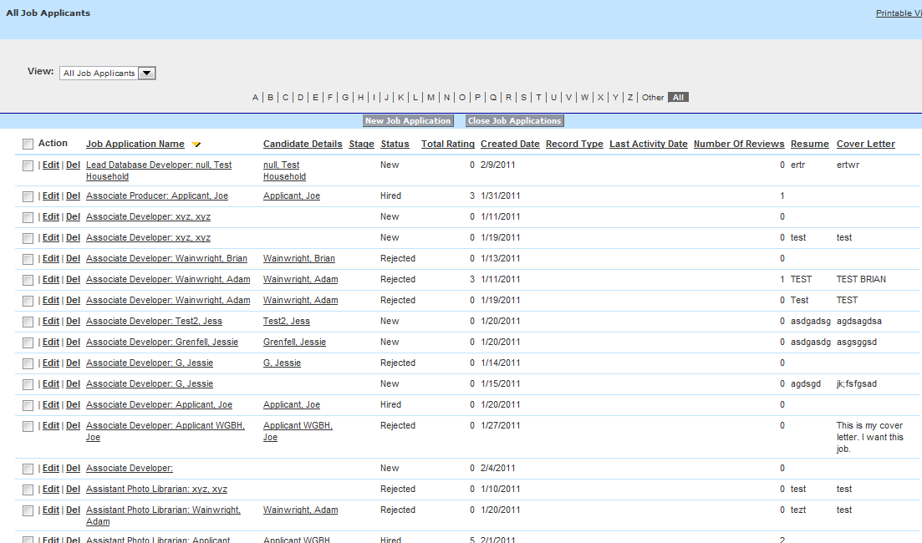

- Ratings need to be applied to each applicant that has an interview – click into the Reviews tab and select the candidate to be reviewed.

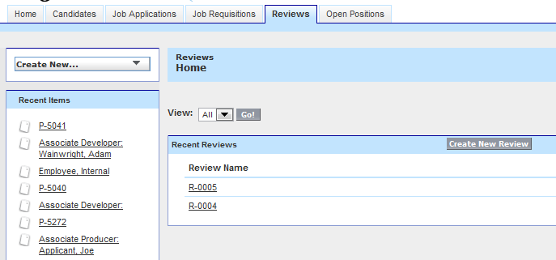
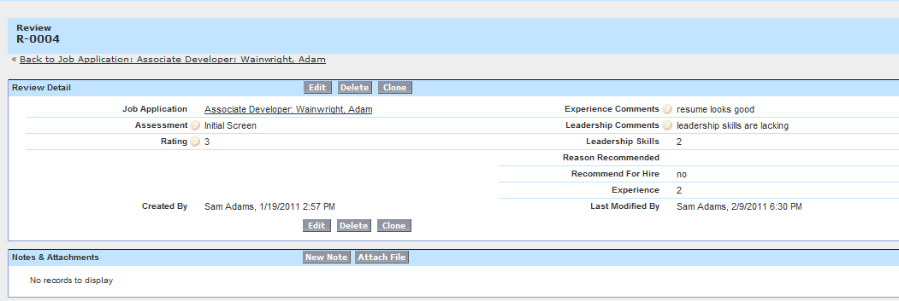

- Hiring Manager recommends or does not recommend candidate, and notifies the Human Resource contact.
- Background and reference checks are performed.
- Candidates are approved for open job requisitions.
- Offer letter and final salary is approved.
- Offer letter and appropriate paper work is sent.
- Job is negotiated and or accepted.
- Job requisition is closed with approved candidate associated to the job.
- Information is gathered on the new employee and all paperwork is complete and validated.
- Information is sent to Lawson to set up new employee, start date, paperwork is validated.
- Start date is confirmed with hiring manager.
- New hire process is started and employee starts at WGBH.

If you wish to review the open position on the web site please open the link in a new window, if you click into the Open Position tab you will go directly to the position and will be logged out of the current application.
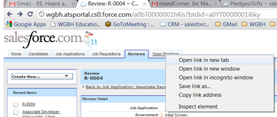
If you need further help please enter a normal IT ticket or contact your Human Resource department.

