July 19, 2011

Mr. Michael W. Mcdowell
185 Dodge Road
Rowley, MA 01969-2208

Dear Mr. Michael W. Mcdowell:

Thank you for your support of WGBH. The statement below indicates the donations you made to WGBH for tax year 2011. It is provided to help with your record keeping and tax preparation in accordance with IRS guidelines.

The total value of your donations is noted on the statement below. From that amount we have subtracted the fair market value of any thank-you gifts received, as that amount is not tax-deductible. The total tax-deductible portion of your contribution to WGBH is indicated at the bottom of the statement.

This letter also provides me the opportunity to recognize your commitment to WGBH and public broadcasting. Thank you again for your generosity; it is deeply appreciated.

Sincerely,
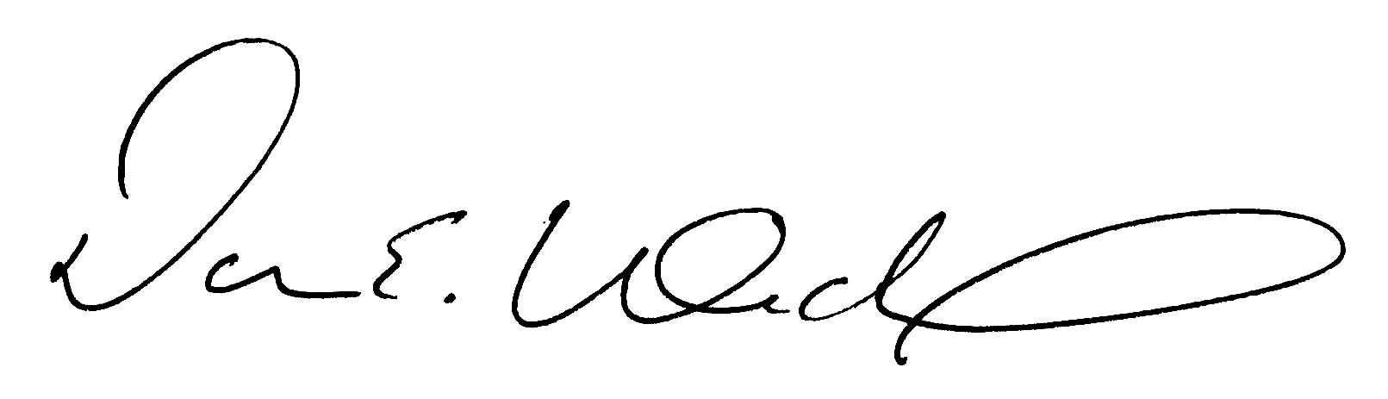
Daren Winckle
Director of Membership

STATEMENT

Name: Mr. Michael W. Mcdowell Member #2568687

Date: 3/23/11 Amount: $360.00

Thank You Gift: 4-tickets: Joe Bonamassa Value: $276

Tax-deductible portion of your contribution is: $84.00

