**Anglia Ruskin University**

**MSc Computer Science**

**MACHINE LEARNING IN FINANCE**

2024 MOD009701 TRI1 F01CAM

ELEMENT 011 – PART 2

***Lab Logbook***

**Jonathan Poston - 1012767**

***Date:*** *13th December 2024* ***Word Count:*** *N/A*

Table of Contents

Lab 1 2

Lab 2 3

Lab 3 4

Lab 4 5

Lab 5 6

Lab 6 7

Lab 7 8

Lab 8 9

Mock Test Week 9

Lab 9 10

Week of In Class Test 10

Lab 10 11

Note regarding issue with graphs 11

Precision 12

Accuracy 13

Lab 11 14

Lab 12 15

Final Week - No Logbook Task 15

# Lab 1

Link to Git Hub:

# A screenshot of a computer Description automatically generatedLab 1



# A screenshot of a chat Description automatically generatedLab 2

# Lab 3

# Lab 4

# Lab 5

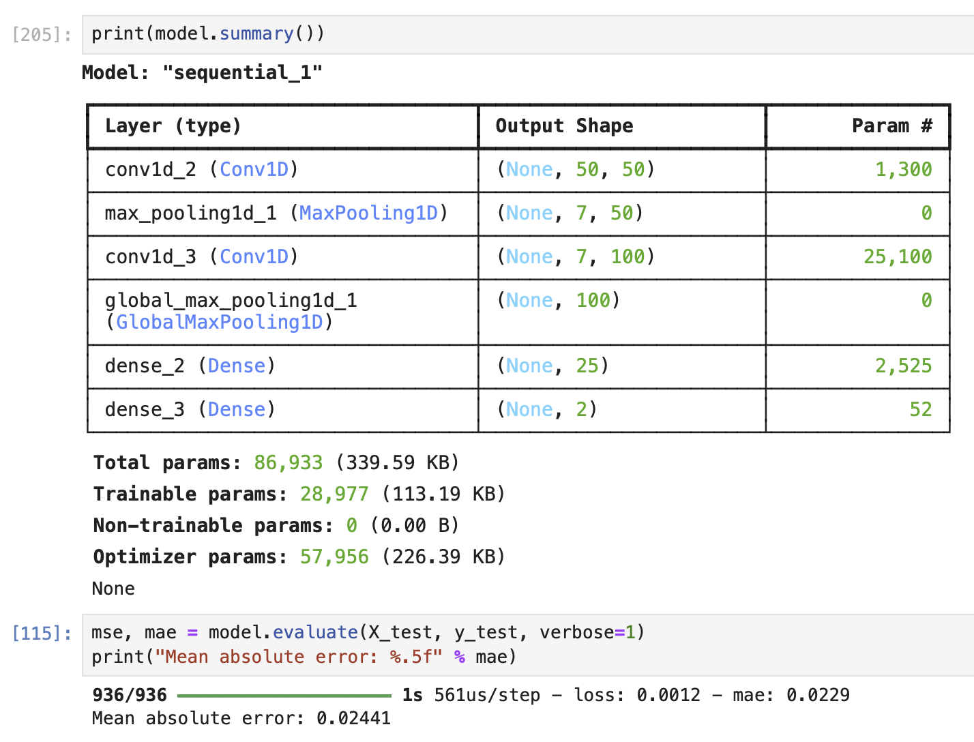

# Lab 6

# Lab 7

# Lab 8

## Mock Test Week

MLP

CNN

LSTM

# Lab 9

## Week of In Class Test

# Lab 10

## Note regarding issue with graphs

Despite my best efforts and everything in the code aligning perfectly with the code provided, I still get these appalling graphs, and I can’t work out why I cannot improve them. The model is exactly the one provided, but always produces the same extremely high val_loss score.

I have tried to starting again from scratch, but I got exactly the same results. I hope the fact that I understand what code to use, etc will mitigate the graphs somewhat.

Below is the training history screenshot for reference.

## Precision

## Accuracy

# Lab 11

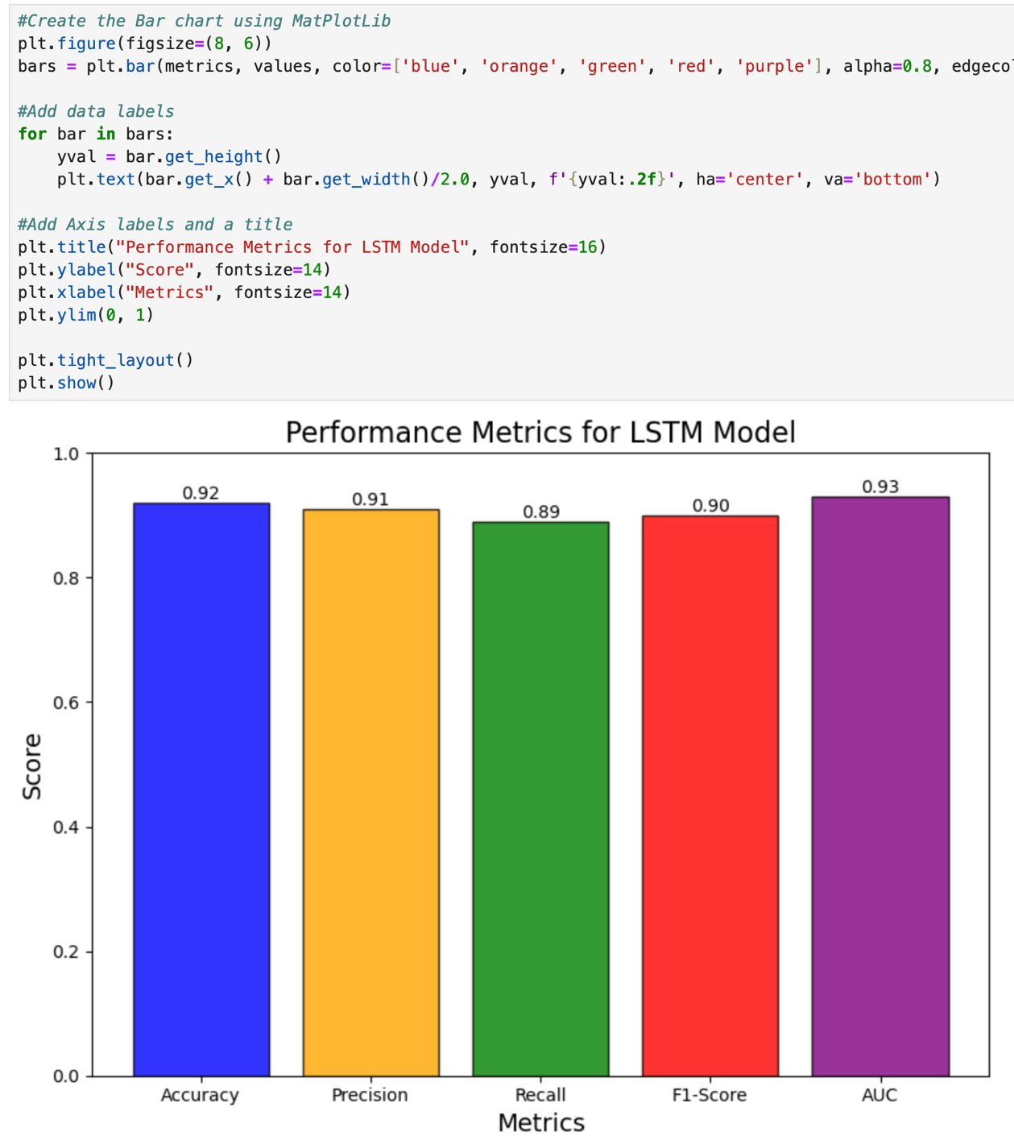

# Lab 12

## Final Week - No Logbook Task