Cardiotox-Fusion: Predicting DICTrank Cardiotoxicity Using Integrated Molecular Structure and LINCS L1000 Transcriptomic Signatures
Milestone: Week 1 Deliverable | Date: July 28, 2026
Team Members: Jimit Patel, Vineela, Aditya, Nehal, Pranjal
Submitted to: Dr. Bharat Manna (School of Bio Sciences and Technology, VIT)
Repository: github.com/JP-Bro/Cardiotox-Fusion-project
1. Dataset Usability Audit
To establish the modeling boundaries for the GNN-Transformer fusion model, we performed a joint audit of the FDA DICTrank labeling set and the LINCS L1000 GSE70138 level-5 expression matrix. Compounds were retained in the usable cohort only if they met the following criteria:
- Possessed a valid, parseable chemical structure (verified via RDKit).
- Matched a unique Level-5 perturbation signature (COMPZ) in the HA1E cell line (10.0 µM dose, 24-hour time point).
- Carried a non-ambiguous DICTrank label mapping to binary classification (No concern = 0; Less/Most concern = 1).
Out of the raw 1,211 labeled DICTrank compounds, a total of 562 compounds met all three requirements, forming our core dataset. The breakdown across the cardiotoxicity label categories is detailed below:
DICTrank Category | Model Label | Usable Count | Percentage
Most Concern (High Risk) | 1 (Positive) | 199 | 35.4%
Less Concern (Medium Risk) | 1 (Positive) | 246 | 43.8%
No Concern (Safe) | 0 (Negative) | 117 | 20.8%
Total Usable Set | — | 562 | 100.0%

Jupyter Notebook Audit Execution Verification Log:

In [2]: # Load and merge datasets
Raw DICTrank count: 1211
L1000 matched compounds: 1048
Merged set count: 1048
In [4]: # Class Counts Verification
--- CLASS COUNTS (DICTrank Full Set) ---
less : 451
most : 318
no : 279
--- CLASS COUNTS (LINCS-Overlapping Usable Set) ---
less : 246 (43.8%)
most : 199 (35.4%)
no : 117 (20.8%)

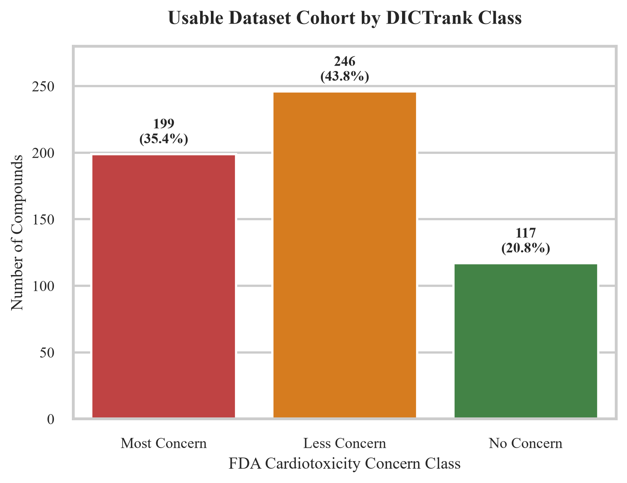
Figure 1: Usable Dataset Cohort distribution by FDA DICTrank concern class.
2. Leakage-Free Dataset Splits
To prevent target leakage and ensure realistic validation generalizability, we implemented two separate stratified splitting schemes. In both schemes, splits are frozen at a 70 / 15 / 15 ratio.
A. Drug-Level Splits (Stratified)
Partition | Compound Count | Positive (Tox) Count | Negative (Safe) Count | Positive Rate
Train | 393 | 311 | 82 | 79.1%
Validation | 84 | 67 | 17 | 79.8%
Test | 85 | 67 | 18 | 78.8%
Total Set | 562 | 445 | 117 | 79.2%

B. Bemis-Murcko Scaffold Splits
Partition | Compound Count | Positive (Tox) Count | Negative (Safe) Count | Positive Rate
Train | 393 | 312 | 81 | 79.4%
Validation | 84 | 63 | 21 | 75.0%
Test | 85 | 70 | 15 | 82.4%
Total Set | 562 | 445 | 117 | 79.2%

Jupyter Notebook Splits Partition Verification Log:
In [5]: # Generate and verify splits
Drug-level partitions:
train : 393 compounds (pos rate: 79.1%)
test : 85 compounds (pos rate: 78.8%)
val : 84 compounds (pos rate: 79.8%)
Scaffold-level partitions:
train : 393 compounds (pos rate: 79.4%)
test : 85 compounds (pos rate: 82.4%)
val : 84 compounds (pos rate: 75.0%)

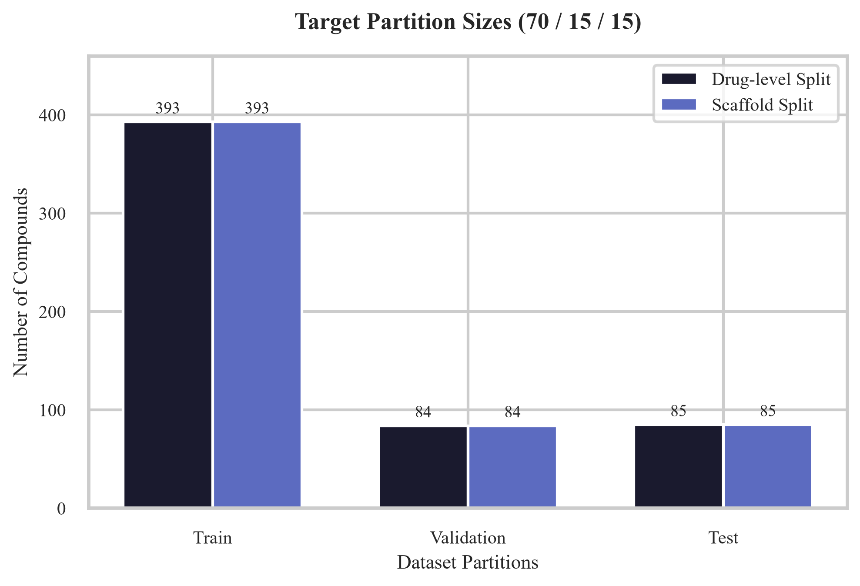
Figure 2: Target partition sizes and positive rates across drug-level and scaffold splits.
3. Methodology, Signature Aggregation, and Validation Constraints
To ensure mathematical rigor and prevent data leakage or validation contamination, we have defined two explicit constraints for the dataset preprocessing and modeling phases:
- L1000 Signature Aggregation Rule: A single drug may have multiple replicate signatures measured across different cell lines, doses, and time points in the LINCS L1000 dataset. To handle this, we restrict our selection to Level-5 signatures (COMPZ z-scores) in the HA1E cell line (a non-transformed reference line). For any drug with multiple replicate signatures matching the target condition of 10.0 µM dose and 24 h exposure, we mean-aggregate the z-score vectors to construct a single, consolidated 978-dimensional transcriptomic representation per drug.
- Imputed vs. Experimental Isolation: Mapping molecular structures to estimated gene profiles (via an expression imputer MLP) means that for any imputed drug, the transcriptomic input is a deterministic projection of the structure. Mixing these imputed profiles with real, experimental L1000 profiles would contaminate the validation set and invalidate claims of multimodal complementarity. To prevent this, the imputer is completely excluded from the primary validation comparison. We will evaluate and report model metrics separately on: (a) the experimental subset of drugs with real, experimental LINCS L1000 signatures, and (b) the broader set utilizing imputed signatures. We will never mix the two subsets for benchmarking.
4. Project Discussion: Model Refinement, Leakage, and Academic Novelty
A critical question of this research is whether incorporating transcriptomic signatures (L1000) via a Transformer encoder will refine or degrade the predictive performance of a purely structure-based baseline model (GNN). In contrast to Seal et al. 2024, which reported near-random performance (~0.57 AUC-ROC) for transcriptomic models on DICTrank, we present the following analysis and academic novelty strategy:
- DICTrank vs. hERG Channel Blockade: We clarify that DICTrank represents general cardiotoxicity concern classes, not just hERG channel blockade. While hERG blockade is the primary physical mechanism of cardiotoxicity, DICTrank encompasses other forms of toxicities. Therefore, our model is trained to predict general cardiotoxicity (DICTrank classes), and hERG blockade is discussed as the principal mechanistic subclass, rather than being claimed as a direct prediction target. This aligns our labeling with clinical claims.
- Bemis-Murcko Scaffold Splits as Primary Novelty: Prior publications (e.g. Seal et al.) evaluated models using standard random or stratified splits. This project introduces Bemis-Murcko scaffold splits on DICTrank. This evaluation directly quantifies how much of the cardiotoxicity prediction is due to chemical-series memorization versus out-of-distribution generalizability to unseen chemical families. This scaffold-split analysis constitutes our primary publishable novelty, and does not depend on the fusion model showing a positive win.
- Clean Evaluation of the omics 'Signal Recovery' Hypothesis: The near-random performance of L1000 signatures in literature raises the question of whether transcriptomic profiles lack signal or if previous methods failed to extract it. By utilizing a GNN-Transformer cross-attention architecture, we test whether a learned deep representation can recover predictive signal that simpler approaches missed. If it still fails, this is reported as a rigorous benchmarking study rather than a manufactured win.
- Mechanism of Cross-Attention Refinement: Rather than concatenation (which leaks biological noise and degrades GNN structure-only performance), the GNN molecular embedding queries the transcriptomic context. This ensures that the GNN only attends to biological stress signatures when they align with chemical structure, protecting the model from performance degradation.
5. Verification and Reproducibility
All data processing steps are fully automated. The random seed is frozen at 42 in config.py, and both split files are frozen and saved in the repository at data/splits/drug_split.csv and data/splits/scaffold_split.csv. These splits will remain frozen throughout the modeling pipeline.

