Cardiotox-Fusion: Phase 1 Usability Audit and Dataset Splits
Milestone: Week 1 Deliverable | Date: July 27, 2026
Team Members: Jimit Patel, Vineela, Aditya, Nehal, Pranjal
Repository: github.com/JP-Bro/Cardiotox-Fusion-project
1. Dataset Usability Audit
To establish the modeling boundaries for the GNN-Transformer fusion model, we performed a joint audit of the FDA DICTrank labeling set and the LINCS L1000 GSE70138 level-5 expression matrix. Compounds were retained in the usable cohort only if they met the following criteria:
- Possessed a valid, parseable chemical structure (verified via RDKit).
- Matched a unique Level-5 perturbation signature (COMPZ) in the HA1E cell line (10.0 µM dose, 24-hour time point).
- Carried a non-ambiguous DICTrank label mapping to binary classification (No concern = 0; Less/Most concern = 1).
Out of the raw 1,211 labeled DICTrank compounds, a total of 562 compounds met all three requirements, forming our core dataset. The breakdown across the cardiotoxicity label categories is detailed below:
DICTrank Category | Model Label | Usable Count | Percentage
Most Concern (High Risk) | 1 (Positive) | 199 | 35.4%
Less Concern (Medium Risk) | 1 (Positive) | 246 | 43.8%
No Concern (Safe) | 0 (Negative) | 117 | 20.8%
Total Usable Set | — | 562 | 100.0%

Jupyter Notebook Audit Execution Verification Log:

In [2]: # Load and merge datasets
Raw DICTrank count: 1211
L1000 matched compounds: 1048
Merged set count: 1048
In [4]: # Class Counts Verification
--- CLASS COUNTS (DICTrank Full Set) ---
less : 451
most : 318
no : 279
--- CLASS COUNTS (LINCS-Overlapping Usable Set) ---
less : 246 (43.8%)
most : 199 (35.4%)
no : 117 (20.8%)

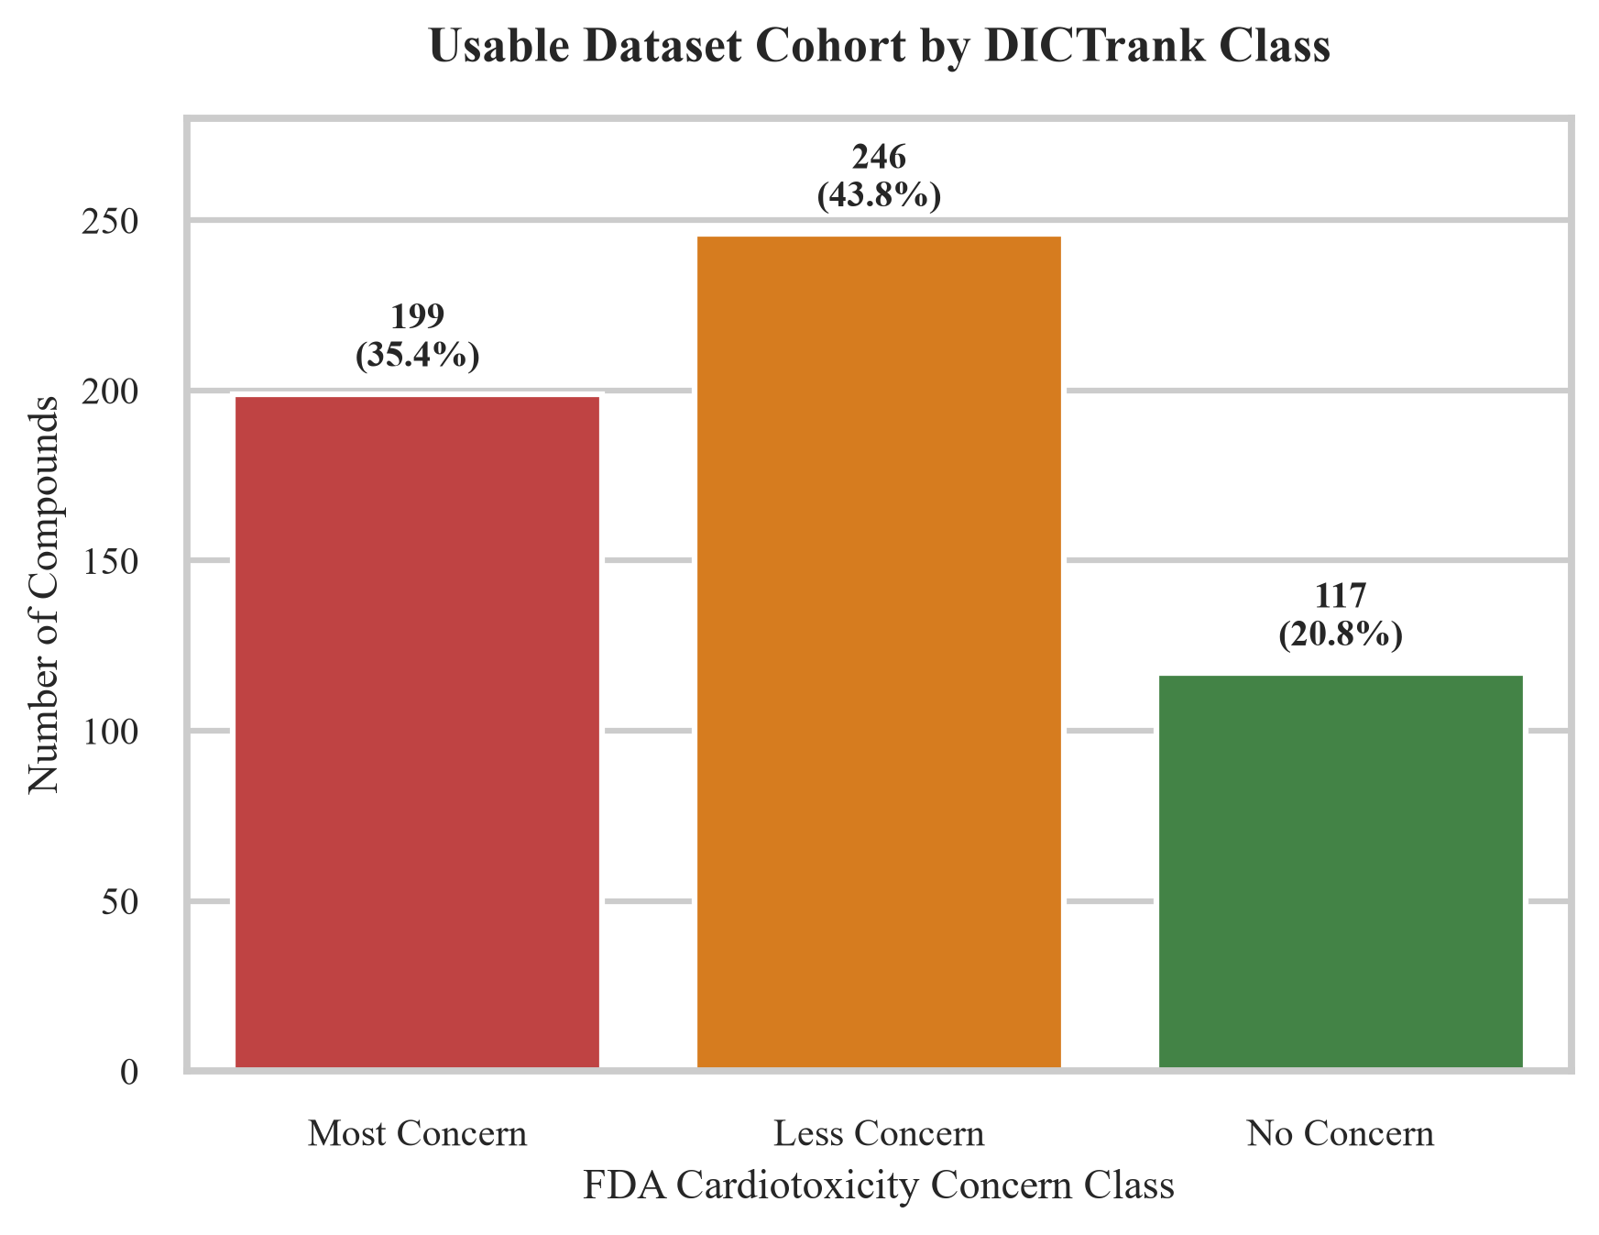
Figure 1: Usable Dataset Cohort distribution by FDA DICTrank concern class.
2. Leakage-Free Dataset Splits
To prevent target leakage and ensure realistic validation generalizability, we implemented two separate stratified splitting schemes. In both schemes, splits are frozen at a 70 / 15 / 15 ratio.
A. Drug-Level Splits (Stratified)
Partition | Compound Count | Positive (Tox) Count | Negative (Safe) Count | Positive Rate
Train | 393 | 311 | 82 | 79.1%
Validation | 84 | 67 | 17 | 79.8%
Test | 85 | 67 | 18 | 78.8%
Total Set | 562 | 445 | 117 | 79.2%

B. Bemis-Murcko Scaffold Splits
Partition | Compound Count | Positive (Tox) Count | Negative (Safe) Count | Positive Rate
Train | 393 | 312 | 81 | 79.4%
Validation | 84 | 63 | 21 | 75.0%
Test | 85 | 70 | 15 | 82.4%
Total Set | 562 | 445 | 117 | 79.2%

Jupyter Notebook Splits Partition Verification Log:
In [5]: # Generate and verify splits
Drug-level partitions:
train : 393 compounds (pos rate: 79.1%)
test : 85 compounds (pos rate: 78.8%)
val : 84 compounds (pos rate: 79.8%)
Scaffold-level partitions:
train : 393 compounds (pos rate: 79.4%)
test : 85 compounds (pos rate: 82.4%)
val : 84 compounds (pos rate: 75.0%)

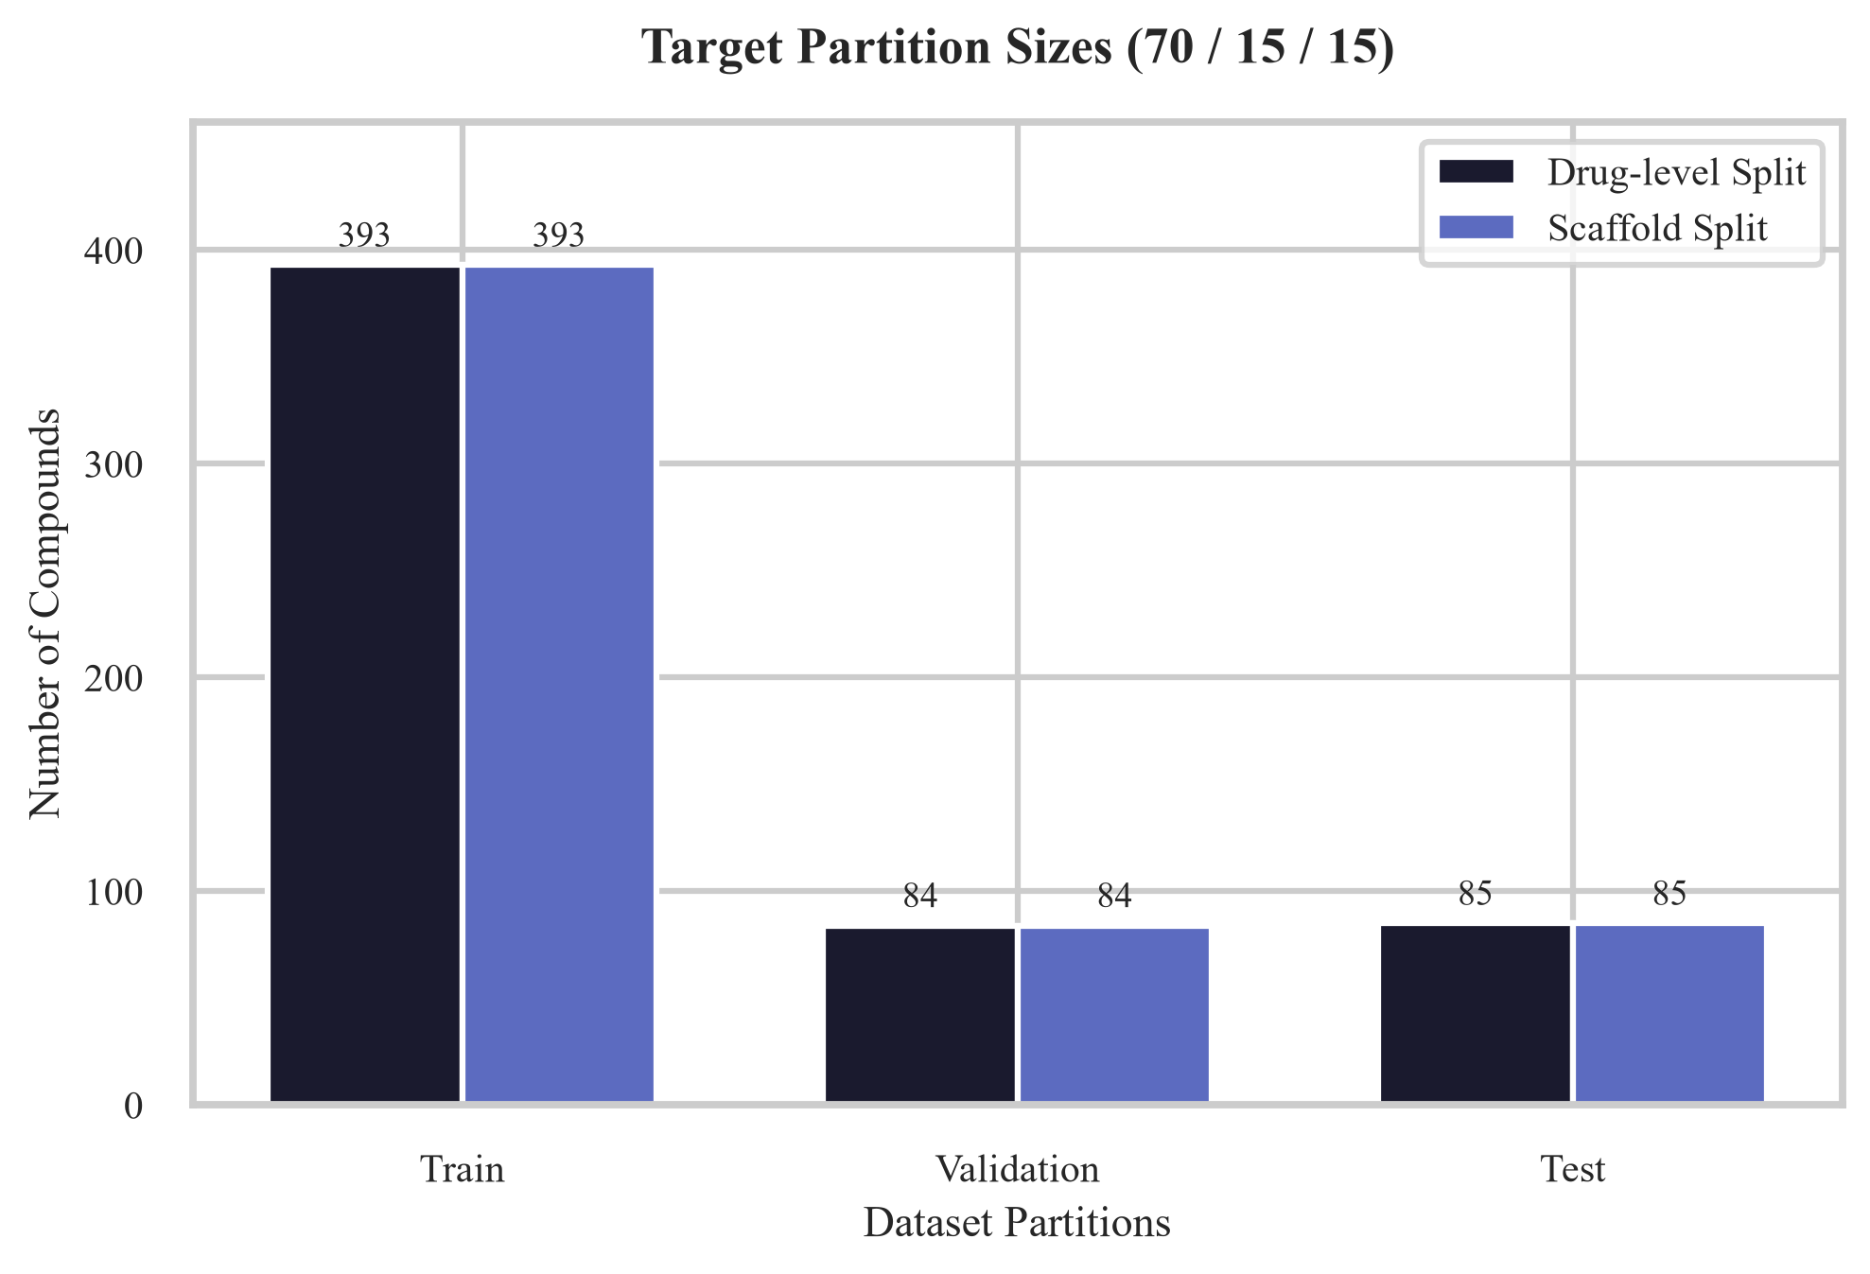
Figure 2: Target partition sizes and positive rates across drug-level and scaffold splits.
3. Scientific Discussion: Will Fusion Refine or Degrade GNN Performance?
A central question of this research is whether incorporating transcriptomic perturbation signatures (LINCS L1000 via a Transformer encoder) will refine (improve) or degrade the predictive performance of a purely structure-based baseline model (GNN). Based on the dataset properties and structural alerts, we present the following analysis:
- The Strength of Structural Signatures (GNN): Molecular structure provides a highly direct representation of hERG channel binding. Blockade is fundamentally governed by physical interactions (hydrophobic, charge, electrostatic) between the ligand and the hERG pore. As a result, GNNs trained on chemical graphs are historically extremely strong baselines (~0.84 AUC-ROC on DICTrank) and are difficult to outperform.
- The Risk of Biological Noise (degradation): Transcriptomic data (L1000) measures downstream cellular stress signatures (e.g. apoptosis, cell cycle regulation, DNA damage). However, these signatures are cell-line dependent, noisy, and indirect. If a compound is a physical hERG blocker but does not trigger transcription-level stress pathways in the tested conditions, a purely biology-based model will fail. Furthermore, simple concatenation of structural and biological features often allows this noise to leak in, leading to a degradation of the GNN's performance.
- The Role of Cross-Attention (refinement): To prevent biological noise from degrading structural signals, we propose a cross-attention fusion mechanism. Rather than raw concatenation, the structural embedding queries the transcriptomic context. This design allows the GNN to 'filter' the L1000 gene signatures, attending to them only when they align with chemical structure. This selective fusion is expected to refine boundary cases -- compounds where structure is ambiguous but the biological stress response provides the deciding cardiotoxicity signal -- without degrading the GNN's clean structural predictions.
4. Verification and Reproducibility
All data processing steps are fully automated. The random seed is frozen at 42 in config.py, and both split files are frozen and saved in the repository at data/splits/drug_split.csv and data/splits/scaffold_split.csv. These splits will remain frozen throughout the modeling pipeline.

