Data Structure and Advanced Programming

Homework 5

**第一題**

1. BDE; 2. CD

**第二題**

1. getEntry(position)

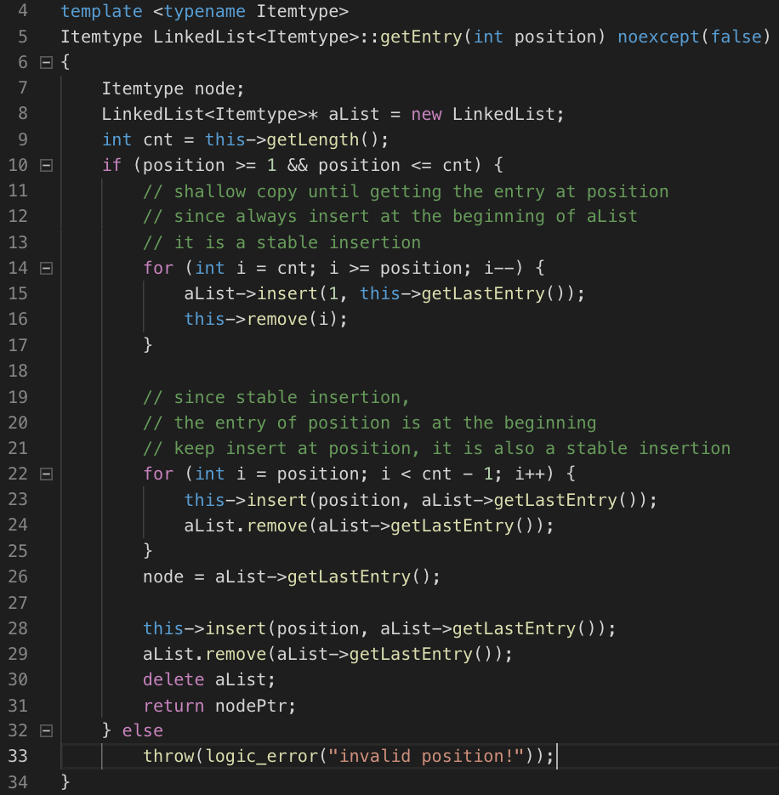

1. class stack

the following four functions, and the constructor, destructor



1. stack::top()

as shown at line11-12 in (b).

1. stack::push(elmnt), stack::pop()

as shown at line 4-9 in (b).