ITRI626 PRACTICAL PROJECT · DEEP LEARNING FOR IMAGE CLASSIFICATION
Swin Transformer for 120-Breed Dog Classification
Report sections for model family 3 of 3: method, setup, results and discussion
Author: Sulaiman
Group: Lindani (baseline CNN), JP (EfficientNetV2-S), Sulaiman (Swin-T)
Dataset: Stanford Dogs, 120 breeds, 20,580 photographs
Draft date: 18 October 2026

HEADLINE RESULT, HELD-OUT TEST SET (3,200 PHOTOGRAPHS)
85.38 %  test accuracy | 0.849  test macro F1 | 98.56 %  top-5 accuracy | 19 min  training time

How to read this document
Draft text for the group report, arranged to drop into sections 4 to 7 of the structure recommended in the brief. Numbers come from Sulaiman_Model/results/runs/swin_t/.
Facts about Swin-T, torchvision and the references were checked against their sources on 18 October 2026.
[GROUP] marks a gap that needs JP's or Lindani's final numbers.

4. Methodology: Swin Transformer

4.1 Why a transformer
The third model gives the comparison an architecture that does not rely on convolution. A convolutional network sees an image through small filters that slide over it, so each layer only looks at a local neighbourhood. A transformer instead lets every part of the image compare itself with other parts through self-attention, so relationships between distant regions, such as ear shape against tail shape, can be learned directly.
The original Vision Transformer (ViT) (Dosovitskiy et al., 2021) applies attention between every pair of image patches, which makes the cost grow with the square of the number of patches, and it needs very large datasets to train well. The Swin Transformer (Liu et al., 2021) was designed to fix both problems, which makes it a better fit for a dataset of about 20,000 photographs.

4.2 How Swin works
- Patches. The 224 x 224 image is cut into 4 x 4 pixel patches, giving a 56 x 56 grid. Each patch becomes a vector of 96 numbers.
- Window attention. The grid is divided into non-overlapping windows of 7 x 7 patches, and attention is computed only inside each window. The cost grows linearly with image size rather than quadratically.
- Shifted windows. In every second block the window grid shifts by half a window (3 patches). Patches that sat on a window edge are now in the middle of one, so information flows between neighbouring windows. This is the “shifted window” in the name.
- Hierarchy. Between stages, neighbouring 2 x 2 patches are merged: the grid halves (56, 28, 14, 7) and the vector size doubles (96, 192, 384, 768). Early stages see fur texture and edges; late stages see whole heads and bodies, like a CNN's pyramid.
- Classification. The final 7 x 7 grid of 768-number vectors is averaged into one summary of the photograph, which a linear layer maps to one score per breed.

Stage | Grid (patches) | Vector size | Blocks | Attention heads
1 | 56 x 56 | 96 | 2 | 3
2 | 28 x 28 | 192 | 2 | 6
3 | 14 x 14 | 384 | 6 | 12
4 | 7 x 7 | 768 | 2 | 24
Swin-T (“Tiny”), the smallest standard variant: C = 96, layer numbers {2, 2, 6, 2}, window size M = 7, 32 dimensions per attention head (Liu et al., 2021).
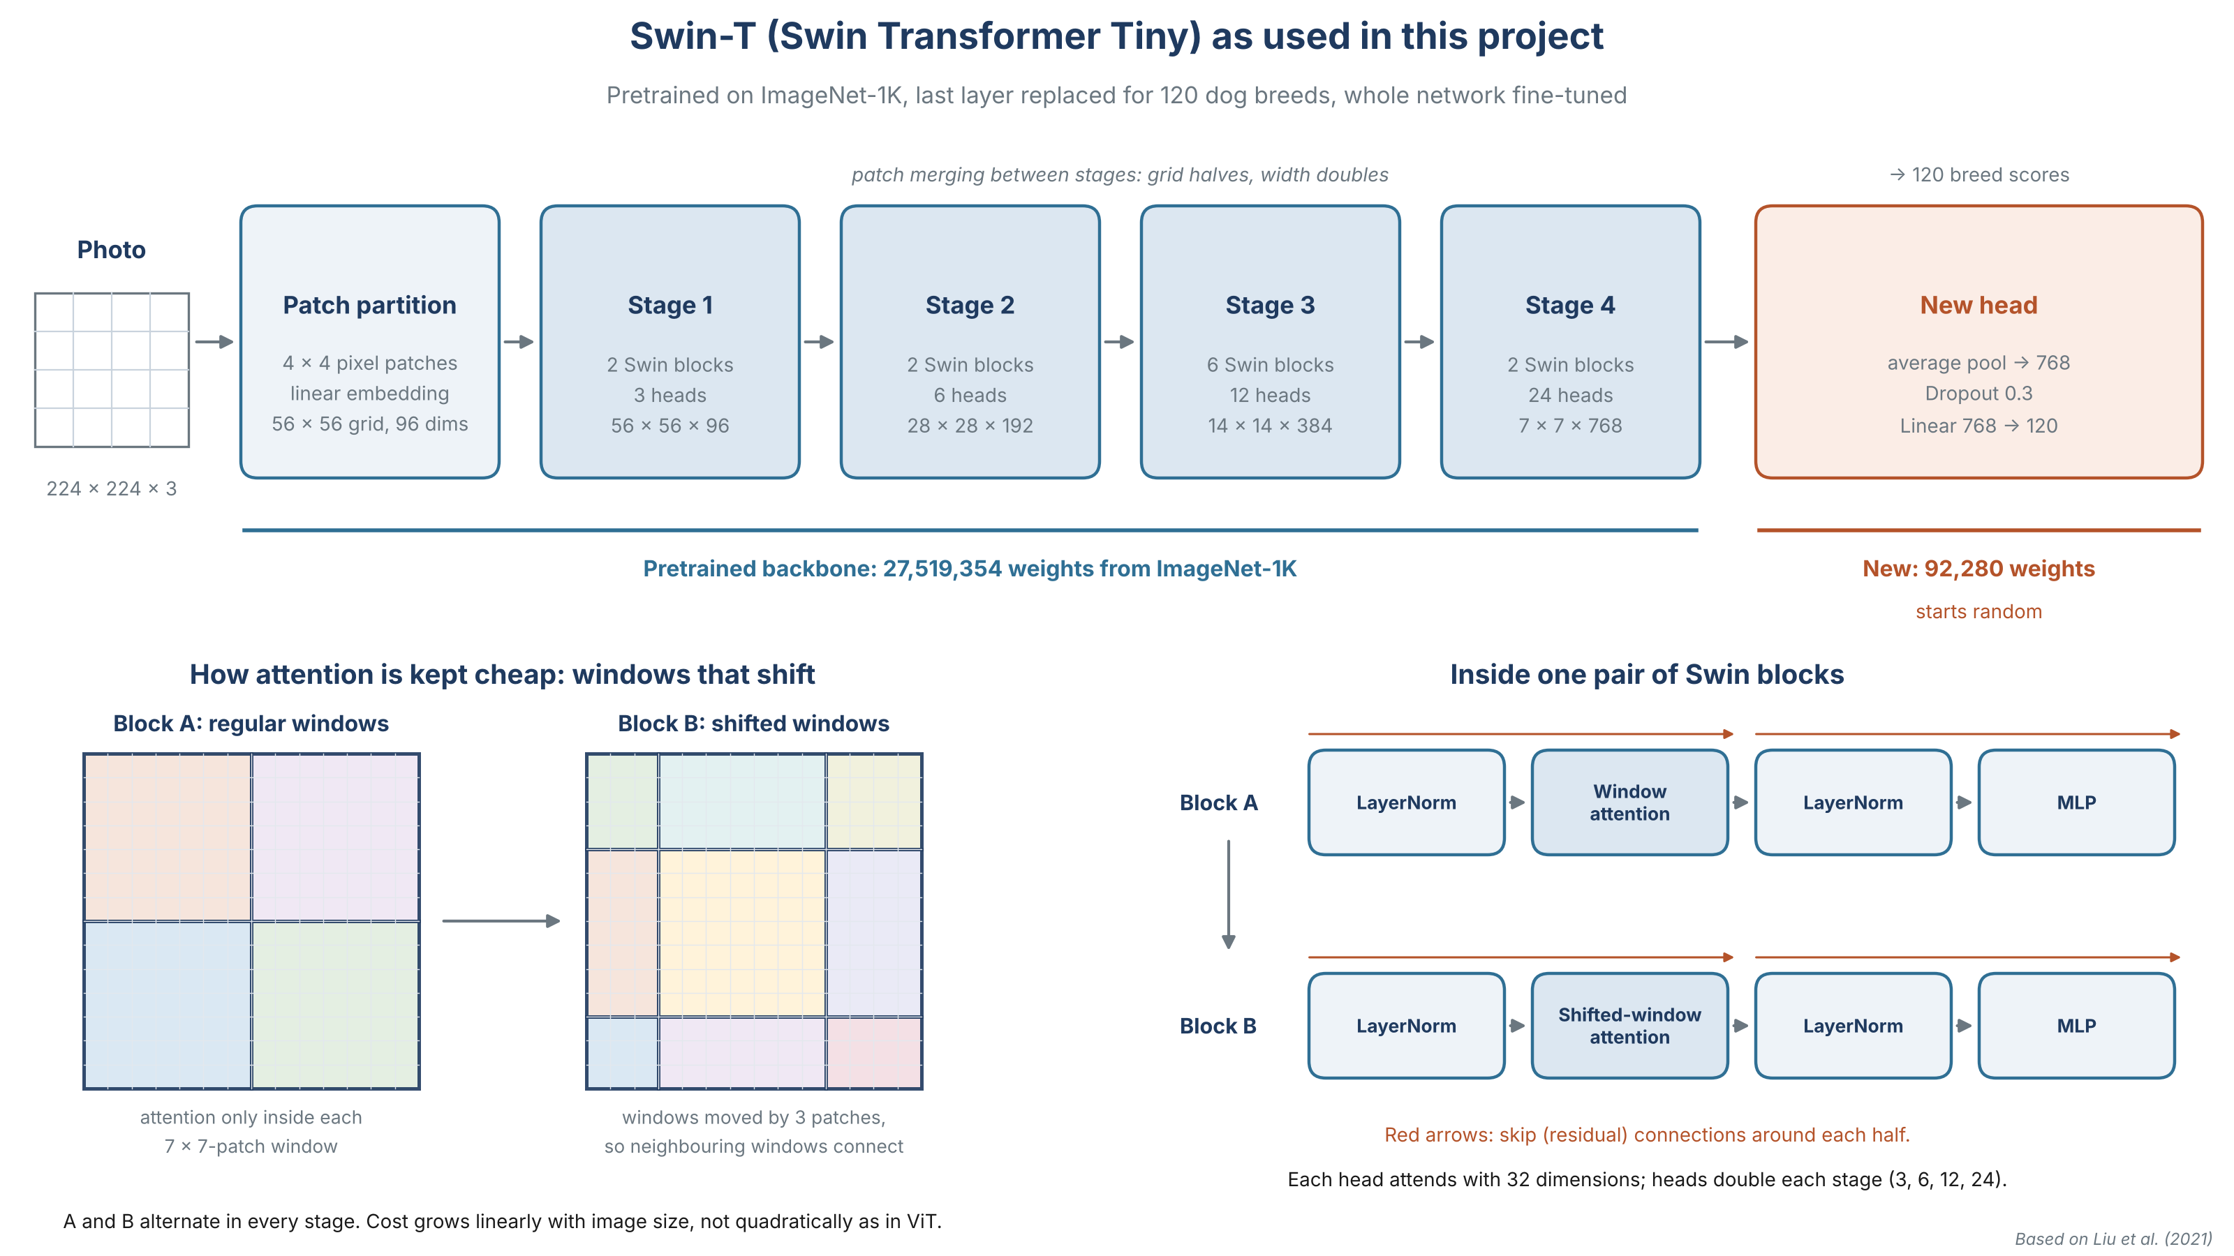
Figure 1. Swin-T as used in this project. Top: the four stages and the new 120-breed head. Bottom left: regular and shifted windows. Bottom right: the layers inside one pair of Swin blocks. Drawn for this report, based on Liu et al. (2021).

4.3 Transfer learning approach
The model was loaded from torchvision with the ImageNet-1K weights Swin_T_Weights.IMAGENET1K_V1, which reach 81.47 per cent top-1 and 95.78 per cent top-5 accuracy on ImageNet-1K, with 28,288,354 parameters including the original 1,000-class head (PyTorch, 2026). The original 1,000-class head was replaced by dropout (p = 0.3) followed by a new linear layer from 768 features to 120 breeds. The new layer starts from random weights; everything else keeps its pretrained weights.
The whole network was then fine-tuned, with no layers frozen. Freezing the backbone would have been faster, but ImageNet's dog classes do not line up exactly with the 120 breeds here, so letting the backbone adjust was expected to help. To stop the large, noisy updates of the untrained head from damaging the pretrained backbone early on, the learning rate was kept small (1e-4) and ramped up from near zero over the first epoch.
Part of the network | Parameters | Starts from
Pretrained backbone | 27,519,354 | ImageNet-1K weights
New head (768 x 120 weights + 120 biases) | 92,280 | Random
Total, all trainable | 27,611,634
For scale: about 17 times the baseline CNN (1,631,128) and of the same order as EfficientNetV2-S [GROUP: JP's measured count].

5. Experimental setup

5.1 Shared with the other two models
Held identical across all three models, so the comparison is fair
- Split file split_manifest.json: 70/15/15, seed 42, giving 14,355 training, 3,025 validation and 3,200 test photographs
- Input 224 x 224 with ImageNet normalisation
- Training-only augmentation: horizontal flip, rotation up to 15 degrees, mild colour jitter
- Loss: cross entropy, no label smoothing
- Metrics and early-stopping rule (validation macro F1)
- Clean test set: the same 3,166 photographs, from Lindani's leaked-photograph list

5.2 Settings specific to Swin-T
Setting | Value | Reason
Model | torchvision swin_t, IMAGENET1K_V1 weights | Smallest Swin variant, similar size to EfficientNetV2-S
Optimiser | AdamW | Standard for transformers; weight decay separate from the gradient step (Loshchilov & Hutter, 2019)
Learning rate | 1e-4 | Small, so pretrained weights are adjusted rather than overwritten
Schedule | 1 epoch linear warm-up, then cosine decay to 0, per batch | Protects the backbone while the new head is random; fine steps at the end
Weight decay | 0.05 | The value Liu et al. (2021) used to train Swin on ImageNet-1K with AdamW, cosine decay and linear warm-up
Batch size | 32, no gradient accumulation | Fits the 8 GB GPU with mixed precision
Epochs | Up to 15, early-stopping patience 4 | Pretrained models converge quickly
Dropout | 0.3 before the new head | Same value as the baseline CNN
Gradient clipping | Max norm 1.0 | Keeps transformer updates stable
Mixed precision | Yes (float16 with gradient scaling) | Faster and lighter on the GPU
Seed | 42 | Same as the split

The learning rate, schedule, weight decay, batch size and epoch budget differ from the baseline CNN (1e-3, no warm-up, 1e-4, 64, up to 60 epochs). These follow from the architecture: a network trained from random weights needs larger steps and many more epochs than one that starts pretrained. The brief allows this where it is justified, and neither model gets more data or a different evaluation.

5.3 Software and hardware
Item | Detail
Software | Python 3.14, PyTorch 2.11.0 (CUDA 12.8), torchvision 0.26.0, NumPy 2.5.2, Matplotlib 3.11.2
Hardware | NVIDIA GeForce RTX 4060 Laptop GPU (8 GB), Windows
Training time | 19.0 minutes in total, about 71 seconds per epoch
Record | Every setting and library version written automatically to run_config.json

GPU training is repeatable to within small differences, not bit for bit, because some CUDA operations add numbers in a non-fixed order. A slower fully deterministic mode is available (train.py --deterministic) but was not used.

6. Results

6.1 Training behaviour
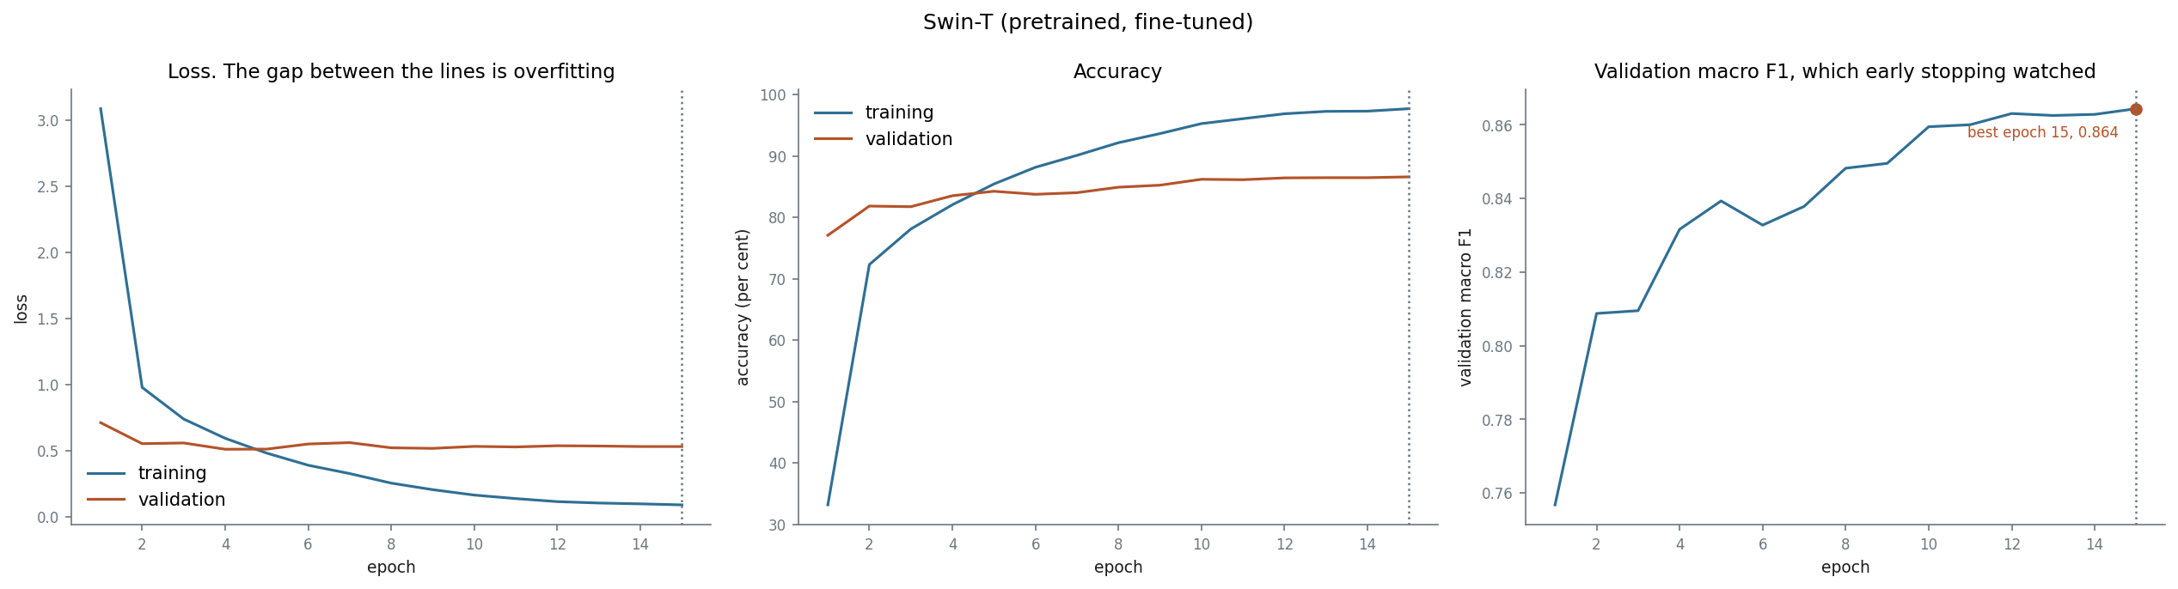
Figure 2. Training and validation loss, accuracy, and validation macro F1 per epoch. The dotted line marks the best epoch (15).
Validation macro F1 reached 0.757 after one epoch, because the pretrained backbone already recognised dogs and only the final breed decision had to be learned. It rose to 0.839 by epoch 5 and 0.860 by epoch 10, then flattened, gaining only 0.001 over the last four epochs. The best epoch was the last (15), so the epoch cap was reached rather than early stopping; the flat curve from epoch 12 indicates the model had converged.
Validation accuracy sits above training accuracy for the first four epochs. This is expected: training accuracy is measured with augmentation and dropout active and while the weights are still changing, whereas validation is measured afterwards on unaltered photographs with dropout off.
Mild overfitting
Training accuracy ends at 97.7 per cent against 86.6 per cent on validation. Validation loss was lowest at epoch 4 (0.513) and drifted up to 0.533 while validation accuracy kept improving: the model got more photographs right but grew more confident on the ones it got wrong. Dropout, weight decay, augmentation and early stopping kept this from hurting accuracy.

6.2 Test results
The test set was scored once, after training was finished.
Metric | Validation (3,025) | Test (3,200) | Clean test (3,166)
Accuracy | 86.61 % (85.35 to 87.78) | 85.38 % (84.11 to 86.56) | 85.50 %
Top-5 accuracy | 98.88 % | 98.56 %
Macro precision | 0.8685 | 0.8542
Macro recall | 0.8649 | 0.8502
Macro F1 | 0.8644 | 0.8490 | 0.8500
Weighted F1 | 0.8650 | 0.8515
Brackets: 95 per cent Wilson confidence interval. Chance level for 120 classes is 0.83 per cent. Clean test leaves out the 34 test photographs with a near-copy in training.
Test accuracy is 1.2 points below validation, with overlapping confidence intervals, so the model was not inadvertently tuned to the validation set. Top-5 accuracy of 98.6 per cent shows that when the model is wrong, the correct breed is almost always among its next four guesses.

6.3 Confusion matrix and per-breed results
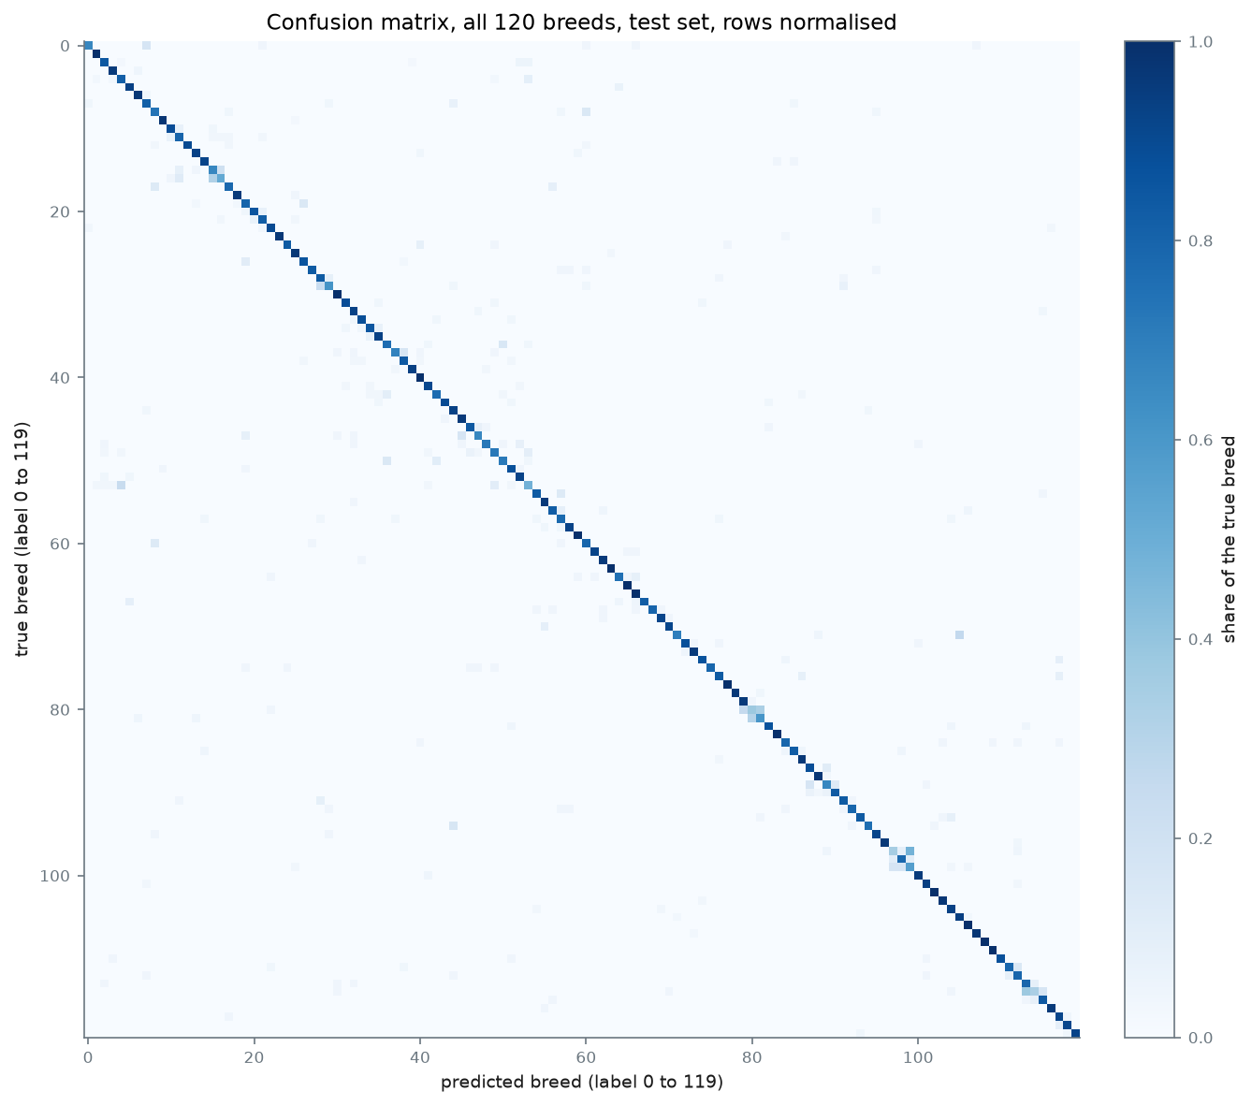
Figure 3. Confusion matrix for all 120 breeds on the test set, each row scaled to sum to 1. Errors gather in small off-diagonal clusters of look-alike breeds.
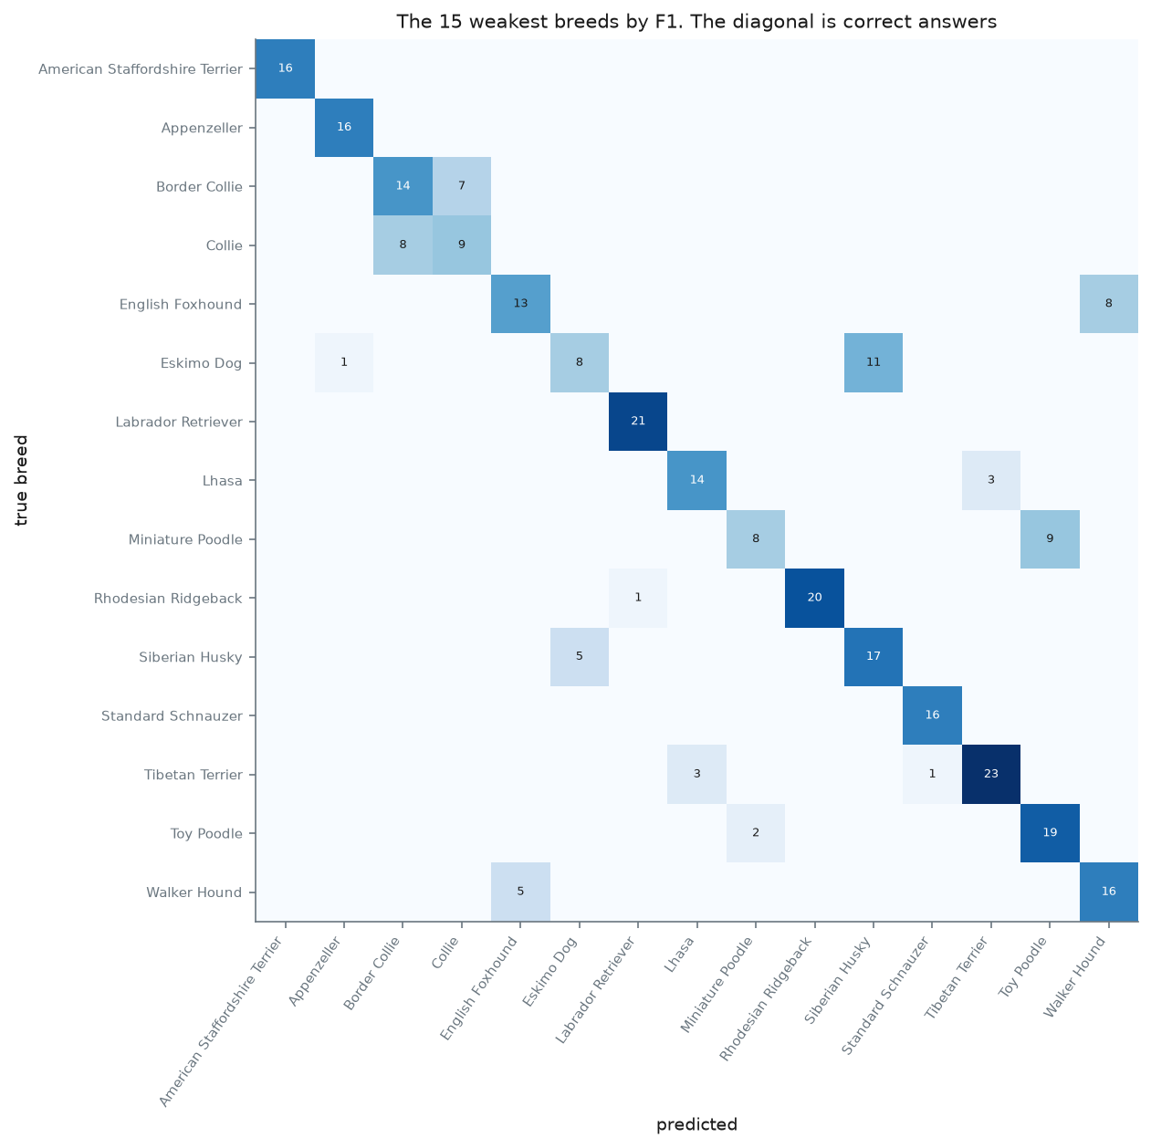
Figure 4. Close-up of the 15 weakest breeds by F1. The diagonal holds correct answers; off-diagonal counts are confusions.
Weakest breeds (test) | F1 | Strongest breeds (test) | F1
Eskimo Dog | 0.410 | Chow | 1.000
Collie | 0.439 | Pug | 0.984
Miniature Poodle | 0.444 | Norwegian Elkhound | 0.983
Lhasa | 0.528 | Saint Bernard | 0.981
Siberian Husky | 0.557 | Old English Sheepdog | 0.980

Most frequent test errors: true breed | Predicted as | Count
Eskimo Dog | Siberian Husky | 11
Miniature Poodle | Toy Poodle | 9
English Foxhound | Walker Hound | 8
Collie | Border Collie | 8
Lhasa | Shih-Tzu | 7
Border Collie | Collie | 7
American Staffordshire Terrier | Staffordshire Bullterrier | 6
Kuvasz | Great Pyrenees | 6
All 120 breeds are in per_class_metrics.csv, suitable for an appendix.

7. Discussion and error analysis

7.1 The errors are look-alike breeds
Every one of the most frequent errors is between two breeds that people also confuse. Several pairs differ mainly in size (Miniature and Toy Poodle; Standard and Miniature Schnauzer), which a photograph without a reference object cannot show. Others are close relatives with overlapping coats and colours (Eskimo Dog and Siberian Husky; Collie and Border Collie; Lhasa and Shih-Tzu). The strongest breeds, by contrast, have no close look-alike in the dataset.
The baseline CNN struggles with several of the same pairs (Eskimo Dog and Siberian Husky; Scottish Deerhound and Irish Wolfhound) [GROUP: confirm against Lindani's test results, and add JP's]. Two very different architectures failing on the same pairs suggests the limit lies in the data rather than in either model.

7.2 Some “errors” are label errors
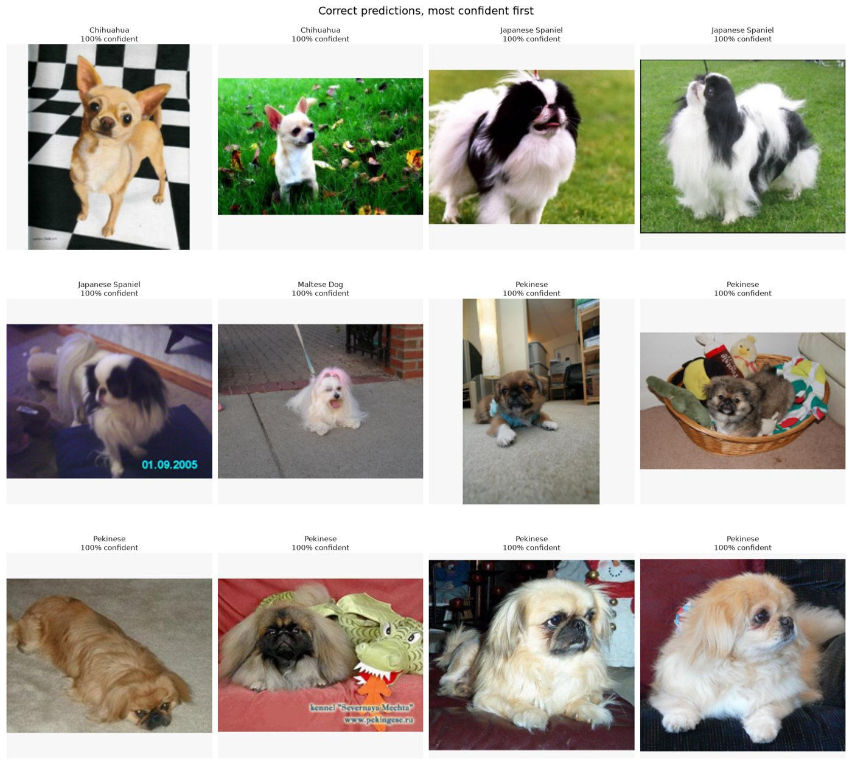
Figure 5. Correct test predictions, most confident first.
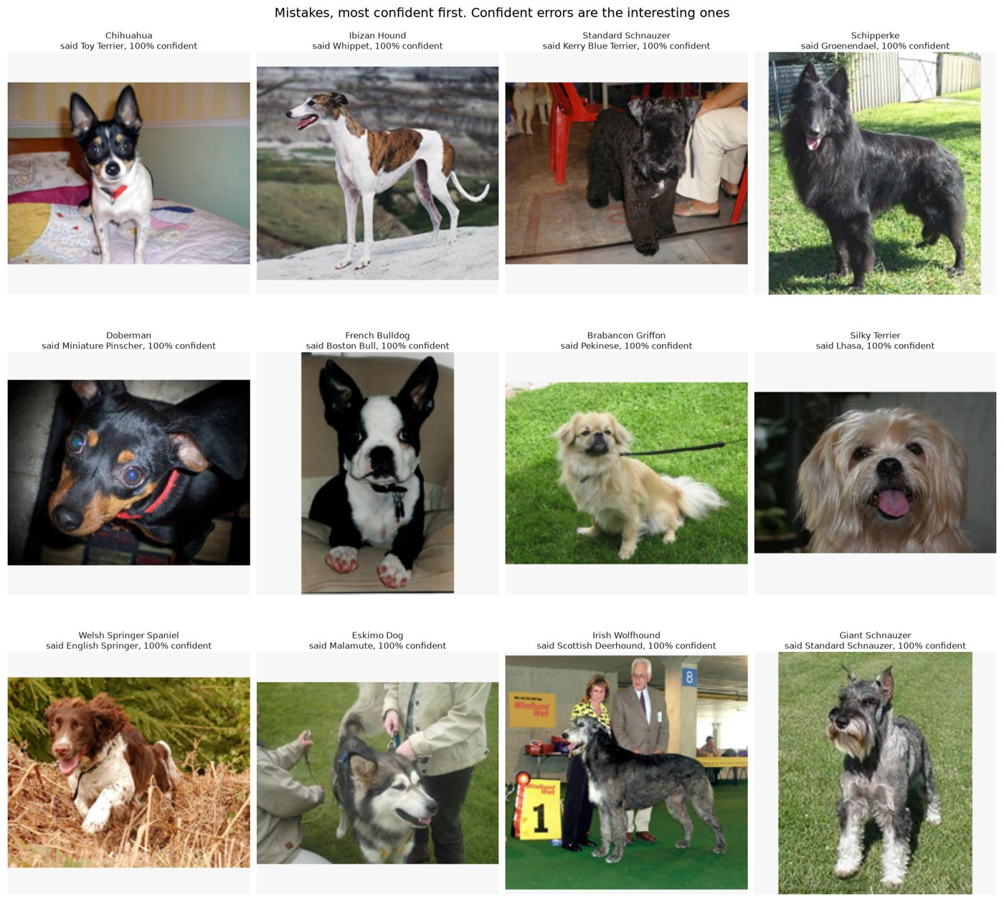
Figure 6. The twelve most confident mistakes. Several are labelling errors rather than model errors (see the table below).
Several of the most confident mistakes are not model errors. The twelve photographs in Figure 6 were checked by eye at full size and against the duplicate-check results:
Labelled as | Model said | Verdict
Schipperke | Groenendael | Label error. A large, long-legged, long-tailed black shepherd, not the small Schipperke. The same photograph is also in the training set labelled Groenendael, so the dataset gives it two labels.
French Bulldog | Boston Bull (Boston Terrier) | Label error. Black-and-white tuxedo markings and the build of a Boston Terrier.
Giant Schnauzer | Standard Schnauzer | Conflicting labels. The same photograph is in the training set labelled Standard Schnauzer. Size, the only real difference, cannot be judged from the photograph.
Doberman | Miniature Pinscher | Probable label error. A close-up of a small dog that looks like a Miniature Pinscher, but a close-up makes size hard to judge.
Judged by eye by a non-expert. The two conflicting-label cases are confirmed by Lindani's duplicate check, independent of judgement.
The Stanford Dogs labels come from ImageNet and were not independently verified, so part of the measured error is label noise, and the model is sometimes penalised for being right.

7.3 Leakage and memorisation
Lindani's duplicate check found 34 test photographs with a near-copy in the training set. Removing them changes accuracy by only +0.13 points (85.38 to 85.50 per cent), which on its own suggests leakage did not matter. Looking at those 34 photographs individually shows something more interesting.
Leaked test photographs | Number | Correct
Training copy has the same breed label | 25 | 25 of 25
Training copy has a different breed label | 9 | 0 of 9

In all nine of the second group, the model predicted exactly the label of the training copy. The model recalls photographs it was trained on: when the labels agree this inflates the score, and when they disagree (a label error in the dataset) it costs a mistake. The two effects happen to cancel in the headline number.
A larger caveat that cannot be measured here
Stanford Dogs was built from ImageNet images (Khosla et al., 2011), and Swin-T was pretrained on ImageNet-1K, so the backbone has very likely seen many of the test photographs before fine-tuning. Some of the gap between the pretrained models and the baseline CNN reflects prior exposure to these exact images, not only better general visual knowledge. This applies equally to EfficientNetV2-S.

7.4 Swin-T against the CNNs
Model | Pretrained | Parameters | Test acc. | Test macro F1 | Training time
Baseline CNN (Lindani) | No | 1.63 M | [GROUP] | [GROUP] | 64.7 min (Tesla T4)
EfficientNetV2-S (JP) | ImageNet-1K | [GROUP] | [GROUP] | [GROUP] | [GROUP]
Swin-T (Sulaiman) | ImageNet-1K | 27.6 M | 85.38 % | 0.8490 | 19.0 min (RTX 4060 Laptop)

Points to make once the table is complete:
- Transfer learning. Swin-T reached 77 per cent validation accuracy after a single epoch, against the baseline's 50.5 per cent at its best epoch (54). Most of that gap is the value of pretraining on a fine-grained task with only about 120 training photographs per breed, with the ImageNet-overlap caveat above.
- Attention against convolution. EfficientNetV2-S and Swin-T are of similar size and both pretrained on ImageNet-1K, so the difference between them is the cleanest test of attention against convolution in this project. Report the difference with its confidence interval: if the intervals overlap, the honest conclusion is that the architectures perform alike on this task.
- Recommendation. Choose on test macro F1 first, then on size and speed.

7.5 Limitations
- One training run with one seed; no estimate of run-to-run variation.
- Hyperparameters were set from the literature and not tuned, to keep the test set untouched and the comparison fair.
- Photographs are squashed to 224 x 224 rather than cropped, which distorts body proportions, one of the cues that separates similar breeds.
- The shared pipeline resizes straight to 224 x 224 with bilinear interpolation, whereas the torchvision weights were trained with a resize to 232 (bicubic) and a centre crop to 224 (PyTorch, 2026). The input therefore differs slightly from what the backbone saw in pretraining. This applies equally to EfficientNetV2-S, so the comparison stays fair.
- Label noise and ImageNet overlap, as above.

References
Formatted to the NWU Harvard referencing guide: all authors up to seven, otherwise the first six, an ellipsis and the last; conference papers as “paper delivered at” with URL and date of access.

Deng, J., Dong, W., Socher, R., Li, L.-J., Li, K. & Fei-Fei, L. 2009. ImageNet: a large-scale hierarchical image database. Paper delivered at the IEEE Conference on Computer Vision and Pattern Recognition (CVPR), Miami, FL. https://ieeexplore.ieee.org/document/5206848 Date of access: 18 Oct. 2026.
Dosovitskiy, A., Beyer, L., Kolesnikov, A., Weissenborn, D., Zhai, X., Unterthiner, T., ... Houlsby, N. 2021. An image is worth 16x16 words: transformers for image recognition at scale. Paper delivered at the International Conference on Learning Representations (ICLR 2021). https://arxiv.org/abs/2010.11929 Date of access: 18 Oct. 2026.
Khosla, A., Jayadevaprakash, N., Yao, B. & Fei-Fei, L. 2011. Novel dataset for fine-grained image categorization. Paper delivered at the First Workshop on Fine-Grained Visual Categorization, IEEE Conference on Computer Vision and Pattern Recognition, Colorado Springs, CO. https://people.csail.mit.edu/khosla/papers/fgvc2011.pdf Date of access: 18 Oct. 2026.
Liu, Z., Lin, Y., Cao, Y., Hu, H., Wei, Y., Zhang, Z., ... Guo, B. 2021. Swin Transformer: hierarchical vision transformer using shifted windows. Paper delivered at the IEEE/CVF International Conference on Computer Vision (ICCV 2021). https://openaccess.thecvf.com/content/ICCV2021/papers/Liu_Swin_Transformer_Hierarchical_Vision_Transformer_Using_Shifted_Windows_ICCV_2021_paper.pdf Date of access: 18 Oct. 2026.
Loshchilov, I. & Hutter, F. 2019. Decoupled weight decay regularization. Paper delivered at the International Conference on Learning Representations (ICLR 2019), New Orleans, LA. https://arxiv.org/abs/1711.05101 Date of access: 18 Oct. 2026.
Paszke, A., Gross, S., Massa, F., Lerer, A., Bradbury, J., Chanan, G., ... Chintala, S. 2019. PyTorch: an imperative style, high-performance deep learning library. Paper delivered at the 33rd Conference on Neural Information Processing Systems (NeurIPS 2019), Vancouver. https://proceedings.neurips.cc/paper/2019/hash/bdbca288fee7f92f2bfa9f7012727740-Abstract.html Date of access: 18 Oct. 2026.
PyTorch. 2026. swin_t: TorchVision documentation. https://docs.pytorch.org/vision/stable/models/generated/torchvision.models.swin_t.html Date of access: 18 Oct. 2026.

Oral presentation notes
The Swin-T slide
The Swin diagram (Figure 1, also saved as swin_architecture.png), the three headline numbers (85.4 % test accuracy, 0.849 macro F1, 98.6 % top-5) and one sentence: “Pretrained attention model; most errors are look-alike breeds, and some are label errors.”

Questions to expect
Question | Short answer
What does “shifted window” mean? | Attention is only computed inside 7 x 7 patch windows to keep it cheap; every second block the windows move by half a window so neighbouring windows can share information.
Why not plain ViT? | ViT's attention cost grows with the square of the number of patches, and it needs far more data. Swin is linear and builds a hierarchy like a CNN.
Why a learning rate of 1e-4, not 1e-3 like the CNN? | The backbone is already trained. Large steps would overwrite what it learned on ImageNet.
What is warm-up for? | The new head starts random, so its first gradients are large and noisy. A tiny starting learning rate stops that noise damaging the backbone.
The epoch cap was reached. Did you stop too early? | Validation F1 was flat from epoch 12 (0.863 to 0.864), so the model had converged.
Validation accuracy was higher than training at first. A bug? | No. Training accuracy is measured with augmentation and dropout on, while the model is still learning.
Is the comparison fair? | Same split, seed, input size, augmentation, loss and metrics. Only settings that follow from the architecture differ, and each is justified.
Why might the score be optimistic? | ImageNet pretraining probably included these photographs, and all 25 leaked same-label test photos were answered correctly.

