**Inherently Safer Design through Process Intensification: A Case Study in C3-alkyne Selective Hydrogenation Distillation Process**

Meng Qia,b,Jiayong Zhub, Jiaming Xuc, Dongfeng Zhaoa,*, Yi Liua,*

a College of Chemical Engineering, China University of Petroleum (Qingdao), Qingdao 266580, China

b Mary Kay O'Connor Process Safety Center, Artie McFerrin Department of Chemical Engineering, Texas A&M University, College Station, TX 77843-3122, USA

c Department of Chemical Engineering, Northeastern University, Boston, Massachusetts 02115, USA

**Abstract**

Inherently safer design (ISD) describes a strategy that reduces and even eliminates inherent hazards in processes. However, ISD principles improving inherent safety always appear as trade-offs between safety and costs due to they are two competing factors. In inherent safety aspects, process intensification (PI), one of the methodologies in ISD, is aim to eliminate equipment and simplify the process. Thus, synchronous promotion of economy and safety is realized. However, applying PI strategies in design stage may bring negative safety effects. Eliminating units may lead to phenomenon of risk transfer and risk accumulation which could lead to serious consequence. In this study, we introduced a new methodology involved in better-suited indicator Advanced Comprehensive Inherent Safety Index (ACISI) along with Quantitative Risk Analysis (QRA) to evaluate safety performance of PI design at early stage. Also, a case study of C3-alkyne selective hydrogenation distillation process was selected to analyze safety and economic impacts on four intensified designs (***e.g.,*** reactive distillation, thermally coupled distillation of a side-rectifying section, thermally coupled distillation of a side-stripping section and fully thermally coupled distillation) using the proposed methodology. Furthermore, safety performance of individual equipment in each process was explored. Potential root causes for risk transfer, investigated from the case study, is related to the vapor-liquid profiles in the column. Considering PI characteristics and risk transfer, this study provides a generally effective framework to achieve ISD through PI.

**Keywords:** Inherently safer design; Process intensification; Economic and safety; Risk transfer; C3 alkyne selective hydrogenation

# Introduction

Inherently Safer design (ISD), proposed by Trevor Kletz, has been well known for more than 40 years [1, 2]. ISD has become recognized safety design methods worldwide. Numbers of hazards present in chemical processes can lead to serious consequences. Contrasting with risk controls by utilizing protection measures, ISD aims to reduce and even eliminate hazards in chemical process [3]. Basic strategies in ISD are described in four principles: simplification, moderate, substitution and minimization. These principles are more of philosophies than specific sets of procedures and implementation. The concepts of these principles are simple, but applying them in a design stage of chemical processes is still challenging [4].

Since inherent safety is a relative concept [5]. Processes cannot be absolutely inherently safe. The processes can be described as inherently safer than others [6]. Incorporating process safety into chemical processes is challenging at process design stage since usually economic benefits are the most important driving force for industries [7]. In fact, there is another important reason for this challenge is that quantifying inherent safety through limited process information in the design stage is difficult, and even more problematic to verify accuracy and objectivity of the quantitative results. Therefore, unlike cost reduction and environmental protection, inherent safety has more of a hidden and fuzzy feature, thus making applying ISD a great challenge when setting as a design objective. So far, several researches have studied on how to realize ISD in different chemical process or operations by considering safety aspects [7-11]. They utilize a variety of means to characterize inherent safety and to conduct multi-objective optimization design. Although the processes were not the same, a consistent conclusion was that there was a trade-off between safety and cost due to they were two competing factors. In other words, improvement of process safety will inevitably cause a certain degree loss of economics. Previous studies showed that inherent safety in process design seems to be contradicted to economic benefits. Industries had less attention on safety than economic objectives in system optimization.

However, simplification and minimization in chemical process development can lead to potential cost reduction as well as inherently safer. Advance process of producing methyl acetate is a good example demonstrating the application of ISD concepts into chemical industry. ***Fig. 1*** shows the process development of methyl acetate production. Before the advent of reactive distillation technology, conventional production process of methyl acetate employed one reactor and nine columns. This conventional process was complex, low reaction conversion rate and high energy consumption [12]. Then the reactive distillation methodology was developed [13, 14] and distillations also act as reactors. Thus, reactors can be removed from the flow sheet. This methodology not only reduces the number of unit operations but also overcomes the equilibrium limitations of reactions by removing product through distillation [15]. The system became not only more efficient, but also is inherently safer because there were less hazardous materials stored in the system and reduced number of equipment.

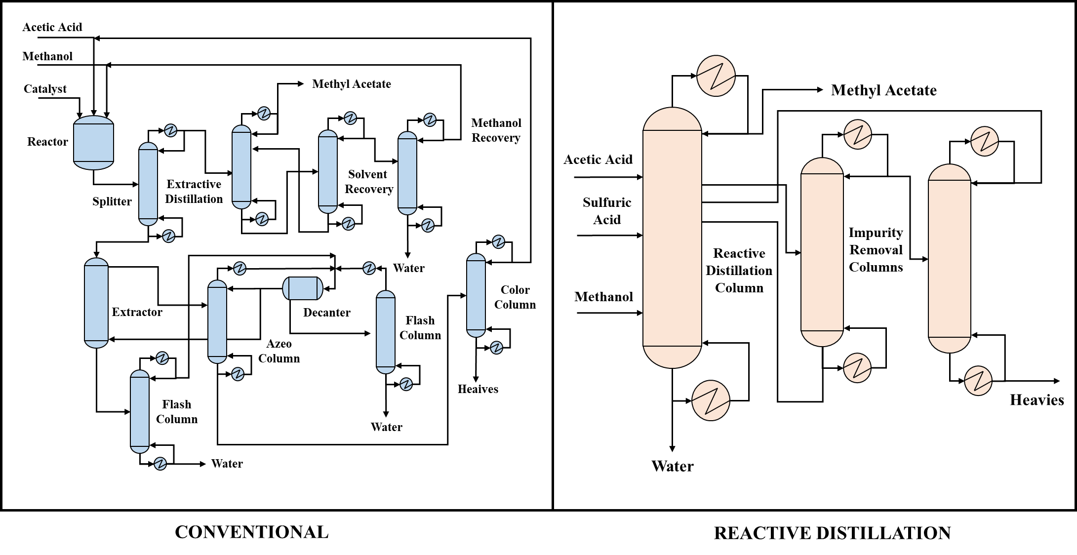

**Fig. 1.** Process development of methyl acetate production [16]

Reactive distillation process of methyl acetate is a successful representative and industrial application of process intensification (PI) technologies. In chemical plants, PI is a novel and promising design method that leads to substantially smaller, cleaner, safer and more energy-efficient process technology [17]. Due to rapid development of process systems engineering and computational power, PI has achieved great progress. More economical and energy-efficient strategies were developed for chemical processes. Those novel PI technologies, such as reactive distillation, membrane reactors, thermally coupled distillation and dividing-wall column, reduce energy consumption and costs while eliminating equipment and simplifying processes along with potential safety improvement. PI can provide a specific methodology to achieve ISD from equipment elimination and process simplification. Therefore, economy and safety can be optimized simultaneously.

Although PI is beneficial to enhance inherent safety for processes, there is no direct research to study how to improve safety using PI strategies. Using PI strategies in processes may not definitely guarantee inherent safety. Application of PI strategies embodies the ISD principle of minimization and simplification, but integration of unit operation functions by reducing process equipment may cause risks from the eliminated equipment accumulated in a new integrated equipment, resulting in a phenomenon of risk transfer and risk accumulation. Risk transfer occurs when risks of multiple units in the original process superimposed on a new unit. Risk is a combination of incidents’ occurrence probabilities and impacts of consequences. From simplification of processes and reduction of unit numbers, frequency of accident occurrence may reduce. However, impacts of risk transfer in the new unit may greatly increase consequences severity. Even though inherent safety level of overall process is improved, a single high-risk unit can also bring processes into a dangerous situation. Based on the considerations on risk transfer and risk accumulation, safety performance in various intensified processes using PI technologies need to be further explored. Thus, better understanding and applications of PI technologies can be obtained to develop an inherent safer process in the design stage.

In this paper, a novel methodology was proposed to quantify and compare safety performance of various intensification alternatives in the design stage. This methodology integrates two of the most representative safety quantification methods, Inherent Safety Index (ISI) and Quantitative Risk Analysis (QRA), to conduct a comprehensive safety analysis on intensified process considering both overall safety and individual unit. The proposed framework will allow engineers to assess risk level associated with various intensified options in a fast and efficient manner. Moreover, a case study on analyzing safety performance and economic impacts of C3-alkyne selective hydrogenation distillation process was conducted utilizing proposed methodology. Four intensified designs (*e.g.*, reactive distillation, thermally coupled catalytic distillation of a side-rectifying section, thermally coupled catalytic distillation of a side-stripping section and fully thermally coupled catalytic distillation) in C3-alkyne selective hydrogenation distillation process were studied. The phenomenon of risk transfer in PI was further verified and explored based on the study case. The analysis provided guideline and framework for more efficient and cost-effective decision-making in inherent safer process design.

The main contribution of this work can be concluded as follows: (1) A novel methodology was proposed to achieve ISD through PI. Design objectives of safety and economics are considered. Safety performance assessments in overall process and individual units are included. This methodology can be implemented easily based on process simulators and optimization software without detail information of process conditions, which are usually not available at preliminary design stage; (2) Advanced comprehensive inherent safety index (ACISI) was developed and was used in this methodology. Based on the original comprehensive inherent safety index (CISI), a scale factor balancing weights between sub-indexes is added. Also, connection score among each equipment was corrected. Its definition was clarified, furthermore, calculations were integrated with process parameters, rather than relying solely on objective experiences; (3) An example of C3-alkyne selective hydrogenation distillation process was studied using the proposed methodology. Risk transfer phenomenon was confirmed and root causes were found out in this case. The case study concluded that ISD using PI is a practical approach. Therefore, inherent safety and economy can be considered simultaneously in process design.

This paper is organized as follows. First, problem is formally stated, and then the methodology for the ISD using PI is outlined. Next, studied indicators were presented. The ACISI was illustrated and detailed modifications were explained. The following section focuses on the case study. Four design alternatives were proposed based on the PI rule and also, economic and safety performance were analyzed. Finally, root cause for risk transfer was explained and some general recommendations were derived from the case study analysis.

# Methodology

To study or consider the safety aspects of various process with intensification, a methodology evaluating safety level along with other design objectives is needed. It is convinced that a quantitative analysis on safety performance assessment among processes is more valued than a qualitative analysis. Currently, there are two representative methods for quantitatively characterizing the safety level of chemical process, inherent safety indexes (ISIs) and quantitative risk analysis (QRA). These methods have also been widely used by other scholars for ISD of various processes. For example, Jaffee-Suardin proposed an inclusion of the Dow fire and explosion index (F&EI) as the safety metric within the design and optimization framework [8]. Saeed-Eini conducted an ISD of reactor network system by setting a safety objective as the risk level, including severity and frequency of incidents [11]. Different safety quantification methods have their advantages and disadvantages. However, there are some challenges for those methods applied in PI design. a) Available data in the design stage are limited. Only limited information, such as process flow diagram (PFD), process conditions, mass and energy balance, was available for assessment; b) Quantitative safety measurements are difficult. Safety measuring indicators on processes with same chemicals and/or minor modifications need to have comparative values so that engineers can easily compare various processes; c) Uncertainties in accuracy of safety assessment on new equipment and novel technologies have not been defined yet in previous studies. d) Risk transfer is not considered in general risk assessment. Risk assessment should not solely focus on the overall risk of the process, but also on individual units.

For process intensification design, especially the design of heat exchanger networks or complex distillation sequences, there are perhaps more than thousands of alternatives. From time-saving and objectivity perspectives, the ISI is the best choice. Though QRA provides a good assessment of the inherent safety of the system, more reliable results need detailed information such as plant layout and equipment design data. However, obtaining these information is time-consumed or the information may be even unavailable at early design stage. Also, it is difficult for optimization with heavily nonlinear and nonconvex equations [7]. The ISI provides a good comparative methodology, it nonetheless cannot solve all issues mentioned before. If risk transfer occurs, assessment of serious consequences on a single unit requires the aid of QRA.

In this study, a simulation-oriented methodology, which combines advantages of two recognized quantitative safety assessment approaches (ISIs and QRA), was proposed and demonstrated in ***Fig.2.*** The Dow Fire & Explosion Index (F&EI) [18], the Dow Chemical Exposure Index (CEI) [19], the Mond Fire, Explosion and Toxicity Index (F,E&T) [20], Safety Weighted Hazard Index (SWeHI) and Integrated Inherent Safety Index (I2SI) proposed by Khan et al [21, 22] are well known ISIs. There are precedents for applying F&EI and SWeHI, but the shortcomings are that they are low sensitivity to process parameters and similar scores (score difference compared to original process may below one) may be obtained for intensified processes. Suitable indexes at the early stage should be closely related to process conditions and simple to figure out. Comprehensive Inherent Safety Index (CISI) [6] is a good alternative. CISI offers a clear modular structure that helps designers to assess various processes. This approach allows process safety to be visualized in a network-type framework with individual units at nodes. CISI is more sensitive to process design parameters and intensified processes can be compared easily. Moreover, in order to make it better alternatives comparison, especially to deal with industrial practices, we have improved the CISI. Advanced Comprehensive Inherent Safety Index (ACISI) was developed in this study.

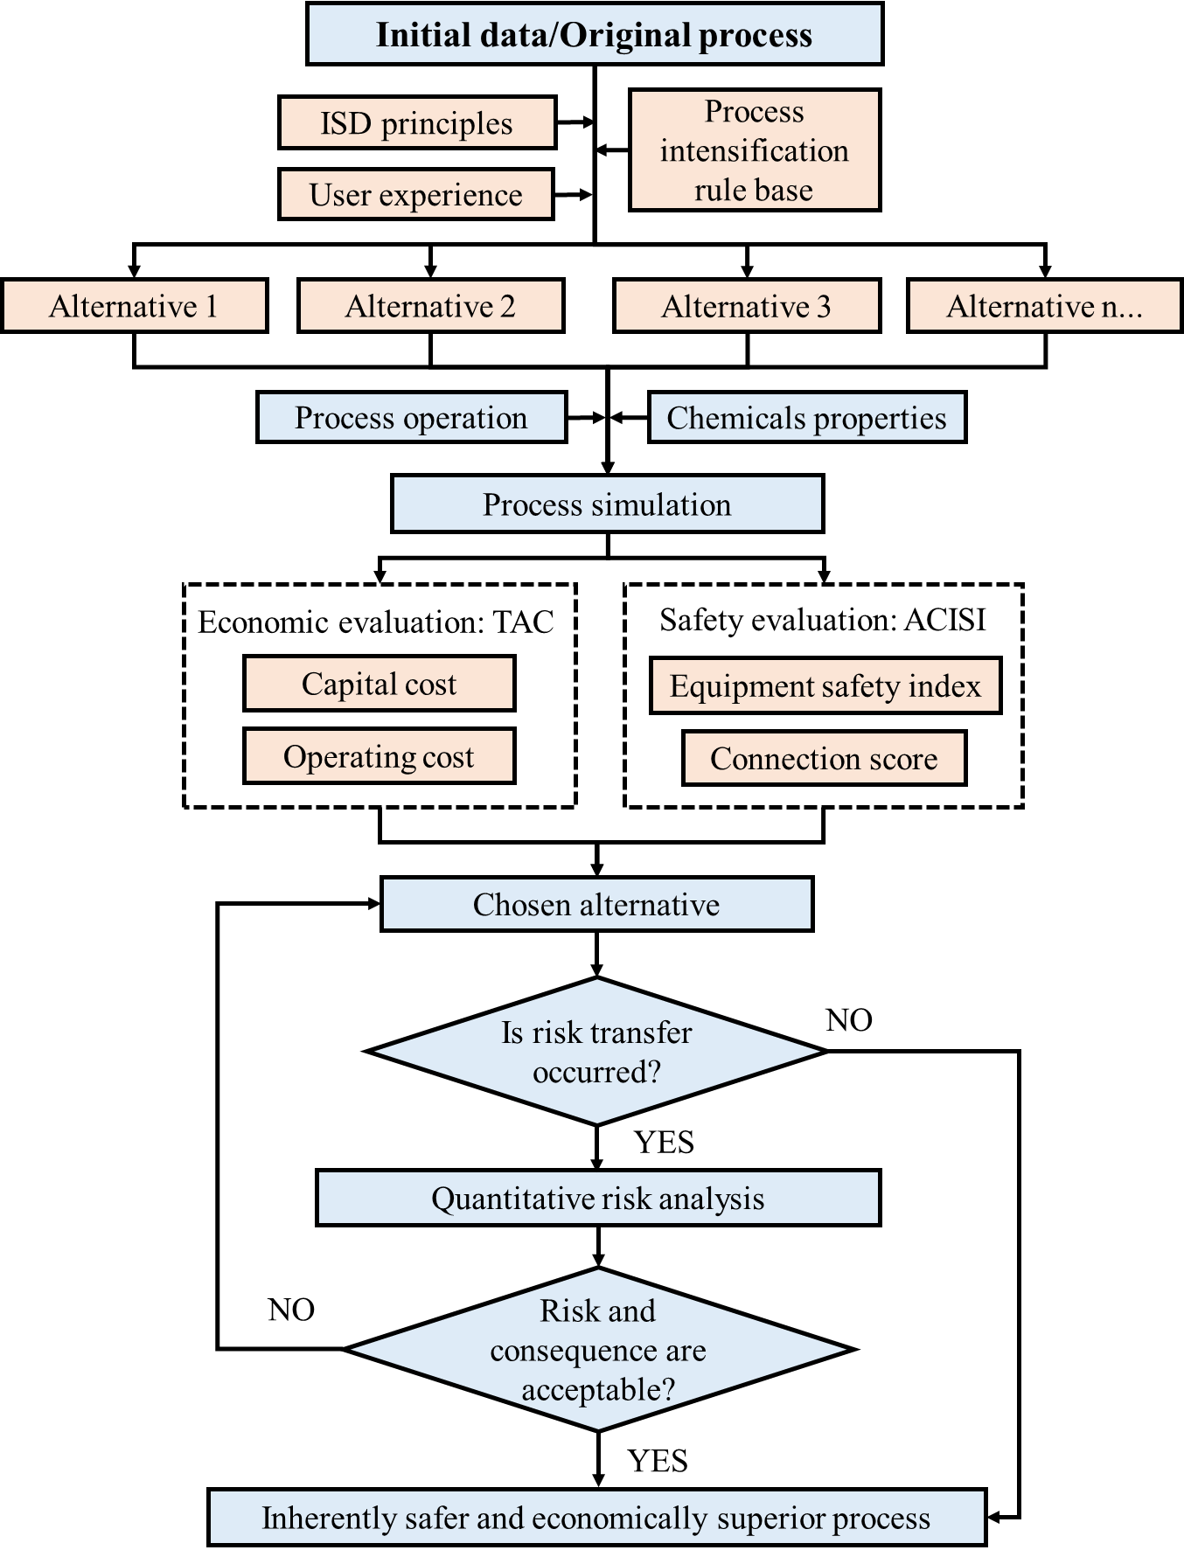

**Fig. 2.** Methodology utilized in this study

In the proposed methodology, first step is to generate alternatives by integrating ISD principles into users’ experience and PI rule base. Then simulations or calculations of each alternative are conducted in the simulator or other calculation software (Aspen Plus software was used in our case study). Optimal parameters were obtained and used in calculations for objective indicators. In addition to safety, economics is also a major consideration in PI design. Total Annualized Cost (TAC) provides a convincing economic evaluation comparing to other indicators. Thus, TAC was used for economic assessment in this study.

A final decision-making was determined from collecting and analyzing TAC and ACISI. Usually, the best alternative is not a clear choice since the two indicators, TAC and ACISI, cannot agree with each other. The reason is that these indicators may emphasize different elements according to company’s policy and goals of the problem in hand. The selected alternative should possess enhancement in both economic and safety performance comparing to conventional process. However, due to potential occurrences of risk transfer, even though overall safety of process is promoted, risk on some units may not be acceptable. In case the number of alternatives has been reduced, QRA is a better approach to measure inherent safety of a single unit. Therefore, QRA is also introduced in this framework to assess individual unit safety so that risk accumulation in units can be prevented.

# Studied indicators

## Total Annualized Cost (TAC)

Total annualized cost (TAC) considers capital costs and operating costs. TAC index assesses economic effects among different alternatives. Analytical expressions of the TAC are defined as:

(1)

(2)

(3)

The capital cost represents major costs of column vessels, trays, and heat exchangers. Other costs, such as valves, pumps, and pipes, are much lower than those major costs, and thus, other costs are ignored. A three-year payback is considered and construction materials of the column vessel is assumed to be stainless steel. Detailed TAC estimates on formula and parameters were based on correlations proposed by Douglas [23] (***Table 1***).

**Table 1. Detailed TAC Estimating Formula and Parameter Selection** [24]

|  |  |  |  |  |  |  |  |
| --- | --- | --- | --- | --- | --- | --- | --- |
| **Capital cost** | | | | | | | |
| Where Dc is the column diameter (m), M&S=1492  Where NT is the number of trays, 0.6 is the typical distance between the trays (m), 0.75 is the tray efficiency and 6 is the installation height (m), Fc=FmFp, Fm=3.67, Marshall & Swift index (M&S) =1431.7[28]. Fp can be determined by the following. | | | | | | | |
| Pressure (atm) | | ≤3.4 | | 6.8 | | 13.6 | |
| Fp | | 1.00 | | 1.05 | | 1.15 | |
|  | | | | | | | |
| where the coefficients Fc=Fs+Ft+Fm, Fs=1.0, Ft=0 (for sieve), Ft=1.8 (for bubble-cap), Fm=1.7 | | | | | | | |
| where Q is the duty of the heat exchanger (kW), is the mean logarithmic temperature difference (K), k is heat transfer coefficients, 0.852 (kW/(K·m2)) for condenser and 0.568 (kW/(K·m2)) for reboiler. Fc=(Fd+Fp)Fm, Fm=3.75, Fd=1.35 (for kettle type), Fd=0.8 (for fixed tubusheet type), Fp can be determined by the following. | | | | | | | |
| Pressure (atm) | ≤10.2 | | 20.4 | | 27.2 | | 54.4 |
| Fp | 0.00 | | 0.10 | | 0.25 | | 0.52 |
| **Operating cost**  Cs is the price for each kind of utility ($/GJ·h-1); Q is the duty of each heat exchanger (GJ/h) | | | | | | | |

## Advanced Comprehensive Inherent Safety Index (ACISI)

### 3.3.1 Original comprehensive inherent safety index

Original Comprehensive Inherent Safety Index (CISI) has two major advantages: a) considering severity of reactions with multiple chemicals present in each unit; b) evaluating connection scores between two units based on their equipment safety scores [6]. It combined with process parameters to reflect the inherent safety of the process. For CISI, individual equipment safety index is calculated as the sum of the equipment chemical safety index (IECI) and the equipment safety index (IEPI) with connection scores, which is calculated as 10% of the total scores of the two individual units.

(4)

(5)

(6)

SC is the chemical severity score, SR is the reactivity severity score, and n is the number of chemicals in the unit. II is the inventory score, IT is the temperature score, IP is the pressure score, and IEQ is the equipment safety score. Chemical severity score considers flammability, explosiveness, toxicity and corrosiveness. Detailed descriptions of scores in each category were shown in ***Table 2***. Reaction severity was characterized by heat formation, ﬁre, formation of toxic and ﬂammable gas, etc. To determine the reactivity hazard in each unit, mixture effects of chemicals in units were considered. ***Table 3*** showed the score criteria.

**Table 2. Calculation of Chemical Severity Score**

|  |  |
| --- | --- |
| Items | Score/1000kg |
| Flammability, IFL  Nonflammable  Combustible (flash point > 55℃) | 0  1 |
| Flammable (flash point ≤ 55℃)  Easily flammable (flash point < 21℃)  Very flammable (flash point < 0℃ and boiling point ≤ 35℃) | 2  3  4 |
| Explosiveness (UEL-UFL) (vol%), IEX  Nonexplosive  0-20  20-45  45-70  70-100  Toxic limit (ppm), ITOX  TLV > 10000  TLV ≤ 10000  TLV ≤ 1000  TLV ≤ 100  TLV ≤ 10  TLV ≤ 1  TLV ≤ 0.1  Corrosiveness, ICOR  Carbon steel  Stainless steel  Better material needed  Chemical Severity Score, SC | 0  1  2  3  4  0  1  2  3  4  5  6  0  1  2  IFL+ IEX+ ITOX+ ICOR |

**Table 3. Calculation of Reactivity Score.**

|  |  |
| --- | --- |
| Reactivity hazard | Score |
| Heat formation  Fire  Formation of harmless, nonflammable gas  Formation of toxic gas  Formation of flammable gas  Explosion  Rapid polymerization  Soluble toxic chemicals | 0.5  0.5  0.5  0.5  0.5  0.5  0.5  0.5 |
| Reactivity Severity Score, SR | []+1 |

IEPI is the determined based on the operating conditions of the process, taking into account the inventory, temperature, pressure and equipment safety. Scores are given in the 0-4 range as shown in ***Table 4***.

**Table 4. Calculation of Process Equipment Index.**

|  |  |
| --- | --- |
| Items | Score/1000kg |
| Inventory, II  0-1 t  1-10 t | 0  1 |
| 10-50 t  50-200 t  200-500 t  500-1000 t | 2  3  4  5 |
| Process temperature, IT  ＜0 ℃  0-70 ℃  70-150 ℃  150-300 ℃  300-600 ℃  ＞600 ℃  Process pressure, IP  0.5-5 bar  0-0.5 bar or 5-25 bar  25-50 bar  50-200 bar  200-1000 bar  Equipment safety, IEQ  Equipment handling nonflammable, nontoxic materials  Heat exchangers, pumps, towers, drums  Air coolers, reactors, high hazard pumps  Compressors, high hazard reactors  Furnaces, fired heaters  Process equipment index, IEPI | 1  0  1  2  3  4  0  1  2  3  4  0  1  2  3  4  II+IT+IP+IEQ |

### 3.3.2 Advanced comprehensive inherent safety index

Development of the original CISI is mainly for comparison of inherent safety between a wide ranges of different processes. In order to make CISI better adapted to comparison of various intensified processes and better utilized in industrial practice, it is necessary to make some corrections for the original CISI so that inherent safety of the process cab be accurately measured. There are two main limitations in CISI. First, when a process scale reaches 10,000 tons/year, IECI is too large comparing to IEPI, and the weighting scale of IEPI is weaken. In order to solve this problem, scale factor is introduced in IECI. The scale factor keeps the gap between IECI and IEPI within two orders of magnitude, so that the IEPI is not weakened due to excessive process scale. Secondly, connection scores are usually based on expert judgement to be in the range between 10% and 20% of two adjacent units scores. In quantitative risk assessment, connection scores for various streams between two units should be systematically calculated. In this study, definition of connection score is clarified and Process Stream Index (PSI) was applied to adjust the connection score. The modified CISI in this study is named Advanced Comprehensive Inherent Safety Index (ACISI).

1. **Scale factor**

The scale factor is a parameter introduced to prevent the imbalance of the weight scale of IECI and IEPI.

(7)

Usually, the score of IEPI ranges from 0 to 17. In order to keep IECI and IEPI within two orders of magnitude, the scale factor is determined using ***Table 5***.

**Table 5. Determination of scale factor.**

|  |  |
| --- | --- |
| IECI | Scale factor |
| ＜1000  1000-10000  10000-100000  100000-1000000 | 1  10  100  1000 |
| 1000000-10000000 | 10000 |

1. **Connection score**

Connection score is defined as impact severity of the connection between the two units in the original CISI. But in real processes, connections between two units can be in one stream or multiple streams. It is not advisable to define multiple streams as a single connection and the scores based on user experience are biased, especially when various intensified processes are comparing. In ACISI, connection scores are defined as impact severity on the primary streams in process flow diagram (PFD). There may be one or multiple connection scores between two units. Conditions, such as heating value, density, pressure, etc. in different streams between two connected units are different, and the connection score calculations also vary. Therefore, following methodology is applied for connection score calculations. First, it is reasonably to assume that each connection score should not exceed 20% of the sum of adjacent unit scores, possibly 15% is more appropriate. In ACISI, original connection score between each unit is calculated, and the mean value of the process connection score is determined. Next, PSI is used to assign weights to modify individual connection score. Thus, inherent safety of each stream is properly measured.

PSI is designed to compare and prioritize levels of inherent safety of individual streams in overall streams [25]. Factors of heating value, pressure, density and combustibility are taken into accounts to calculate relative inherent safety levels in the streams. Combustibility of each stream is calculated from Eqs. (8)-(9).

(8)

(9)

where LFLi is the lower flammability limit of component i, UFLi is the upper flammability limit of component i, yi is the mole fraction of component i in mixture. Then, PSI is calculated using Eqs. (10)-(14).

(10)

(11)

(12)

(13)

(14)

The connection score of each stream in ACISI is determined by Eq. (15).

(15)

# Case Study for C3-alkyne Hydrogenation Distillation

## 4.1 Process description

In this study, the proposed process is based on the front-end depropanization and front-end hydrogenation processes for ethylene production. While in ethylene processing plants, 1.0%-3.5% of impurities (***e.g.,*** propyne, or MA and propadiene, or PD) are usually generated in cracking operations for C3 components. To meet the specifications for subsequent polymerization processes, it is necessary to cut down impurities [26]. The liquid-phase selective hydrogenation is a specific industrial method to removal the MAPD [27], and the studied process for C3-alkyne hydrogenation distillation is shown in ***Fig. 3***.

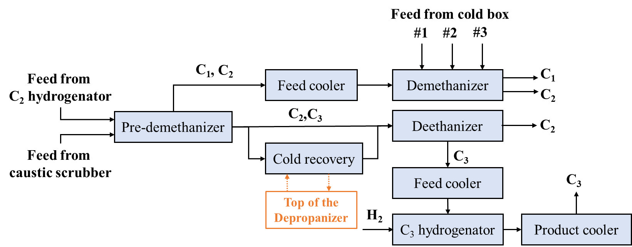

**Fig. 3** Schematic diagram of C3-alkyne hydrogenation process

In the selective hydrogenation processes, feeds of pre-demethanizer unit were obtained from acetylene hydrogenation reactor and caustic scrubber. Top outlet stream from pre-demethanizer unit was further cooled then fed to the demethanizer. Also, three additional feeds from cold box system were fed into demethanizer unit. Bottom outlet stream from pre-demethanizer was fed into a deethanizer unit along with a cold recovery stream. C3 stream from the deethanizer was cooled and mixed with hydrogen then entered C3 hydrogenation reactor so that MA and PD were converted to propylene and propane.

## 4.2 Design alternatives

So far, many researches are focusing on the energy-saving intensified design of C3 alkyne hydrogenation distillation process [26, 28, 29]. Reactive distillation was first employed due to an important advantage of decreasing the chance of deep hydrogenation, which may lead to the increase of by-products [26]. However, distillation as the main separation way for chemicals occupied huge energy consumption ratio in the whole process. Based on energy-saving technologies, thermally coupled distillation is an effective method to enhance energy utilization efficiency [30, 31]. Three structures in the thermally coupled distillation system were studied. These structures were fully thermally coupled structure, thermally coupled structure of a side-rectifying section, and thermally coupled structure of a side-stripping section. Also, reactive distillation and thermally coupled distillation technologies were applied to the proposed synthesis designs. As results, four process syntheses techniques were investigated. These syntheses techniques were catalytic hydrogenation distillation process (Design B); pre-demethanizer/deethanizer thermally coupled catalytic distillation (Design C); pre-demethanizer/demethanizer thermally coupled catalytic distillation (Design D) and fully thermally coupled catalytic distillation (Design E).

## 4.3 Process simulation

The input information of original process including feed stock, total stage number, feed stage are using actual industry data from Wang [32]. Summary of the feed streams information is shown in ***Table 6***.

**Table 6. Information of Feed Streams in Every Column**

|  |  |  |  |  |  |
| --- | --- | --- | --- | --- | --- |
| **Items** | **Pre-demethanizer** | | **Demethanizer** | | |
| Feed stage | 15 | 22 | 8 | 12 | 16 |
| Temperature/℃ | −38.2 | −18.5 | -111.1 | -98.0 | -77.0 |
| Mole Flow/kmol·h-1 | 2813.9 | 1912.6 | 459.5 | 758.1 | 1476.0 |
| **Components mole fraction** | | | | | |
| Carbon monoxide | 1.293 | 1.116 | 2.555 | 2.037 | 1.804 |
| Hydrogen | 0.019 | 0.014 | 0.085 | 0.059 | 0.039 |
| Methane | 13.583 | 9.700 | 67.028 | 47.227 | 29.872 |
| Ethylene | 53.111 | 41.202 | 29.221 | 47.117 | 61.263 |
| Ethane | 10.529 | 8.891 | 1.109 | 3.554 | 6.973 |
| Propadiene | 0.157 | 0.431 | 0 | 0 | 0 |
| Methylacetylene | 0.157 | 0.431 | 0 | 0 | 0 |
| Propylene | 20.199 | 36.155 | 0 | 0.005 | 0.049 |
| Propane | 0.929 | 1.921 | 0 | 0 | 0.001 |
| Butenes | 0.020 | 0.126 | 0 | 0 | 0 |
| Butanes | 0.002 | 0.010 | 0 | 0 | 0 |

In the simulation of the process alternatives, the flow rate at the top and bottom of the distillation column was constant to satisfy mass balance. Reflux ratio was optimized using sensitivity analysis tool to ensure the separation met the requirements and the total energy consumption of the process was minimized. To facilitate the comparative analysis of the results in various processes, stage number for each designs (expect Design E) remained the same and the C3 products were maintained at 40°C. The macroscopic kinetics used for simulation came from Yu. et al. The kinetics equations were describe below [33]:

 (16)

 (17)

**r(MA, PD):** the hydrogenation reaction rate for converting MA, PD to propylene [mol·h−1·(g cat) −1]

**r(C3H8):** the hydrogenation reaction rate for converting propylene to propane [mol·h−1·(g cat) −1]

**T:** the reaction temperature [K]

**c(MA, PD):** the MA, PD and hydrogen concentration [mol·(g cat) −1]

**c(H2):** the hydrogen concentration [mol·(g cat) −1]

The process flow diagrams of original and four intensified processes (Design A, B, C, D and E) and corresponding simulation results were shown in ***Fig.4*** to ***Fig. 8*,** respectively. Design A (***Fig. 4***) was the original design for C3-alkyne selective hydrogenation distillation. Design B (***Fig. 5***) integrated C3-alkyne hydrogenation reaction in the deethanizer. Hydrogen entered at the bottom of the deethanizer, passed up through the reaction zone and reacted with MA, PD to produce propylene and propane. The reaction zone was between 40th and 45th trays. Excess hydrogen went to the top and the C3 components were separated and left at the bottom. The pre-demethanizer in Design C (***Fig. 6***) did not have a reboiler. A liquid-phase side stream from the deethanizer entered at the bottom of the pre-demethanizer. The feed and withdrawal locations for the deethanizer and pre-demethanizer connection streams were at the 18th tray and the 19th tray, respectively. The simulated draw out flow rate was 90319 kg/h. In Design D (***Fig. 7***), condenser in pre-demethanizer was removed. A gas-phase side stream from the demethanizer was connected to the top of the pre-demethanizer. In the simulations, flow rates of the side streams were specified, and the reflux ratios were optimized to meet the separation requirements and to minimize energy consumption. consumption. The feed and withdrawal trays for the demethanizer were 23 and 24, respectively, and the simulated draw out flow rate is 9136 kg/h. In Design E (***Fig. 8***), both reboiler and condenser in pre-dementhanizer were removed. A gas-phase side stream and a liquid-phase side stream from the main fractionator was connected to the top and the bottom of the pre-demethanizer, respectively. The main fractionator replaces the demethanizer and the deethanizer. C1 component was produced at the top while C3 component was produced at the bottom. A gas-phase stream came out from the middle of the main fractionator, part of the stream went back to the column as a reflux, and part of them was condensed to C2 component. It is worth noting that due to there was large difference in gas-liquid loading between the demethanizer and the deethanizer in the original process, an intermediate condenser was introduced into the main fractionator to minimize energy loss caused by the increased flow rate in rectifying section.

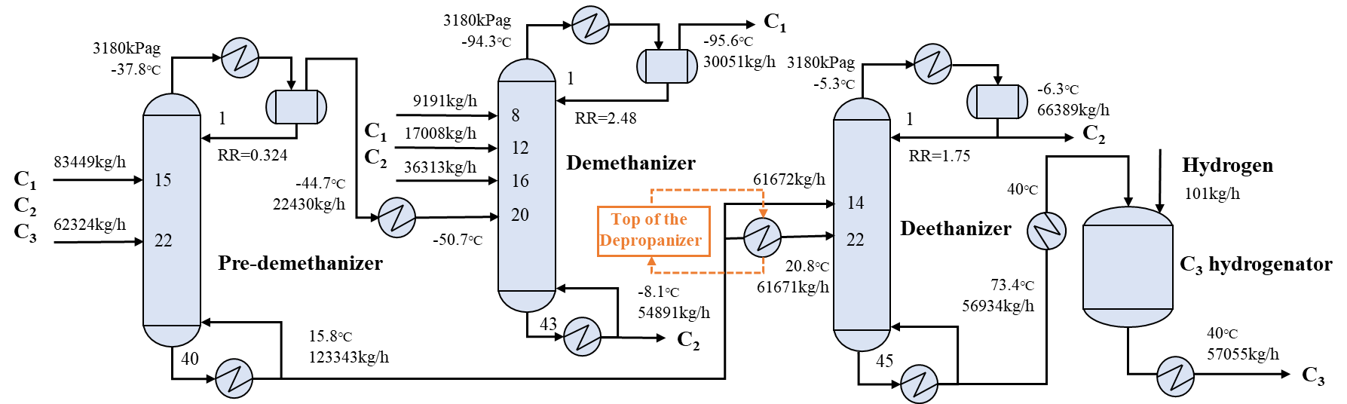

**Fig. 4.** Original Process (Design A)

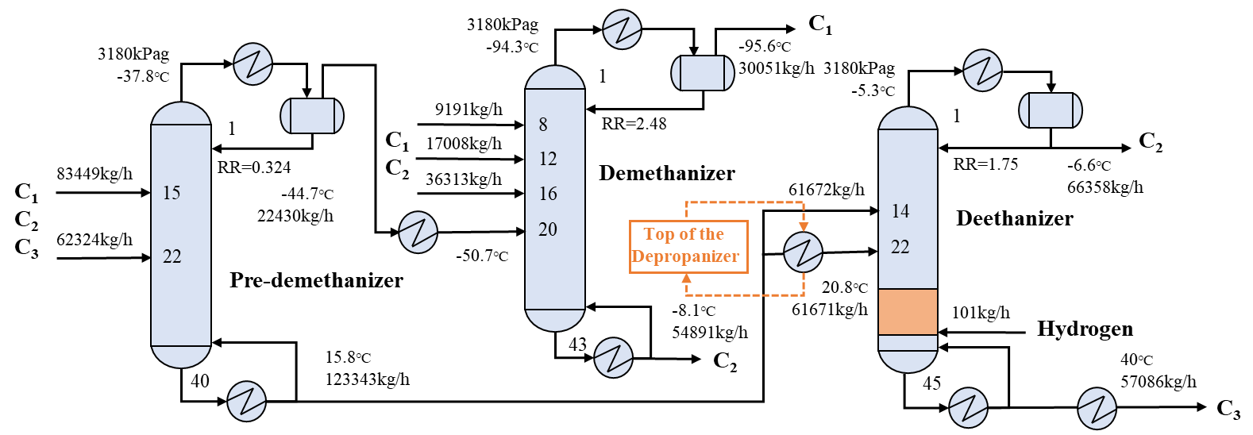

**Fig. 5.** Catalytic hydrogenation distillation process (Design B)

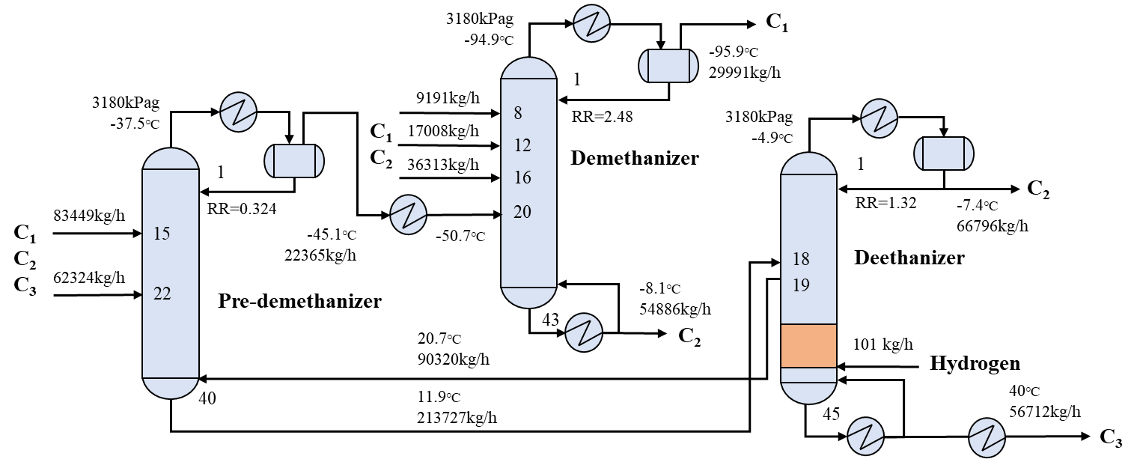

**Fig. 6.** Pre-demethanizer/deethanizer thermally coupled catalytic distillation process (Design C)

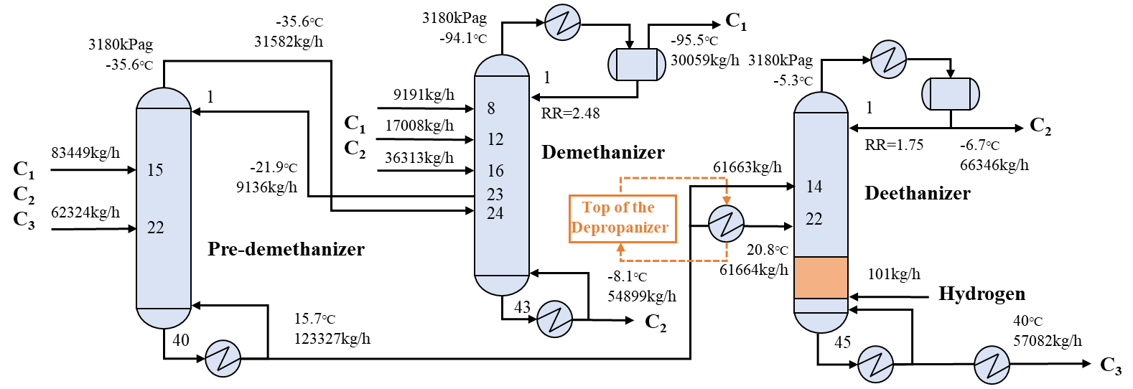

**Fig. 7.** Pre-demethanizer/demethanizer thermally coupled catalytic distillation process (Design D)

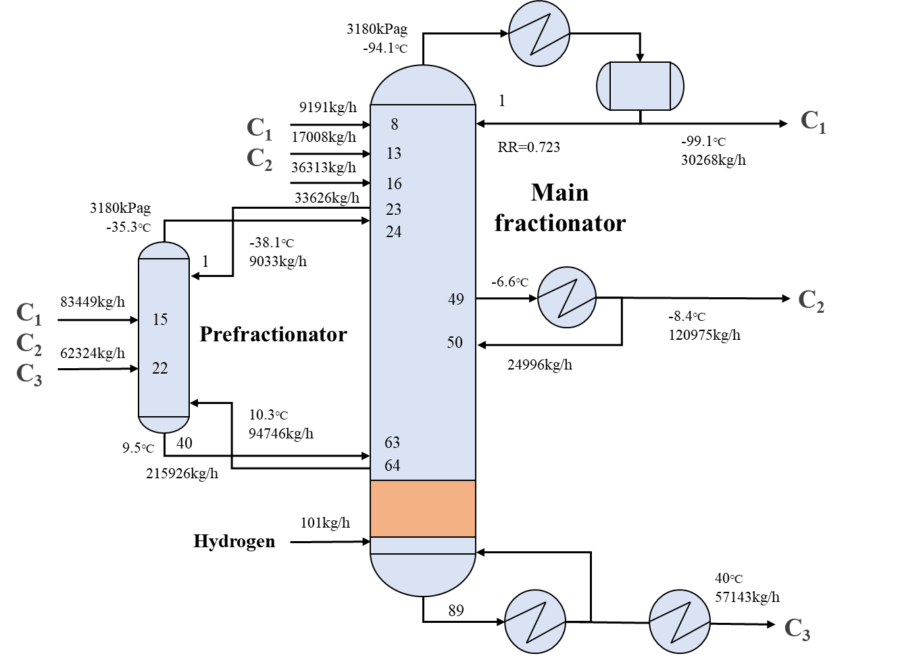

**Fig. 8.** Fully thermally coupled catalytic distillation process (Design E)

## 4.4 Process economic performance

For the process economic assessment, TAC models used for this case study were described in section 3. The column diameters were calculated by “Tray Sizing” function in Aspen Plus. Summary of the energy consumption and utilities in each processing designs were shown in ***Table 7.*** While in ethylene plant, the heating utility source for reboiler of all distillation columns was from quench water and recycled C2, C3 refrigerant, which can be provided by quench tower and recycling of the cold box system. The cooling utility were from C2 refrigerants in -22℃, -62℃ and -100℃ as well as cooling water. Prices of different levels of cooling are shown in ***Table 8***. Since the costs of hot utilities had negligible impact on the total cost comparing to the costs of cooling utilities, hot utilities were ignored in the calculations.

**Table 7. Energy Consumption of Five Processes**

|  |  |  |  |  |
| --- | --- | --- | --- | --- |
| Designs | Items | Target temperature/℃ | Duty/MW | Utility |
| Design A | Pre-demethanizer condenser | -44.69 | -0.81 | -62℃ C2 refrigerant |
| Demethanizer feed cooler | −50.70 | -0.47 | -62℃ C2 refrigerant |
| Demethanizer condenser | −95.61 | -4.89 | -100℃ C2 refrigerant |
| Deethanizer condenser | -6.27 | -12.30 | -22℃ C2 refrigerant |
| C3 hydrogenator feed cooler | 40.00 | -1.92 | Cooling water |
| C3 product cooler | 40.00 | -2.03 | Cooling water |
| Design B | Pre-demethanizer condenser | -44.69 | -0.81 | -62℃ C2 refrigerant |
| Demethanizer feed cooler | −50.70 | -0.47 | -62℃ C2 refrigerant |
| Demethanizer condenser | −95.61 | -4.89 | -100℃ C2 refrigerant |
| Deethanizer condenser | -6.61 | -12.37 | -22℃ C2 refrigerant |
| C3 product cooler | 40.00 | -1.84 | Cooling water |
| Design C | Pre-demethanizer condenser | -45.02 | -0.92 | -62℃ C2 refrigerant |
| Demethanizer feed cooler | −50.70 | -0.44 | -62℃ C2 refrigerant |
| Demethanizer condenser | −95.92 | -4.80 | -100℃ C2 refrigerant |
| Deethanizer condenser | -7.38 | -10.70 | -22℃ C2 refrigerant |
| C3 product cooler | 40.00 | -1.86 | Cooling water |
| Loss of cold recovery | - | -1.50 | Cooling water |
| Design D | Demethanizer condenser | −95.54 | -4.92 | -100℃ C2 refrigerant |
| Deethanizer condenser | -6.66 | -12.37 | -22℃ C2 refrigerant |
| C3 product cooler | 40.00 | -1.84 | Cooling water |
| Design E | Main column condenser | -99.14 | -4.09 | -100℃ C2 refrigerant |
|  | Intermediate condenser | -7.82 | -9.94 | -22℃ C2 refrigerant |
|  | Loss of cold recovery | - | -1.50 | Cooling water |
|  | C3 product cooler | 40.00 | -1.88 | Cooling water |

**Table 8. Prices for Cooling Utilities**

|  |  |  |
| --- | --- | --- |
| Utility | Temperature/℃ | Price/USD·GJ-1 |
| Cooling water | Inlet:30 Outlet:35 | 0.785 |
| C2 refrigerant | -22 | 8.513 |
| C2 refrigerant | -62 | 16.716 |
| C2 refrigerant | -100 | 24.770 |

In Design A, B and D, cold energies in one of the deethanizer feeds were recovered, but they were not recovered in Design C and E. Therefore, utility costs of the unrecovered energy needed to be considered in energy consumptions and TAC calculations of Design C and E. Generally, this part of energy was utilized for cooling the top of the high-pressure depropanizer. Without recovery, cooling water will be used for cooling. For the case of unrecovered, additional $35,000 was added to the costs of the cooling water consumptions for Design C and E.

Energy consumption and costs of the five processing designs were shown in ***Table 9***. The results showed that Design E had the lowest TAC among five processing designs. Even though Design E had the largest capital cost because of its large main fractionator, it had excellent advantages on energy-saving performance.

**Table 9. Energy Consumption and Economic Performance of Five Designs**

|  |  |  |  |  |  |
| --- | --- | --- | --- | --- | --- |
| Items | Design A | Design B | Design C | Design D | Design E |
| Cooling requirements, MW | 22.40 | 20.38 | 20.22 | 19.13 | 15.91 |
| Heating requirements, MW | 27.94 | 25.99 | 25.90 | 24.71 | 21.11 |
| Total energy consumption, MW | 50.34 | 46.37 | 46.12 | 43.84 | 36.20 |
| Capital cost, MUSD | 16.09 | 15.36 | 15.05 | 14.47 | 16.97 |
| Operating cost, MUSD | 7.37 | 7.34 | 7.12 | 6.91 | 5.71 |
| Total annual cost, MUSD | 12.73 | 12.46 | 12.14 | 11.73 | 11.36 |
| TAC decreased compared to Design A | - | 2.12% | 4.63% | 7.86% | 10.76% |

## 4.5 Process safety performance

For process safety assessment, this study utilized the methodology mentioned in section 2. First, safety performance of five designs including the original process designs and four different alternatives, are quantified by using CISI and ACISI, shown in ***Table 10***. Calculations of connection score in CISI and an averaged connection score in ACISI was 15%, based on user experiences. According to the results, all four process intensified designs had different degrees of improvement in process safety despite regarding to CISI or ACISI. For CISI, Design D scored 19677 was the best inherently safer process among the five designs. For ACISI, Design E scored 2169.73 turn into the most inherently safer process. Since the ACISI has corrected the limitations on the original CISI. Therefore the results were more reasonable and convincible.

**Table 10. Safety Performance of Five Designs**

|  |  |  |  |  |  |
| --- | --- | --- | --- | --- | --- |
| Items | Design A | Design B | Design C | Design D | Design E |
| CISI | 22374 | 20658 | 21783 | 19677 | 20079 |
| ACISI | 2423.76 | 2171.37 | 2400.68 | 2170.38 | 2169.73 |
| CISI decreased compared to Design A | - | 7.67% | 2.64% | 12.05% | 10.26% |
| ACISI decreased compared to Design A | - | 10.41% | 0.95% | 10.45% | 10.48% |

The ACISI block diagrams for five designs are shown in ***Fig.9***. The results illustrated that pre-demethanizer (T1), demethanizer (T2) with its reboiler (E2), and deethanizer (T3) with condenser (E6) and reboiler (E7) were the key hazardous equipment.

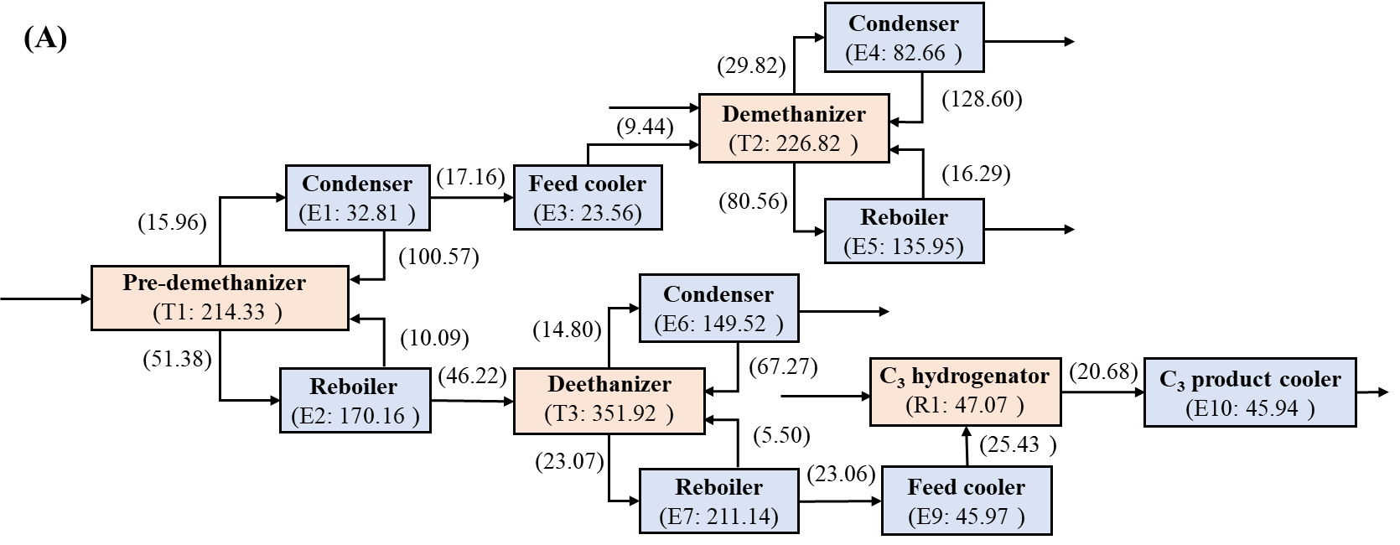

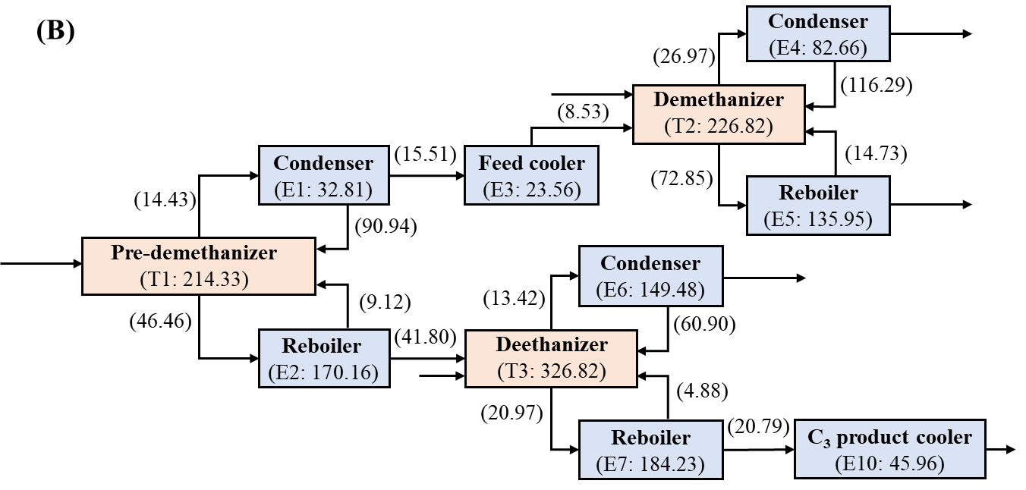

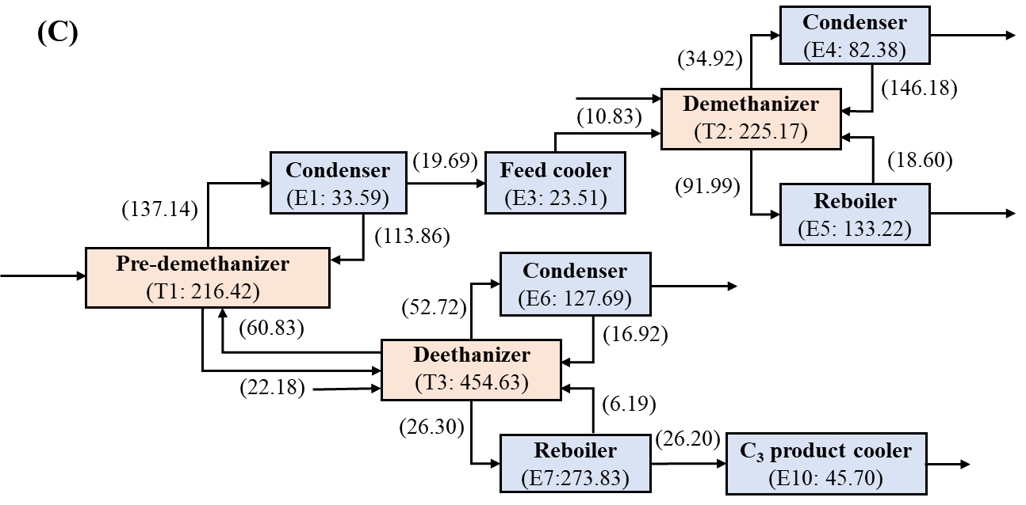

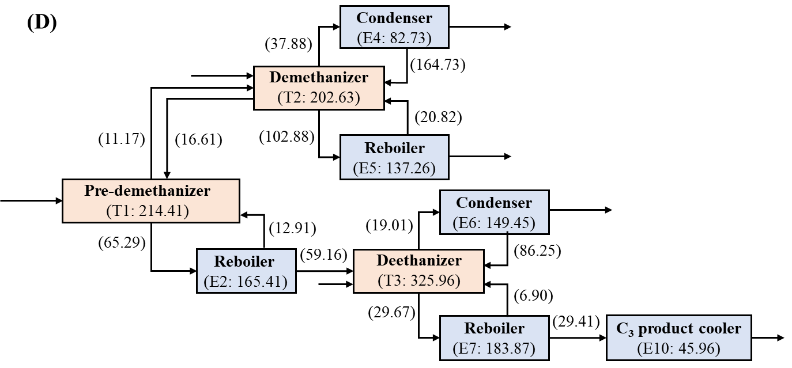

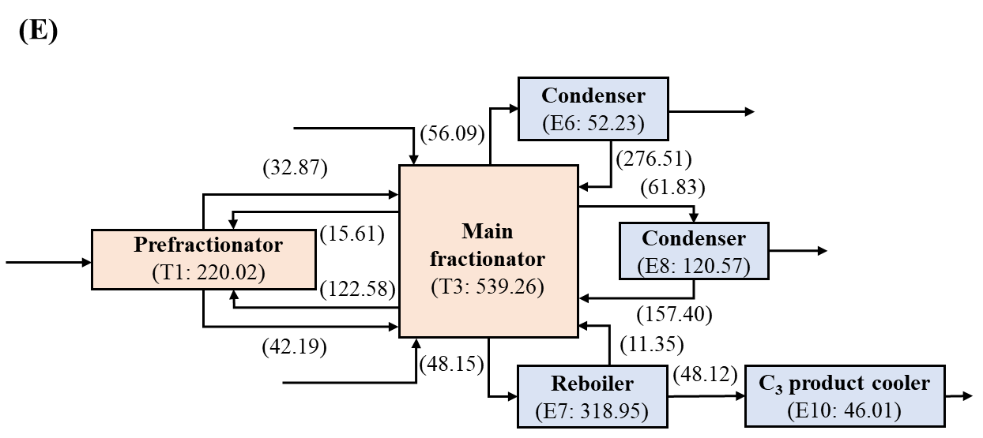

**Fig. 9.** Block diagram of five designs, blue module stands for heat exchanger and orange module stands for vessel. (T1-T3, E1-E10 are labels that represent each corresponding equipment)

## 4.6 Risk transfer verification

According to the results of economic and safety analysis, Design E had the best economic and inherent safety performance and thus, Design E is an ideal process choice among five designs. However, before making a final decision, it is necessary to analyze whether there is a risk transfer occurred in Design E. If a risk transfer occurs, the risks in the worst case on safety equipment must be within tolerable limits. Otherwise, the process should not be used and alternative processes should be chosen. ***Fig.10*** shows a comparison of ACISI in each of the five processes. The equipment’s ACISI scores are derived from the sum of the equipment’s IECI, IEPC and out-stream connection scores.

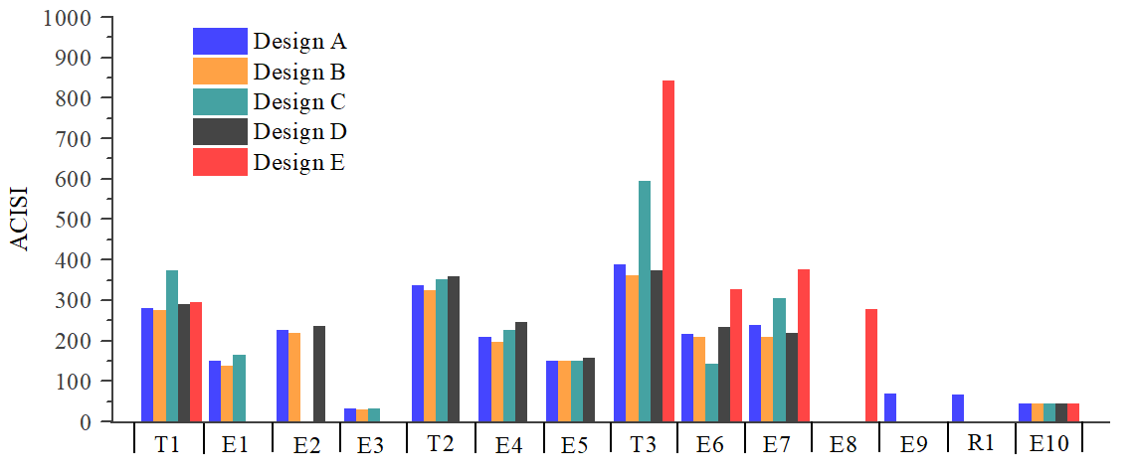

**Fig. 10.** Comparison of ACISI in same equipment of five designs. (The corresponding label of the equipment is shown in **Fig. 9**.)

Comparing to the original design, number of equipment in Designs B, C, D and E was reduced. ***Table 11*** shows the details of removed equipment. Removal of equipment E9 and R1 in Design B and elimination of equipment E1 and E3 in Design D did not increase ACISI in other equipment noticeably. However, removing equipment in Designs C and E increased ACISI in equipment T3 and E7 significantly. The results showed that risk transfer occurred from Designs C and E. Therefore, a quantitative risk analysis need to be conducted for the worst equipment in Design D.

**Table 11. Details of Reduced Equipment in Each Designs.**

|  |  |
| --- | --- |
| Designs | Description |
| Design B | Removed equipment E9, R1 |
| Design C | Removed equipment E9, R1, E2 |
| Design D | Removed equipment E9, R1, E1, E3 |
| Design E | Removed equipment E9, R1, E1, E2, E3, T2, E4, E5  Added equipment E8 |

## 4.7 Quantitative risk analysis for Design E

In Design E, the worst inherent safety level equipment is the main fractionator (T3), which owns the highest ACISI score. Loss of containment from this distillation column has a high potential to cause an explosion. Therefore, it is essential to analyze the consequences and the frequency of an explosion event due to the main fractionator.

1. Estimate of explosive frequency

The frequency of an explosion was estimated using fault tree analysis (FTA) or event tree analysis (ETA) method. Three most common failures causing high consequences are considered here: 1) rupture of the main fractionator, 2) rupture of a liquid pipe and 3) rupture of a vapor pipe. Two types of releases could occur. They are an instantaneous release from a catastrophic rupture and a continuous release from a partial rupture. Partial rupture leads to a rupture of less than 20% of total diameter, and total rupture, also called catastrophic rupture, represents a rupture of 20% or more of total diameter. In this study, ETA was utilized to estimate the frequency of an explosion. An example of event trees framework for flammable loss of containment with various ignition types is shown in ***Fig.11***.

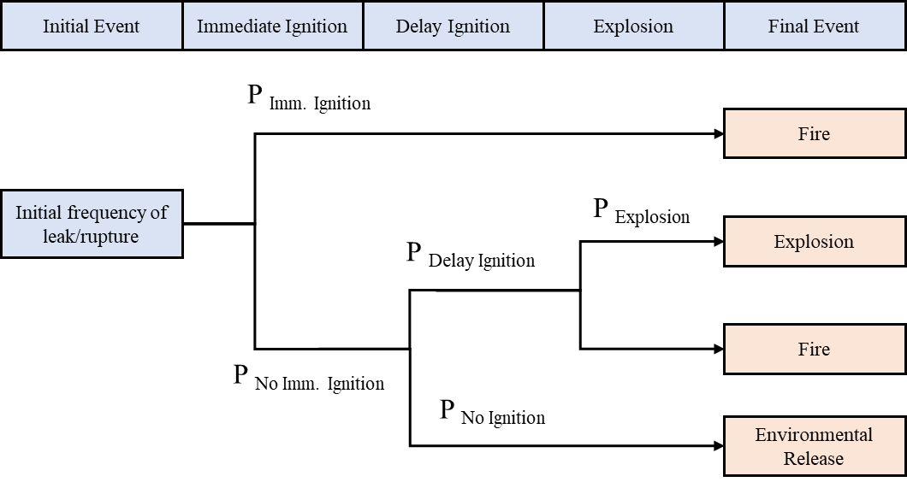

**Fig. 11.** ETA framework for ﬂammable loss of containment [34]

Catastrophic rupture, as the worst release scenario, is used for estimating the potential risk of an explosion. ***Fig. 12*** shows the fault trees for instantaneous releases for the main fractionator which was studied by Medina-Herrera [9]. The same failure rate for different construction material is assumed. In the calculations, 55m of liquid pipe and 25m of vapor pipe were assumed. The estimated initial frequency of rupture (Finitial) is 2.3E-5/yr.

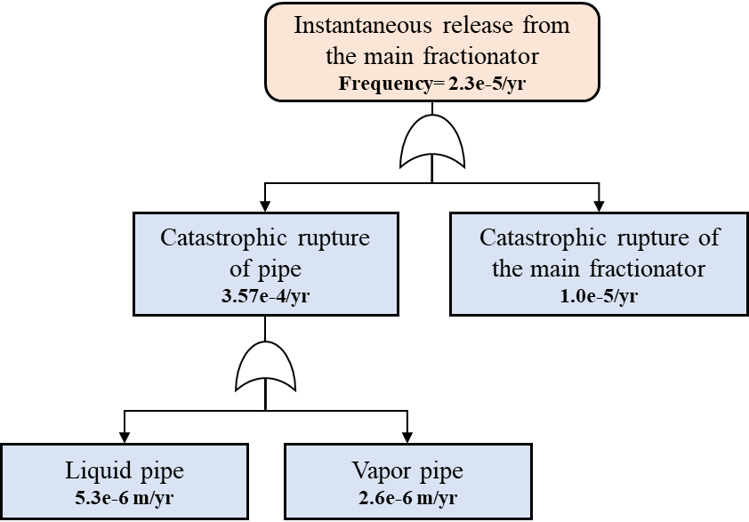

**Fig. 12.** Instantaneous release fault trees [9]

The probability of immediate ignition is related to ratio of temperature to auto ignition temperature (AIT) in different chemicals. On the other hand, minimum ignition energy (MIE) is used to describe the potential of static charge. The probability of immediate ignition is estimated using Eq. 18 [35]:

(18)

where T and AIT are the released and auto ignition temperatures (°F), respectively. P is a source pressure (psig) and MIE is minimum ignition energy (mJ). The MIE and AIT for mixtures can be evaluated using Le chatelier’s mixing principle. The following constraints are placed below.

A minimum value of 0 is allowed for T.

For T/AIT <0.9,

For T/AIT>1.2,

Delayed ignition could occur in the absence of immediate ignition. Vapor clouds need sufficient amount of flammable mass. ***Table 12*** shows the probability of delayed ignition for various ignition sources. Because this study was conducted at early design stage, detailed information of plant layout was not available, the delayed ignition probability was conservatively considered to be equal to 0.5.

**Table 12. Probability of delayed ignition in one minute for various ignition sources** [11]**.**

|  |  |
| --- | --- |
| Source | Probability of ignition |
| High equipment density | 0.5 |
| Medium equipment density | 0.25 |
| Low equipment density | 0.1 |
| Confined space with no-equipment | 0.02 | |

Typically, the probability of an explosion is estimated from the flammable released rate (mf) [36].

(19)

where mf is the flammable released rate in lb/sec.

The explosion frequency (Fexplosion) can be estimated by Eq. 20.

(20)

1. Estimate of explosive severity

An explosion is considered as a credible event from the loss of containment of the column. The severity of an explosion can be estimated by aftermath, such as fatalities, injuries and structural damage. Blast effect is generated from an explosion due to a transient change in gas density, pressure and velocity. This effect can be estimated using various models. However, the TNO multi-energy model is a widely accepted and user-friendly method to estimate blast overpressure. Considering instantaneous release gives conservative results. The mass released is the total amount of mass inside the main fractionator. The total released mass (mf) can be estimated from Eq. (21)-(25). [9]

(21)

(22)

(23)

(24)

(25)

where Vcolumn is the column volume, fvapor, fliquid and ρvapor, ρliquid are the fractions and densities for vapor and liquid, respectively. Capacities of reflux drum and reboiler were assumed to be 12 and 6 min of the feed flowrate, respectively. mcolumn, mcond, mreb are the mass inside the column, reflux drum and reboiler, respectively.

The explosion energy (E) can be estimated by the product of flammable mass (mf) and heating value (Hv). Sachs-scaled distance (Rs) can be estimated from this energy using Eq. (26)-(27)

(26)

(27)

where R represents the distance from the source and P0 indicates the ambient pressure.

Ten different blast strength curves are used to estimate the side-on blast overpressure, Δps. The magnitude of blast strength estimated from curve 7 is found to be closer to the actual values and the balst strength was implemented for hydrocarbon explosion analysis [37]. The mathematical model developed for curve 7 is given below.

(28)

The blast overpressure Ps represents the increase of ambient pressure due to explosion blast effect.

(29)

The Probit method can be implemented for analyzing consequences resulting from explosion. The values of Probit parameters (k1 and k2) for the fatalities, injuries and structural damage are listed in ***Table 13***. The Probit variable (Y) and probability (P) of various consequences can be computed from Eq. (30)-(31).

(30)

(31)

**Table 13. Probit parameters values for the explosion and fire impacts** [38]**.**

|  |  |  |  |
| --- | --- | --- | --- |
| Possible impacts | V | k1 | k2 |
| Death from lung hemorrhage | Ps | -77.1 | 6.91 |
| Ear drum rupture | Ps | -15.6 | 1.93 |
| Structural damage | Ps | -23.8 | 2.92 |

## 4.8 Decision making

The frequency of an explosion caused by catastrophic rupture of the main fractionator is evaluated as 9.64E-6. The numbers of fatalities are estimated by considering the actual number of workers exposed to explosion. In this case study, 100 workers in a circle area with a radius of 1000 meters are assumed to be exposed to an explosion event and the probability of fatalities is calculated using the Probit method. The estimated value of the probability of fatality is 0.52.

Risk of explosion can be estimated using the 3-region frequency number (F-N) curve. These three regions are “tolerable”, “as-low-as-reasonably-practicable (ALARP)” and “intolerable”. The potential risk acceptability criterion defined in the F-N curve are developed on the basis of the acceptability criteria established by the Chinese authority. The risk can only be reduced to the ALARP region, when safety measures and controls mechanisms are fully configured in the design. The process will be recommended for inherently safer and economically superior design, if the potential risk falls under the tolerable and ALARP zone of the F-N curve. If the estimated value of potential risk lies in the intolerable region of this curve, the process will not be accepted. Therefore, another alternative should be evaluated by repeating the QRA process. The estimated potential risk of Design E is shown in ***Fig.13***, and it is found within the ALARP zone. Therefore, Design E can be regarded as the inherently safer and economically superior process.

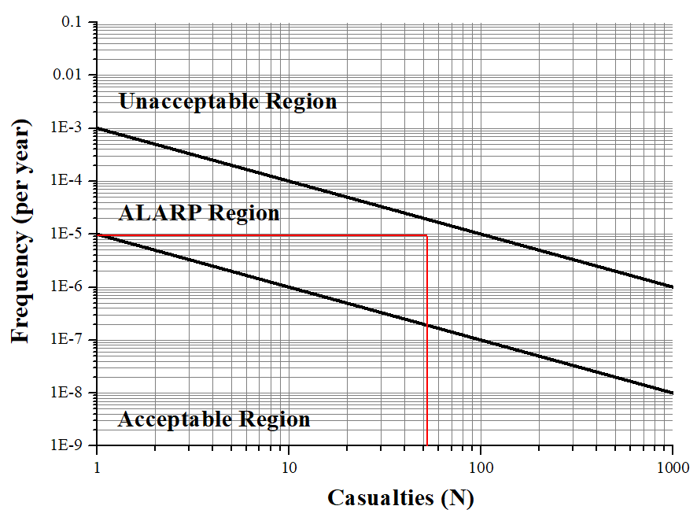

**Fig. 13.** Potential risk of an explosion from the catastrophic rupture of the main fractionator

# Root causes for risk transfer

The safety performance (ACISI score) of Equipment T3, E6 and E7 had the greatest differences among the five processes (Shown in ***Fig. 10***). There was a significant increase of ACISI score of T3 and E7 in Designs C and E. The reason for this was mainly related to the liquid-vapor profiles in the column. In Design C, the bottom stream of Pre-dementhanizer directly entering the deethanizer caused a significantly liquid-vapor load increase of the stripping section. The deethanizer reboiler was responsible for the duty of the two reboilers in the Design A. As results, large amount of energy and materials in the bottom of the deethanizer led to increasing ACISI score (***Fig. 14***). Similarly, the main fractionator reboiler in Design E replaced the three reboilers in the Design A. Thus, more materials and energy were expected in the main fractionator reboiler (***Fig. 15***).

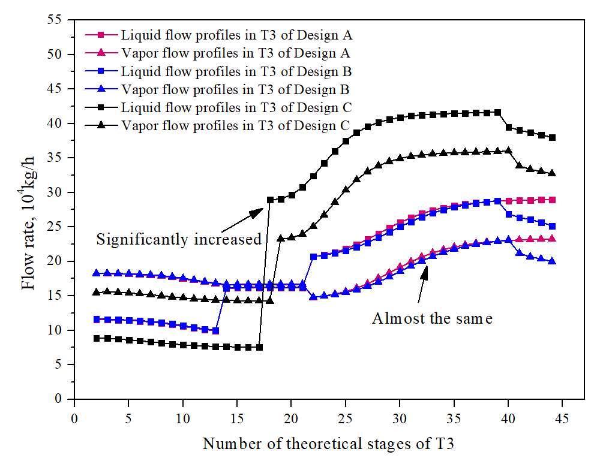

**Fig. 14.** Liquid-Vapor flow profiles of T3 in Designs A, B and C vs. Number of theoretical stages

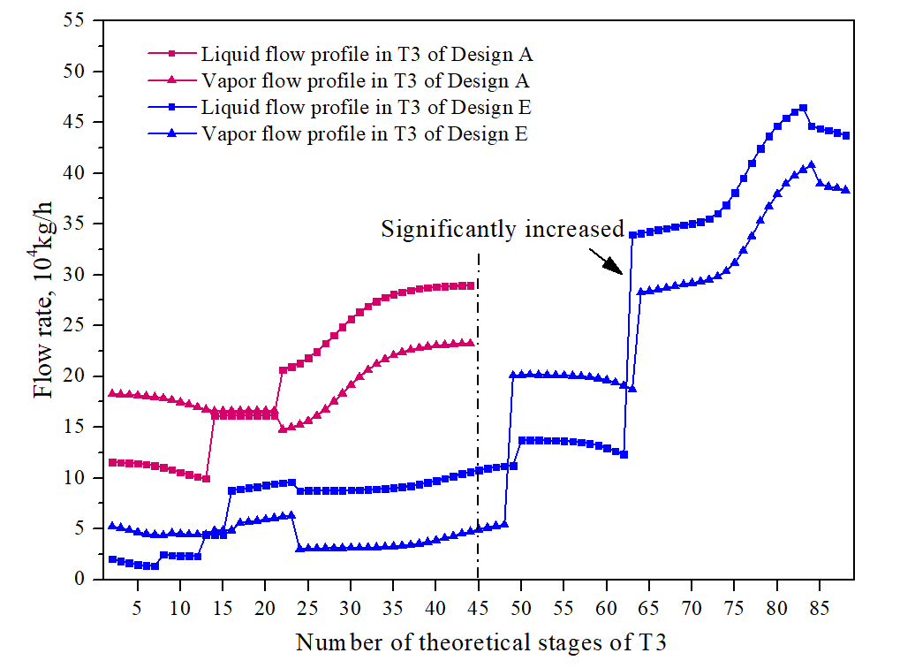

**Fig. 15.** Liquid-Vapor flow profiles of T3 in Designs A and E vs. Number of theoretical stages

In Design D, even though the condenser in the pre-demethanizer was removed, the amount of materials entering into the demethanizer did not change much due to a lower reflux ratio in the pre-demethanizer. Thus, the liquid-vapor profile in the demethanizer changed slightly (***Fig. 16***), and the CISI score remained nearly unchanged. The risk of reduced equipment through PI has not been transferred to other equipment. Although the ACISI score of Design D is not the lowest, from the perspective of intrinsic safety design, it is the best inherent safety process. The investigation from the cases showed that elimination of equipment with lower risks has more chance to improve overall safety of the process. Merging two higher risk equipment may lead to a more dangerous source of hazards.

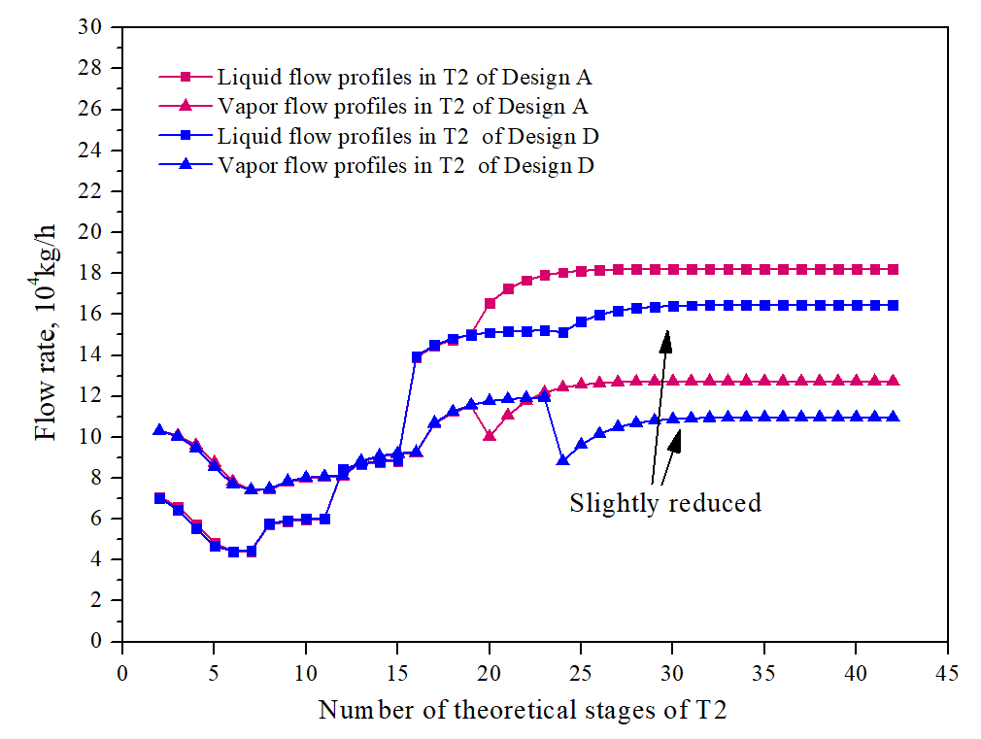

**Fig. 16.** Liquid-Vapor flow profiles of T2 in Designs A and D vs. Number of theoretical stages

# Conclusions

ISD through PI realizes the simultaneous improvement of process economics and safety thus is an ideal way to ensure inherent safety in processes. Though using PI can further improve inherent safety rather than solely optimizing parameters, concerns on risk transfer and risk accumulation are raised. In this paper, a novel methodology was proposed for ISD through PI. ISD can be integrated with process design simulator or optimization software for the seamless process design. The newly methodology combines two currently widely used inherent safety assessment methods, ISIs and QRA, to evaluate process safety. In order to better compare safety of intensified processes, ACISI was developed based on CISI. Scale factor and modified connection score are added for better application. ACISI is also able to accurately compare the relative safety of each unit in processes to determine whether risk transfer occurred or not. Once risk transfer occurs in initial identified optimal process, QRA will be used to assess the potential risks, and to judge if the consequences and risks are acceptable.

An example of C3 alkyne selective hydrogenation distillation process was studied in this paper to demonstrate implementation of ISD through PI. The safety and economic performance of 4 different process intensified designs, using the reactive distillation (Design B), thermally coupled catalytic distillation of a side-rectifying section (Design C), thermally coupled catalytic distillation of a side-stripping section (Design D) and full thermally coupled catalytic distillation (Design E), are explored. The results showed that economic performance of four schemes improved from Design B to Design E, but safety performance in distinctive designs showed different results. Design E owns the lowest ACISI score. Thus, Design E was regarded as the optimal process in this case. However, a much higher ACISI score was in the main fractionator. High ACISI score represents risk transfer occurring in the system. Therefore QRA was conducted for further analysis. The results showed that the risk was within the ALARP region. Once sufficient safety measures and protection layers are installed, Design E can be considered as the best inherent safety process among the five designs.

In addition, causes of risk transfer phenomenon were studied in this study case. From the perspective of ISD principles, Design D is the best inherently safer design since it permanently eliminates the risk of removed equipment. Designs C and E have risk transfer. The reason for risk transfer is related to the vapor-liquid profiles in the distillation column. Intensive materials and energy lead to superposition of risks. The results also showed that eliminating equipment with relatively low risk is easier to achieve inherent safety for the system without risk transfer. In this case study, Design E is considered the best design because it can achieve maximum economic benefits from a relatively safe perspective, but Design D is inherently safer.

# Reference

1. Kletz, T.A., *What you don’t have, can’t leak.* Chemistry and Industry, 1978. **6**: p. 287-292.

2. Kletz, T.A. and P. Amyotte, *Process plants: A handbook for inherently safer design*. 2010: CRC Press.

3. Kletz, T.A., *Inherently safer design—its scope and future.* Process Safety and Environmental Protection, 2003. **81**(6): p. 401-405.

4. Kletz, T., *The origins and history of loss prevention.* Process Safety and Environmental Protection, 1999. **77**(3): p. 109-116.

5. Hendershot, D.C., *Conflicts and decisions in the search for inherently safer process options.* Process Safety Progress, 1995. **14**(1): p. 52-56.

6. Gangadharan, P., et al., *Novel Methodology for Inherent Safety Assessment in the Process Design Stage.* Industrial & Engineering Chemistry Research, 2013. **52**(17): p. 5921-5933.

7. Vázquez, D., et al., *Multiobjective Early Design of Complex Distillation Sequences Considering Economic and Inherent Safety Criteria.* Industrial & Engineering Chemistry Research, 2018. **57**(20): p. 6992-7007.

8. Suardin, J., M.S. Mannan, and M. El-Halwagi, *The integration of Dow's fire and explosion index (F&EI) into process design and optimization to achieve inherently safer design.* Journal of Loss Prevention in the Process Industries, 2007. **20**(1): p. 79-90.

9. Medina-Herrera, N., A. Jiménez-Gutiérrez, and M.S. Mannan, *Development of inherently safer distillation systems.* Journal of Loss Prevention in the Process Industries, 2014. **29**: p. 225-239.

10. Eini, S., et al., *Inherently safe and economically optimal design using multi-objective optimization: The case of a refrigeration cycle.* Process Safety and Environmental Protection, 2016. **104**: p. 254-267.

11. Eini, S., et al., *Inherently safer design of a reactor network system: A case study.* Journal of Loss Prevention in the Process Industries, 2018. **51**: p. 112-124.

12. Bessling, B., et al., *Investigations on the synthesis of methyl acetate in a heterogeneous reactive distillation process.* Chemical Engineering & Technology: Industrial Chemistry‐Plant Equipment‐Process Engineering‐Biotechnology, 1998. **21**(5): p. 393-400.

13. Harmsen, J., *Process intensification in the petrochemicals industry: drivers and hurdles for commercial implementation.* Chemical Engineering and Processing: Process Intensification, 2010. **49**(1): p. 70-73.

14. Malone, M.F. and M.F. Doherty, *Reactive distillation.* Industrial & Engineering Chemistry Research, 2000. **39**(11): p. 3953-3957.

15. Harmsen, G.J., *Reactive distillation: the front-runner of industrial process intensification: a full review of commercial applications, research, scale-up, design and operation.* Chemical Engineering and Processing: Process Intensification, 2007. **46**(9): p. 774-780.

16. Stankiewicz, A., *Reactive separations for process intensification: an industrial perspective.* Chemical Engineering and Processing: Process Intensification, 2003. **42**(3): p. 137-144.

17. Reay, D., C. Ramshaw, and A. Harvey, *Process Intensification: Engineering for efficiency, sustainability and flexibility*. 2013: Butterworth-Heinemann.

18. Fire, D., *Explosion Index Hazard Classification Guide.* AICHE New York, 1994.

19. Chemicals, D., *Chemical Exposure Index.* AIChE, New York, 1988.

20. Lewis, D. *The Mond fire explosion and toxicity index—a development of the Dow Index*. in *Proceedings of the AIChE on loss prevention symposium, New York*. 1979.

21. Khan, F.I., T. Husain, and S.A. Abbasi, *Safety weighted hazard index (SWeHI): a new, user-friendly tool for swift yet comprehensive hazard identification and safety evaluation in chemical process industrie.* Process Safety and Environmental Protection, 2001. **79**(2): p. 65-80.

22. Khan, F.I. and P.R. Amyotte, *Integrated inherent safety index (I2SI): a tool for inherent safety evaluation.* Process Safety Progress, 2004. **23**(2): p. 136-148.

23. Douglas, J.M., *Conceptual design of chemical processes*. Vol. 1110. 1988: McGraw-Hill New York.

24. Li, X., et al., *Optimization of pressure-swing batch distillation with and without heat integration for separating dichloromethane/methanol azeotrope based on minimum total annual cost.* Industrial & Engineering Chemistry Research, 2017. **56**(14): p. 4104-4112.

25. Shariff, A.M., C.T. Leong, and D. Zaini, *Using process stream index (PSI) to assess inherent safety level during preliminary design stage.* Safety science, 2012. **50**(4): p. 1098-1103.

26. Qian, X., et al., *Selective hydrogenation and separation of C3 stream by thermally coupled reactive distillation.* Chemical Engineering Research and Design, 2015. **99**: p. 176-184.

27. Wu, W. and Y.-L. Li, *Selective hydrogenation of methylacetylene and propadiene in an industrial process: a multiobjective optimization approach.* Industrial & Engineering Chemistry Research, 2010. **50**(3): p. 1453-1459.

28. Arganbright, R.P., *Hydroisomerization process*. 1992, Google Patents.

29. Qian, X., et al., *Model predictive control of reactive dividing wall column for the selective hydrogenation and separation of a C3 stream in an ethylene plant.* Industrial & Engineering Chemistry Research, 2016. **55**(36): p. 9738-9748.

30. Petlyuk, F.B., *Thermodynamically optimal method for separating multicomponent mixtures.* Int. Chem. Eng., 1965. **5**: p. 555-561.

31. Fidkowski, Z. and L. Krolikowski, *Thermally coupled system of distillation columns: optimization procedure.* AIChE journal, 1986. **32**(4): p. 537-546.

32. Yizhou, W., et al., *Simulation of thermally coupled catalytic distillation flowsheets for C3 alkyne selective hydrogenation* CIESC Journal, 2016. **67**(2): p. 580-587.

33. Yu, Z., B. Gao, and J. Zhang, *Kinetic study of C3 cut liquid-phase selective hydrogenation over supported metal catalyst.* Industrial Catalysis (China), 2002. **10**: p. 11-16.

34. Javidi, M., et al., *A multivariable model for estimation of vapor cloud explosion occurrence possibility based on a Fuzzy logic approach for flammable materials.* Journal of Loss Prevention in the Process Industries, 2015. **33**: p. 140-150.

35. Moosemiller, M., *Development of algorithms for predicting ignition probabilities and explosion frequencies.* Journal of Loss Prevention in the Process Industries, 2011. **24**(3): p. 259-265.

36. Lees, F., *Lees' Loss prevention in the process industries: Hazard identification, assessment and control*. 2012: Butterworth-Heinemann.

37. Pasha, M., D. Zaini, and A.M. Shariff, *Inherently safer design for heat exchanger network.* Journal of Loss Prevention in the Process Industries, 2017. **48**: p. 55-70.

38. Crowl, D.A. and J.F. Louvar, *Chemical process safety: fundamentals with applications*. 2001: Pearson Education.