Juan Pablo Mantilla Oliveros
(+57) 304 6344936
jpmanti@gmail.com

Experience
2022 Co-Founder MantEch
- Responsible for market analysis and creating business and financial plan
2020 Freelance IT Various
- Created an automatic page navigation system based on Microsoft Edge Read Aloud.
- Developed and maintained Backend and Frontend for web game using Django and ReactJS. This included:
  - Unit Testing
  - DB management (PostgreSQL)
  - Token based Authentication
  - Design of game solving algorithms
2017-10 - R&D Engineer Quantum Medical - Universitat de
2019-07 Barcelona
- Defined and standardized protocol to extract and pre-process data from 10 years worth of patients records.
- Implemented several Artificial Neural Networks to predict sedation effect of anesthetic drugs and control doses in real time
- Participated in data collection in ORs, following OR and clean room procedures.

Education

2018 Master's Degree in Innovation and Entrepreneurship in Biomedical
2019 Engineering Universitat de Barcelona, Barcelona, Spain
- Excelled in Machine learning, Financial management of biomedical firms, Management of Innovation and Entrepreneurship coursework
2014 BS in Biomedical Engineering Universitat de Barcelona, Barcelona,
2018 Spain
- Excelled in Modeling of biological systems, Innovation and Creativity in Organizations coursework
- Awarded “The Best solution developed to address the needs of a health information system based on continuity of care” in the Medical Informatics and Telemedicine course.
- Dissertation: “Modeling and Control of Anesthetic Drug Effects on Physiological Signals Using Neural Networks.” Advisor: Dr. Pedro Gambús

Achievements
◦ First place in the Autonomous Regions phase of the XXV Olimpiada Española de Biología.
◦ Reached the national phase of the Olimpiada Colombiana de Matemáticas 2012, 2013 and 2014.
◦ Completed “Biomedical Engineering: Analysis, Computing and Applications” seminars by CEEIBIS 2016.

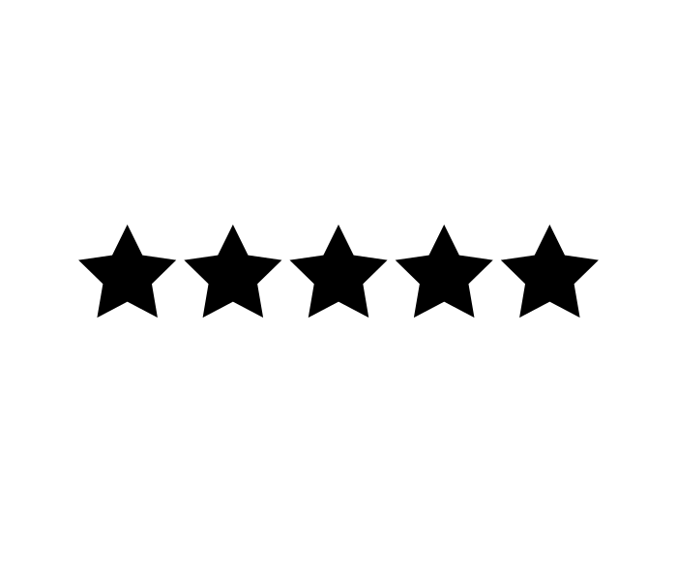
Skills
Python
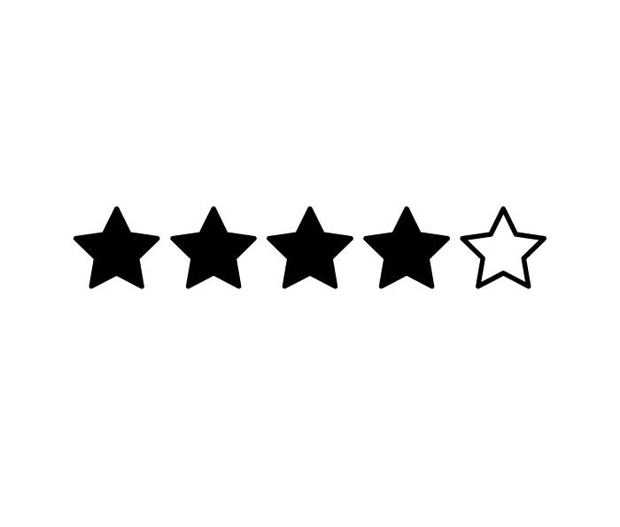
LabView (CLAD)
JavaScript
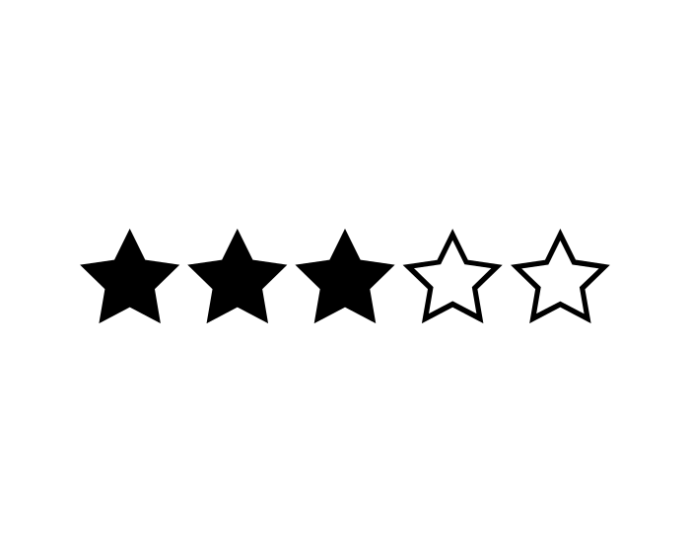
Django
ReactJS
MATLAB
C#
TensorFlow/Keras
R/RStudio

Languages
English
Spanish
Catalan

Hobbies & Interests
Chess: 1800 rated (2000 Lichess)
Music: I play bass and guitar and love listening to live music.
Fitness: I enjoy cooking healthy food and going to the gym.

