### Opening CSV File

Opening .csv file (I’ve previously combined all the datasets into one file):

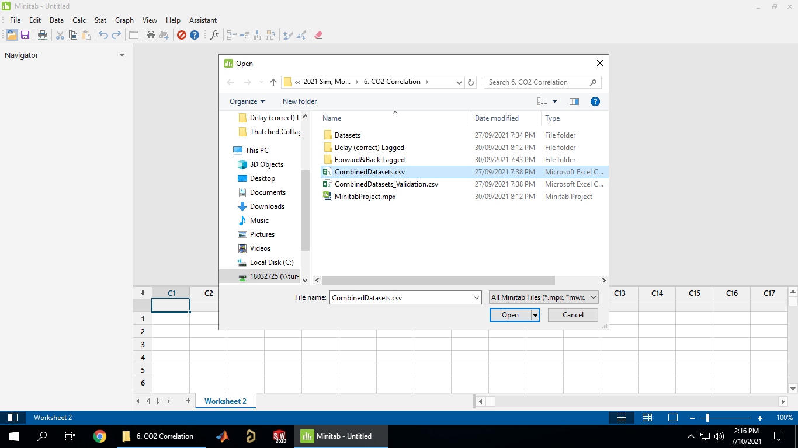

Selecting data to import (default options import everything):

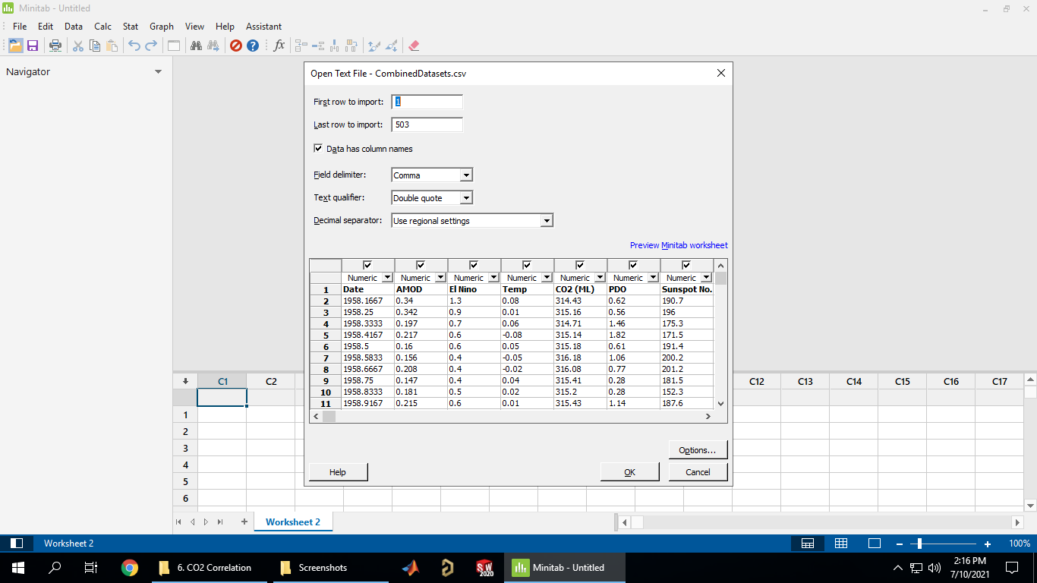

Imported data (you can also manually copy/paste directly from Excel into Minitab and from Minitab into Excel as well if needed):

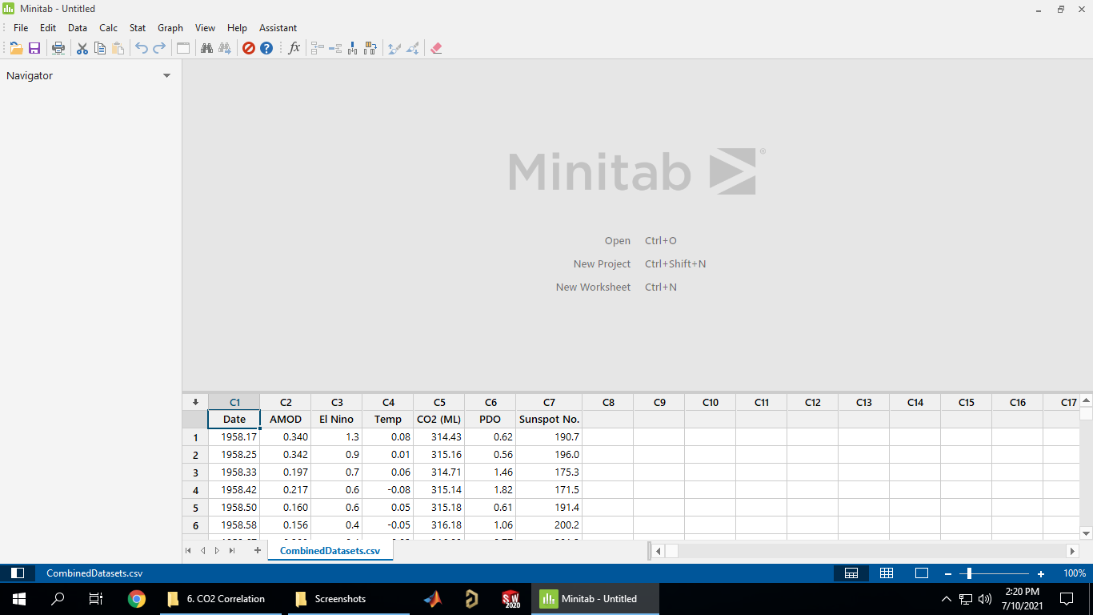

### Cross Correlation

Go to Stat->Time-Series->Cross Correlation…

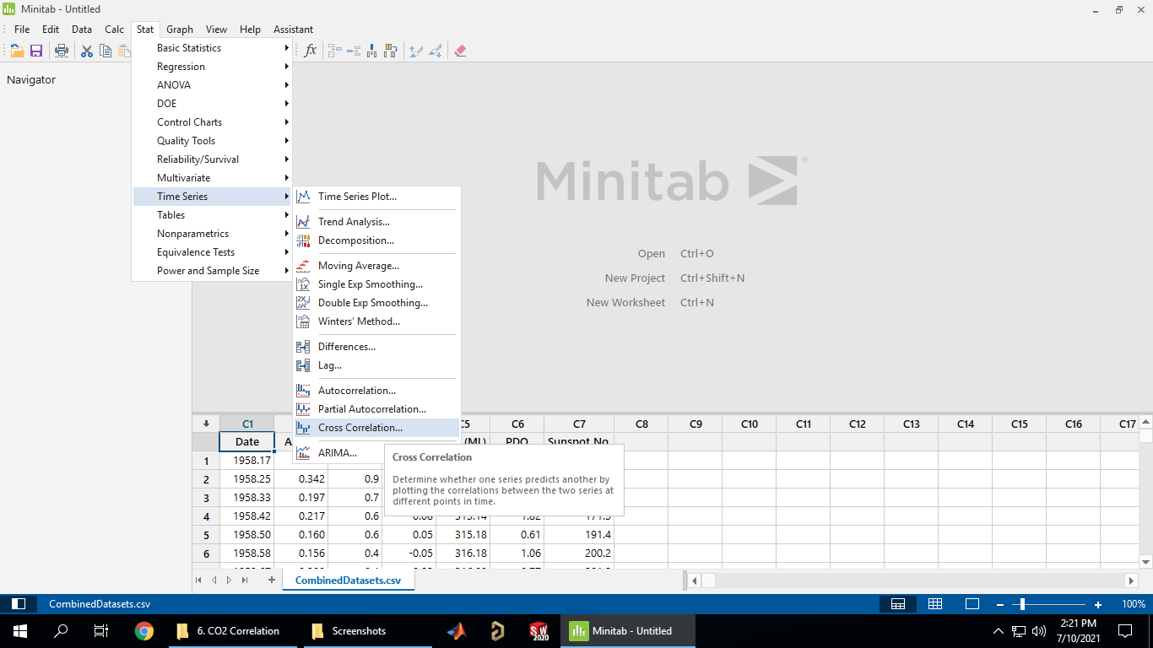

Gives options to select the two series to cross correlate + the number of lags to check (the default is ±30). Select the First Series box, circled in red, then double click on a series from the list on the left, circled in blue, then do the same for the Second Series box:

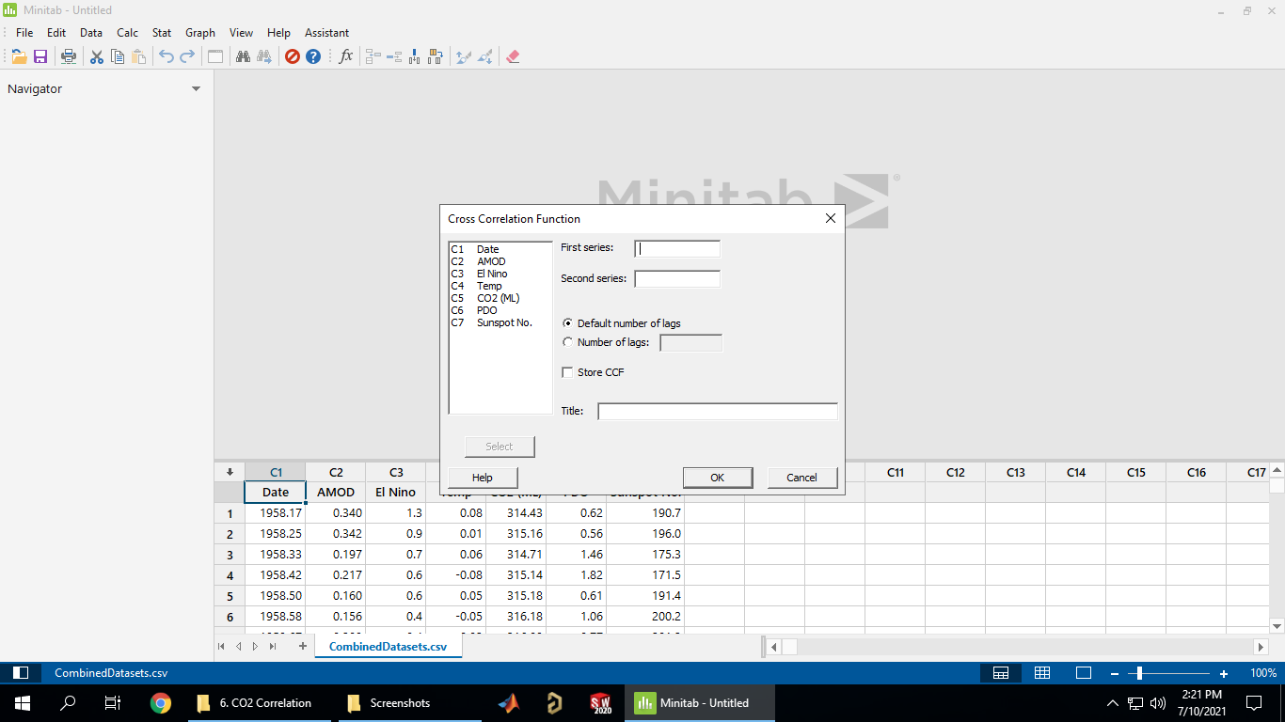

For example, cross correlation between CO2 and Temperature, should look something like this:

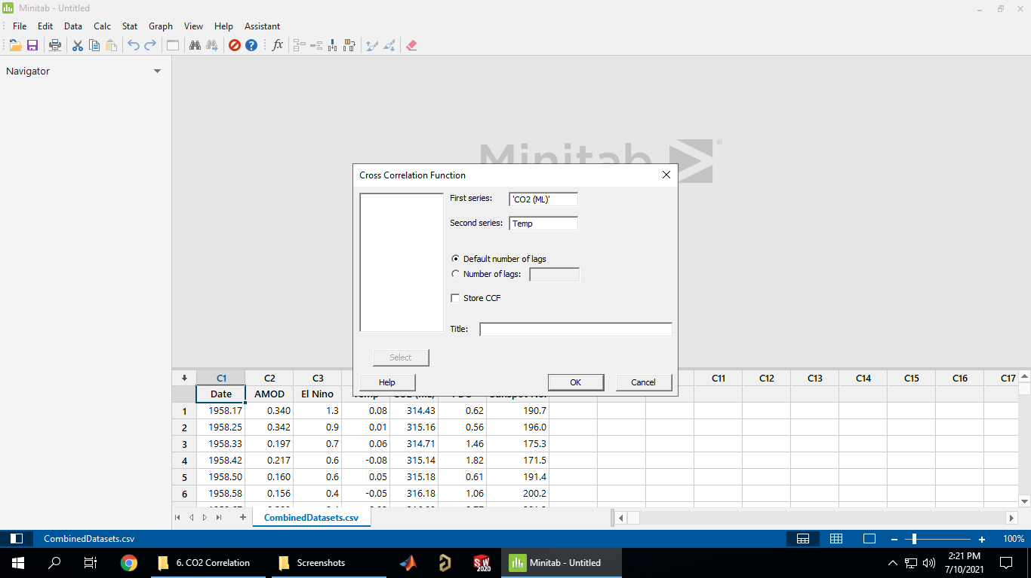

Once its run you get a table of individual lag correlations:

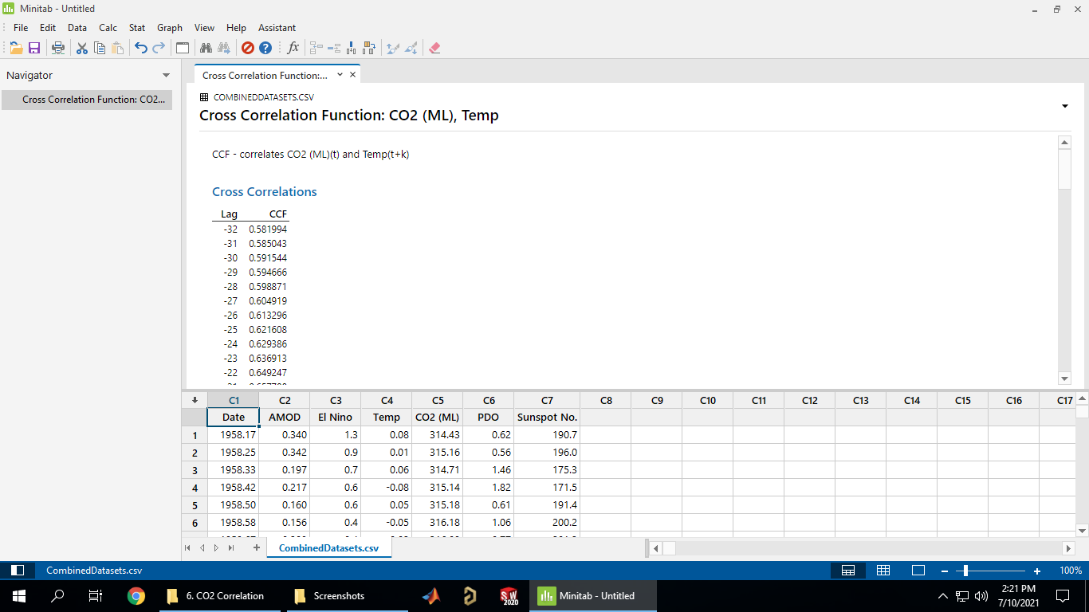

As well as a summary graph (scroll to the bottom of the output):

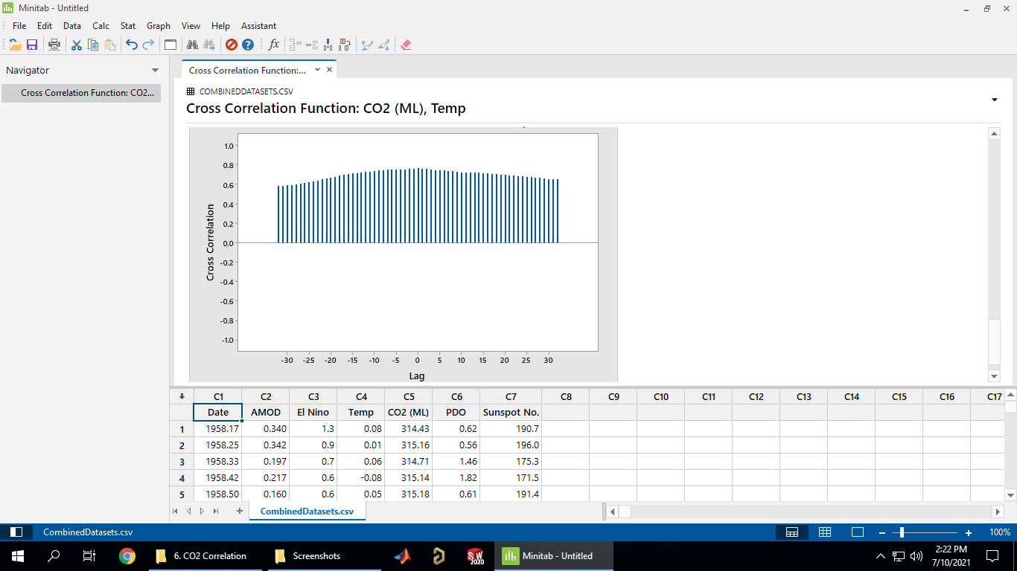

### Lagging Data

To lag the data got to Stat->Time Series->Lag…

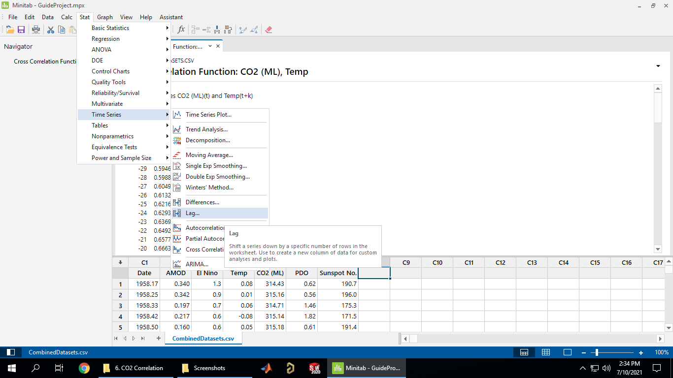

Select the series to lag (red, double click series from list to select), what column to store the lagged series in (blue) and what size lag to apply (green):

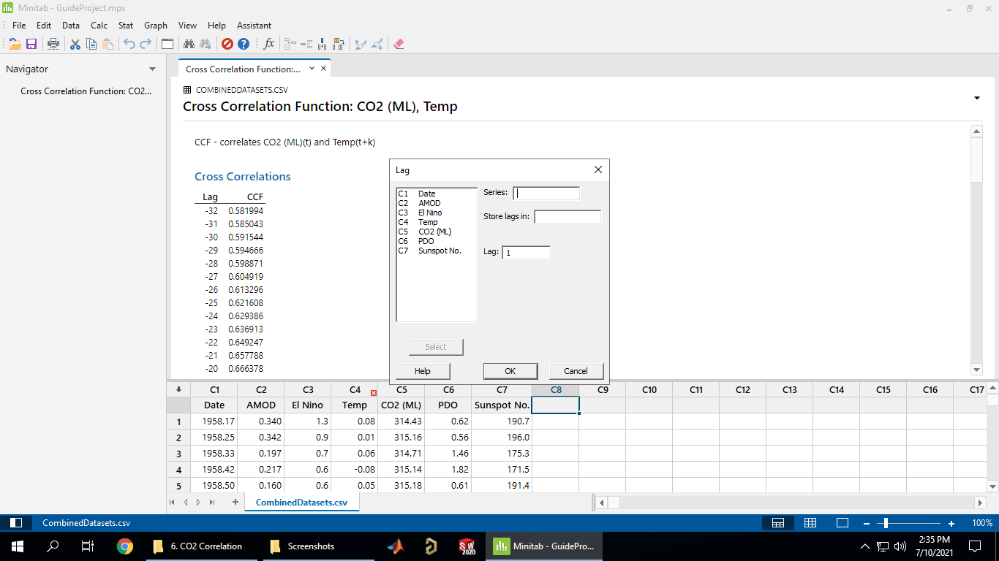

For example, to lag CO2 by 10, storing in C9: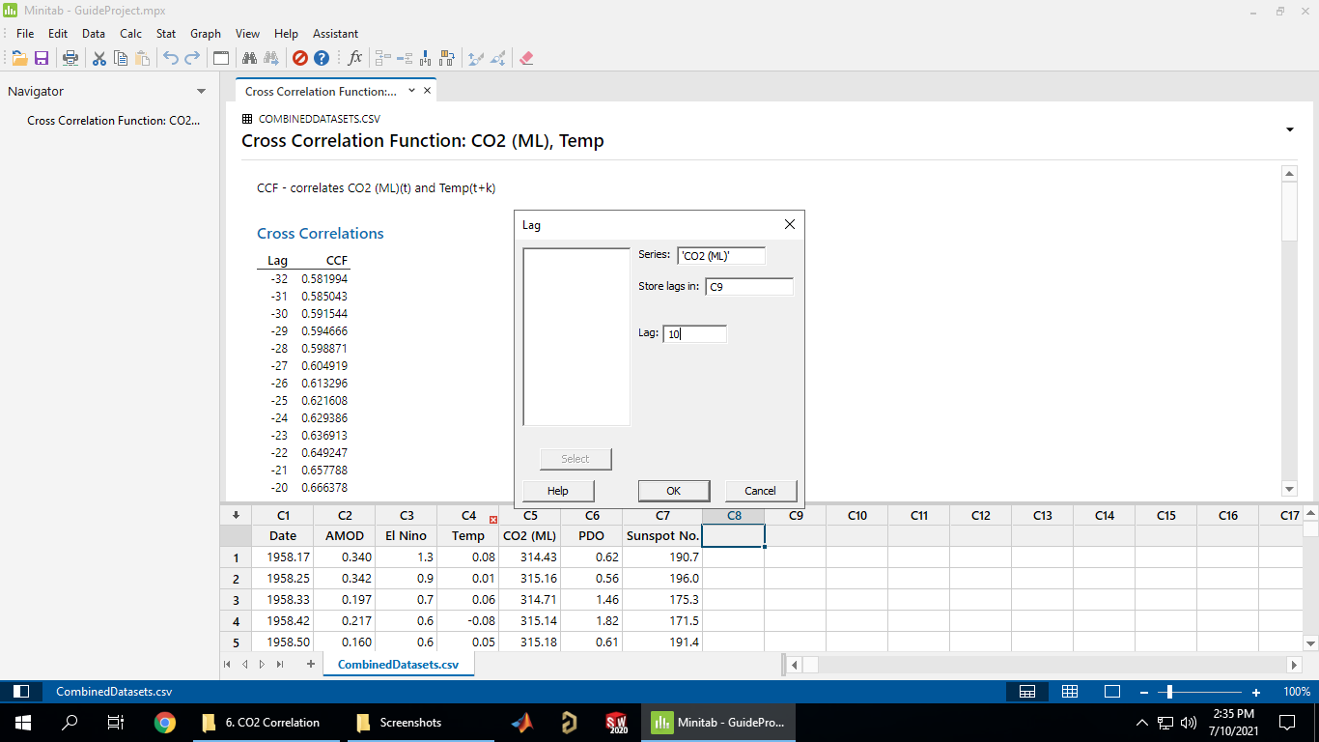

Gives the following result (‘*’ denotes missing/unknown data):

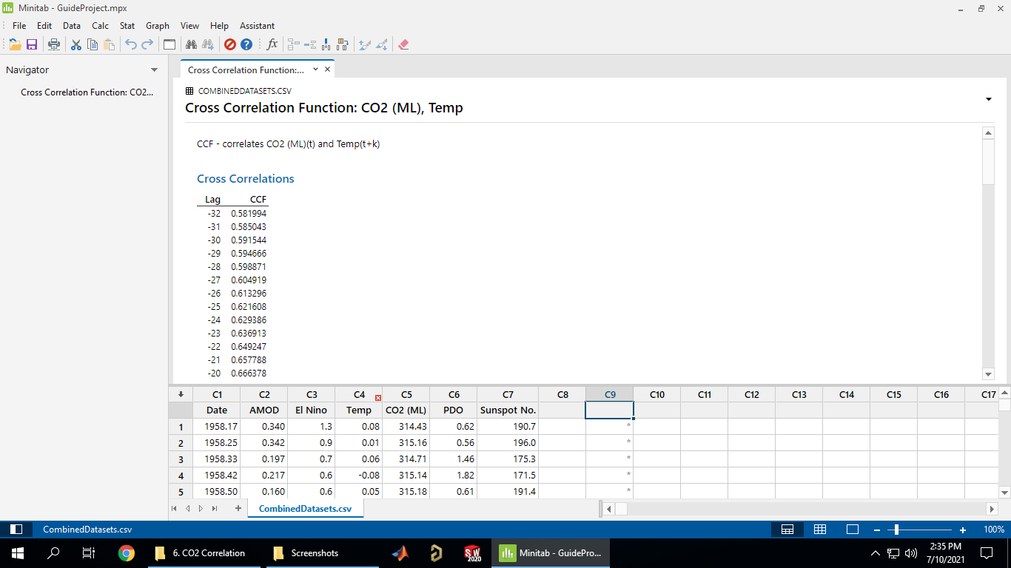

You’ll need to manually enter a series name (double click on top cell):

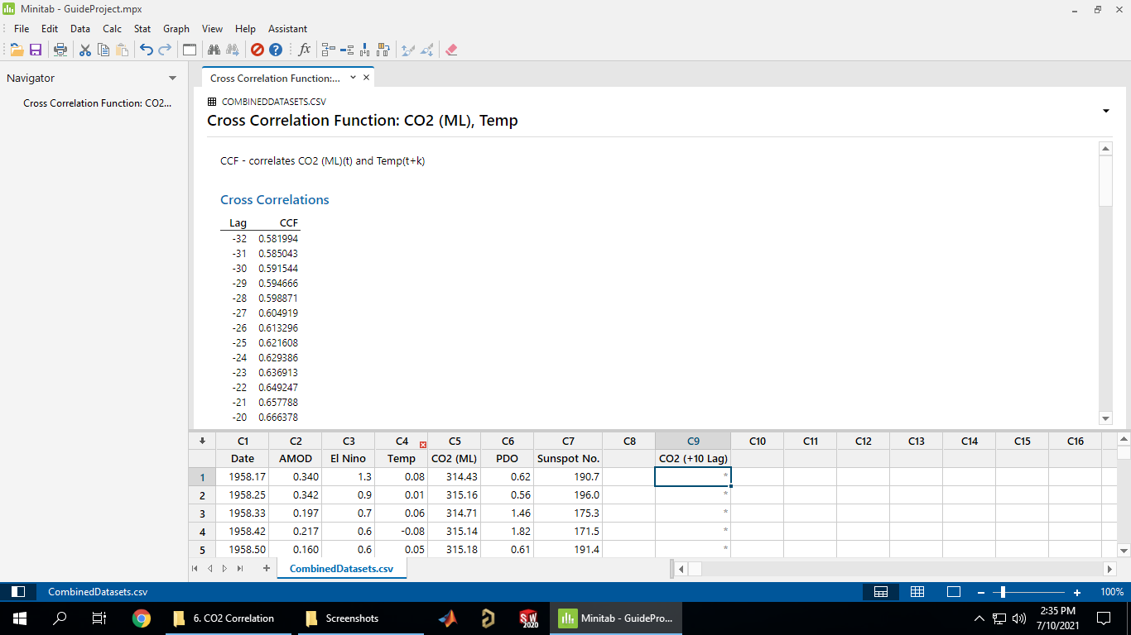

Scrolling down a bit:

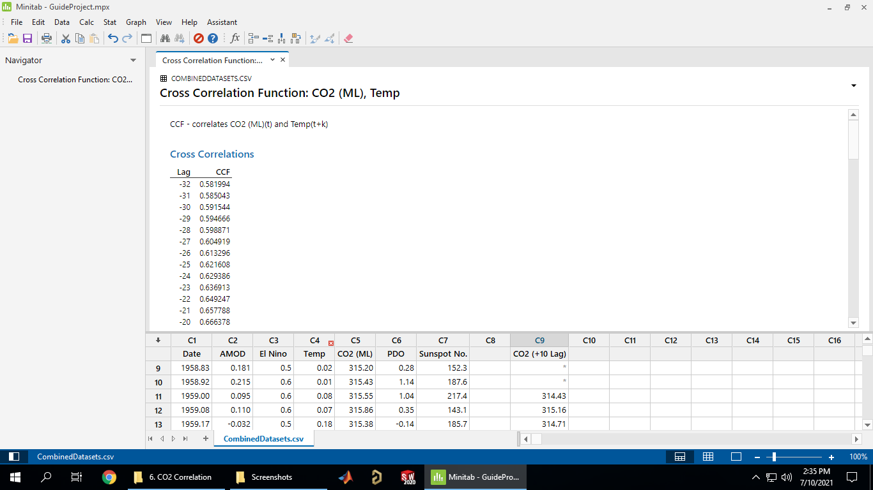

### Fitting a Regression Model

To fit a regression model got to Stat->Regression->Regression->Fit Regression Model…

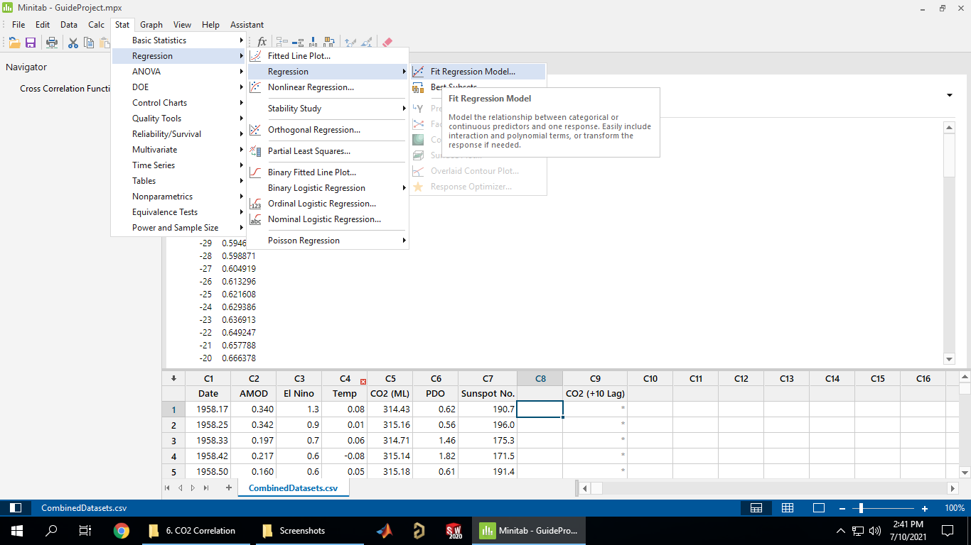

Need to select response and predictor series (usual procedure, select box the double click on series):

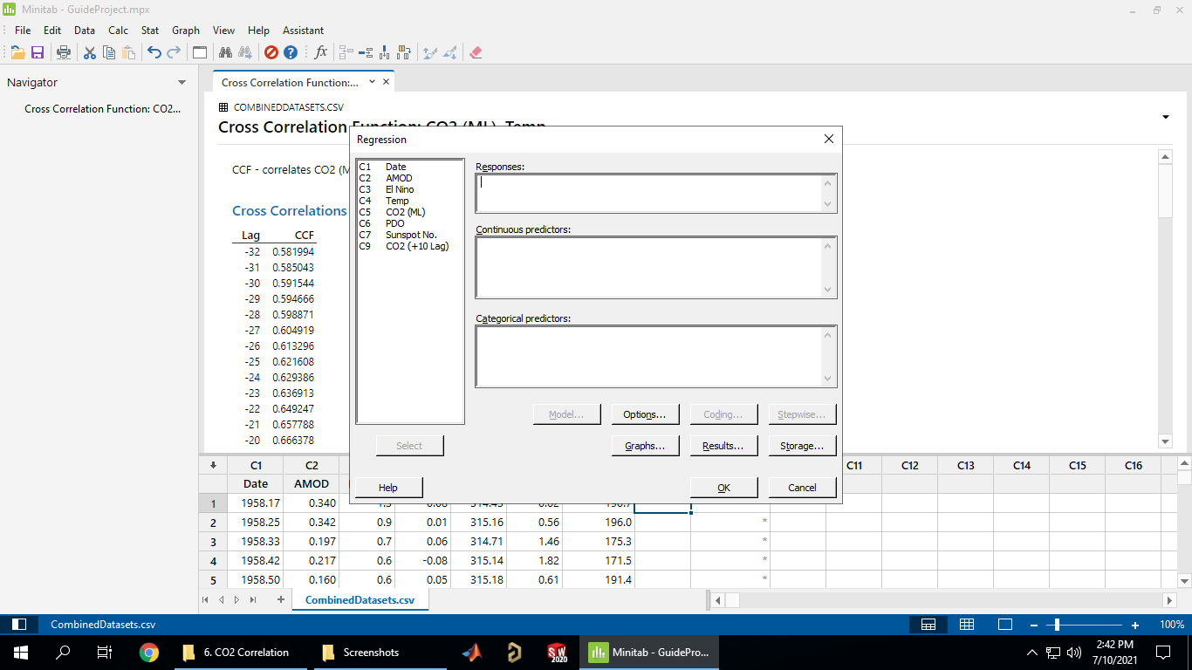

For example, predicting Temperature with El Niño and the lagged CO2 series (you can add higher order and interaction terms under model, red circle, if desired):

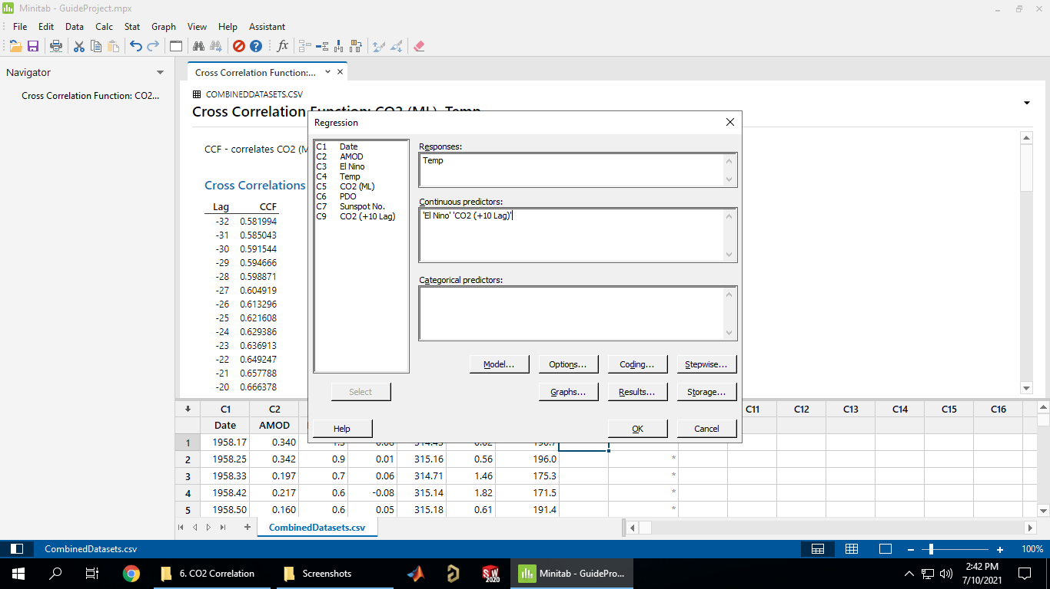

Gives the model equation (due to the missing data from lagging some of the rows are not used, red circle):

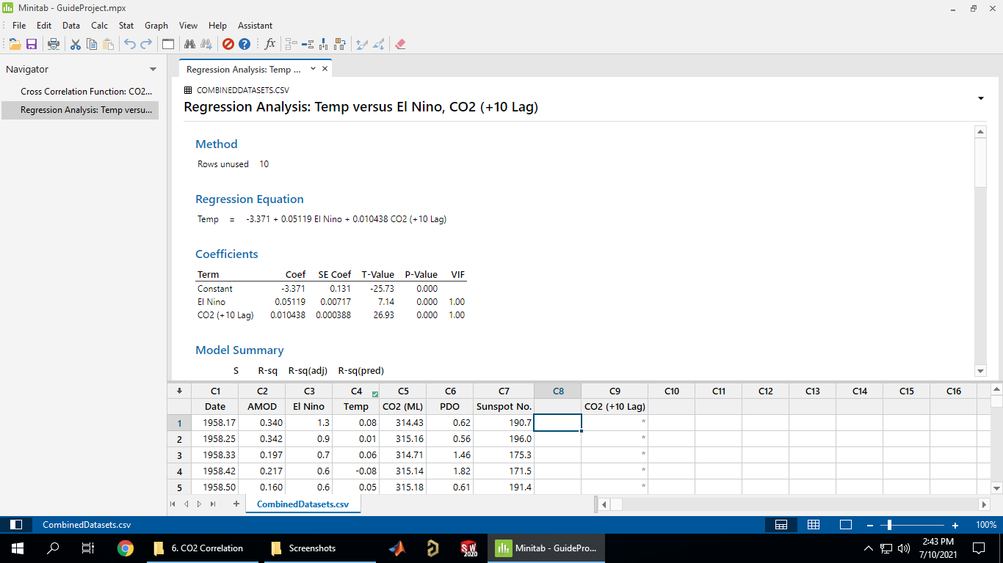

As well as various statistics on the model, R2:

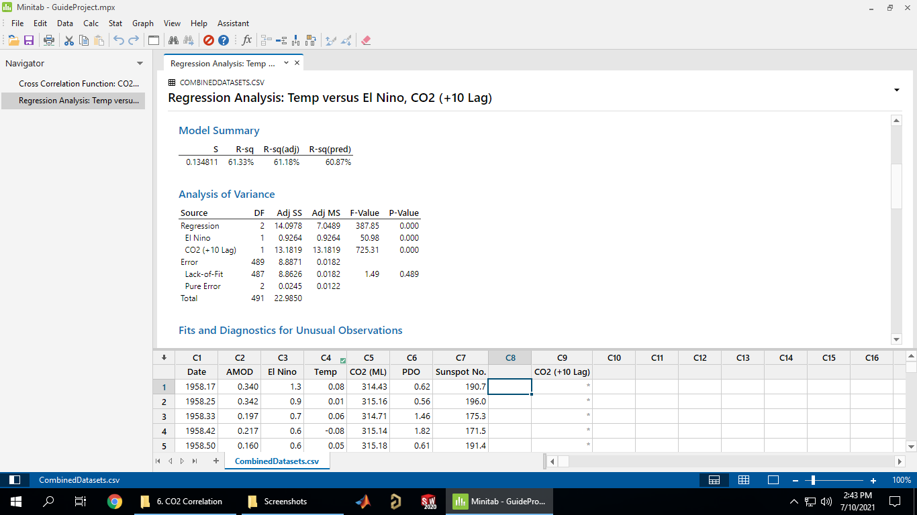

Predictor significance:

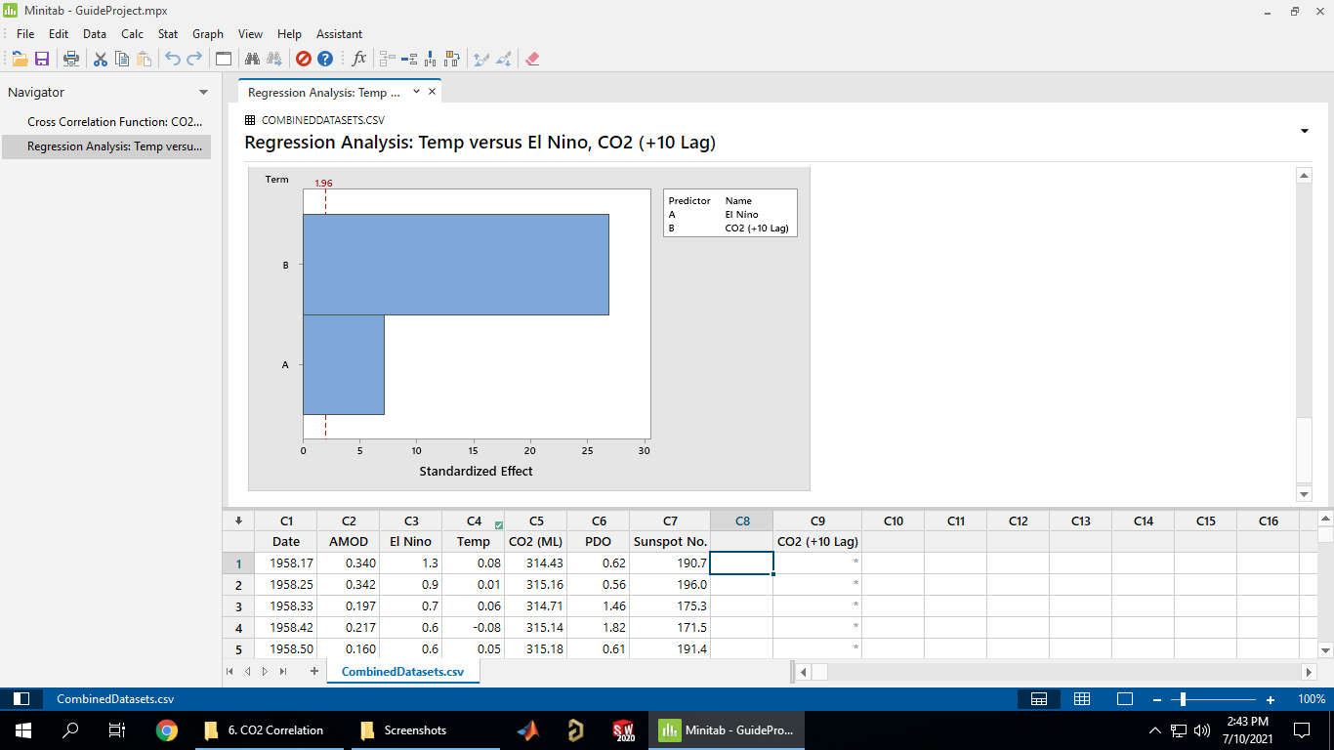

Going to Stat->Regression->Regression there are bunch of statistics you can produce about the model:

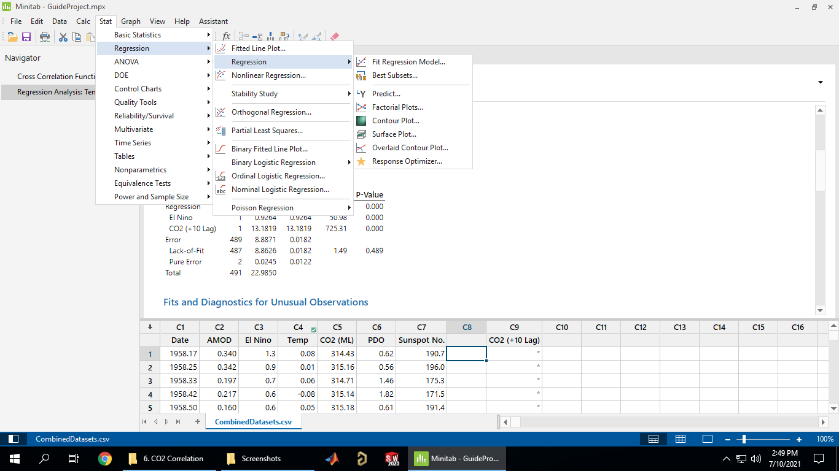

### Predictions with Model

Loading in some data to make predictions on (copying and pasting from Excel), and applying the same lag to the CO2 prediction data:

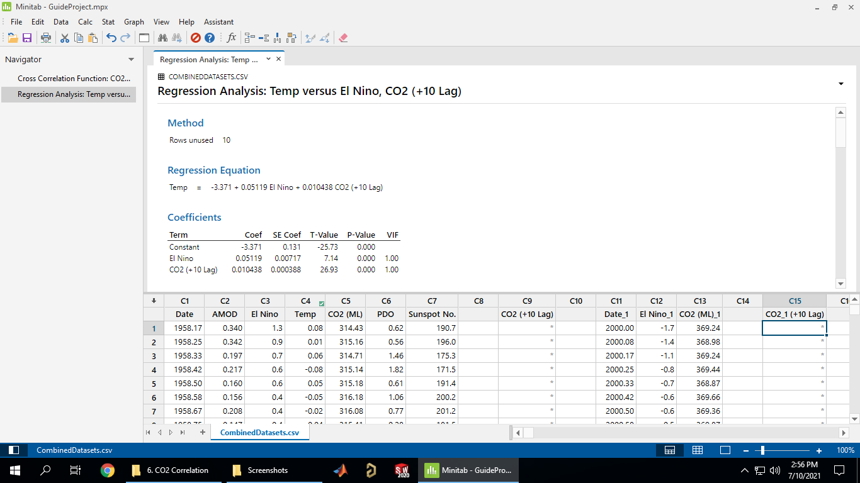

Minitab complains if you try to predict with missing data so I just copied the prediction data minus the first 10 rows into separate columns:

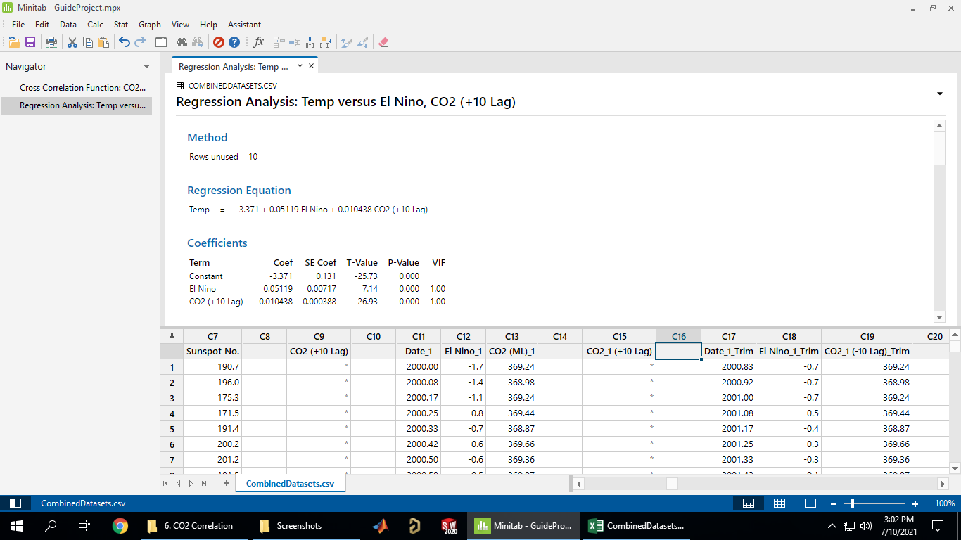

Then to make a prediction to go Stat->Regression->Regression->Prediction:

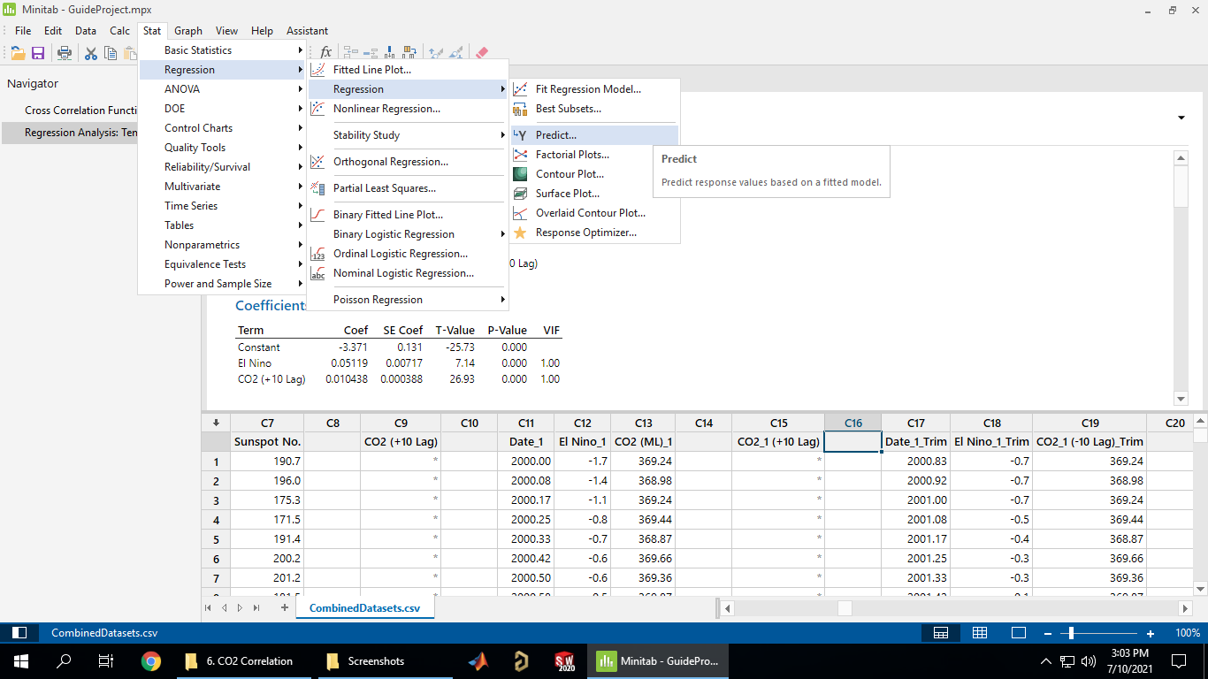

Select “Enter columns of values” as that’s what we’re using:

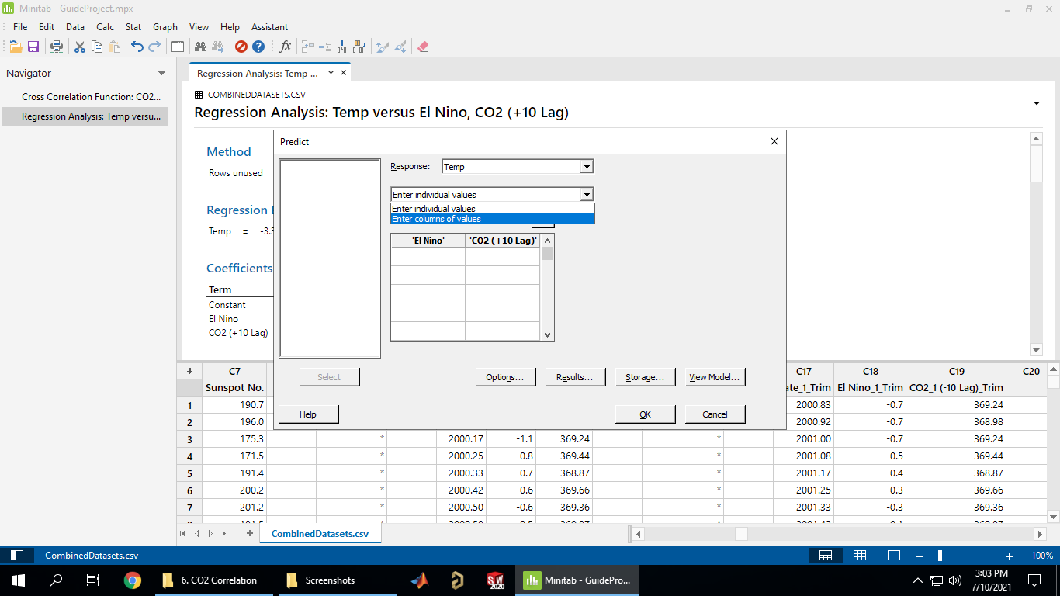

Select the two prediction series (usual click on box then double click series from list on the left):

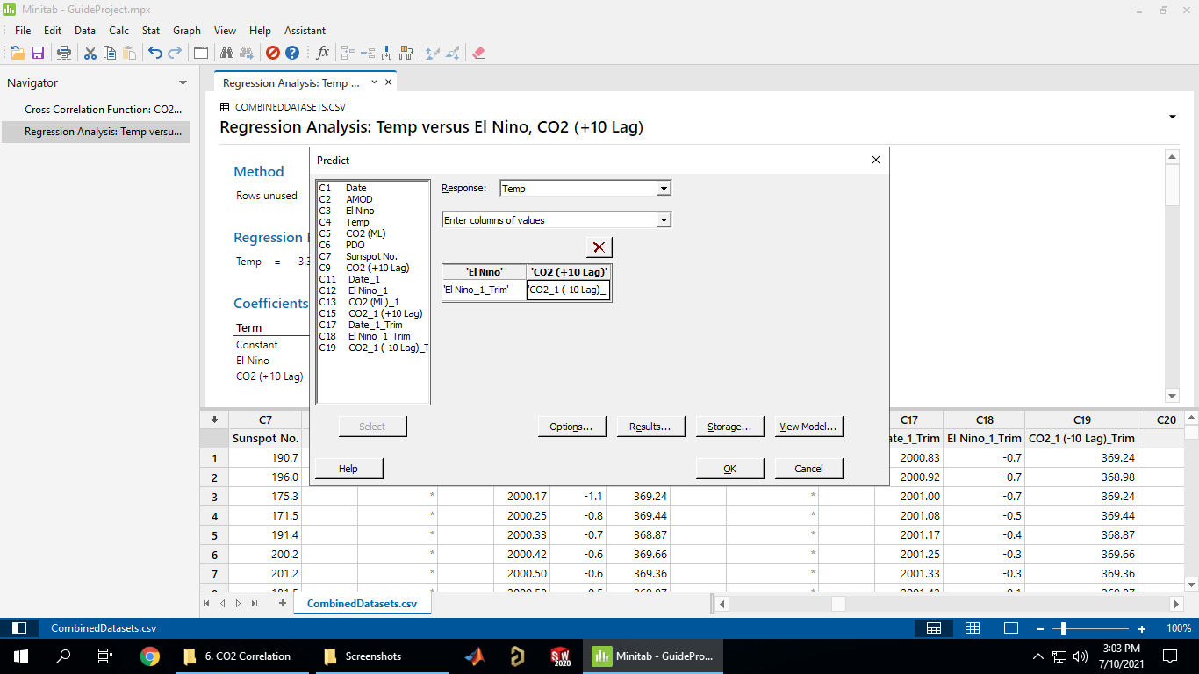

Rather than a separate output display, Minitab puts the predictions into new columns in the datasheet. It gives the predicted fits (PFITS), standard error (PSEFITS), and upper/lower limits (C and P LIMs) for the confidence and prediction intervals:

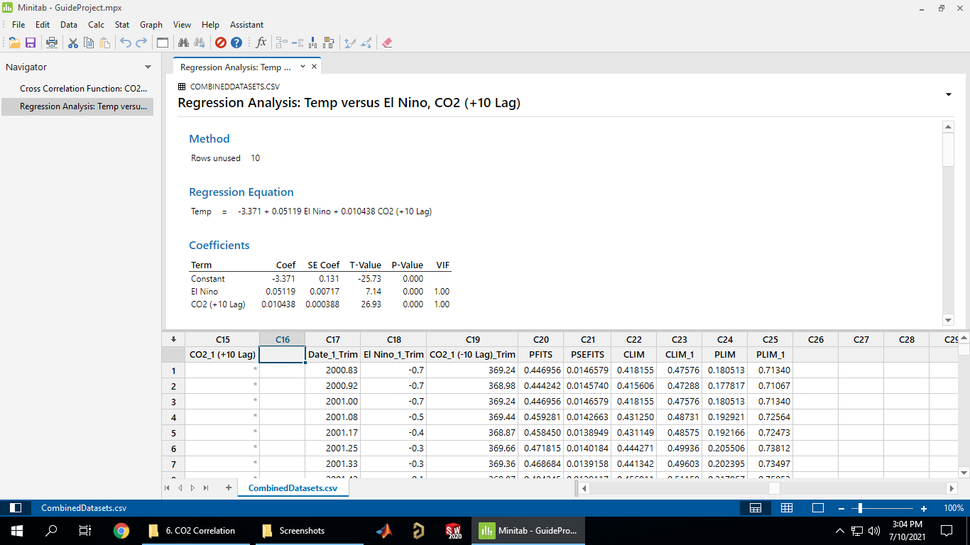

You can probably graph the result in Minitab, but I found it easier just to copy and paste into Excel and graph it (I also copied the actual temperature data in):

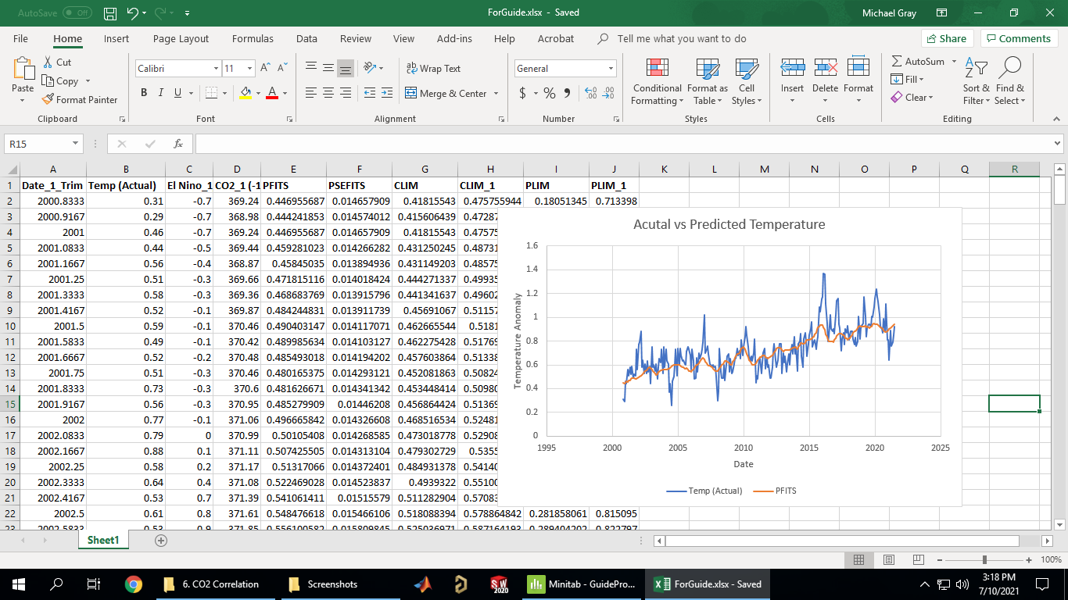

You can also add the confidence/prediction intervals to the graph, first you need to create two columns for the difference between the predicted value and the upper/lower limits (in this case doing the confidence interval):

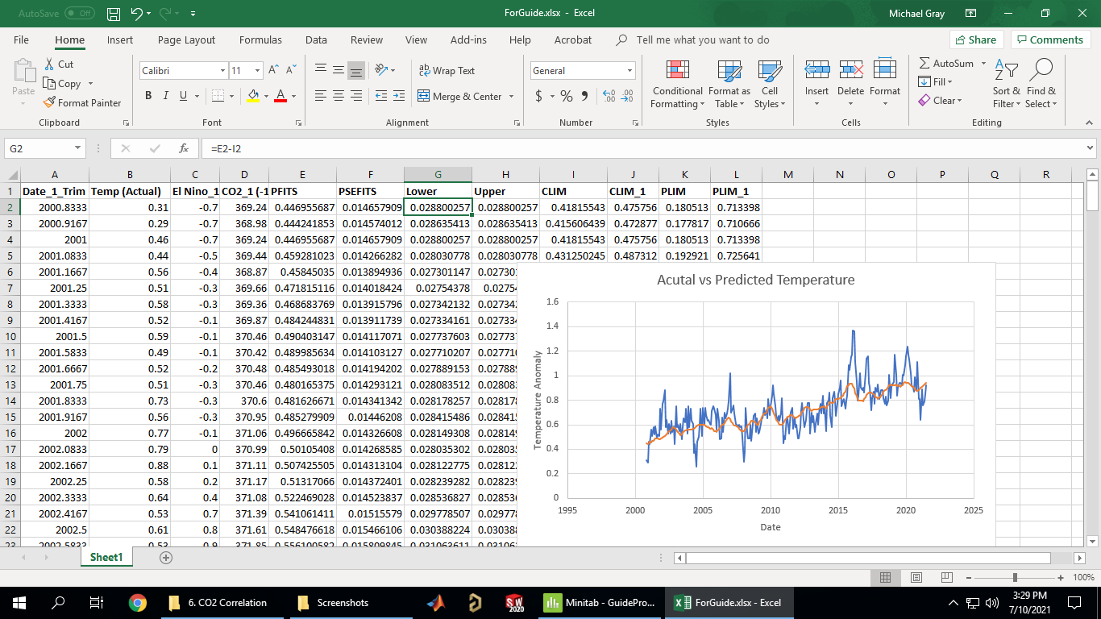

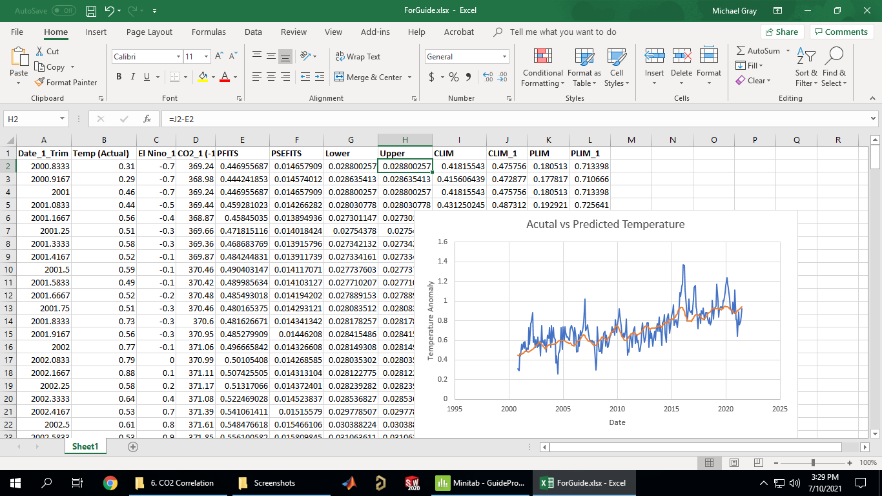

Then select the ‘+’->Error Bars->More options…

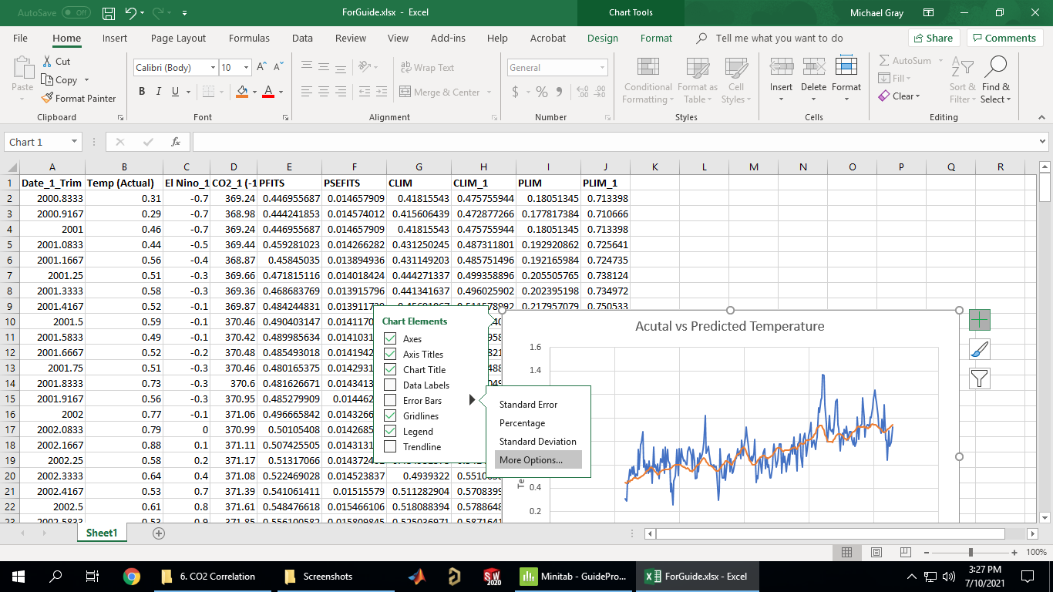

We want error bars for the predicted fits:

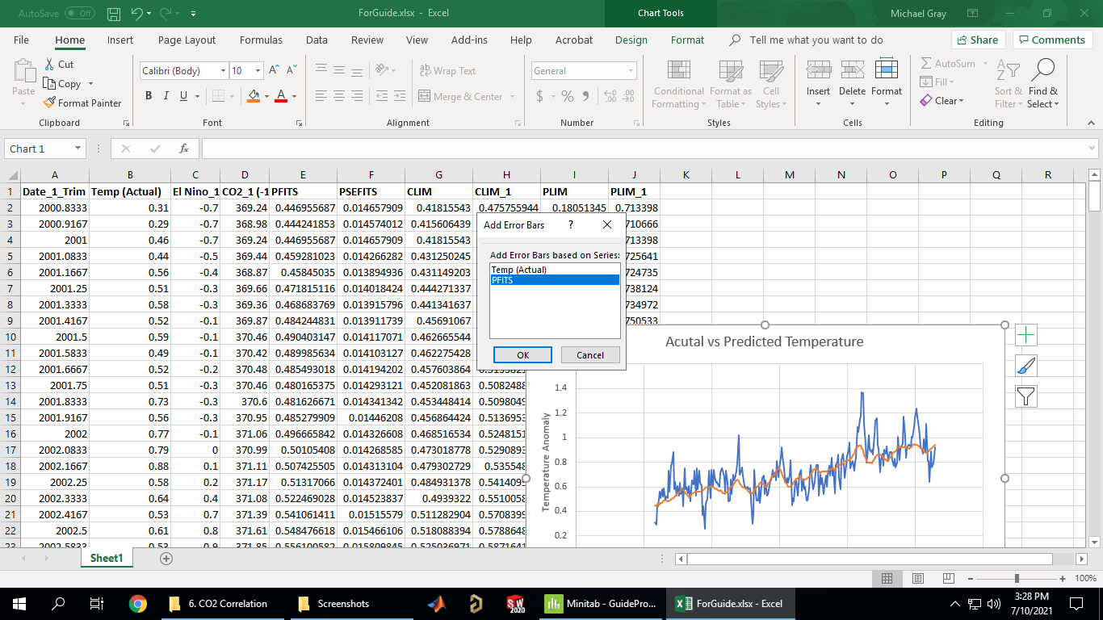

Scroll down and select custom then click specify value:

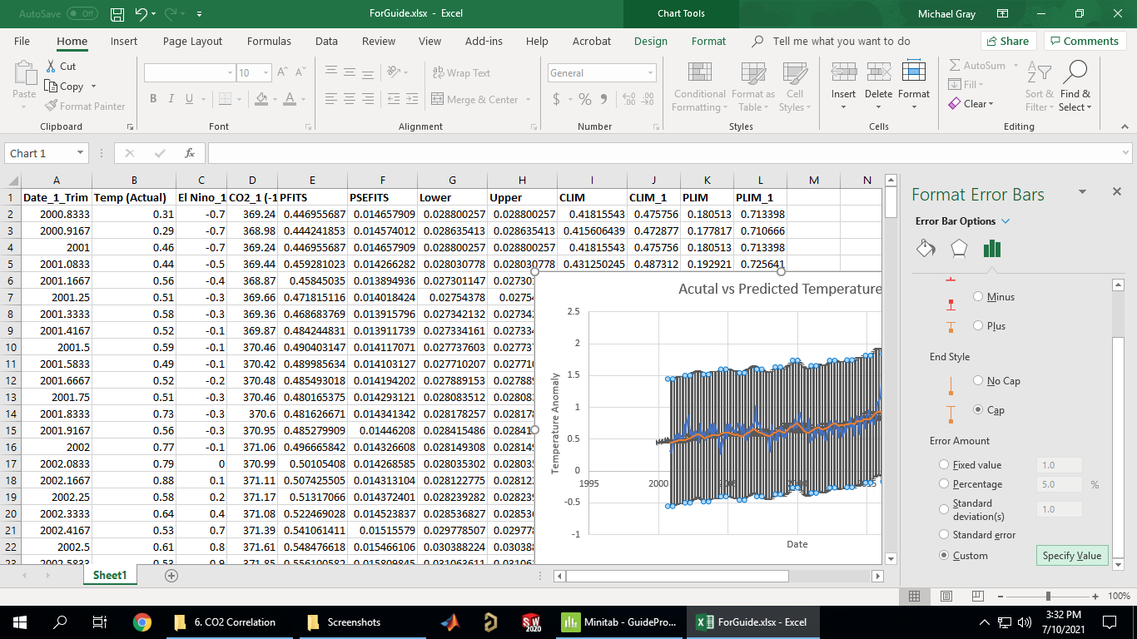

Select the two columns just created:

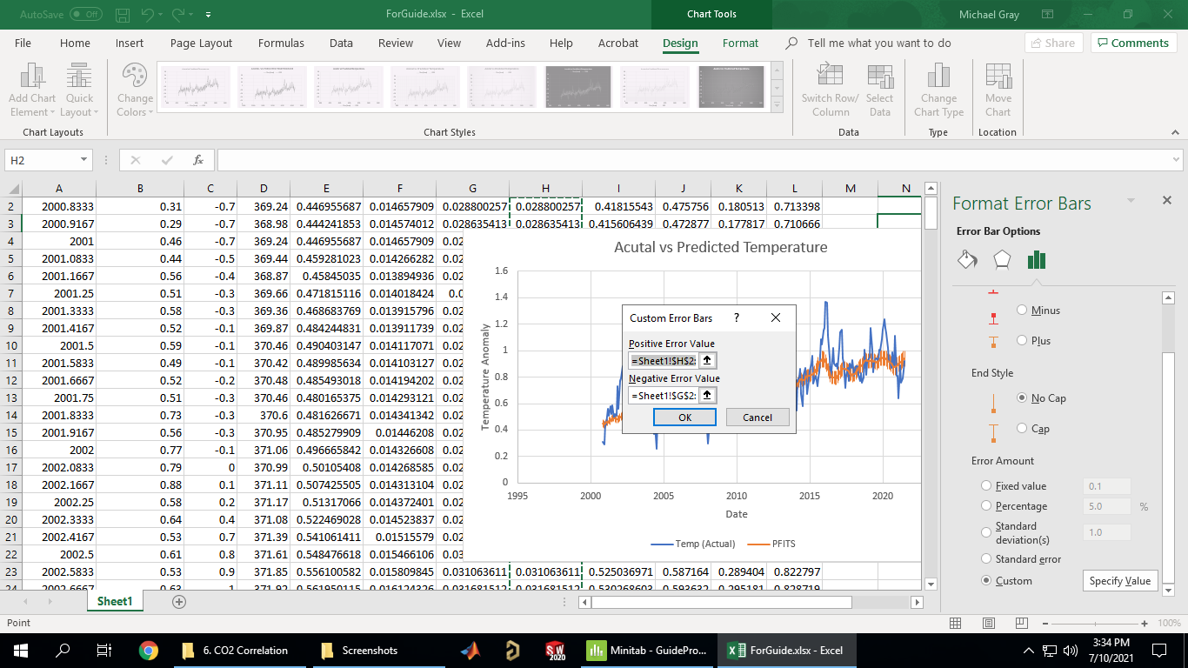

Format as desired (you may also need to delete/make invisible the horizontal error bars):

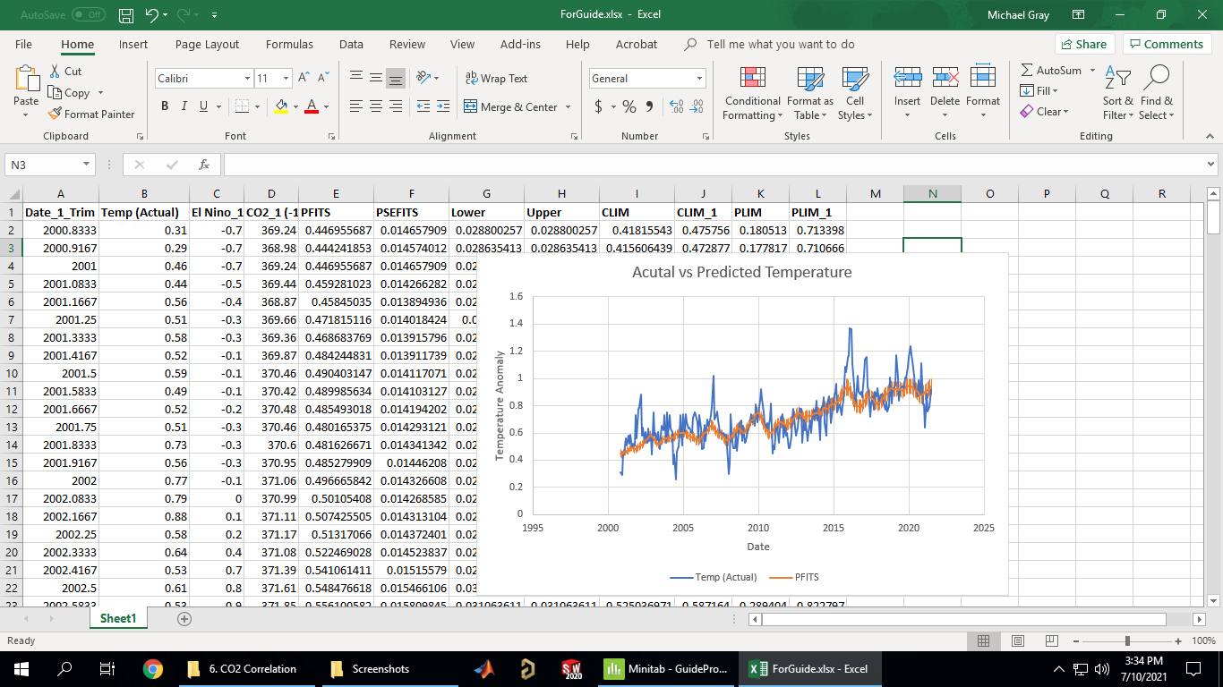

You can do the same thing for the prediction interval (I find having the error bars somewhat transparent makes the graph far more readable):

