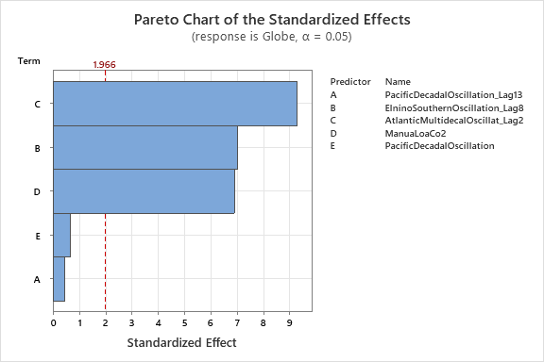

CO2 is a very important factor in predicting temperature

The satellite data also suggests elnino and Atlantic oscillation are important where the GIS data does not