Accessing GFD Data with Python

This document illustrates the process of downloading financial data using the REST API and the Python programming language, with an example code implementation. This is intended to accompany the script python_api_script.py. If you do not have this script, please contact GFD.

There are two web-based APIs: a multiseries API with price data and a search API. The search API searches the entire scope of Global Financial Data (GFD) data regardless of whether the user has access to particular price data and returns series metadata, while the multiseries API returns one or more series with historical pricing data. The multiseries API requires a user to have access to the specific price data being queried.

Additional GFD REST API documentation can be found at api.globalfinancialdata.com.

Multi Series with Price Data

The GFD multiseries API allows retrieval of equity, security, and economic time series. The basic query consists of a URL, username, password, and either a securities ticker or economic time series name. The data is returned in JSON format. For example, to fetch data for the S&P 500 (ticker: _SPXD) we construct the API call as follows:

First, the necessary Python packages are loaded (you will need install them if you do not have them already):

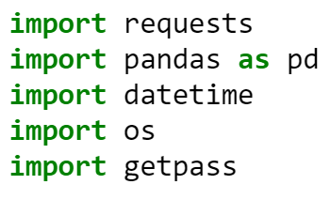

Next, the function gfd_auth() is defined and called to handle token authentication. Replace your user name with YOUR_USER_NAME below:

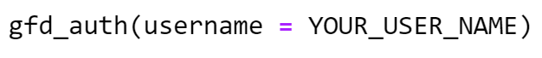

You will be prompted for your password. Once successful, your token will be assigned to an environmental variable called GFD_API_TOKEN.

Next, the URL and API call parameters need to be defined. The multiseries API supports a number of parameters, some of which are required for a proper call, and some of which help shape the output data.

Required parameters:
- seriesname: The name of the series to search for, by series symbol/ticker. Options: (String)
- seriesid: The GFD series ID for a specific series. Options: (String)
- token: The token received via gfd_auth(). Options: (String)
Note: Either seriesname or seriesid can be used to search for specific series. Both are not required, but at least one is.
Optional parameters (defaults are in brackets):
- splitadjusted: Flag for whether the data should be split adjusted. Options: (true, false)
- startdate: Specify start date for price data. Options: ("MM/DD/YYYY", "YYYY"), Default: Earliest available datapoint.
- enddate: Specify end date for price data. Options: ("MM/DD/YYYY", "YYYY"), Default: Latest available datapoint.
- periodicity: Indicates the time slice between each data point. Options: ("Daily", "Weekly", "Monthly", "Quarterly", "Annual")
- closeonly: Only returns close data for each time increment. Options: (true, false)
- currency: Currency unit of the returned price data. Options: (NATIVE, USD, GBP, JPY, EUR, CAD, AUD, CHF, INR, BRL, CNY)
- inflationadjusted: Flag if data should be adjusted for inflation. Options: (true, false)
- annualflow: Annual flow summation for given series. Options: (true, false)
- totalreturn: Rate of return over the given time interval. Options: (true, false)
- corporateactions: List of actions (dividends, splits, etc) undertaken by the queried company. Options: (true, false)
- metadata: Additional metadata for the series. Options: ("full", "autotrack", "stocks")
- includeaverage: Period average over the given time interval. Options: (true, false)
- periodpercentchange: Percent change over the given time interval. Options: (true, false)
Below is an example:
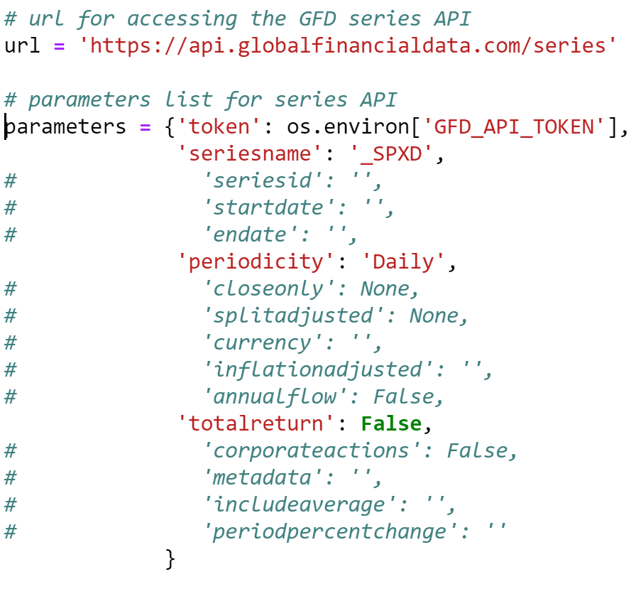
Once the appropriate parameters are defined, the API call can be made. Note: the GFD multiseries API only supports POST calls.
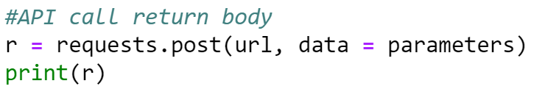
Finally, the JSON is parsed and the price data or metadata (data information) can be extracted:
Search API
The GFD search API allows retrieval of series metadata. This includes metadata for all series in all GFD databases, regardless of whether the subscription covers a chosen data series. Note: this API returns only the series metadata, not pricing data. The basic query consists of a URL, UserName, Password, and SearchString, and the data is returned in JSON format.
Required parameters:
- SearchString: The name of the series to search for, by series symbol/ticker. Options: (String)
- token: The token received via gfd_auth(). Options: (String)
Note: Either seriesname or seriesid can be used to search for specific series. Both are not required, but at least one is.
Optional parameters (defaults are in brackets):
- SearchType: Specifies the keyfiend to search. Options: ("name", "symbol")
- BaseFilter: Specifies how to search fields. Options: ("contains", "startswith", "exactmatch")
- Sort: Specifies return file sort order. Options: ("pop", "alpha")
- Page: Specifies page to return if paging is selected. Use with PageSize below. Options: (Integer), Default: ""
- PageSize: Specifies number of records to return if paging is selected. Options (Integer 10-100), Default: ""
Below is an example.
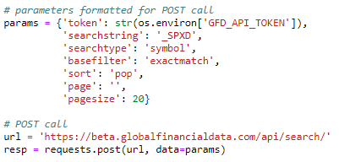
Unlike the series API, the search API only returns metadata for the series searched for.

