|  |  |  |  |  |  |  |
| --- | --- | --- | --- | --- | --- | --- |
| Project Name: **Oracle Fountain (wellness engine)**  Creation Date: April 10th, 2024 | | | | | | |
| Student Name: **JP Funk** | | | Capstone Date: May 17th | | | |
| Project Motivation and Overview:  The Oracle Fountain is a IoT smart indoor water feature with Lighting, Sound & Environmental components that would create Tranquil and Relaxing Ambiance for interior spaces. The fountain would have 3 main modes: 2 Water Flow: (high, low) Levels, *Lighting for atmosphere (Multi-modes nighttime) and *Sound (Looping soundscapes), Environment sensor with internet dashboard control/connectivity.  **Minimum Features:**   * Waterfall pump, LED light show, BME * Dashboard * minimum button control * 3D Printed Housing, with one Stage waterfall ring   **Desired Features:**   * MP3 player with speaker * 2 modes water flow * 3D Printed Housing, with 2 stages waterfall rings * Auto and Sleep Mode * Button less interface/controls (ToF)   **Stretch Goal Features:**   * Phone App (subscription for sound loops and additional content *) * Patent, and produce for market | | | | | | |
| **Anticipated Components:**   * *TOF sensors (at least 1), small board w/ P2, water pump, relay, neopixel ring *OLED, BME, *Encoder * 3D Printed sections: Base, lower ring, top ring, LED module (top) * Waterfall components: Tubing, connectors, water diffusers * Electrical wiring, power supply (s) | | | | | | |
| **Concerns and Considerations (Project Risks and Potential Mitigation's)**   * Getting TOF sensors to work properly for controls * 3D printed housing functional for waterfall feature. *3D design will center around 3D Printing footprint (base printing size/area) * Automated modes, sleep * Dashboard/bluetooth/code-red functions | | | | | | |
| **Other Information:**  *OLED may/may not be used depending on design build.  The Capstone design will be built to emphasis IoT features, the MVP production version will be refit with minimum E-components to accommodate a Starter Model not requiring P2 programming/connection. | | | | | | |
| Project Implementation Timeline: | | | | | | |
| Tasks | 12-APR | 19-APR | 26-APR | 3-May | 10-May | 17-May |
| Project Plan | X |  |  |  |  | Presentation |
| JP_Capstone Oracle Fountain  Daily work/production will logged on Calendar | Submit Project plan summary | Prototype case with TOF, starting code | Design and build 3D Waterfall housing | Write/implement code,  testing,  Debug | Create:  Presentation  Media, Video, Hackster.io etc. | Demo:  Presentation  Hackster  Video  Q/A |
| Hours per week/ |  |  |  |  |  |  |
| Capstone Presentation |  |  |  |  |  | X |

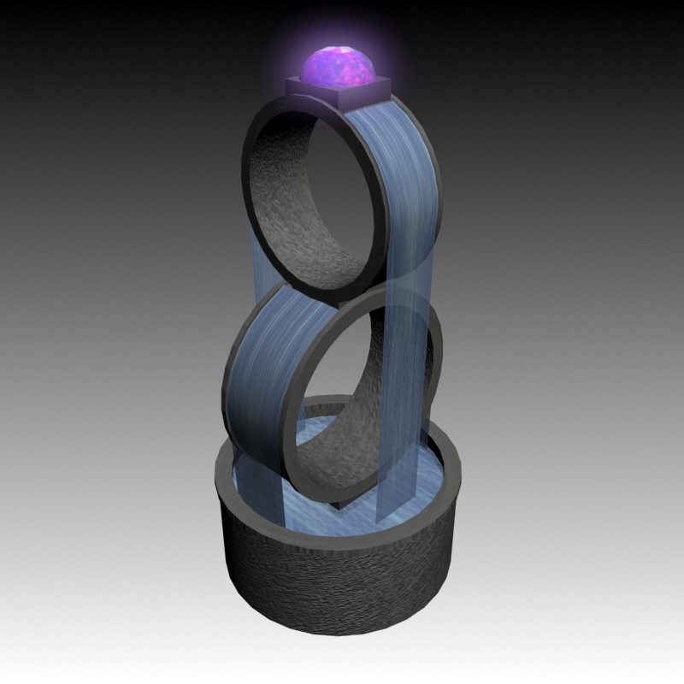

3D Render simple visualization concept: The base reservoir section (Bottom) will be designed to house the electrical components of the project with designated channels in the base (bottom or a specific section of the side) to house the processor and board.

ToF, OLED, BME, Encoder etc. will be implemented inside electrical gaps/channels residing between the outer face/shell and water shell wall with cut outs (custom installation mounts) for these features. Similar implementation will be used to run the water tubing and wiring through the rings for LED, OLED, BME features etc.