BYTEPLUS for Maya
Generative AI inside your Maya workflow
Practical Guide — Technology Preview
Render with Seedance 2.0 · Dream with Seedream 5.0 · Generate Texture
Powered by BytePlus ModelArk
Developed by John Paul Giancarlo on behalf of ByteDance
June 2026

Contents
Contents 2
1. What is BYTEPLUS for Maya? 3
2. Install (Windows · macOS · Linux) 3
3. First-time setup 3
4. The BYTEPLUS menu 4
5. Features & workflows 6
5.1 Render with Seedance 2.0 6
5.2 Dream with Seedream 5.0 6
5.3 Animate (Dream → video) 7
5.4 Generate Texture 7
5.5 Video Gallery 8
6. Settings reference 10
6.1 Generation 10
6.2 Storage & Hosting 10
6.3 Analytics & your details 11
7. Usage & data 12
8. Best practices 13
9. Support & notice 13

1. What is BYTEPLUS for Maya?
BYTEPLUS for Maya is a plugin that brings BytePlus ModelArk generative AI directly into Autodesk Maya. It lets 3D artists turn their scenes into finished AI imagery and video without leaving Maya:
- Render with Seedance 2.0 — turn your animated scene into a 1080p AI video that keeps your render look and your animation's motion.
- Dream with Seedream 5.0 — generate concept images from your viewport plus a text prompt.
- Animate — bring a generated image to life, driven by your scene's motion.
- Generate Texture — create a PBR texture from a prompt, wired straight into a new OpenPBR shader.
Everything runs through your own BytePlus ModelArk API key. It works in Maya 2025+ on Windows, macOS and Linux.
Who is this for?
Artists / clients: a fast way to explore looks, previsualize shots, and produce AI video from real 3D scenes.
Team / TDs: a single drag-and-drop install, per-scene output organization, and anonymous usage analytics for adoption tracking.

2. Install (Windows · macOS · Linux)
The plugin installs by drag-and-drop — no admin rights, no environment variables:
- Unzip the BYTEPLUS for Maya package anywhere.
- Open Maya.
- Drag install.py from your file browser into the Maya viewport (the 3D area).
- A confirmation appears and the BYTEPLUS menu shows up in the top menu bar — it loads automatically on every future launch.
Keep install.py and byteplus_maya.py together in the same folder when you drag.

3. First-time setup
Open BYTEPLUS > Settings… and, in the API & Models tab, paste your BytePlus ModelArk API key. Tick Remember to keep it between sessions.
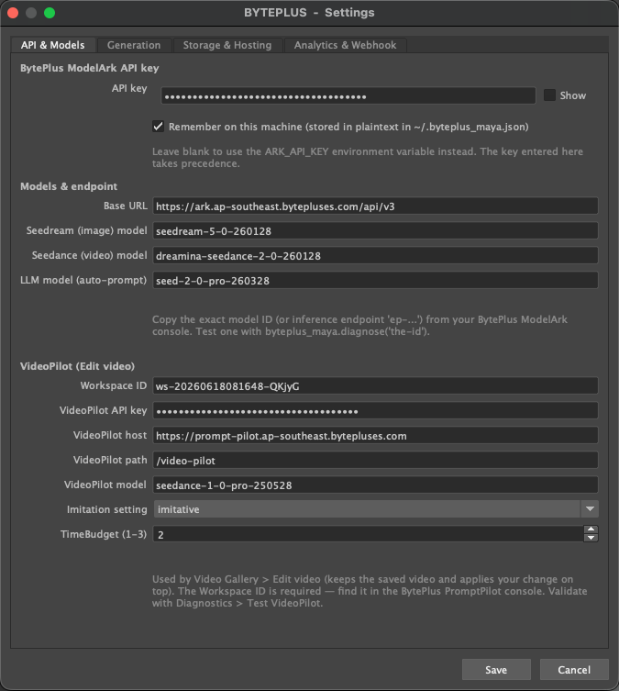
Settings — API & Models: paste your API key; model IDs and VideoPilot are pre-filled.
Tip
Validate your key any time with BYTEPLUS > Diagnostics > Test Seedream (Diagnostics is shown in developer mode).

4. The BYTEPLUS menu
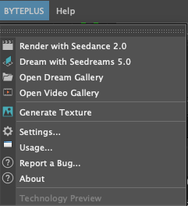
The BYTEPLUS menu in Maya's main menu bar.
Menu item | What it does
Render with Seedance 2.0 | Renders your animated scene → 1080p AI video
Dream with Seedreams 5.0 | Viewport + prompt → generated concept image
Open Dream Gallery | Browse / refine / regenerate / animate your images
Open Video Gallery | Browse / open / save your videos
Generate Texture | Prompt → texture wired into a new OpenPBR shader
Settings… | API key, models, resolution, hosting, analytics
Usage… | Images / videos / tokens used on this machine
Report a Bug… / About | Support and the Notice & Disclaimer

5. Features & workflows

5.1 Render with Seedance 2.0
Turns your animated 3D scene into a photoreal AI video. Set up your animation and camera, then run the command — the plugin:
- Renders several keyframes with your current renderer (Arnold, etc.) for the LOOK — color management and Arnold Imagers (tonemap, lens effects) are baked in.
- Captures a polygons-only playblast for the MOTION.
- Sends both to Seedance and returns a 1080p video in the Video Gallery.
Look vs. Motion
The rendered frames define the look; the playblast defines the motion. There's no prompt to type — it uses your scene.

5.2 Dream with Seedream 5.0
Generate a concept image from your viewport plus a prompt.
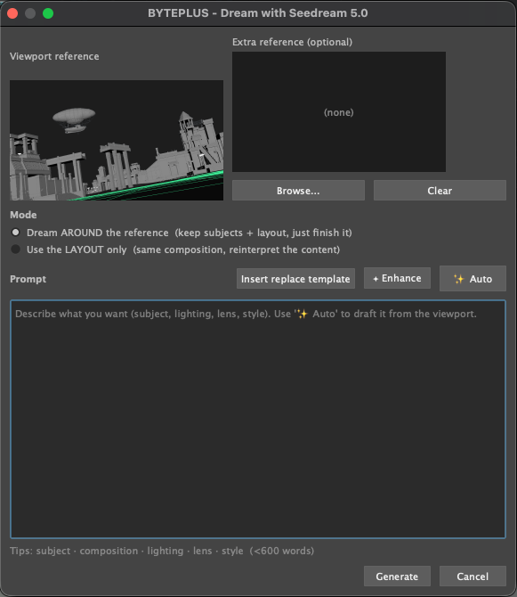
Dream dialog: viewport reference, two modes, and prompt helpers (✦ Enhance, ✨ Auto).
- Dream AROUND the reference — keeps your subjects and layout, just finishes the look.
- Use the LAYOUT only — keeps composition but reinterprets the content.
- ✦ Enhance polishes your wording (text only); ✨ Auto drafts a prompt from the viewport.
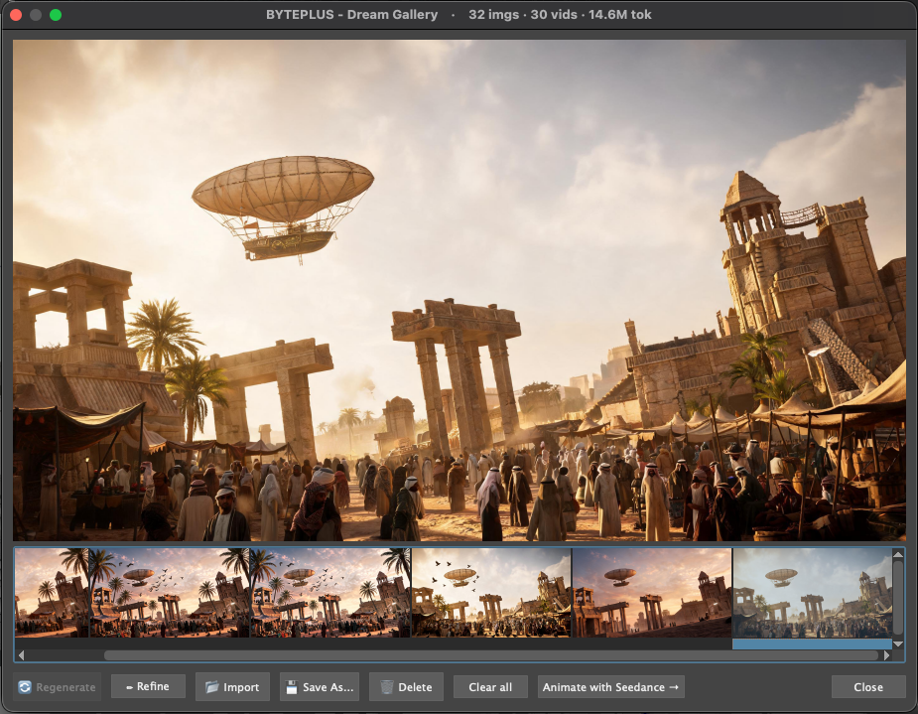
Dream Gallery: every result, with Regenerate, Refine, Import, Save, Delete and Animate.

5.3 Animate (Dream → video)
From the Dream Gallery, select an image and press Animate with Seedance. The image defines the look; optionally the scene playblast drives the motion.
Writing the motion text
With playblast ON: the playblast owns the camera and main motion — add only ambient motion + mood (leaves sway, dust, clouds, people). Avoid camera words like 'dolly' or 'orbit'.
Without playblast: the text IS the motion — describe camera, action and pacing freely.
An ⓘ Guide button in the dialog explains this in-place.

5.4 Generate Texture
Select an object, run Generate Texture, and describe the material (e.g. “weathered bronze with green patina”). The plugin generates the maps and wires them into a new OpenPBR shader assigned to your object. Texture sets are saved under images/textures/<material>/.

5.5 Video Gallery
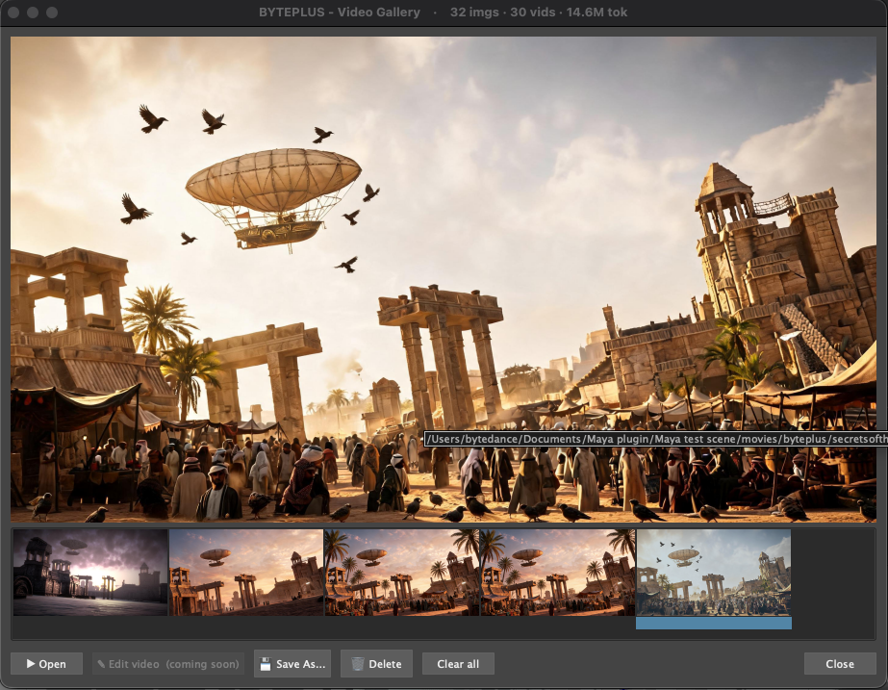
Video Gallery: open, save, delete, and (coming soon) Edit video.
- Open / Save As / Delete / Clear all — manage your generated videos.
- ✎ Edit video (coming soon) — VideoPilot editing keeps the saved video and applies a described change. Currently greyed out while the BytePlus VideoPilot service is enabled for the region.
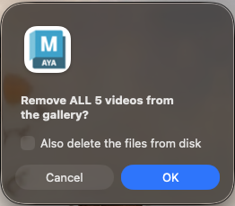
Clearing a gallery: choose whether to also delete the files from disk.

6. Settings reference

6.1 Generation
Video resolution, aspect ratio, reference-frame count, reference render size, texture bump depth, and color management for rendered references.
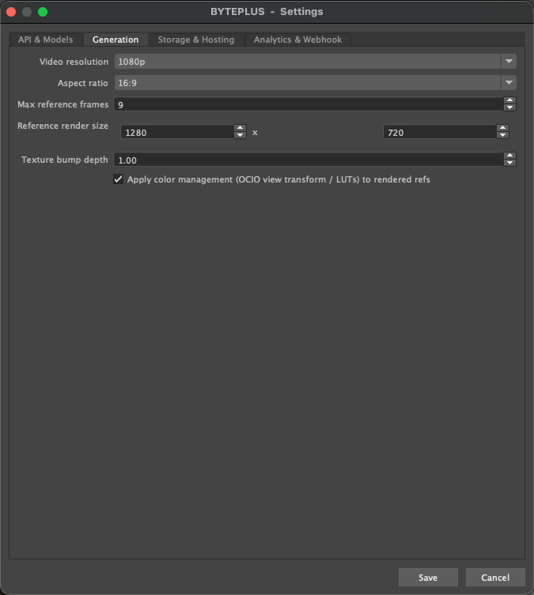
Settings — Generation.

6.2 Storage & Hosting
SSL verification, TOS object storage, and Cloudflare R2 for motion-video hosting (used by Render and Animate). The playblast is uploaded as a private, time-limited URL and deleted when the job finishes.
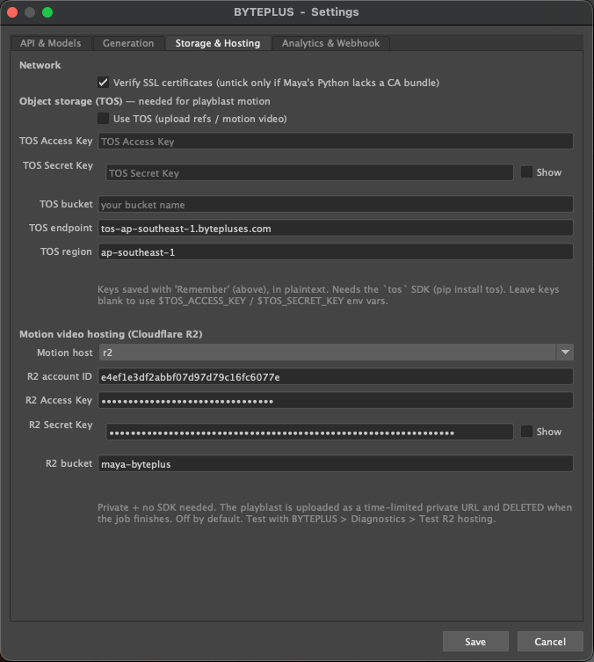
Settings — Storage & Hosting.

6.3 Analytics & your details
Anonymous usage analytics, plus optional personal details to help support you. No prompts, scenes, images, videos or API keys are ever sent.
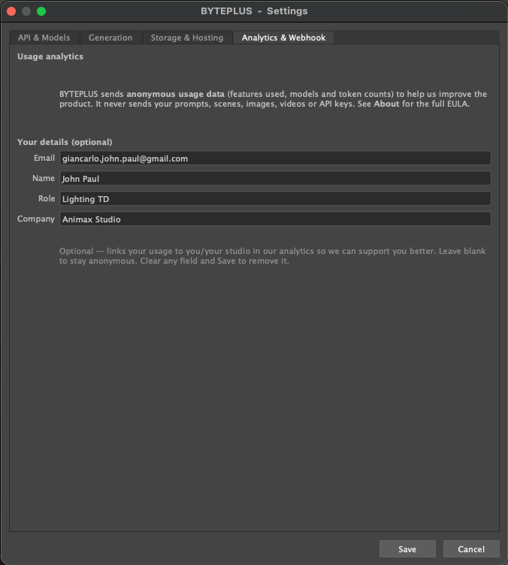
Settings — Analytics & Webhook.

7. Usage & data
BYTEPLUS > Usage… shows the images, videos and tokens used on this machine. A compact running total also appears in each gallery's title bar.
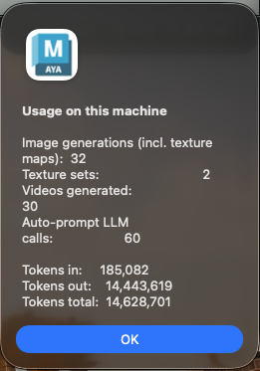
Usage on this machine.
Privacy
Telemetry is anonymous: features used, model ids, token counts. It never includes your prompts, scenes, images, videos or API keys.
You use your own BytePlus API key, so all usage and charges are billed to you by BytePlus.

8. Best practices
- Save your scene first — outputs are organized per scene (images/byteplus/<scene>/, movies/byteplus/<scene>/). Unsaved scenes go under “untitled”.
- Real human faces are rejected — Seedance blocks unverified real faces by policy. Use stylized / non-human subjects, or 'Render with Seedance' for 3D characters.
- Arnold look — with Arnold Imagers on, rendered references match the Arnold RenderView (tonemap, grading, color transform are baked in).
- Something failing? — the Diagnostics submenu (developer mode) has a test for each service.

9. Support & notice
Report a bug: BYTEPLUS > Report a Bug… · john.giancarlo@bytedance.com
This is a Technology Preview provided as-is, at your own risk, without warranties. It calls BytePlus ModelArk APIs under your own key and runs inside Autodesk Maya under Autodesk's separate license. See About in the plugin for the full Notice & Disclaimer.

