BYTEPLUS for Maya — User Guide
Bring BytePlus ModelArk generative AI into your Maya workflow: turn your 3D scenes into rendered video, generate concept images from the viewport or from reference images, design characters, build quick 3D assets and blockouts, and chat with an AI that knows the models — and your scene.
Technology Preview v1.09 — developed by John Paul Giancarlo on behalf of ByteDance. Works in Maya 2025+ on Windows and macOS.

1. Install
- Unzip the package.
- Open Maya.
- Drag `install.py` into the Maya viewport (the 3D area).
- When it finishes, restart Maya once (this applies a crash-prevention setting).
- The BYTEPLUS menu appears in the top menu bar and loads automatically on every future launch.
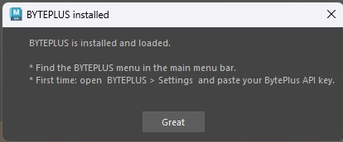
BYTEPLUS installed confirmation
Nothing else to install — no Python packages, no ffmpeg setup (ffmpeg is bundled for Windows; macOS doesn't need it).
On the first launch after installing, Maya may show "Secure UserSetup Checksum verification" (because the installer enabled BYTEPLUS to auto-load). Click Yes — this is expected and safe.
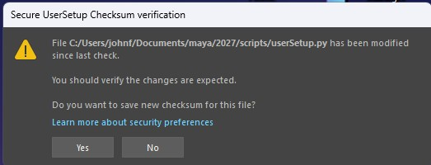
Secure UserSetup Checksum verification — click Yes

2. First-time setup
Open BYTEPLUS > Settings… and, in the API & Models tab:
- Paste your BytePlus ModelArk API key.
- Tick Remember if you want it saved between sessions.
- (Optional) Choose your Default image model (Pro / Lite), output format, video resolution, aspect ratio, etc.
Tip: validate your key any time with BYTEPLUS > Diagnostics > Test Seedream.
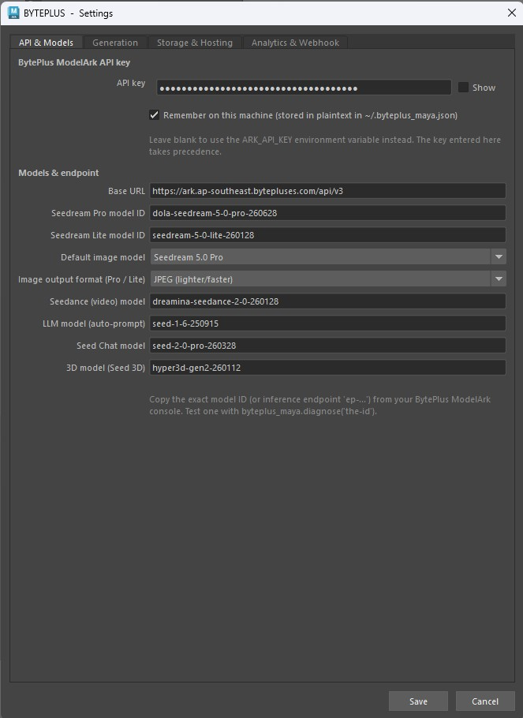
Settings — API & Models tab
On first run you'll also see a one-time "Help improve the plugin" prompt — optionally share your details, or click Stay anonymous. It won't ask again.
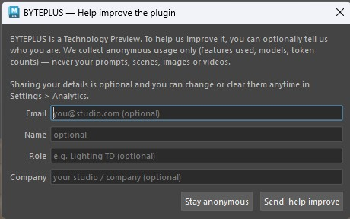
First-run Help improve prompt

3. The menu at a glance
Menu item | What it does
Render with Seedance 2.0 | Renders your animated scene → 1080p AI video
Video GEN | Full Seedance 2.0: Text→Video / Image→Video / First+Last frame / Multimodal, + model/resolution/ratio/duration/audio
Dream with Seedreams 5.0 | Viewport + prompt → generated concept image (image-to-image)
Text to Image | Pure prompt → image, no viewport. Best for AI people / faces
Image to Image | Combine 1–14 reference images (layout + materials + products) → one render
Layout → Still | Viewport locks the composition; text describes the look → matched still
Open Dream Gallery | Browse / refine / interactive-edit / compare / animate / blockout your images
Open Video Gallery | Browse / open / edit / save your videos
Open Audio Gallery | Browse / play / save your generated audio (voice / music / SFX)
Seed Chat | Chat with Seed 2.0 — prompt help, describe images, ask Model Genius, how-to
Seed 3D | Text or image → a 3D asset, imported into your scene
Seed Audio | Generate voice / music / SFX (Seed Audio 1.0) — TTS, described voices, cloning
Seed Character | Character generator — character sheets, a game A-pose turnaround, prop/clothing sheets
Trusted Characters | Upload an AI character once → a permanent asset:// you can animate forever (+ a reusable voice)
Dialogue Scene | Multi-character spoken dialogue → Seedance video with synced voices (EN/ES/JA/ID/PT)
Blockout from image | Rough primitive layout from a reference image (a guide for Dream)
Seed Assistant | Agent that inspects/automates your scene (runs code only after you approve)
Generate Texture | Prompt → texture wired into a new OpenPBR shader
Settings… | API key, models, resolution, hosting, analytics
Set up motion hosting… | Guided wizard to enable faithful video motion
Usage… | Images / videos / 3D / tokens used on this machine
Report a Bug… | Email a report to the developer
About | Version & credits
Diagnostics | Connectivity / endpoint test probes
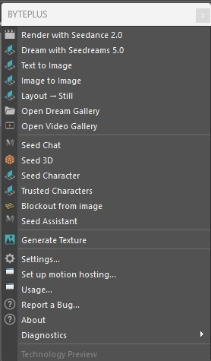
The BYTEPLUS menu

4. Choosing the image model — Pro vs Lite
Every image window (Text to Image, Image to Image, Dream, Layout → Still, Seed Character, Refine, Interactive Edit, Generate Texture) has a Model dropdown with a short capability note. Pick per generation:
- Seedream 5.0 Pro (default) — the highest quality, with precise / interactive editing and animatable faces (Seedance-trusted). Up to 10 reference images, output up to 2048×2048. It runs a higher-quality mode, so it is slower (a detailed image can take a few minutes) — the plugin waits for it automatically.
- Seedream 5.0 Lite — faster and cheaper, up to 4K output and 14 reference images. Ideal for large character sheets and quick iterations. Faces are animatable too.
Output format (JPEG / PNG) is set once in Settings > API & Models and applies to both models. JPEG is lighter and faster (recommended); PNG is lossless but heavy.
Set the default in Settings > API & Models > Default image model — each window's dropdown starts there, and you can still switch per generation.

5. Features

🎬 Render with Seedance 2.0
Turns your animated 3D scene into a photoreal AI video.
- Set up your animation and camera as usual.
- BYTEPLUS > Render with Seedance 2.0.
- The plugin renders several keyframes with your current renderer (Arnold, etc.) for the look, captures a playblast for the motion, and sends both to Seedance. (No prompt to type — it uses the scene's look and motion.)
- The result opens in the Video Gallery.
Frames scale with clip length: ~3 references for short clips, up to 9 for longer ones.
Best practice: for the motion to be faithfully followed, set up motion hosting once (see below) so the playblast can be sent as a reference. Keep the playblast length matched to a whole-second output duration — otherwise Seedance time-warps the motion.

🎥 Video GEN
The full Seedance 2.0 generator in one window — every modality and parameter.
- BYTEPLUS > Video GEN.
- Pick a Mode:
- Text → Video — pure prompt.
- Image → Video — animate a start frame (from the gallery or a file).
- First + Last frame — a start and an end frame.
- Multimodal — 1–9 reference images (look / identity / props) + up to 3 reference videos (motion) + up to 3 character voices.
- Choose the Model (Base = 1080p/4k · Fast / Mini = 480/720, cheaper), plus Resolution, Aspect ratio, Duration (or Auto), Generate audio, Watermark and Priority.
- (Optional) tick 🎥 Use the scene's animation (playblast) so the clip follows your Maya camera/motion (Text→Video or Multimodal; needs motion hosting).
- Write the prompt (✦ Enhance; put spoken lines in "double quotes") and Generate → the clip lands in the Video Gallery.
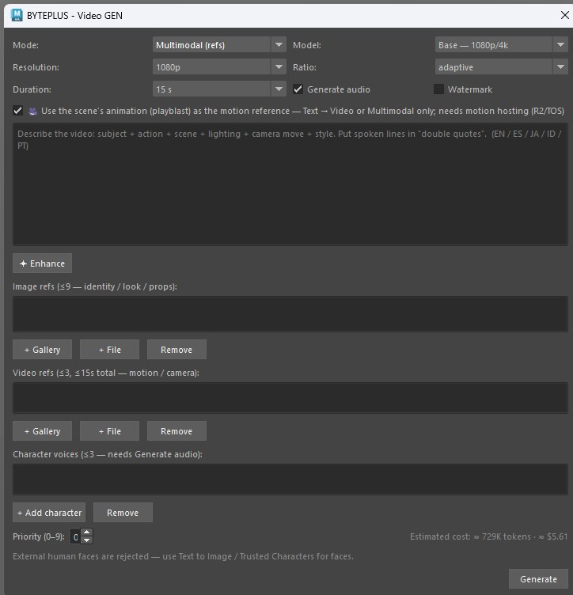
Video GEN
Best practice: prototype at 480p/720p (or Fast / Mini), lock the prompt, then re-render at 1080p/4k on Base. External human faces are rejected — use trusted images (Text to Image / Trusted Characters) for faces.

🌅 Dream with Seedreams 5.0
Generate a concept image from your viewport + a text prompt (image-to-image).
- Frame your shot in the viewport.
- BYTEPLUS > Dream with Seedreams 5.0.
- Choose how to use the viewport:
- Dream AROUND the reference — keeps your subjects + layout and just finishes the look.
- Use the LAYOUT only — same composition, but the look comes entirely from your prompt text.
- Pick a Model (Pro / Lite), type a prompt, and use the helpers:
- ✦ Enhance — improves your prompt's wording (text only; keeps your intent).
- ✨ Auto — writes a prompt from scratch by analysing the viewport.
- Choose Variations and Generate → preview opens with Save As. Saved images land in the Dream Gallery.
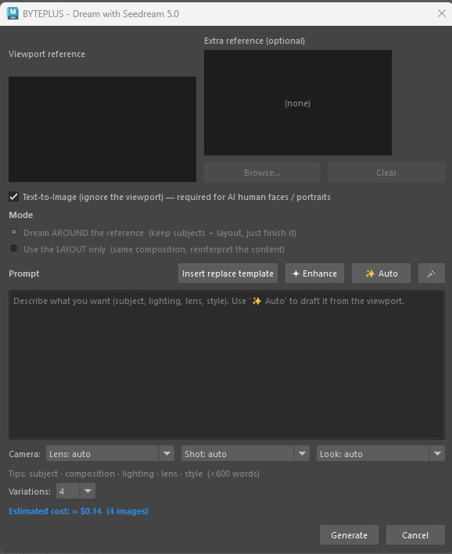
Dream with Seedreams 5.0
Best practice: an Extra reference injects a subject (a clean, isolated object/character) into your composition — it is not for copying a whole scene's look. If you add a busy scene as the extra reference it competes with your viewport layout and usually wins.

🧑‍🎤 Text to Image
Pure prompt → image, with no viewport — the dedicated tool for AI people, portraits and faces.
- BYTEPLUS > Text to Image.
- Pick a Model (Pro / Lite — both produce animatable faces), type your prompt, press ✦ Enhance to tighten it, choose Variations.
- Generate → results open in the Dream Gallery.
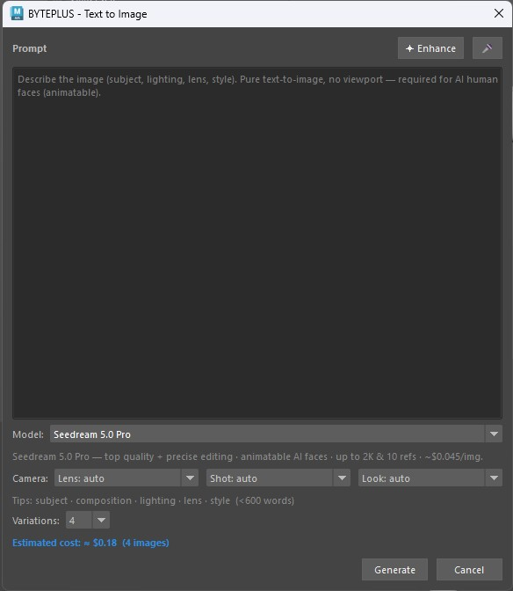
Text to Image
Why it matters for video: a face made here is a trusted AI output, so you can Animate it with Seedance. Viewport-guided or imported faces are treated as image-to-image and are rejected unless your account has KYC HIGH. For a face you'll reuse across many videos, register it in Trusted Characters (permanent — see below).

🖇️ Image to Image
Combine multiple reference images — a layout, materials, products, decor — into one photoreal render (no viewport involved). Seedream accepts up to 14 references (Lite) / 10 (Pro).
- BYTEPLUS > Image to Image.
- Add images… (or From gallery). They are numbered Image 1, Image 2, … in the order shown.
- Press ✨ Auto-compose (recommended) — Seed 2.0 looks at each image, gives it a role (composition / material / product / decor) and writes the structured prompt for you. Review/edit it, or press ✦ Enhance to tighten it.
- Pick a Model and Variations, then Generate. Results open in the Dream Gallery.
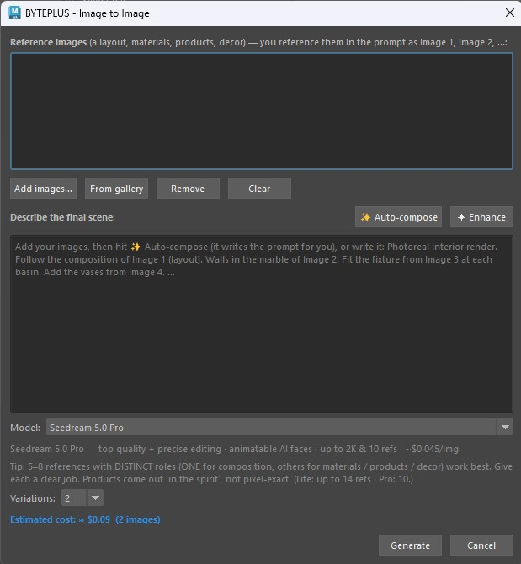
Image to Image
Best practice: 5–8 references with DISTINCT roles work best — exactly one image for the composition/layout, the rest for materials, products and decor. Give each a clear job. Products come out "in the spirit", not pixel-exact (Seedream treats references as soft guidance, not a stencil). Always try ✨ Auto-compose first — a plain hand-written prompt tends to blend everything together.

🧭 Layout → Still
When you want your viewport composition but a completely different look, this is the dedicated tool (A/B-verified to lock the layout).
- Frame the shot — positions, facing and camera are what get locked.
- BYTEPLUS > Layout → Still.
- Describe the LOOK (subjects, style, materials, lighting, scene) and press ✦ Enhance if you want the wording tightened.
- Pick a Model and how many Variations, then Generate.
Best practice: do not add a reference image here. The composition is locked to your viewport and the look comes from the text — a second image competes with the layout and usually wins.
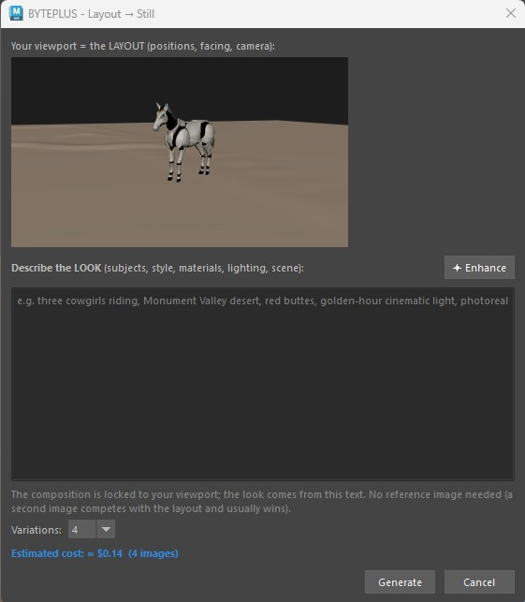
Layout → Still

🖼️ Dream Gallery
Everything you've generated, persistent across sessions and sorted by date (newest on the right). Zoom any thumbnail with the mouse wheel and pan by dragging. Select an image and:
- 🔄 Regenerate — a fresh variation of the original prompt.
- ✏ Refine — describe an edit (with its own ✦ Enhance).
- ✎ Interactive Edit — draw edit marks directly on the image (see below).
- ⇄ Compare — an A/B wipe slider between two images.
- 📂 Import — bring an external image into the gallery.
- Animate with Seedance → — send the image to Seedance to make it move.
- Save As / 🗑 Delete / Clear all.
- Right-click → Blockout from image / Interactive Edit.
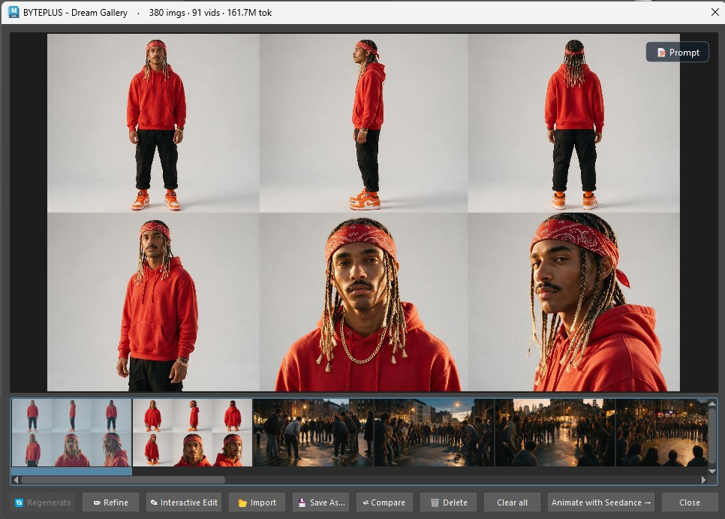
Dream Gallery
Refine — describe an edit to apply to the selected image:
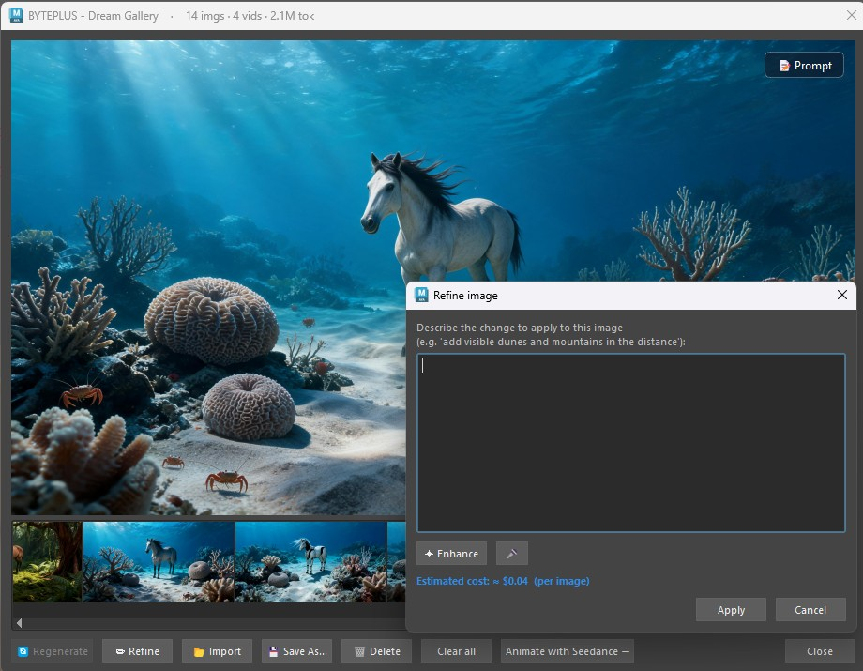
Refine an image

🖊️ Interactive Edit
Leverages Seedream 5.0 Pro's interactive editing — you draw what you want changed directly on the image instead of describing coordinates in words.
- In the Dream Gallery, select an image → ✎ Interactive Edit (button or right-click).
- Mark up the canvas with the tools: box, arrow, pencil, text label, numbered marker, colour picker, undo/clear. Use Select to move or delete a mark, and the mouse wheel to zoom.
- Optionally add reference images (e.g. the glasses or hat you want inserted) — they become reference image 2, 3, ….
- Type the edit prompt (✦ Enhance available, plus templates for layer separation / precise coordinates / sketch tags) and Generate. The marks guide the edit and are removed from the final image.
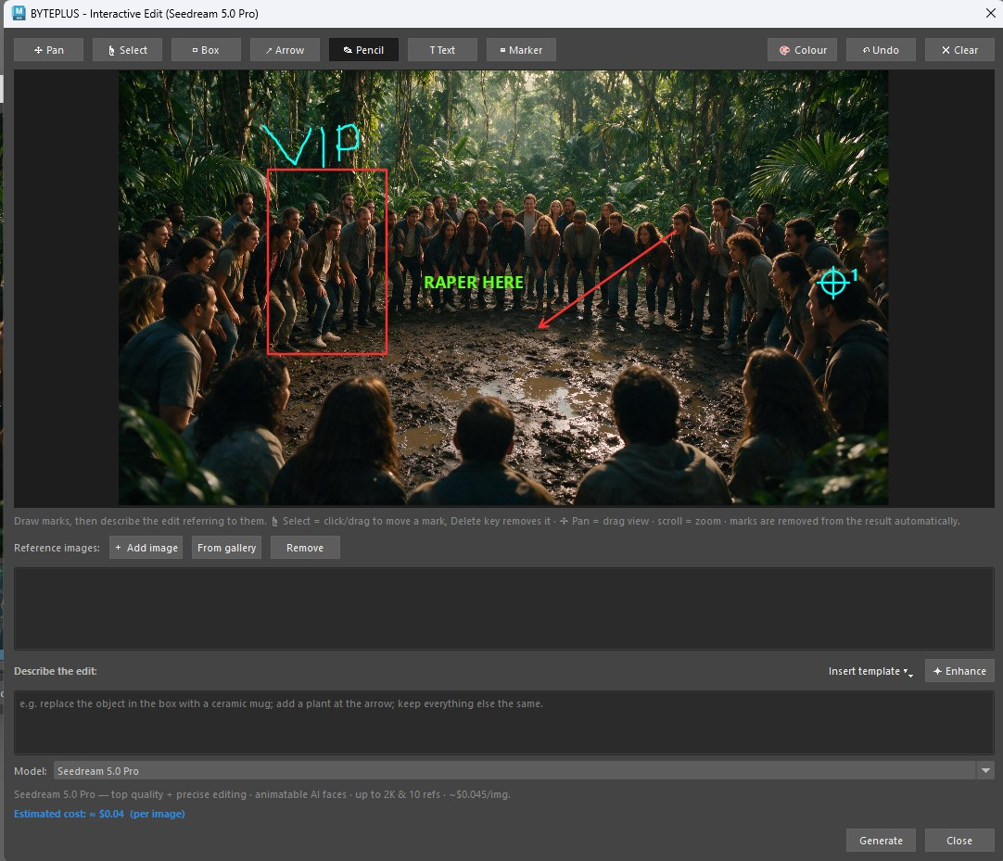
Interactive Edit
Compare — drag the slider to wipe between two versions:
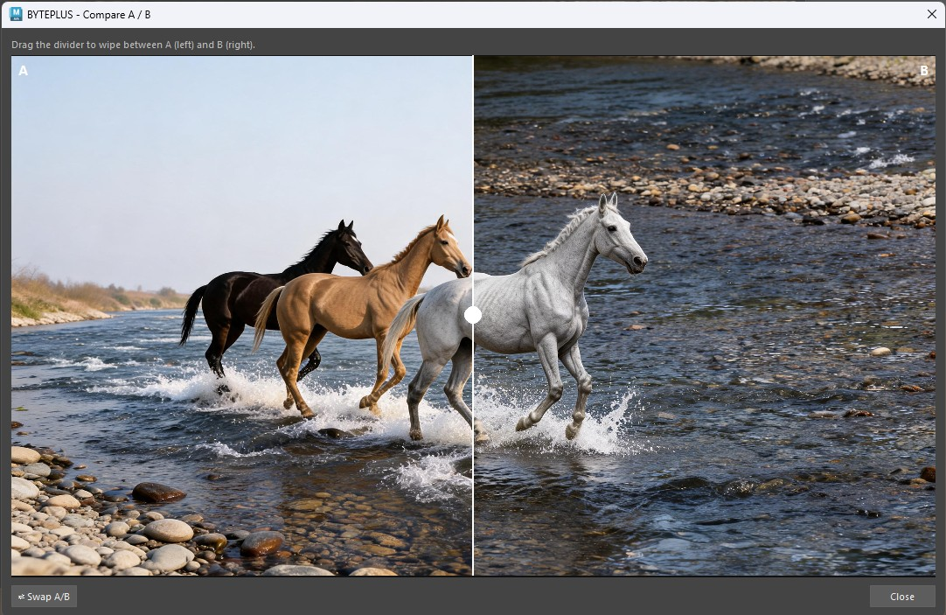
Compare A / B

✨ Animate (from the Dream Gallery)
Make a still image move.
- In the Dream Gallery, select an image → Animate with Seedance →.
- Describe the motion, or use ✨ Analyze for a suggestion. You can pick a different source frame with the reference picker.
- 🎭 Trusted character (optional) — use a permanent trusted character (asset://) as the main image instead of the selected one: no 24-hour expiry and no face rejection (see Trusted Characters).
- Optionally tick use playblast so the motion follows your 3D scene's animation while the image defines the look.
- Generate → the video appears in the Video Gallery.
The image is the look reference; the playblast is the motion reference.
Multiple videos at once: you can queue several Animate jobs in parallel (up to your account's Seedance limit — 3 on individual accounts, 10 on enterprise-verified ones). Set the cap in Settings > Generation > Max concurrent Seedance jobs. Submitting past the cap tells you to wait.
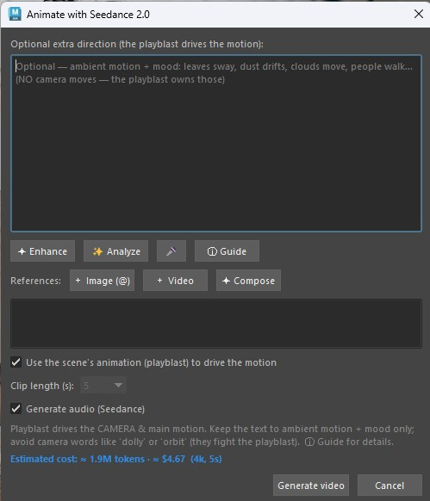
Animate with Seedance 2.0
Reference picker — choose which image drives the animation:
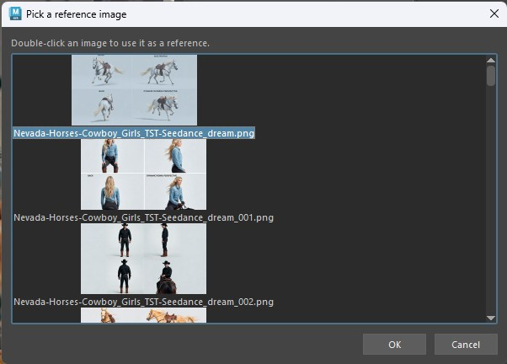
Animate — reference picker

🔗 Set up motion hosting (for faithful motion)
For Animate / Render to faithfully follow your scene's motion, the playblast must be uploaded somewhere Seedance can read it. A one-time, ~2-minute setup:
- BYTEPLUS > Set up motion hosting…
- Choose Cloudflare R2 (recommended — nothing to install). Follow the on-screen steps to create a free bucket + API token, then paste your Account ID, Access Key ID, Secret Access Key and Bucket.
- Click Test connection — it uploads a tiny file, fetches it back and deletes it. Wait for the green ✓.
- Click Save & enable.
Without hosting, Animate still works — the motion just comes from your text description (approximate) instead of the playblast.
Advanced: BytePlus TOS is also supported (same vendor as your API key) but needs the tos Python package; the wizard shows the command. R2 needs nothing.
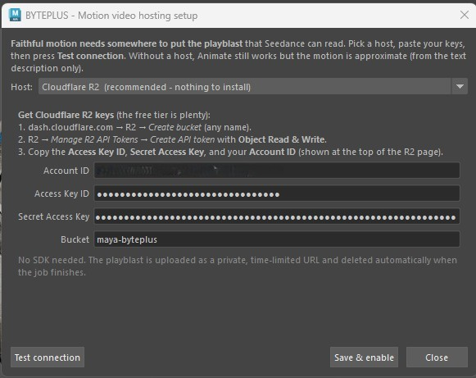
Motion hosting setup — Cloudflare R2 (recommended)
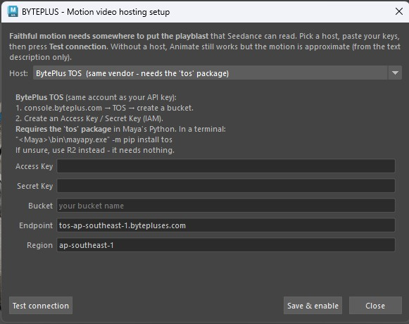
Motion hosting setup — BytePlus TOS (advanced)

🎞️ Video Gallery
All your videos, persistent and sorted by date. Each thumbnail is a real frame of the clip (the first non-black frame), so posters are stable — not random. Select a clip and:
- ▶ Open — play it in your default player.
- ✎ Edit video — Seedance 2.0 video-to-video: keeps the source clip (subject, motion, camera) and transforms only the change you describe (e.g. "set his hair on fire", "make it night"). Press ✦ Enhance to auto-write the full prompt. Keeps the clip's original audio.
- Save As / 🗑 Delete / Clear all.
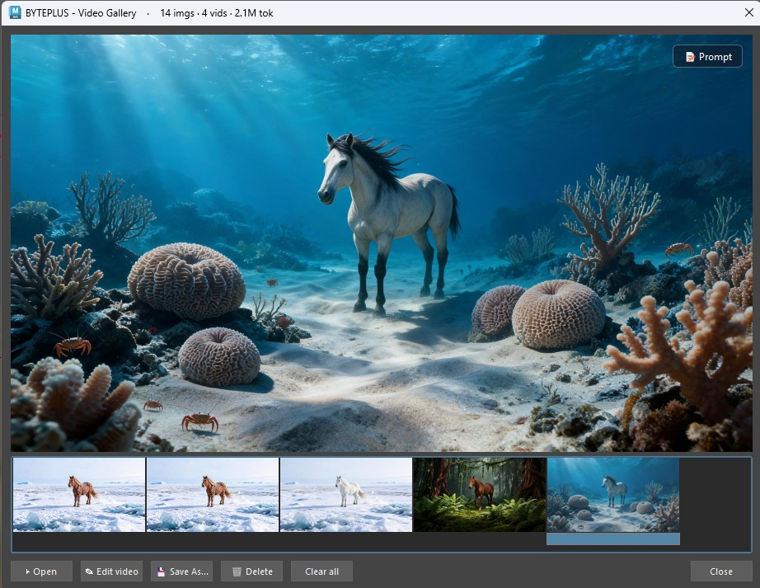
Video Gallery
Edit video — describe a change; Seedance keeps the source clip and transforms it:
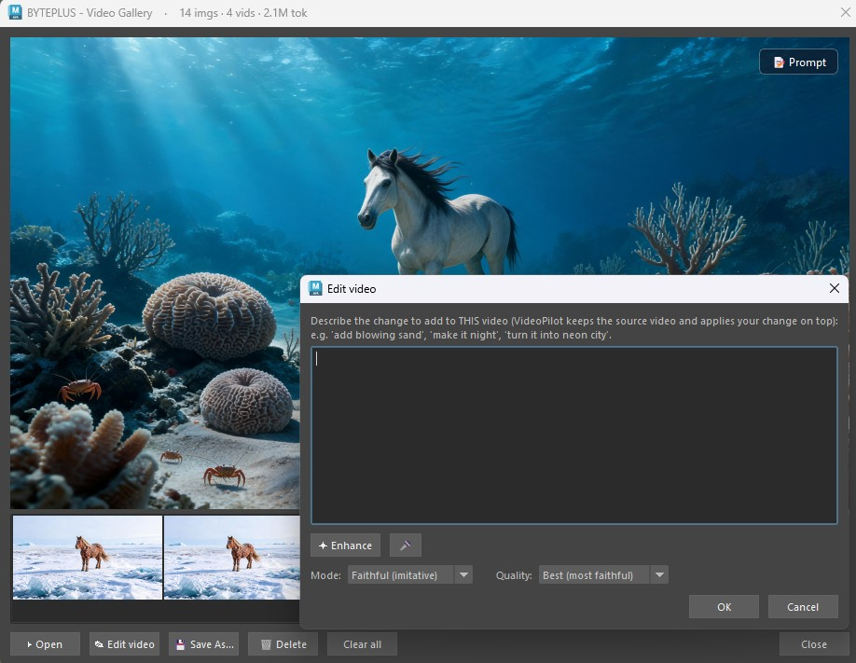
Edit video

💬 Seed Chat
A chat window backed by Seed 2.0 (multimodal). Use it to plan shots, learn the models, turn a rough idea into a clean prompt — or ask how to use the plugin (it knows the menu and features).
- BYTEPLUS > Seed Chat.
- Pick a Mode: 💬 Chat, 🖼 Image prompt (Seedream) or 🎬 Video prompt (Seedance) — the mode tunes the ✨ Prompt Doctor button.
- Attach references with 📎 Image or 🖼 Viewport to have it describe them.
- Buttons:
- ✨ Prompt Doctor — rewrites your text into an optimized English prompt.
- 🔎 Describe image — describes the attached image and suggests a prompt.
- → Dream / → Seed 3D — send the last reply straight into that tool.
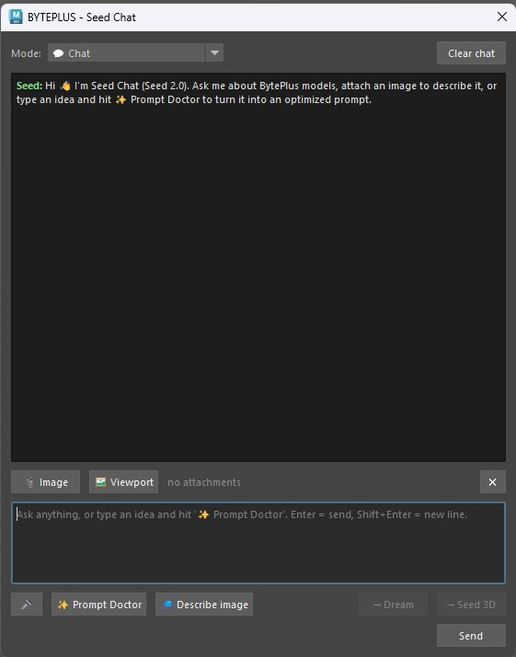
Seed Chat

🧊 Seed 3D
Generate a 3D asset from text or an image and import it into your scene.
- BYTEPLUS > Seed 3D.
- Choose Text → 3D or Image → 3D (Browse… or From gallery for the image).
- Describe the asset (✦ Enhance to tidy the wording).
- Options: Material (PBR / Shaded / None), Mesh (Quad / Raw), Format (usdz / fbx / obj).
- Generate → the mesh is imported with its textures wired up.
Best practice: for Image → 3D, use a single clean, well-lit subject on a plain background. Choose PBR + Quad for a game-ready, textured, clean-topology asset. To model a character, feed one A-pose view from Seed Character's game turnaround — not the whole multi-view sheet.
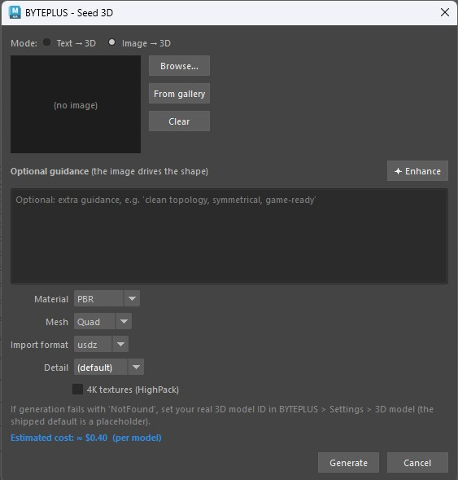
Seed 3D

🔊 Seed Audio
Generate voice, music and sound effects with Seed Audio 1.0, then reuse them in your videos.
- BYTEPLUS > Seed Audio (first paste your Seed Audio API key in Settings > API & Models — it's a separate key from the Voice console).
- Pick a mode: 🎙️ Voice / TTS, 🎵 Music & SFX, or 👤 Clone voice (from a reference clip).
- Describe the voice in the prompt — Seed Audio's strength, e.g. "A warm confident male narrator says: 'Welcome to the show.'" Multi-character scripts in one prompt are supported. Or pick a preset voice (optional) and 🔊 Preview.
- Set format / pitch / speed / length and Generate → it plays and lands in the Audio Gallery.
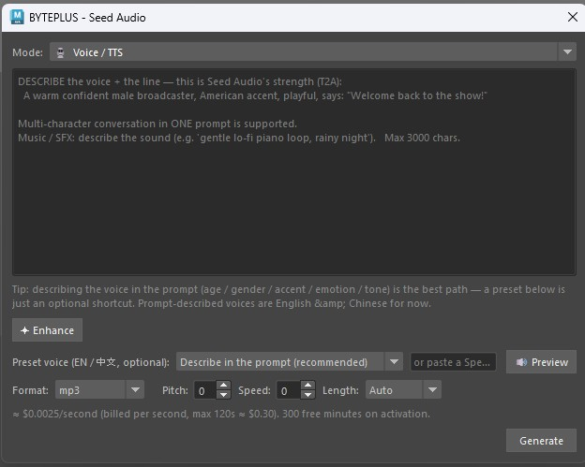
Seed Audio
Language: Seed Audio currently generates English & Chinese (more coming). Seedance video dialogue also speaks Spanish / Japanese / Indonesian / Portuguese — see Dialogue Scene below.

🧍 Seed Character
A dedicated character generator — people, creatures or robots — plus their props and clothing, on clean grey studio backgrounds.
- BYTEPLUS > Seed Character.
- Fill in the character fields, or load a photo and let the assistant describe it and fill the fields for you.
- Choose what to produce:
- Character sheet (2×2 / 2×3 grid of consistent views / expressions).
- Game A-pose turnaround — clean front/side/back A-pose views intended for 3D modelling (send one view to Seed 3D).
- Prop / clothing sheet — ghost-mannequin item sheets (glasses, hats, shoes, outfits) on grey.
- Pick a Model (Lite is great for the large sheets; Pro for top fidelity) and Generate → results open in the Dream Gallery.
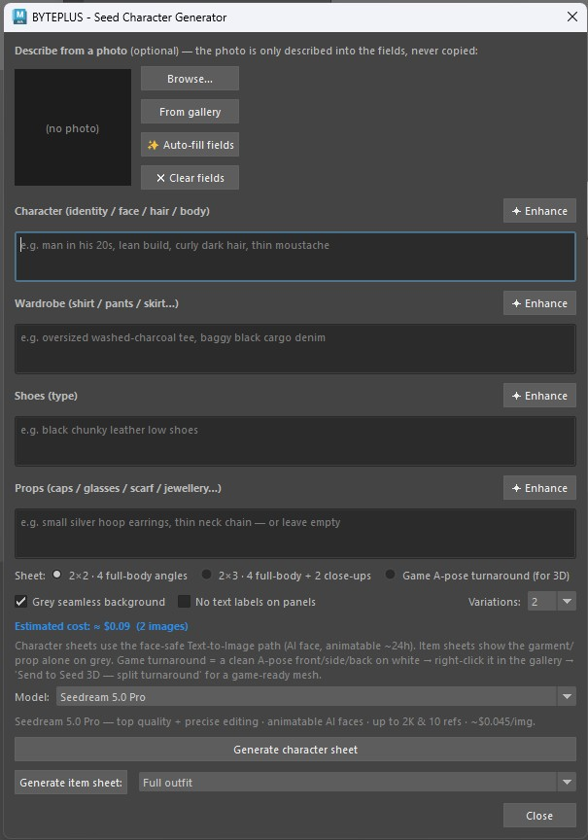
Seed Character generator
Best practice: generate the character sheet first to lock the identity, then the turnaround and item sheets for the same character. For 3D, send a single A-pose view to Seed 3D (a full sheet would be modelled as a flat board).

🎭 Trusted Characters
Upload an AI character once and get a permanent asset:// reference that Seedance trusts forever — no 24-hour expiry, and it animates without face rejection, with consistent identity across videos. (Requires Advanced Creation Rights on your BytePlus account.)
One-time setup
- In your BytePlus console, create an Access Key + Secret Key (AK/SK) (IAM > Access Keys) — these are different from your Bearer API key.
- Paste them in BYTEPLUS > Settings > Storage & Hosting > Trusted Asset Library (or leave blank to reuse your TOS keys — same account).
- The first time you create a character, BytePlus asks you to sign a one-time authorization letter in the console (Model Playground > My assets > Virtual Portrait).
Using it
- BYTEPLUS > Trusted Characters.
- + New — create a character (group). Add images with + From gallery or + From file — for best consistency add a full-body frontal and a face close-up to the same character.
- Each image processes to ✅ Active (watch the status badge). Once active it's permanent.
- In Animate, press 🎭 Trusted character and pick it — it becomes the main image, permanently animatable.
- (Optional) give the character a 🎙️ voice — Generate voice… (from its image, a description, or a preset). The voice is reused for consistent dialogue.
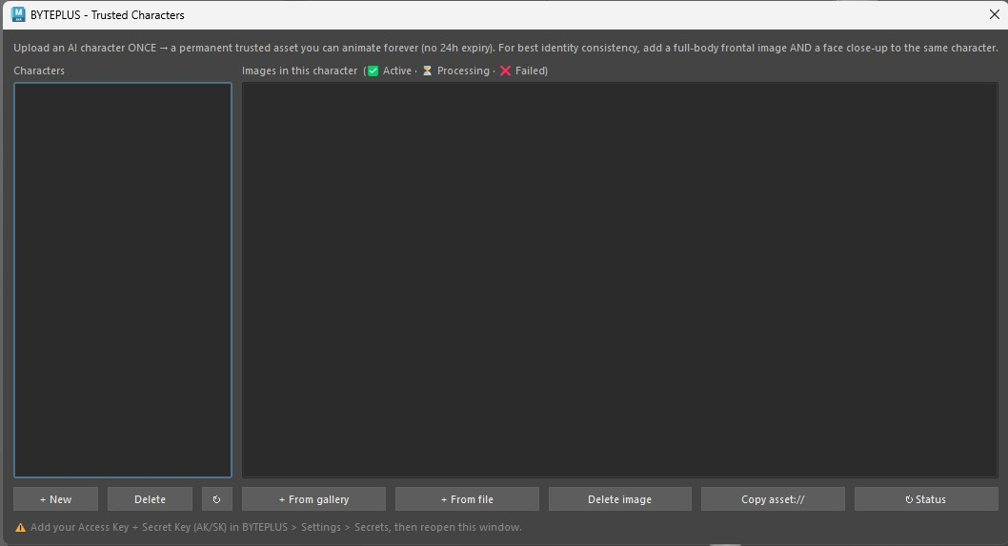
Trusted Characters
Real human faces are never allowed (AI-generated characters only). Uploading a local image needs motion hosting (R2/TOS) configured; gallery images with a fresh Seedream URL upload without it.

🎭 Dialogue Scene
Multi-character spoken dialogue, generated by Seedance 2.0 with synced lips.
- BYTEPLUS > Dialogue Scene.
- Build a cast (up to 3): + Add character picks a Trusted Character (its image + its voice, if it has one).
- Write the script, one line per character: @Ana: ¡Hola Danny! ¿Cómo estás? / @Danny: Muy bien, ¿y tú?
- Optionally add a Scene line (setting / mood / camera), pick the duration, and Generate scene → the clip lands in the Video Gallery.
Works in Spanish (and English / Japanese / Indonesian / Portuguese) — Seedance speaks the lines directly. Give each character a voice in Trusted Characters for a consistent timbre.

🧱 Blockout from image
Turn a reference image into a rough 3D primitive layout — a controllable guide you tweak, then feed back to Dream or use to guide animation. Available from the menu and from the Dream Gallery right-click.
- BYTEPLUS > Blockout from image (or right-click an image in the Dream Gallery → Blockout from image).
- Seed 2.0 detects the main objects (boxes + depth + a suggested primitive) and lists them — uncheck anything you don't want.
- Choose a Placement:
- Camera-matched (looks like the photo) — best as a Dream reference / animation guide.
- Floor layout (3D stage) — objects stood on a floor + back wall.
- Optionally tick Project the photo onto the blocks (2.5D matte) and press 6 for textured view.
- Create blockout — geometry is built in a single undo step.
Best practice: this is a rough 2.5D guide (depth is estimated, not measured). Adjust the blocks/camera, then Dream or animate through `blockout_cam`.

🤖 Seed Assistant
An in-Maya agent that can inspect and automate your scene. It proposes Python and runs it only after you approve it.
- BYTEPLUS > Seed Assistant.
- Tell it what to do — e.g. "select all lights", "rename selected to prop_###", "lay these out on a grid".
- It shows the code it wants to run; review it and approve (or decline).
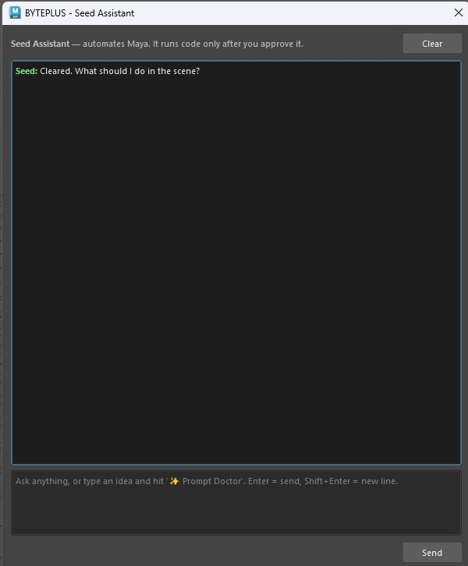
Seed Assistant
Best practice: always read the proposed code before approving, and save your scene first for anything that modifies geometry.

🎨 Generate Texture
- Select an object (or just run it).
- BYTEPLUS > Generate Texture.
- Pick a Model, type what you want (e.g. "weathered bronze with green patina"), and set the bump depth if needed.
- The plugin generates the texture and wires it into a new OpenPBR shader assigned to your object.

6. Best practices (quick reference)
- Pick the right image tool. Viewport look-dev → Dream · keep my composition, new look → Layout → Still · combine reference images → Image to Image · AI people/faces → Text to Image · design a character + props → Seed Character · draw an edit on an image → Interactive Edit.
- Pro or Lite? Pro for top quality, precise editing and the most reliable animatable faces; Lite for speed, cost and big 4K character sheets.
- One job per reference. In Image to Image, give each image a single distinct role and exactly one image the composition. In Dream, an Extra reference is a subject to inject, not a scene to copy.
- Let the AI write the prompt. ✨ Auto-compose (Image to Image), ✨ Auto (Dream) and ✨ Prompt Doctor (Seed Chat) beat a quick hand-written prompt — start there.
- English prompts land best across Seedream / Seedance; the Enhance / Doctor buttons output English for you.
- Faithful video motion needs motion hosting enabled and a playblast length that matches a whole-second duration. Describe the camera move in the prompt when you want a specific one.
- AI faces in video: make the face with Text to Image (Pro or Lite) and animate it, or — for a face you'll reuse — register it in Trusted Characters for a permanent animatable reference. Viewport-guided (image-to-image) faces need KYC HIGH; real human faces are never allowed.
- For 3D characters: send a single A-pose view from Seed Character's game turnaround to Seed 3D, not the whole sheet.
- Save your scene before running Seed Assistant actions or Generate Texture.
- Mind the cost guard. Big jobs prompt before spending; images are cheap and never prompt. Check Usage… anytime.

7. Settings reference
Tabs in Settings…:
- API & Models — API key, base URL, Seedream Pro / Lite model IDs, Default image model (Pro / Lite), image output format (JPEG / PNG), Seedance / 3D / LLM / Seed Chat model IDs.
![Settings — API & Models](images/Settings_API_MODELS.jpg)
- Generation — video resolution & aspect ratio, Max concurrent Seedance jobs, max reference frames, playblast size (preset dropdown), bump depth, colour management, SSL verify.
![Settings — Generation](images/Settings_GENERATIONS.jpg)
- Storage & Hosting — Cloudflare R2 / BytePlus TOS for hosting videos, and the Trusted Asset Library Access Key / Secret Key. Easiest to set up hosting via the Set up motion hosting… wizard.
![Settings — Storage & Hosting](images/Settings_STORAGE_HOSTING.jpg)
- Analytics & Webhook — anonymous usage telemetry (PostHog / R2), callback URL.
Cost guard: when an estimate exceeds your threshold (Settings > Generation > Confirm above), BYTEPLUS asks before spending. Cheap jobs (images) never prompt.
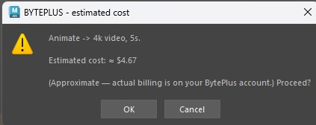
Estimated cost confirmation

8. Tips & troubleshooting
- Menu didn't appear? Restart Maya once; if still missing, re-drag install.py and check the Script Editor for a [BYTEPLUS] error.
- Maya crashed during generation? The installer disables Autodesk ADP (a known Windows crash) — make sure you restarted Maya after installing.
- "model or endpoint does not exist" / HTTP 404? Your key is reaching the server but that model isn't enabled for your account/region. Re-check the API key and model IDs in Settings; verify with Diagnostics > Test Seedream.
- "All variations failed" with Pro? Pro runs a higher-quality mode and can take a few minutes per image — the plugin waits, but a very slow network can still time out. Try again, switch that window to Lite, or set output format to JPEG (Settings > API & Models).
- Animate motion is only "approximate"? Enable the playblast as a motion reference via BYTEPLUS > Set up motion hosting… (then tick use playblast).
- Video motion drifts / speeds up? Match the playblast length to a whole-second output duration so Seedance doesn't time-warp it.
- A face is rejected when animating. Make faces with Text to Image and animate them, or register the character in Trusted Characters (permanent). Viewport-guided faces need KYC HIGH; real human faces are never allowed.
- Trusted Characters: "+ New" does nothing? Add your Access Key + Secret Key in Settings > Storage & Hosting > Trusted Asset Library first, then reopen the window. The very first character also needs the one-time authorization letter signed in the console.
- "Edit video" / uploading a local trusted image needs motion hosting. Set up Cloudflare R2 / TOS in Settings > Storage & Hosting.
- Image to Image mixed everything together? Use ✨ Auto-compose, keep to one composition image, and give every other image a distinct role.
- SSL certificate error? In Settings, install certifi into Maya's Python or untick Verify SSL certificates (less secure).
- Something failing? The Diagnostics submenu has a test for each service. Results print to the Script Editor.
- Check your usage. BYTEPLUS > Usage… shows images, videos, 3D and tokens used on this machine.
- Found a bug? BYTEPLUS > Report a Bug…
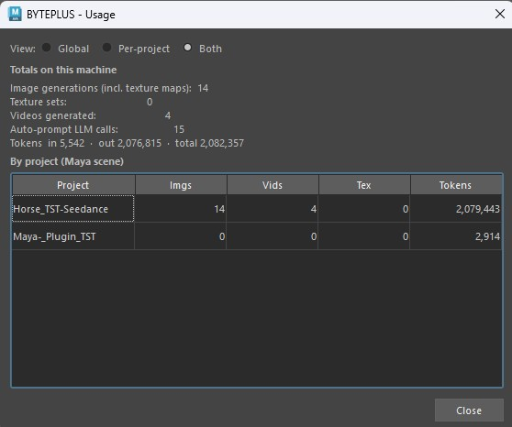
Usage — totals and per-project breakdown
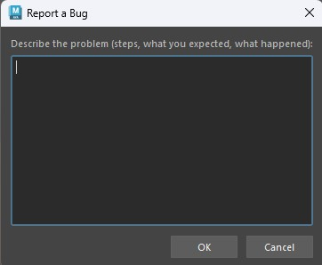
Report a Bug

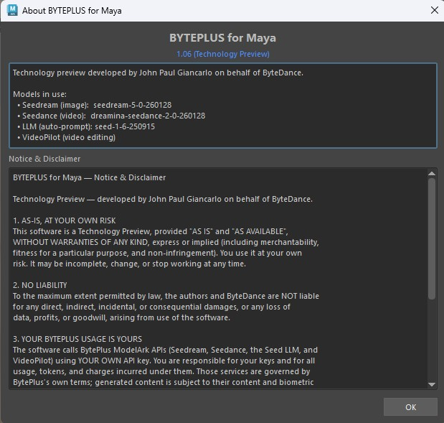
About BYTEPLUS for Maya
BYTEPLUS for Maya — Technology Preview v1.09. Built on BytePlus ModelArk: Seedream 5.0 (image), Seedance 2.0 (video), Seed 3D, and Seed 2.0 (LLM).

