Advanced Programming 2025
Commodity-Price Dynamics and One-Month-Ahead Conflict Prediction
in Sub-Saharan Africa
Final Project Report
[Your Name]
[your.email@unil.ch]
Student ID: [XXXXXXXX]
August 28, 2026

Abstract
This project investigates whether global commodity-price changes and short-run volatility improve the one-month-ahead prediction of high-conflict months in Sub-Saharan Africa beyond information contained in recent conflict history. A balanced country-month panel is constructed for 48 countries from UCDP Georeferenced Event Dataset v26.1 conflict events and World Bank Pink Sheet commodity indices. The baseline feature set contains country and seasonality indicators together with current, lagged, and three-month conflict-history measures; the augmented set adds monthly price changes and three-month volatility for energy, food, fertilizers, metals and minerals, and precious metals. Logistic Regression, k-nearest neighbors, a Decision Tree, AdaBoost, and a feed-forward multilayer perceptron are selected using a chronological training-validation design and then evaluated once on an untouched 2022-2025 test period. The strongest frozen model is the conflict-history MLP (F1 = 0.857), closely followed by commodity-augmented Logistic Regression (F1 = 0.855) and a persistence benchmark (F1 = 0.846). Commodity features improve Logistic Regression by only 0.003 F1 and do not improve the other model families; alternative target and volatility specifications reverse the small Logistic gain. The evidence therefore supports conflict persistence as the dominant short-run predictive signal and suggests that aggregate global commodity indicators provide, at most, a weak and specification-sensitive supplement.
Keywords: conflict forecasting; commodity prices; volatility; Sub-Saharan Africa; machine learning; UCDP; early warning

1. Introduction
Armed conflict creates immediate humanitarian costs and also generates operational uncertainty for governments, humanitarian organizations, firms, investors, and households. Anticipating where violence is likely to intensify can improve preparedness even when forecasts are imperfect. Humanitarian actors may use early-warning information to pre-position relief items, diversify transport routes, prepare surge capacity, and adapt supply chains before access deteriorates. Companies operating in or sourcing from fragile regions face related problems: extraction sites, transport corridors, inventories, contracts, and commodity exposures can all be affected by conflict. For commodity producers, traders, insurers, and other exposed firms, an improved view of short-run conflict risk can complement market-price risk management with operational contingency planning.
This project focuses on one potential source of early-warning information: movements in global commodity prices. The idea is plausible because commodity shocks can affect producer incomes, consumer prices, transport costs, government revenues, the value of territorial control, and the opportunity cost of participation in violence. Yet the same conceptual literature also suggests that these mechanisms are heterogeneous. A fall in an agricultural export price may reduce rural income and change recruitment incentives, while a rise in the value of an extractive resource may increase rents from controlling territory. Moreover, global prices are only upstream signals; their local effects depend on trade exposure, exchange rates, infrastructure, market integration, and the geographic location of production and consumption.
The research question is therefore deliberately predictive rather than causal: Can global commodity-price changes and short-run volatility improve the one-month-ahead prediction of high-conflict months in Sub-Saharan Africa beyond information contained in recent conflict history? The key phrase is "beyond recent conflict history." Conflict is strongly persistent, so a model using recent events already provides a demanding benchmark. The project does not ask whether commodities cause conflict; it asks whether publicly observable global commodity signals add useful predictive information once a strong short-run history baseline is available.
The contribution is threefold. First, the project builds a reproducible monthly panel from event-level conflict data and global commodity indices, with explicit treatment of temporal precision and zero-conflict months. Second, it compares five course-aligned classification families under a common baseline-versus-augmented design and a leakage-safe chronological evaluation protocol. Third, it evaluates the commodity contribution directly through within-model changes in F1 and then checks whether the result survives alternative target and volatility definitions. The remainder of the report reviews the relevant literature, explains the data and modeling choices step by step, summarizes the implementation and repository, presents the final held-out results, and discusses why the incremental commodity signal is weak.

2. Research Question & Literature

2.1 Resources, commodity shocks, and conflict
The relationship between natural resources and conflict has a long and contested empirical literature. Collier and Hoeffler (2004) argue that economic conditions linked to the feasibility of rebellion have substantial explanatory power for civil war, which helped motivate the broader "greed versus grievance" debate. Subsequent work cautions against treating primary commodities as a homogeneous risk factor. Ross (2004), reviewing cross-national evidence, concludes that the association between broad primary-commodity measures and conflict onset is not uniformly robust and that resource type matters. Fearon (2005) also shows that a broad primary-commodity export result is fragile and argues that oil may be distinctive because it is associated with state capacity and the value of controlling the state. Humphreys (2005) similarly emphasizes that several competing mechanisms can connect resources to violence, making a single common sign theoretically unlikely.
Price-shock studies sharpen this issue by exploiting changes in world markets. Brueckner and Ciccone (2010) find that downturns in the international prices of countries' main export commodities are associated with civil-war onset in Sub-Saharan Africa. The exposure structure is central to that design: the price signal is linked to what a country actually exports. Dube and Vargas (2013), using local Colombian exposure to coffee and oil, demonstrate that commodity shocks can operate through opposing channels. Agricultural price increases can raise wages and opportunity costs of fighting, whereas resource rents from oil can increase incentives to contest valuable areas. Berman et al. (2017) provide related Africa-wide evidence at a highly disaggregated spatial scale, showing that changes in world mineral prices matter especially around mining locations. These studies suggest that exposure weighting and spatial matching may be more informative than applying the same global index to every country.
Other research also warns that conflict onset and conflict continuation are different processes. Bazzi and Blattman (2014), using export-price shocks, find little robust effect on new conflict but evidence consistent with income and state-capacity channels during existing wars. This distinction is particularly relevant here because the target is a high-conflict month, not a pure onset indicator. The target can represent continuation of an already violent episode, escalation, or occasionally the start of a new episode. A commodity shock could be important for one of these processes without materially improving a pooled one-month classifier.

2.2 From explanation to forecasting
The project also connects to the literature on conflict early warning. The ViEWS system developed by Hegre et al. (2019), for example, produces monthly forecasts of several forms of political violence and combines information from multiple thematic models. A recurring insight in conflict forecasting is that recent violence is itself highly informative: places with recent conflict remain at elevated short-run risk. This is substantively useful but creates a difficult benchmark for incremental predictors. A new signal should therefore be evaluated against persistence rather than against an empty model.
A second forecasting issue is timing. Global commodity prices may not affect local conditions contemporaneously. Bekkers et al. (2017) show that international-to-local food-price pass-through varies across countries and is naturally modeled with lags, while Dillon and Barrett (2016) find that global oil prices transmit to East African local food prices through transport costs with channel-specific adjustment speeds. These results motivate the interpretation of a weak one-month commodity signal as a possible horizon or transmission mismatch rather than proof that commodities are irrelevant to conflict. They also motivate future work with distributed lags and multiple forecast horizons.

2.3 Research gap and empirical expectation
Much of the resource-conflict literature is designed to identify causal or quasi-causal relationships using exposure-specific price shocks, while operational early-warning systems combine a broad set of political, economic, geographic, and historical features. This project occupies a narrower space between the two: it tests whether a small, transparent set of global commodity signals improves short-run predictive classification when added to recent conflict history. The expected effect is therefore incremental rather than transformative. If the augmented models consistently outperform otherwise identical baseline models, the commodity variables would have practical early-warning value. If not, the result would imply that aggregate world-price information is too indirect, too heterogeneous, or too slow-moving to add much at a one-month horizon without country-specific exposure information.

3. Methodology

3.1 Data sources and country-month panel
Conflict data come from the Uppsala Conflict Data Program Georeferenced Event Dataset (UCDP GED) Global version 26.1, which records georeferenced events of organized violence and distinguishes state-based, non-state, and one-sided violence. The project uses the 2000-2025 period and a fixed universe of 48 sovereign Sub-Saharan African countries. The raw global GED contains 417,968 event rows; 50,372 rows fall within the selected country-period universe. Commodity data come from the World Bank Commodity Price Data (the Pink Sheet), using monthly indices for Energy, Food, Fertilizers, Metals & Minerals, and Precious Metals.
The first methodological challenge is temporal precision. A monthly prediction task should not assign an event to a month when the source does not identify the month reliably. Events with UCDP date precision of 4 or better are therefore eligible for the primary monthly panel. Events with date_prec = 5 are retained separately for auditability but excluded from the primary monthly allocation. This excludes 814 selected events. Those observations contain a large fatality mass, which is one reason the primary target is based on event counts rather than fatalities. For eligible events spanning a date interval, the assigned month is the month containing the midpoint between the reported start and end dates. Event counts and fatalities are then aggregated to country-months, and the panel is balanced so that country-months without recorded events appear explicitly with zero counts.
The resulting primary conflict panel contains 48 countries by 312 months from January 2000 through December 2025. Of the 49,558 monthly-eligible events, 3,696 country-months contain at least one event and 11,280 country-months are explicit zeros. This balanced design is essential because the absence of an event is informative for classification and should not be treated as missing data.

3.2 Commodity feature engineering
For each World Bank index, two predictors are constructed. Monthly percentage change is defined as 100 x (Index_t / Index_(t-1) - 1). Short-run volatility is the sample standard deviation of the current and previous two monthly percentage changes, equivalent to a three-month rolling standard deviation. October-December 1999 is used as a lookback period so that January 2000 already has complete commodity features. No interpolation, winsorization, clipping, or smoothing is applied to the primary commodity variables because large shocks may be the observations of substantive interest. The final augmented feature set therefore contains ten commodity predictors: five monthly changes and five three-month volatility measures.

3.3 Conflict-history predictors and prediction horizon
The baseline is designed to represent information that an analyst could plausibly know at the end of month t. Six conflict-history variables are created for each country: current-month event count, current-month fatalities, one-month-lagged event count, one-month-lagged fatalities, the three-month sum of events, and the three-month sum of fatalities. Country identity and month-of-year are added to capture persistent cross-country differences and seasonality. The three-month sums include t, t-1, and t-2. January and February 2000 are dropped because a complete three-month conflict history is not yet available.
The prediction horizon is exactly one month: all predictors measured through month t are used to classify whether month t+1 is a high-conflict month. This temporal ordering is preserved throughout feature construction, model selection, and testing. December 2025 feature rows are excluded because January 2026 outcomes are not available in the source dataset.

3.4 Target definition
A single absolute event threshold would classify countries with very different long-run conflict baselines unfairly. The project therefore defines high conflict relative to each country's own historical distribution. For country c, the 75th percentile of monthly event counts is estimated using outcomes from January 2000 through December 2018 only. The discrete cutoff is cutoff_c = max(2, floor(Q75_c) + 1). A positive target requires at least two events and must strictly exceed the training-period 75th percentile when that percentile is an integer or falls below the minimum threshold. The dependent variable equals one when the event count in t+1 reaches or exceeds this fixed country-specific cutoff.
An early audit showed why the minimum cutoff matters: for many low-conflict countries the 75th percentile is zero. Without a minimum event requirement, a single event could mechanically be classified as "high conflict" in a way that is difficult to interpret operationally. The threshold is never re-estimated using validation or test outcomes.

3.5 Final modeling table and chronological split
After merging conflict and commodity data and aligning the one-month target, the frozen modeling table contains 14,832 country-month observations. Feature months run from March 2000 through November 2025 and target months from April 2000 through December 2025. The baseline feature set contains country, month-of-year, and the six conflict-history variables. The augmented feature set contains the same variables plus the ten commodity predictors. The global commodity variables are identical across countries within a month; consequently, the panel contains 14,832 rows but only 309 independent monthly realizations of the commodity signals. This is an important limitation for learning stable commodity-conflict relationships.
Table 1. Chronological modeling split and target prevalence.
Partition | Target months | Rows | Positive class
Train | Apr 2000-Dec 2018 | 10,800 | 8.58%
Validation | Jan 2019-Dec 2021 | 1,728 | 21.24%
Test | Jan 2022-Dec 2025 | 2,304 | 22.01%
Total | Apr 2000-Dec 2025 | 14,832 | 12.14%

The split is chronological by target month rather than random. The rise in the positive-class share after 2018 represents a substantial distribution shift: validation and test contain more high-conflict observations relative to the thresholds estimated from the earlier period. Although this makes the task harder, it better approximates genuine forecasting than a random split that mixes past and future observations. During model selection, encoders and scalers are fit on training data only. Validation selects transformations and hyperparameters. The test set remains unopened until all model-family configurations and feature-set choices are frozen; only then are training and validation combined for a final refit and one-shot test evaluation.
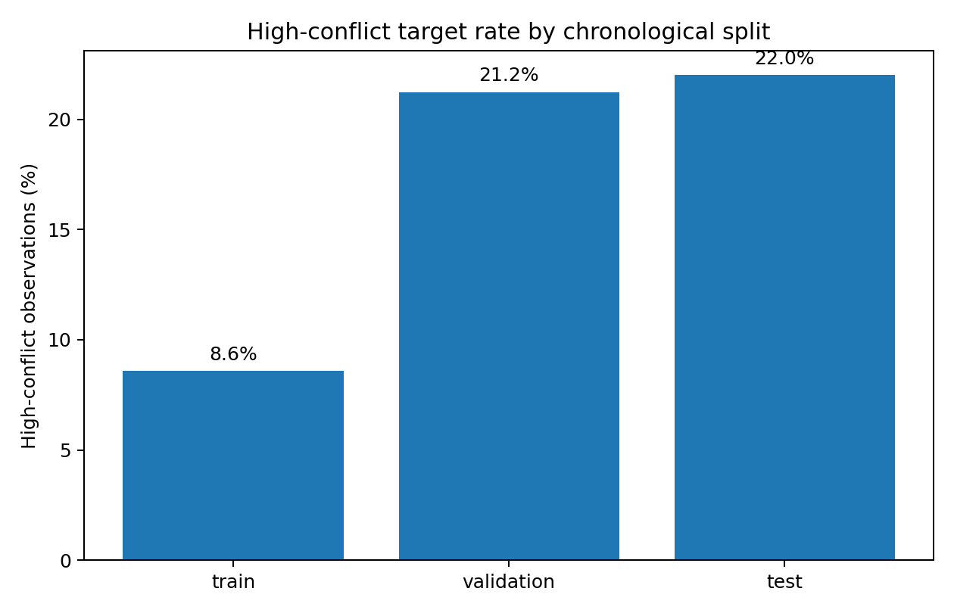
Figure 1. Positive-class rate by chronological split. Source: own calculations from UCDP GED v26.1.

3.6 Algorithms and preprocessing
Five classifiers are used to span distinct methods covered by the course. Logistic Regression provides an interpretable linear probability model and a strong regularized benchmark. k-nearest neighbors (kNN) provides a distance-based nonlinear classifier. The Decision Tree captures nonlinear threshold interactions and remains directly interpretable. AdaBoost combines sequential decision stumps to test whether an ensemble can extract weak nonlinear signals missed by a single tree. Finally, a feed-forward multilayer perceptron (MLP) provides a flexible nonlinear function approximator. The objective is not to declare a universally best algorithm, but to test whether the commodity increment is consistent across different inductive biases.
Country and month-of-year are one-hot encoded. Logistic Regression, kNN, and the MLP standardize numerical inputs because distance and gradient-based methods are scale sensitive. For these model families, raw versus log1p-transformed conflict counts are compared on validation because the conflict variables are strongly right-skewed. Decision Tree and AdaBoost use raw numeric features without scaling because tree splits are invariant to monotonic rescaling. No class resampling is used in the main design. Fixed random seed 42 is applied wherever an estimator or neural-network training procedure is stochastic.

3.7 Evaluation and model-freezing protocol
F1 is the primary selection metric because the positive class is imbalanced and because both false positives and false negatives matter for an early-warning application. Precision, recall, accuracy, and confusion matrices are reported as secondary metrics. Two simple benchmarks provide context. The majority classifier predicts the training majority class and illustrates why accuracy alone can be misleading. The persistence benchmark predicts high conflict next month when the current month already meets the country-specific high-conflict cutoff. This is intentionally demanding because short-run violence is highly persistent.
For every algorithm, the central comparison is within-family: baseline predictors versus the same model augmented with commodity features. The quantity Delta F1 = F1_augmented - F1_baseline is the direct empirical answer to the research question. Hyperparameter choices are made on validation F1 only. Logistic Regression tunes regularization strength and conflict transformation; kNN tunes neighbor count and voting weights; the Decision Tree tunes depth and minimum leaf size; AdaBoost tunes estimator count and learning rate; and the MLP compares several small feed-forward architectures and learning rates with validation-based early stopping. At the end of model selection, one feature-set/configuration winner is frozen for each family before the test set is opened.

4. Implementation
The implementation is organized around the validity risks of a time-dependent classification problem rather than around individual library calls. The most important engineering decision concerns UCDP date precision. Monthly aggregation can create false precision if events known only approximately are forced into a specific month; the pipeline therefore retains imprecise events for audit but excludes them from the primary monthly allocation. A second challenge is leakage. Country thresholds are estimated from the original training period only, chronological splits are defined by target month, and preprocessing objects are fit only on the data available at each modeling stage. The final held-out test is opened only after feature sets and hyperparameters have been frozen.
Skewed conflict counts are another practical issue. Exploratory analysis showed large reductions in skewness after log1p transformation, so raw and log-transformed variants were compared for the scale-sensitive model families without changing the tree-based specification. The neural network is implemented as a small PyTorch feed-forward MLP using ReLU hidden units, Adam optimization, binary cross-entropy, deterministic seeds, and a fixed epoch policy derived from validation. TensorFlow was not available in the final reproducible runtime, so PyTorch was used to preserve the planned feed-forward neural-network experiment without changing its role in the research design.
The final software environment uses Python 3.13 with NumPy 2.3.5, pandas 2.2.3, scikit-learn 1.8.0, matplotlib 3.10.8, PyTorch 2.10.0, openpyxl 3.1.5, and pytest 8.4.2. The analysis does not require specialized hardware; the submitted workflow is designed to run in a standard Python environment.

5. Codebase & Reproducibility
All analyses are implemented in Python and organized in a modular GitHub-ready repository with pinned dependencies, tests, versioned data snapshots, and frozen model configurations. Running `python main.py` from the repository root reproduces the core final-model evaluation; `python main.py --rebuild-data` reconstructs the 14,832-row modeling table from the included source snapshots, while `--from-raw` supports reconstruction from the original UCDP and World Bank files when they are available. A clean-run check passes all repository tests and reproduces the stored final metrics within the documented numerical tolerance. The code repository is submitted alongside this report.

6. Results

6.1 Class imbalance, distribution shift, and the persistence benchmark
The first result is descriptive but important for interpreting all subsequent metrics. The positive-class rate increases from 8.58% in training to 21.24% in validation and 22.01% in the final test period. A classifier that always predicts no high-conflict month can therefore appear accurate while having zero recall and zero F1 for the class of substantive interest. This is why F1, precision, recall, and explicit benchmarks are emphasized rather than accuracy alone.
The persistence benchmark is unusually strong. On the held-out 2022-2025 test period it reaches F1 = 0.846, with precision = 0.843 and recall = 0.848. This means that simply knowing whether the current month is already above its country-specific high-conflict cutoff is highly informative about the next month. The result is substantively consistent with conflict continuation and statistically important because it leaves limited headroom for a slower-moving global macroeconomic signal.

6.2 Final held-out performance of frozen models
Table 2. Final held-out test performance of the frozen model-family winners.
Model | Feature set | F1 | Precision | Recall | Accuracy
MLP | Baseline | 0.857 | 0.917 | 0.805 | 0.941
Logistic Regression | Augmented | 0.855 | 0.924 | 0.795 | 0.941
Persistence | Benchmark | 0.846 | 0.843 | 0.848 | 0.932
kNN | Baseline | 0.844 | 0.935 | 0.769 | 0.938
AdaBoost | Augmented | 0.832 | 0.879 | 0.789 | 0.930
Decision Tree | Baseline | 0.802 | 0.876 | 0.740 | 0.920

The best frozen family-level model is the conflict-history MLP, with test F1 = 0.857. Commodity-augmented Logistic Regression is almost identical at 0.855 and has slightly higher precision (0.924 versus 0.917), while the MLP has higher recall (0.805 versus 0.795). kNN also performs strongly in precision but sacrifices recall. The Decision Tree is the weakest of the selected family winners, although an F1 of 0.802 remains far above the trivial majority benchmark. The rankings therefore do not indicate that the predictive models are generally weak. Rather, several models forecast the high-conflict class well, and the central question becomes whether commodities improve those forecasts.
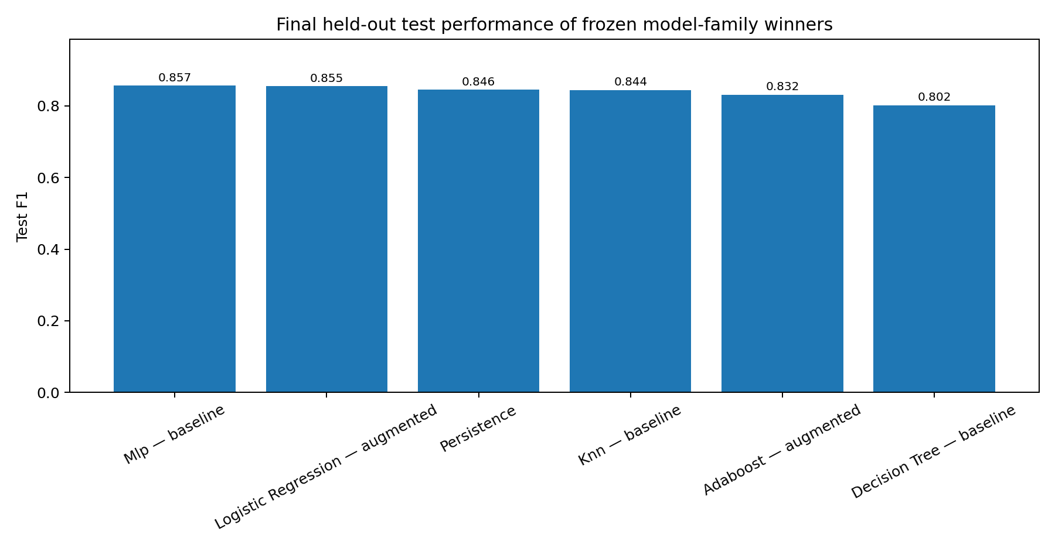
Figure 2. Final held-out test F1 for frozen model-family winners. Source: own calculations.

6.3 Do commodity variables add predictive value?
Table 3. Incremental test F1 from adding commodity-price features within each model family.
Model family | Baseline F1 | Augmented F1 | Delta F1
Logistic Regression | 0.852 | 0.855 | +0.0030
kNN | 0.844 | 0.800 | -0.0446
Decision Tree | 0.802 | 0.802 | 0.0000
AdaBoost | 0.844 | 0.832 | -0.0123
MLP | 0.857 | 0.853 | -0.0043

The answer to the research question is substantially more conservative than the overall model ranking might suggest. Logistic Regression is the only family in which commodity augmentation increases held-out F1, and the improvement is very small: 0.852 to 0.855, or Delta F1 = +0.0030. The Decision Tree is unchanged, while kNN, AdaBoost, and the MLP perform worse after commodity variables are added. The appropriate conclusion is therefore not that commodity prices improve prediction. The data support, at most, a weak and model-dependent incremental signal.
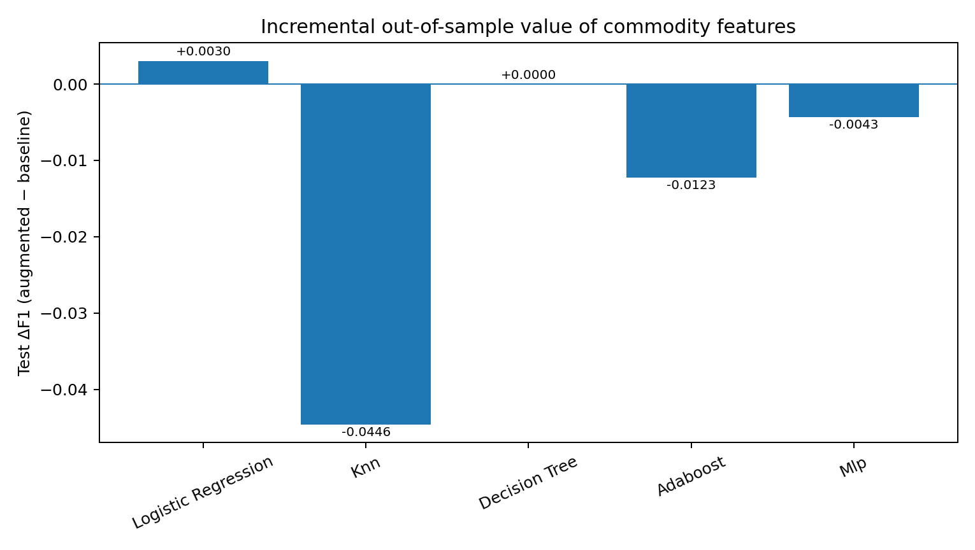
Figure 3. Test Delta F1 from commodity augmentation. Positive values indicate improvement over the same baseline model.
The fitted commodity-augmented Logistic model also provides a descriptive view of how the commodity signals enter the linear decision boundary after standardization. Energy monthly change has the largest positive commodity coefficient (+0.072), followed by energy three-month volatility (+0.040); metals and minerals volatility has the largest negative commodity coefficient (-0.095). These coefficients should not be read as causal effects or statistical evidence that a particular commodity raises or lowers violence. They are conditional predictive associations in a regularized model with correlated global signals, country indicators, seasonality, and conflict-history variables.

6.4 Robustness checks
Table 4. Logistic Regression robustness checks using the frozen hyperparameter specification.
Specification | Baseline F1 | Augmented F1 | Commodity Delta F1
Primary q75 target + 3m volatility | 0.852 | 0.855 | +0.0030
Alternative q80 target + 3m volatility | 0.858 | 0.851 | -0.0064
Primary q75 target + 6m volatility | 0.851 | 0.849 | -0.0021

Two pre-specified robustness checks weaken the already small positive Logistic result. First, the high-conflict definition is made stricter by replacing the country-specific 75th percentile with the 80th percentile, while estimating the alternative cutoffs from the original 2000-2018 training outcomes only. Under this target, the augmented Logistic model performs slightly worse than the baseline (Delta F1 = -0.0064). Second, three-month commodity volatility is replaced by a six-month volatility window while keeping the frozen Logistic hyperparameters. The commodity increment is again negative (Delta F1 = -0.0021). Because the sign of the primary +0.003 gain reverses under reasonable alternatives, the commodity result is specification-sensitive rather than robust.
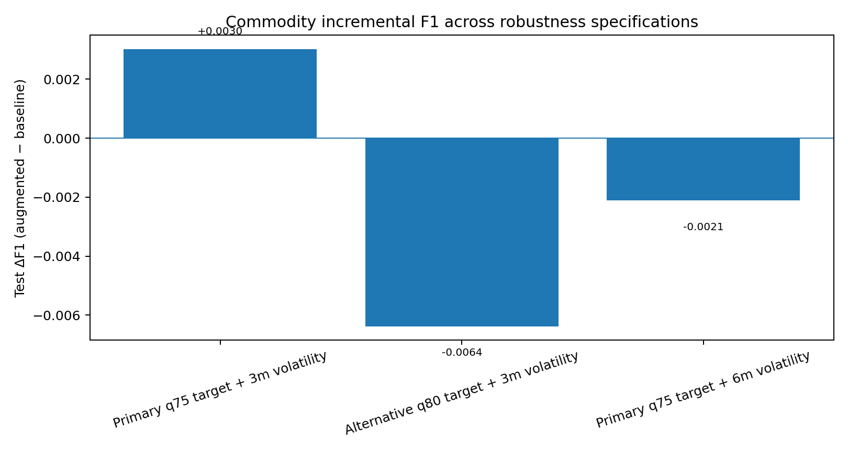
Figure 4. Commodity Delta F1 across the primary and robustness Logistic specifications. Source: own calculations.

6.5 Interpretation and discussion
The main interpretive question is not why the models fail; they do not. The best models reach F1 scores around 0.85 and outperform a strong persistence rule by a small margin. The more precise question is why aggregate global commodity indicators add so little once recent conflict history is known. Several explanations are consistent with both the empirical design and the literature.
First, the one-month forecast horizon may be too short for several commodity-conflict channels. A world-price shock must often pass through exchange rates, domestic prices, wages, transport costs, public revenue, firm behavior, or household welfare before it changes incentives on the ground. Bekkers et al. (2017) explicitly model global-to-local food-price transmission with lags, and Dillon and Barrett (2016) show that transmission speeds differ across channels in East Africa. Testing distributed commodity lags and three-, six-, or twelve-month conflict horizons is therefore a natural extension, but it should be treated as future work rather than post-test tuning of the current hypothesis.
Second, the exposure measure is coarse. Every country receives the same five global index values in a given month. The resource-conflict studies that find clearer relationships often exploit exposure: a country's main export commodity (Brueckner and Ciccone, 2010), municipal coffee or oil intensity (Dube and Vargas, 2013), or the location of mines (Berman et al., 2017). A global metals shock should plausibly matter more for a mineral-exporting district than for a country with little mining activity, while a food-price shock can have different implications for net importers, net exporters, farmers, and urban consumers. The current feature design cannot represent these heterogeneous exposures.
Third, opposing mechanisms may cancel when countries and commodity groups are pooled. Dube and Vargas (2013) illustrate the possibility of an opportunity-cost channel for agricultural income and a rent or rapacity channel for oil. If positive and negative relationships coexist across sectors, a common global predictor can average toward zero even when commodity shocks matter in specific places. Country-by-commodity exposure interactions are therefore more promising than adding additional unweighted global indices.
Fourth, the country-month unit is relatively coarse. UCDP is georeferenced, but the primary project aggregates events to the country level. Local conflict near a mine, border crossing, transport corridor, or crop-producing region may be diluted by the rest of the country. This is particularly relevant in large and heterogeneous states. A subnational design could match local violence to mines, crops, trade routes, weather shocks, or local market prices and would align more closely with the spatial mechanisms identified by Berman et al. (2017).
Fifth, the target mixes onset, continuation, and escalation. Bazzi and Blattman (2014) show why conflict onset and continuation should not automatically be treated as the same process. The strong persistence benchmark in this project confirms that much of the classification problem is about continuation or near-term escalation of already active conflict. Commodity shocks may be more relevant for the onset of new violence, the duration of existing violence, or certain types of organized violence than for the pooled high-conflict indicator used here.
Finally, there is limited independent variation in the commodity data relative to the panel size. The final table has 14,832 rows, but commodity values vary across 309 feature months and are repeated across 48 countries. At the same time, important short-run determinants of violence are omitted: elections, governance, local food and fuel prices, exchange rates, rainfall and climate shocks, displacement, neighboring conflict, armed-group capacity, peace processes, and security interventions. Against a conflict-history baseline that already captures substantial state dependence, global commodity indices may simply be too indirect to produce a stable additional signal.
For practical users, this does not imply that commodity monitoring is useless. It implies that the five global indices used here should not be treated as standalone triggers for humanitarian pre-positioning, corporate route changes, or financial hedging. They may still be useful as one layer in a broader early-warning system when combined with country-specific exposure measures, local market data, political indicators, and conflict dynamics. The result is therefore informative for model design: adding more global variables is less promising than making economic exposure more local, more heterogeneous, and better aligned with the mechanisms through which prices reach conflict-affected populations and assets.

7. Conclusion
This project asked whether global commodity-price changes and short-run volatility improve the one-month-ahead prediction of high-conflict months in Sub-Saharan Africa beyond recent conflict history. The answer is largely negative. The predictive models themselves are reasonably strong: the frozen baseline MLP reaches F1 = 0.857 on the held-out 2022-2025 test period, commodity-augmented Logistic Regression reaches 0.855, and a simple persistence benchmark reaches 0.846. Recent violence is therefore the dominant short-run signal. Commodity variables add only +0.003 F1 to Logistic Regression, add nothing to the Decision Tree, and reduce F1 for kNN, AdaBoost, and the MLP. The small positive Logistic increment also turns negative under an alternative q80 target and a six-month volatility window.
The study contributes a transparent predictive test rather than a causal estimate. Its strengths are the careful construction of a balanced monthly panel, explicit handling of event-date precision, country-specific target thresholds estimated from training outcomes only, a strong persistence benchmark, validation-only model selection, an untouched chronological test period, and a fully reproducible Python repository. These design choices make the weak commodity result more credible: it is not a consequence of models that cannot predict conflict at all, nor of evaluating on randomly mixed time periods.
Several limitations define the next research steps. Global prices should be replaced or supplemented with country-specific export/import weights, fiscal dependence, mine locations, crop shares, and local food or fuel prices. Distributed lags and multiple forecast horizons should test whether transmission operates more slowly than one month. Subnational matching would better connect economic exposure to conflict locations. Future targets should separate onset, continuation, escalation, and types of violence. Finally, political, climate, displacement, exchange-rate, and neighboring-conflict variables could be added and evaluated using rolling-origin backtests. The current evidence therefore suggests that publicly observable global commodity prices, in their aggregate form, are a weak supplement to recent conflict history rather than a robust standalone early-warning signal.

References
Bazzi, S., & Blattman, C. (2014). Economic shocks and conflict: Evidence from commodity prices. American Economic Journal: Macroeconomics, 6(4), 1-38. https://doi.org/10.1257/mac.6.4.1
Bekkers, E., Brockmeier, M., Francois, J., & Yang, F. (2017). Local food prices and international price transmission. World Development, 96, 216-230. https://doi.org/10.1016/j.worlddev.2017.03.008
Berman, N., Couttenier, M., Rohner, D., & Thoenig, M. (2017). This mine is mine! How minerals fuel conflicts in Africa. American Economic Review, 107(6), 1564-1610. https://doi.org/10.1257/aer.20150774
Brueckner, M., & Ciccone, A. (2010). International commodity prices, growth and the outbreak of civil war in Sub-Saharan Africa. The Economic Journal, 120(544), 519-534. https://doi.org/10.1111/j.1468-0297.2010.02353.x
Collier, P., & Hoeffler, A. (2004). Greed and grievance in civil war. Oxford Economic Papers, 56(4), 563-595. https://doi.org/10.1093/oep/gpf064
Davies, S., Pettersson, T., & Oeberg, M. (2026). Organized violence 1989-2025, and violent political protests. Journal of Peace Research, 63(4), 705-723. https://doi.org/10.1093/jopres/xjag046
Dillon, B. M., & Barrett, C. B. (2016). Global oil prices and local food prices: Evidence from East Africa. American Journal of Agricultural Economics, 98(1), 154-171. https://doi.org/10.1093/ajae/aav040
Dube, O., & Vargas, J. F. (2013). Commodity price shocks and civil conflict: Evidence from Colombia. The Review of Economic Studies, 80(4), 1384-1421. https://doi.org/10.1093/restud/rdt009
Fearon, J. D. (2005). Primary commodity exports and civil war. Journal of Conflict Resolution, 49(4), 483-507. https://doi.org/10.1177/0022002705277544
Hegre, H., Allansson, M., Basedau, M., Colaresi, M., Croicu, M., Fjelde, H., et al. (2019). ViEWS: A political violence early-warning system. Journal of Peace Research, 56(2), 155-174. https://doi.org/10.1177/0022343319823860
Humphreys, M. (2005). Natural resources, conflict, and conflict resolution: Uncovering the mechanisms. Journal of Conflict Resolution, 49(4), 508-537. https://doi.org/10.1177/0022002705277545
Ross, M. L. (2004). What do we know about natural resources and civil war? Journal of Peace Research, 41(3), 337-356. https://doi.org/10.1177/0022343304043773
Sundberg, R., & Melander, E. (2013). Introducing the UCDP Georeferenced Event Dataset. Journal of Peace Research, 50(4), 523-532. https://doi.org/10.1177/0022343313484347
Uppsala Conflict Data Program. (2026). UCDP Georeferenced Event Dataset (GED) Global version 26.1. Uppsala University. https://ucdp.uu.se/downloads/
World Bank Prospects Group. (2026). World Bank Commodity Price Data (The Pink Sheet), monthly historical data. World Bank. https://www.worldbank.org/en/research/commodity-markets

Appendix A. AI Tools Used
Generative AI tools were used as coding and writing assistants. ChatGPT (OpenAI) supported project planning, code drafting and debugging, data-pipeline design, model-comparison structure, interpretation, reproducibility documentation, literature-search support, and editorial restructuring of the report. All empirical results in the final submission are generated from the submitted Python code and source data; the author reviewed the analytical decisions, checked the outputs, and remains responsible for the final content and academic claims.
AI tools are not used as evidence for academic claims. Substantive statements in the report should be supported by the cited peer-reviewed literature, official dataset documentation, or the reproducible project outputs.

