Table des matières
Introduction 2
IEEE 802.11 WLAN simulator KERNEL 3
IEEE 802.11 Wireless simulator 4
XML configuration file: 10
Simulator Features 11
-PHY layer 11
Loading the simulator 13
Performing a Simulation: Step by step 13
Configuring the simulation 13
The network configuration group 13
Running the simulation 16
Viewing the results 17
Using Results files 17
Google Earth visualization 17
Using the application’s XML file 19
Description of traffic source elements 23
Generic source (data) 23
FTP source 24
HTTP source 24
Video source 24
Simulator calibration 26

Introduction
This WLAN simulator is available on Sourceforge:
https://sourceforge.net/projects/hewsimulator/

802.11ax is an IEEE wireless standard that deals with high density environments such as urban areas, commercial malls, trains.
No other open or close source simulator such as NS2, NS3 or Opnet provide means to simulate 802,11ax whose first chipsets should reach the market in 2018.

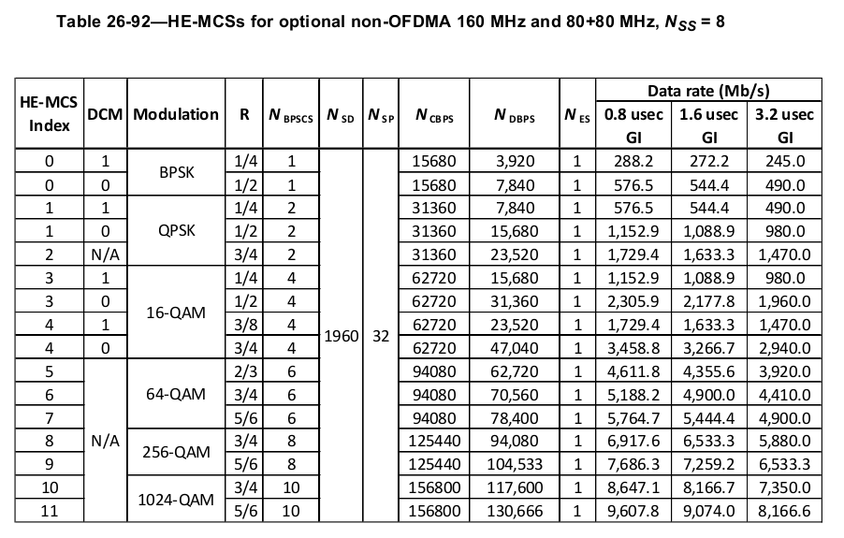

This simulator is intended to also simulate 802,11ac, 802,11af , LTE-U and 802.11ah, however LTE-U and 802,11ah simulators are still not written.
IEEE 802.11 simulator uses the Jemula discrete event network simulator. It is an Alpha software which means it is still unstable and should not be used in production environments. As in real life products, not all features of the IEEE 802,11ax amendments are implemented.

There are two way to write parameters, one which is limited but easy and fast, the other which enables lot of options but which is quite difficult to use. We use the fast lane:

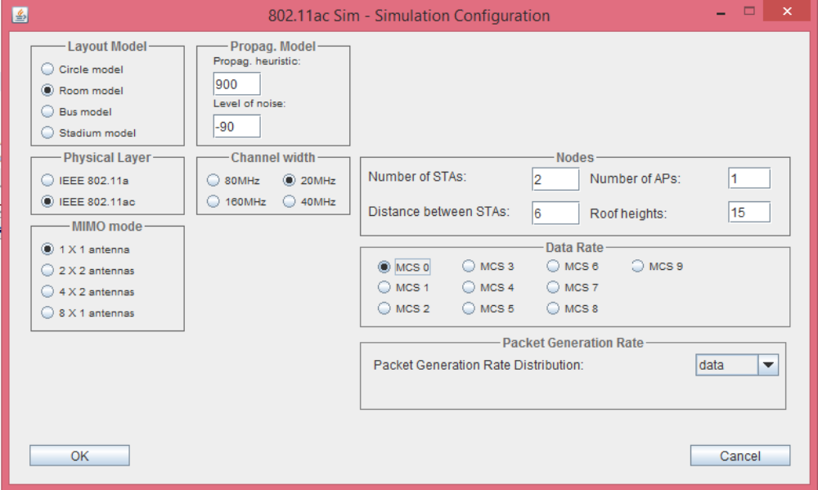

IEEE 802.11 WLAN simulator KERNEL
IEEE 802.11 WLAN simulator uses Jemula kernel which is an open source JAVA library that constitutes a kernel for event-driven stochastic simulation.
The kernel is based on events for the simulation thereby all simulations must start with an initial event and finish of the same form or just with lack of events.
The simulation core consists of three main packages called kernel, statistics and plot. The first package ‘kernel’ provides the classes for event handling and scheduling of events, including event, event handler, simulation time, and event scheduler. The other two packets provide utilities for statistics and plots to illustrate the function of the system.
Note that simulations operate with their own simulated time, which is non-real-time and entirely independent of the time consumed during a simulation.

IEEE 802.11 WLAN simulator provides flexible settings that make the configuration easy and thorough. At first,
The XML configuration file enables to configure different parameters of each station like delays, modulations and different parameters of each standard. The definition of stations and interconnection between them is made manually by assigning position and send/receive against other station making easy the formation of different topologies (star, tree, etc).

IEEE 802.11 Wireless simulator

A. Emulation Scope
IEEE 802.11 is a set of standard that has grown since his first released in 1997 so at this moment it contains a lot of amendments addressing many work items or even radio bands so emulating all amendments to the standard is too complicated for a single simulator and it is the case of IEEE 802.11 WLAN simulator.

This IEEE 802.11 emulator code is at this time, only in the 5 GHZ band.

B. Code Schema
The topology of the code simulator is based on a layer model similar to OSI model for network architecture. Making it more modular helped in the process of adaptation, modifications.

IEEE 802.11 WLAN simulator defines eight principal packages:
- emulator,
- layer0_medium,
- layer1_phy,
- layer2,
- layer3_network,
- layer4, station
- layer5, the traffic management

The ‘emulator’ package load the XML configuration and initialize all the components for starting the simulation, it launches the first event.
The objects generated during the configuration represent the different stations and communications. Each station is represented by a single “Station” object but each connection between stations are represented by a set of objects of the package layers so one station may have running several ‘JE802_11Mac’ objects at the same time. Most of complexity is in layer2.
The simulator consisting of forty five events that are sent and received between the different classes of the source.
Several event are empty, are never sent or just never received/captured. It's the case of: ‘Packet_timeout’, ‘PHY_Channel_Switch_red’, ‘RegisterCcaTX_req’, ‘Rx_expired_ind’, ‘Tx_expired_ind’ and ‘Virtual_collision_ind’. Discarded several events, started the identification of independent events, in other words, events that are independent of the protocol used, events that start and stop de simulation or are sent to the statistic code of simulator.
The simulation starts with ‘start_req’ events sent by ‘JE802Control’ class, called by ‘JE802Starter’. The different stations in the simulation send the same event asynchronously starting of this form the transmission of the different events.
Studying deeply the rest of the event observed that some events are equals in the both protocols and matching with the different SAP defines in the protocol. An example of it is the events ‘PHY_RxStart_ind’ and ‘PHY_TxStart_req’ that matching with the PHY SAP primitives define in 802.1 standards.

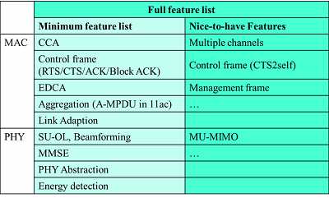

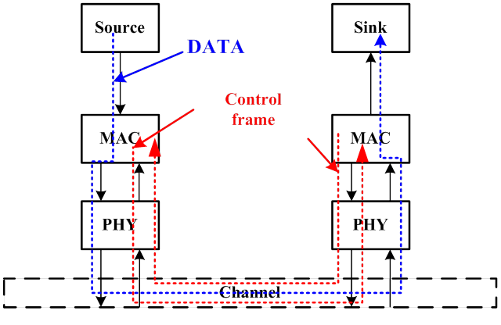

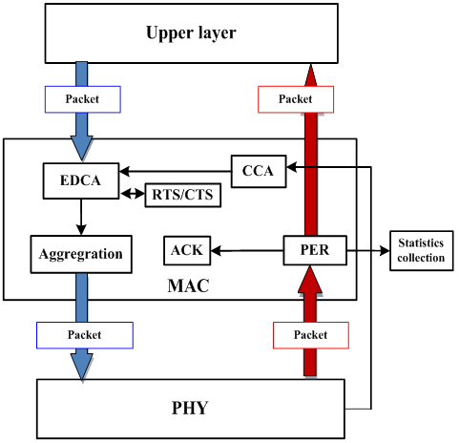

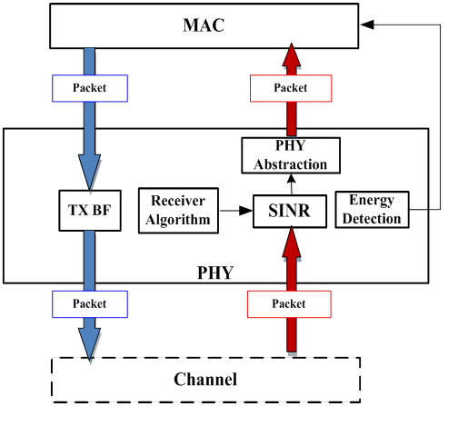

XML configuration file:
The configuration format consist of four principal sections:
- ‘Control’ that defines time of emulation, parameters of evaluation and parameters of visualization results,
- ‘Station’ the more complex section defines all parameters of the different layers of the protocol (will be explained more thoroughly in the following paragraph) and are defines one per real station in the simulation,
- ’WirelessChannels’ defines frequencies and values of different channels for communication,
- ’PhyModes’ defines the modulation techniques that can be applied.

The ‘Station’ section subdivides in
- ‘Mobility’ defines the location in the simulation of this station,
- ‘TCP’ defining the buffer size, timeout among others;
- ‘MAC’ defines all parameters of Mac and physical layer,
- ‘TrafficGenerator’ include values for generation of traffic between stations, are defines at least one per communication inter stations.

Simulator Features
IEEE 802.11 WLAN simulator performs a simulation of the MAC protocol and a partial simulation of the PHY layer, based on the IEEE 802.11 specification.

-PHY layer
Approximately 802.11ac
- 10 MCS
- 4 Channel widths
- Space Streams up to 8

It can also take in account the physical radio environment or at least have placeholders for future features:
- Type of physical layout of stations (in a circle, length, etc.)
- adjustable propagation models
- a level of noise (not yet supported)
- multiple BSS over the same area, there is a bug that prevents from correctly simulate here)
- the number of stations, they are distributed automatically depending on the model (circle, etc.)
- the distance between stations (take into account hidden stations)

The packets can be adjusted:
* in size with several possibilities to vary the size automatically
* in number per second (with there also several possibilities of automatic variation)

Other features:
- EDCA
- possibility of manual adjustments on a convenient enough XML configuration file.

The major advantages of the application concerning simulation of 802.11ac WLANs are the following:
- Support of data rate agility. This means that each node can work on its own data rate, depending on the distance from the receiver.
- Support of the CTS-to-Self virtual carrier sense and protection mechanism: This means that a node can support RTS/CTS or the CTS-to-Self virtual carrier sense mechanism for better network performance.
RTS/CTS in Jemula802: To simulate various scenarios with and without the RTS/CTS handshake mechanism. This can be enabled and disabled setting the parameters dot11RTSThreshold in the XML scenario files inside the MIB of 802.11:
- <MIB802.11-1999 dot11BroadcastAddress=”255″ dot11FragmentationThreshold=”1024″ dot11LongRetryLimit=”3″ dot11MACAddress=”1″ dot11MaxReceiveLifetime=”1000″ dot11MaxTransmitMSDULifetime=”1000″ dot11RTSThreshold=”5000″ dot11ShortRetryLimit=”3″/>
Set the value to a large number to make sure no packet will be transmitted with the RTS/CTS, for example 5000. If the value is set to, for example, 200, then every packet longer than 200byte will be transmitted with RTS/CTS, and every smaller packet will be transmitted without RTS/CTS. Setting the value to zero means that every packet will be transmitted with RTS/CTS enabled.
- Support of different types of traffic sources: IEEE 802.11 WLAN simulator supports traffic sources, like FTP, HTTP, Video, as described in 3GPP standardization group. The DATA traffic type creates packets with arbitrary lengths, between 0 and the maximum provided (1500 Byte for example, but any number is possible in the simulator – in real life it has to be less than 2305 Byte). The length is uniformly distributed. Small packets create a lot of overhead because of the CSMA protocol. here are other traffic types: SATURATION, CBR, SATURATION_FIXED, DATA, DISABLED.
- DATA: default model, behavior as described above. Packet interarrival time is Poisson distributed
- SATURATION: same as data, but the instead of following the throughput definition, this always pumps packets so that the channel is always full, and the listen before talk CSMA protocol is always active.
- CBR: constant bit rate: packet size is always the maximum, interarrival time is constant
- SATURATION_FIXED: Combination of CBR and SATURATION
- DISABLED: No packets are generated
- Support of the IEEE 802.11e EDCA function for QoS and service differentiation in 802.11ac WLANs.
- Support of many statistic results, which show detailed information concerning the MAC layer performance.

Loading the simulator
Open a terminal, browse to the folder and run the command:
Java –jar 11acSimulator.jar

Performing a Simulation: Step by step
The steps for performing a simulation is to configure the simulation, run it and view the results.

Configuring the simulation
Once you have loaded IEEE 802.11 WLAN simulator , an application window is displayed named 802.11ac WLAN Simulator. All the simulation parameters are configured from this window and are explained below:
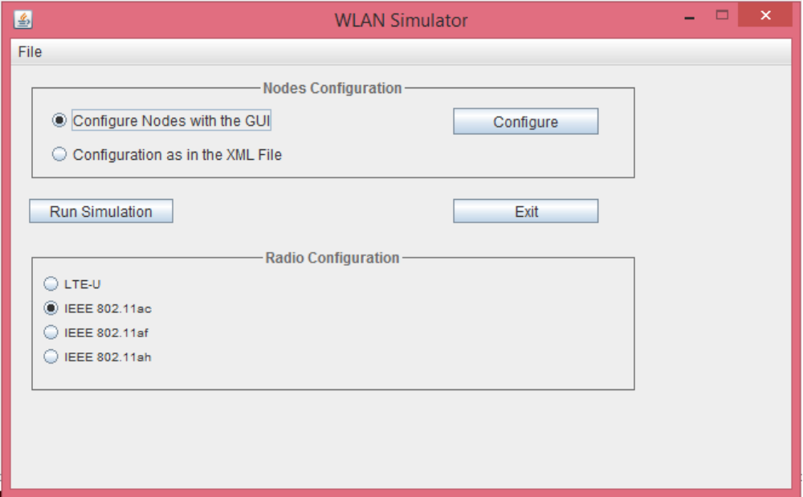
Radio configuration: Select one of the available physical layers for your network.
The only available configuration is 802,11a. Other configurations are only available in a commercial product. Please contact http://padiracinnovation.org for more information.

The network configuration group
There are two available options there.
- Graphical configuration: Use this option if all nodes of your network have the same parameter values. Note: If you choose to configure nodes globally then LOS will be assumed for all nodes. If you plan to include the hidden terminal problem in your simulation scenario then you must configure the nodes using the Network XML configuration file.
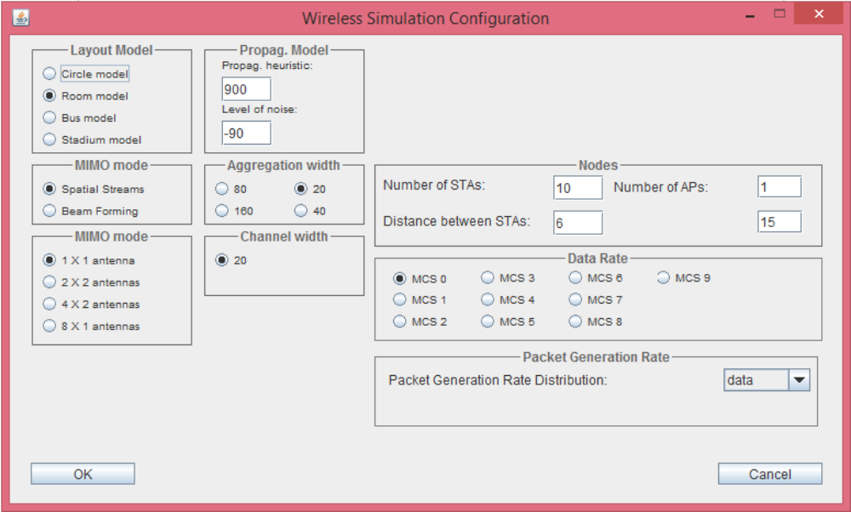

- Configuration with application’s XML file: When configuring the simulation parameters (either globally or through network XML configuration file), IEEE 802.11 WLAN simulator creates an XML file, which is read by the simulation engine when the user presses the Run button. This XML file is located in the conf folder of the application directory. Users that are familiar with XML can use this file to define the simulation scenario. This gives also the ability to copy the XML file in a backup directory, if you intend to load the scenario some other time (you can do that even if you are not familiar with xml). Keep in mind that the most sophisticated features supported by IEEE 802.11 WLAN simulator can only be available if you use this option.

In the remainder of this subsection, the meaning of some parameter for global node’s configuration are explained.
Nodes’ configuration: The following parameters must be configured:
Number of Nodes: Insert the number of nodes that exist in your network.
Packet length configuration: The following items must be configured:
Packet Length Distribution: Select one of the distributions the length of the generated packets obeys.
Packet Length mean: Select the mean value of the packet length in bits. Note that the maximum value the protocol allows is 32768bits. If you set the mean to a higher value then the packet will be fragmented.
Packet generation rate configuration: The following items must be configured:
Packet Generation Rate Distribution: Select the distribution the packet generation rate obeys.
Packet generation rate mean: Select the mean value of packet generation rate in packets per second.
Rate (only available in network XML configuration file): The node’s data rate in b/s.
X-Position (only available in network XML configuration file): The node’s horizontal coordinate in meters, related to an abstract coordination center (point 0).
Y-Position (only available in network XML configuration file): The node’s vertical coordinate in meters, related to an abstract coordination center (point 0).
Coverage (only available in network XML configuration file): The node’s coverage radius in meters.
Physical layer-PHY (only available in network XML configuration file): The node’s physical layer type.
AC (only available in network XML configuration file): The node’s access category for 802.11e QoS support (0, 1, 2 or 3).

Running the simulation
In this point the simulation configuration is completed. Click on the “Run” button to start the simulation execution. The simulation execution window is opened which shows the simulation progress. This may take from a minute to a century, mostly depending on the simulation time and your CPU speed. The simulation execution runs as a process with normal priority in the operating system. You can use the task manager to increase or decrease the priority of the task. It is recommended not to use high or real time priority because you will not be able to touch your PC until the simulation is complete. You can pause or stop the simulation any time you want. However, if you stop the simulation, results will be collected until this moment but mean values will not be collected at all. Once you have done, close the window to return to the main console.

Viewing the results
Click on the “View Results” button to view the results.
The results are available both in a visual way and in many text files that could be analyzed with various scripts.
You can zoom in and out in this GUI window not only with “+” and “-” but also by striking “i” and “o” (equivalent to zooming in and out).
If the GUI is enabled in the scenario file (showGui attribute in the JE802Control tag) a Java frame will pop up and show the ongoing simulation. You can use the mouse and the following keys to navigate:
- Use the mouse wheel to scroll left and right or < and Y.
- Use left click to zoom in and right click to zoom out or I/+ and O/-.
- F switches through different visualization of the packets.
- B toggles backoff visualization.
- N toggles NAV visualization.
- C switches through all available channels.

Additional information is shown in the packets if zoomed to a certain level.

Using Results files
The simulation will create a folder where it stores all the result files. The folder can be specified in the scenario file (Path2Results attribute in the JE802Control/JE802StatEval tag). The following result files are generated:
overall throughput, offer and delay (total_*.m)
throughput, offer and delay per access category (*_ACx.m)
throughput, offer and delay per link and access category
power consumption (overall and per station)
retransmission rates (only for TCP traffic)

The *.m file are are formatted as a matrix an can directly be read into Matlab. They also contain a key for the different columns. Overalls and averages are always accumulated.

Google Earth visualization

The simulation also generates a Google Earth file (*.kml) for visualization of the results. If enabled in the scenario file (generateGEarth attribute in the JE802Control/JE802Animation tag), it can also be found in the result folder after the simulation has completed. The different parts of the visualization can be enabled using the check-boxes on the left. Hit the play button in the top left corner of the map. If it plays to fast, you can adjust the speed in the settings of the play bar.
When simulating with Jemula802, at the end you may want to create an KML Google Earth animation file. Depending on the scenario, this may consume a lot of memory, and an error message like below may appear:
[java] Exception in thread “main” java.lang.OutOfMemoryError: Java heap space
Solution: dont forget to increase the VM space by adding an argument such as -Xmx512M or -Xmx1g to the run configuration. When using ANT, then the maxmemory attribute has to be added:
<java classname=”${main.class}” fork=”true” maxmemory=”1024M”>.
Another way to solve the memory problem is to increase the overlayaccuracy in the JEAnimation tag of the XML scenario file.

Using the application’s XML file
The application’s XML file is an alternative method to configure a simulation. Using this method, a text-based configuration can be done, without having to pass through all configuration steps when there is the need to repeat a simulation with minimal changes.
Note: All new features supported by IEEE 802.11 WLAN simulator are applicable only through the application’s XML file. This means that, if you want to configure sources other than generic, or if you want to configure nodes with more than one sources, then you must do it through the application’s XML file.
Despite the fact that the document is based on the XML language, its structure is simple, so there is no need to know XML in order to configure it.
The application’s XML file is always stored in the folder IEEE 802.11 WLAN simulator _HOME/config. Hence, pay attention to always keep a backup of the XML configuration files you create. A folder named bkp exists for this purpose, where backups of the original XML configuration files exist. It is recommended not to modify the files of this folder.
The remaining of this section describes the structure of the XML network XML configuration file.

showGui="true"
EmulationDuration_ms="10000"
resume="false"
resumeFile="results\hibernation.zip">
seed="1"
EvalThrpPerAC="true"
EvalDelayPerAC="true"
EvalOfferPerAC="true"
EvaluationStarttime_ms="0"
EvaluationInterval_ms="100"
Path2Results="results"
EvalTotalOffer="true"
EvalTotalThrp="true"
EvalTotalDelay="true"
HistogramMax_ms="100"
HistogramNumOfBins="2000">
attenuationFactor="3.5"
baseLatitude="47.37655200000001"
baseLongitude="8.548604999999982"
generateGEarth="true"
maxDelay="5"
maxThrp="3"
maxTxdBm="20"
mbPerBlock="0.2"
minTxdBm="-60"
overlayAccuracy="2"
generateOfferBlocks="true"
generatePowerOverlay="true"
routingEnabled="false"
channelSwitchingEnabled="false"
multiChannelPathMetricEnabled="false"
activeRouteTimeout_ms="3000"
ipHeaderByte="20"
brokenLinkAfterLoss="10"
helloInterval_ms="5000"
channelSwitchingDelay_ms="1" />
isMobile="false"
xLocation="0"
yLocation="0"
zLocation="0"
oldFormat="true"
b="1"
bufferSizePackets="10"
minimumTimeoutMs="50"
slowStartThreshold="10"
dot11MacAddress4_byte="6"
dot11MacFCS_byte="4"
dot11MacHeaderACK_byte="10"
dot11MacHeaderCTS_byte="10"
dot11MacHeaderDATA_byte="24"
dot11MacHeaderRTS_byte="16"
dot11WepEncryption="false">
NameOfAlgorithm="phymode_54Mbps"
ComputingInterval_ms="100"
ShowPlot="false"
AC="1"
queuesize="10">
dot11EDCAAIFSN="2"
dot11EDCACWmax="1023"
dot11EDCACWmin="15"
dot11EDCAMSDULifetime="1000"
dot11EDCAPF="2.0"
dot11EDCATXOPLimit="3008"
dot11BroadcastAddress="255"
dot11FragmentationThreshold="512"
dot11LongRetryLimit="4"
dot11MACAddress="1"
dot11MaxReceiveLifetime="1000"
dot11MaxTransmitMSDULifetime="1000"
dot11RTSThreshold="500"
dot11ShortRetryLimit="7" />
PLCPHeaderWithoutServiceField_ms="0.004"
PLCPPreamble_ms="0.016"
PLCPServiceField_bit="16"
PLCPTail_bit="6"
SymbolDuration_ms="0.004">
SIFS="0.016" aSlotTime="0.009"
dot11CurrentChannelNumberRX="6"
dot11CurrentChannelNumberTX="6"
dot11CurrentTransmitPowerLevel_dBm="20" /> |  | Used to create new JE802_11Ppdu
xDirection="0" |  | Used to create an antenna
yDirection="-5" |  | Used to create an antenna
zDirection="1.6" |  | Used to create an antenna
angle_degrees="30" |  | Used to create an antenna
gain_dBi="50" /> |  | Not used
<JEWirelessChannels>
useMIMO | As name tells
theReuseDistance_m="200" | Distance at which two BSS can use the same channel safely, otherwise if they use the same channel, they are in OBSS, however RTS/CTS could protect transmission | Used in JE802PHY, JE802_11PHY and JE802Control. But only JE802Control used it for animation, JE802PHY, JE802_11PHY only expose it and it is not used.
useInterference="false" | Removed as always true, now.
orthogonalChannelDistance="1" | this should represent interchannel interference but is poorly implemented | Used in JE802MediumInterferenceModel()
channelBusyThreshold_dBm="-82" | Manage CCA level | Used in JE802MediumInterferenceModel()
noiseLevel_dBm="-95"> | ambient noise | Used in JE802MediumInterferenceModel()
dot11MaximumTransmitPowerLevel_dBm="20.0" |  | Not used
aChannelNumber="11" |  | Used
dot11FreqBandWidth_MHz="22.0" |  | Not used
dot11CenterFreq_MHz="2462" |  | One the two parameters used to instantiate a new JE802ChannelEntry, the other parameter being the channel number
<JE802PhyModes>
aPhyMode | Defines a PHY MCS, which is part of what defines a station. In a station, the aPhyMode is associated to a MAC.
Mbps="06" | Throughput in Mbits/sec | Used only in JE802PhyMCS which is unused (but may be used later with adaptation rate or MIMO.
Name="MCS0" |  | Used in JE802PHY and JE802_11PHY for setCurrentPhyMode()
basic="true" |  | Used only in JE802PhyMCS which is unused.
bit_per_symbol="24" | Number of bits in one OFDM symbol, where the modulation gives the number of modalities, i.e. how many bits a sub-carrier carries, it should be multiplied by the number of sub-carriers in the OFDM symbol, to get the number of bits in one OFDM symbol. For example MCS0 uses BPSK, so on bit per sub-carrier, the coding is ½ which means half of bits transmitted are usable data. There are 56 sub-carriers in this MCS (and 8 “pilot” sub-carriers) so there are 56/2 bits per OFDM symbols. | Used in JE802_11BackoffEntity to calculate the number of symbols.
id="1" |  | Used only in JE802PhyMCS which is unused.

Description of traffic source elements
In this subsection, a description of the parameters of each source element is outlined.

Generic source (data)
This source represents a generic (abstract) source, producing abstract traffic, obeying specific parameters. Use this source by specifying type=”generic” in the definition of the source element.
- pktLngth: The node’s packet length mean value in bits. Can be a decimal number.
- pktDist: The distribution of the packet length: c for constant, u for uniform and e for exponential. Be sure to write only one of the above three characters in lowercase. Write only one of the predefined characters. Any other character will be handled as exponential distribution.
- intArrTime: The mean value of the packet generation rate in packets/sec. Can be a decimal number.
- intArrDstr: The distribution of the packet generation rate: c for constant, u for uniform and e for Poisson. Be sure to write only one of the above three characters. Write the characters in lowercase. Write only one of the predefined characters. Any other character will be handled as Poisson distribution.

FTP source
This source represents a source generating FTP traffic, as described in 3GPP TR 25.892 V6.0.0 (see Appendix). Use this source by specifying type=”ftp” in the definition of the source element. For the explanation of the parameters that follow, please have a look at the appendix.
- pktSize: The MSDU packet size in bits. Can be a decimal number.
- fileSizeMean: The mean value of the file size in bytes. Can be a decimal number.
- fileSizeStDev: The standard deviation of the file size in bytes. Can be a decimal number.
- fileSizeMax: The maximum value of the file size in bytes. Can be a decimal number.
- readingTime: The reading time in seconds. Can be a decimal number.

HTTP source
This source represents a source generating HTTP traffic, as described in 3GPP TR 25.892 V6.0.0 (see Appendix). Use this source by specifying type=”http” in the definition of the source element. For the explanation of the parameters that follow, please have a look at the appendix.
- pktSize: The MSDU packet size in bits. Can be a decimal number.
- mainObjectMean, mainObjectStDev, mainObjectMin, mainObjectMax: The mean, standard deviation, minimum and maximum values of the main object in bytes. Can be a decimal number.
- embObjectMean, embObjectStDev, embObjectMin, embObjectMax: The mean, standard deviation, minimum and maximum values of the embedded object in bytes. Can be a decimal number.
- NumOfEmbObjectsMean, NumOfEmbObjectsMax: The mean and maximum values of the number of embedded objects. Can only be integer values.
- readingTime: The reading time in seconds. Can be a decimal number.
- parsingTime: The parsing time in seconds. Can be a decimal number.

Video source
This source represents a source generating video traffic, as described in 3GPP TR 25.892 V6.0.0 (see Appendix). Use this source by specifying type=”video” in the definition of the source element. For the explanation of the parameters that follow, please have a look at the appendix.
- frameRate: The frame rate in frames/sec. Can only be an integer number.
- packetsPerFrame: The number of packets per frame. Can only be an integer number.
- pktSize: The mean value of the packet size in bytes. Can be a decimal number.
- pktSizeMax: The maximum value of the packet size in bytes. Can be a decimal number.
- pktIntArr: The mean value packet interarrival time in seconds. Can be a decimal number.
- pktIntArrMax: The maximum value of the packet interarrival time in seconds. Can be a decimal number.

Simulator calibration
(from Perahia and Stacey book: “Next generation Wireless Lans”)

PHY PS/Actual

PHY throughput | 20MHz | 40MHz | 80MHz | 160MHz
1*1 | 50/72 | 130/144
2*2 | 130/288 | 270/577
3*3 | 300/ | 400
4*4 | 260 | 500

Test 1: PremiseModel

Verify in./results/result that the <> parameter works for all values four models are visible in <PremiseModel>

Test 2: Propagation model

Verify in./results/result that the <ProPag> parameter works for two different values

Test 3: Level of noise in the premise

Verify in./results/result that the <Ambient_Noise> parameter works for all values

Test 4: Type of PHY layer

Verify in./results/result that the <phyLayer> parameter works for all values

"1" is 802.11a

try with MCS 0; throughput should be between 4 and 6 Mbytes/sec

try with MCS 7; throughput should be between 35 and 50 Mbytes/sec

"2" is 802.11ac (20MHz, short GI)

try with MCS 0; throughput should be between 4 and 7 Mbytes/sec

try with MCS 1; throughput should be between 7 and 14 Mbytes/sec

try with MCS 3; throughput should be between 10 and 28 Mbytes/sec

try with MCS 5; throughput should be between 30 and 57 Mbytes/sec

try with MCS 9; throughput should be between 50 and 95 Mbytes/sec

Test 5: Impact of spatial streams (20MHz, short GI)

Verify in./results/result that the <SpatialStreams> parameter works for all values (the throughput is a direct function of the number of SS)

try with MCS 0, 1 X 1; throughput should be between 4 and 7 Mbytes/sec

try with MCS 3, 2 X 2; throughput should be between 100 and 120 Mbytes/sec

try with MCS 5, 4 X 2; throughput should be between 430 and 480 Mbytes/sec

try with MCS 9, 8 X 1; throughput should be between 700 and 780 Mbytes/sec

Test 6: Impact of channel size (802.11ac, MCS 7, short GI, 1 X 1)

Verify in./results/result that the <channel_width> parameter works for all values

try with 20MHz; throughput should be between 65 and 72 Mbytes/sec

try with 40MHz; throughput should be between 110 and 144 Mbytes/sec

try with 80MHz; throughput should be between 230 and 288 Mbytes/sec

try with 160MHz; throughput should be between 450 and 560 Mbytes/sec

Test 7: TCP/IP
802.11a
10 users: 6 Mbits
20 users: 3 Mbits
50 users: 1 Mbits/
Below is shown three tests at MCS 0, MCS 4, MCS 9.
The fourth test highlight spatial streams.
Influence of channel width is also demonstrated.

Test 1
2 stations, channel width 20Mhz, MCS : 0
The next picture shows three frames exchanged between the two stations.

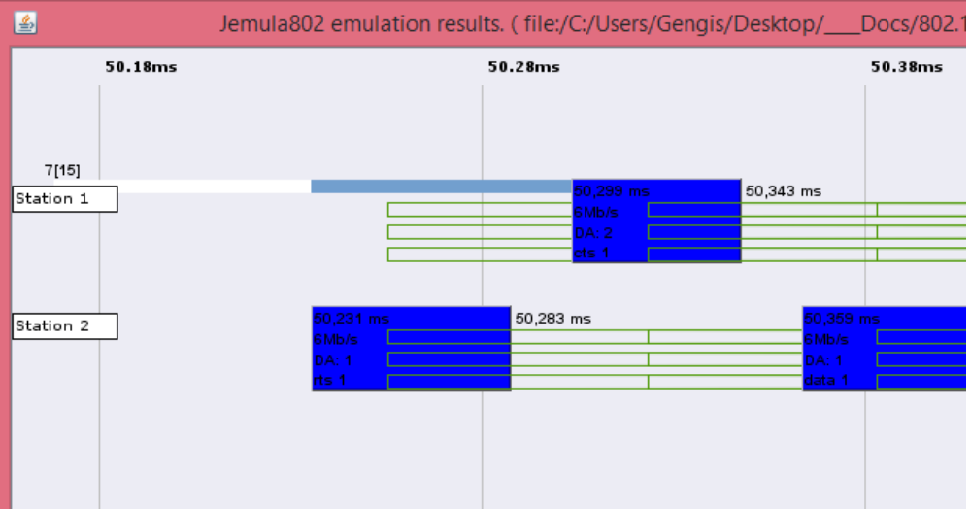
Partial output of the file “total_thrp.m”:

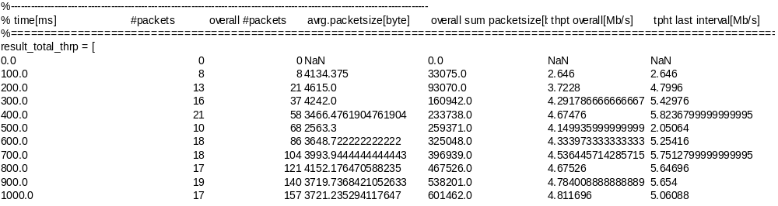
MCS 0 in a 20 MHz channel gives 6 MHz.

Test 2
2 stations, channel width 20Mhz, MCS : 4

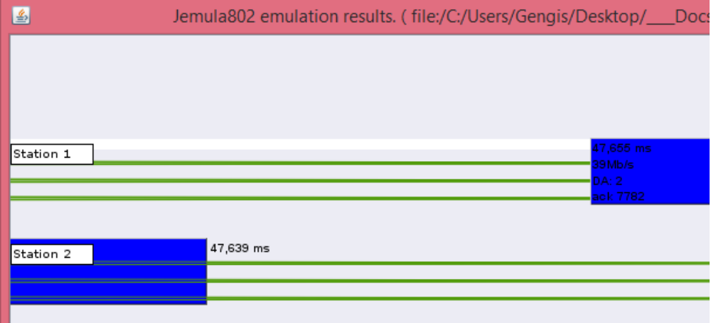
MCS 4 in a 20 MHz channel gives 39 MHz (with 0,8 µs guard interval).

Partial output of the file “total_thrp.m”:

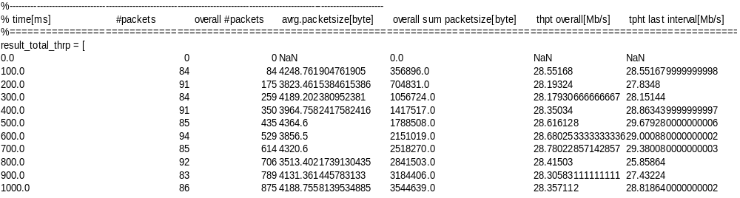

Test 3
2 stations, channel width 20Mhz, MCS : 9

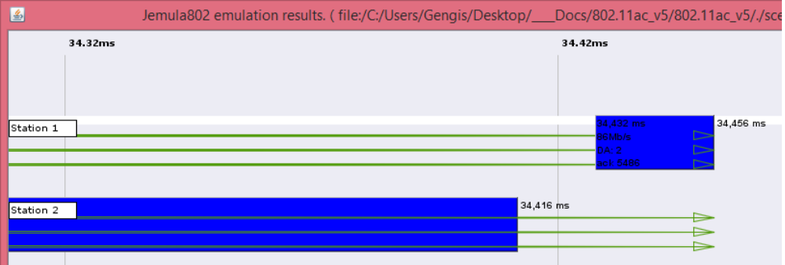
MCS 9 in a 20 MHz channel is not specified in IEEE 82,11 amendment, but we implemented it for symmetry reasons, it gives 86 MHz (with 0,8 µs guard interval).

Partial output of the file “total_thrp.m”:

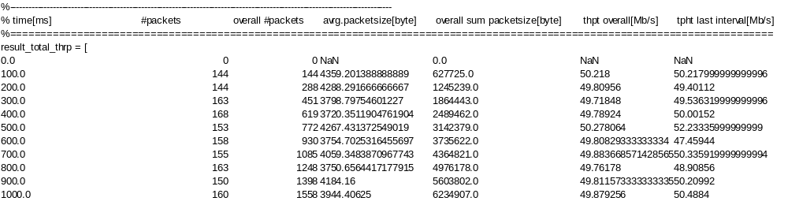
We can observe that contrary to previous tests at MCS 0 and MCS 4, here we can't reach the full 86 MHz. There are many reasons, one being that at high modulations, without frame aggregation, IEEE 802,11ac can't utilize optimally the airtime because the preamble 802,11a which surrounds the 802,11ac frame for legacy compatibility, uses a fraction too great of the total airtime used by the frame.

Test 4
The previous tests used only one spatial stream, here we will showcase the 2*2, 4*2 and 8*1 spatial streams.
Spatial streams are one of the main (and numerous) ways to do MIMO. In 802,11ac another is beamforming. Spatial streams use separate paths from one antenna in emission and one antenna in reception. Theoretically it would be possible achieve n * m gain in throughput, i.e. 2*2 would generate a four times throughput enhancement. Unfortunately that would require complex mathematical operations that current CPUs can't process at the required speed, so the gain in real life, is always the lowest number in antenna either at emitter or receiver.

Beamforming uses the interference mechanism i.e. the phases of the different signals coming out of the emitting station, are shifted in order to reinforce the signal strength at a given point. The mathematics are not complex but accurate timing information, synchronization between antennas and ability to know the state of the channel make beamforming more difficult to implement that IEEE engineers envisioned when they introduced it in IEEE 802,11n in 2007.

Test at 20 MHz wide channels, MCS 4, 2*2

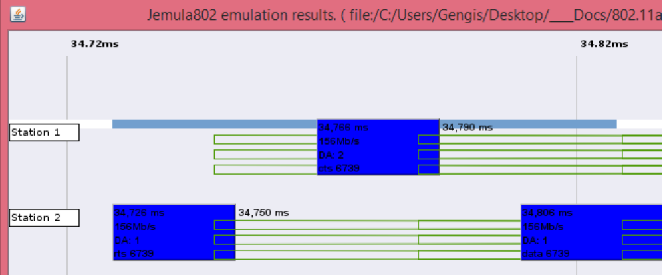
Due to a bug in the software the speed is indicated as 156Mb/s. The partial output of the file “total_thrp.m” shows the real value:

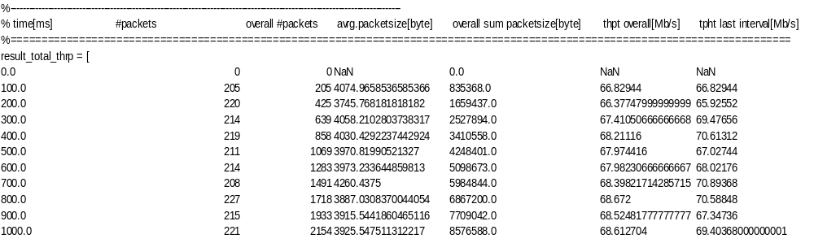

Test 5
IEEE 802,11 channels are usually 20MHz wide (802,11a has also 5 MHz and 10 MHz wide channels). As 802,11ac works in 5 GHz band where there are near 20 channels (depending on national regulations), it could aggregate several 20 MHz channels to achieve a greater throughput.

We will showcase a 80 MHz channel at MCS 4 and one spatial stream.
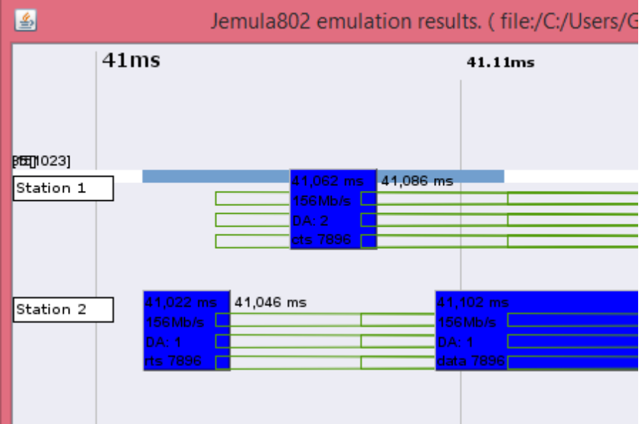

Unfortunately there is another bug this time in the file “total_thrp.m” which doesn't show the correct throughput which is 156 Mb/sec.

