2.2

2.3.  
vd: swap

4. id  
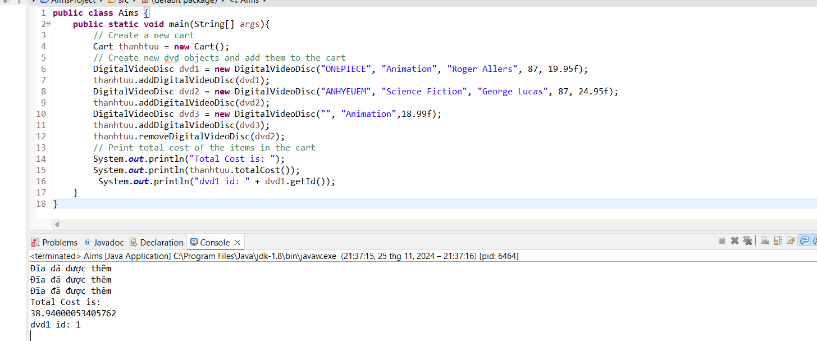  
5 cart test  
phương thức hiển thị hàng thêm vào giỏ

xem sp trong gio  
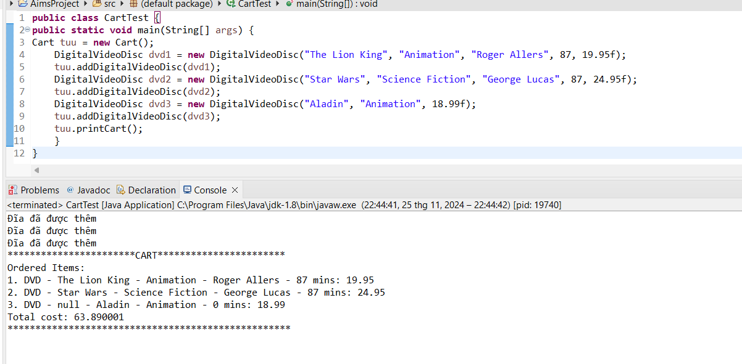  
  
tim bang id  
  
  
  
  
6   
tao phuong thuc store  
storetest  
8.to chuc du an  
9.  
