Yaris Driver by The Yaris Wonderboys

Gamefleadh Design Document

By Josh, Michael, Piotr, James and Conor

# Initial Pitch

Our friend Michael owns a Yaris so we wanted to make a game to poke fun at this because we always rode around in it, we thought up an idea that fit well with the theme of an Infinite Runner, the Idea we came up with was our other friend Josh in game stole Michaels Yaris (Despite not having a license) and now has to avoid obstacles while driving down the wrong lane of a motorway.

# Overview

## Goals

1. Yaris and Obstacles: Completed 6. Scoreboard: Completed
2. Movement: Completed 7. Sound Effects: Completed
3. Death Screen: Completed 8. Radio: Completed
4. Main Menu: Completed 9. Fuel Gauge: Completed
5. Pause Button: Completed 10. Trailer: Completed

## Controls

Up (^) and Down (v) arrows for movement up and down screen.

1 and 2 to change the radio channel.

Space Bar to toggle radio on and off.

ESC to pause game.

## Features Overview

The Game Includes a lot of features which I will outline below,

Collectables

1. An Item known as “HILK” (a combination of Heineken and Milk which is Josh’s favorite on a night out) which when collected causes the screen to go wavy making the game harder (Don’t Drink and Drive)
2. 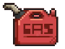An Item called “Fuel” which when collected replenishes fuel meter meaning you can drive for longer.
3. An Item known as “Wrench” which when collected repairs your car and replenishes health.

Obstacles

1. An obstacle modeled after vehicles such as a bus or cars must be avoided and if hit will cause the Yaris to take damage.
2. An Oil spill is one of the objects that must be avoided if hit it will obstruct the screen for a period.
3. Cones can spawn in and cause damage to the Yaris if hit and must be avoided.

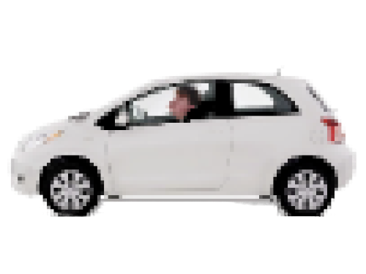Yaris

The player character known as “Josh in the Yaris” must avoid all obstacles as he only has a limited amount of health, he must collect Fuel as his fuel gauge is quickly going empty, he can repair his car by collecting Wrenches on the ground to fix the Yaris. Buckle up Josh!

# Other Info

## Used Tools

1. Unity to develop the Game.
2. G.I.M.P to edit and create sprites.
3. Clipchamp for the creation of the Trailer.
4. Audacity for sound effects and music
5. removeBg to edit sprites
6. Adobe Express to create and edit YWB Logo

## UI and GUI

## End Result

[Trailer](trailers/YWB%20Driver%20Trailer.mp4)

Game Screenshots: 1, 2, 3

## Sourcing

Items Sourced

Music: [Nihilore](https://nihilore.itch.io/), [PookiDJ](https://www.youtube.com/watch?v=-KpLXZKzYs8) and [S. H. Aasen](https://s-h-aasen.itch.io/s-h-aasens-chiptunes-1-12)

Sprites:

SFX:

Other: N/A

## Reflection