JPS Sales & Load Forecast
Formal Summary Report — Fiscal Year 2026 Full-Year Outlook
Actuals through June 2026 · Forecast July–December 2026 (Driver Forecast engine) · Prepared by FP&A Sales Analytics · July 2026

Executive Summary
Total (ex-EV) | FY2025 Actual | FY2026 Budget | FY2026 Forecast | Var vs Budget | Var vs FY2025
All Rate Classes | 3,251.0 | 3,250.4 | 3,263.2 | +0.4% | +0.4%

Full-year 2026 load is forecast at 3,263.2 GWh, +0.4% vs the FY2026 budget and +0.4% vs FY2025 actual — a modest net beat that masks material divergence underneath: RT70 (large industrial/mining) is running well ahead of budget (+13.5%), tracking the bauxite/alumina capacity investments and Other Metal Ore Mining rebound sourced in the Assumptions section, while RT40 and RT50 (medium commercial/general service) are tracking well behind budget (-6.7% and -9.0% respectively) — directionally consistent with the real (sourced) Hurricane Melissa tourism impact, compounded by 3 confirmed live operational adjustments on individual accounts (see Methodology), though the Hotels driver behind part of this needs review (see Assumptions — flagged, not resolved). Residential (RT10) and RT20 are both tracking ahead of budget (+3.3% and +4.4% respectively) — RT20 is driven by the residential seasonal pattern, not the commercial one (see note below); the driver value itself is unsourced SME judgment (see Assumptions).
Methodology: H2 2026 (Jul–Dec) is forecast using a faithful line-for-line Python port of the live Driver Forecast engine's own JavaScript (_dfcBuildIndices/_dfcComputeChain, JPS_Sales_Platform_v1.html), run directly against a fresh pull of the same tables the app reads (jps_actuals, jps_budget, jps_kam, jps_industries, jps_macro_assumptions, jps_operational_adjustments_current, jps_forecast_new_customers) — not an independent approximation. Each account (KAM-assigned) or cohort (rate_class|parish|consumption_bucket, for everyone else) is forecast month-by-month as: rolling 3-month trailing average × (1 + macro% + weather% + industry-or-seasonality% + operational%) + manual kWh override. Note RT20 runs on the residential driver in this engine, not commercial — a platform classification quirk, not a typo. Three live operational adjustments are active in H2 2026: a -50%/-80% solar-PV cutover, a -50% one-month plant maintenance shutdown at Caribbean Cement, and a -100% store closure for three months. Validated against the live Driver Forecast engine's own FY2026-by-rate-class output before use (exact match to 2 decimal places on all 6 rate classes).

Forecast Assumptions by Driver & Rate Class
Two segment-level macro drivers apply to every rate class based on its residential/commercial segment in the Driver Forecast engine (RT10, RT20 = Residential; RT40, RT50, RT60-ST, RT70 = Commercial).
Driver | Jul | Aug | Sep | Oct | Nov | Dec
Commercial (%) | +3.60% | +1.00% | -2.04% | -1.94% | -1.64% | -3.98%
Residential (%) | +8.81% | +5.88% | +1.00% | +1.53% | -0.91% | -1.43%

Weather driver: a +2% adjustment is applied for July and August 2026 only (Sep–Dec have no weather row in jps_macro_assumptions, so the driver silently defaults to 0% those months — a real gap, not a verified “no effect” finding). Directional support only: the CIMH Caribbean Regional Climate Outlook (May–Jul 2026) points to ENSO-neutral transitioning toward El Niño by July with unusually warm sea-surface temperatures near Jamaica and an elevated hot/humid season — consistent with a positive AC-driven load adjustment, but no JPS-specific or month-by-month figure was found. The exact +2% magnitude is SME judgment layered on that signal, not independently verified.

Industry-Level Drivers (Commercial sub-segments, selected)
Applied on top of the commercial segment driver, for KAM-assigned key accounts tagged to each industry only.
Industry | Jul | Aug | Sep | Oct | Nov | Dec
Banking, Insurance and Investments | +3.6% | +1.2% | +1.5% | +2.2% | +2.2% | +1.6%
Executive Offices | -2.3% | -2.9% | +7.8% | +5.5% | +0.0% | -5.0%
Full-Service Restaurants | +3.0% | +3.9% | +0.5% | -3.4% | -2.0% | +2.0%
Hotels (except Casino Hotels) and Motels | +6.2% | -3.1% | -7.9% | +0.3% | -10.5% | +5.0%
Other Metal Ore Mining | +2.4% | +2.5% | +0.4% | +1.0% | -10.9% | -5.2%
Poultry Hatcheries | +2.5% | -2.9% | +0.5% | +5.9% | +4.3% | +4.5%
Telemarketing Bureaus and Other Contact Centers | +2.1% | +0.8% | -4.8% | -0.2% | -8.4% | -9.2%
Water Supply and Irrigation Systems | +4.8% | -1.3% | -3.6% | +0.2% | -5.1% | -5.3%
Wired and Wireless Telecommunications Carriers (except Satellite) | +2.5% | +0.3% | -3.5% | +1.7% | -2.3% | -2.5%
Air Traffic Control | +1.0% | +1.0% | — | — | — | —
Cement Manufacturing | +0.0% | +0.0% | +2.0% | +2.0% | +2.0% | +0.0%

Sourced (2 of 11): Cement Manufacturing — internal Sales & Customers Analysis, May 2026: Caribbean Cement's kiln and bag house equipment upgrade lets it maximize output per tonne, and production has increased steadily since the start of the year coming out of the hurricane shortfall — corroborated externally by Caribbean Cement's own Q1 2026 disclosure of +33.1% YoY production (289,695 tonnes), recovering from a 30-day kiln shutdown post-Hurricane Melissa (Jamaica Observer, Apr 30 2026). Other Metal Ore Mining — internal May 2026 report: Windalco's current production increase is tied to turbine maintenance activity and a pilot project testing energy-cost reduction, forecast to continue until mid-summer — corroborated externally by Jamalco's $70.5M mine-life extension and Windalco's $29M haulage-road project (AlCircle industry press). Remaining 9 industries: SME estimate, not independently sourced (see jps_macro_assumptions.source_note for the per-row record).

Hotels driver conflicts with external data — needs review before H2 is finalized: real JTB/airport statistics show Sangster International H1 2026 passengers -26.7% YoY and stopover arrivals -27.5%, driven by Hurricane Melissa hotel-capacity loss (~70% of inventory available) and US-market softness (Caribbean National Weekly, Travel and Tour World, Jun 2026). Recovery is expected from Q4 2026 as repairs complete and Porter Airlines adds new Toronto/Ottawa/Hamilton routes for the 2026-27 winter season. Internal May 2026 report partially corroborates the recovery side: MBJ Airports Ltd has resumed expansion projects halted by the hurricane, hotels are reopening on a phased basis, and passenger arrivals are ticking up with growth projected into summer — consistent with a steadily improving trend, not the sharp November trough (-10.5%, worst month) the current assumption shows right when winter-season recovery should be accelerating. Recommend the revenue/commercial team review this driver specifically before relying on the Hotels or RT50/RT70 forecast for external commitments.

Industry H2 Actual vs. Forecast (GWh)
H2 2025 actual vs H2 2026 forecast, summed across every rate class the industry appears in. Covers KAM-assigned accounts tagged to each industry only.
Industry | H2 2025 Actual (GWh) | H2 2026 Forecast (GWh) | Δ %
Water Supply and Irrigation Systems | 100.1 | 98.3 | -1.8%
Hotels (except Casino Hotels) and Motels | 94.8 | 82.3 | -13.2%
Other Metal Ore Mining | 47.8 | 71.0 | +48.6%
Cement Manufacturing | 52.2 | 42.2 | -19.2%
Full-Service Restaurants | 24.3 | 24.1 | -1.0%
Poultry Hatcheries | 21.7 | 20.7 | -4.6%
Wired and Wireless Telecommunications Carriers (except Satellite) | 39.2 | 18.5 | -52.7%
Banking, Insurance and Investments | 18.7 | 16.3 | -13.1%
Executive Offices | 22.5 | 8.8 | -60.8%
Telemarketing Bureaus and Other Contact Centers | 11.4 | 8.3 | -26.9%
Colleges, Universities, and Professional Schools | 4.3 | 4.0 | -6.3%
Air Traffic Control | 0.7 | 0.6 | -10.7%

Rate Class Performance: Forecast vs Budget vs Prior Year
Rate Class | FY2025 Actual (GWh) | FY2026 Budget (GWh) | FY2026 Forecast (GWh) | Var vs Budget | Var vs FY2025
RT10 | 1,157.3 | 1,146.5 | 1,184.1 | +3.3% | +2.3%
RT20 | 627.3 | 622.0 | 649.6 | +4.4% | +3.6%
RT40 | 776.7 | 805.2 | 751.0 | -6.7% | -3.3%
RT50 | 362.8 | 375.9 | 342.0 | -9.0% | -5.7%
RT60-ST | 38.6 | 36.9 | 36.9 | -0.1% | -4.6%
RT70 | 288.1 | 263.8 | 299.5 | +13.5% | +4.0%
TOTAL | 3,251.0 | 3,250.4 | 3,263.2 | +0.4% | +0.4%

Figures are rounded to 1 decimal for display; TOTAL is calculated from unrounded values.

Monthly Trend — Actual (Jan–Jun) vs Forecast (Jul–Dec) 2026
Solid line = actual; dashed line = forecast. Each panel scaled to its own rate class.
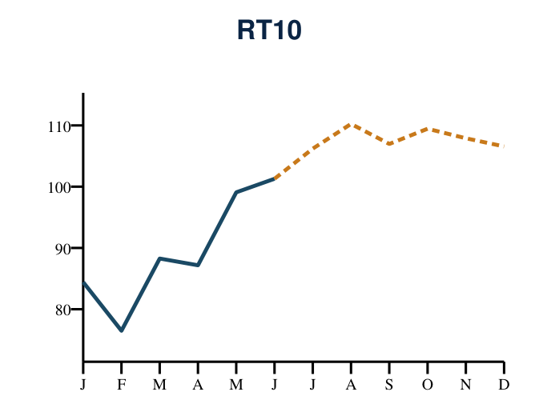 | 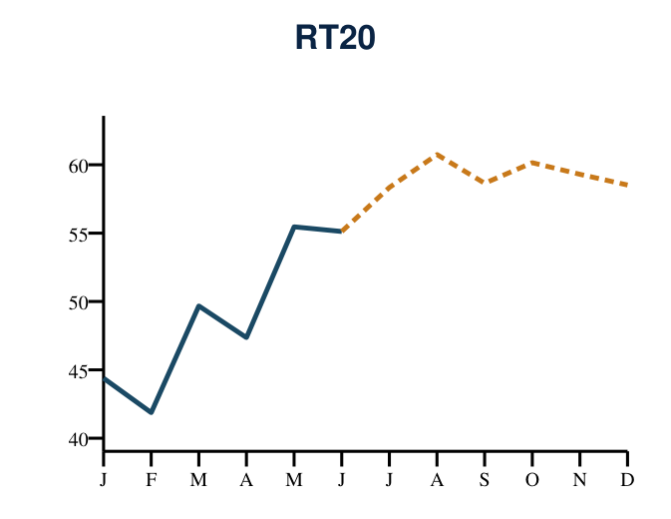
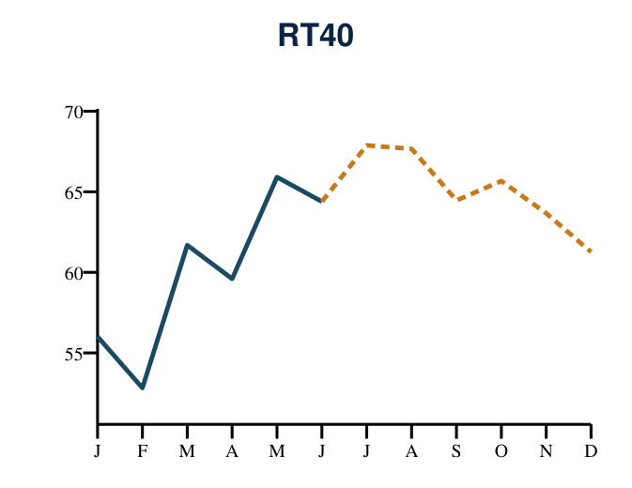 | 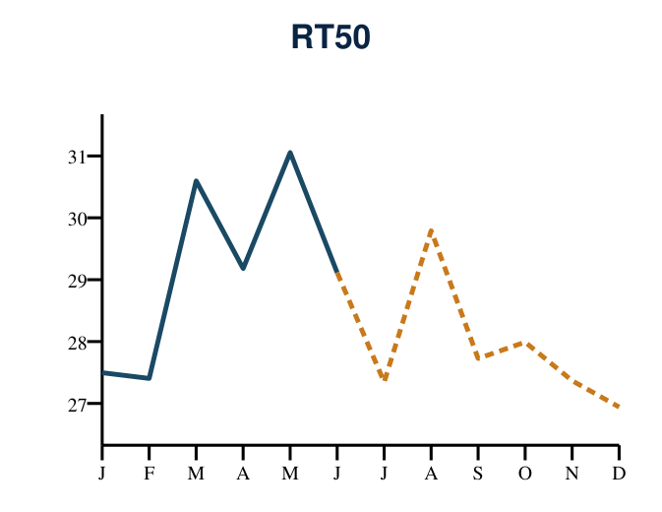
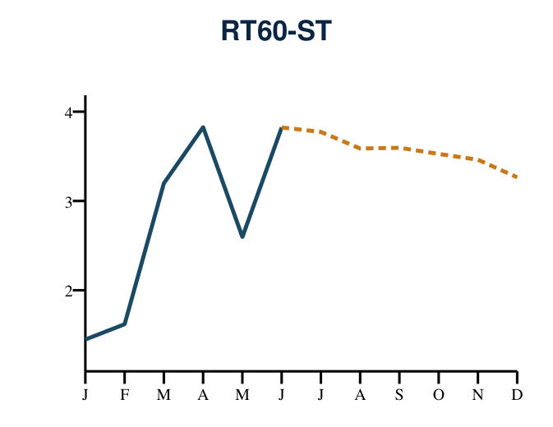 | 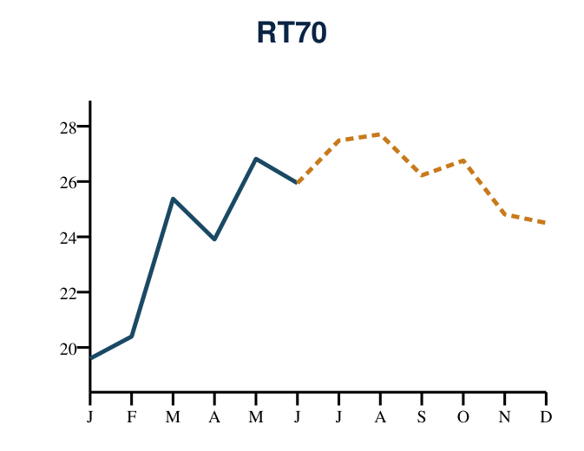

First-Half & Second-Half Detail
Figures below are rounded to 1 decimal for display.
H1 2026 Actual vs. H1 2025 Actual
Rate Class | H1 2025 Actual (GWh) | H1 2026 Budget (GWh) | H1 2026 Actual (GWh) | vs Budget | vs H1 2025
RT10 | 577.8 | 529.5 | 536.7 | +1.4% | -7.1%
RT20 | 314.8 | 287.7 | 293.9 | +2.2% | -6.6%
RT40 | 393.8 | 367.3 | 360.4 | -1.9% | -8.5%
RT50 | 184.5 | 170.7 | 174.9 | +2.4% | -5.2%
RT60-ST | 20.2 | 17.1 | 17.3 | +1.0% | -14.4%
RT70 | 145.5 | 124.1 | 142.0 | +14.4% | -2.4%
TOTAL | 1,636.4 | 1,496.4 | 1,525.2 | +1.9% | -6.8%

H2 2026 Forecast vs. H2 2025 Actual
Rate Class | H2 2025 Actual (GWh) | H2 2026 Budget (GWh) | H2 2026 Forecast (GWh) | vs Budget | vs H2 2025
RT10 | 579.5 | 617.0 | 647.4 | +4.9% | +11.7%
RT20 | 312.5 | 334.3 | 355.7 | +6.4% | +13.8%
RT40 | 383.0 | 437.9 | 390.6 | -10.8% | +2.0%
RT50 | 178.4 | 205.2 | 167.2 | -18.5% | -6.3%
RT60-ST | 18.5 | 19.8 | 19.6 | -1.1% | +6.1%
RT70 | 142.6 | 139.7 | 157.5 | +12.7% | +10.4%
TOTAL | 1,614.6 | 1,754.0 | 1,738.0 | -0.9% | +7.6%

Top 10 Customers by Volume (FY2026)
Ranked by FY2026 kWh (H1 actual + H2 forecast), aggregated by customer name across all billing accounts. Excludes EV rate class and bulk-billed placeholder accounts.
# | Customer | Rate Class | FY2026 (GWh) | FY2025 (GWh) | YoY %
1 | National Water Commission | RT40 | 180.2 | 188.9 | -4.6%
2 | Caribbean Cement Co Ltd | RT50 | 99.1 | 92.1 | +7.6%
3 | Alcoa Mins Of Ja Ltd | RT70 | 98.8 | 78.9 | +25.2%
4 | Windalco | RT70 | 30.9 | 21.1 | +46.7%
5 | Caribbean Broilers Ja Ltd | RT40 | 27.4 | 26.0 | +5.1%
6 | Riu Jamaicotel Limited | RT50/RT70 | 25.8 | 24.5 | +5.4%
7 | Kingston Free Port Terminal Limited | RT70 | 24.2 | 26.6 | -9.3%
8 | Ministry of Health | RT40 | 20.6 | 21.3 | -3.4%
9 | Petrojam Ltd | RT70 | 19.3 | 19.7 | -2.3%
10 | Port Marly Limited | RT70/RT50 | 18.5 | 17.7 | +4.8%

National Water Commission (180.2 GWh) and Caribbean Cement Co Ltd (99.1 GWh, +7.6% YoY) are the two largest metered customers by this measure. Rolled up to customer (not individual account) level — several customers such as NWC bill through dozens of separate premises.

Sourced, internal May 2026 report: National Water Commission's YoY decline is real and operational, not a data artifact — several facilities remain non-operational post-Hurricane Melissa, and the Essex Valley (St. Elizabeth) facility now runs a smaller pump/motor unit, needing less power. Windalco's growth is tied to increased production and turbine maintenance activity, plus a pilot project testing energy-cost reduction. Caribbean Cement's growth reflects a kiln/bag-house equipment upgrade that increased output per tonne, on top of steady production recovery since the start of the year.

Bottom 10 Customers — Largest YoY Declines
Among material accounts (FY2025 volume > 0.3 GWh), ranked by steepest YoY decline, aggregated by customer name.
# | Customer | Rate Class | FY2026 (GWh) | FY2025 (GWh) | YoY % | Status
1 | Club Caribbean Limited | RT40/RT50 | 0.0 | 1.6 | -100.0% | NEEDS VERIFICATION
2 | Nestle Jamaica Ltd | RT50 | 0.0 | 0.4 | -100.0% | NEEDS VERIFICATION
3 | BBNH Resorts Limited | RT70 | 0.0 | 0.5 | -100.0% | NEEDS VERIFICATION
4 | Beaches Boscobel Hotel Management Company Limited | RT40 | 0.0 | 2.4 | -100.0% | NEEDS VERIFICATION
5 | Contax360 BPO Solutions Inc. | RT40 | 0.0 | 0.6 | -100.0% | NEEDS VERIFICATION
6 | Jewel Paradise Cove Beach Resort &Spa | RT60-ST | 0.0 | 0.3 | -94.9% | Confirmed decline
7 | Coyaba Bch Rst & Club Lt | RT40 | 0.1 | 0.8 | -88.7% | Confirmed decline
8 | Carib Products Co Ltd | RT50 | 0.1 | 1.3 | -88.6% | Confirmed decline
9 | HOCATSA Jamaica Limited | RT50 | 0.9 | 4.6 | -79.5% | Confirmed decline
10 | X FUND PROPERTIES LIMITED | RT50 | 2.0 | 9.3 | -78.3% | Confirmed decline

Read with caution — 5 accounts flagged "NEEDS VERIFICATION": these show a FY2026 forecast of essentially zero because the engine's rolling 3-month base found no recent (Apr–Jun 2026) billed kWh under that account number. That is consistent with either a genuine closure/wind-down OR an account renumbering not reflected here — the engine output alone cannot distinguish the two. Recommend Sales/KAM confirm status before reporting these as lost load. The remaining accounts show real, non-zero but sharply reduced consumption.

