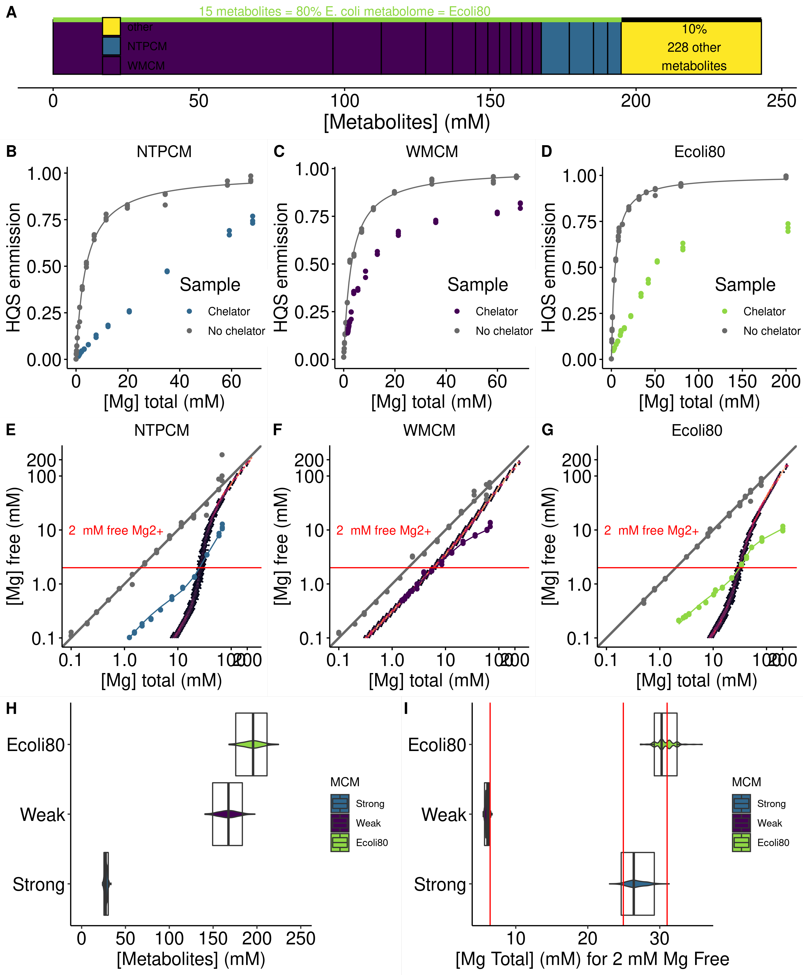**Figure 1** *E. coli* metabolite and Mg2+ mixtures approximate single site binding near 2 mM free Mg2+.

**Figure 2** *E. coli* metabolite and Mg2+ mixtures stabilize the chemical structure of RNA.

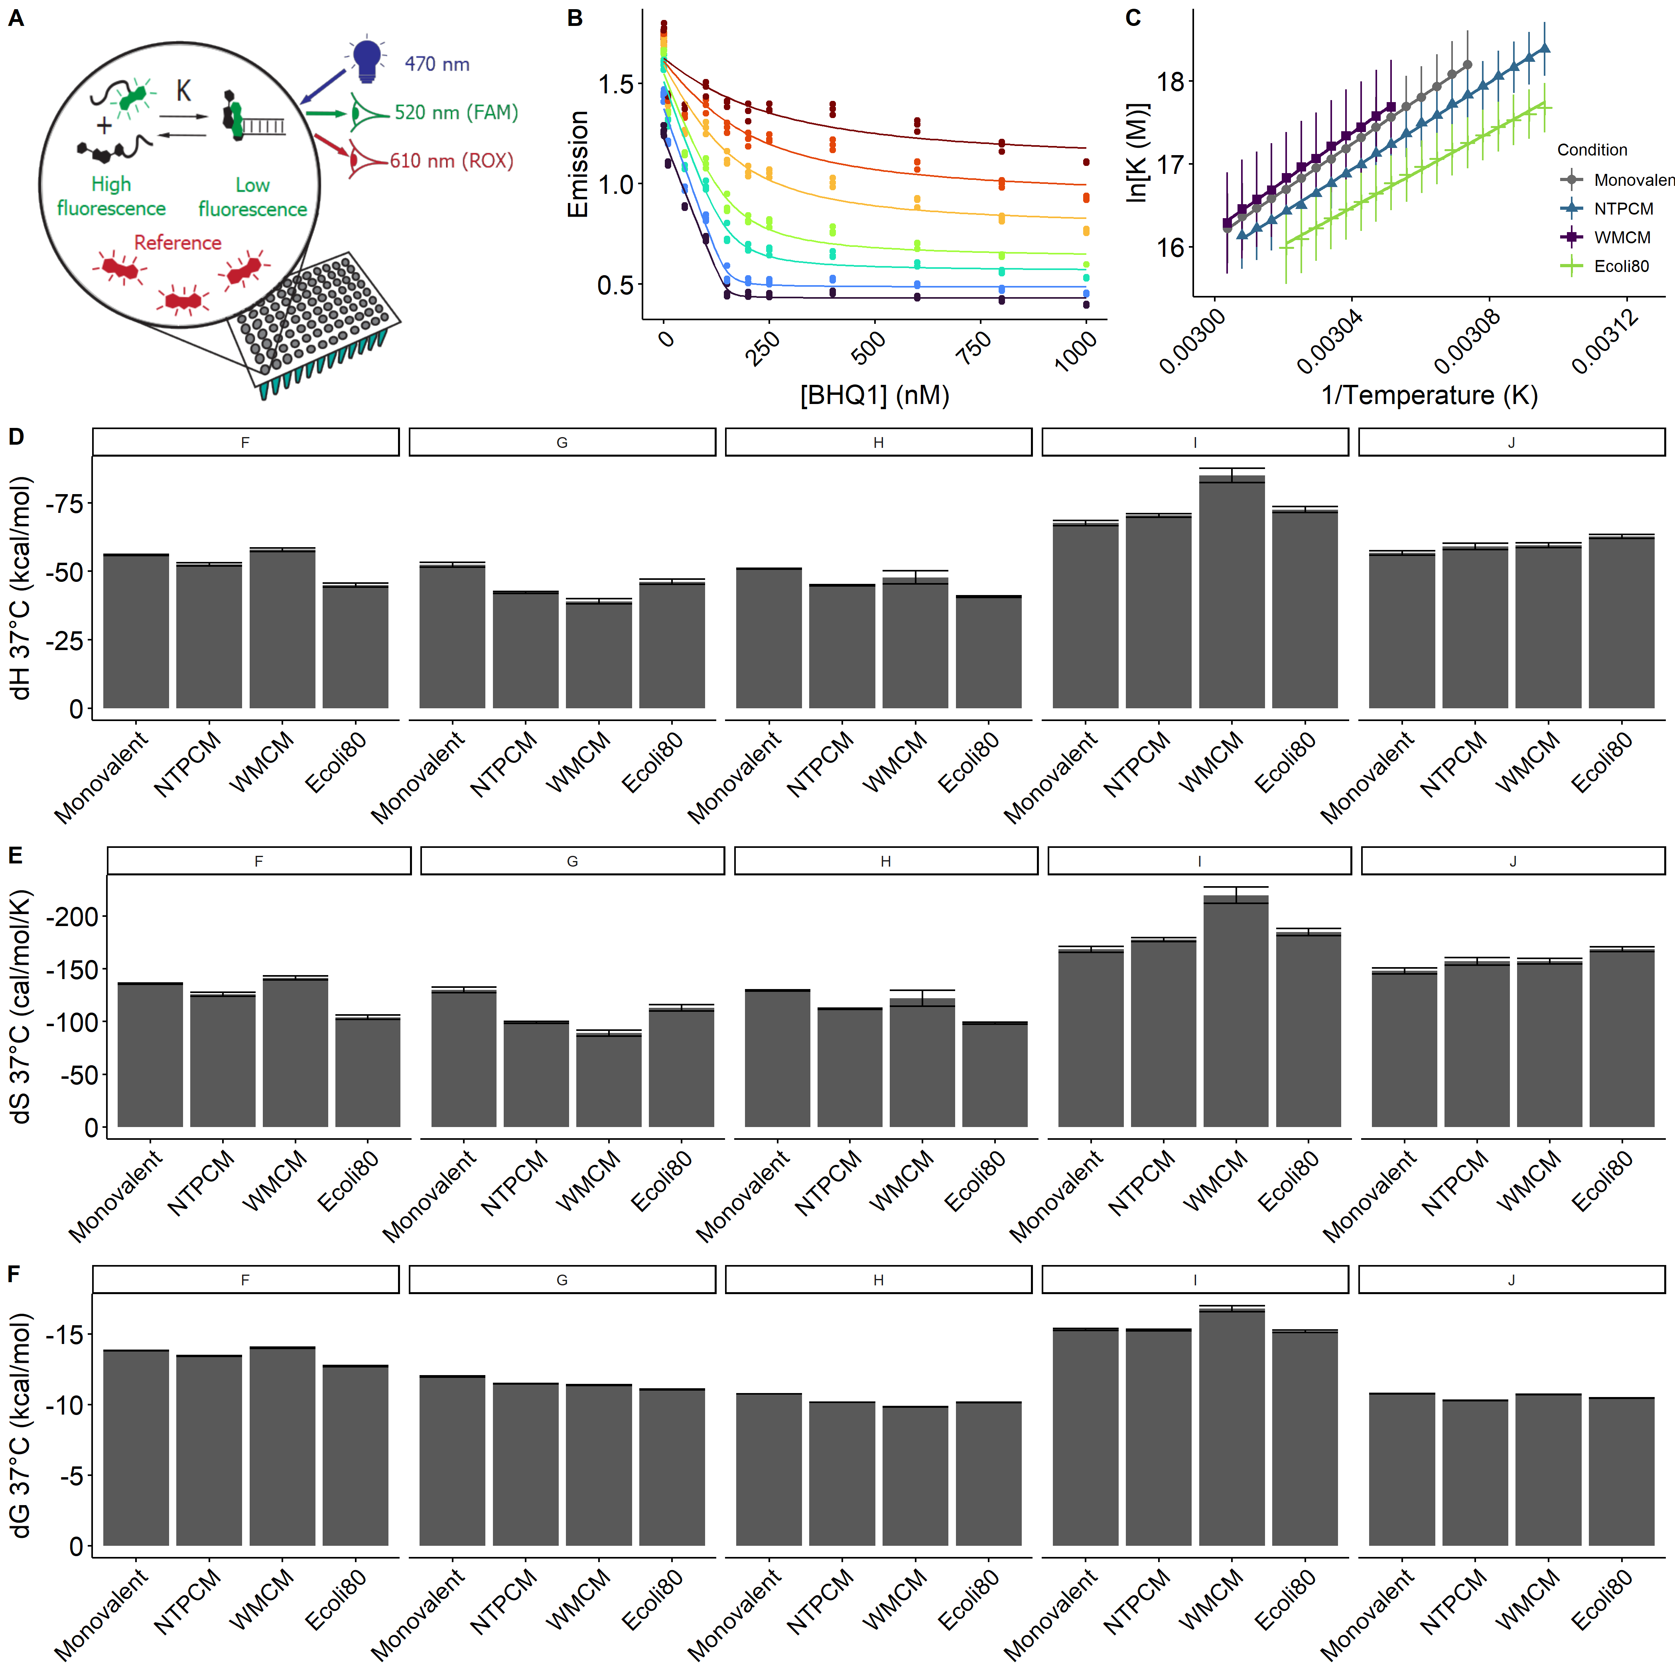**Figure 3** *E. coli* metabolite and Mg2+ mixtures destabilize RNA secondary structure.

**Figure 4** *E. coli* metabolite and Mg2+ mixtures increase functional RNA compactness.

Table 1. The top 14 most abundant metabolites that comprise 80% of the E. coli metabolome.

|  |  |  |  |
| --- | --- | --- | --- |
| Metabolite | Conc. (mM) | K’D and 95% CI (mM) | Chelation stength |
| ATP | 9.63 | 0.276 (0.272 to 0.279) | Strong |
| UTP | 8.29 | 0.238 (0.230 to 0.245) | Strong |
| GTP | 4.87 | 0.201 (0.195 to 0.208) | Strong |
| dTTP | 4.62 | 0.160 (0.153 to 0.166) | Strong |
| L-Glutamic acid | 96 |  | Weak |
| Glutathione | 16.6 |  | Weak |
| Fructose 1,6-BP | 15.2 | 5.9 (5.6 to 6.2) | Weak |
| UDP-GlcNAC | 9.24 | 29.0 (28.4 to 29.6) | Weak |
| Glucose 6-P | 7.88 | 17.3 (16.8 to 17.7) | Weak |
| L-Aspartic acid | 4.23 |  | Weak |
| L-Valine | 4.02 |  | Weak |
| L-Glutamine | 3.81 |  | Weak |
| 6-P-gluconic acid | 3.77 | 14.4 (5.6 to 6.2) | Weak |
| Pyruvic acid | 3.66 |  | Weak |
| Dihydroxyacetone phosphate | 3.06 | 19.7 (19.2 to 20.2) |  |

aDetermined at 37 °C with Isothermal titration calorimetry. Error is the propagated standard error in the fit parameter.

bDetermined by correcting absolute binding constants from the liturature for pH and ionic strength.

cmetabolites with KDs for Mg2+ less than 2 mM are considered strong Mg2+ chelators.

Table 2. Stability of RNA helices in *E. coli* **metabolite mixtures.**

|  |  |  |  |  |  |  |  |  |  |
| --- | --- | --- | --- | --- | --- | --- | --- | --- | --- |
| Helix | Sequence (5'-FAM/ BHQ1-3') | AU  content | Condition | dH (kcal/mol) | dS (cal/mol/K) | dG (kcal/mol) | ddH (kcal/mol) | ddS (cal/mol/K) | ddG (kcal/mol) |
| F | CGCAUCCU/AGGAUGCG | 0.38 | 2 mM free |  |  |  |  |  |  |
| NTPCM |  |  |  |  |  |  |
| WMCM |  |  |  |  |  |  |
| Ecoli80 |  |  |  |  |  |  |
| G | CCAUAUCA/UGAUAUGG | 0.63 | 2 mM free |  |  |  |  |  |  |
| NTPCM |  |  |  |  |  |  |
| WMCM |  |  |  |  |  |  |
| Ecoli80 |  |  |  |  |  |  |
| H | CCAUAUUA/UAAUAUGG | 0.75 | 2 mM free |  |  |  |  |  |  |
| NTPCM |  |  |  |  |  |  |
| WMCM |  |  |  |  |  |  |
| Ecoli80 |  |  |  |  |  |  |
| I | CGGAUGGC/GCCAUCCG | 0.25 | 2 mM free |  |  |  |  |  |  |
| NTPCM |  |  |  |  |  |  |
| WMCM |  |  |  |  |  |  |
| Ecoli80 |  |  |  |  |  |  |
| J | CGUAUGUA/UACAUACG | 0.63 | 2 mM free |  |  |  |  |  |  |
| NTPCM |  |  |  |  |  |  |
| WMCM |  |  |  |  |  |  |
| Ecoli80 |  |  |  |  |  |  |