Impact

1. Provide the field with in vivo-like MCM conditions to help understand how RNA folds in vivo
2. Show changes in global RNA secondary structure stability

Experiments

1. Model metabolome/metalome
2. Use ITC to determine exact Kds at pH 7 and relevant ionic strength - Temperature
3. Use Draper dye (8-hydroxyquinoline-5-sulfonic acid) to confirm free and chelated Mg concen trations
4. Use fluorescence Tms to show changes in global RNA secondary structure stability + configurational stability

Side notes for discussion

1. Rouskin Nat. Commun. ~2014 How much energy would the helicase secondary structure weakening cost?
2. Swap single stranded and double stranded state in fluorescence layout
3. Write abstract – Wait on the intro
4. Martin Grueblee JACS communications
5. Mathew’s JACS communication
6. Figure 1 Change A to C and Show MCM
7. Add a cut off line Table 1
8. Commas SE, sig figs, MCM into Table 1
9. Intro, Pilak and coworkers begin with cell extracts. However, we will take a bottom up approach to complexity, with the intention of understanding speciation and molecular contribution.
10. Try 1B as a van’t hoff plot

Template for Submission of Manuscripts to American Chemical Society Journals
Word 2010, Page Wide Abstract Version
This template is a guide to be used to prepare manuscripts for submission. Please consult the Instructions to Authors or a recent issue of the journal for detailed guidelines and procedures for submission. This template is intended to benefit to the author in that the entire manuscript (text, tables, and graphics) may be submitted in one file. Inserting graphics and tables close to the point at which they are discussed in the text of the manuscript can also be a benefit for the reviewer.
When you submit a manuscript using this template, you will not actually see the page formatting that appears in the printed journal. This will occur as part of the editorial production process. Abbreviated instructions for using the template follow. Consult the documentation for your specific application and version for more information. Additional instructions can be found in the readme file at the web page where you downloaded this template.
Using the template
In ACS publications there are many different components of a manuscript (i.e., title, abstract, main text, figure captions, etc.) that are represented in the template. See the Guide, Notes, Notice, or Instructions for Authors on the journal’s homepage to determine which parts should be included for the manuscript that you are preparing
- If typing your manuscript directly into the template, select (highlight) the text of the template that you want to replace and begin typing your manuscript (i.e., select the Title section for typing in your title).
- If you have already prepared your document in a Word file, you will need to attach the template to your working document in order to apply the Word Style tags. Further instructions can be found in the readme file at the web page where you downloaded this template.
- Go to the Word Style list on the formatting toolbar and you will see all the Word Styles from the template that has now been imported into the current document. A Styles toolbar has been generated that will display the different Styles for you to choose from. If this is not present, select View, Toolbars, and then select Styles and it should appear. You can close this at any time and then reopen it when needed.
- Click in the sentence or paragraph and then go to the Word Style menu on the toolbar and select the relevant Word Style. This will apply the Word Style to the entire text (sentence or paragraph). Do this for all sections of the manuscript.
- To insert graphics within the text or as a figure, chart, scheme, or table, create a new line and insert the graphic where desired. If your graphic is not visible, ensure that the Word Style is “Normal” with an automatic height adjustment. If the size of the artwork needs to be adjusted, re-size the artwork in your graphics program and re-paste the artwork into the template (maximum width for single-column artwork, 3.3 in. (8.5 cm); maximum width for double-column artwork, 7 in. (17.8 cm)). NOTE: If you are submitting a Table of Contents graphic, please insert the graphic at the end of the file.
- Ensure that page numbers are present on all pages before submitting your manuscript.
- Delete these instructions and any sections that are not needed.
- Save the file with the graphics in place: select Save As (File menu) and save it as a document file (not a .dot template file).
- Proof the manuscript to ensure that all parts of the manuscript are present and clearly legible.

The Bacterial Metabolome and Metalome Weakens Global RNA Secondary Structure Stability and Protects RNA from Degredation
Jacob P. Sieg^{1,2}, Philip C. Bevilacqua^{1,2,3}*
¹Department of Chemistry, Pennsylvania State University, University Park, PA 16868
²Center for RNA Molecular Biology, Pennsylvania State University, University Park, PA, 16868
³Department of Biochemistry and Molecular Biology, Pennsylvania State University, University Park,
PA, 16802
*Corresponding author. E-mail: pcb5@psu.edu. Phone: (814)863-3812

KEYWORDS
Magnesium ion, Chelated magnesium, RNA folding, secondary structure, metabolites

ORCID
Ryota Yamagami: 0000-0002-06947-1906
Jacob P. Sieg: 0000-0001-5414-1667
Philip C. Bevilacqua: 0000-0001-8074-3434

ABSTRACT: Herein, we examine the complicated network of interactions among RNA, the metabolome, and the metalome in E. coli. First, we examine the effects of temperature on the binding affinity of the top 14 E. coli metabolites, comprising 80% of the total metabolome, at physiological pH and monovalent ion concentrations using ITC and HQS fluorescence titrations. Then, we use this information to inform creation of artificial cytoplasms that mimic in vivo E. coli conditions. We then examine the effects of the these in vivo-like conditions on RNA thermodynamic stability and RNA chemical stability. We find that these in vivo-like conditions lead to opposing effects, wherein thermodynamic stability is weakened but chemical stability is strengthened.

Summary of progress on in vivo-like conditions. Studies that consider cellular components one at a time. Studies that consider cellular components together in artificial cytoplasm. In contrast, we take a bottom up, “aufbau”, approach that builds up complexity, in artificial cytoplasms. This aufbau approach allows us to understand the effects of most of the metabolite and metal ions species that compose the network of interactions that RNA experiences in E. coli cells.
First, we considered metabolites. E. coli cells contain hundreds of metabolites for a total metabolite concentration of about 243 mM, too many metabolites to test systematically . However, 15 abundant metabolites comprise 80% (194 mM) of total metabolites, and 15 metabolites is an experimentally manageable number (F1igure 1A).
Next, we considered the metalome. As a negatively charged polymer, RNA folding and function is highly dependent on positively charged metal ion concentrations, especially divalent magnesium ions (Mg²⁺), as thousands of studies show. E. coli cells contain about 240 mM monvalent sodium (Na⁺), 140 mM divalent potassium (K⁺), and 54 mM Mg²⁺. Most Mg²⁺ in the cell is chelated, were Mg²⁺ is coordinated with only an estimated 0.5 to 3.0 fully hydrated, so called “free”, Mg²⁺ in E. coli.
Lasly, we considered how metabolites effect the speciation of free and chelated Mg²⁺. All 15 of the most abundant metabolites have functional groups, carboxylates and phosphates, that drive chelating interactions with divalent Mg²⁺ ions (Table 1), and we have previously estimated that the metabolite pool in E. coli has potential to chelate 51 mM Mg²⁺, assuming 2 mM free Mg²⁺, an ionic strength of 0.15 M and a pH of 7.5.
Table 1. The top 14 most abundant metabolites that comprise 80% of the E. coli metabolome.
Metabolite | Conc.  (mM) | K’_{D}  (mM) | Chelation  stength
ATP | 9.63 | 0.28 (±0.01) | Strong
UTP | 8.29 | 0.238 (±0.004) | Strong
GTP | 4.87 | 0.200 (±0.009) | Strong
dTTP | 4.62 | 0.163 (±0.003) | Strong
L-Glutamic acid | 96 | 67 | Weak
Glutathione | 16.6 | 147 | Weak
Fructose 1,6-BP | 15.2 |  | Weak
UDP-GlcNAC | 9.24 |  | Weak
Glucose 6-P | 7.88 |  | Weak
L-Aspartic acid | 4.23 | 285 | Weak
L-Valine | 4.02 | 26487 | Weak
L-Glutamine | 3.81 | 130315 | Weak
6-P-gluconic acid | 3.77 |  | Weak
Pyruvic acid | 3.66 | 134 | Weak
ªDetermined at 37 °C with Isothermal titration calorimetry. Error is the propagated standard error in the fit parameter.
^{b}Determined by correcting absolute binding constants from the liturature for pH and ionic strength.
^{c}metabolites with K_{D}s for Mg²⁺ less than 2 mM are considered strong Mg²⁺ chelators.
While extensive liturature exists on chelating interactions between Mg²⁺ and small molecules, our
previous estimates are putative at best because Mg²⁺ chelation strength is highly dependent on enviromental factors such as pH, ionic strength, composition of background ions, and temperature. Thus, we sought to better characterize the Mg²⁺ chelation strength of the top 15 most abundant E. coli metabolites at the physiological ionic strength of 390 mM, physiological pH of 7.0, and physiological temperature range of 25°C to 50 °C.
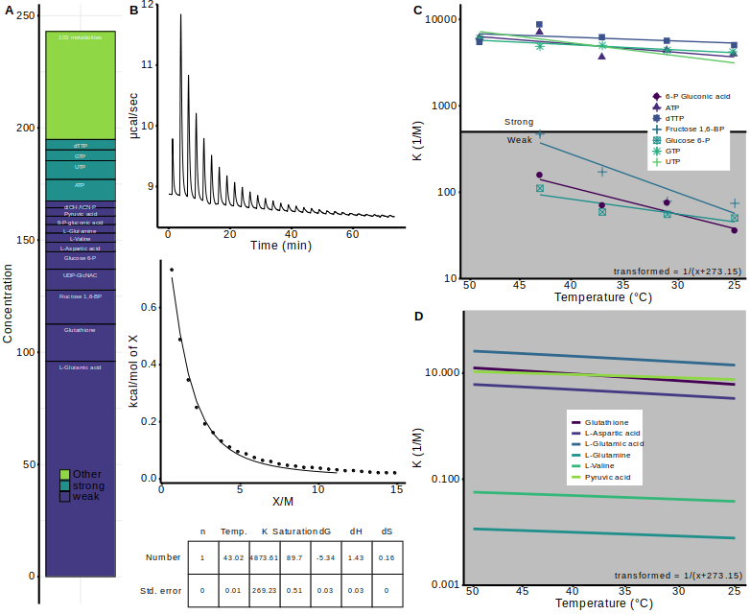
Figure 1. The top 15 metabolites in E. coli bind to Mg²⁺. (A)
Isothermal titration calorimetry (ITC) was used to determine inverse molar association constants for 9 of the 15 most abundant E. coli metabolites (Figure 1B & C).
The 6 remaining metabolites were not amenable to isothermal titration calorimetry because their interactions with Mg²⁺ are very weak and require high, molar, concentrations of reagents making heat of dilution a large portion of the ITC signal.
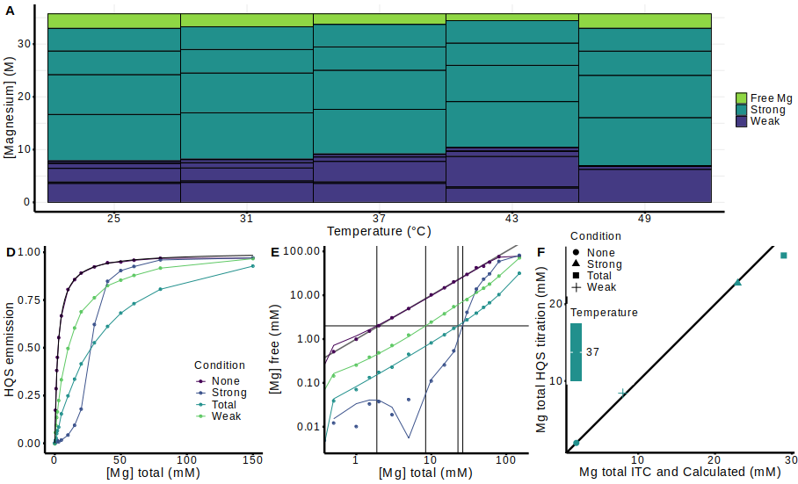
Figure 2. Mg²⁺ speciation at cellular pH and ionic strength.
Table 2. RNA helices tested in this study.
Helix | Sequence (5'-FAM/BHQ1-3') | Length | AU  content
A | CGAAAGGU/ACCUUUCG | 8 | 0.5
B | CGAACUCU/AGAGUUCG | 8 | 0.5
C | CUGAGUC/GACUCAG | 7 | 0.43
D | CGUUGC/GCAACG | 6 | 0.33
E | CGACGC/GCGUCG | 6 | 0.18
F | CGCAUCCU/AGGAUGCG | 8 | 0.38
G | CCAUAUCA/UGAUAUGG | 8 | 0.63
H | CCAUAUUA/UAAUAUGG | 8 | 0.75
I | CGGAUGGC/GCCAUCCG | 8 | 0.25
J | CGGAUGGC/GCCAUCCG | 8 | 0.63

Figure 2. The temperature dependence of metabolites binding Mg at cellular pH and ionic strength.
TEXT (Word Style "TA_Main_Text"). For full instructions, please see the journal’s Instructions for Authors. Do not modify the font in this or any other section, as doing so will not give an accurate estimate of the formatting for publication and final length of the paper.
TEXT (Word Style "TA_Main_Text"). For full instructions, please see the journal’s Instructions for Authors. Do not modify the font in this or any other section, as doing so will not give an accurate estimate of the formatting for publication and final length of the paper.
TEXT (Word Style "TA_Main_Text"). For full instructions, please see the journal’s Instructions for Authors. Do not modify the font in this or any other section, as doing so will not give an accurate estimate of the formatting for publication and final length of the paper.
TEXT (Word Style "TA_Main_Text"). For full instructions, please see the journal’s Instructions for Authors. Do not modify the font in this or any other section, as doing so will not give an accurate estimate of the formatting for publication and final length of the paper.
TEXT (Word Style "TA_Main_Text"). For full instructions, please see the journal’s Instructions for Authors. Do not modify the font in this or any other section, as doing so will not give an accurate estimate of the formatting for publication and final length of the paper.
TEXT (Word Style "TA_Main_Text"). For full instructions, please see the journal’s Instructions for Authors. Do not modify the font in this or any other section, as doing so will not give an accurate estimate of the formatting for publication and final length of the paper.
TEXT (Word Style "TA_Main_Text"). For full instructions, please see the journal’s Instructions for Authors. Do not modify the font in this or any other section, as doing so will not give an accurate estimate of the formatting for publication and final length of the paper.
TEXT (Word Style "TA_Main_Text"). For full instructions, please see the journal’s Instructions for Authors. Do not modify the font in this or any other section, as doing so will not give an accurate estimate of the formatting for publication and final length of the paper.
TEXT (Word Style "TA_Main_Text"). For full instructions, please see the journal’s Instructions for Authors. Do not modify the font in this or any other section, as doing so will not give an accurate estimate of the formatting for publication and final length of the paper.
Figure 5. Cartoon depiction of the three way network of RNA, metabolite, and Mg2+ interactions.

Displayed equations can be inserted where desired making sure they are assigned Word Style "Normal". Displayed equations can only be one column wide. If the artwork needs to be two columns wide, it must be relabeled as a figure, chart, or scheme and mentioned as such in the text.
ASSOCIATED CONTENT
(Word Style “TE_Supporting_Information”). Supporting Information. A brief statement in nonsentence format listing the contents of material supplied as Supporting Information should be included, ending with “This material is available free of charge via the Internet at http://pubs.acs.org.” For instructions on what should be included in the Supporting Information as well as how to prepare this material for publication, refer to the journal’s Instructions for Authors.
AUTHOR INFORMATION
Corresponding Author
* (Word Style “FA_Corresponding_Author_Footnote”). Give contact information for the author(s) to whom correspondence should be addressed.
Present Addresses
†If an author’s address is different than the one given in the affiliation line, this information may be included here.
Author Contributions
The manuscript was written through contributions of all authors. / All authors have given approval to the final version of the manuscript. / ‡These authors contributed equally. (match statement to author names with a symbol)
Funding Sources
Any funds used to support the research of the manuscript should be placed here (per journal style).
Notes
Any additional relevant notes should be placed here.
ACKNOWLEDGMENT
(Word Style "TD_Acknowledgments"). Generally the last paragraph of the paper is the place to acknowledge people (dedications), places, and financing (you may state grant numbers and sponsors here). Follow the journal’s guidelines on what to include in the Acknowledgement section.
ABBREVIATIONS
CCR2, CC chemokine receptor 2; CCL2, CC chemokine ligand 2; CCR5, CC chemokine receptor 5; TLC, thin layer chromatography.
REFERENCES
(Word Style "TF_References_Section"). References are placed at the end of the manuscript. Authors are responsible for the accuracy and completeness of all references. Examples of the recommended formats for the various reference types can be found at http://pubs.acs.org/page/4authors/index.html. Detailed information on reference style can be found in The ACS Style Guide, available from Oxford Press.
SYNOPSIS TOC (Word Style “SN_Synopsis_TOC”). If you are submitting your paper to a journal that requires a synopsis graphic and/or synopsis paragraph, see the Instructions for Authors on the journal’s homepage for a description of what needs to be provided and for the size requirements of the artwork.
To format double-column figures, schemes, charts, and tables, use the following instructions:

Place the insertion point where you want to change the number of columns
From the Insert menu, choose Break
Under Sections, choose Continuous
Make sure the insertion point is in the new section. From the Format menu, choose Columns
In the Number of Columns box, type 1
Choose the OK button

Now your page is set up so that figures, schemes, charts, and tables can span two columns. These must appear at the top of the page. Be sure to add another section break after the table and change it back to two columns with a spacing of 0.33 in.
Table 1. Example of a Double-Column Table
Column 1 | Column 2 | Column 3 | Column 4 | Column 5 | Column 6 | Column 7 | Column 8
Authors are required to submit a graphic entry for the Table of Contents (TOC) that, in conjunction with the manuscript title, should give the reader a representative idea of one of the following: A key structure, reaction, equation, concept, or theorem, etc., that is discussed in the manuscript. Consult the journal’s Instructions for Authors for TOC graphic specifications.
Insert Table of Contents artwork here

