Big picture stuff
Reviewers:
Important correspondence:
1.) We don’t want to mess with published data
Brent: What melt data should we use? My main thought here is that I don't want to draw negative attention to any of our previous melt data...where people begin to question the data we and others have already published using Meltwin. I'm not sure how to handle this. Some possibilities would include (1) using unpublished data but not provide sequences (maybe just refer to them as Duplex 1, not provide raw data, etc.) so we could publish later in a thermo paper (not sure if that's legit), (2) using previously published data if the free energy values are very similar and we're just focusing on smaller error (again...not drawing too much negative attention to previously published work), or (3) collect new data that will not be part of another project (which will take more time and have some cost associated with it). I can see how a direct comparison to Meltwin could be a good thing for MeltR, but I'd hate to do that at the expense of all of the data previously published using Meltwin. This is my major concern. Is there a way to tout the data analysis of MeltR without bringing down Meltwin? Thoughts?
Phil: I think we can say only the nicest things about Meltwin. Nothing disparaging at all. At the same time, we can talk about reducing error and improving accuracy going forward. We would be very careful to say that prior data is still valuable.
Jacob: I agree with Phil. We say, “Meltwin is great. It enabled a generation of nearest neighbor parameters and all the tools that rely on them. Nobody can get Meltwin anymore and its a black box.” We can leave it at that.
On not drawing negative attention to published data, this is important. Any differences between the analysis below and the published analysis are do to idiosyncrasies. I want to proceed with the data we have. However, this is ultimately, not our data. If we are nearing a complete draft and all authors are not comfortable, I will collect a new data set to use for this paper.
2.) How do justify baseline trimming versus fitting the whole data set?
Brent: If a lot of the focus is on the baseline trimming tool, we need to be able to convince people (who think like Phil) that there are good reasons to trim.
Phil: I think we should allow different options for trimming but my philosophy is the baselines as long as possible but not longer option. This might do something recursive like look for the first five data points away from the transition that fit y=mx+b with random residuals and then lengthen 1 point at a time, stopping when the residual lose randomness.
Jacob: There are good reasons to trim. First of all, everyone does it. Second, linear baselines are an approximation and this approximation gets less valid the longer the baseline is. The question is “how to trim?” and everyone has to make their own idiosyncratic rules, which are always hard to justify because every reviewer can say “what about this?”. My feeling is that people would be happy for us to take this out of their hands if we present a sufficiently clever method.
I really liked Phil’s idea for the recursive residual analysis. Unfortunately, it does not work. (1) The baselines of ideal melting curves are never perfectly linear because it is a sigmoid. (2) On real data, this strategy just starts grabbing random parts of the melting curve.
3.) Meltwin exists and is trusted, how do we justify MeltR
Brent: I'm not sure what you had in mind for the paper. At first, I was thinking about all of the comparisons that could be made to Meltwin. But now, the more I think about it, I'm not sure that is necessary. Not many people use Meltwin, so a point-by-point comparison is probably not needed, as MeltR would be the only software available for this purpose (unless you know of others). But, I could work with Sebastian to come up with a list of limitations related to Meltwin that aren't related to the data analysis (not available for distribution, some features don't work on newer operating systems, etc.) that could be discussed in the paper.
Phil: This is more tricky. Again, I think we should cherish Meltwin and the many important papers published with it.
Jacob: I want a direct comparison because it will make Meltwin users feel safe and I want to use the word “Meltwin” a lot because it will make our paper pop up on google when somebody does a melting curve, reads a Znosko paper, and starts looking for a copy of Meltwin.
Results to do list
- Plot the H and S instead of the H and Tm on Figure 2A-C
- Add the error quantile argument to figure 2D
- Move figure 3 to methods
SI to do list
- Supplemental_file_1.pdf: Supplemental figures and tables
- Supplemental_file_2.pdf: meltR.A help documentation
- Supplemental_file_3.pdf: BLtrimmer help documentation
Manual to do list
- Theory section for the baseline trimmer
Coding to do list
- Check pH extinction coefficient options
- Add an easy outlier exclusion protocol to meltR.A
- Generate a library of modeled absorbance data and fit it using the BLtrimmer to make sure it works
- Add a cleaner pre-canned output to the BLtrimmer for the two-state folding test
- Iron out parallel code
- Expand description of the outputs in the help file
- Add a csv to the BLtrimmer output

MeltR: A Software Package that Provides Facile Determination of
RNA Folding Energies from Absorbance Data
Jacob P. Sieg^{1,2}, Sebastian Arteaga, Brent Znosko, Philip C. Bevilacqua^{1,2,3}

¹Department of Chemistry, Pennsylvania State University, University Park, PA 16802.
²Center for RNA Molecular Biology, Pennsylvania State University, University Park, PA 16802.
³Department of Biochemistry and Molecular Biology, Pennsylvania State University, University Park, PA 16802.
Keywords: Absorbance melting curves, folding energies, RNA thermodynamics
Abstract
UV-detected absorbance melting curves of RNA are used to determine helix folding energies, providing thermodynamic insight into RNA secondary structure, which underlies a plethora of structure prediction tools. Appropriate analysis of absorbance melting curves is not trivial, requiring many data preprocessing, regression, and error analysis steps. The absorbance melting curve-fitting software Meltwin, originally introduced in 1996, provided researchers with a consistent and facile absorbance melting curve-analysis platform that underlies a generation of RNA folding parameters. Unfortunately, Meltwin software, has non-transparent algorithms, is no longer maintained, and relies on idiosyncratic choices by the user. Herein, we provide MeltR, an open-source, curve-fitting package in the popular R statistical programming language. The meltR.A function of MeltR provides the same facile conversion of absorbance data to folding energies provided by Meltwin, but has additional useful features for experiments. In particular, the BLtrimmer function provides a consistent protocol that improves folding energy estimation and uncertainty analysis, based on analysis of an ensemble of trimmed baselines. We believe that MeltR will be a useful tool for analyzing another generation of absorbance melting curve experiments.
Introduction
Paragraph 1: Absorbance melting curves are important
Paragraph 2: Fitting is tedious
Paragraph 3: Meltwin is nice
Paragraph 4: Present MeltR, MeltR is an R package, and its advantages
Using MeltR requires a small amount of knowledge of the R programming language. This knowledge is easily picked up from the extensive help documentation, manuals, and video tutorials provided at https://github.com/JPSieg/MeltR to help new users. R specific words that are helpful for the reader of this paper are underlined and definitions are provided at the end of the text.
Results
Facile fitting of raw absorbance data with meltR.A
MeltR includes the function meltR.A, which provides the same analysis as Meltwin using a simple usage (Figure 1A). The meltR.A function requires three user defined arguments. The first essential argument provides the data set, which is produced by reading a tidy formatted, delimited text file into a R data frame (Figure 1A.1). The second essential argument, NucAcid, specifies the nucleic acid species in the melt, provided in R as a vector, and is used to determine the extinction coefficient of the nucleic acid and subsequently the nucleic acid strand concentration (Figure 1A.2). The first element of the vector is the type of nucleic acid, either “DNA” or “RNA”, and the remaining elements are the sequences in the sample. Alternatively, the first element can be “custom”, and the remaining elements are custom extinction coefficients in M⁻¹cm⁻¹. The third element is the molecular model of the duplex, either "Monomolecular.2State", "Heteroduplex.2State", or "Homoduplex.2State", for a single self-structured strand, two non-self-complementary strands forming a duplex, or a single, self-complementary strand forming a duplex (Figure 1A.3). The ”meltR.A” function has two other important arguments, the “concT”, or the concentration used to calculate the strand concentration (Figure 1A.4), and “fitTs”, or the temperatures range used in the fit (Figure 1A.5). The “fitTs” argument is used for baseline trimming (discussed in detail below), and can be a vector, containing the high and low temperatures of the range to be fit for all samples. Alternatively, a list of vectors specifying temperature ranges for each sample.
The meltR.A function provides three analysis (Figure 1B). The first analysis, is method 1-individual fits, which fits each sample to am individual regression model to calculate thermodynamic energies (Figure 1B.1) and reports the average of thermodynamic energies (Figure 1B.2), and was also provided by Meltwin. The second analysis is method 2-which fits the Van’t Hoff relationship between the thermodenaturation temperature and the strand concentration (C_{t}) from different samples to a regression model to calculate thermodynamic energies (Figure 1B.2), and was likewise also provided by Meltwin. The meltR.A function also provides a third analysis, not provided by Meltwin, Method 3- Global fitting (Figure 1B.2). Global fitting combines method 1 and method 2, by directly fitting the raw absorbance melting curves, similar to method 1, but uses information from every sample and the relationship between the equilibrium constant and temperature provided by the Van’t Hoff relationship, similar to method 2. Figure 1B shows the response generated when a user fits a data set with meltR.A. Note, the response includes the fractional error between methods (Figure 1B.3), which is the range of each folding energy calculated for methods 1, 2, and 3, divided by the average. This metric is useful for assessing fits.
The meltR.A function saves the result of a fit to a number of PDF and comma separated value (CSV) spreadsheets to help the user assess and present results (SI Figure 1). The CSV spreadsheets can be opened with Excel or passed to other data analysis programs. The first two files are PDF depictions of the quality of the fits for method 1, where a good fit shows agreement between the data and the fits, depicted as black circles and red lines, respectively (SI Figure 1A-B). The third file is a CSV containing the results for the individual fits in Method 1 (SI Figure 1C). The fourth file is a PDF depiction of the data and fit for method 2, where a good fit exhibits a linear relationship between 1/T_{m} and lnC_{t} (SI Figure 1D). The fourth and fifth files are PDF depictions of the quality of the fits for method 3, where a good global fit shows agreement between the data and the fits, depicted as black circles and red lines, respectively (SI Figure 1E-F). The last file is a CSV summarizing the folding energies calculated using all three methods (SI Figure 1G).
A number of other features of meltR.A are described in the help file (SI file 2). Notably, meltR.A settings can be changed to use alternative an alternative method to calculate the T_{m} for each sample, calculate extinction coefficients at different wavelengths, and to turn off methods 2 and 3. Turning off methods 2 and 3 is useful for experiments that compare absorbance melting curves between conditions. Likewise, meltR.A generates an extensive fit object in R, consisting of a list of data and statistics. The meltR.A fit object is included for advanced analysis of the data, including regression statistics, residuals, and useful transformations of the data such as first and second derivatives. This fit object includes more information than was provided by Meltwin, elements can be written to text files for analysis in other programs, or passed to other R based analysis such as the BLtrimmer in MeltR (see below).
Fit parameters are sensitive to baseline trimming
Baselines are approximated as linear in melting curve analysis in both Meltwin and MeltR. The linear assumption is approximately true, due to small changes in base stacking in the duplex and single stranded state with temperature. This approximation as no physical basis and is quantitatively true over short temperature ranges, meaning that baselines should be trimmed to include no more data than is required to define the duplex and single stranded state. Aberrant data at low temperatures due to condensation on the cuvette or aberrant data at high temperatures due to sample trimming. Baselines should also be trimmed to compensate for small internal aberrations due to instrumental errors or air bubbles. Accordingly, Meltwin and MeltR provide the capability to trim baselines by specifying a temperature range to fit. However, users must make idiosyncratic choices about how to trim manually as no protocols have been established. We thus sought to provide an auto-baseline trimmer in MeltR that provides users with a consistent, rational, and statistically appropriate baseline-trimming protocol.
To first understand how the length of baselines affects the accuracy of folding energy determination, we first fit modeled data (Figure 2A top panel, black circles). Data was modeled for assuming a ΔH° of -64.76 kcal/mol, a Tm of 46.4 °C, a Ct of 8 μM, a random absorbance error of 0.001, and realistic baseline slope and intercepts. The range where the helix was between 90% folded and 10% folded was identified to be the upper and lower bounds of the low temperature and high temperature baselines respectively. Then base lines were added in 1 °C increments and the data was fit to determine the relationship between fit accuracy and baseline length (Figure 2A top panel, colored lines). The resulting ΔH° and Tm produced by these fits were inaccurate below 5 °C but converged on the correct value at higher temperatures (Figure 2A, middle and bottom panels). Thus, analysis of modeled data indicated that baselines should be no shorter than 5 °C higher and lower than the temperature where the helix is 90% folded and 10% folded.
We next analyzed the dependence of baseline length on the accuracy of folding energy determination on real data. We started on a nearly ideal, real melting curve (Figure 2B top panel, black circles). We first estimated the temperature range where the helix was between 90% and 10% folded using a fit of the entire data set. Then we added baselines in 1 °C increments and fit the data. The resulting ΔH° and Tm produced by these fits were inaccurate below 5 °C but converged on the correct value at higher temperatures (Figure 2B, middle and bottom panels). Next, we analyzed the dependence of the accuracy of folding energy determination on baseline length on a non-ideal, real melting curve. Once again, the ΔH° and T_{m} produced was inaccurate for baselines that were less than 5 °C. However, the ΔH° did not converge on a single consistent value (Figure 2B, middle panel).
The data is real and the true ΔH° and T_{m} is not known. However, a user could identify an optimum baseline range by iteratively fitting the data using different baseline ranges with Meltwin or meltR.A. The results for this curve could be compared with the results for the other curves in the data set, then the user could choose the baseline range that provides the best internal consistency across the data set. This approach would lead to a more accurate estimate of the folding energy from a data set but is time consuming, idiosyncratic, and incorporates a systematic error (the choice of baseline range to use in the analysis) that is difficult to treat statistically.
Thus, MeltR provides a baseline trimmer function, thermed the “BLtrimmer”, that works on three principles.
- A large number of baseline ranges should be randomly generated and subsequently fit. These baseline ranges should be between 5 and 25 °C lower and higher than the temperatures where the sample is 90% and 10% helical for low temperature and high temperature baselines respectively. The 5 °C lower limit on baseline length ensures that the baseline ranges can produce accurate folding energies (Figure 2A). The 25 °C upper limit on baseline length ensures that the baseline range minimizes violation of the linear approximation.
- The best combinations of baseline ranges produce the most internally consistent folding energy estimates across the data set, as assessed by agreement between ΔH° produced by different samples by method 1, and by agreement between the ΔH° produced by method 1 and 2.
- Besides principle 1 and 2, the 25% of baseline ranges that produce the most internally consistent folding energies should be treated as an ensemble of equally feasible folding energies. This converts baseline trimming, a systemic error that cannot be treated statistically, into a random error which can be treated statistically.
The BLtrimmer treats fit results from an optimal ensemble of baseline combinations statistically
This section introduces the BLtrimmer function in MeltR, demonstrates it’s usage and results (Figure 2D-E), and describes its internal function. The next sections examine the accuracy of the BLtrimmer fitting modeled, published, and unpublished data.
The BLtrimmer has only one required argument, a MeltR fit object produced by meltR.A (Figure 2D.1). Other arguments are shown in Figure 2D are adjustable but set to the recommended value by default. The first optionally adjustable argument is the number of ranges to generate per sample (Figure 2D.2). The second optionally adjustable argument is the temperature step between baselines (Figure 2D.5). Thus, by default, the BLtrimmer will produce 5 symmetrical baselines per sample, at lengths of 5, 10, 15, 20, and 25 °C. The third optionally adjustable argument is the number of baseline combinations to test (Figure 2D.4). The BLtrimmer exhaustively permutes each baseline range with every other baseline range for the other samples. By default, this will produce 5^{N} combinations, where N is the number of samples in the data set. Testing all 5^{N} combinations would require a lot of computational power and is not necessary. In our experience, 1000 randomly selected baseline combinations are enough to explore the error space, and takes 1-3 minutes to test on a laptop computer. The last argument is the error distance threshold, which by default selects the 25% of baseline combinations that produce the most internally consistent folding energies. The error distance is a statistic that combines agreement between ΔH° produced by different samples by method 1, and by agreement between the ΔH° produced by method 1 and 2 equally (see methods). The error distance threshold can be decreased to be more selective, or increased to 1 in order to generate an exhaustive description of the dependence folding energies on baseline trimming.
The
The BLtrimmer function saves the result of a of PDF and a comma separated value (CSV) spreadsheets
Paragraph 1: Baseline trimmer usage (Figure 2A)
Paragraph 3: Other useful BLtrimmer features (SI file 3, help file)
MeltR reproduces thermodynamic parameters from Meltwin
Paragraph 1: meltR.A and the BLtrimmer work on modeled data (SI figure 3).
Paragraph 2: Compare method 1, 2, and 3 for MeltR (SI table 1). Describe method 1 MeltR versus Method 1 Meltwin (SI table 1) and method 2 MeltR versus Method 2 Meltwin (SI table 2)
Paragraph 3: Describe method 3 MeltR versus Method 1 Meltwin and method 2 Meltwin (SI table 3, Figure 4)
The BLtrimmer provides a two-state folding test
Paragraph 1: Two-state folding test based on analysis of the distribution of randomly chosen baselines
Paragraph 4: Why the BLtrimmer does not force a two state interpretation on non-two state RNA.
Discussion
Materials and Methods
Data transparency and reproducibility
Absorbance melting curves
Paragraph 1: How Brent and Sebastian compiled Adams data
Paragraph 2: Aquisition in the Bevilacqua lab
Fitting absorbance melting curves
This will be copied and cleaned up from the theory section of the MeltR manual
BLtrimmer
This will be copied and cleaned up from the theory section of the MeltR manual Figure 4
Definitions
tidy formatted

Acknowledgments
References
Tables
Table 1 Regression equations used to determine folding energies in meltR.A.
Figures and legends
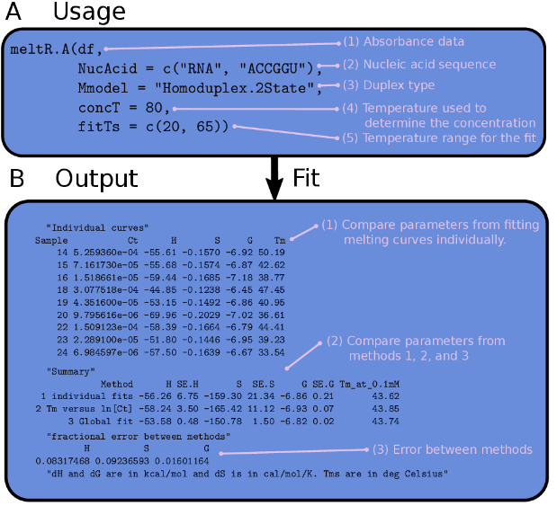
Figure 1 The usage and output of meltR.A in the MeltR package. (A) The usage of meltR.A in an R script. (1) The data frame (df) containing the absorbance data, created by reading a flat text file. (2) A vector containing the nucleic acid type and sequence, used to calculate extinction coefficients. Alternatively, custom extinction coefficients can be provided (Supplemental file 2). (3) Duplex type, either "Monomolecular.2State", "Heteroduplex.2State", or "Homoduplex.2State". (4) The temperature used to calculate the RNA concentration using Beer’s law. (3) The temperature range that is fit. Used for manual baseline trimming. Either a single range for the whole data set, or a list of ranges, one for each sample. (B) The output of meltR.A in an R console. (1) Thermodynamic parameters generated by fitting each curve in a data set individually. (2) Comparison of the results for the different methods that meltR.a used to determine folding energies. Method 1 averaged the results from fitting each melting curve individually. Method 2 fit the Van’t Hoff relationship between the melting temperature and the RNA strand concentration. Method 3 combined Method 1 & 2, by using the Van’t Hoff equation to globally fit the entire data set to one regression model. (3) Fractional error between methods used for a test of two-state folding. Non two-state folding generates a fractional error between methods that is greater than 0.15.
Figure 2 Auto-baseline trimming absorbance data using the BLtrimmer in MeltR. (A) Dependence of fit parameter accuracy on baseline length for fitting modeled absorbance data assuming a ΔH° of -64.76 kcal/mol, a T_{m} of 46.4 °C, and a C_{t} of 8 μM. Lower and upper base lines start where 90% and 10% (molar basis), respectively, of the RNA strands are in the helical state. (Top panel) Linear baseline fits superimposed on raw absorbance data. Colors correspond to baseline length specified in middle and bottom panels. (Middle panel) Dependence of ΔH° on baseline length. (Bottom panel) Dependence of T_{m} on baseline length. (B) Dependence of fit parameter accuracy on baseline length for fitting a nearly-ideal, real absorbance melting curve collected on a CGAAAGGU/ACCUUUCG at a C_{t} of 8 μM. (C) Dependence of fit parameter accuracy on baseline length for fitting a non-ideal, real absorbance melting curve collected on a CGAAAGGU/ACCUUUCG at a C_{t} of 12 μM. (D) BLtrimmer usage in a R script. (1) A MeltR fit object produced by fitting raw data with meltR.A. (2) The number of baseline ranges the BLtrimmer will produce for each sample. (3) The temperature difference for each baseline produced on an absorbance melting curve. (4) The number of baseline combinations to test in a given BLtrimmer run. (E) Output of the BLtrimmer in the R console. Data were fit using 1000 baseline combinations and then a subset of the most internally consistent combinations were used to estimate folding energies and 95% confidence intervals.
Figure 3 MeltR functions meltR.A and BLtrimmer reproduce folding energies calculated using Meltwin with minimal user input. (A) Helix association ΔH° determined from the method 3, global fitting, using meltR.A followed by the BLtrimmer, versus the ΔH° determined from method 1 (purple) and method 2 (green) using Meltwin to fit the same absorbance data set. Horizontal error bars represent precision in the parameters calculated by Meltwin and vertical error bars represent 95% confidence intervals calculated using the BLtrimmer. (B) Helix association ΔS° determined from the method 3, global fitting, using meltR.A followed by the BLtrimmer, versus the ΔS° determined with Meltwin. Colors and error bars are the same as A. (C) Helix association ΔG°³⁷ determined from the method 3, global fitting, using meltR.A followed by the BLtrimmer, versus the ΔG°³⁷ determined with Meltwin. Colors and error bars are the same as A. (D) T_{m} at 0.1 mM determined from the method 3, global fitting, using meltR.A followed by the BLtrimmer, versus the T_{m} at 0.1 mM determined with Meltwin. Colors and error bars are the same as A.

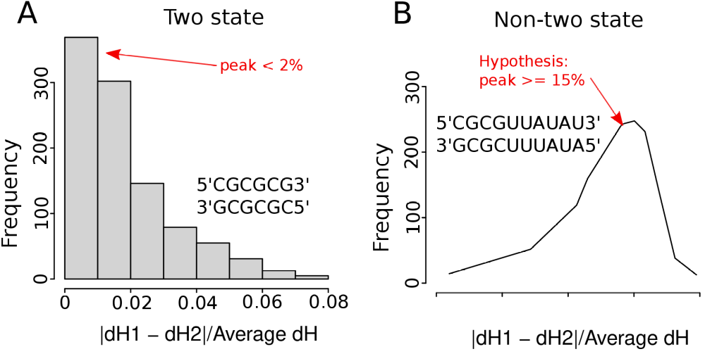
Figure 4 Two-state folding test using the BLtrimmer in MeltR. (A) The distribution of the error between the ΔH° using Method 1 (average of fitting samples individually) and Method 2 (Van’t Hoff analysis) using 1000 randomly determined baseline combinations peaked at 2% for two-state folding sequences. (B) The distribution of the error between the ΔH° using Method 1 (average of fitting samples individually) and Method 2 (Van’t Hoff analysis) using 1000 randomly determined baseline combinations peaked at >15% for non-two-state folding sequences.
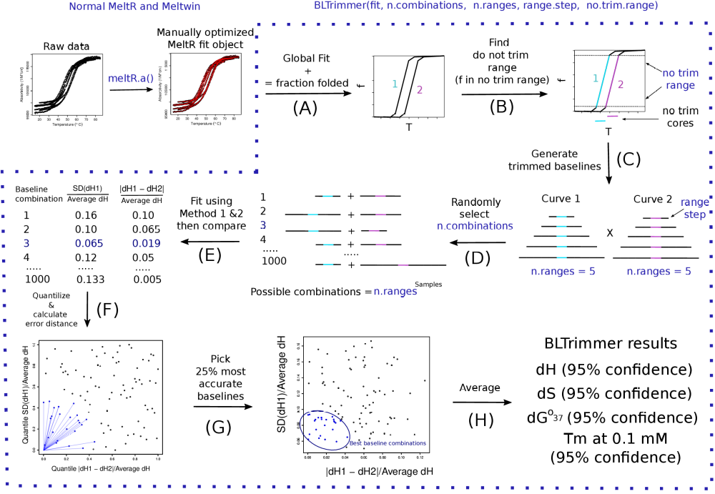
Figure 5 The MeltR BLtrimmer applies an ensemble analysis to calculate optimum helix association energies for an absorbance data set. (A) A MeltR fit object, produced by fitting raw absorbance data with meltR.A, is used to calculate the fraction of strands in the helical state (f) as a function of temperature. (B) The “no trim” temperature range is identified where f is greater than 0.1 and less than 0.9. (C) Baselines are added to the now trim range in 5 °C steps. (D) Ranges from each sample are exhaustively permuted to generate n.ranges^{Samples} baselines. (E) Thermodynamic parameters are determined from a subset of the baseline combinations using method 1 (average of fitting samples individually) and method 2 (Van’t Hoff analysis). Baseline combinations are assessed for enthalpy agreement for method 1 and enthalpy agreement between method 1 and method 2 to identify the baseline combinations that have the highest internal consistency. (G) The top 25% most internally consistent baseline combinations are selected for ensemble analysis. (H) The ensemble of internally consistent baseline combinations is passed to meltR.A and fit. The results are treated statistically to determine folding energies and 95% confidence intervals.

