MeltR is a Software Package that Provides Facile Determination of Biopolymer Thermodynamics: Application to RNA UV-Absorbance Data
Jacob P. Sieg^{1,2}, Sebastian J. Arteaga³, Brent M. Znosko³, Philip C. Bevilacqua^{1,2,4}

¹Department of Chemistry, Pennsylvania State University, University Park, PA 16802.
²Center for RNA Molecular Biology, Pennsylvania State University, University Park, PA 16802.
³Department of Chemistry, Saint Louis University, Saint Louis, MO 63103.
⁴Department of Biochemistry and Molecular Biology, Pennsylvania State University, University Park, PA 16802.
Keywords: Absorbance melting curves, thermodynamics, RNA
Abstract
UV-detected absorbance melting curves of macromolecules are used to determine folding thermodynamic parameters. Notably, this thermodynamic insight into RNA and DNA structure underlies a plethora of structure prediction tools. Appropriate analysis of absorbance melting curves is complex, requiring many data preprocessing, regression, and error analysis steps. The absorbance melting curve-fitting software MeltWin, introduced in 1996, provided researchers with a consistent and facile absorbance melting curve analysis platform that provided a generation of RNA folding parameters. Unfortunately, MeltWin software has non-transparent source code, is not maintained, and relies on idiosyncratic choices by the user. Herein, we provide MeltR, an open-source, curve-fitting package in the popular R programming language for analysis of macromolecular thermodynamics data. The MeltR provides the same facile conversion of absorbance melting curve data to folding energies provided by MeltWin but has additional features for experiments. MeltR can be a useful tool for analyzing the next generation of DNA and RNA absorbance melting curve experiments. and can be used to analyze other types of melting data, collected on diverse biological macromolecules.
Introduction
Thermodenaturation (melting) curves monitor macromolecular structure as a function of temperature and thus provide thermodynamic insight into macromolecular structure. UV-detected absorbance melting curves of short nucleic acid helices have provided extensive thermodynamic characterization of the sequence dependence RNA and DNA structure. This thermodynamic characterization has provided the nearest neighbor model for calculating the energy nucleic acid structure, which underlies a plethora of popular algorithms for predicting the behavior of nucleic acids (Figure 1A).
Extraction of thermodynamic parameters from raw melting data requires many preprocessing, regression, and error analysis steps, which can be difficult to achieve by hand on a large scale (Figure 1B). The program MeltWin, introduced in 1996, provided researchers with a consistent and facile data analysis, which underlies the aformentioned thermodynamic characterization of nucleic acid structure. While the the current characterization of nucleic acid structure in many environments, in particular RNA secondary structure in 1 M NaCl, is extensive, a lot of questions remain. In particular, the thermodynamic contribution of the cellular environment and nauturally-modified nucleotides are areas of active research. Unfortunately, Meltwin is no-longer maintained, has non-transparent algorithms, and relies on idiosyncratic choices by the user to process data.
MeltR is an open source package in the popular R statistical programming language that provides facile conversion of raw data to thermodynamic parameters. MeltR provides fitting protocols for fluorescence binding isotherms (previously reported) and absorbance melting curves similar to MeltWin. Herein, we describe the application of MeltR for fitting UV-detected absorbance melting curves of RNA, describe unique features to automate data processing not provided by MeltWin, and benchmark the accuracy of MeltR on real and modeled data.
Using MeltR requires a small knowledge of the R programming language. This knowledge is easily picked up from the extensive help documentation, manuals, and video tutorials provided at https://github.com/JPSieg/MeltR to help new users. A small number of R specific words that are helpful for the reader of this paper are underlined and definitions are provided at the end of the text.
Results
Facile fitting of raw absorbance data with meltR.A
MeltR includes the function meltR.A, which provides the same analysis as MeltWin and a simple usage (Figure 1C). The meltR.A function requires three user-defined arguments: data set, nucleic acid species, and molecular model of the nucleic acid species. The first essential argument provides the data set, which is produced by reading a tidy formatted, delimited text file into an R data frame (Figure 1C.1). The second essential argument, NucAcid, specifies the nucleic acid species in the melt. This is provided in R as a vector, and is used to determine the extinction coefficient of the nucleic acid. The extinction coefficient is used to estimate the nucleic acid strand concentration (Figure 1C.2). The first element of the vector is the type of nucleic acid, either “DNA” or “RNA”, and the remaining elements are the individual residues in the sample. Alternatively, the first element can be “custom”, and the remaining elements can be custom extinction coefficients in M⁻¹cm⁻¹. The third element is the molecular model of the nucleic acid species, either "Monomolecular.2State", "Heteroduplex.2State", or "Homoduplex.2State", for a single self-structured strand, two non-self-complementary strands forming a duplex, or a bimolecular association of a self-complementary strand forming a duplex, respectively (Figure 1C.3). The “meltR.A” function has other arguments with default settings that can be adjusted for customized fitting. Importantly, the “concT”, or the concentration used to calculate the strand concentration (Figure 1C.4), and “fitTs”, or the temperature range used in the fit (Figure 1A.5). The fitTs argument is used for baseline trimming (discussed in detail below), and can be a vector containing the high and low for the temperature range to be fit for all samples. Alternatively, the fitTs argument can be a list of vectors specifying a temperature range for each sample.
The meltR.A function provides three analyses: individual fits, T_{m} vs. C_{t}, and global fitting (Figure 1D). The first analysis is individual fits (method 1), which fits each sample to an individual regression model to calculate thermodynamic parameters (Figure 1D.1). For method 1, the averages of thermodynamic energies from fits for each sample are reported (Figure 1D.2). The second analysis is T_{m} vs. C_{t} (method 2), a van’t Hoff analysis, which fits the relationship between the T_{m} and the strand concentration (C_{t}) from different samples to a regression model to calculate thermodynamic parameters (Figure 1D.2). Methods 1 and 2 were both provided by MeltWin. The meltR.A function also provides a third, global-fitting analysis (method 3), not provided by MeltWin (Figure 1B). Global fitting combines methods 1 and 2 by directly fitting the raw absorbance melting curves, similar to method 1, but uses information from every sample to calculate thermodynamic parameters, similar to method 2. Figure 1B shows the response generated when a user fits a data set with meltR.A. Note, the response includes the %error between methods (Figure 1D.3), which is the range of each folding energy calculated for methods 1, 2, and 3, divided by the average. This metric is useful for assessing the overall quality of fits, and two-state folding where a %error between methods greater than 10% is diagnostic of a multistage-folding sequence. Lastly, the meltR.A function saves the result of a fit to a number of PDF figures and comma separated value (CSV) spreadsheets to help the user assess and present results (Figure S1).
Several other features of meltR.A are described in the help file (SI file 2). Notably, meltR.A settings can be changed to use an alternative method to calculate the T_{m} for each sample, calculate extinction coefficients at different wavelengths , and turn off methods 2 and 3. Turning off methods 2 and 3 is useful for experiments that compare absorbance melting curves between conditions. Method 2 is turned off automatically for monomolecular systems because there is no dependence between the T_{m} and concentration. Likewise, meltR.A generates an extensive fit object in R, consisting of a list of data and statistics (Supplemental file 2 meltR.A help file). The meltR.A fit object is included for advanced analysis of the data, including regression statistics, residuals, and useful transformations of the data such as first and second derivatives. Elements of the meltR.A fit object can be written to text files for analysis in other programs or passed to other analyses.
MeltR provides a consistent, rational, and statistically appropriate baseline-trimming protocol
Both MeltWin and MeltR approximate the absorbance of the folded and unfolded states as lines derived from the lower and upper baselines surrounding the melt region. These lines approximate absorbance changes due to changes in base stacking in the duplex and single stranded states with temperature. At a high level, baselines should be trimmed to exclude abberant data at extream temperatures and to include no more data than is required to define the duplex and single stranded state to avoid incorrectly extrapolating baseline behavior that is quantified at temperatures far from the melt region. However, users must make idiosyncratic choices about how to trim manually, as no protocols have been established.
One approach to baseline trimming is to trim to a constant widow surrounding the melt region, for example 20 °C, which incorporates a systematic error. Alternatively, a user could identify an optimum baseline range by iteratively fitting the data using different baseline ranges with MeltWin or meltR.A and choose the baseline range that provides the best internal consistency across the data set. This approach would lead to a more accurate estimate of the folding energy from a data set but is still idiosyncratic. We thus sought to provide an auto-baseline trimmer in MeltR that gives users a consistent, rational, and statistically appropriate baseline-trimming protocol.
MeltR provides a baseline trimming function, the “BLtrimmer”, that works on three principles:
1. A large number of baseline ranges should be randomly generated and subsequently fit.
2. The best combinations of baseline ranges produce the most internally consistent folding energy estimates across the data set.
3. Baseline ranges that produce the most internally consistent folding energies should be treated as an ensemble of equally feasible folding energies.
The BLtrimmer has only one required argument, a MeltR fit object produced by meltR.A (Figure 2A.), and prints an analysis of thermodynamic parameters produced by analysis of an ensemble of baseline combinations (Figure 2B). The BLTrimmer also provides a precanned analysis all the tested baselines (Figure S1H-I).
The other arguments shown in Figure 2D are adjustable but set to the recommended value by default. The first optionally adjustable argument is the Trim.method, which corresponds to the method used to randomly generate baselines. The “floating” method allows different baseline lengths for each sample, and the “fixed” method uses the same baseline length for each sample. The Assess.method, argument corresponds to the method used to asses each baseline range for internal consistency. It can be 1 of 3 integer values, “1” to optimize agreement between samples in method 1, “2” to optimize agreement between methods 1 and 2, or “3” to optimize both agreement between method 1 and agreement between methods 1 and 2. The no.trim.range argument defines the core melt region, by default between 10% and 90% unfolded. The quantile.threshold argument, corresponds to the fraction of baseline combinations to analyze in the final ensemble. By default, the BLtrimmer will use the 25% of baseline combinations that produce the most consistent parameters.
The final adjustable arguments determine how baselines are randomly generated and either apply to the fixed or floating argument. The n.ranges argument is the number of ranges to generate per sample and the range.step argument is the temperature step between baselines. By default, using the floating method, the BLtrimmer will produce 5 symmetrical baselines per sample, at lengths of 5, 10, 15, 20, and 25 °C. Testing all “floating” combinations would require a lot of computational power and is not necessary. One thousand randomly selected baseline combinations are enough to explore the error space and requires 1-3 minutes to test on a laptop computer (Figure S2). The “n.combinations” argument allows the user to specify the number of random baseline combinations to test.
MeltR accurately reproduces thermodynamic parameters
We first determined that MeltR accurately determined folding energies by fitting modeled data. Nine absorbance melting curve were modeled for 90 two-state folding helices (see methods).The modeled data were then fit with meltR.A followed by the BLtrimmer with no manual baseline trimming. BLtrimmer results for all three methods were in good agreement with the known folding energies (Figure S4). Errors were evenly distributed between being higher than the known value and lower than the known value, indicating that the BLtrimmer was not incorporating a systematic error.
We next tested MeltR by fitting real data. We compiled five data sets of previously published data for self-complementary RNA, and six new data sets collected on a non-self-complementary RNA duplex, which are presented here. The data were fit with meltR.A and these fits were passed through BLtrimmer, resulting in folding energy estimates using the three aforementioned methods (Table S1). The three methods were in good agreement, with an average ΔH°, ΔS°, ΔG°₃₇ and T_{m} error between methods of 4.8%, 5.4% , 1.2%, and 0.4%, respectively.
To obtain an independent measure of accuracy, we compared the folding energy we calculated with MeltR to folding energies calculated with MeltWin. Folding energies calculated with methods 1 and 2 using MeltWin were obtained from the published source for the self-complementary duplexes. Folding energies calculated with methods 1 and 2 were obtained using MeltWin. MeltR method 1 (Figure 3A), was in good agreement with MeltWin method 1 (Figure 3A). The average ΔH°, ΔS°, ΔG°₃₇, and T_{m} error between programs was 1.8%, 2.0%, 2.5%, and 2.2%, respectively. Likewise, MeltR method 2 was in good agreement with MeltWin method 2. The average ΔH°, ΔS°, ΔG°₃₇ and T_{m} error between programs was 3.0%, 3.3%, 2.6%, and 2.2%, respectively. Interestingly, MeltR method 3 reasonably reconstituted both MeltWin methods 1 and 2 (Figure 3B-F). MeltR method 3 was in agreement with MeltWin method 1, with an average ΔH°, ΔS°, ΔG°₃₇ and T_{m} error between programs of 1.5%, 1.7%, 2.6%, and 2.3%, respectively. Likewise, method 3 was in similar agreement with MeltR method 2, with an average ΔH°, ΔS°, ΔG°₃₇ and T_{m} error between programs of 4.1%, 4.6%, 3.0%, and 2.4%, respectively.
We next tested MeltR for agreement with the consensus nearest neighbor model. Folding energies were calculated using published Watson-Crick nearest neighbor parameters for each helix. Errors were within 10% of the ΔG°₃₇ provided by the nearest neighbor and there was no significant difference between the distribution of errors between any of the methods for MeltR and MeltWin (Figure S4).
The MeltR provides a two-state folding test
Helices are tested for two-state folding by comparing the ΔH° differences between methods 1 and 2. If the difference is smaller, or larger, than 15% of the mean value, the helix is considered two-state, or non-two-state, respectively. However, the results of methods 1 and 2 are both sensitive to baseline-trimming. This leads to an issue, determining if the helix is truly two-state folding or if errors in baseline trimming caused the appearance of two-state folding. The baseline trimmer provides a solution to this problem, based on analysis of the distribution of helix energies derived from randomly trimmed baselines.
For example, we compared the distribution of distribution of helix energies derived from randomly trimmed baselines for a helix that is expected to exhibit strong two-state folding (Figure 5A) and a helix that was designed to exhibit non-two-state folding (Figure 5B). This non-two-state folding helix consisted of a 4 nucleotide GC rich helix and a 4 nucleotide AU rich helix, separated by a 2 nucleotide inaternal loop. Thus, the AU rich end of the helix is expected to melt at a lower temperature, and independently from the GC rich helix, thus populating a third state during the melting transition.
We examined the distribution of the differences between the ΔH° calculated using method 1 and method 2 for 1000 randomly generated baseline combinations (Figure 5C). The distribution peaks below 10% for the two-state folding sequence and the distribution beaks above 10% for the non-two-state folding sequence. In fact, the distribution of ΔH° values overlaped for the two-state folding sequence and does not overlap for the non-two-state folding sequence (Figure 5D). This distribution analysis provides a less biased metric of two-state folding than analysis of a single baseline combination.
Discussion
We determined that MeltR was accurate in comparison to MeltWin, a similar program. An uncertainty of 6%, 6%, and 3% for the ΔH°, ΔS°, and ΔG°₃₇ is expected for UV-detected absorbance melting curve analysis of nucleic, from systematic errors such as faulty instrument calibration and discrepancies in data analyses. We found that MeltR was able to reconstitute analysis with minimal user intervention with discrepancies smaller than, 4.1%, 5.6%, and 3%, even using independent methods to calculate thermodynamic parameters (Figure 3A). Discrepancies between programs using the same method, was even smaller and, likely reflect discrepancies in baseline trimming choices between manual trimming in MeltWin and automated baseline trimming in MeltR. We believe that baseline trimming is an important and poorly understood aspect of extracting thermodynamic parameters from raw melting curves. Thus, MeltR provides a consistent, rational, and statistically appropriate baseline-trimming protocol.
Interestingly, we determined that Method 2, fitting the relationship between T_{m} and lnC_{t}, was less accurate for fitting modeled data. Less accurate fitting of modeled data by method 2 indicates that method 2 is more sensitive to random fluctuations in absorbance measurements, because that is the only type of error incorporated into the model. In general, method 2 is favored by the nucleic acid thermodynamics field, because it links melting curves in the data set to a single regression model. Our results indicate that this preference should be reconsidered.
The BLTrimmer identifies an ensemble of optimum baseline combinations via agreement between different methods. An obvious concern is that baselines will be selected to appear two state via agreement between the ΔH° calculated from methods 1 and 2. In our experience, this is not a concern using the BLTrimmer with the default parameters, as the ΔH° distribution from methods 1 and 2 do not overlap for a truly non-two-state sample (Figure 4D). However, users should check the distribution of errors in the ΔH° from a large number of randomly trimmed baselines for non-two-state behavior, especially if users choose to modify the default parameters.
MeltR is written in the popular R programming language, is open source, and is freely available, which provides the following advantages. First, MeltR is as accurate as the comparable software MeltWin, even though MeltR requires less user intervention to process melting curve data. Second, MeltR is inherently transparent because the source code is free to all end-users and written in a programming language that is known to be easy to learn. The source code can also be modified and redistributed without restrictions, providing a platform for the field to improve analysis of melting curves. Second, MeltR provides transparent analysis because it can be installed on any computer with R and the MeltR command used to analyze a data set can be saved and distributed in a script, which another researcher can then open and reproduce. Lastly, MeltR could provide a platform for analysis for facile and reproducible diverse thermodenaturation experiments. Thus, MeltR can be a useful tool for analyzing melting curve experiments.
Materials and Methods
Data transparency and reproducibility
Data were analyzed in R (V4.2.1). All raw data files, analysis code, and figures are available at https://github.com/JPSieg/meltR.a.paper. MeltR is availible at https://github.com/JPSieg/MeltR and and V1.0 is archived at “insert Zenodo URL”.
Absorbance melting curves
Unmodified absorbance data from the instrument were compiled from the original publication and parsed into a tidyformat for MeltR for homoduplex, self-complementary RNA. Heteroduplex RNA were ordered from Integrated DNA Technology with RNase free HPLC purification, resuspended, and buffer exchanged into 1 M NaCl, 20 mM MOPS pH 7.0, 0.01 mM EDTA, 0.001% (w/v) SDS buffer. Samples were diluted in buffer to their final volume and melting experiments were performed on an OILS-refurbished HP 8425 diode array spectrophotometer from 5 to 95 °C at a ramp rate of 0.5 °C/min.
Modeled absorbance melting curves were simulated to have realistic random scatter, baseline slopes and intercepts, and concentrations as described in the supplemental methods. Data were fit with MeltWin as described previously, and with MeltR using the minimum number of user specified parameters (see above). A detailed description of the inner workings is available in the supplemental methods.
Supplemental Materials
Supplemental methods, including data modeling and data processing by meltR.A and the BLTrimmer, supplemental figures, and supplemental tables.
Definitions
Function: Code that automates a task. Argument: The input a function needs to run. Tidy formatted: A consistent data format where each variable has its own column. Each observation has its own row. Each value has its own cell. Data frame: A table of data in R. Specifically, a list of vectors of the same length, each containing a different variable. Vector: Basic unit of data storage in R. A vector is created with the “c” function. For example, to create a vector for the NucAcid argument for meltR.A, one can use the “c” function, “c(“RNA”, “AAAA”, “UUUU”)”. List: A more advanced type of data storage in R and can be a list of anything, including vectors, data frames, and other lists.
Acknowledgments
Funding
References
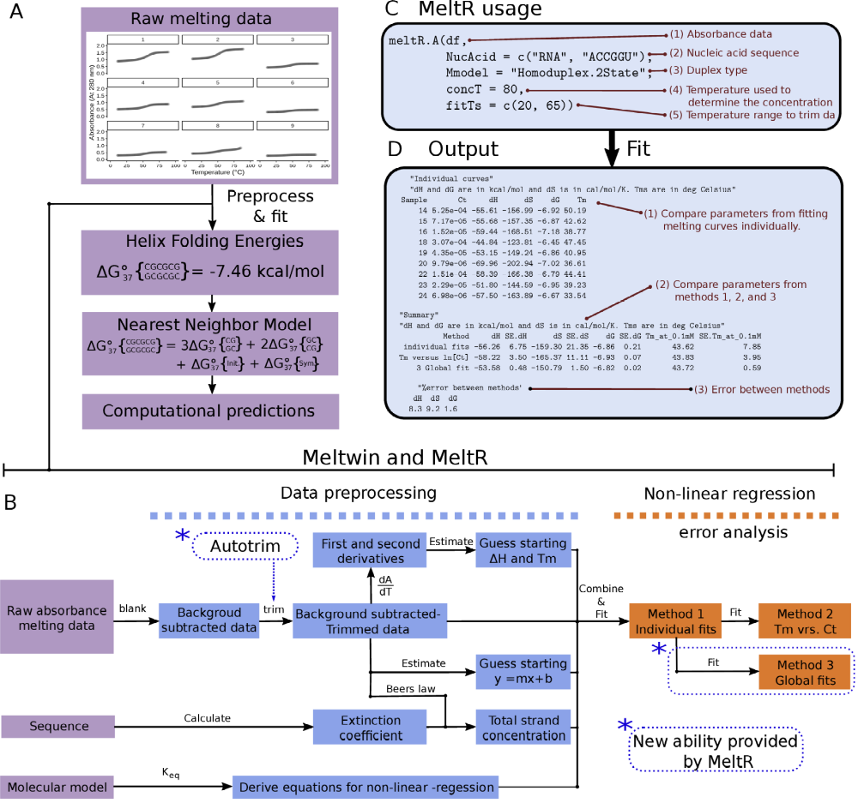
Figure 1 Determination of thermodynamic parameters from absorbance melting data using meltR.A in the MeltR package. (A) Themodenaturation data underlies algorithms that predict structure and function. (B) Raw data to thermodynamic parameter conversion is automated with MeltR. (C) The usage of meltR.A in an R script. (1) The data frame (df) containing the absorbance data (2) A vector specifying the nucleic acid. (3) Duplex type, either "Monomolecular.2State", "Heteroduplex.2State”, or "Homoduplex.2State”, (4) The temperature used to calculate the RNA concentration. (5) An optional temperature range that is fit, used for manual baseline trimming. (D) The raw output of meltR.A.
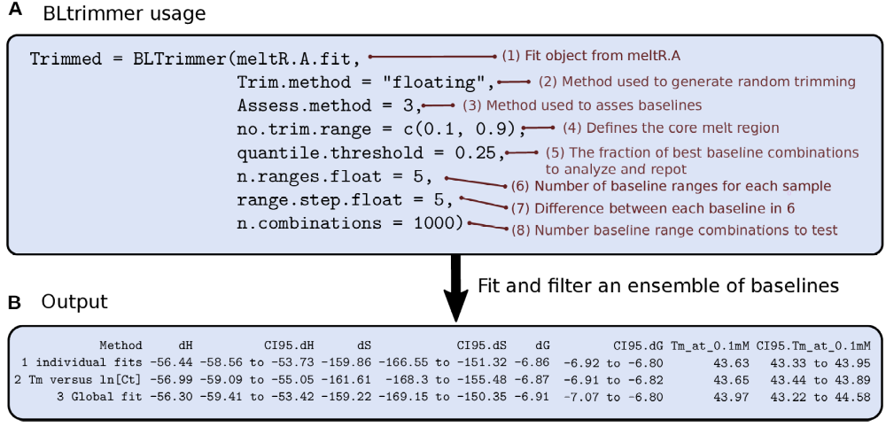
Figure 2 Auto-baseline trimming absorbance data using the BLtrimmer. (A) BLtrimmer usage in a R script. (1) A MeltR fit object from meltR.A. (2) Method used to generate random baselines. Either “fixed” or “floating”. (3) The method used to asses each baseline range for internal consistency across samples. (4) Defines the core or the melt region which is not trimmed. (5) The fraction of optimum baseline combinations to analyze in the final ensemble. (6) The number of baseline ranges the BLtrimmer will produce for each sample. (7) The temperature difference for each baseline produced on an absorbance melting curve. (8) The number of baseline combinations to test in a given BLtrimmer run. (B) The raw output of the BLtrimmer.
Figure 3 MeltR functions meltR.A and BLtrimmer reproduce folding energies calculated using MeltWin. (A) Average error between MeltR and MeltWin for each method. (B-F) Thermodynamic parameters determined from method 1 (purple) and method 2 (green) using MeltWin versus parameters method 3, global fitting, using MeltR. Horizontal error bars represent precision in the parameters calculated by MeltWin and vertical error bars represent 95% confidence intervals calculated using the BLtrimmer.
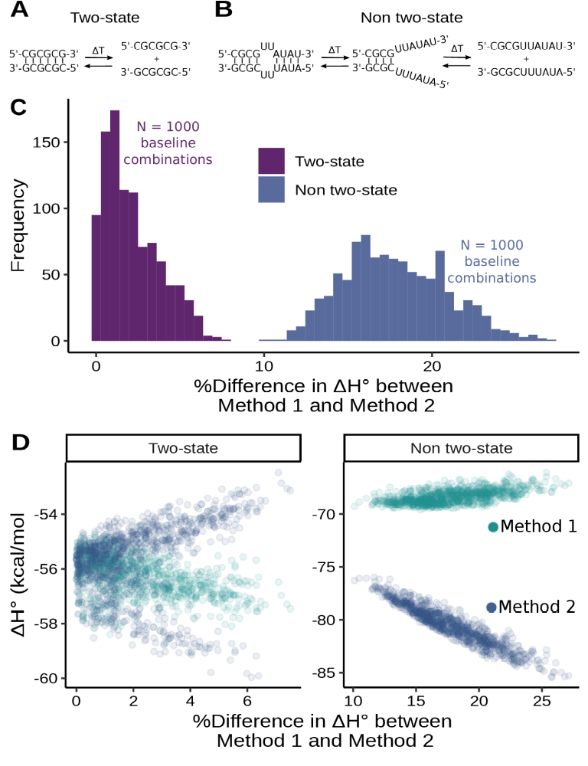
Figure 4 Two-state folding test using the BLtrimmer in MeltR. (A) Melting transition for a two-state folding sequence. (B) Melting transition for a two-state folding sequence. (C) The distribution of the error between the ΔH° using methods 1 (average of fitting samples individually) and method 2 (van’t Hoff analysis).

