**High-Capacity Exide Invertors and Batteries**

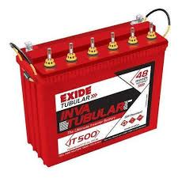

**Offers**

1. 1.25Va with 150 AH with tabular invertor battery by Exide

With 3 years flat replacement

*Invertor 2 years

For 5 Fans, 5 Tub lights, TV

**Price 20,990/-**

1. 1225Va with 150 AH with tabular invertor battery by Exide

With 3 years flat replacement

*Invertor 2 years

For 6 Fans, 6 Tub lights, TV

OR

Mixer, 3 Fans, 4 Tub lights

**Price 22,680/-**

**Contact Details**

**Phone Number – 9403061199**

**Email id:** [**jptechatronics@gmail.com**](mailto:jptechatronics@gmail.com)

Hurry!! Hurry!!