QUOTATION

Quotation no: RiteshChodankar102
Date 24/06/2025

To,

Ritesh Chodankar
Goa

Dear Sir,
Kindly find the quotation as per your requirement.

 |  | Area |  | ON/OFF  Circuits |  | Fan ON/OFF |  |  | Dali dimming |  | Main keypad |  | second Keypad |  | Curtain Automation | Automation Controller
Ground Floor |  | Staircase |  |  |  |  |  |  | Yes |  |  |  |  |  |  | 1
 |  | Ent. Foyer |  | 4 |  |  |  |  |  |  | 1 |  |  |  |  | 1
 |  | Guest room |  | 4 |  |  |  |  |  |  | 1 |  |  |  | 2 | 1
 |  | Dining Area |  | 3 |  |  |  |  |  |  |  |  | 1 |  | 2 | 1
 |  | Living Area |  | 4 |  |  |  |  |  |  | 1 |  | 1 |  | 4 | 1
 |  | Leisure Area |  | 4 |  |  |  |  |  |  |  |  | 1 |  | 2 | 1
 |  | Master Bedroom |  | 4 |  |  |  |  |  |  | 1 |  | 1 |  | 2 | 1
 |  | Walk In Closet |  | 2 |  |  |  |  |  |  |  |  |  |  |  | 1
 |  | Master Toilet |  | 2 |  |  |  |  |  |  |  |  |  |  |  | 1
 |  | Kitchen |  | 3 |  |  |  |  |  |  | 1 |  |  |  |  | 1
 |  | Powder Room |  | 2 |  |  |  |  |  |  |  |  |  |  |  | 1
 |  | Toilet |  | 2 |  |  |  |  |  |  |  |  |  |  |  | 1
 |  | Puja Room |  | 4 |  |  |  |  |  |  |  |  |  |  | 2 | 1
First Floor |  | Staircase |  |  |  |  |  |  |  |  |  |  |  |  |  | 1
 |  | Bedroom -01 |  | 4 |  |  |  |  |  |  | 1 |  | 1 |  | 4 | 1
 |  | Balcony |  | 2 |  |  |  |  |  |  |  |  |  |  |  | 1
 |  | Walk In Closet |  | 2 |  |  |  |  |  |  |  |  |  |  |  | 1
 |  | Toilet |  | 2 |  |  |  |  |  |  |  |  |  |  |  | 1
 |  | Bedroom -02 |  | 4 |  |  |  |  |  |  | 1 |  | 1 |  | 4 | 1
 |  | Balcony |  | 2 |  |  |  |  |  |  |  |  |  |  |  | 1
 |  | Walk In Closet |  | 2 |  |  |  |  |  |  |  |  |  |  |  | 1
 |  | Toilet |  | 2 |  |  |  |  |  |  |  |  |  |  |  | 1
 |  | Passage |  | 3 |  |  |  |  |  |  |  |  | 1 |  |  | 1
 |  | Bedroom -03 |  | 4 |  |  |  |  |  |  | 1 |  | 1 |  | 2 | 1
 |  | Walk In Closet |  | 2 |  |  |  |  |  |  |  |  |  |  |  | 1
 |  | Toilet |  | 2 |  |  |  |  |  |  |  |  |  |  |  | 1
 |  | Bedroom -04 |  | 4 |  |  |  |  |  |  | 1 |  | 1 |  | 2 | 1
 |  | Walk In Closet |  | 2 |  |  |  |  |  |  |  |  |  |  |  | 1
 |  | Toilet |  | 2 |  |  |  |  |  |  |  |  |  |  |  | 1
 |  | Bedroom -05 |  | 4 |  |  |  |  |  |  | 1 |  | 1 |  | 2 | 1
 |  | Walk In Closet |  | 2 |  |  |  |  |  |  |  |  |  |  |  | 1
 |  | Toilet |  | 2 |  |  |  |  |  |  |  |  |  |  |  | 1
 |  | Multimedia Room |  | 3 |  |  |  |  |  |  | 1 |  | 1 |  | 4 | 1
 |  | Balcony |  | 2 |  |  |  |  |  |  |  |  |  |  |  | 1
 |  | Total Matrix Qty: |  | 90 |  |  |  |  |  |  | 11 |  | 11 |  | 32 | 1
PROJECT MATRIX |  |  |  | ON/OFF  Circuits |  | Fan ON/OFF |  |  | Phase  cut/ Dimming Circu₈its |  | BUTTON KEYPAD |  | secondar y  Keypads |  | Curtain Automat | Automat ion Controlle
*NOTE: ON/OFF Circuits are on basic calculation basis & vary as per the actuals light point. Client scope:
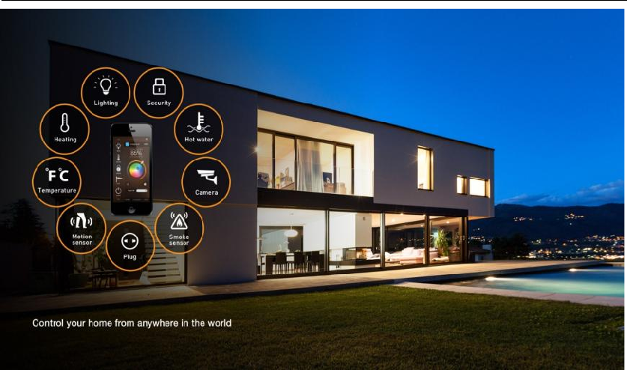

Quotation (smart home lighting automation solutions)
S.no | Make / Brand | Product Description | Qty | UOM | Price | Line Total | Image | SOLUTION CATEGORY
1 | MDT | KNX Push Button Smart 86 WITH COLOUR DISPLAY, WHITE GLOSSY FINISH( BE-TAS86.02) | 11 | No.s | 62,000.00 | 682,000.00 | 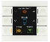 | Main Automation Keypad
In lieu of 1 | TENSE | KNX_INTBG8.01 KNX Intensity Brushed Gold 8F | 11 | No.s | 96,000.00 | 1,056,000.00 | 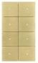 | Main Automation Keypad
2 | MDT | Push Button Lite 55 4-Fold, RGBW, white Glossy Finish(BE-TAL5504) | 11 | No.s | 30,000.00 | 330,000.00 | 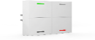 | Secondary Keypad
In lieu of 2 | TENSE | KNX Intensity Brushed Gold 4F(KNX_INTBG4.01) | 11 | No.s | 69,000.00 | 759,000.00 | 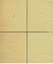 | Secondary Keypad
3 | MDT | 2 Gang Frame For keypad(BE-TAL55004) | 11 | No.s | 2,400.00 | 26,400.00 | 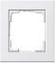 | Provision for manual switch board control
4 | MDT | KNX Bus Power Supply 640ma | 1 | No.s | 82,000.00 | 82,000.00 | 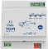 | DB PANEL COMPONENTS  (Automation backend )
5 | 1Home | 1 Home sever | 1 | No.s | 197,800.00 | 197,800.00 | 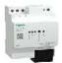 | DB PANEL COMPONENTS  (Automation backend )
7 | MDT | KNX Modular multi-applications ON/OFF controllers (24ch x 16 A outputs) | 5 | No.s | 187,000.00 | 935,000.00 | 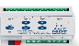  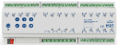 | DB PANEL COMPONENTS  (Automation backend )
 | MDT | KNX Modular multi-applications ON/OFF controllers (16ch x 16 A outputs) | 2 | No.s | 138,000.00 | 276,000.00 | 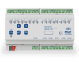 | DB PANEL COMPONENTS  (Automation backend )
8 | MDT | KNX 2*64CH Dali Gateway (2*64 LIGHTS) | 1 | No.s | 142,000.00 | 142,000.00 | 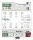 | 64ch-Dali gateway (FOR DALI LIGHTS DIMMING)
9 | KNX Bus Cable | KNX CABLE 2 PAIR (R12174) | 915 | Mtrs | 160.00 | 146,400.00 | 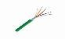 | cable
 |  |  | Total |  |  | 4,632,600.00 | Offer price
GST @18% EXTRA

Curtains:
OPTION -01
AUTOM CURTAIN- QUOTE
S.no | Make / Brand | Product Description |  |  | Qty | UOM | Price | Line Total | TRACK RMTS
1 | AUTOM | a. | MOTOR &FABRICATED TRACK PRICE (NORMAL RUNNER)(M) |  | 1 | No.s | 18,900.00 | 18,900.00 | UPTO 5.99M
 | AUTOM | b. | Channel & others Accessories |  | 1 | No.s | 5,900.00 | 5,900.00 | UPTO 5.99M
2 | AUTOM | a. | MOTOR &FABRICATED TRACK PRICE (NORMAL RUNNER)(S) |  | 1 | No.s | 18,900.00 | 18,900.00 | UPTO 5.99M
 |  | b. | Channel & others Accessories |  | 1 | No.s | 5,900.00 | 5,900.00 | UPTO 5.99M
TOTAL |  |  |  |  |  |  |  | 49,600.00
GST @18% EXTRA

*Considering 32 Curtains
1 | [32 x (1a + 1b)] = [32 x (18900 + 5900)] |  |  |  |  |  | 793,600.00
2 | [32 x (2a + 2b)] = [32 x (18900 + 5900)] |  |  |  |  |  | 793,600.00
 | Total |  |  |  |  |  | 1,587,200.00
GST @18% EXTRA

OPTION -02 |  |  |  |  |  |  |  |  | 
S.no | Make / Brand | Product Description |  |  | Qty | UOM | Price | Line Total | TRACK RMTS
1 | HD | a. | HD Silent Heavy Duty PLEATED Curtain Track With Accessories (M) |  | 1 | No.s | 19,800.00 | 19,800.00 | Upto 5.99
 | HD | b. | HD-60G QRF-AC-6 Wire Motor |  | 1 | No.s | 18,000.00 | 18,000.00 | Upto 5.99
2 | HD | a. | HD Silent Heavy Duty PLEATED Curtain Track With Accessories (S) |  | 1 | No.s | 19,800.00 | 19,800.00 | Upto 5.99
 | HD | b. | HD-60G QRF-AC-6 Wire Motor |  | 1 | No.s | 18,000.00 | 18,000.00 | Upto 5.99
TOTAL |  |  |  |  |  |  |  | 75,600.00
GST @18% EXTRA

*Considering 32 Curtains
1 | [32 x (1a + 1b)] = [32 x (19800 + 18000)] |  |  | 1,209,600.00
2 | [32 x (2a + 2b)] = [32 x (19800 + 18000)] |  |  | 1,209,600.00
 | Total |  |  | 2,419,200.00
GST @18% EXTRA

Client scope:
Cheque to be made in favor of JP Techatronics
Scaffolding wherever required to be provided.
Electrification wherever necessary to be provided.
Fabrication like poles etc. to be provided.
Fabricated poles if required to be provided.
Civil work if required.
Networking, cabling will be provided as per the requirements.

Payment Terms
75% Advance
25% upon delivery of materials.

Company’s Bank Details
Bank Name: Central Bank of India
Account Number: 3167002097
Branch & IFS Code: Panaji & CBIN0280713

Terms & conditions apply.
Quotation valid for 10 days only.
If payment not received on time interest @ 15% will be levied per annum.
Any extra item if required to be charged as actual.
Warranty as per manufacturer not valid in case of surges, fluctuation, lightening etc.to be claimed directly with the
manufacturer without involving JP TECHATRONICS.
Solution done as per recommendation and request by client hence, JP TECHATRONICS or its employees should not be held responsible for any kind of malfunctioning of the system for any reasons.
Services like data backup, searching footage, port forwarding etc. to be charged as actuals.
Service calls post installation to be charged as actuals.

