EcoDash: African Digital Logistics & Infrastructure Simulator
WAS262/SF1 — Task 1: Planning & Ethics
Student name: [Insert your name] Student number: [Insert your number]
Important: This is a starter report. Replace bracketed notes with your own testing, GitHub URL, and verified STADIO Library references. Use your own words and be prepared to explain every section.

1.1 GitHub repository setup
Repository name: EcoDash-African-Logistics
Repository URL: [Paste your public GitHub repository URL here]
The repository separates page structure (index.html), visual design (styles.css), and simulation logic (app.js). The README provides setup instructions, project features, an AI usage disclosure, and a staged commit plan. The repository should show real progress through at least eight meaningful commits made on different days. Do not make commits for changes that have not actually been completed.

1.2 African problem investigation

Problem context
EcoDash models the challenge of delivering medical supplies to a rural South African clinic. Rural freight and transport links affect how goods reach communities, and transport access can influence access to markets and services (Sieber, 2009). Research into electrifying Cape Town's last-mile delivery fleet has also examined charging demand and the possible role of decentralised solar energy in reducing pressure on the electricity grid (World Electric Vehicle Journal, 2025).
The simulation represents this challenge through an electric delivery vehicle, a clinic destination, damaged-road hazards, a battery meter, a solar charging zone, and a simulated load-shedding event. When the charging station is unavailable, the player must adapt the route and conserve battery. This is a fictional educational scenario, not a simulation of a named real road or a prediction of actual vehicle performance.

Physics and mathematical model
The vehicle stores position as x and y coordinates and velocity as vx and vy. Keyboard input adds acceleration to velocity, and velocity changes position on each animation frame. A drag multiplier slightly below 1 slows the vehicle over time. The speed is calculated with speed = √(vx² + vy²), and the program limits the speed so diagonal movement is not faster than straight movement.
The vehicle angle is calculated with Math.atan2(vy, vx), which lets the drawn vehicle face its direction of travel. Battery reserve decreases when the vehicle moves and increases while it is inside the solar zone, unless the simulated blackout is active. Circular distance calculations detect hazards, while axis-aligned bounding-box (AABB) checks detect overlap with the clinic and charging zone. These values are simplified game mechanics rather than real engineering data.
The animation uses requestAnimationFrame() to update and redraw the Canvas. MDN Web Docs describes this as a browser method for scheduling animation updates (MDN Web Docs, n.d.).

1.3 Wireframe
The wireframe below shows the main game screen, player, score, battery indicator, status information, field-note legend, and controls. The mini-map is optional and is not included in this design.
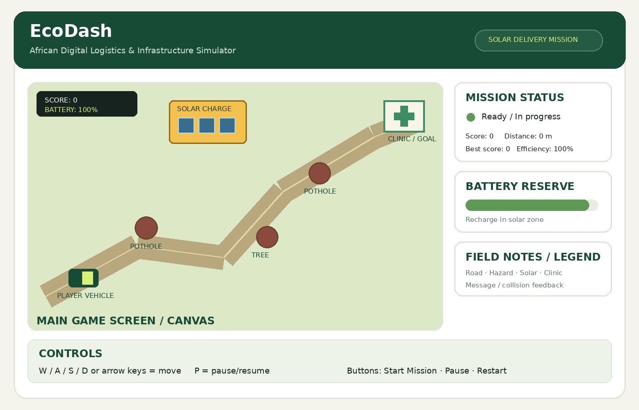

AI Reflection Log

Prompt used
“Help me plan a beginner-friendly HTML5 Canvas and vanilla JavaScript simulation called EcoDash. It should model an electric delivery vehicle in a South African rural environment and include movement, battery management, solar charging, obstacles, collision detection, scoring, pause/restart, and local storage. Explain the code so I can test and defend it.”

Summary of AI response
AI assistance was used to organise the project into HTML, CSS, and JavaScript files; suggest a Canvas animation loop; explain a vehicle class, keyboard controls, movement physics, collision detection, charging, game states, and local storage; and draft a report structure.

Evaluation and improvements
The suggested implementation must be tested rather than assumed correct. Battery drain, speed, distance, and blackout timing are simplified values and do not represent measured real-world performance. The code should be checked in a browser, bugs should be fixed, and documentation should be updated to match the final implementation. The original feature is deliberately left as a student task: implement a day/night cycle independently without Generative AI.
My testing and changes (complete after testing):
- Movement and boundaries: [Record what you tested and changed.]
- Hazard collisions: [Record what you tested and changed.]
- Battery and solar charging: [Record what you tested and changed.]
- Pause, restart, and saved score: [Record what you tested and changed.]
- Original feature implemented without AI: [Describe your own code and test results.]

AI usage disclosure
AI use | Potential limitation | Student responsibility
Project planning and structure | May not exactly match the final submission | Compare with the rubric and update files
Starter code explanation | Code may contain bugs or simplified assumptions | Test, debug, and explain it
Documentation draft | References or claims may need verification | Verify sources and rewrite accurately
Original feature | Must not be generated by AI | Write and test the feature independently

GitHub progress plan
Make at least eight meaningful commits on different days. Examples: create repository and README; add Canvas page; style the interface; add vehicle movement; add battery management; add collision detection; add solar charging and blackout logic; add score and local storage; implement the original feature independently; and finish documentation and testing. Only commit changes that you have actually made.

References
- MDN Web Docs (n.d.) Canvas API. Available at: https://developer.mozilla.org/en-US/docs/Web/API/Canvas_API (Accessed: 12 October 2026).
- Sieber, N. (2009) Freight transport for development toolkit: rural freight. Washington, DC: World Bank. Available at: https://documents.worldbank.org/en/publication/documents-reports/documentdetail/140791468315544452 (Accessed: 12 October 2026).
- World Electric Vehicle Journal (2025) ‘Simulating the electrification of Cape Town’s last-mile motorcycle fleet: Grid impact and resource requirements’, World Electric Vehicle Journal, 16(12), article 641. Available at: https://doi.org/10.3390/wevj16120641 (Accessed: 12 October 2026).
STADIO Library requirement: The assignment specifically requires at least two academic references from STADIO Libraries. Search the STADIO Library for two relevant scholarly sources, verify their details, and add them here. Do not claim that a source came from STADIO Library unless you have verified access to it.

