Software Design Document
ADC Driver Module
Lab 03 – Microcontrollers and Embedded Systems
Module | ADC Driver
Version | 1.0.0
Author(s) | J.M. Páez Sandoval, L.A. Lugo Muñiz, D. Lopez Moreno, C.A. Martínez Macías
Institution | CETYS Universidad — Facultad de Ingeniería
Date | 22/05/2026

1. Introduction

1.1 Purpose
This document describes the design and architecture of the adc_driver module. It covers the handle-less configuration API, single-channel regular conversion, resolution and alignment control, sample time configuration, software-triggered conversion start, EOC polling with overrun detection, and data read.

1.2 Scope
The adc_driver is a low-level bare-metal module for STM32F4xx ADC peripherals. It operates in single-conversion software-triggered mode (no DMA, no interrupts, no scan mode). It supports 12/10/8/6-bit resolution, right/left alignment, all eight sample time settings (3–480 cycles), and channels 0–18. The module is pointer-based: the caller passes an ADC_TypeDef* directly, enabling use with ADC1, ADC2, or ADC3.

1.3 Definitions, Acronyms, and Abbreviations
Term | Definition
ADC | Analog-to-Digital Converter — converts voltage to digital value
EOC | End-Of-Conversion flag (SR bit 1) — set by hardware when DR is ready
OVR | Overrun flag (SR bit 5) — set when a new conversion completes before DR is read
CR1 | ADC Control Register 1 — resolution (RES), scan mode (SCAN)
CR2 | ADC Control Register 2 — ADON, CONT, ALIGN, EOCS, SWSTART
SWSTART | Software Start bit (CR2 bit 30) — triggers a regular conversion
EOCS | End-Of-Conversion Selection (CR2 bit 10) — EOC after each conversion
ALIGN | Data alignment bit (CR2 bit 11) — 0=right, 1=left in 16-bit DR
ADON | ADC On/Off bit (CR2 bit 0) — powers the ADC analog section
CONT | Continuous mode bit (CR2 bit 1) — 0=single, 1=continuous
SQR1 | Regular Sequence Register 1 — L[23:20] = sequence length – 1
SQR3 | Regular Sequence Register 3 — SQ1[4:0] = first channel in sequence
SMPR1 | Sample Time Register 1 — 3-bit fields for channels 10–18
SMPR2 | Sample Time Register 2 — 3-bit fields for channels 0–9
DR | Data Register — 16-bit; reading clears SR.EOC
RES | Resolution bits [25:24] in CR1 — 00=12b, 01=10b, 10=8b, 11=6b
ADC_Config_t | Configuration struct: resolution, align, channel, sampleTime
ADC_Status_t | Return type: ADC_OK=0, negative values = error codes

1.4 Requirements
All requirements are allocated in Docs/SRS/ADC_Driver_SRS.md (provided by instructor without modification). Functional requirements FR-1 to FR-8 and non-functional requirements NFR-1 to NFR-3 are addressed.

2. System Architecture

2.1 High-Level Design
The adc_driver sits directly above the ADC hardware registers. GPIO pin configuration (analog mode) must be performed by the caller before adc_init(). APB2 clock for the ADC must also be enabled by the caller. The driver performs no clock gating.

Layer | Modules
Application | main.c / sensor.c — calls adc_init, adc_enable, adc_start, adc_poll_eoc, adc_read
ADC Driver | All ADC register operations: config, power, trigger, poll, read
Hardware | STM32F411RE ADC1 (APB2). Analog input on GPIO pin configured as ANALOG mode.

2.2 Module Interfaces
Public API declared in adc_driver.h. Dependency: stm32f411xe.h. No HAL, no gpio_driver, no timer. The caller must: (1) enable RCC->APB2ENR.ADC1EN, (2) configure the GPIO pin as ANALOG mode, before calling adc_init().

3. Detailed Design

3.1 Class Diagram
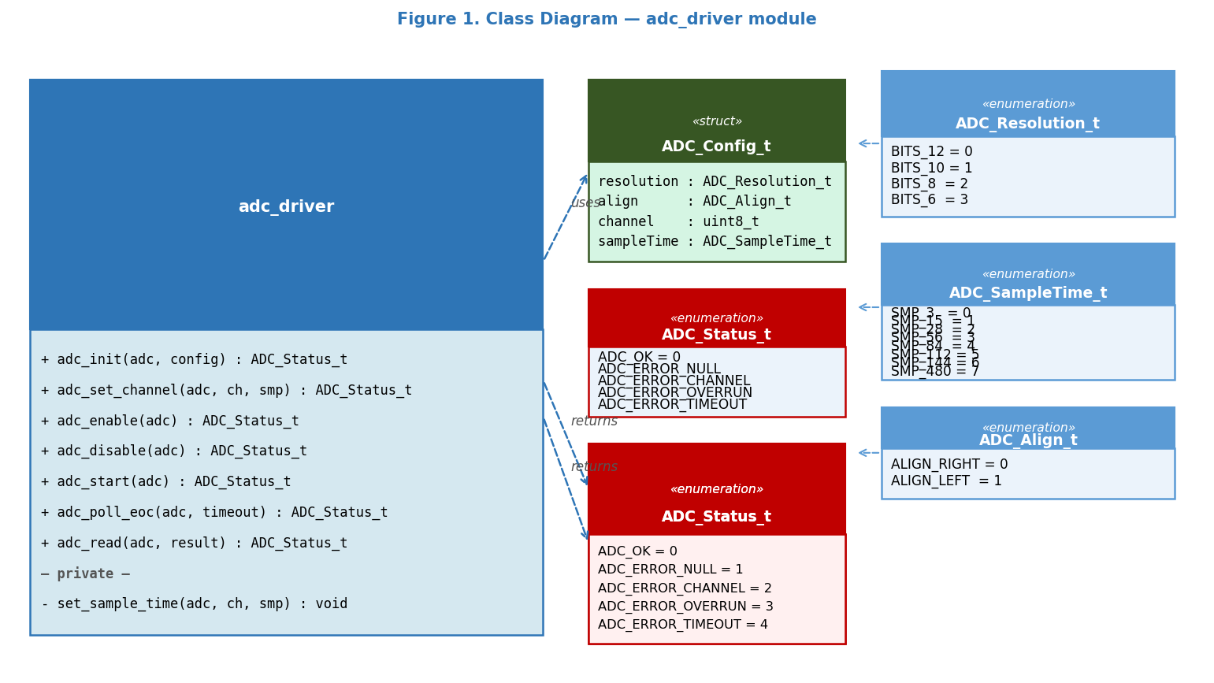
Figure 1. Class Diagram — adc_driver, ADC_Config_t, enumerations

3.2 Module Behavior
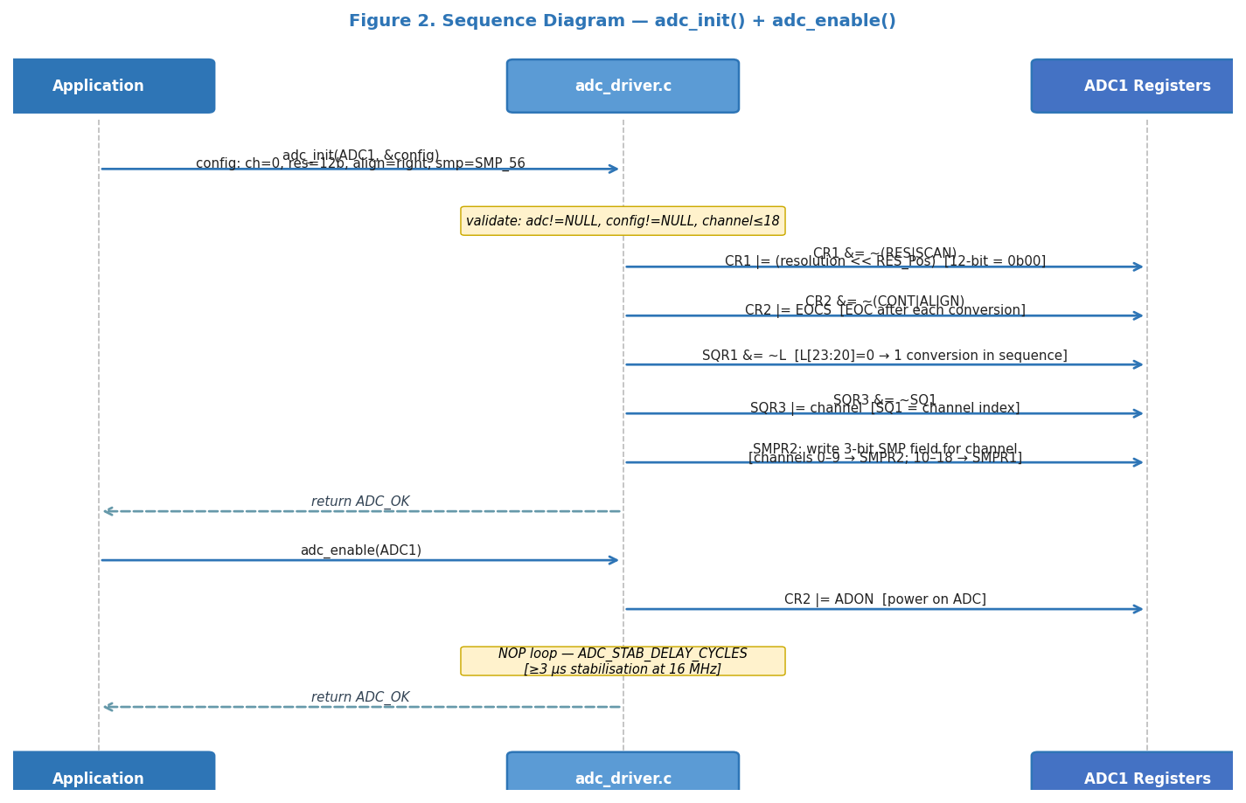
Figure 2. Sequence Diagram — adc_init() CR1/CR2/SQR/SMPR write, adc_enable() ADON + stabilisation delay

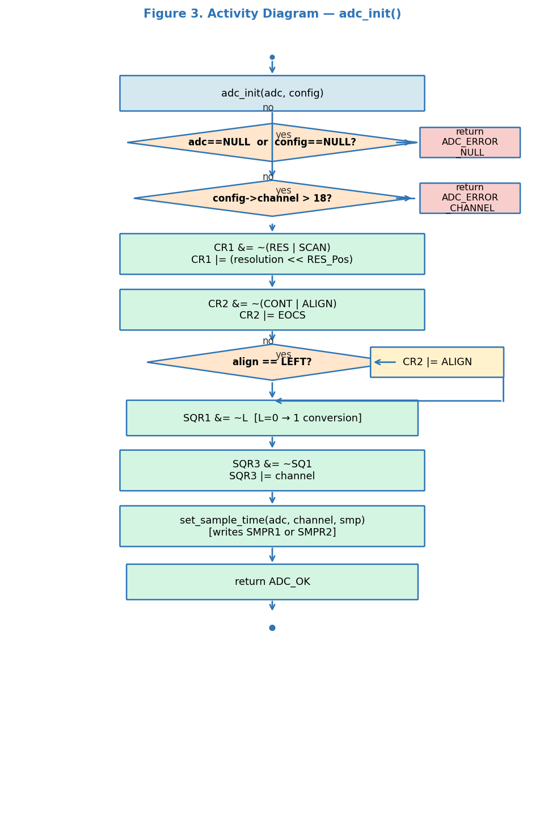
Figure 3. Activity Diagram — adc_init(): NULL/channel checks, register configuration, alignment branch

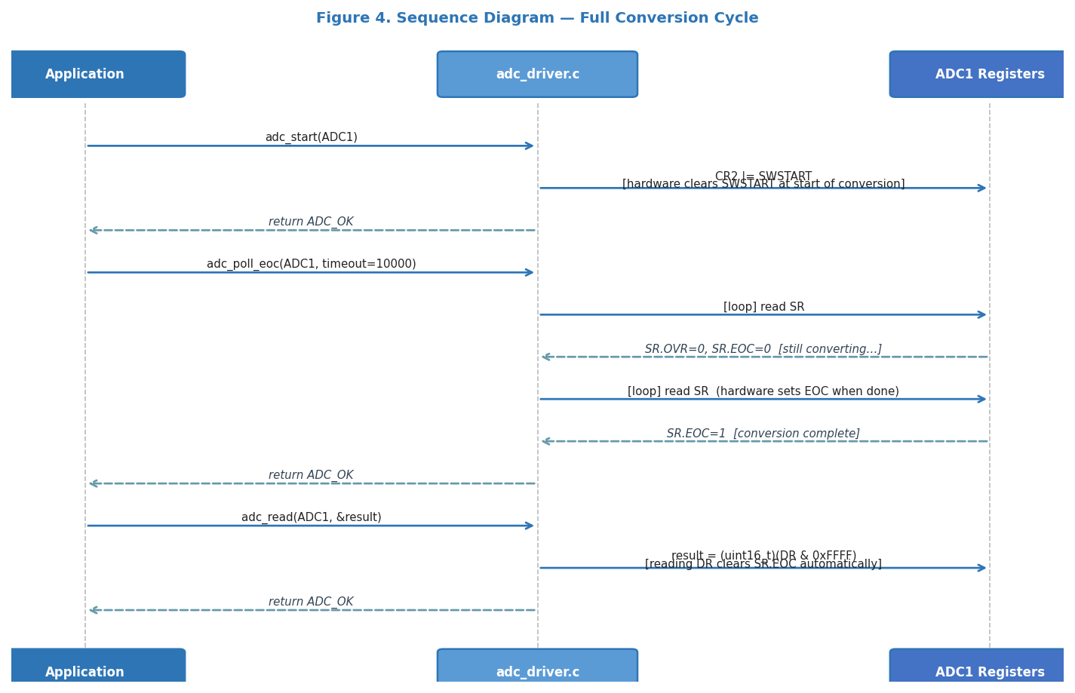
Figure 4. Sequence Diagram — Full conversion cycle: adc_start() → adc_poll_eoc() → adc_read()

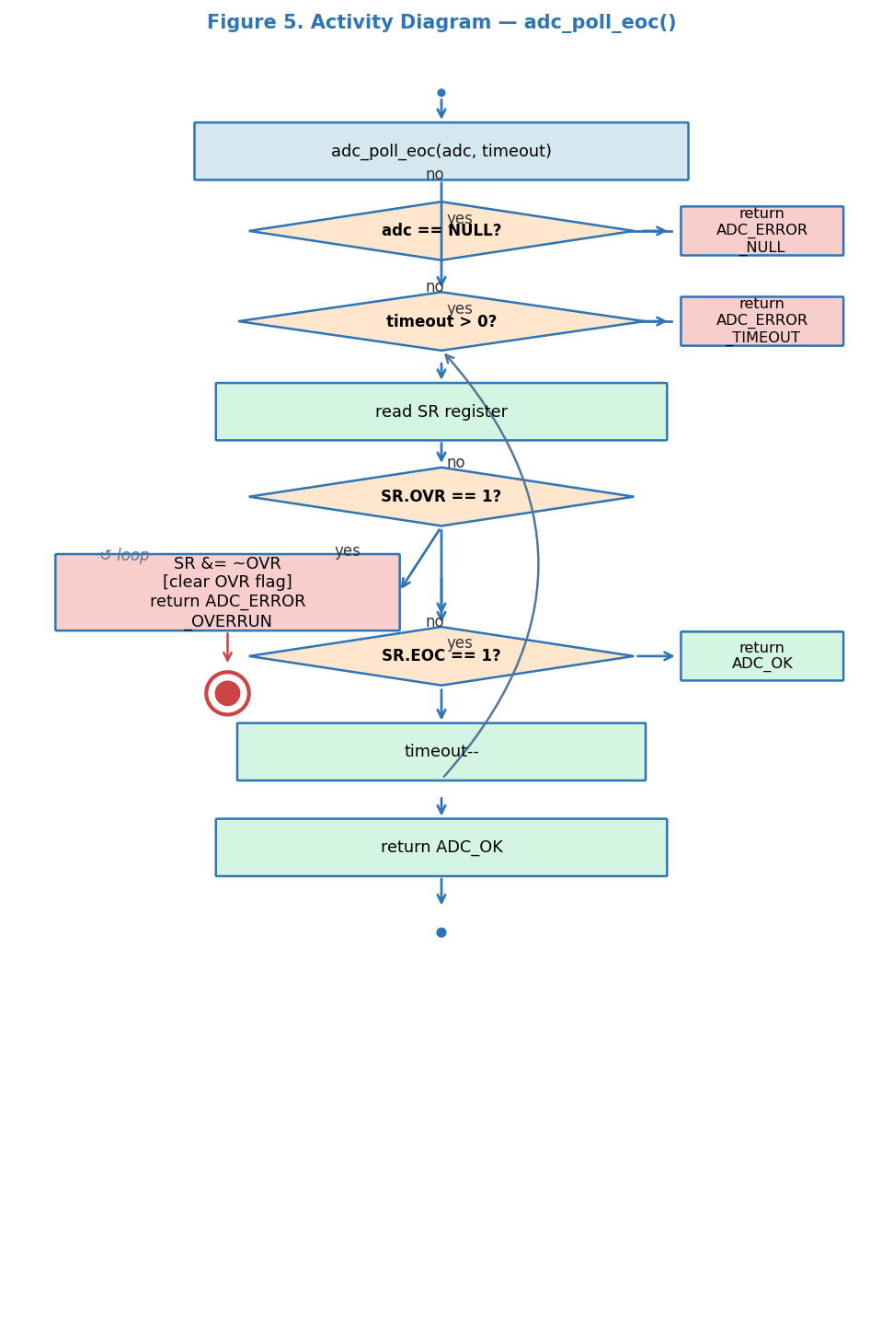
Figure 5. Activity Diagram — adc_poll_eoc(): OVR detection, EOC polling, timeout decrement loop

4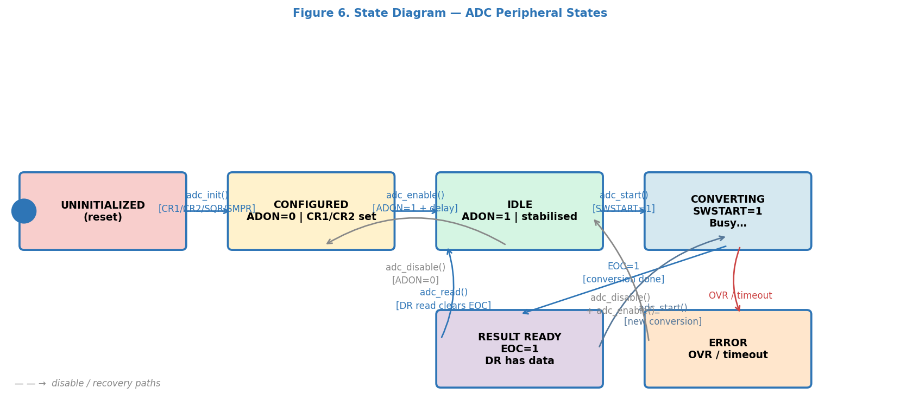
Figure 6. State Diagram — ADC Peripheral States

3.3 ADC Driver Module Description
adc_init() validates the ADC pointer and config struct, then configures four register groups. CR1: clears RES[25:24] and SCAN, writes resolution. CR2: clears CONT and ALIGN, sets EOCS=1 (EOC after each conversion), optionally sets ALIGN for left alignment. SQR1: clears L[23:20] to program a sequence of exactly one conversion. SQR3: writes the channel index into SQ1[4:0]. Finally calls adc_set_channel() to write the 3-bit sample time into SMPR1 or SMPR2 depending on the channel number.

adc_enable() sets CR2.ADON and executes a NOP loop for at least ADC_STAB_DELAY_CYCLES cycles (~3 µs at 16 MHz) to allow the ADC analog section to stabilise before the first conversion is triggered.

adc_start() sets CR2.SWSTART to trigger a software-initiated regular conversion. Hardware clears SWSTART automatically at the start of conversion.

adc_poll_eoc() polls SR in a timeout loop. On each iteration it first checks SR.OVR (a previous result was overwritten before DR was read) and returns ADC_ERROR_OVERRUN immediately after clearing the flag. Then checks SR.EOC — if set, returns ADC_OK. Decrements timeout on each iteration; returns ADC_ERROR_TIMEOUT if the counter reaches zero.

adc_read() reads DR as a 16-bit value masked with 0xFFFF. Reading DR clears SR.EOC automatically (hardware behaviour). For right-aligned 12-bit results the valid data is in bits [11:0].

set_sample_time() is a private helper that writes the 3-bit SMP field for a given channel. Channels 0–9 map to SMPR2 (field at bits [ch×3+2 : ch×3]); channels 10–18 map to SMPR1 (field at bits [(ch-10)×3+2 : (ch-10)×3]).

4. Application Programming Interfaces

4.1 Data Types and Macros
Type | Fields / Values | Notes
ADC_Config_t | resolution: ADC_Resolution_talign: ADC_Align_tchannel: uint8_t (0–18)sampleTime: ADC_SampleTime_t | Configuration struct passed by const pointer to adc_init()
ADC_Resolution_t | BITS_12=0, BITS_10=1BITS_8=2, BITS_6=3 | Written to CR1.RES[25:24]
ADC_Align_t | ALIGN_RIGHT=0ALIGN_LEFT=1 | Controls CR2.ALIGN bit
ADC_SampleTime_t | SMP_3=0, SMP_15=1, SMP_28=2SMP_56=3, SMP_84=4, SMP_112=5SMP_144=6, SMP_480=7 | 3-bit field in SMPR1/SMPR2
ADC_Status_t | ADC_OK=0, ADC_ERROR_NULL=1ADC_ERROR_CHANNEL=2ADC_ERROR_OVERRUN=3ADC_ERROR_TIMEOUT=4 | Return type for all public functions
ADC_MAX_CHANNEL | 18U | Maximum valid channel index
ADC_STAB_DELAY_CYCLES | ≥ 48U (3 µs @ 16 MHz) | NOP loop count in adc_enable()

4.2 Error Codes
Code | Value | Definition
ADC_OK | 0 | Operation completed successfully
ADC_ERROR_NULL | 1 | NULL pointer passed as adc or config/result
ADC_ERROR_CHANNEL | 2 | channel > ADC_MAX_CHANNEL (18)
ADC_ERROR_OVERRUN | 3 | SR.OVR was set — previous DR not read before new conversion finished
ADC_ERROR_TIMEOUT | 4 | timeout counter reached zero before SR.EOC was set

4.3 Function Definitions

adc_init
Function Name | adc_init
Syntax | ADC_Status_t adc_init(ADC_TypeDef *adc, const ADC_Config_t *config)
Parameters (in) | adc — ADC peripheral pointer (ADC1/ADC2/ADC3)config — const pointer to configuration struct
Return value | ADC_OK, ADC_ERROR_NULL, or ADC_ERROR_CHANNEL
Description | Configures CR1 (resolution, no scan), CR2 (single, EOCS, alignment), SQR1 (L=0), SQR3 (SQ1=channel), SMPR1/SMPR2 (sample time). Does not power on the ADC.
Constraints | Caller must enable APB2 ADC clock and configure GPIO pin as ANALOG before calling.
Available via | adc_driver.h

adc_set_channel
Function Name | adc_set_channel
Syntax | ADC_Status_t adc_set_channel(ADC_TypeDef *adc, uint8_t channel, ADC_SampleTime_t smp)
Parameters (in) | adc, channel (0–18), smp — sample time enum
Return value | ADC_OK, ADC_ERROR_NULL, or ADC_ERROR_CHANNEL
Description | Updates SQR3.SQ1 and the corresponding SMPR1/SMPR2 field. Allows channel change without full reinit.
Constraints | ADC must be disabled (ADON=0) when changing channel to avoid mid-conversion changes.
Available via | adc_driver.h

adc_enable
Function Name | adc_enable
Syntax | ADC_Status_t adc_enable(ADC_TypeDef *adc)
Parameters (in) | adc — ADC peripheral pointer
Return value | ADC_OK or ADC_ERROR_NULL
Description | Sets CR2.ADON then executes a NOP loop for ADC_STAB_DELAY_CYCLES to allow analog section stabilisation before the first SWSTART.
Constraints | Must be called after adc_init(). Satisfies FR-4.
Available via | adc_driver.h

adc_disable
Function Name | adc_disable
Syntax | ADC_Status_t adc_disable(ADC_TypeDef *adc)
Parameters (in) | adc — ADC peripheral pointer
Return value | ADC_OK or ADC_ERROR_NULL
Description | Clears CR2.ADON to power off the ADC analog section. Satisfies FR-5.
Constraints | Any ongoing conversion is aborted.
Available via | adc_driver.h

adc_start
Function Name | adc_start
Syntax | ADC_Status_t adc_start(ADC_TypeDef *adc)
Parameters (in) | adc — ADC peripheral pointer
Return value | ADC_OK or ADC_ERROR_NULL
Description | Sets CR2.SWSTART to software-trigger a regular conversion. Hardware clears SWSTART at the start of conversion. Satisfies FR-6.
Constraints | ADC must be enabled (ADON=1). adc_poll_eoc() must be called before the next adc_start() to avoid OVR.
Available via | adc_driver.h

adc_poll_eoc
Function Name | adc_poll_eoc
Syntax | ADC_Status_t adc_poll_eoc(ADC_TypeDef *adc, uint32_t timeout)
Parameters (in) | adc — ADC pointertimeout — max polling iterations (e.g. 10000)
Return value | ADC_OK, ADC_ERROR_NULL, ADC_ERROR_OVERRUN, or ADC_ERROR_TIMEOUT
Description | Polls SR in a loop: checks OVR first (clears flag, returns overrun error), then checks EOC (returns OK). Decrements timeout; returns timeout error at zero. Satisfies FR-7.
Constraints | Blocking (CPU busy-wait). timeout=0 returns ADC_ERROR_TIMEOUT immediately.
Available via | adc_driver.h

adc_read
Function Name | adc_read
Syntax | ADC_Status_t adc_read(ADC_TypeDef *adc, uint16_t *result)
Parameters (in) | adc — ADC pointerresult — pointer to destination uint16_t
Return value | ADC_OK or ADC_ERROR_NULL
Description | Reads DR & 0xFFFF into *result. Reading DR clears SR.EOC automatically. For 12-bit right-aligned, valid data is in bits [11:0]. Satisfies FR-8.
Constraints | Must be called after adc_poll_eoc() returns ADC_OK to ensure valid data.
Available via | adc_driver.h

4.4 Internal Function Definitions

set_sample_time (static)
Function Name | set_sample_time
Syntax | static void set_sample_time(ADC_TypeDef *adc, uint8_t channel, ADC_SampleTime_t smp)
Parameters (in) | adc, channel (0–18), smp — 3-bit sample time value
Return value | void
Description | Channels 0–9: writes 3-bit SMP field in SMPR2 at bits [(ch×3+2):(ch×3)]. Channels 10–18: writes in SMPR1 at bits [((ch-10)×3+2):((ch-10)×3)]. Uses read-modify-write.
Constraints | Not accessible outside adc_driver.c. Called by adc_init() and adc_set_channel().

5. Future Enhancements
• Add DMA-based continuous mode: enable CR2.CONT, configure DMA1 Stream0, and provide a callback for buffer-full notification.
• Add multi-channel scan mode: configure L[23:20] > 0 in SQR1 and populate SQR2/SQR3 with channel sequences.
• Implement interrupt-driven EOC: enable CR1.EOCIE and provide an IRQ handler with a completion callback.
• Add adc_calibrate() to perform the STM32F4 ADC factory calibration procedure for improved accuracy.

