Software Design Document
SPI Driver Module
Lab 05 – Microcontrollers and Embedded Systems
Module | SPI Driver
Version | 1.0.0
Author(s) | J.M. Páez Sandoval, L.A. Lugo Muñiz, D. Lopez Moreno, C.A. Martínez Macías
Institution | CETYS Universidad — Facultad de Ingeniería
Date | 29/05/2026

1. Introduction

1.1 Purpose
This document describes the design and architecture of the spi_driver module for Lab 05. It covers the GPIO and SPI1 peripheral initialization sequence, polled transmit/receive operations, chip-select control, and the full-duplex dummy-byte receive pattern.

1.2 Scope
The spi_driver is a low-level bare-metal module for the STM32F411RE SPI1 peripheral. It operates in master mode using polling (no interrupts, no DMA). The fixed configuration is SPI Mode 3 (CPOL=1, CPHA=1), 8-bit frames, MSB-first, software NSS, fPCLK/32 ≈ 3.1 MHz. GPIO configuration is handled internally via gpio_driver. The module exposes five public functions and four private helpers that encapsulate the four initialization phases.

1.3 Definitions, Acronyms, and Abbreviations
Term | Definition
SPI | Serial Peripheral Interface — synchronous four-wire full-duplex bus
MOSI | Master Out Slave In — data driven by master to slave
MISO | Master In Slave Out — data driven by slave to master
SCK | Serial Clock — generated by master; controls data sampling
CS / NSS | Chip Select / Slave Select — active-low, selects the slave device
CPOL | Clock Polarity — 0=SCK idles LOW, 1=SCK idles HIGH
CPHA | Clock Phase — 0=data captured on first edge, 1=on second edge
Mode 3 | CPOL=1, CPHA=1 — SCK idles HIGH, data captured on rising edge
MSB first | Most Significant Bit transmitted first (LSBFIRST=0)
TXE | TX buffer Empty flag (SR bit 1) — safe to write next byte
RXNE | RX buffer Not Empty flag (SR bit 0) — received byte available
BSY | Busy flag (SR bit 7) — SPI peripheral actively transferring
OVR | Overrun error — new byte received before previous DR was read
SSM / SSI | Software Slave Management / Internal select bit (master mode)
BR[2:0] | Baud Rate prescaler bits [5:3] in CR1 — fPCLK divisor
DFF | Data Frame Format — 0=8-bit, 1=16-bit
SPE | SPI Enable bit (CR1 bit 6) — activates the peripheral
SPI_Status_t | Return type: SPI_OK=0, SPI_ERROR=1

1.4 Requirements
All requirements are allocated in Docs/SRS/SPI_Driver_SRS.md. Functional requirements FR-1 to FR-8 and non-functional requirements NFR-1 to NFR-3 are addressed.

2. System Architecture

2.1 High-Level Design
The spi_driver sits between the application layer and the SPI1 hardware registers. GPIO initialization is delegated to gpio_driver. Four private helpers encapsulate the four initialization phases; only five public functions are exposed to callers.

Layer | Modules
Application | main.c — calls spi_cs_enable(), spi_transmit(), spi_receive(), spi_cs_disable()
SPI Driver | GPIO config (via gpio_driver) + SPI1 peripheral config + polled TX/RX
GPIO Driver | gpio_driver.c — pin mode, AF5, speed, push-pull configuration
Hardware | STM32F411RE SPI1 (APB2). PA5=SCK, PA6=MISO, PA7=MOSI (AF5). PA9=CS (output).

2.2 Module Interfaces
Public API declared in spi_driver.h. Dependencies: stm32f411xe.h, gpio_driver.h, stdint.h. No HAL. Hardware pins are fixed: PA5=SCK, PA6=MISO, PA7=MOSI (AF5), PA9=CS (push-pull output) on SPI1.

3. Detailed Design

3.1 Class Diagram
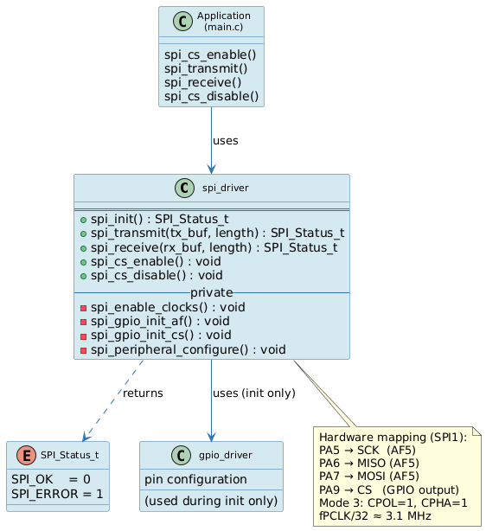
Figure 1. Class Diagram — spi_driver module, SPI_Status_t, gpio_driver dependency, hardware mapping

3.2 Module Behavior
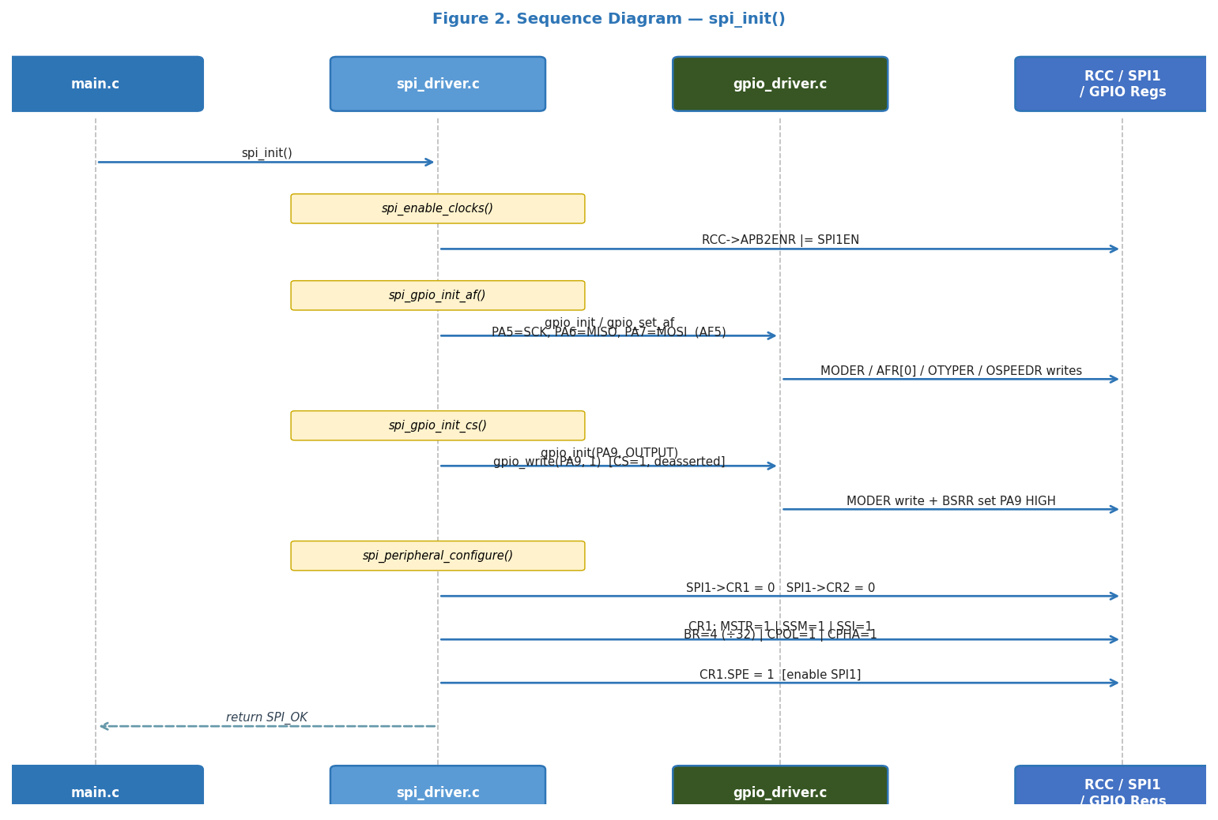
Figure 2. Sequence Diagram — spi_init(): clock enable, GPIO AF config, CS init, CR1 write, SPE=1
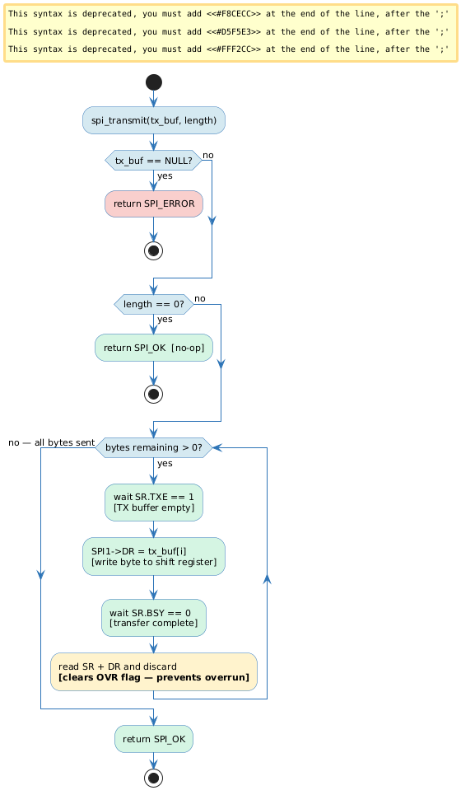
Figure 3. Activity Diagram — spi_transmit(): TXE→DR write→BSY wait→DR discard per byte

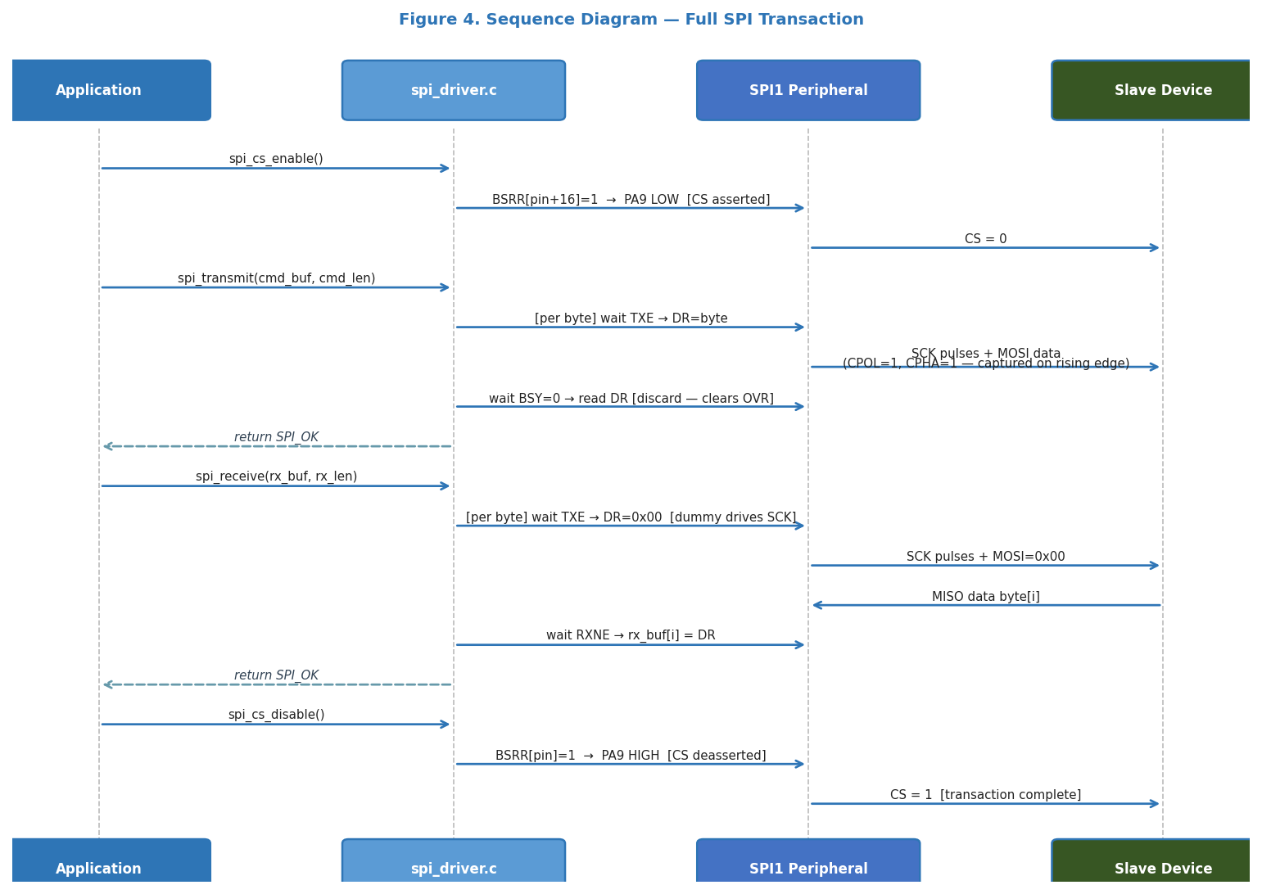
Figure 4. Sequence Diagram — Full transaction: cs_enable → transmit → receive → cs_disable

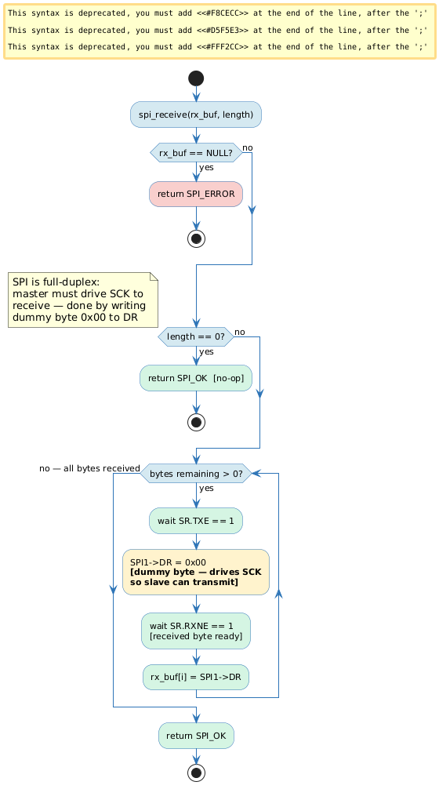
Figure 5. Activity Diagram — spi_receive(): dummy byte drives SCK, RXNE→DR read per byte

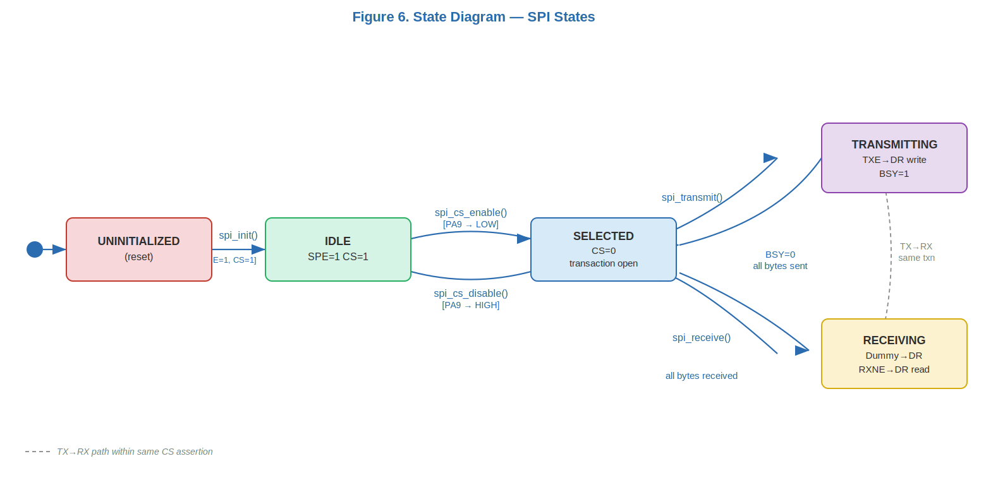
Figure 6. State Diagram — SPI States

3.3 SPI Driver Module Description
spi_init() calls four private helpers in sequence. spi_enable_clocks() sets RCC->APB2ENR.SPI1EN. spi_gpio_init_af() configures PA5, PA6, PA7 as AF5 push-pull very-high-speed via gpio_driver. spi_gpio_init_cs() configures PA9 as push-pull output and drives it HIGH (deasserted). spi_peripheral_configure() clears CR1/CR2, writes MSTR=1, SSM=1, SSI=1, BR=4 (÷32), CPOL=1, CPHA=1, and finally sets SPE=1 last to ensure all parameters are stable.

spi_transmit() iterates over the TX buffer. Per byte: waits for TXE, writes DR, waits for BSY=0, then reads and discards DR. The discard step is critical — without it, the OVR (overrun) flag accumulates and corrupts subsequent RXNE-based reads.

spi_receive() uses the full-duplex nature of SPI: the master must generate SCK to clock in data from the slave. Per byte: waits for TXE, writes dummy 0x00 (drives SCK), waits for RXNE, reads DR. The slave transmits its data synchronized to the SCK pulses generated by the dummy write.

spi_cs_enable() uses gpio_write(GPIOA, 9, 0) → BSRR atomic reset (PA9 LOW). spi_cs_disable() uses gpio_write(GPIOA, 9, 1) → BSRR atomic set. The application controls CS framing around each transaction.

4. Application Programming Interfaces

4.1 Data Types and Macros
Type / Macro | Values | Notes
SPI_Status_t | SPI_OK=0SPI_ERROR=1 | Return type for init, transmit, receive
SPI_PORT | GPIOA | Shared port for SCK/MISO/MOSI/CS
SPI_PIN_SCK | 5U | PA5 — Serial Clock (AF5)
SPI_PIN_MISO | 6U | PA6 — Master In Slave Out (AF5)
SPI_PIN_MOSI | 7U | PA7 — Master Out Slave In (AF5)
SPI_PIN_CS | 9U | PA9 — Chip Select (GPIO output, active-low)
SPI_BR_DIV32 | 4U | BR[2:0]=4 → fPCLK/32 ≈ 3.1 MHz

4.2 Error Codes
Code | Value | Definition
SPI_OK | 0 | Operation completed successfully
SPI_ERROR | 1 | NULL pointer passed as tx_buf or rx_buf

4.3 Function Definitions

spi_init
Function Name | spi_init
Syntax | SPI_Status_t spi_init(void)
Parameters (in) | None
Return value | SPI_OK (hardware assumed present)
Description | Enables APB2 clock, configures PA5/PA6/PA7 as AF5 push-pull VHIGH, PA9 as output CS=1, writes CR1 Mode3/Master/SSM/BR÷32, sets SPE=1. Satisfies FR-1, FR-2.
Constraints | Must be called before any other spi_* function.
Available via | spi_driver.h

spi_transmit
Function Name | spi_transmit
Syntax | SPI_Status_t spi_transmit(const uint8_t *tx_buf, uint16_t length)
Parameters (in) | tx_buf — source buffer (not NULL)length — number of bytes
Return value | SPI_OK or SPI_ERROR (tx_buf==NULL)
Description | Per byte: wait TXE → write DR → wait BSY=0 → discard DR (prevents OVR). Satisfies FR-3, FR-4.
Constraints | length=0 is a no-op. CS must be asserted by caller first.
Available via | spi_driver.h

spi_receive
Function Name | spi_receive
Syntax | SPI_Status_t spi_receive(uint8_t *rx_buf, uint16_t length)
Parameters (in) | rx_buf — destination buffer (not NULL)length — number of bytes
Return value | SPI_OK or SPI_ERROR (rx_buf==NULL)
Description | Per byte: wait TXE → DR=0x00 (dummy drives SCK) → wait RXNE → rx_buf[i]=DR. Satisfies FR-5, FR-6.
Constraints | SPI is full-duplex — receiving requires clock from dummy TX.
Available via | spi_driver.h

spi_cs_enable
Function Name | spi_cs_enable
Syntax | void spi_cs_enable(void)
Parameters (in) | None
Return value | void
Description | Drives PA9 LOW via BSRR atomic reset. Call before the first byte of a transaction. Satisfies FR-7.
Constraints | gpio_write(GPIOA, 9, 0).
Available via | spi_driver.h

spi_cs_disable
Function Name | spi_cs_disable
Syntax | void spi_cs_disable(void)
Parameters (in) | None
Return value | void
Description | Drives PA9 HIGH via BSRR atomic set. Call after the last byte of a transaction. Satisfies FR-8.
Constraints | gpio_write(GPIOA, 9, 1).
Available via | spi_driver.h

4.4 Internal Function Definitions
Private Function | Description
spi_enable_clocks() | RCC->APB2ENR |= SPI1EN. Called once at start of spi_init().
spi_gpio_init_af() | PA5/PA6/PA7 → AF5, push-pull, VHIGH, no pull via gpio_driver.
spi_gpio_init_cs() | PA9 → output push-pull, drives HIGH (CS deasserted). Called by spi_init().
spi_peripheral_configure() | Clears CR1/CR2, writes all SPI1 config bits, sets SPE=1 last.

5. Future Enhancements
• Add DMA-based spi_transmit_dma() / spi_receive_dma() to eliminate CPU busy-wait.
• Add 16-bit frame mode (DFF=1) for display controllers using 16-bit commands.
• Add spi_transceive() for simultaneous TX+RX in one call.
• Make pin/port assignments configurable via spi_config_t to support SPI2/SPI3.

