Software Design Document
TIM Driver Module
Lab 02 – Microcontrollers and Embedded Systems

Module | TIM Driver
Version | 1.0.0
Author(s) | J.M. Paez Sandoval, C.A. Martínez, D. Lopez Moreno, L.A. Lugo Muñiz
Institution | CETYS Universidad — Facultad de Ingeniería
Date | 25/04/2026

1. Introduction

1.1 Purpose
This document describes the design and architecture of the tim_driver module. It provides details on data structures, enumerations, algorithms, and control flow to guide implementation and testing of the STM32F4 timer peripheral driver.

1.2 Scope
The tim_driver is a low-level bare-metal module for STM32F4xx timers. It provides APIs to initialize timers, start/stop counters, read and clear the Update Interrupt Flag (UIF), and configure PWM output modes via CCMRx registers. It is used by the timer module (TIM2 delays) and the pwm module (TIM1 PWM). Peripheral clock enabling is not performed by tim_driver — caller modules must enable the APBx clock before calling tim_init().

1.3 Definitions, Acronyms, and Abbreviations

Term | Definition
TIM | Timer peripheral (TIM1–TIM11 on STM32F411)
PSC | Prescaler register — divides timer clock: tick = CLK / (PSC+1)
ARR | Auto-Reload Register — counter wraps at ARR+1; shadow register
CNT | Counter register — current timer count value
UIF | Update Interrupt Flag (SR bit 0) — set on counter overflow
UEV | Update Event — triggered by EGR.UG; copies shadow registers to active
EGR.UG | Update Generation bit — forces immediate UEV (shadow copy)
CCMRx | Capture/Compare Mode Register — configures OC mode (PWM1/2)
OC1M | Output Compare Mode field — 110b=PWM Mode 1, 111b=PWM Mode 2
OC1PE | Output Compare Preload Enable — CCR1 updates on UEV only
ARPE | Auto-Reload Preload Enable (CR1 bit 7) — ARR double-buffered
CCER | Capture/Compare Enable Register — CCxE enables channel output
CCRx | Capture/Compare Register — duty cycle control value
BDTR.MOE | Main Output Enable (BDTR bit 15) — required for TIM1/TIM8 output
APB1 | Advanced Peripheral Bus 1 — TIM2–TIM5 (16 MHz at reset)
APB2 | Advanced Peripheral Bus 2 — TIM1, TIM9–TIM11 (16 MHz at reset)
TIM_Status_t | Return type: TIM_OK=0, TIM_ERROR=1

1.4 Requirements
All requirements are allocated in Docs/SRS/TIM_Driver_SRS.md (provided by the instructor without modification).

2. System Architecture

2.1 High-Level Design
The tim_driver sits at the lowest software layer, directly above the hardware registers. Peripheral clocks are not enabled here — the calling module is responsible.

Layer | Modules
Application | main.c — calls led, timer, pwm APIs; no register access
Middleware | timer.c (TIM2 delays), pwm.c (TIM1 PWM) — built on tim_driver
TIM Driver | All TIM register operations. Caller enables APBx clock first.
Hardware | STM32F411RE TIM1 (APB2) and TIM2 (APB1) via CMSIS TIM_TypeDef

2.2 Module Interfaces
Public API declared in tim_driver.h. Dependencies: stm32f411xe.h, stdint.h, stddef.h. Constants: TIM_APB1_CLOCK_HZ = 16000000U, TIM_APB2_CLOCK_HZ = 16000000U. No HAL.

3. Detailed Design

3.1 Class Diagram
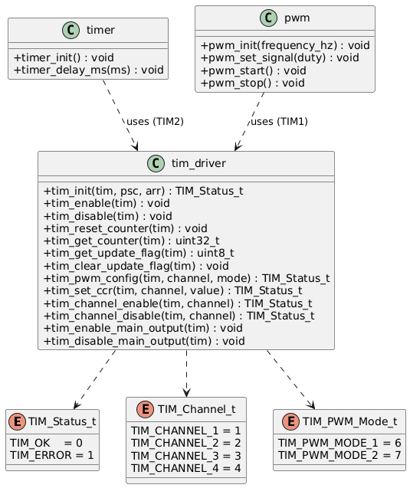
Figure 1. Class Diagram — tim_driver module, enumerations, and dependent modules (timer, pwm)

3.2 Module Behavior
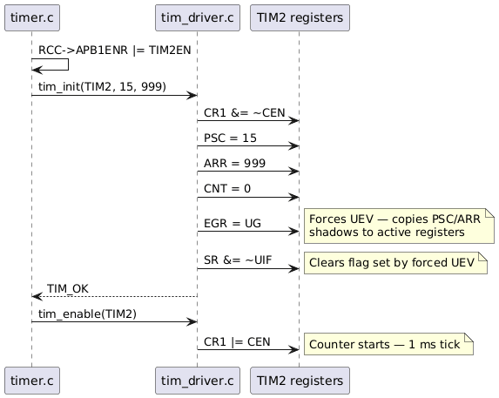
Figure 2. Sequence Diagram — tim_init() + tim_enable() for TIM2 1 ms tick

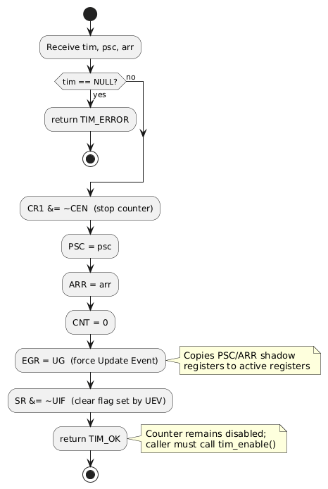
Figure 3. Activity Diagram - tim_init(): NULL check, PSC/ARR/CNT write, EGR.UG, UIF clear

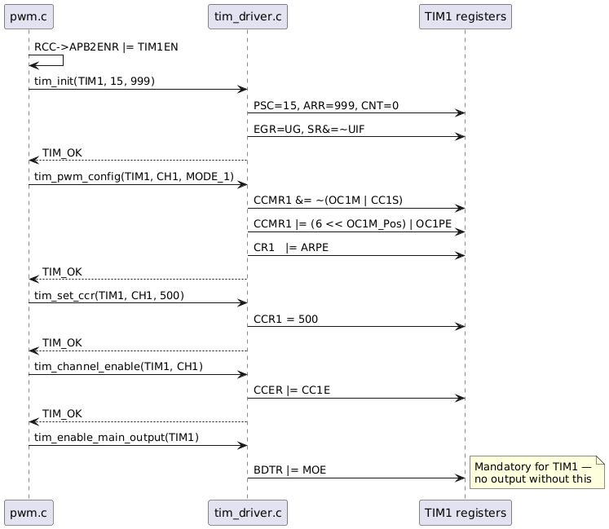
Figure 4. Sequence Diagram — tim_pwm_config() channel switch + tim_set_ccr() + tim_channel_enable() + MOE

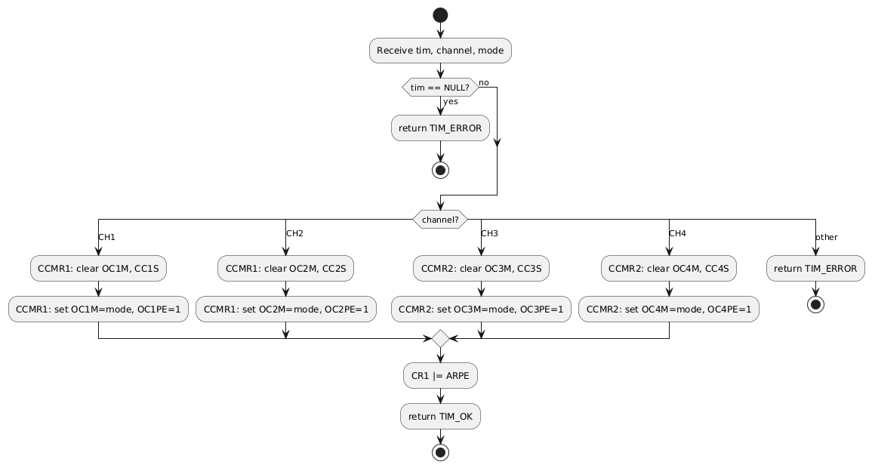
Figure 5. Activity Diagram - tim_pwm_config() channel selection switch

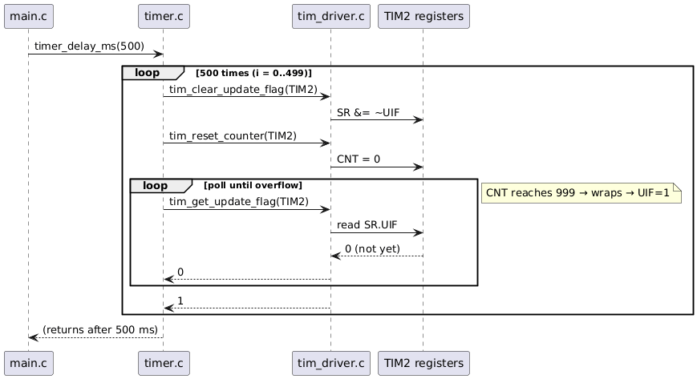
Figure 6. Sequence Diagram - timer_delay_ms() polling TIM2 UIF for 500 ms delay
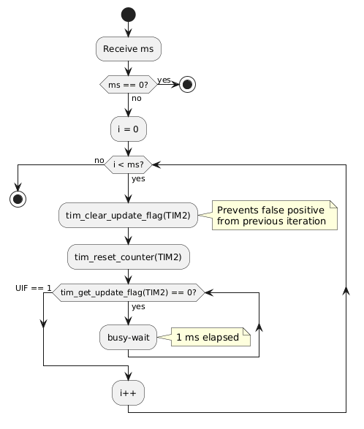
Figure 7. Activity Diagram - timer_delay_ms() busy-wait loop on SR.UIF

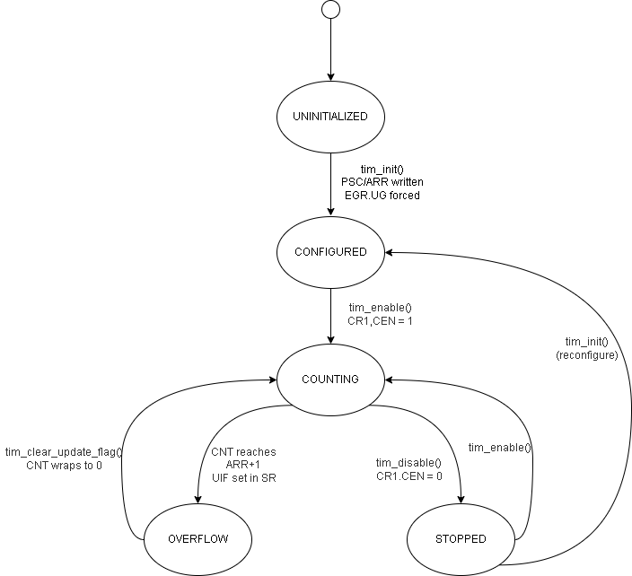
Figure 8. State Diagram - TIM states: UNINITIALIZED → CONFIGURED → COUNTING ↔ OVERFLOW / STOPPED

3.3 TIM Driver Module Description
tim_init() initializes a timer safely: stops the counter (CR1.CEN=0), writes PSC and ARR preloads, resets CNT, triggers a forced Update Event via EGR.UG (which copies shadow registers to active registers), then clears the UIF flag set by the forced UEV. The timer is left disabled; the caller must call tim_enable() to start counting.

tim_enable() / tim_disable() set or clear CR1.CEN. tim_reset_counter() writes zero to CNT. tim_get_counter() returns the raw CNT value.

tim_get_update_flag() reads SR.UIF: returns 1 if the counter has overflowed since the last clear, else 0. tim_clear_update_flag() writes 0 to SR.UIF (rc_w0 register). In timer_delay_ms(), UIF is cleared before resetting CNT to avoid a false-positive from a previous iteration.

tim_pwm_config() configures a channel in PWM output mode via a switch on the channel enum. For each channel it clears CCxS (output mode), sets the OCxM field to the requested PWM mode value (6=Mode 1, 7=Mode 2), enables preload (OCxPE=1), and sets CR1.ARPE.

tim_set_ccr() writes the CCRx register for the specified channel. With OC1PE set, the write goes to the preload register and becomes active at the next UEV — avoiding glitches during duty cycle changes.

tim_enable_main_output() sets BDTR.MOE (bit 15). This is mandatory for TIM1 and TIM8: without it, channel outputs remain disabled even with CCxE=1 and the counter running.

4. Application Programming Interfaces

4.1 Data Types and Macros

Enum | Values | Notes
TIM_Status_t | OK=0, ERROR=1 | Return type; void functions have no return code
TIM_Channel_t | CH1=1, CH2=2, CH3=3, CH4=4 | Channel index; maps to CCMRx/CCER bit position
TIM_PWM_Mode_t | MODE_1=6, MODE_2=7 | Written to OCxM: 6=active-high, 7=active-low

Constant | Value | Notes
TIM_APB1_CLOCK_HZ | 16000000U | TIM2–TIM5 input clock at HSI, APB1 pre=1
TIM_APB2_CLOCK_HZ | 16000000U | TIM1, TIM9–TIM11 input clock at HSI, APB2 pre=1

4.2 Error Codes

Code | Value | Definition
TIM_OK | 0 | Operation completed successfully
TIM_ERROR | 1 | NULL timer pointer or invalid channel (outside 1–4)

4.3 Function Definitions

tim_init

Function Name | tim_init
Syntax | TIM_Status_t tim_init(TIM_TypeDef *tim, uint16_t psc, uint32_t arr)
Parameters (in) | tim — TIM peripheral pointer (TIM1, TIM2, …)psc — Prescaler value (0 = divide by 1)arr — Auto-reload value; counter wraps at arr+1
Parameters (inout) | None
Parameters (out) | None
Return value | TIM_OK or TIM_ERROR (if tim==NULL)
Description | Stops counter, writes PSC/ARR/CNT, forces UEV via EGR.UG to copy shadow registers, clears UIF. Timer is left disabled after this call.
Constraints | Caller must enable APBx clock before calling. Timer remains stopped; call tim_enable() to start.
Available via | tim_driver.h

tim_enable / tim_disable

Function Name | tim_enable / tim_disable
Syntax | void tim_enable(TIM_TypeDef *tim)void tim_disable(TIM_TypeDef *tim)
Parameters (in) | tim — TIM peripheral pointer
Parameters (inout) | None
Parameters (out) | None
Return value | void
Description | tim_enable: sets CR1.CEN=1 — counter starts. tim_disable: clears CR1.CEN=0 — counter freezes at current CNT value.
Constraints | No NULL check. tim_disable() does not reset CNT.
Available via | tim_driver.h

tim_reset_counter / tim_get_counter

Function Name | tim_reset_counter / tim_get_counter
Syntax | void tim_reset_counter(TIM_TypeDef *tim)uint32_t tim_get_counter(TIM_TypeDef *tim)
Parameters (in) | tim — TIM peripheral pointer
Parameters (inout) | None
Parameters (out) | None
Return value | void / uint32_t (current CNT value)
Description | tim_reset_counter: writes 0 to CNT; used in timer_delay_ms() to start a fresh 1 ms window. tim_get_counter: returns raw CNT register value.
Constraints | No NULL check. TIM2 has 32-bit CNT; other timers have 16-bit CNT.
Available via | tim_driver.h

tim_get_update_flag / tim_clear_update_flag

Function Name | tim_get_update_flag / tim_clear_update_flag
Syntax | uint8_t tim_get_update_flag(TIM_TypeDef *tim)void tim_clear_update_flag(TIM_TypeDef *tim)
Parameters (in) | tim — TIM peripheral pointer
Parameters (inout) | None
Parameters (out) | None
Return value | uint8_t (1=overflow occurred, 0=not yet) / void
Description | tim_get_update_flag: reads SR.UIF. tim_clear_update_flag: clears SR.UIF (rc_w0 — write 0 clears the bit).
Constraints | UIF is also set by the forced EGR.UG in tim_init() and cleared there automatically.
Available via | tim_driver.h

tim_pwm_config

Function Name | tim_pwm_config
Syntax | TIM_Status_t tim_pwm_config(TIM_TypeDef *tim, TIM_Channel_t channel, TIM_PWM_Mode_t mode)
Parameters (in) | tim — TIM pointerchannel — TIM_CHANNEL_1…4mode — TIM_PWM_MODE_1 or TIM_PWM_MODE_2
Parameters (inout) | None
Parameters (out) | None
Return value | TIM_OK or TIM_ERROR
Description | Clears CCxS (output mode), sets OCxM=mode, sets OCxPE=1 (preload), sets CR1.ARPE. Uses a switch on channel to select correct CCMR1/CCMR2 fields.
Constraints | Pin must be in AF mode before calling. Call tim_channel_enable() and tim_enable_main_output() (for TIM1) before starting the counter.
Available via | tim_driver.h

tim_set_ccr

Function Name | tim_set_ccr
Syntax | TIM_Status_t tim_set_ccr(TIM_TypeDef *tim, TIM_Channel_t channel, uint32_t value)
Parameters (in) | tim — TIM pointerchannel — TIM_CHANNEL_1…4value — 0 to ARR+1 for 0–100% duty
Parameters (inout) | None
Parameters (out) | None
Return value | TIM_OK or TIM_ERROR
Description | Writes value to CCRx for the specified channel. Duty (%) = value / (ARR+1) x 100. With OCxPE=1, activates on the next UEV.
Constraints | value > ARR+1 produces 100% duty. value = 0 produces 0% duty.
Available via | tim_driver.h

tim_channel_enable / tim_channel_disable

Function Name | tim_channel_enable / tim_channel_disable
Syntax | TIM_Status_t tim_channel_enable(TIM_TypeDef *tim, TIM_Channel_t channel)TIM_Status_t tim_channel_disable(TIM_TypeDef *tim, TIM_Channel_t channel)
Parameters (in) | tim, channel — TIM_CHANNEL_1…4
Parameters (inout) | None
Parameters (out) | None
Return value | TIM_OK or TIM_ERROR
Description | Sets or clears CCER.CCxE for the specified channel. Bit positions: CH1=bit0, CH2=bit4, CH3=bit8, CH4=bit12.
Constraints | For TIM1/TIM8, BDTR.MOE must also be set via tim_enable_main_output().
Available via | tim_driver.h

tim_enable_main_output / tim_disable_main_output

Function Name | tim_enable_main_output / tim_disable_main_output
Syntax | void tim_enable_main_output(TIM_TypeDef *tim)void tim_disable_main_output(TIM_TypeDef *tim)
Parameters (in) | tim — TIM pointer
Parameters (inout) | None
Parameters (out) | None
Return value | void
Description | Sets or clears BDTR.MOE (bit 15). Required for TIM1/TIM8: without MOE=1, channel pins are not driven regardless of CCxE or counter state.
Constraints | No NULL check. Must be called after tim_channel_enable() and before tim_enable() for TIM1.
Available via | tim_driver.h

4.4 Internal Function Definitions
The tim_driver module has no internal (static) functions. All logic is implemented directly within the public API functions.

5. Future Enhancements
- Add interrupt-driven UIF handling: expose tim_enable_update_irq() / tim_disable_update_irq() to set/clear DIER.UIE.
- Implement tim_set_frequency() and tim_set_duty_cycle() as high-level wrappers computing PSC/ARR/CCRx from Hz and percentage inputs.
- Add input capture mode configuration (CCxS = 01/10) for frequency measurement and pulse timing.
- Add one-pulse mode (OPM) support via CR1.OPM for single-shot timer events.

