PREPRINT • ORIGINAL RESEARCH
Reduced DDX24 expression in CD8 T cells in axial spondyloarthritis
A participant-level meta-analysis with cross-context transcriptomic assessment
João Pais • Diana Koshman
No institutional affiliation
8 independent cohorts • 217 participants mapped • Primary CD8 synthesis: 2 cohorts, 47 participants

Abstract

Background
Ankylosing spondylitis is an immune-mediated disease with heterogeneous blood transcriptomic findings. We evaluated whether DDX24 shows reproducible, cell-contextual expression differences that justify independent functional testing.

Methods
We performed a staged, reproducible secondary integration of eight independent human case-control cohorts. Three peripheral-blood microarray cohorts formed the candidate-generation stage. GSE194315 provided CD8 cell-context refinement; the expected lower-in-case direction was then locked before evaluation of GSE288581 as the external CD8 validation cohort. These two compatible CD8 cohorts formed the primary meta-analysis. GSE163314 was added only as a broader-CD8 sensitivity analysis. Two whole-blood RNA-sequencing cohorts and the three discovery microarrays were retained as contextual evidence and were not treated as independent confirmation of target selection. Donors, never cells, were the statistical units. [2] [3]

Results
The complete descriptive evidence map included 8 independent cohorts and 217 participants. Across two compatible CD8 cohorts (47 participants), the pooled effect was -0.148 log2-CPM (95% CI -0.272 to -0.024; p=0.0193). Adding the independent broad-CD8 GSE163314 pilot produced a sensitivity estimate of -0.145 (95% CI -0.249 to -0.041; p=0.0061; 51 participants). Three candidate-generation peripheral-blood microarray cohorts (146 participants) were directionally concordant, although the random-effects result was imprecise (effect=-0.267, p=0.109) and heterogeneous. Two whole-blood RNA-sequencing cohorts were directionally mixed. ADA was mixed across contexts (4 of 7 cohorts lower).

Conclusions
DDX24 showed a lower-in-case association in the prespecified CD8 synthesis and retained that direction in a broader-CD8 sensitivity analysis. Evidence from the candidate-generation and contextual blood cohorts supports biological follow-up but is not additional confirmatory evidence. The result supports a falsification-focused laboratory study but does not establish causality, diagnostic validity, druggability or therapeutic efficacy.

Introduction
Blood transcriptomic studies of ankylosing spondylitis vary in participant selection, cellular composition and assay technology. Pooling all such effects into one estimate can obscure genuine cell-state specificity. DDX24 emerged from three AXIS peripheral-blood microarray discovery cohorts as a recurrent candidate [8] and is biologically relevant to innate RNA-sensing pathways [1]. The present study asked a narrower question: is reduced DDX24 expression reproducible within human peripheral CD8 T-cell populations, and is its direction supported in independent blood cohorts?

Methods

Design and eligibility
Public human case-control transcriptomic cohorts were eligible when disease and control groups could be separated at participant level. Evidence roles were assigned before synthesis: candidate generation, cell-context refinement, locked external validation, sensitivity, or contextual evidence. A study used to nominate DDX24 was never relabelled as independent validation. Repeated assays, technical libraries and cells were not counted as independent observations. Studies without healthy controls, pooled participants without donor resolution, or non-expression assays were excluded from inferential synthesis.

Target and outcomes
DDX24 was nominated from GSE25101, GSE18781 and GSE73754, then localized to CD8 states in GSE194315. Its expected lower-in-case direction and participant-level primary outcome were frozen before GSE288581 was evaluated. The primary outcome was case-minus-control DDX24 expression in compatible memory/effector CD8 populations. GSE163314 used a broader author-annotated CD8_T population and was therefore sensitivity-only. ADA was analysed identically as a contextual comparison target, not as a multiplicity correction for DDX24 selection. [2] [3]

Statistical synthesis
Within compatible strata, inverse-variance DerSimonian-Laird random-effects models were used [11]. CD8 effects were derived from donor pseudobulk log2-CPM, preserving the participant as the unit of replication [9]. Microarray effects were case-minus-control normalized log expression. Whole-blood FPKM and long-read TPM studies were reported directionally and were not pooled with CD8 or microarray effects. No global cross-platform effect or p-value was estimated.

Robustness and confounding
GSE194315 was adjusted using available processing-batch principal components and analysed separately by cell type. Each participant was omitted in turn. GSE288581 was similarly evaluated by leave-one-donor-out analysis. Age, sex, medication and disease activity were unavailable in the principal single-cell deposit and were retained as unresolved limitations. [2] [3]

Results

CD8-specific evidence
Both compatible CD8 cohorts showed lower DDX24 expression in cases. The pooled CD8 estimate was -0.148 log2-CPM (95% CI -0.272 to -0.024; p=0.0193), and every donor omission in the external cohort preserved the direction. In GSE194315, CD8 TEM and CD8 Naive directions also persisted after processing-batch adjustment and participant omission. The broader-CD8 GSE163314 pilot included only two cases and two controls and was individually imprecise (effect -0.155; p=0.478). Adding it as cell-definition sensitivity retained the combined direction (effect -0.145; 95% CI -0.249 to -0.041; p=0.0061). [2]

Evidence across blood contexts
All three candidate-generation microarray cohorts showed lower DDX24 expression, but magnitude varied substantially and the random-effects confidence interval included zero. The whole-blood RNA-sequencing stratum was mixed (1 lower and 1 higher). Consequently, the evidence is best interpreted as a robust CD8 association with broader but heterogeneous blood support.

Comparison target
ADA did not reproduce the same cross-context pattern. Its direction differed between CD8 and microarray strata, supporting the interpretation that the DDX24 result is not merely a universal consequence of combining all blood datasets.

Discussion
The main contribution is not a new global transcriptomic signature, but a carefully bounded observation: after nomination in bulk blood and cell-context refinement, the lower-in-case DDX24 direction persisted in a locked external CD8 cohort and in the compatible two-cohort synthesis. Participant-level analyses reduce the risk of cell-level pseudoreplication, while the independent sorted-CD8 cohort reduces reliance on one atlas. Nevertheless, residual clinical confounding, small external cohorts and cross-platform heterogeneity remain.
The result should be used to design a falsification experiment. An initial RT-qPCR study in isolated CD8 cells can test whether the direction survives prospective matching and clinical metadata collection. Functional restoration experiments should proceed only after expression replication and must include fitness and nonspecific RNA-processing safety endpoints.

Limitations
Age, sex, medication and disease activity could not be adjusted consistently. The CD8 meta-analysis contains only two independent cohorts, one of which contributed to cell-context refinement before the external direction was locked. Thus, the pooled p-value is not equivalent to two prospective confirmations. The broad-CD8 sensitivity cohort contains only four participants. Whole-blood RNA-sequencing studies disagree directionally. No human genetic association currently establishes DDX24 causality, and no perturbation result establishes therapeutic direction.

Data and code availability
Public source accessions, eligibility decisions, checksums and reconstruction code are preserved by AXIS. Participant-derived frozen working files are not redistributed. AXIS version 0.2.0 is archived at https://doi.org/10.5281/zenodo.21762169 and the software is installable from PyPI as axis-bio.

Declarations
Ethics. This study reanalysed previously published, publicly accessible, de-identified datasets and involved no new participant recruitment or intervention. The ethical and consent conditions of each source study remain applicable.
Data and code availability. Source datasets are available from the public accessions listed in Table 1. AXIS source code is available at https://github.com/JPais7/AXIS under Apache-2.0. AXIS version 0.2.0 is archived at https://doi.org/10.5281/zenodo.21762169 and installable as axis-bio from PyPI. Participant-derived frozen working files are not redistributed; accessions, checksums, eligibility rules and reconstruction code preserve the audit trail.
Funding. No specific funding was reported during drafting; both authors must confirm this statement before posting.
Competing interests. The final declaration must be confirmed by both authors before posting.
Author contributions. João Pais: conceptualization, software, formal analysis, data curation, visualization and writing-original draft. Diana Koshman: methodology, validation, interpretation and writing-review and editing. This proposed contribution statement and the complete manuscript require approval by both authors before circulation.
Use of artificial intelligence. AI-assisted tools supported software development, document structuring and language editing. Scientific inclusion decisions, interpretation, numerical verification and authorship responsibility remained with the authors.
Version and correspondence. Preprint draft 1, 2 August 2026. Correspondence: joaopais2000@hotmail.com.

Figures
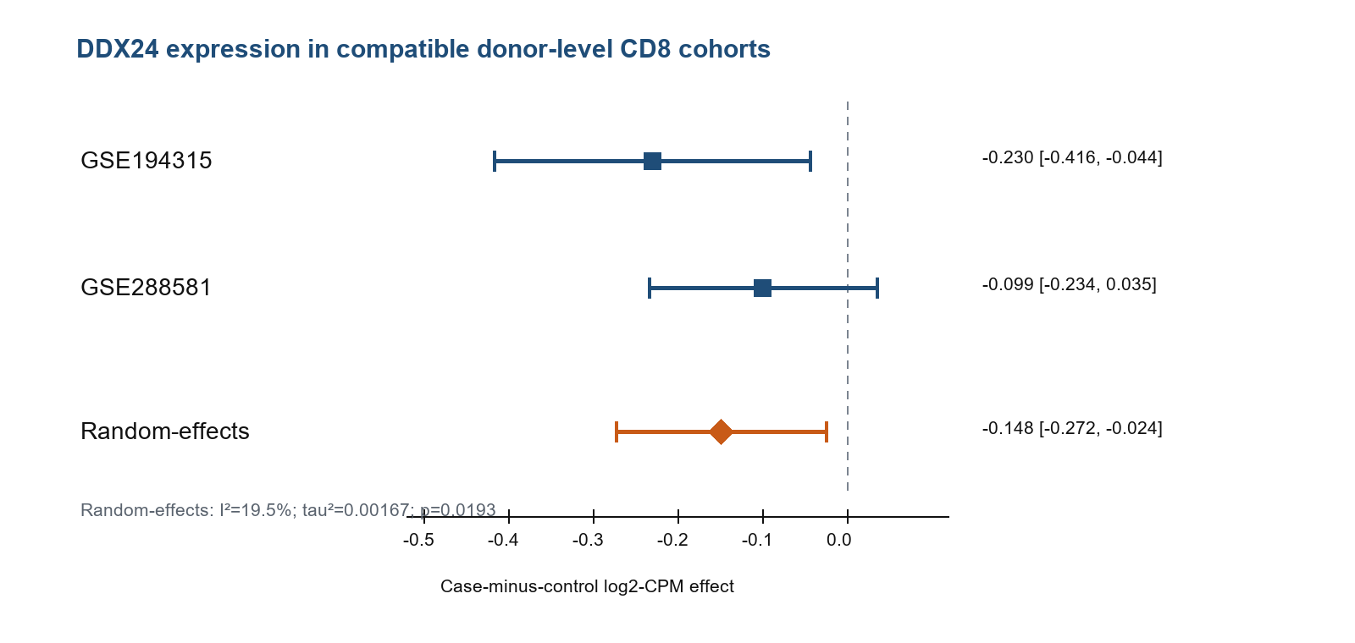
Figure 1. Participant-level DDX24 effects in the two compatible CD8 cohorts and their random-effects synthesis. Negative values indicate lower donor-pseudobulk log2-CPM in cases. GSE194315 provided cell-context refinement; the direction was locked before external evaluation in GSE288581.
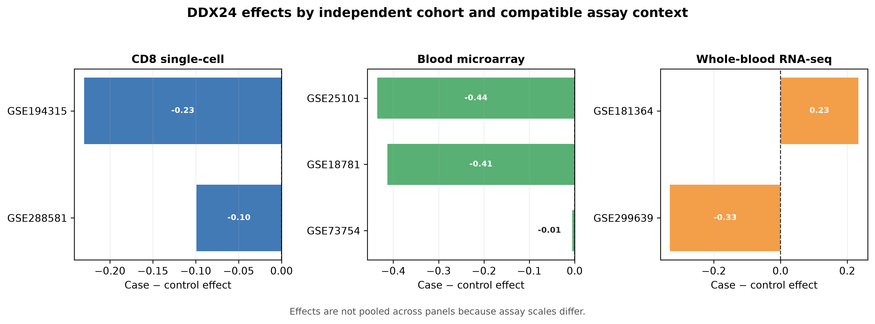
Figure 2. DDX24 case-minus-control effects in seven independent cohorts, separated into compatible assay contexts. Negative values indicate lower expression in cases. Effects are not pooled across panels because assay scales differ. The later GSE163314 broad-CD8 sensitivity cohort is reported separately in the text and Table 1.
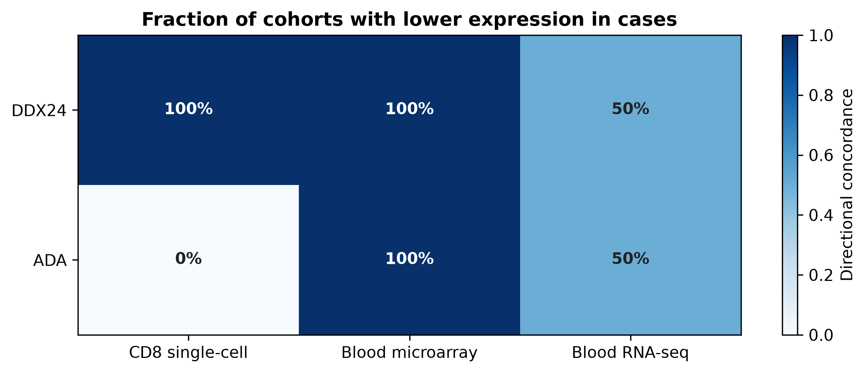
Figure 3. Directional concordance for DDX24 and ADA. Values show the fraction of independent cohorts within each context whose case-minus-control effect was below zero.

Table 1. Included cohorts
Cohort | Context | Cases | Controls | Effect | Direction | Evidence role
GSE194315 | CD8 single cell | 10 | 29 | -0.230 | lower in case | compatible within CD8 pool
GSE288581 | CD8 single cell | 4 | 4 | -0.099 | lower in case | compatible within CD8 pool
GSE163314 | broad CD8 single cell | 2 | 2 | -0.155 | lower in case | sensitivity only broad CD8
GSE25101 | peripheral blood microarray | 16 | 16 | -0.435 | lower in case | compatible within microarray pool
GSE18781 | peripheral blood microarray | 18 | 25 | -0.413 | lower in case | compatible within microarray pool
GSE73754 | peripheral blood microarray | 51 | 20 | -0.005 | lower in case | compatible within microarray pool
GSE181364 | whole blood RNA sequencing | 5 | 3 | 0.233 | higher in case | directional only incompatible scales
GSE299639 | whole blood RNA sequencing | 6 | 6 | -0.331 | lower in case | directional only incompatible scales
Note: Effects are comparable only within their prespecified assay context. A global cross-platform effect was not estimated.

References
- Ma Z, et al. DDX24 negatively regulates cytosolic RNA-mediated innate immune signaling. PLoS Pathogens. 2013;9. PMID: 24204270.
- Alber S, et al. Single cell transcriptome and surface epitope analysis of ankylosing spondylitis facilitates disease classification by machine learning. Front Immunol. 2022;13:838636. doi:10.3389/fimmu.2022.838636.
- Tang M, Qaiyum Z, Lim M, Inman RD. Single cell immune profiling in ankylosing spondylitis reveals resistance of CD8+ T cells to immune exhaustion. iScience. 2025;28:112715. doi:10.1016/j.isci.2025.112715.
- Mauro D, et al. Ankylosing spondylitis: an autoimmune or autoinflammatory disease? Nat Rev Rheumatol. 2021;17:387-404. doi:10.1038/s41584-021-00625-y.
- Page MJ, et al. The PRISMA 2020 statement: an updated guideline for reporting systematic reviews. BMJ. 2021;372:n71. doi:10.1136/bmj.n71.
- NCBI Gene Expression Omnibus. GSE194315: RNA and surface epitope sequencing of single cells involved in spondyloarthritis.
- NCBI Gene Expression Omnibus. GSE288581: Single Cell Immune Profiling in Ankylosing Spondylitis.
- Pais J, Koshman D. AXIS: auditable molecular evidence synthesis and therapeutic hypothesis generation. Version 0.2.0. Zenodo. 2026. doi:10.5281/zenodo.21762169.
- Murphy AE, Skene NG. A balanced measure shows superior performance of pseudobulk methods in single-cell RNA-sequencing analysis. Nat Commun. 2022;13:7851. doi:10.1038/s41467-022-35519-4.
- Ritchie ME, et al. limma powers differential expression analyses for RNA-sequencing and microarray studies. Nucleic Acids Res. 2015;43:e47. doi:10.1093/nar/gkv007.
- DerSimonian R, Laird N. Meta-analysis in clinical trials. Control Clin Trials. 1986;7:177-188. doi:10.1016/0197-2456(86)90046-2.
- Benjamini Y, Hochberg Y. Controlling the false discovery rate: a practical and powerful approach to multiple testing. J R Stat Soc B. 1995;57:289-300. doi:10.1111/j.2517-6161.1995.tb02031.x.
- Barrett T, et al. NCBI GEO: archive for functional genomics data sets-update. Nucleic Acids Res. 2013;41:D991-D995. doi:10.1093/nar/gks1193.

