Oceanography Lab

2024-04-01

## Sounds Good. Listening in the Ocean.

In the lecture we discussed some of the reasons utilizing sound to study the ocean is beneficial. In the underwater environment, sound travels much further than light which is dispersed, absorbed, and defracted by suspended particles. Sound, on the other hand, is much more efficient in travelling through water. As such, many species from clams to beaked whales have evolved to use sound in the marine environment.

In this lab we will build on the Argo data lab by exploring how sound moves in the marine environment. We will download Argo data, extract the the temperature, salinity, and depth and use these to create a soundspeed profile. We will then use ray-tracing models to look at the sound propagation through the water column. Finally, we will simulate a sound source (e.g. whale, ship, shrimp, sub) and estimate how far that sound could be detected.

## Workspace Setup

The first step with any analysis is to set up our libraries, paths, functions, and variables. It’s generally good practice to clear your work space before you start. We do this with the rm(list =ls()) command.

rm(list=ls())  
library(argoFloats) # Load and manipulate the argos data  
library(ocedata) # Required to plot argos data  
library(ggplot2) # tidy package for plotting  
library(scales) # also scales  
library(viridisLite) # for colorblined friendly color scales

These are the packages we will use. Because the analysis gets a little intense I’ve also written functions for calculating and plotting the transmission. We will load these as well as the Argo data from last time. **You will need to change the path to for the r script and the Argo data to wherever you have them stored locally.**

# Load the custom functions to process soundspeeds  
source("~/GitHub/SFUGuestLecture/TL function.R")  
  
# Load the argos data  
load("~/GitHub/SFUGuestLecture/indexAll.RData")

## How Far Can You Hear It?

As we discussed in the lecture, we know that sounds must received above a certain signal-to-noise ratio (**SNR**) to be detected. Most simply, SNR is defined as how loud the thing you are interested in (**Source Level; SL**) minus the background noise at the sensor (NL) and how much energy the sound signal lost covering the space between the source and receiver. This is referred to as **Transmission** or **Propagation** **Loss (TL)**.

SNR= SL-TL-NL

All values are in decibels and *must* be measured over the same frequency range with the same reference pressure. In this lab we are going to play with this function to first estimate our detection radius and then were are going to take a dive into propagation modelling with the Argo data you worked with last time.

In an unrestricted environment sound will attenuate with spherical or cylindrical spreading. Imagine all the sound energy in your source at an initial time. As with surface waves on a pond, they spread away from the source location and the height (amplitude) of the wave decreases with time as the diameter of the wave increases. Thus the transmission loss can be simplified to TL= 20* log10(r) where r is the range from source in meters

# Lets simulate the the amplitude of a wave as it spreads linearly from the source location (x = 0) to some other point (x=r)  
  
  
  
# The transmission loss at 1 meter 1 km and 10kms using spherical spreading  
20*log10(1)

## [1] 0

20*log10(1000)

## [1] 60

20*log10(10000)

## [1] 80

We can now calculate the SNR as a function of range. Lets assume a source (e.g. whale) produces a sound at 120 dB re 1uPa and the background sound level is comprised of wind and wave noise at an average of 80 dB re 1uPa

# Range in meters  
r = seq(1,10000, length.out =200)  
SL = 120 #how loud the whale or ship or explosion is  
NL = 80 # how loud the background noise is  
  
# Signal to noise ratio  
SNR = SL-20*log10(r)-NL  
  
# Plot it!  
plot(r, SNR, xlab = 'Range (m)', ylab = 'SNR', type='l')

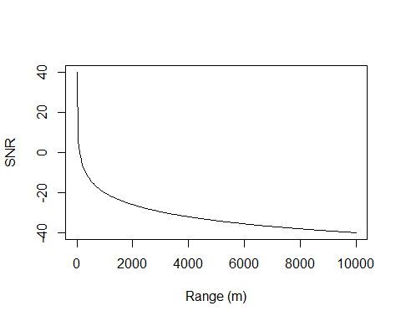

At what range does the SNR drop below 0 db?

## Loading the Argo Data

As the last lab, we need to select one or many of the Argo float datasets to work with. Here we will just work with the July data.

# Plot all of the ARGOS float locations  
plot(argosClean, which="map", bathymetry=TRUE,  
 xlim=c(-129,-122), ylim=c(45,52),  
 col=rgb(0,0,0,.5), cex=0.3, pch=16)

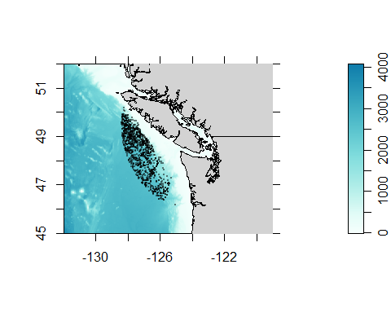

This should look familiar! Now lets select one of the floats from July (where there is a thermocline).

argosID = argosClean[['ID']]  
index2 = subset(argosClean, ID="4901570") # select one track ID  
  
pressureJul = index2[['argos']][[1]][['pressure']]  
temperatureJul = index2[['argos']][[1]][['temperature']]  
salJul = index2[['argos']][[1]][['salinity']]  
  
  
  
# plot July profile  
plot(temperatureJul, -pressureJul, ylim=rev(c(0,-1200)),  
 xlim=c(3,13),  
 xlab='Temperature (C)', ylab='Depth (dbar)',  
 pch=16, col=rgb(0,0,0,.4),  
 type='l')  
legend('bottomright', legend='July',bty='n')

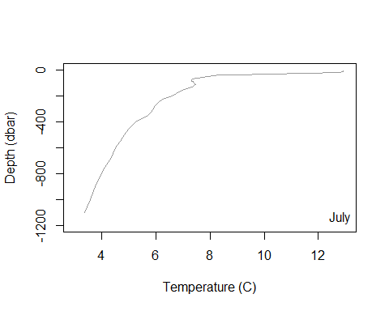

## Sound Speed Profile From Argo Data

You previously learned that Argo data contain temperature, salinity, and depth information. Incidentally, these are the values we need to calculate the sound speed. We will use the Mackenzie 1981 equation to convert these variables to a sound speed for each depth step. Together this is called a sound speed profile.

As with a temperature profile, which looks at the how temperature changes with depth we can begin to understand how sound travels in the ocean by creating a soundspeed profile. While this is less relevant to marine life, it does impact how sound travels in the environment as sound bends and refracts when it encounters different specific acoustic impedance values (rho *c).

In the next section of code uses the Argo data to create a soundspeed profile.

# Functions to create a smooth temp/salintiy gradient at arbitrary depths.  
salJulfx = approxfun(pressureJul, salJul)  
tempJulfx = approxfun(pressureJul, temperatureJul)  
  
  
# Set up the soundspeed profile, we want to estimate it for the entire depth at uniform intervals. This isn't required but it keeps things neat.  
depth <- seq(0, 1200, by =3)  
temp <- tempJulfx(depth)  
sal <- salJulfx(depth)  
  
# Use the salinity and temperature to calculate the soundspeed at each depth  
ssp <-soundSpeedMackenzie(D = depth, S = sal, Temp = temp)  
  
# Plot the soundspeed profile  
plot(ssp, -depth, xlab = 'Soundspeed',  
 ylab = 'Depth (m)',  
 main ='Soundspeed Profile (m/s)', type ='l')

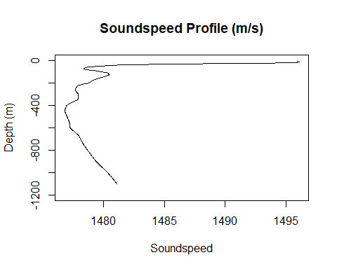

You can see that the soundspeed profile changes by about 15m/s from the top of the ocean down to 1200m. This, in some cases, can cause a tunneling effect in which sound gets ‘trapped’ in channels. For a good example of this, Google the SOFAR channel 🧠💥.

## Ray Tracing (Single and Multiple Rays)

Ray tracing in [underwater] acoustics is a way of mapping how sound moves. We intuitively know that sound is reflected by a change of density (i.e. echos). In the ocean sound bounces off the surface and bottom as it travels away from the source.

The path of travel can be represented using single lines. By doing this, scientists can figure out how sound spreads underwater and how it interacts with things like the ocean floor and underwater objects. This helps us understand underwater communication, detect submarines, and study marine life. Here we will use ray tracing to look at the path of sound produced at a certain angle.

# The Argos float only goes down so deep (hitting the bottom with an expensive bit of kit is ill advised). So lets populate the rest of the SSP with the value of the last observed soundspeed. This isn't perfect but it's a reasonable approximation  
  
# Clear out SSP values with NA  
depth= depth[!is.na(ssp)]; ssp=ssp[!is.na(ssp)]  
  
# Set up a sound source (e.g. dolphin, snapping shrimp etc.) and we are going to pretend that the sound it produces travels in only one direction (theta). That sound will bounce off the surface and bottom moving away from the source.  
  
#Start distance for the source, leave at 0  
sourceDist = 0  
  
# Sound source depth in meters  
sourceDepth = 200   
  
# Angle at which the sound is directed  
theta0 = 2  
  
# For how long should we measure the sound (seconds)  
tt = 60  
  
#xxx tweak to not plot ssp  
rt<-raytrace_TL(x0=sourceDist, z0= sourceDepth,   
 theta0, tt, zz = depth, cc = ssp, plot=TRUE, progress = FALSE)

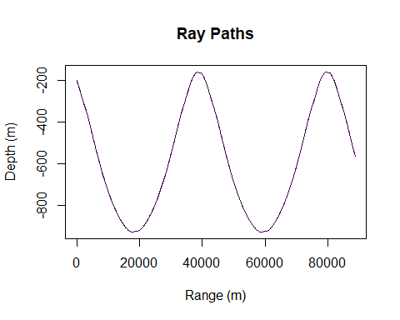

If we look above, in a 2d space we can see that there are regions where the sound hits and regions where it misses. In reality though, very few sources are truly directional. So lets plot lots of rays with angles between -10 and 10 deg. Additionally, the above plot shows how sound bounces but it does not show how sound attenuates with distance (imagine trying to hear someone at 5 meters away vs 500). So lets run the code again with 1) multiple rays and 2) exacting the transmission loss (TL) from the output.

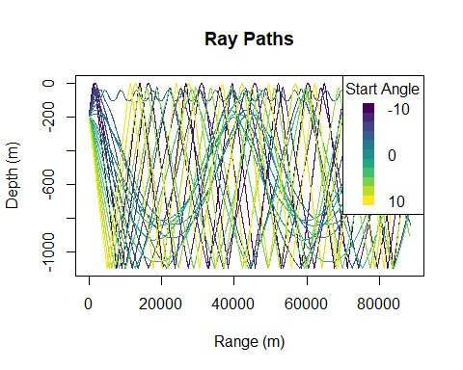

In the above figure you can see that, depending on the angle at which the sound is directed it can fail to get above the thermocline. This doesn’t mean that no sound can be heard if the source is below the thermocline but it may reduce the amplitude at the arrival location. If you were looking to find submarines that are known to travel mostly at 200m where should and shouldn’t you put your hydrophone in order to increase your chances of hearing it.

## Transmission Loss

In the above section we looked at how sound travels and before that we considered transmission loss. Moving forward we will consider both of them together. The following plot shows the transmission loss at various locations from the source

# Plot the transmission loss of all of the data  
 min_length <- min(lengths(data$x), lengths(data$z), lengths(data$TL))  
  
 # Truncate x, z, and TL vectors to the minimum length  
 x <- unlist(lapply(data$x, head, n = min_length))  
 z <- unlist(lapply(data$z, head, n = min_length))  
 TL <- unlist(lapply(data$TL, head, n = min_length))  
  
  
 # Create a new datafram out of our rt list and limit the range to only plot  
 # from r = 0 to r = 4000  
 dfout= data.frame(x=x, z =z, TL=TL)  
 dfout= subset(dfout, x<4000)  
  
 # Plot using ggplot and geom_point with color gradient  
 ggplot(dfout, aes(x = x, y = -z, color = TL)) +  
 geom_point() +  
 scale_color_viridis_c()+ # Adjust color scale as needed  
 labs(x = "Range (m)", y = "Depth (m)", color = "Average TL") +  
 ggtitle("Average Transmission Loss (TL) by Depth and Range")

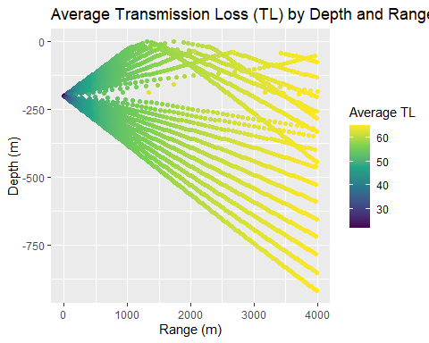

Here we can see that the transmission loss increases with range so that, regardless of the angle the we do lose energy with the distance the sound has traveled. You can also see that in some regions sound arriving from multiple directions intersects. This can sometimes relate to constructive or destructive interference.

## Single Rays to Propagation Grid

Up until this point we have been considering different rays which are like lasers in the night (insidently lasers are used in archetectural acoustics to figure out where sound travels and how much to charge for the cheap seats). But to estimate the transmission loss for an omni directional source (think lamp instead) we can average over multiple angles. The code below will take multiple source angles and average them over a grid that we set up. Don’t worry about the warnings

# Example usage with user-defined parameters  
  
#sourceDepth <- 20 # Source depth in meters (as before)  
  
theta_range <- seq(-90, 90, by = 2) # Range of angles for multiple rays  
tt <- 60 # Total travel time  
  
# Set up the intended output grid for the transmission loss  
range_extent <- 10000 # Range extent in meters (e.g., 10 km)  
depth_extent <- max(depth) # Depth extent in meters  
range_resolution <- 100 # Range resolution in meters (e.g., 100m)  
depth_resolution <- 20 # Depth resolution in meters (e.g., 10m)  
  
# Run the transmission loss model, this will take a little while  
result_grid <- compute_avg_TL_grid(sourceDist,   
 sourceDepth,   
 theta_range, tt, depth, ssp,  
 range_extent, depth_extent,  
 range_resolution, depth_resolution,  
 progress = FALSE,  
 plot = TRUE)  
  
  
# Plot the result  
p<- plotTLgrid(result_grid)  
p

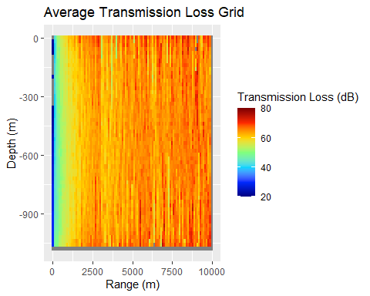

## Fun Stuff (for some…)

Some fun acoustics links

Animations of the principals of acoustics - <https://www.acs.psu.edu/drussell/Demos/Reflect-Particles/Reflect-Particles.html>

All things sound in the sea- <https://dosits.org/>

What’s your favorite animal sound from this website?