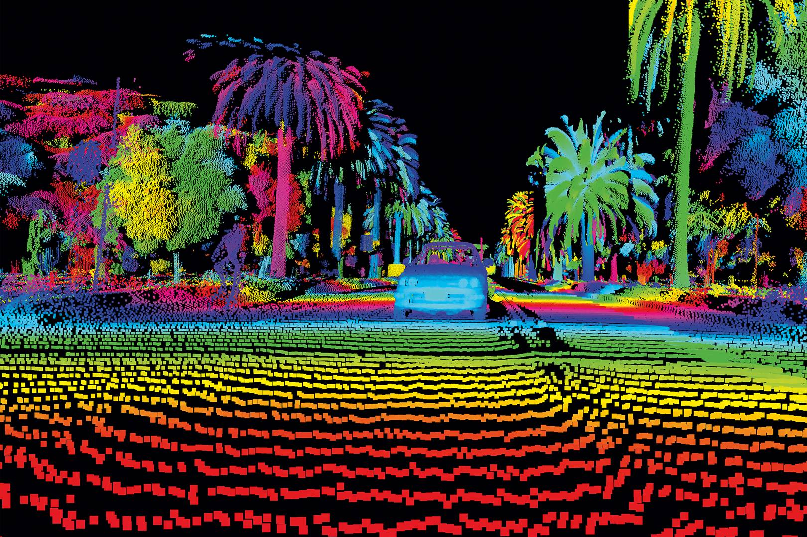  [2]  GEOVEN Project SAIT1 LIDAR REPORT  Findings, conclusions, and methodology of SAIT1 Project | By Justin Pan

Contents
Introduction 2
Scope of project 3
Methodology 3
Project location 3
Geodatabase Creation and Visualization 4
Height, Area, and Distance Measurements 5
Digital Terrain Models 6
TIN (triangulated interpolation network) 7
Contour 7
Degree Slope Model 7
Aspect 8
Building Footprint 8
Average Tree Height Calculation 8
Results 11
Geodatabase Creation and Visualization 11
Height and distance Measurements 11
Building Footprint 11
Digital Terrain Models 12
3d layer for Slope in degrees 13
Aspect 3d model 14
Average Tree Height Calculation 17
References 19

Introduction
Lidar stands for light detection and ranging and is a remote sensing method used for examining the earth’s surface. The method uses light in form of pulsed lasers to measure the distances to surfaces and create 3d information, similarly to the pulses of a radar. This is also comparable to a bat’s use of echolocation. Instruments usually consist of a laser, scanner, and GPS receiver. Lidar can be conducted airborne (in the air), or terrestrially (on the ground) [1] [2].
Advantages of lidar include the ability to operate independent of light levels, being able to operate at night or day. Good accuracy can be obtained at the centimeter level for positions. [3] A large point density helps with data sampling, and the method has an extensive area of coverage. Another advantage to note is the ability for lidar to have multiple returns, as pulses will return to the sensor at different times depending on whether they have reflected from higher elevation objects(trees), or lower elevation ground. [4] First return refers to the first pulse that returns to the sensor during a lidar survey, which can occur when a pulse laser comes back from a higher point on the ground, such as a tree. [5]
The general disadvantages of lidar include its limited ability to measure water depth and turbulent breaking waves (surfaces that are not constant). As well, lasers have difficulty penetrating thick vegetation [6]. Another disadvantage is that lidar technology may have trouble operating with areas or situations which have high sun angles, and or reflections, as the laser pulses depend on the principle of reflection [4]. There is a high operating cost, due to the technology needed, as well as the expertise of the pilot. Consideration for the increased cost for small areas is also needed [4], and large data storage is required for lidar surveys. [4] Since points are measured in one trip, there is a lack of redundancy, unlike other surveys.

In airborne lidar, an airplane with location correction devices, and a laser scanner are flown over a certain area of land. While the airplane flies, A laser scanner on the airplane or helicopter, emits pulsed lasers towards the surface, which return to the sensor after hitting the surface. The return lasers are measured, and an exact distance is derived from the laser to the objects [4]. Components for an airborne laser scanner include the scanner assembly, airborne GPS antenna, an inertial measurement unit (IMU), a control and data recording unit, as well as the operator laptop, and flight management system [4]. The position of the sensor as it is flying is calculated using a combined GPS and IMU correction sensor which operates as the airplane moves. The GPS provides an “absolute” [7] position for the sensor platform, while the IMU records the angular altitude of the platform (yaw, roll, pitch, yaw/heading). The advantage of this is that the aircraft can have an absolute position generated at any given time.

Scope of project
Teradyne renovations have collaborated with GEOTEN construction company and are planning to create additional greenhouses for the SAIT environmental studies program. In preparation for the construction, the company wants to know the average height data for tree canopies on SAIT as well as other obstructions and has requested a lidar survey project be completed. Deliverables include a map of the SAIT campus area, lidar measurements of SAIT campus buildings, as well as digital elevation models.
The first phase of the project has already been completed, and point data has been created from an airborne lidar survey that was conducted over the SAIT campus area.
The lidar analyst has been tasked with completing 5 objectives to extract the necessary features from the airborne lidar data. This included creating a registered mosaic of the point cloud data, measurements of the point data, a map of obstacles and buildings on the SAIT campus, a 3d terrain model of the area, as well as an average tree canopy height calculation.
When this is done, this report will be compiled by the analyst, to show and make conclusions on the findings and procedures needed for the extraction of features in airborne lidar data. There is always an error in any feature extraction from terrain models [8], and the analyst will show their findings in the report on what issues and errors they have encountered and the results of their project.

Methodology

Project location
The scanning area of the project was conducted on the SAIT college campus area with some surrounding housing areas. in the northwest quadrant of Calgary at approximately 51 degrees 3 minutes and 25.80 seconds north, and -114 degrees 5 minutes and 17.40 seconds west [9].
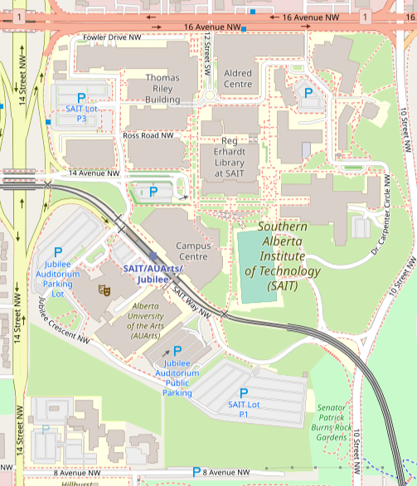
Figure 2. Map showing SAIT campus area surveyed. [9]

Geodatabase Creation and Visualization
The lidar data came as a folder with 6 point cloud data files, with the names, A1, A2, B1, B2, C1, and C2. Each data file had the point cloud data of a different section covered in the survey area and was geographically connected in a grid pattern. Point data had been classified as either non-ground, or ground data, with buildings and tree points being in the non-ground classification, and lower-lying points as being ground data.
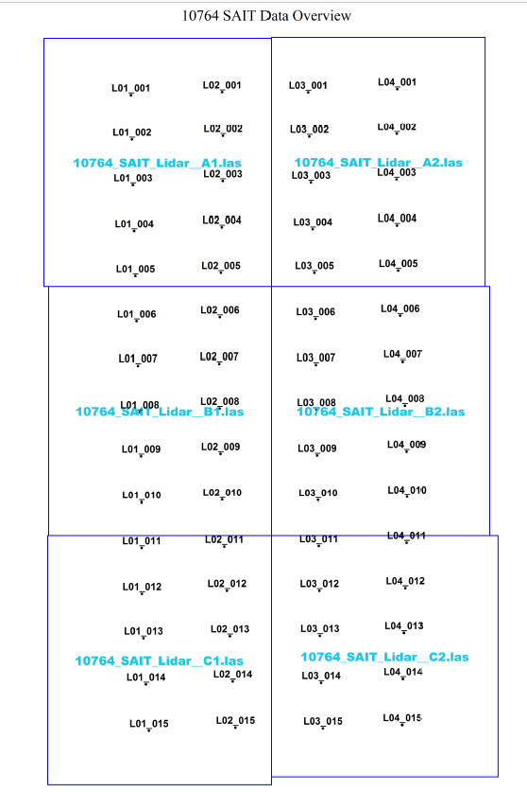
Figure 3. The layout of file data for lidar survey. Each square is a separate lidar point data file.
The project was completed using a variety of software tools, such as ArcGIS Pro, Microsoft excel, as well as Microsoft word. ArcGIS pro was used to measure, as well as create models, and extract features from the surface formed by the lidar data. Excel was used for calculations, and Microsoft word was used for recording important information. For easier organization and to decrease the chance of making mistakes, the 6 las dataset files were combined into a single LAS dataset file or LASD using the ArcGIS software. For easy finding, the file was stored in an ArcGIS project folder. No coordinate adjustments were made to the LASD data, as all data was already georeferenced during the survey. Inside the project folder, a database was made. This database was used to manage and organize digital surface models made from the LASD, as well as other necessary processing data. As a precautionary measure, the 6 files of the original Lidar data were not stored in the project folder so that it would be still available in case the project folder was accidentally destroyed or corrupted.

Height, Area, and Distance Measurements
Height measurements as well as area measurements were requested by the client for buildings and other surrounding structures of the SAIT campus. A table was created by the client with information for each measurement to be completed. The client requested these measurements be completed to establish an additional means of verification for potential future surveys in the area before the construction of the greenhouse and to give the client more localized data.
For the requested measurement locations, each location either had a description of the location and coordinate data provided in latitude and longitude format, or only a description of the location.
Using ArcGIS, requested measurement locations were found by the combined use of a coordinate finding tool for provided coordinate locations, and visual aids, such as satellite imagery base map, and knowledge of the area achieved using an area map (in this case the SAIT campus map) for locations with only the description.
Most measurements for elevation were conducted by obtaining the elevation value of the point nearest the specified coordinate. For measurements of the highest elevation of buildings, the symbology of the lidar point cloud data was changed to that of a temporary elevation surface that was generated from the point data, with 9 classes of elevation ranges (one being the lowest, and 9 being the highest). For each building being measured, the elevation class of the building was modified so that the lowest range of the class was increased. For example, for a building that was colored in the class 7 elevation class, the lowest elevation value of class 7 was increased, and the maximum elevation of class 6 was increased. This was done until there was only a small area of color from class 7 for the building. By doing so, one could see changes in elevation easier with between class 6 and class 7 on the building, which would allow for the determination of what area of the building had the highest elevation points. A point in the highest elevation area would be measured for elevation.
For distance and area measurements, approximate measurements were made with software tools. By measuring the edges and lines of building footprints formed by the lidar cloud data.

Digital Terrain Models
After measurements were completed, 3d models were created in the ArcGIS project from the point cloud data, to allow for a 3d visualization of the overall site area.
The first 3d model was created as a digital elevation model of the surface from point interpolation and was stored as a raster in the project database. Average binning was used as the interpolation method, to avoid thinning issues associated with triangulation, and its ability to represent general trends (more appropriate to hill surfaces). Empty data areas were set to be filled linear. Floating-point was used as an output data type so that the data could support a wide range of values. [10]. For sampling type, cell size was used and was set to 3 meters.
Several types of 3d models were created from the digital elevation model, such as a model showing the slope of the area in degrees, a model showing the aspect (what directions objects face), as well as a contour and TIN elevation model.

TIN (triangulated interpolation network)
Using ArcGIS, a TIN elevation model was created from the LASD point data.
Due to a limit for the number of points that could be generated in a TIN [11], point thinning (removing points) was used in the conversion. Selection for thinning points was set to random, and a percent thinning was used to remove 90 percent of the points in the point data. To display the TIN, symbology for the TIN was changed to assign different colors to different areas of the TIN based on certain elevation range intervals.

Contour
A contour 3d model can be created from either a raster or TIN surface model. The raster DEM surface was used, as it did not have point thinning applied for it, which might lead to data loss. A contour interval of 4 meters was used to avoid overcrowding the surface, and contour lines were used to portray the exact areas where a 4-meter change in elevation occurred. The surface symbology was changed so that contours were colored based on equal elevation intervals, with 5 elevation ranges in total.

Degree Slope Model
A Slope 3d model was generated in the ArcGIS pro to show areas of a large and sudden increase in elevation. The output measurement used for the slope 3d model was that of degrees for it to be more user-friendly. To options were provided in creating the model. An option for the surface model to be generated 3d x, y, and z surface generated from a flat earth surface (planar), or as x, y, and z coordinates from a curved surface(geodesic). Since a planar surface was used from the 3TM NAD83 coordinate system, the surface was generated as a planar surface. The slope 3d model can be either created from a DEM or Tin surface model. For reliability of data, the DEM was used for the model.

Aspect
The aspect surface model was created as a raster file using the DEM in the ArcGIS pro project, for the same reason as stated previously. Like the Degree slope model, the surface was generated as a planar surface to avoid issues with the planar projection coordinate system used in the project.

Building Footprint
To create the requested map, polygon data was traced from the point data in the LASD using ArcGIS pro. To organize the polygon data, feature datasets were made to store the polygon data inside a database. A feature dataset was made for each general feature type: buildings, vegetation, transportation, miscellaneous, and polygon data were organized according to these feature datasets.
The SAIT campus map was used as a means of verifying the correct classification of objects like buildings, and tree canopies were found by changing the symbology of the lidar point cloud data to a first return surface, for the most significant return, and association with the highest feature on a surface [5].

Average Tree Height Calculation
To calculate average tree heights for the SAIT campus area, the first step was to create a surface model of the ground only and to create a surface with trees and the ground included. The average tree height would be found by finding the difference in elevations between the point data of the two surfaces and averaging them.
The two surface models created were the digital terrain model (DTM), and another was the digital elevation model (DEM). The DTM was created with all lidar points included, while the DEM was created with only the ground points of the lidar data.
For creating the DTM, average binning was used as a method of point interpolation, to avoid issues with point thinning using TIN interpolation. Cells assignment for points was assigned based on maximum height to be able to include the highest tree height values and to increase the amount of information available. For sampling size, a 60 cm sampling size was used, to fit the 0.2-meter point density of the project.
The DEM used minimum binning point interpolation to get the lowest values of the ground surface. For a constant variable, a 60 cm sampling size was also used.
Then, a raster surface was created by subtracting the points in the DEM surface from the DTM surface, or DTM minus DEM. To increase the amount of sampling for tree heights, the entire area of the DTM and DEM was used.
To avoid outlier data, a limit was needed for the maximum and minimum tree height. To find an appropriate limit for the maximum tree height, points from tree canopies in the point cloud were checked for their elevation. The largest tree was found to be around 26 meters. Since most trees are larger than 3 meters [8], 3 meters was used as the minimum allowable tree height value.
The final step involved creating a raster from a logical “and” statement in programming, where tree heights were to be more than or equal to 3 meters, and less than 26 meters, to meet the requirements stated.
A surface was created with the points meeting of the DHM which met the less than or equal to 26-meter requirements, and one for the more than or equal to 3-meter requirement.
From this, a new surface was created which met both requirements by multiplication of the points in the surface with points meeting the 26-meter requirement, and points in the surface meeting the 3-meter requirement. This was based on a mathematical “and” logical statement, where if both conditions are true, they can be multiplied.
From this, an average for the surface was found using the “Zonal statistics” which found the average elevation of tree heights for the surface.
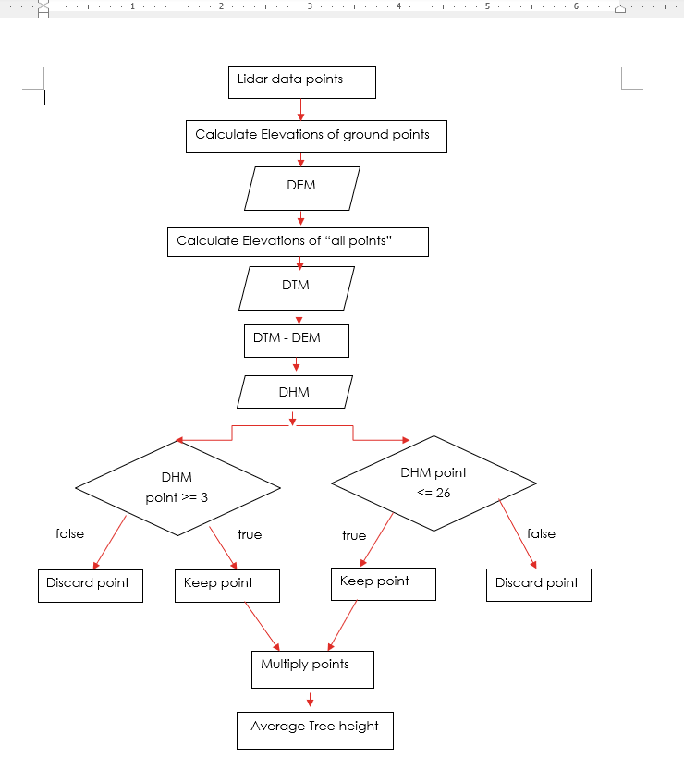
Figure 4. Flowchart showing the workflow used in the calculation of average tree heights.
The flowchart used, has input steps, such as “calculate elevations of ground points”, shown in rectangles. Output results are shown in rhombus shapes. Decisions are diamond-shaped and have true and false as outputs.

Results

Geodatabase Creation and Visualization
The methodology used for creating the geodatabase was successful, as the 6 lidar data files were successfully combined into a lidar dataset file (LASD). Options to change the symbology of the file to that of a continuous surface were available, which helped find boundaries.

Height and Distance Measurements
Changing the appearance of the LASD to that of a contour map was more difficult for finding elevations and boundaries, as the lines of the contours were harder to interpret compared to other methods, which increased the chances of mistaken identification of features. In contrast, changing the appearance of the LASD file to that of an elevation surface with different elevation interval classes was effective, as straight-line boundaries of buildings were easy to see. Using coordinate searching for locations was not always successful, as one latitude and longitude coordinate were given incorrectly in the client’s information. However, this issue was easily fixed using the SAIT campus map, as well as the use of world imagery.
It was found that the method used for the height measurements for the top of buildings, and elevation measurements were often inefficient and required lots of trial and error to see elevation changes based on color for the building being measured. A more optimal method would have involved viewing the data using a 3d model and finding the highest points of the building visually, or another more reliable means of finding the data, such as the use of another tool or function.
Distances and areas made with the measurement tools on the point cloud were often inaccurate, due to the point cloud data being irregular in shape, which would cause edges of building footprints to not be clearly defined. Several measurements often yielded results that were offset by more than 3 meters.
 | Feature | Measurement (m)
 | Point Cloud A1
1 | Elevation of top of the mechanical equipment on the Thomas Riley (51:3:57.56N,114:5:25.92W) | 1110.26
2 | Elevation of the center of the overpass above 14th Street | 1091.59
3 | Elevation of the round Quonset on campus (51:3:58.22N, 114:5:37.35W) | 1097.8
4 | Length of the large square building south of the Quonset | 61.8
5 | Width of the small rectangular building in the center of the buildings close to the Quonset | 20.46
 | Point Cloud A2
6 | Height of the top of the new residence (51:3:55.32N, 114:4:11.03W) | 67.86
7 | Elevation of the top of the new residence | 1157.26
8 | Elevation of the top of the central “wave” of the Aldred Center (51:3:59.98N, 114:5:18.67W) | 1116.333
9 | Elevation of the bottom of the “wave” of the Aldred Center (51:3:59.83N, 114:5:19.86W) | 1114
10 | Length of the Aldred Center | 153.19
 | Point Cloud B1
11 | Area of the Jubilee Auditorium (just the cone looking shape) | 3351.95
12 | Minimum elevation value of the point cloud | 988.32
13 | Maximum elevation value of the point cloud | 1192.55
14 | Length of the train platform | 138.86
 | Point Cloud B2
15 | Elevation of the highest point on Senator Burns | 1142.83
16 | Area of the soccer field | 10991.53
17 | Area of the K wing of Senator Burns | 2147.17
18 | The overall length of Senator Burns (going E-W) | 188.49
19 | Elevation of the midpoint of the C-train bridge over 10th Street | 1070.356
 | Point Cloud C2
20 | Point count | 7084987
Figure 5. Table showing results of point data measurements

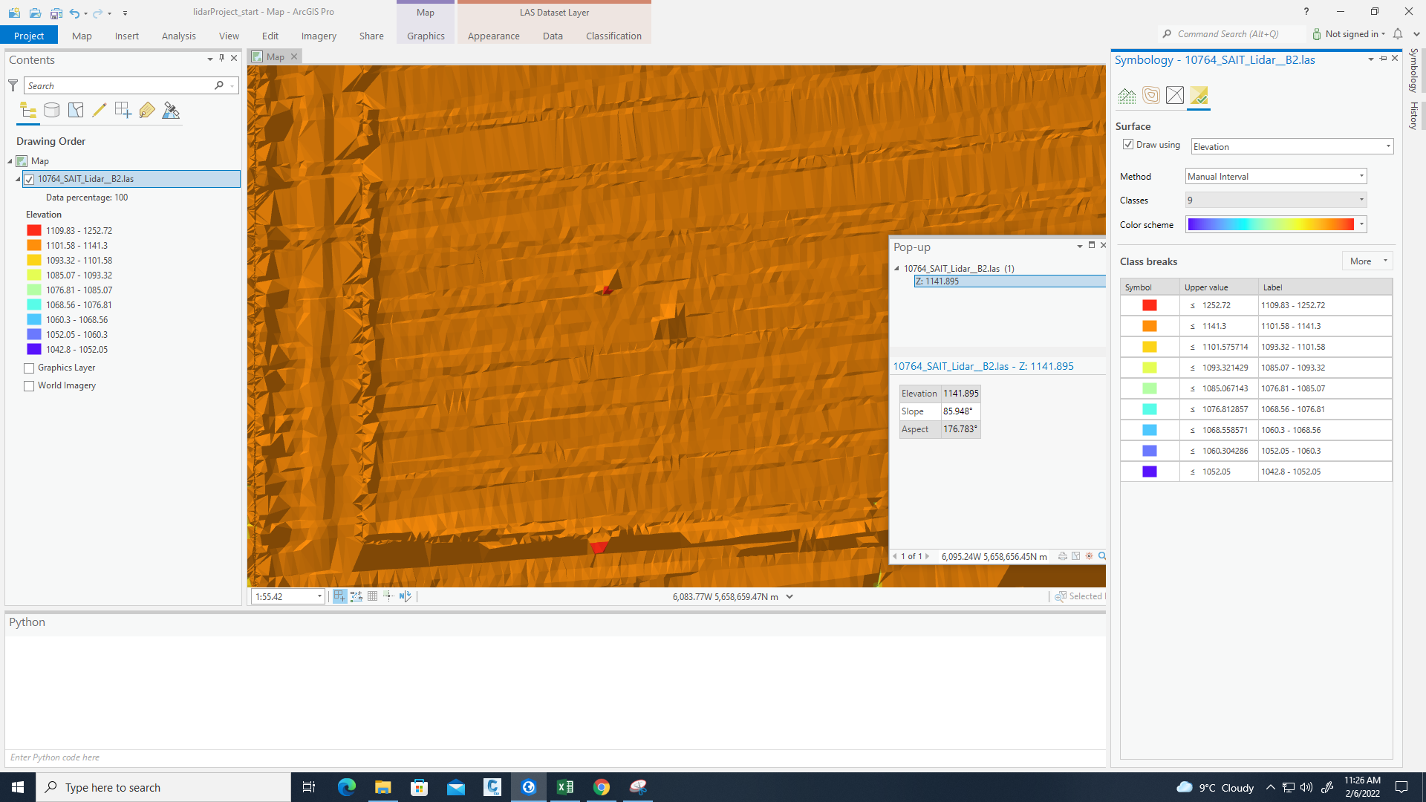
Figure 6. example of manipulating elevation intervals to find the highest elevation areas on the top of a building

Building Footprint and Map
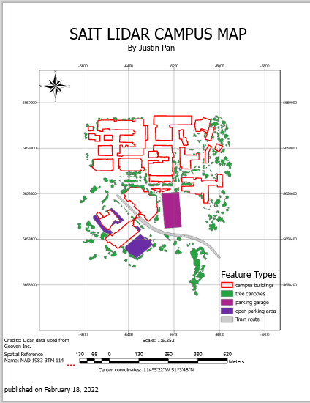
Figure 7. SAIT campus area map made from lidar point data
The map was successful in showing the general boundaries of building footprints, as well as other large area structures, as well as tree canopies. Campus buildings are easy to see, as well as the general areas and boundaries of tree canopies. The boundaries may be distorted, and many objects closer to the ground in the area may not be visible. This is due to accidental mistracking of certain areas.
For the building footprint process, it was found that changing the appearance of the LASD data to that of a first return surface of the point data was most effective in finding tree clusters and buildings for extraction, with tree canopy boundaries and buildings being easier to distinguish from surroundings when compared to changing the appearance to an elevation surface model with class ranges, or that of a contour map. With the elevation surface, it was difficult to distinguish cars from trees, as small area shapes were often like each other. In the first return surface, shapes and boundaries for smaller areas were more defined, which helped in finding tree canopies.

It was difficult to find the start and end of attached buildings, as there was no data that could be used to correlate the start and ends for attached buildings. Finding the boundaries of lower-lying sidewalks or road areas was also difficult, as they were often at a similar elevation from the lidar data. The use of a visible light aerial or multispectral satellite image would be better suited for defining low-lying features with similar elevations to the surface.

Digital Terrain Models
For all 3d models, it was easier to see areas where distortion of data occurred, since the models had more well-defined lines and polygons. This distortion can be seen at the bottom and top of the left side of the area for each 3d model, with strips of lines being seen that converge towards points on the boundary of the models.

3d Layer for TIN
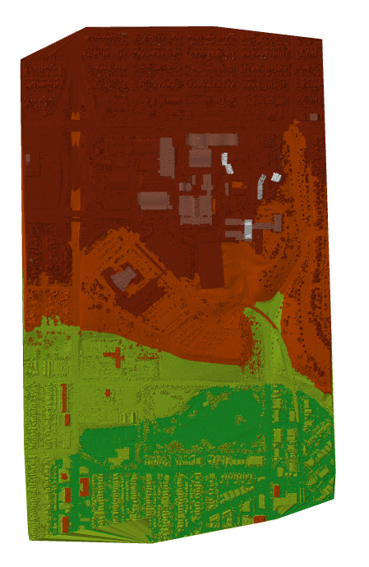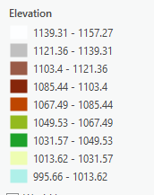
Figure 8. Triangulated inverse Network surface model(left) with a legend(right).
The TIN model was able to show the general shape of the terrain, as well as the shape of buildings in and out of the SAIT campus. Unfortunately, it was difficult to see features close to the ground, such as roads, or higher height vegetation on the ground, such as trees and other shrubs. The most prominent features of this model are the buildings at the SAIT campus, with other buildings and features being barely visible. Lower elevation houses and other buildings can also be seen in the green area of the model, although the detail and spatial resolution on them are poor in quality. It is important to note that the accuracy of data for the TIN model may be lower compared to other 3d models, due to the process of point thinning, which was required to reduce the amount of memory used in the processing.
Overall, the TIN model was found to be effective at modeling the general elevation changes occurring in the area, as well as the shapes of the large area buildings, but is less effective in portraying small area features, such as the housing units in the green area of the TIN.

3d layer for Slope in degrees
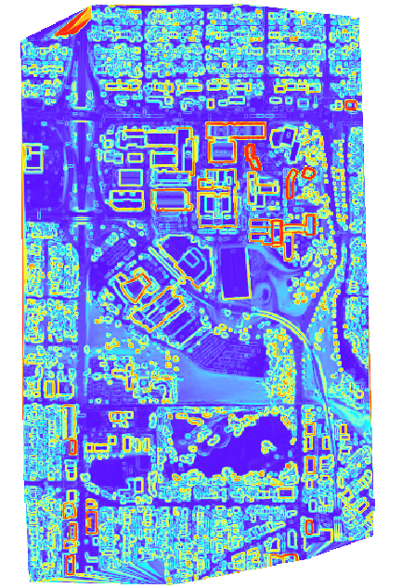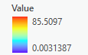
Figure 9. Degree slope surface model(left) with legend(right)
The 3d model for the slope in degrees shows almost all buildings in the area, with both the SAIT campus buildings in the middle of the area and lower elevation buildings surrounding the campus being visible. The boundaries for all SAIT campus buildings are highlighted clearly and are easy to make out. Boundaries and shapes for smaller area buildings (e.g., houses) are hard to make out, and in some cases, it is hard to distinguish between lower elevation buildings and trees, as they all have a similar squiggly and unorganized appearance. Roads and other transport structures are also shown but are not well highlighted in shape. No slope values are above 86 degrees, which may indicate either errors in the interpolation of slopes, areas with less data, or distortions with angles that may have occurred due to gaps of point data during the processing.

At the very bottom of the image, a large distortion of this type can be seen, with large blurry lines, which may indicate that there were fewer point data for the interpolation of slope values during the generation of the model.

Aspect 3d model

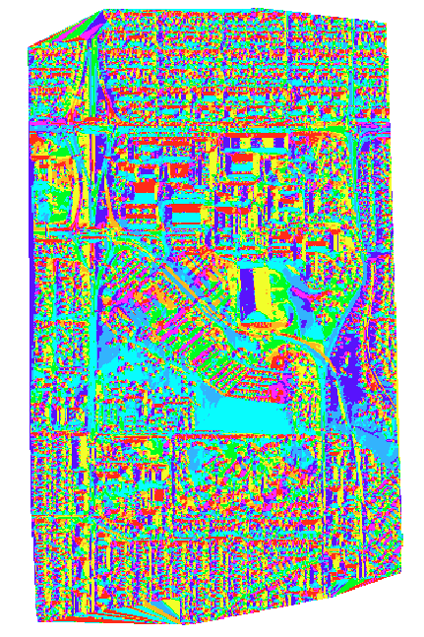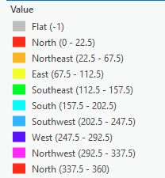
The aspect 3d model was able to portray what directions features in the area will slope towards, using azimuth degree directions, with 0 degrees being north, and 180 degrees being south. An advantage to this model is the ability to see slope directions for every part of the area. A disadvantage for the model is that no vegetation can be seen, and smaller road networks are barely visible. Smaller area structures (such as houses in the south) may be hard to distinguish from the environment because of the aspect information being shown.
Of special note is the soccer field shown in the black circle, which slopes towards the east on one side, and west on another. This is a result of the structure being designed to slope on two sides to drain water.

Contour Model
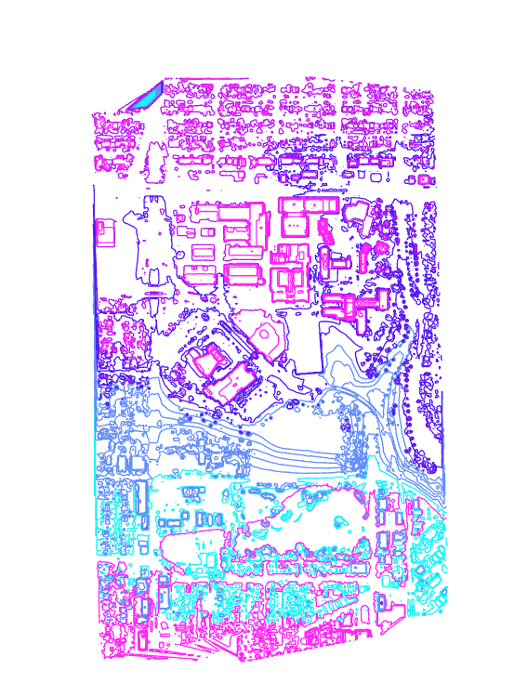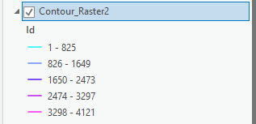
The slope model shows the boundaries of all objects on the area, with tree canopies appearing in circular clusters in a spiky shape, and buildings and other manmade structures appearing in a more rectangular manner. An issue found with the model was the difficulty in identifying small area manmade structures from tree canopies for the areas surrounding the college campus.

Average Tree Height Calculation
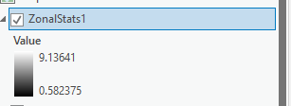
The elevation found was 9.13641 meters, which is a lower-than-expected outcome. This may have been caused by the contamination of data through houses and other buildings lower in height than the tree canopies being averaged. For optimization of such calculations in the future, the use of a separate classification for tree canopies in the lidar point data would help in the separation of buildings from tree canopies in the average tree height calculation.
Limiting the area to not include the lower-lying buildings would also have helped to improve results. Although data contamination would still occur, due to the majority of SAIT area buildings being less than 26 meters.

References

[1] | National Oceanic and Atmospheric Administration, "What is lidar?," [Online]. Available: https://oceanservice.noaa.gov/facts/lidar.html. [Accessed 12 Jan 2022].
[2] | B. Sharma, "What is LiDAR technology and how does it work? " 2 October 2021. [Online]. Available: https://www.geospatialworld.net/blogs/what-is-lidar-technology-and-how-does-it-work/. [Accessed 12 January 2022].
[3] | Geo-Plus, "Airborne versus Terrestrial: how to choose the right Lidar for your needs," [Online]. Available: https://www.geo-plus.com/blog-airborne-versus-terrestrial/#:~:text=What%20are%20the%20advantages%20of,time%20compared%20to%20terrestrial%20Lidar. [Accessed 20 January 2022].
[4] | H. G. M. G. Vosselman, Airborne, and Terrestrial Laser Scanning, Dunbeath: Whittles Publishing, 2010.
[5] | ArcGIS Pro, "What is Lidar data?," [Online]. Available: https://pro.arcgis.com/en/pro-app/latest/help/data/las-dataset/what-is-lidar-.htm#:~:text=The%20first%20returned%20laser%20pulse,detected%20by%20the%20lidar%20system. [Accessed 11 February 2022].
[6] | LiDAR and RADAR Information, "Advantages and Disadvantages of LiDAR," [Online]. Available: https://lidarradar.com/info/advantages-and-disadvantages-of-lidar. [Accessed 20 January 2022].
[7] | Newport, "Light Detection and Ranging," [Online]. Available: https://www.newport.com/n/lidar#:~:text=The%20airborne%20LiDAR%20system%20is,a%20GPS%2C%20and%20an%20IMU. [Accessed 21 January 2022].
[8] | C. Butterworth, "SURV362: 3D Modelling Lectures," Calgary, 2022.
[9] | Countries, "Latitude and longitude of SAIT Polytechnic," [Online]. Available: https://latitude.to/articles-by-country/ca/canada/22750/sait-polytechnic.
[10] | O'Reilly Online Learning, "Advantages and Disadvantages of Floating-Point Numbers," [Online]. Available: https://www.oreilly.com/library/view/c-primer-plus/9780132781145/ch03lev2sec13.html. [Accessed 4 February 2022].
[11] | ArcGIS Pro, "Point thinning and scalability of a LAS dataset," [Online]. Available: https://pro.arcgis.com/en/pro-app/latest/help/data/las-dataset/point-thinning-and-scalability-of-a-las-dataset.htm. [Accessed 18 February 2022].
[12] | geospatialmedia, [Online]. Available: https://geospatialmedia.s3.amazonaws.com/wp-content/uploads/2019/01/Wired1.jpg.

