Stereo Reconstruction using Image Rectification and PatchMatch

(Abstract)
bla bla..

Introduction
- what is it needed for
- how is it done: blockmatch, patchmatch, deep learning, flow estimation, bla..

Theory

- Correspondences in an image pair:
In order to estimate the depth of a scene from two cameras, the stereo reconstruction problems effectively reduces to the problem of finding for each pixel in one image a corresponding pixel in the other image. Since multiple similar pixel might occur in an image, it is usual to compare not only the pixel color, but also its surrounding pixels or to compute more sophisticated features. The simple approach to this problem is to brute-force search the entire image for a corresponding match. Therefore some preprocessing steps can be performed to ease the search problem.

- simplification by rectification OR parallel stereo setup

- intrinsics, extrinsics of a camera setup

- BlockMatch (only horizontal search)

- PatchMatch and our variant (only horizontal search)

Methods/Materials
- libraries we used
- c++
- qtcreator
- datasets!
- self-generated data

Results
- rectification (independent)

The stereo reconstruction was performed for different image pairs and the depth maps retrieved from the BlockMatch and PatchMatch algorithm are shown in the following.

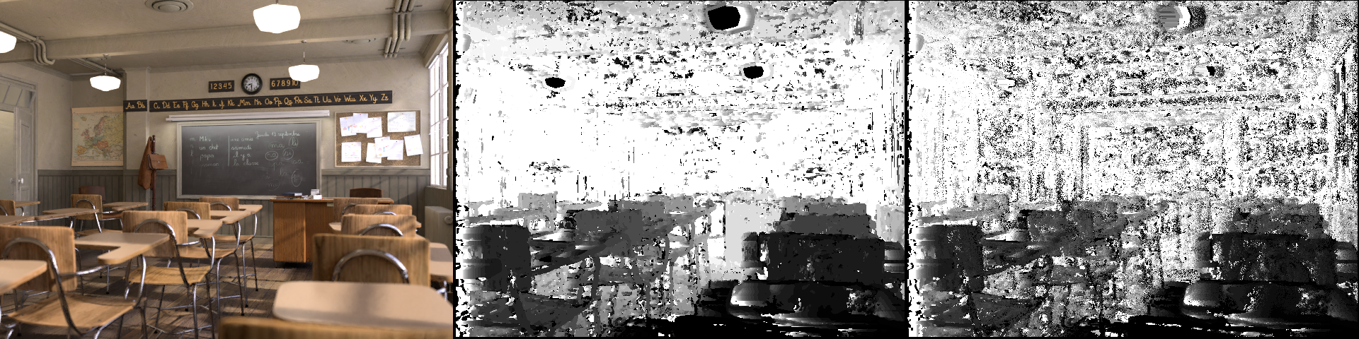
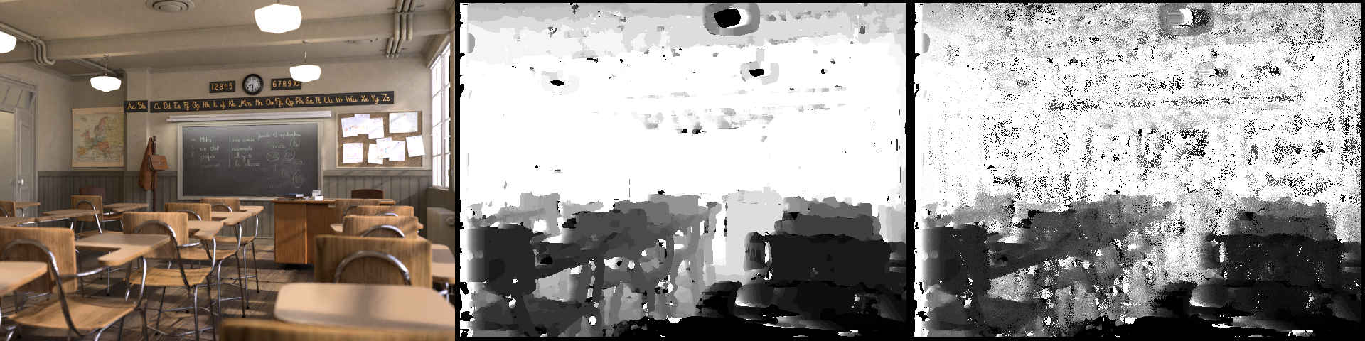
Figure: Depth reconstruction from blender classroom scene. (left) The image from the left camera view. (middle) Depth map obtained from BlockMatch and (right) PatchMatch. The upper row shows the reconstruction with a patch size of 5 pixel and the lower row with a patch size of 11 pixel.

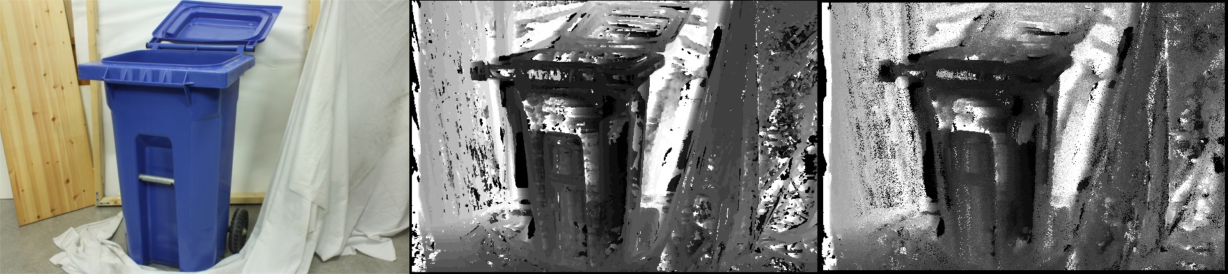
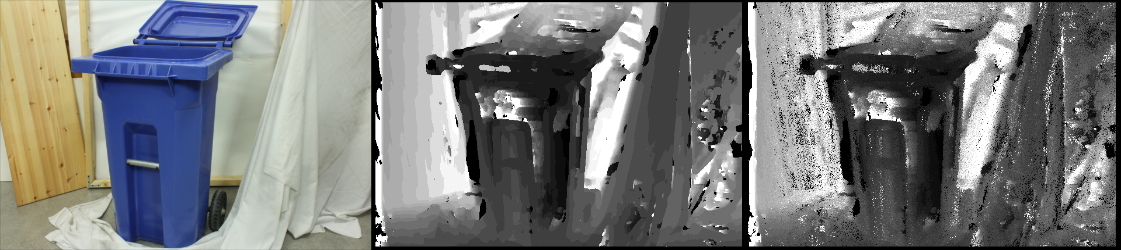
Figure: Depth reconstruction from the recycle-bin scene.

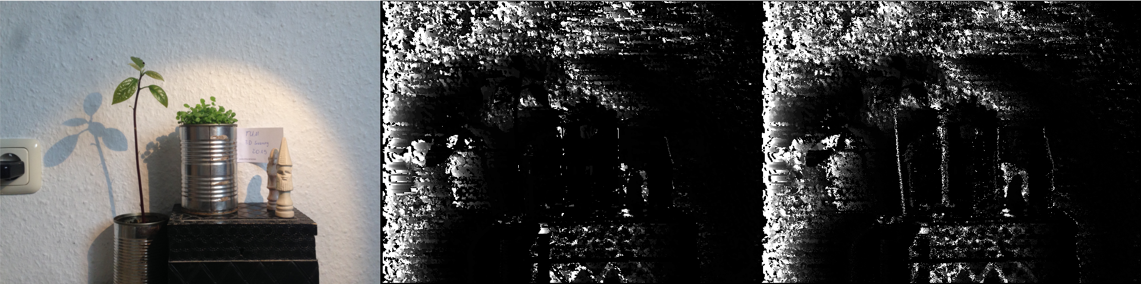
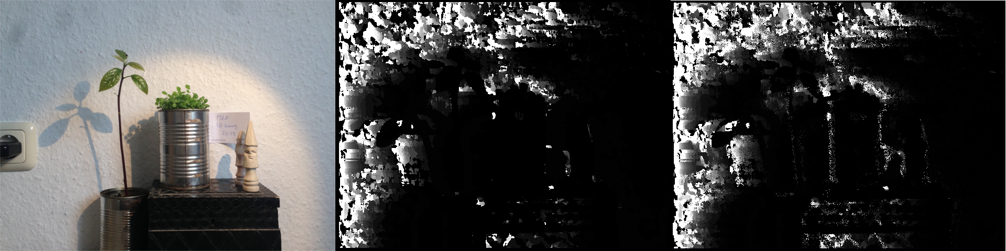
Figure: Depth reconstruction from the stereo camera rig. (CHANGE)

Conclusions/Discussion
bla bla..

