The methodology combines different open data sources and generates a generic network by open-source technology [34]. The generic network designed by algorithm matches the real sewage network to a certain extent. Therefore, the generic network makes it possible to spot suitable locations for exploitation of waste heat from sewers without having the original GIS data of the sewer. Overall, the methodology allocates population density to street networks and calculates the wastewater volume flow (WWV) for each street. WWV results from the product of population density (PD) and the country-specific water usage (WU) (2.1). Finally, an algorithm determines the shortest paths from each street to the wastewater treatment plant and accumulates the wastewater volume flows along these paths.

The methodology assumes the following:

* Water consumption is equivalent to the amount of wastewater.
* Specific water consumption is the statistical average at national level.
* Rainwater accumulates discontinuously and is therefore neglected.
* The path of the sewage system is said to be the shortest path along the street network from wastewater occurrences to the wastewater treatment plant. Obstacles (e.g. rivers, bridges, train tracks), pumps, geodesic heights are not taken into account in the first step.

The methodology uses graph theory and creates an undirected and unweighted graph out of open-source data, which is finally transformed to a directed and weighted graph to meet the purposes of the methodology. ([35] gives a good introduction into graph theory.)

First an undirected, unweighted graph is defined taking advantages of GIS data, its attributes and its geometric information [35, 36]. The graph consists of edges and nodes which correspond to the roads and crossroads in the geometric information of the GIS data. Additionally, edges contain the attributes of roads, whereas nodes keep the attributes of crossroads. All necessary data can now be allocated to the graph’s elements, such as inhabitants, length of roads and geodesic heights to node’s and edge’s attributes if applicable.

For later calculation the graph is now weighted by its length. Furthermore, the shortest ways from any node to the wastewater treatment plant are calculated with respect to the weight of the graph [37]. The direction of the shortest paths converts the undirected graph into a directed graph. An example of a graph with the shortest ways from node 3 and 4 to node 0 is given in Figure 2.

Secondly, a census or a different source of population distribution gives the possibility to allocate inhabitants to each node of the graph. The population density of each census raster polygon distributes equally to all nodes that are within this polygon. The higher the resolution of the census data, the more accurate the amount of inhabitants per each graph’s nodes. Based on a graph with the number of inhabitants for each node, the amount of wastewater is calculated by using population density and the key figure of the average water usage in the relevant country (2.1).

Figure 2 Graph of a map section, showing six crossroads and five streets. Attributes of nodes are their number and inhabitants, attributes of edges is their geological length. Node 0 denotes the wastewater treatment plant.

Figure 3Figure 4 Graph of a map section, showing 6 crossroads and 5 streets. Attributes of nodes are their number and inhabitants, attributes of edges is their geological length. Node 0 is said to be the wastewater treatment plant.

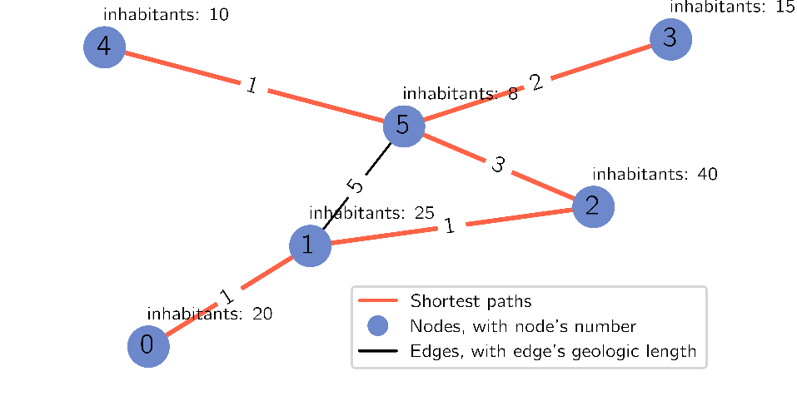

(2.1)

To determine the maximum wastewater flow ${WWV}_{n}$ has to be adjusted either by a flow coefficient used for the construction of the sewer system or by a load profile. According to [38], the water consumption can be calculated with the general flow formula (3.1). This formula is valid for pipes filled to design capacity [39].

$f\left(h\right)= {Q(h)}/{Q_{hm}}$ (2.1)

with

$Q_{hm}= {\sum_{i=0}^{8760}{Q\left(i\right)}}/{8760}$ (2.2)

|  |  |
| --- | --- |
| f(h) | dimensionless load factor [-] |
| Q(h) | hourly consumption [m³/h] |
| Qhm | average hourly consumption [m³/h] |

The f(h) differs by the size of the city. It is said that the smaller the city, the more water is tapped simultaneously [38, p. 164 et. seq., 40, p. 30]. Figure 5 shows the load factor for urban areas from different literature [41–43]. Load factor 1 and load factor 3 proceed the same way and are in the range between 0.20 [41] and 1.66 [41]. For the calculation the figures from [41] are taken. Compared to [14, 44, 45] a maximum load factor of 1.60 seems to be reasonable for maximum flow.

${WWV}_{n}$ is then evenly distributed to all nodes of the graph that are spatial within ${WWV}_{n}$ occurrences.

The directed and weighted graph has now all necessary information to calculate the wastewater flows along given paths. The paths run along the shortest connection from each node that holds a wastewater flow towards the wastewater treatment plant (see Figure 1). To accumulate the wastewater flows running through any node (N) by considering the shortest paths from all nodes to the wastewater treatment plant, the following sets are defined:

Figure 5 The load factor determines the hourly average water consumption using the average water usage per day [41–43].

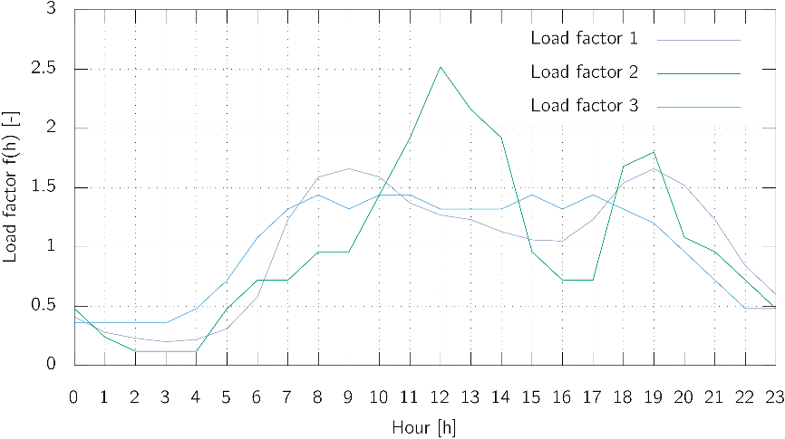

, set of all nodes (2.3)

$θ_{i}$, set of all nodes which run to $N_{i}$ on the shortest paths, excluding $N_{i}$ (2.4)

$\overline{θ_{i}}$, set of all nodes which are not laying on the shortest paths to $N_{i}$, excluding $N_{i}$ (2.5)

Equations 2.3 to 2.5 divide the graph into three sets. Equation 2.3 contains all nodes of the graph. Equation 2.4 includes all nodes that are on any shortest path towards $N_{i}$, but Equation 2.4 does not include the node $N_{i}$ itself. Equation 2.5 is nearly the invers of Equation 2.4, which means it holds all nodes that are not connected via a shortest path to the node, with the exception of the regarded node itself.

With Equations 2.3 to 2.5 can be stated:

$θ= θ_{i} ∪ \overline{θ_{i}} ∪ \left\{N_{i}\right\}$. (2.6)

The wastewater flow for the observed node can now be calculated with

$\left|N_{i}\right|$ is the value of $N_{i}$,

and accordingly the sum of waste water flows towards $N_{i}$ along the shortest paths:

$\left|N_{i}\right|= \sum{\left|N_{k}\right|}$ for all $N_{k} ∈ θ_{i}$. (2.7)

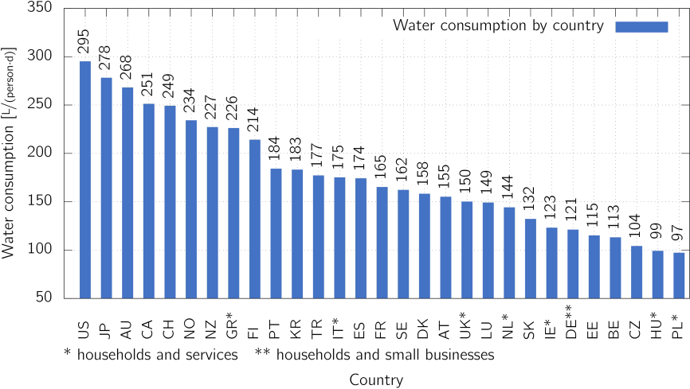

Figure 6 Overview of water consumption by country

|  |  |
| --- | --- |
|  |  |
| Figure 7 Water consumption by different building types. The amount of water usage depends on the reference value x. (1 x = bed, 2 x = person, 3 x =guest, 4 n.a., 5 x = patient + personell, 6 x = child, 7 x = employee, 8 x = pupil, 9 x = seat) | Figure 8 Water consumption by different building types (* used during daytime) |