Combined nectar nonsugar compounds enhance bumblebee cognition

PELLETTIERI, Julieta ^{1,2}; FARINA, Walter M.^{1,2*}

¹Laboratorio de Insectos Sociales, Departamento de Biodiversidad y Biología Experimental, Facultad de Ciencias Exactas y Naturales, Buenos Aires, Argentina.
²Instituto de Fisiología, Biología Molecular y Neurociencias (IFIBYNE), CONICET-Universidad de Buenos Aires, Buenos Aires, Argentina.
* Corresponding author: Email: walter@fbmc.fcen.uba.ar

ABSTRACT
The use of native pollinators is a growing practice that enhances agricultural productivity while preserving local biodiversity. In South America, the bumblebee Bombus pauloensis has become increasingly employed across a variety of crops. In honeybees, nectar nonsugar compounds (NSCs), such as the alkaloid caffeine and the amino acid arginine, have been shown to enhance long-term memory and increase foraging activity, particularly when offered in combination. In this study, we investigated the effects of NSCs on associative learning and survival in the bumblebee B. pauloensis. We assessed acquisition and long-term memory retention using a classical olfactory conditioning paradigm, where the sugared reward contained traces of caffeine, arginine, or their combination, each tested at two concentrations. When applied individually, NSCs improved performance only at high doses; however, when combined, they enhanced long-term memory retention even at low doses, indicating a combined effect. Moreover, the presence of NSCs at field-realistic concentrations enhanced the survival of conditioned bees.

Key words: Caffeine, L-Arginine, learning, Bombus pauloensis, combined effects

Introduction

Results and Discussion

To evaluate the effect of the non-sugar nectar compounds (NSCs) caffeine (CAF) and L-arginine (ARG) on olfactory learning and long-term memory in the South American bumblebee Bombus pauloensis, 435 individuals from 11 colonies were subjected to a modified olfactory conditioning protocol (see Materials and Methods). The training phase consisted of six exposures to a pure odor (linalool, LIO), each followed by the delivery of a sugar reward containing trace doses of the compounds under evaluation (Table 1). Of the 435 bumblebees exposed to the training, 396 ingested at least one reward bout. Among those that exhibited effective acquisition—defined as free-moving proboscis extension in response to the odor during training (FMPER)—223 showed FMPER at 24 hours when exposed to the trained odor alone. Additionally, 42 individuals did not extend their proboscises during training but nevertheless exhibited FMPER at 24 hours (S1). Overall, approximately one in five bumblebees formed a positive association during training but did not express it through FMPER at 24 hours (Table S2, Supplementary). Free-moving proboscis extension responses (FMPER) were recorded both during acquisition and during the test performed 24 hours later, which also included a control trial using a novel odor (nonanal, NONA) not previously presented during training (Figure 1).

Table 1. Composition of the sucrose solution and non sugar compounds used for the different treatments

Treatment | Concentration | Odor
Unscented | 50% w/w SS | No
Control | 50% w/w SS | Yes
L-Arginine | SS+0.03 mM ARG | Yes
 | SS+0.06 mM ARG | Yes
Caffeine | SS+0.15 mM CAFF | Yes
 | SS+0.3 mM CAFF | Yes
Mixture | SS+0.03 mM ARG+0.15 mM CAFF | Yes
 | SS+0.06 mM ARG+0.3 mM CAFF | Yes

Sucrose solution (SS; 50% w/w) was used as the unconditioned stimulus;
caffeine (CAFF) and L-arginine (ARG) were added to this at the indicated
concentrations.

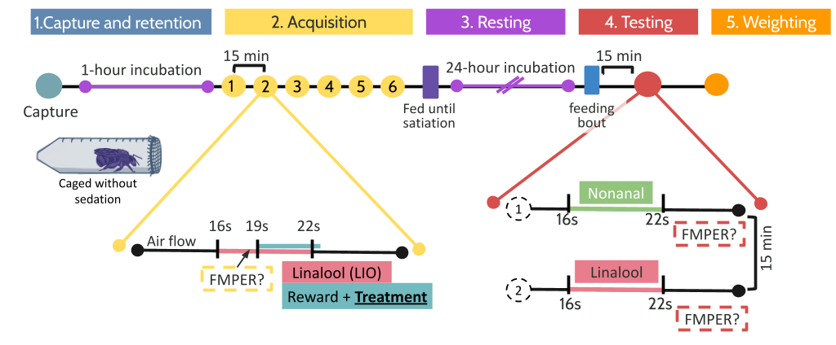
Figure 1. Experimental protocols to examine long-term memory under laboratory conditions in the bumblebee Bombus pauloensis.

Training phase
The results show that during training, the proportion of bumblebees exhibiting a proboscis extension response (FMPER) to the conditioned odor increased progressively, indicating successful learning. By the end of the training phase, significant differences in response rates were detected among treatments. In particular, significant increases relative to the control group (Wald tests, p < 0.05, Table S3, Supplementary) were observed when double doses were administered, demonstrating a dose-dependent effect of the compounds. The combined administration of caffeine and arginine did not produce a greater effect than caffeine alone, although caffeine exhibited a marginally significant effect even at low doses. In contrast, arginine administered alone at high doses also produced significant differences compared with the control, indicating a positive effect of this amino acid on odor acquisition in a pollinating insect (Figure 2).

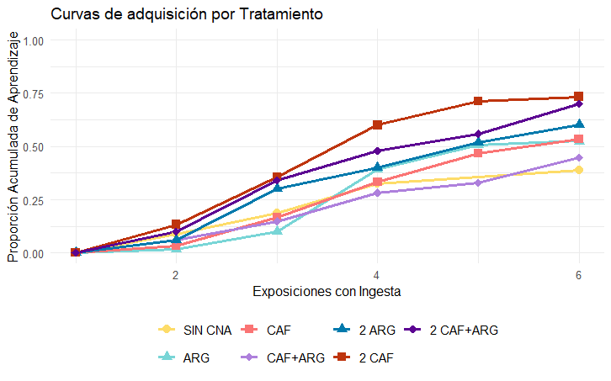
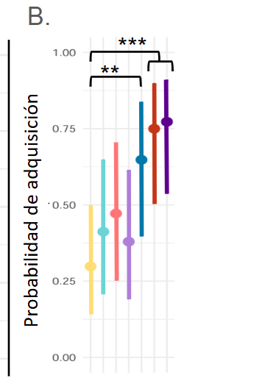

Figure 2: Acquisition responses during training procedure. A. Acquisition curve according to treatment (prop.). B. Probability of acquisition during training according to the treatment, estimated using a generalized linear mixed model with treatment as a fixed-effects variable and nest and day as random-effects variables. Asterisks represent significant differences (**) p-value < 0.01 and (***) p-value < 0.001 (Wald test). Bars represent 95% confidence intervals.

Long-term memory
Regarding long-term memory (LTM), a positive effect was observed for the treatments combining caffeine and arginine, regardless of the administered dose. This effect emerged only when the compounds were administered individually at their highest doses, suggesting that the combined treatment produces an additive—or at least greater—effect than that generated by each compound alone (Figure 3, Table S4, Supplementary). Furthermore, it is noteworthy that olfactory memory specificity was not affected by the evaluated compounds (p > 0.05, Table S5, Supplementary), remaining consistently high (i.e., generalization rate was 5.6% (95% CI: 3.7–8.5%).
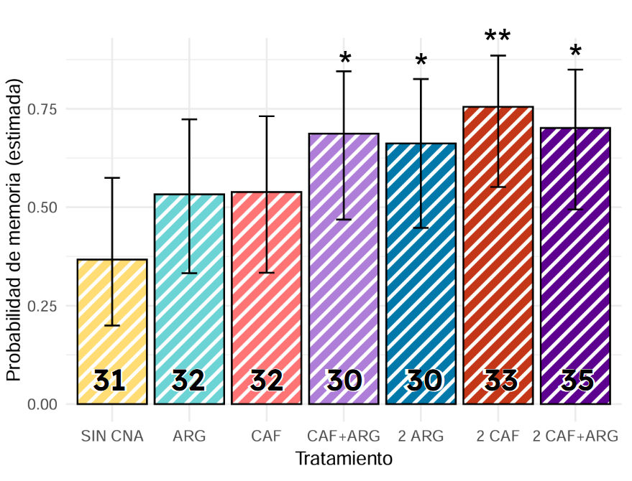

Figure 3. Probability of a free-moving proboscis extension response (FMPER) 24 hours post-training as a function of the administered treatment. Estimates were obtained from a generalizedlinear mixed model (GLMM) including nest identity and experimental day as random effects. Only individuals that ingested the reward at least four times during training and exhibited effective acquisition were included in the analysis. Generalized linear mixed models: Generalize ~ Group_Treatment, binomial, bin; GLMM with two or more ingesting bouts: Generalize ~ 1, binomial, bin); emmeans: global model, ~ 1, type = "response"; confidence level: 0.95 intervals are back-transformed from the logit scale. Treatments that differ significantly from the control (without NSCs) according to the Wald test are marked with asterisks: (*) p < 0.05, (**) p < 0.01. Bars represent 95% confidence intervals. Sample sizes for each treatment are indicated in bold.

These results are consistent with those reported for Apis mellifera, where combined effects were detected when mixtures of both compounds were offered under laboratory conditions (Marchi et al., 2021). It is worth noting that the effects of CAF on long-term memory consolidation in bumblebees have been documented only for visual—rather than olfactory—learning protocols (e.g., Bombus impatiens; Muth et al., 2022). The effect of arginine on short-term memory retention has been previously reported (Chalisova et al., 2011; Lopatina et al., 2017). However, its influence on long-term memory had not been demonstrated, even in Apis mellifera, using protocols comparable to those employed here (Marchi et al., 2021).
This study provides the first evidence supporting a potential role of arginine in both the acquisition and the formation of stable, persistent memories. Overall, the incremental effects observed for the uncombined NSCs (CAF2 and ARG2) suggest that the persistence of associative memory in this native bumblebee can be enhanced through two complementary mechanisms: (i) increased excitability of Kenyon cells in the mushroom bodies, where caffeine has been shown to act (Wright et al., 2013; Menzel, 2012), and (ii) increased availability of the substrate (arginine) required for nitric oxide (NO) synthesis, a pathway involved in biochemical cascades that promote neuronal protein synthesis (Müller, 1996, 1997). This evidence highlights the need for future studies aimed at dissecting the underlying processes and mechanisms involved in both pathways, in this and other pollinating insect species.
Survival
Overall survival was 86.5% (Table S6, Supplementary). Each treatment group experienced fewer than four deaths, and some groups had no mortality at all, resulting in complete separation and preventing the implementation of a GLMM. All treatments showed a trend toward reduced mortality. However, the low number of deaths, combined with the large number of contrasts, limits the statistical power of the proposed model. Despite this, the caffeine and low-dose arginine treatments showed significant differences compared with the control. The same treatments at high doses, as well as the low-dose combination of both compounds, exhibited marginal p-values. The high p-value observed for the high-dose combination may be associated with the proximity to the maximum dose that can be administered before adverse effects of caffeine emerge (Wright et al., 2013).

Table 2. Effect of caffeine (CAF, 2CAF), L-arginine (ARG, 2ARG) and their combination (CAF+ARG, 2CAF+ARG) on the survival of bumblebees in the context of a modified olfactory conditioning protocol. Survival was assessed 24 h after administration of the non sugar nectar compounds.

Treatment | n | Mortality (IC95%) | Odds ratio vs Control | p-value
Control | 67 | 0.169 (0.097 – 0.278) | – | –
ARG | 56 | 0.026 (0.005 – 0.121) | 0.133 | 0.0237
2 ARG | 43 | 0.034 (0.007 – 0.153) | 0.173 | 0.0502
CAF | 52 | 0.009 (0.001 – 0.135) | 0.047 | 0.0363
2 CAF | 42 | 0.012 (0.001 – 0.162) | 0.058 | 0.0515
CAF+ARG | 52 | 0.047 (0.014 – 0.150) | 0.243 | 0.0517
2 CAF+ARG | 46 | 0.096 (0.038 – 0.219) | 0.520 | 0.2703
Significant differences with the control in bold; marginal significances in italian.

Weight
The bumblebees were divided into three groups according to weight tertiles, and variables such as acquisition rate, FMPER at 24 hours, and mortality were analyzed (Table 3). The results show that although the lowest-weight tertile exhibits a reduced acquisition rate (p-value 1 vs. 2: 0.0514; p-value 1 vs. 3: 0.0847), these marginal differences disappear when evaluated long-term memory. In other words, while all bumblebees respond equally to the familiar odor at 24 hours regardless of weight, lighter individuals tend to show less effective acquisition than medium- and heavier-weight bumblebees. This pattern could be explained by earlier satiation in the smallest individuals.
Table 3. Behavioral variables and mortality according to the weight of experimental subjects

Weight (tercile) | Acquisition |  |  | FMPER (24hs) |  |  | Mortality
Weight (tercile) | Prob. | SE | sig. | Prob. | SE | sig. | Prob. | SE | sig.
1 | 0,453 | 0,104 | a# | 0,420 | 0,071 | a | 0,1679 | 0,0319 | a
2 | 0,637 | 0,095 | a | 0,487 | 0,070 | a | 0,0657 | 0,0212 | b
3 | 0,631 | 0,096 | a | 0,487 | 0,071 | a | 0,0657 | 0,0212 | b
Different letters represent significant differences (tukey p value < 0,05).
#Tercile 1 shows a marginal significance from terciles 2 and 3 (tukey p-values between 0.05 and 0.1).

Materials and methods
Study site, animals and chemical compounds
Experiments were performed at the Experimental Field of the Faculty of Exact and Natural Sciences of the University of Buenos Aires, Argentina (34º32’S, 58º26’W), carrying out during the spring-summer season of 2024-2025. A total of 11 nests of bumblebees Bombus pauloensis were provided by Biobest Argentina S.A. that is breeding this species in captivity. The colonies were housed in their original commercial boxes (27cm x 24cm x 20cm). The experimental nests were placed outdoors and allowed to forage freely for nectar and pollen from the flora available in the surrounding area.
Pure odors commonly presented in the floral fragrances (Knudsen et al., 1993; Raguso and Pichersky 1999), such as the case of linalool (LIO) and nonanal (NONA) (Sigma-Aldrich, Steinheim, Germany), were used during the experiments. The chemical compounds used to prepare the different sugared rewardswere caffeine (CAF) and L-arginine (ARG) (Sigma-Aldrich, Steinheim, Germany). To prepare the different solutions, we considered the caffeine and L-arginine concentrations previously reported (Wright et al. 2013; Chalisova 2011; Lopatina 2017; Marchi et al. 2021). All the concentrations used are part of the range found in natural nectars (Baker and Baker 1976; Wright et al. 2013).

Bees’ capture and preparation
For the experiments, free flying bumblebees that were taken off from the experimental nest were captured with a net and carefully placed in 50ml centrifuge tubes. After being captured, bumblebees were kept individually in the tubes which were covered with mesh to allow ventilation and environmental interaction. The use of spacious containers avoided the need for anesthesia, thereby minimizing stress and preventing cold-induced amnesia. Thereafter, each centrifuge tube was located in an incubator for 1 hour at 29 ºC (capture and retention, Figure 1).

Behavioural assays
To determine how caffeine, arginine and their mixes could affect associative learning and memory in this South American bumblebee, several workers were captured at the nest entrance to undergo an olfactory conditioning protocol adapted from the proboscis extension response (PER) paradigm (honeybees: Takeda, 1961; bumblebees: Palottini et al. 2018).

After one hour in the incubator, the bumblebees located inside the centrifugate tubes were placed individually in front of the device used for application of the odorant during the conditioning procedure. To perform the odor conditioning assays, a device that delivered a continuous airflow (50 ml s−1) was used for the application of the odorant (henceforth: conditioned stimulus, CS), which consisted on 4 μl of pure odorant impregnated on 30 × 3 mm filter paper inside a syringe were delivered through a secondary airstream (6.25 ml s−1) to the proximity of the mesh side of the tube. A fan extracted the released odours to avoid contamination. If the bumblebees protruded the proboscises (henceforth: free-moving proboscis extension response, FMPER) underwent the presentation of 5 µL of 50% weight on weight (w/w) sucrose solution (henceforth: unconditioned stimulus, US) containing the different treatments (Table 1). After six learning trials of paired the presentations of the conditioned stimulus (linalool, LIO; CS) and the US, with an inter-trial interval between CS presentations of 15 min approximately. Each learning trial lasted 39 s. Before odour presentation, bumblebees located inside the tubes rested for 16 s in the airflow for familiarization as well as for testing the bees’ response towards the mechanical stimulus. Only bees that did not respond to the mechanical airflow stimulus were used. For the olfactory conditioning procedure, the CS was presented for 6 s. Reward, according to the treatment, was presented for 3 s on the proboscis (mouthparts), 3 s after the onset of the CS. After odour presentation, the learning trial ended with 17 s of clean airflow (training, Figure 1). During this phase, bumblebees were closely observed to determine whether they extended their proboscises (FMPER?), and the corresponding responses were recorded.
After training, each experimental subject was fed until satiation with 50% w/w unscented sucrose solution., they were kept in darkness within an incubator at 29 °C and 75% relative humidity for 24 hours (resting, Figure 1).
To evaluate the long-term memory after olfactory conditioning, the trained bees were tested to both odours alone 24 hours later. Bumblebees were first exposed to a novel odor (nonanal, NONA) during 6s to record the presence of FMPER. After 15 min the test was repeated with the conditioned odor (linalool, LIO). Before testing, the subjects were given approximately 5 µL of 50% sucrose solution to reactivate them after incubation (testing, Figure 1).
All the experimental subjects were weighed, and then released whenever their condition and weather allowed (weighting, Figure 1).
Moreover, the survival of the experimental subjects exposed to the conditioning was evaluated, from the end of the training period to the evaluation occurred 24 hours later. The response variable obtained in this case was also of the dichotomous “yes / no” type at the end of the prescribed time.

Statistical analysis
All statistical tests were performed with R v4.4.1 (R Core Team, 2024). The proposed models have a binomial logistic regression, since their variables respond to a certain number of successful events (individuals who extend the proboscis or manage to survive) out of a defined total number of individuals which are part of the experimental group. The free-moving proboscis extension response (FMPER) in the conditioning trials and the response in the test were evaluated using generalized linear mixed effects models (GLMM). In contrast, the survival stage showed cases of complete separation and were therefore analyzed using penalized logistic regression with Firth correction (logistf; Heinze et al. 2024), with marginal means and planned contrasts obtained using the emmeans package.
In the conditioning assays, a model including individual weight and treatment as
fixed factors was proposed. The weight factor corresponded to the categorical
variable, which classified individuals into tertiles based on body mass, while the
treatment factor included the experimental groups and their control. Furthermore,
nest and day were included as random effects (1|Nest) + (1|Day) to account for the
hierarchical structure of the experimental design. In the case of the treatment factor, post-hoc contrasts were performed comparing each treatment against the control.
For the FMPER test those bees that could survive after 24 hours and who had also managed to respond effectively during the training were used as the total base of individuals to be analized. Then, only those individuals who had retained their previous behaviour (responding effectively to the CS but not to the NO), were registered as effective responses in this instance.
The GLM and GLMM models were simplified as follows: significance of the different terms was evaluated using Type III Wald chi-square tests implemented with the Anova() function from the car package (Fox and Weisberg, 2019). Non-significant terms (P > 0.05) were removed (see Tables S…, S…., and S….). In the case of comparisons between the different levels of treatment during the acquisition phase, post hoc comparisons were made using least-squares contrasts (see Tables S3 and S5). For this, the emmeans function of the emmeans package (Lenth et al., 2018) was used, and contrasts for the treatment factor were specifically performed against the control group. The alpha level was set at 0.05.

References

