Responses of the arbuscular mycorrhizal fungus Rhizophagus intraradices GC3 to copper in a slightly contaminated soil: an in vitro–in vivo comparison
[Authors to be completed]
¹Laboratorio de Microbiología del Suelo, Instituto de Biodiversidad y Biología Experimental y Aplicada, CONICET-UBA, Facultad de Ciencias Exactas y Naturales, Universidad de Buenos Aires, Ciudad Universitaria, 4to piso, Pabellón 2, 1428 Buenos Aires, Argentina.
²Gerencia Investigación y Aplicaciones, Centro Atómico Constituyentes, Comisión Nacional de Energía Atómica, Av. Gral. Paz 1499, B1650KNA San Martín, Buenos Aires, Argentina.
³Gerencia Química, Laboratorio de Fluorescencia de Rayos X, Centro Atómico Constituyentes, Comisión Nacional de Energía Atómica, Av. Gral. Paz 1499, B1650KNA San Martín, Buenos Aires, Argentina.
⁴International Center for Earth Sciences, Comisión Nacional de Energía Atómica, Complejo Minero Fabril San Rafael, San Rafael, Mendoza, Argentina.
Corresponding author: vanesasilvani@gmail.com; Tel. +54 11 5285 8598

Abstract
Copper (Cu) accumulates in agricultural soils, yet it remains unclear how arbuscular mycorrhizal (AM) fungi respond at the low end of the contamination range, and whether in vitro assays predict responses in the presence of a whole plant. We exposed Rhizophagus intraradices GC3 to Cu in a soil-based, bi-compartmented in vitro system with Ri T-DNA carrot roots (n = 3) and in a greenhouse experiment with sunflower (Helianthus annuus; n = 4), each inoculated or not. In vitro, Cu in the hyphal compartment (measured 100, about 180 and about 290 mg kg⁻¹) did not alter root colonisation but changed fungal development: soil sporulation increased at the intermediate dose (2.8-fold; 95% CI 1.1–7.2) and collapsed at the highest (0.06-fold; 0.02–0.15), to values indistinguishable from the non-inoculated background, whereas spores in the Cu-free root compartment did not decline. In vivo, Cu did not affect plant biomass, colonisation or soil hyphal length. Inoculation raised easily extractable glomalin-related soil protein at all doses (1.5- to 2.0-fold), with no dose–response, and total protein only modestly; neither fraction responded to inoculation in vitro, which suggests that the in vivo increase is not a direct measure of fungal production. Sunflower behaved as a Cu excluder (bioconcentration factor < 1), and plants held < 0.5% of the soil Cu pool. Colonisation was a poor indicator of Cu stress, whereas sporulation in soil was highly sensitive. Our results support a metal-avoidance response of GC3 rather than a Cu-induced increase in glomalin.
Keywords: arbuscular mycorrhizal fungi; copper; glomalin-related soil protein; Rhizophagus intraradices; root organ culture; sporulation; sunflower; trace elements

1. Introduction
Copper (Cu) is an essential micronutrient that can become a potentially toxic trace element in soil (Duffus 2002; Pourret and Hursthouse 2019). Fungicides, fertilisers and other agricultural inputs have raised its concentration in cultivated land: in a survey of European topsoils, mean Cu reached 49 mg kg⁻¹ in vineyards against an overall mean of 17 mg kg⁻¹ (Ballabio et al. 2018; see also Tóth et al. 2016). Excess Cu impairs root growth and nutrient acquisition, particularly of phosphorus (P), and its effects can be modulated by soil P supply (Brunetto et al. 2016; Baldi et al. 2018; Feil et al. 2020). Its transfer to crops is also of dietary concern: the European Food Safety Authority recently set an acceptable daily intake of 0.07 mg kg⁻¹ body weight, with food and pesticide use among the contributing sources (EFSA Scientific Committee 2023).
Arbuscular mycorrhizal (AM) fungi contribute to the uptake of low-mobility nutrients, including P and Cu, and modulate plant metal acquisition across a broad range of soil concentrations (Parniske 2008; Ferrol et al. 2016). They may alleviate metal toxicity through binding to hyphal walls, compartmentalisation in vesicles and spores, and active efflux (Hildebrandt et al. 2007; González-Guerrero et al. 2008; Cornejo et al. 2013; Janeeshma and Puthur 2020; Gómez-Gallego et al. 2024). Avoidance of contaminated patches has also been proposed (Pawlowska and Charvat 2004). The outcome for the host depends on the combination of fungus, plant and Cu level (Meier et al. 2012; Merlos et al. 2016; Colombo et al. 2024), and much of the evidence comes from heavily polluted sites (Cornejo et al. 2008; Colombo et al. 2020; Benavidez et al. 2024). Less is known about slightly contaminated soils.
Glomalin-related soil protein (GRSP) is frequently invoked in this context. It has been related to soil aggregation and to the binding of metals (Wright and Upadhyaya 1998; Rillig 2004; González-Chávez et al. 2004; Cornejo et al. 2008; Son et al. 2024), and glomalin yield has been reported to increase under some suboptimal conditions (Rillig and Steinberg 2002; Hammer and Rillig 2011). However, GRSP is defined operationally: hot citrate extracts contain heat-stable proteins and other compounds of non-mycorrhizal origin, and Bradford-based quantification overestimates glomalin (Rosier et al. 2006; Gillespie et al. 2011; Holátko et al. 2021). Axenic controls are therefore valuable for separating fungal production from background.
Root organ cultures offer such control, but traditionally use synthetic media. The soil-based system developed by Silvani et al. (2019) exposes the extraradical mycelium (ERM) to a real soil matrix while keeping the root in a separate compartment. With this system, Cu has been mapped in intraradical structures of R. intraradices GC3 by microPIXE (Statello et al. 2024), but the developmental response of the fungus to a Cu gradient, and whether it anticipates the response in the presence of a whole plant in soil, have not been evaluated. Sunflower is a suitable host for this comparison: it is a crop species, and its response to Cu and AM fungi has been examined previously (Castañón-Silva et al. 2013; Meier et al. 2012).
Here, we compared the response of R. intraradices GC3 to Cu in the soil-based in vitro system and in sunflower grown in the same type of soil. We hypothesised that (i) Cu would reduce extraradical growth and sporulation in soil before affecting root colonisation; (ii) GRSP would increase with Cu; (iii) inoculation would limit the transfer of Cu from soil to shoots; and (iv) the direction of the responses shared by both systems would agree.

2. Materials and methods

2.1. Biological material and soil
Rhizophagus intraradices (N.C. Schenck & G.S. Sm.) C. Walker & A. Schüßler, strain GC3, was provided by the Banco de Glomeromycota In Vitro (BGIV, www.bgiv.com.ar) and maintained with Ri T-DNA transformed carrot (Daucus carota L.) roots on Minimal Medium (MM; Bécard and Fortin 1988). Sunflower (Helianthus annuus L. var. Mammoth Russian; [seed size]) was the host in vivo. Both assays used a Mollisol from Buenos Aires province (silt loam: 12% sand, 65.5% silt, 22.5% clay; pH 5.1; total C 14.9 g kg⁻¹; total N 1.53 g kg⁻¹; P 13.9 mg kg⁻¹ [extraction method]).

2.2. In vitro assay
The assay followed Silvani et al. (2019), using bi-compartmented Petri plates (90 × 14 mm) that separated a root compartment (RC) from a hyphal compartment (HC; St-Arnaud et al. 1996). The RC received 30 mL of MM and a 5-cm non-mycorrhizal root fragment, inoculated with a plug of a 4-month-old monoxenic culture containing approximately 200 spores, mycelium and colonised roots. The HC received 30 mL of sterile dry soil, homogeneously amended with 4 mL of filter-sterilised (0.2 µm) CuSO₄ solution (Cu1: 150 mg L⁻¹; Cu2: 300 mg L⁻¹) or sterile deionised water (Cu0). Cu1 corresponded to values recorded in soils of the Riachuelo basin, Buenos Aires (Mendoza et al. 2015; Colombo et al. 2020). Non-inoculated (NI) plates received only the root fragment. The six treatments (GC3 or NI × Cu0, Cu1 or Cu2) had three replicates each and were incubated in the dark at 25 °C for 120 days.

2.3. In vivo assay
Seeds were surface-sterilised (70% v/v ethanol, 20 min; 20% v/v sodium hypochlorite with 0.1% Tween 20, 30 min), rinsed with sterile distilled water and germinated on moist filter paper at 25 °C in the dark for 4 days. Three seedlings were sown in 1.5-L pots with tyndallised soil and thinned to one three days after emergence. Inoculated plants received a 1-cm³ plug of 4-month-old monoxenic culture; NI plants received a plug of MM with non-mycorrhizal transformed roots only. Pots were watered by capillarity with deionised water and fertilised every 15 days with 100 mL of P-free Hewitt solution (Hewitt 1952). After 30 days, each pot received 420 mL of CuSO₄ solution (Cu1: 150 mg L⁻¹; Cu2: 300 mg L⁻¹) or sterile deionised water (Cu0). The 24 pots (six treatments, n = 4) were randomised in a greenhouse under natural light and temperature [dates, mean temperature] and harvested 130 days after sowing.

2.4. Harvest and fungal variables
Shoots and roots were separated and dried at 70 °C for 48 h to determine dry weight. Root samples from both assays were cleared (10% w/v KOH, 90 °C, 15 min), acidified (0.1 N HCl, 5 min) and stained with 0.02% w/v trypan blue in lactic acid (90 °C, 10 min; modified from Phillips and Hayman 1970). Frequency (%F) and intensity (%I) of colonisation were estimated according to Declerck et al. (2004) under a light microscope at 400× on root fragments mounted in groups of 10; in the in vitro assay, arbuscules (%A), vesicles (%V) and intraradical spores (%IS) were also recorded. One gram of dry soil from each pot or HC was shaken with 100 mL of 0.002% trypan blue for 10 min, and aliquots were poured on a 9-cm Petri dish with a 1-cm² grid; hyphal length was calculated from grid intersections (Newman 1966). In the RC, hyphal length and spores were counted in five randomly chosen 1-cm² squares under a stereomicroscope (4.5×). Newly formed spores in soil were counted per gram of dry soil. Because RC and HC values are expressed in different units, the compartments were compared only through relative changes (section 2.6).

2.5. GRSP and elemental analyses
Bradford-reactive GRSP was determined following Cornejo et al. (2008). Easily extractable GRSP (EE-GRSP) was extracted from 1 g of dry soil with 8 mL of 20 mM citrate (pH 7.0; 121 °C, 30 min). Total GRSP (T-GRSP) was obtained by repeated extraction of 1 g of dry soil with 8 mL of 50 mM citrate (pH 8.0; 121 °C, 60 min), up to five cycles, until the reddish-brown colour disappeared. Extracts were centrifuged (3000 rpm, 15 min), and T-GRSP extracts were pooled and centrifuged again (10,000 rpm, 10 min). Protein was quantified by the Bradford method (Bradford 1976) with bovine serum albumin as standard. [State the volume and dilution factors used to express results per gram of soil.]
Cu and P concentrations in soil and plant material were determined by energy-dispersive X-ray fluorescence on pressed pellets (Custo et al. 2005). Samples were dried at 70 °C for 48 h, milled and sieved (850 µm). [Report instrument, limits of detection and quantification, certified reference materials and recoveries.] For each pot, we calculated the bioconcentration factor (BCF = element concentration in shoot or root / concentration in soil), the translocation factor (TF = concentration in shoot / concentration in root) and the plant Cu content (concentration × dry weight, summed over shoot and root). The soil Cu pool per pot was estimated from soil concentration and the soil mass recorded at harvest.

2.6. Statistical analysis
Analyses were performed in R 4.6.1 (R Core Team 2026). Continuous responses measured in inoculated and NI units were analysed with generalised linear models (Gamma, log link) with inoculation, Cu dose and their interaction, using type II F tests (package car; Fox and Weisberg 2019). Percentages were analysed in inoculated units with quasi-binomial models. Hyphal length and spore numbers per compartment were analysed with linear models on log-transformed values, which are conservative with n = 3. To test whether Cu shifted development between compartments independently of their units, we analysed a per-plate allocation index, log(HC/RC), which is equivalent to the compartment × Cu interaction on the log scale. Results are reported as ratios of means with 95% confidence intervals (CI; emmeans; Lenth 2025). To compare systems, we estimated unit-free ratios (Cu2/Cu0 and GC3/NI) and tested the corresponding system × treatment interaction. Multiplicity was controlled with the Benjamini–Hochberg procedure (BH; Benjamini and Hochberg 1995), both across all model terms within each system and within a primary family defined a priori (T-GRSP, EE-GRSP and soil, root and shoot Cu in vivo). Model fit was assessed with simulated residuals (DHARMa; Hartig 2025). Key contrasts were checked with exact permutation tests, with the minimum attainable P noted where relevant. The multivariate response in vivo was assessed by PERMANOVA on standardised log-transformed variables (vegan; Oksanen et al. 2025). Data handling decisions are documented in the accompanying code. [Data exclusions to be confirmed.]

3. Results

3.1. Copper measured in the substrate
In vitro, soil Cu increased with dose from about 100 mg kg⁻¹ in Cu0 to 158 ± 34 (GC3) and 198 ± 7 (NI) mg kg⁻¹ in Cu1 and to 299 ± 27 and 278 ± 5 mg kg⁻¹ in Cu2 (P < 0.001), with no effect of inoculation (Table 1, Fig. 4a). In vivo, soil Cu was 49 ± 3 mg kg⁻¹ in NI-Cu0 and rose to 80 ± 18 and 149 ± 32 mg kg⁻¹ in NI-Cu2 and GC3-Cu2, respectively (Cu: P = 0.017; Table 3, Fig. 4b). Elemental analyses in vivo were performed only on Cu0 and Cu2 [state the reason].

3.2. In vitro assay
R. intraradices GC3 developed in both compartments at all doses (Fig. 1). Root length was unaffected by Cu (P = 0.54; Table 1). Cu did not change %F (84–91%), %I (41–50%) or %A (60–74%) (P ≥ 0.13). Vesicles and intraradical spores tended to be less abundant with Cu (%V: 59, 28 and 36%; P = 0.083; %IS: 81, 34 and 57%; P = 0.057; Table 1).
In contrast, development in the HC responded strongly and non-monotonically to Cu (Fig. 2). Soil spore numbers differed among doses (F_{2,6} = 54.4, P < 0.001): relative to Cu0, they increased 2.8-fold in Cu1 (95% CI 1.1–7.2; P = 0.034) and fell to 0.06-fold in Cu2 (0.02–0.15; P < 0.001). The value in GC3-Cu2 (9 ± 2 g⁻¹) did not exceed the background of NI plates (7 ± 1 g⁻¹). Hyphal length in the HC followed the same pattern with less amplitude (F_{2,6} = 7.4, P = 0.024): 1.8-fold in Cu1 (1.1–3.1; P = 0.031) and 0.83-fold in Cu2 (0.49–1.39; P = 0.41).
In the Cu-free RC, spore numbers varied in the opposite direction (F_{2,5} = 11.5, P = 0.013): 0.44-fold in Cu1 (0.19–1.04; P = 0.057) and 1.8-fold in Cu2 (0.78–4.3; P = 0.13). Consequently, the spore allocation index log(HC/RC) changed markedly with dose (F_{2,5} = 39.3, P < 0.001), rising 6.8-fold in Cu1 (1.2–38) and falling to 0.035-fold in Cu2 (0.006–0.20). The hyphal allocation index showed a similar, non-significant trend (F_{2,6} = 4.7, P = 0.060); hyphal length in the RC was 3241 ± 453 cm in Cu2 compared with 1307 ± 413 cm in Cu0. Excluding two questionable plates did not modify the spore pattern.
T-GRSP (20–24 µg g⁻¹) and EE-GRSP (3–10 µg g⁻¹) in the HC were unaffected by inoculation (P = 0.27 and 0.99) or Cu (P = 0.44 and 0.47; Fig. 3a, c). A T-GRSP inoculation × Cu interaction (P = 0.033) reflected higher values in NI-Cu1 and did not survive BH correction (P = 0.20). Total soil P was slightly lower in GC3-Cu2 than in NI-Cu2 (363 ± 27 vs 413 ± 3 mg kg⁻¹; ratio 0.88, 0.78–0.99; P = 0.040, BH-adjusted P = 0.17).

3.3. In vivo assay
Cu did not affect sunflower biomass: total dry weight ranged from 9.5 to 12.1 g, with no effects of inoculation, Cu or their interaction (P ≥ 0.21; Table 2). The shoot:root ratio increased with Cu (P = 0.040). GC3 colonised sunflower roots at all doses (%F 77–80%; %I 18–22%; P ≥ 0.72). Soil hyphal length tended to decrease with Cu (80 ± 11, 66 ± 17 and 51 ± 8 cm g⁻¹; Cu2/Cu0 = 0.63, 0.34–1.19; P = 0.13). No AM fungal hyphae were found in NI pots, and no extraradical spores were detected in any treatment. [Soil aggregation: not reported; see comment.]
Inoculation increased EE-GRSP (F_{1,18} = 46.2, P < 0.001; BH-adjusted P < 0.001): the GC3/NI ratio was 1.45 (1.08–1.96), 1.90 (1.41–2.56) and 1.98 (1.47–2.67) in Cu0, Cu1 and Cu2. Inoculation also increased T-GRSP (F_{1,18} = 8.7, P = 0.009; BH-adjusted P = 0.065), with ratios of 1.30 (0.98–1.71), 1.03 (0.78–1.36) and 1.46 (1.11–1.92; P = 0.010). Neither fraction showed a Cu effect or an inoculation × Cu interaction (P ≥ 0.19; Fig. 3b, d); within inoculated pots, the Cu2/Cu0 ratio was 1.20 (0.91–1.59; P = 0.17) for T-GRSP and 1.10 (0.82–1.49; P = 0.49) for EE-GRSP.
Shoot Cu concentrations (22–32 mg kg⁻¹) did not differ among treatments (Table 3, Fig. 4d). Root Cu was 1.6-fold higher in GC3-Cu2 than in NI-Cu2 (19.3 ± 1.3 vs 12.2 ± 1.9 mg kg⁻¹; 1.05–2.36; P = 0.031; permutation P = 0.11), while the interaction was marginal (P = 0.068; Fig. 4c). Soil Cu tended to be higher in GC3-Cu2 than in NI-Cu2 (ratio 1.87, 0.90–3.88; P = 0.087). BCF values were below 1 in all treatments (root 0.14–0.31; shoot 0.23–0.56), and TF exceeded 1 (1.3–2.6), with a tendency towards lower values in inoculated plants (P = 0.069). Plant Cu content was 194–380 µg per plant, less than 0.5% of the estimated soil Cu pool (71–187 mg per pot), and doubled with Cu only in inoculated plants (Cu2/Cu0: GC3 1.96, 1.01–3.80, P = 0.047; NI 1.01, 0.55–1.88, P = 0.96). [Tissue P results withheld pending verification of the XRF values; see comment and Table S1.] Soil P did not differ among treatments (635–671 mg kg⁻¹).
Considered jointly, biomass, GRSP and Cu variables responded to inoculation (PERMANOVA: R² = 0.20, P = 0.011) and to Cu (R² = 0.15, P = 0.039), without interaction (P = 0.16; n = 13).

3.4. Comparison between systems
Unit-free ratios indicated that the effect of Cu on colonisation and soil hyphal length had the same direction in both systems, and the system × Cu interaction was not significant for any fungal variable or GRSP fraction (P ≥ 0.20; Fig. 5a). The systems differed in the response of GRSP to inoculation (Fig. 5b): the inoculation × system interaction was significant for EE-GRSP (P < 0.001) and T-GRSP (P = 0.038). Spore production could not be compared because no extraradical spores formed in vivo.

4. Discussion

4.1. Sporulation in soil, not colonisation, reflected the Cu gradient
Our first hypothesis was partly supported. Root colonisation was insensitive to Cu in both systems, in agreement with the tolerance described for R. intraradices and related fungi (Ferrol et al. 2016), and would have led to the conclusion that Cu had no effect. Sporulation in soil, by contrast, differed about 50-fold between Cu1 and Cu2. This pattern is consistent with the findings of Pawlowska and Charvat (2004), who reported that, in compartmented cultures of G. intraradices, inhibition by Cd, Pb and Zn was limited to the metal-enriched compartment, that sporulation was more sensitive than mycelial expansion, and that these features could reflect a metal-avoidance strategy. Here, the response extends to Cu in a soil matrix: at the highest dose, soil sporulation dropped to background while spores in the Cu-free compartment did not decrease.
The stimulation observed at the intermediate dose resembles hormesis (Calabrese and Baldwin 2003), although Cu is also a micronutrient, and a nutritional effect cannot be excluded. The in vitro design cannot separate a true redirection of resources from independent responses of each compartment, and replication was low; the allocation shift should therefore be confirmed with greater replication and more doses, ideally with intermediate steps between Cu1 and Cu2 to locate the threshold. Testing whether spores formed under Cu accumulate the metal, as reported for other fungi (Cornejo et al. 2013; Benavidez et al. 2024), would help to distinguish avoidance from compartmentalisation, which need not be mutually exclusive. Efflux, recently shown to be a major detoxification route in the ERM of R. irregularis (Gómez-Gallego et al. 2024), could also contribute. From an ecotoxicological perspective, sporulation in soil may be a more informative endpoint than colonisation.

4.2. No evidence that copper increased GRSP
Our data did not support the second hypothesis. Neither GRSP fraction increased with Cu within inoculated units, in either system. The increase with inoculation in vivo was consistent across doses for EE-GRSP and, although largest at Cu2 for T-GRSP, was not accompanied by a significant interaction. This agrees with the lack of a direct effect of Pb contamination on GRSP in a recent field gradient (Cáceres-Mago et al. 2025) and contrasts with the stress-induced increases reported for specific conditions in vitro (Rillig and Steinberg 2002; Hammer and Rillig 2011), which were themselves stressor-dependent.
The lack of an inoculation effect in the axenic HC, despite abundant hyphae, deserves attention. First, about 80% of glomalin produced in vitro remains in hyphae and spores and is released mainly upon degradation (Driver et al. 2005), a process that would be limited under axenic conditions. Second, the citrate–Bradford procedure co-extracts proteins and other compounds of non-mycorrhizal origin (Rosier et al. 2006; Gillespie et al. 2011; Holátko et al. 2021), which is consistent with the substantial signal in NI units; in vivo, inoculation could also increase this signal indirectly by altering root inputs or microbial activity in a non-sterile rhizosphere. Third, the systems differ in host species and carbon supply, soil volume and duration. Thus, the in vivo increase should not be read as a direct measure of fungal glomalin production, and evaluating immunoreactive protein, or an independent marker of AM fungal biomass, is needed. Previous microPIXE mapping in this system showed Cu mainly in vesicles and, to a lesser extent, in colonised roots (Statello et al. 2024); the present data add no direct evidence linking GRSP to Cu binding, which would require quantifying Cu in purified extracts (Cornejo et al. 2008; Cáceres-Mago et al. 2025).

4.3. Copper partitioning: an excluder host with limited extraction
The third hypothesis was not supported: inoculation did not lower shoot Cu. Sunflower tolerated the added Cu without growth reduction, with shoot concentrations far below the 300 mg kg⁻¹ threshold proposed for Cu hyperaccumulation (van der Ent et al. 2013) and BCF < 1 throughout; they were close to the 5–30 mg kg⁻¹ regarded as adequate for crop tissues (Adriano 2001). The amount extracted by plants was negligible relative to the soil pool, so these data do not support phytoextraction. The tendency towards higher root Cu and lower TF in inoculated plants is compatible with the retention of Cu in mycorrhizal roots (Ferrol et al. 2016; Statello et al. 2024), but it was not robust, and effects of AM fungi on Cu partitioning are known to vary with the host and the fungal inoculum (Meier et al. 2012; Merlos et al. 2016). TF values above 1 are not usual for Cu, although low uptake with translocation to the shoot has been described for GC3 in another host (Colombo et al. 2024); this result should be confirmed with analytical methods validated for tissue at these concentrations. Given the lack of growth effects, the Cu level reached in pots should be regarded as slight contamination rather than a stress condition for this host.
Total soil Cu cannot demonstrate immobilisation. Soil Cu did not vary with inoculation in the closed plates, and the higher mean in inoculated pots, which was not statistically supported, cannot be attributed to plant uptake given its magnitude; spatial heterogeneity in pots watered by capillarity is a plausible explanation. Estimating bioavailable and bound fractions, through DTPA extraction (Lindsay and Norvell 1978) and sequential extraction (Rauret et al. 1999) in rhizosphere and bulk soil, would provide a direct test.

4.4. What the in vitro system predicted, and what it did not
The fourth hypothesis was supported only in part. The in vitro system correctly anticipated the insensitivity of colonisation and the direction of the Cu effect on soil hyphae at the highest dose, but it did not predict the inoculation effect on GRSP, and spore production could not be compared because sunflower pots yielded no extraradical spores. Direct comparison of absolute values is inappropriate because system is fully confounded with host species, Cu exposure route, duration and extraction conditions. We therefore suggest using ratios within each system. Soil-based in vitro assays may be most useful for detecting fungal developmental responses that are less visible in pots, whereas plant-level outcomes require whole-plant experiments.
This study has limitations. Replication was low and several tissue variables had only three values per treatment, so non-significant results do not demonstrate absence of effects. Only total concentrations were measured, a single strain and host were tested, and vegetative tissues alone were analysed, so no inference can be drawn about Cu in edible seed, which is influenced by P supply and AM colonisation in other crops (Zhang et al. 2020).

5. Conclusions
In a soil with low-level Cu contamination, R. intraradices GC3 maintained root colonisation, while its sporulation in soil responded strongly to the Cu gradient, with an increase at the intermediate dose and a collapse at the highest. These results are compatible with metal avoidance and identify sporulation as a sensitive endpoint. Inoculation increased Bradford-reactive GRSP in vivo independently of Cu and had no effect in the axenic system, so these data do not support Cu-induced glomalin production. Sunflower behaved as a Cu excluder, with negligible extraction. Confirming immobilisation will require analyses of Cu fractions and of Cu bound to purified GRSP.

Declarations
Funding. This work was supported by Universidad de Buenos Aires, Consejo Nacional de Investigaciones Científicas y Técnicas (CONICET) and Agencia Nacional de Promoción Científica y Tecnológica [grant numbers].
Acknowledgements. We thank Dr Pablo Pomata (IBYME-CONICET) for technical assistance.
Competing interests. The authors declare no competing interests. Author contributions. [CRediT statement]. Data availability. [Repository and DOI]

References
Adriano DC (2001) Trace elements in terrestrial environments: biogeochemistry, bioavailability, and risks of metals, 2nd edn. Springer, New York. https://doi.org/10.1007/978-0-387-21510-5
Baldi E, Miotto A, Ceretta CA, Quartieri M, Sorrenti G, Brunetto G, Toselli M (2018) Soil-applied phosphorous is an effective tool to mitigate the toxicity of copper excess on grapevine grown in rhizobox. Sci Hortic 227:102–111. https://doi.org/10.1016/j.scienta.2017.09.010
Ballabio C, Panagos P, Lugato E, Huang JH, Orgiazzi A, Jones A, Fernández-Ugalde O, Borrelli P, Montanarella L (2018) Copper distribution in European topsoils: an assessment based on LUCAS soil survey. Sci Total Environ 636:282–298. https://doi.org/10.1016/j.scitotenv.2018.04.268
Bécard G, Fortin JA (1988) Early events of vesicular–arbuscular mycorrhiza formation on Ri T-DNA transformed roots. New Phytol 108:211–218. https://doi.org/10.1111/j.1469-8137.1988.tb03698.x
Benavidez M, de la Fournière E, Colombo R, Silvani V, Debray M, Scotti A, Godeas A (2024) Micro PIXE mapping proves a differential distribution and concentration of trace elements in fungal structures of Rhizophagus intraradices. Fungal Biol 128:2089–2093. https://doi.org/10.1016/j.funbio.2024.08.008
Benjamini Y, Hochberg Y (1995) Controlling the false discovery rate: a practical and powerful approach to multiple testing. J R Stat Soc Ser B 57:289–300. https://doi.org/10.1111/j.2517-6161.1995.tb02031.x
Bradford MM (1976) A rapid and sensitive method for the quantitation of microgram quantities of protein utilizing the principle of protein-dye binding. Anal Biochem 72:248–254. https://doi.org/10.1016/0003-2697(76)90527-3
Brunetto G, Bastos de Melo GW, Terzano R, Del Buono D, Astolfi S, Tomasi N, Pii Y, Mimmo T, Cesco S (2016) Copper accumulation in vineyard soils: rhizosphere processes and agronomic practices to limit its toxicity. Chemosphere 162:293–307. https://doi.org/10.1016/j.chemosphere.2016.07.104
Cáceres-Mago K, Salazar MJ, Becerra AG (2025) Glomalin-related soil protein produced by arbuscular mycorrhizal fungi: its role in Pb stabilization at heavily contaminated sites. Chemosphere 385:144589. https://doi.org/10.1016/j.chemosphere.2025.144589
Calabrese EJ, Baldwin LA (2003) Toxicology rethinks its central belief. Nature 421:691–692. https://doi.org/10.1038/421691a
Castañón-Silva PA, Venegas-Urrutia MA, Lobos-Valenzuela MG, Gaete-Olivares HJ (2013) Influencia de micorrizas arbusculares Glomus spp. en el crecimiento y acumulación de cobre en girasol Helianthus annuus L. Agrociencia 47:309–317
Colombo RP, Benavidez ME, Fernandez Bidondo L, Silvani VA, Bompadre MJ, Statello M, Scorza MV, Scotti A, Godeas AM (2020) Arbuscular mycorrhizal fungi in heavy metal highly polluted soil in the Riachuelo river basin. Rev Argent Microbiol 52:145–149. https://doi.org/10.1016/j.ram.2019.05.001
Colombo RP, Silvani VA, Benavidez ME, Scotti A, Godeas AM (2024) Different behavior of two strains of the arbuscular mycorrhizal fungus Rhizophagus intraradices on Senecio bonariensis Hook. & Arn. against heavy metal soil pollution: a pilot-scale test. Int J Phytoremediation 26:1741–1748. https://doi.org/10.1080/15226514.2024.2353389
Cornejo P, Meier S, Borie G, Rillig MC, Borie F (2008) Glomalin-related soil protein in a Mediterranean ecosystem affected by a copper smelter and its contribution to Cu and Zn sequestration. Sci Total Environ 406:154–160. https://doi.org/10.1016/j.scitotenv.2008.07.045
Cornejo P, Pérez-Tienda J, Meier S, Valderas A, Borie F, Azcón-Aguilar C, Ferrol N (2013) Copper compartmentalization in spores as a survival strategy of arbuscular mycorrhizal fungi in Cu-polluted environments. Soil Biol Biochem 57:925–928. https://doi.org/10.1016/j.soilbio.2012.10.031
Custo G, Boeykens S, Dawidowski L, Fox L, Gómez D, Luna F, Vázquez C (2005) Soil characterization by energy dispersive X-ray fluorescence: sampling strategy for in situ analysis. Anal Sci 21:751–756. https://doi.org/10.2116/analsci.21.751
Declerck S, D'Or D, Bivort C, de Souza FA (2004) Development of extraradical mycelium of Scutellospora reticulata under root-organ culture: spore production and function of auxiliary cells. Mycol Res 108:84–92. https://doi.org/10.1017/S0953756203008761
Driver JD, Holben WE, Rillig MC (2005) Characterization of glomalin as a hyphal wall component of arbuscular mycorrhizal fungi. Soil Biol Biochem 37:101–106. https://doi.org/10.1016/j.soilbio.2004.06.011
Duffus JH (2002) "Heavy metals"—a meaningless term? (IUPAC Technical Report). Pure Appl Chem 74:793–807. https://doi.org/10.1351/pac200274050793
EFSA Scientific Committee, More SJ, Bampidis V, Benford D, et al (2023) Re-evaluation of the existing health-based guidance values for copper and exposure assessment from all sources. EFSA J 21:e07728. https://doi.org/10.2903/j.efsa.2023.7728
Feil SB, Pii Y, Valentinuzzi F, Tiziani R, Mimmo T, Cesco S (2020) Copper toxicity affects phosphorus uptake mechanisms at molecular and physiological levels in Cucumis sativus plants. Plant Physiol Biochem 157:138–147. https://doi.org/10.1016/j.plaphy.2020.10.023
Ferrol N, Tamayo E, Vargas P (2016) The heavy metal paradox in arbuscular mycorrhizas: from mechanisms to biotechnological applications. J Exp Bot 67:6253–6265. https://doi.org/10.1093/jxb/erw403
Fox J, Weisberg S (2019) An R companion to applied regression, 3rd edn. Sage, Thousand Oaks
Gillespie AW, Farrell RE, Walley FL, Ross ARS, Leinweber P, Eckhardt KU, Regier TZ, Blyth RIR (2011) Glomalin-related soil protein contains non-mycorrhizal-related heat-stable proteins, lipids and humic materials. Soil Biol Biochem 43:766–777. https://doi.org/10.1016/j.soilbio.2010.12.010
Gómez-Gallego T, Molina-Luzón MJ, Conéjéro G, Berthomieu P, Ferrol N (2024) The arbuscular mycorrhizal fungus Rhizophagus irregularis uses the copper exporting ATPase RiCRD1 as a major strategy for copper detoxification. Environ Pollut 341:122990. https://doi.org/10.1016/j.envpol.2023.122990
González-Chávez MC, Carrillo-González R, Wright SF, Nichols KA (2004) The role of glomalin, a protein produced by arbuscular mycorrhizal fungi, in sequestering potentially toxic elements. Environ Pollut 130:317–323. https://doi.org/10.1016/j.envpol.2004.01.004
González-Guerrero M, Melville LH, Ferrol N, Lott JNA, Azcón-Aguilar C, Peterson RL (2008) Ultrastructural localization of heavy metals in the extraradical mycelium and spores of the arbuscular mycorrhizal fungus Glomus intraradices. Can J Microbiol 54:103–110. https://doi.org/10.1139/w07-119
Hammer EC, Rillig MC (2011) The influence of different stresses on glomalin levels in an arbuscular mycorrhizal fungus—salinity increases glomalin content. PLoS ONE 6:e28426. https://doi.org/10.1371/journal.pone.0028426
Hartig F (2025) DHARMa: residual diagnostics for hierarchical (multi-level/mixed) regression models. R package version 0.5.0
Hewitt EJ (1952) Sand and water culture methods used in the study of plant nutrition. Technical Communication 22. Commonwealth Bureau of Horticulture and Plantation Crops, Farnham Royal
Hildebrandt U, Regvar M, Bothe H (2007) Arbuscular mycorrhiza and heavy metal tolerance. Phytochemistry 68:139–146. https://doi.org/10.1016/j.phytochem.2006.09.023
Holátko J, Brtnický M, Kučerík J, Kotianová M, Elbl J, Kintl A, Kynický J, Benada O, Datta R, Jansa J (2021) Glomalin – truths, myths, and the future of this elusive soil glycoprotein. Soil Biol Biochem 153:108116. https://doi.org/10.1016/j.soilbio.2020.108116
Janeeshma E, Puthur JT (2020) Direct and indirect influence of arbuscular mycorrhizae on enhancing metal tolerance of plants. Arch Microbiol 202:1–16. https://doi.org/10.1007/s00203-019-01730-z
Lenth RV (2025) emmeans: estimated marginal means, aka least-squares means. R package version 2.0.4
Lindsay WL, Norvell WA (1978) Development of a DTPA soil test for zinc, iron, manganese, and copper. Soil Sci Soc Am J 42:421–428. https://doi.org/10.2136/sssaj1978.03615995004200030009x
Meier S, Borie F, Curaqueo G, Bolan N, Cornejo P (2012) Effects of arbuscular mycorrhizal inoculation on metallophyte and agricultural plants growing at increasing copper levels. Appl Soil Ecol 61:280–287. https://doi.org/10.1016/j.apsoil.2011.10.018
Mendoza RE, García IV, de Cabo L, Weigandt CF, Fabrizio de Iorio A (2015) The interaction of heavy metals and nutrients present in soil and native plants with arbuscular mycorrhizae on the riverside in the Matanza-Riachuelo River Basin (Argentina). Sci Total Environ 505:555–564. https://doi.org/10.1016/j.scitotenv.2014.09.105
Merlos MA, Zitka O, Vojtech A, Azcón-Aguilar C, Ferrol N (2016) The arbuscular mycorrhizal fungus Rhizophagus irregularis differentially regulates the copper response of two maize cultivars differing in copper tolerance. Plant Sci 253:68–76. https://doi.org/10.1016/j.plantsci.2016.09.010
Newman EI (1966) A method of estimating the total length of root in a sample. J Appl Ecol 3:139–145. https://doi.org/10.2307/2401670
Oksanen J, Simpson GL, Blanchet FG, et al (2025) vegan: community ecology package. R package version 2.7-6
Parniske M (2008) Arbuscular mycorrhiza: the mother of plant root endosymbioses. Nat Rev Microbiol 6:763–775. https://doi.org/10.1038/nrmicro1987
Pawlowska TE, Charvat I (2004) Heavy-metal stress and developmental patterns of arbuscular mycorrhizal fungi. Appl Environ Microbiol 70:6643–6649. https://doi.org/10.1128/AEM.70.11.6643-6649.2004
Phillips JM, Hayman DS (1970) Improved procedures for clearing roots and staining parasitic and vesicular-arbuscular mycorrhizal fungi for rapid assessment of infection. Trans Br Mycol Soc 55:158–161. https://doi.org/10.1016/S0007-1536(70)80110-3
Pourret O, Hursthouse A (2019) It's time to replace the term "heavy metals" with "potentially toxic elements" when reporting environmental research. Int J Environ Res Public Health 16:4446. https://doi.org/10.3390/ijerph16224446
R Core Team (2026) R: a language and environment for statistical computing. R Foundation for Statistical Computing, Vienna
Rauret G, López-Sánchez JF, Sahuquillo A, Rubio R, Davidson C, Ure A, Quevauviller P (1999) Improvement of the BCR three step sequential extraction procedure prior to the certification of new sediment and soil reference materials. J Environ Monit 1:57–61. https://doi.org/10.1039/a807854h
Rillig MC (2004) Arbuscular mycorrhizae, glomalin, and soil aggregation. Can J Soil Sci 84:355–363. https://doi.org/10.4141/S04-003
Rillig MC, Steinberg PD (2002) Glomalin production by an arbuscular mycorrhizal fungus: a mechanism of habitat modification? Soil Biol Biochem 34:1371–1374. https://doi.org/10.1016/S0038-0717(02)00060-3
Rosier CL, Hoye AT, Rillig MC (2006) Glomalin-related soil protein: assessment of current detection and quantification tools. Soil Biol Biochem 38:2205–2211. https://doi.org/10.1016/j.soilbio.2006.01.021
Silvani VA, Statello M, Scorza MV, Pérgola M, Colombo RP, Godeas AM (2019) A novel in vitro methodology to cultivate arbuscular mycorrhizal fungi combining soil and synthetic media. Symbiosis 79:163–170. https://doi.org/10.1007/s13199-019-00637-z
Son Y, Martínez CE, Kao-Kniffin J (2024) Three important roles and chemical properties of glomalin-related soil protein. Front Soil Sci 4:1418072. https://doi.org/10.3389/fsoil.2024.1418072
St-Arnaud M, Hamel C, Vimard B, Caron M, Fortin JA (1996) Enhanced hyphal growth and spore production of the arbuscular mycorrhizal fungus Glomus intraradices in an in vitro system in the absence of host roots. Mycol Res 100:328–332. https://doi.org/10.1016/S0953-7562(96)80164-X
Statello M, Colombo R, de la Fournière E, Debray M, Godeas A, Silvani V (2024) The microPIXE technique to understand the distribution of heavy metals in arbuscular mycorrhizal symbiosis. Rev Argent Microbiol 56:198–199. https://doi.org/10.1016/j.ram.2023.12.006
Tóth G, Hermann T, Da Silva MR, Montanarella L (2016) Heavy metals in agricultural soils of the European Union with implications for food safety. Environ Int 88:299–309. https://doi.org/10.1016/j.envint.2015.12.017
van der Ent A, Baker AJM, Reeves RD, Pollard AJ, Schat H (2013) Hyperaccumulators of metal and metalloid trace elements: facts and fiction. Plant Soil 362:319–334. https://doi.org/10.1007/s11104-012-1287-3
Wright SF, Upadhyaya A (1998) A survey of soils for aggregate stability and glomalin, a glycoprotein produced by hyphae of arbuscular mycorrhizal fungi. Plant Soil 198:97–107. https://doi.org/10.1023/A:1004347701584
Zhang W, Zou C, Chen X, Liu Y, Liu D, Yang H, Deng Y, Chen X (2020) Phosphorus application decreased copper concentration but not iron in maize grain. Agronomy 10:1716. https://doi.org/10.3390/agronomy10111716
Table 1. Measured soil elements, root length, fungal development and root colonisation in the soil-based in vitro system with Rhizophagus intraradices GC3 and non-inoculated (NI) controls, at three Cu doses.
Variable | Group | Cu0 | Cu1 | Cu2 | P (Cu)
Soil Cu, measured (mg kg⁻¹) | GC3 | 100 ± 1 | 158 ± 34 | 299 ± 27 | <0.001
 | NI | 103† | 198 ± 7 | 278 ± 5
Soil P, measured (mg kg⁻¹) | GC3 | 430 ± 20 | 403 ± 3 | 363 ± 27 | 0.065
 | NI | 410† | 423 ± 7 | 413 ± 3
Root length, RC (cm) | GC3 | 688 ± 6 | 488 ± 22 | 656 ± 161 | 0.536
 | NI | 498 ± 39 | 479 ± 33 | 402 ± 74
Hyphal length, RC (cm) | GC3 | 1307 ± 413 | 1205 ± 646 | 3241 ± 453 | 0.118
Hyphal length, HC (cm g⁻¹) | GC3 | 84.1 ± 11.3 | 153.3 ± 24.5 | 70.0 ± 11.6 | 0.024
 | NI | — | 15.0 ± 0.3 | 6.6 ± 2.2
Spores, RC (count) | GC3 | 208 ± 54 | 89 ± 4 | 397 ± 109 | 0.013
Spores, HC (g⁻¹) | GC3 | 141 ± 21 | 445 ± 145 | 9 ± 2 | <0.001
 | NI | — | 7 ± 2 | 7 ± 1
Frequency, %F | GC3 | 91.1 ± 2.2 | 83.7 ± 1.6 | 90.1 ± 2.5 | 0.128
Intensity, %I | GC3 | 49.6 ± 4.7 | 41.0 ± 6.0 | 40.5 ± 4.2 | 0.411
Arbuscules, %A | GC3 | 59.5 ± 26.6 | 67.5 ± 7.0 | 74.2 ± 3.7 | 0.697
Vesicles, %V | GC3 | 59.1 ± 10.3 | 28.2 ± 6.7 | 36.3 ± 5.1 | 0.083
Intraradical spores, %IS | GC3 | 80.7 ± 2.6 | 34.4 ± 6.2 | 57.1 ± 12.8 | 0.057
Values are means ± SE (n = 3, unless noted; n = 2 for some GC3-Cu0 variables). †Single value, without SE. —, not available. RC, root compartment; HC, hyphal compartment with soil. P values: effect of Cu in GC3 from log-normal models (hyphae and spores), quasi-binomial models (percentages) or the factorial Gamma model (soil elements and root length). NI values in the HC represent background.
Table 2. Plant growth, root colonisation, soil hyphal length and glomalin-related soil protein (GRSP) in sunflower inoculated with Rhizophagus intraradices GC3 or non-inoculated (NI), at three Cu doses.
Variable | GC3-Cu0 | GC3-Cu1 | GC3-Cu2 | NI-Cu0 | NI-Cu1 | NI-Cu2 | P Inoc. | P Cu | P I×Cu
Root dry weight (g) | 0.75 ± 0.08 | 0.76 ± 0.12 | 0.67 ± 0.04 | 0.99 ± 0.05 | 0.56 ± 0.10 | 0.80 ± 0.14 | 0.607 | 0.146 | 0.087
Shoot dry weight (g) | 9.37 ± 1.04 | 10.69 ± 0.61 | 11.44 ± 0.26 | 11.15 ± 0.71 | 8.89 ± 1.48 | 10.55 ± 1.36 | 0.727 | 0.536 | 0.234
Total dry weight (g) | 10.12 ± 1.10 | 11.44 ± 0.60 | 12.11 ± 0.26 | 12.14 ± 0.76 | 9.46 ± 1.53 | 11.36 ± 1.49 | 0.775 | 0.532 | 0.205
Shoot:root ratio | 12.5 ± 1.0 | 15.3 ± 2.9 | 17.4 ± 1.1 | 11.2 ± 0.3 | 16.3 ± 2.4 | 13.6 ± 1.3 | 0.308 | 0.040 | 0.428
Frequency, %F | 79.8 ± 3.6 | 77.8 ± 10.8 | 76.6 ± 2.7 | — | — | — | — | 0.944 | —
Intensity, %I | 22.0 ± 3.1 | 17.6 ± 5.4 | 20.0 ± 1.5 | — | — | — | — | 0.724 | —
Soil hyphal length (cm g⁻¹) | 80.3 ± 11.1 | 65.7 ± 17.5 | 51.0 ± 7.9 | — | — | — | — | 0.308 | —
T-GRSP (µg g⁻¹) | 46.7 ± 4.3 | 44.9 ± 3.1 | 56.3 ± 4.5 | 36.1 ± 5.9 | 43.5 ± 2.6 | 38.5 ± 1.7 | 0.009 | 0.400 | 0.192
EE-GRSP (µg g⁻¹) | 80.7 ± 3.7 | 92.7 ± 5.8 | 89.1 ± 4.9 | 55.5 ± 4.6 | 48.8 ± 6.8 | 45.1 ± 7.2 | <0.001 | 0.809 | 0.281
Values are means ± SE (n = 4). P values from Gamma models with type II F tests, or for Cu in GC3 only (quasi-binomial for percentages, Gamma for hyphal length). —, not applicable.
Table 3. Copper in soil and sunflower tissues, bioconcentration and translocation factors, plant Cu content and soil P in the in vivo assay (Cu0 and Cu2).
Variable | NI-Cu0 | GC3-Cu0 | NI-Cu2 | GC3-Cu2 | P Inoc. | P Cu | P I×Cu
Soil Cu (mg kg⁻¹) | 49.2 ± 2.8 | 66.9 ± 20.6 | 79.8 ± 18.2 | 149.0 ± 32.1 | 0.068 | 0.017 | 0.497
Root Cu (mg kg⁻¹) | 15.0 ± 1.9 | 14.0 ± 1.2 | 12.2 ± 1.9 | 19.3 ± 1.3 | 0.154 | 0.866 | 0.068
Shoot Cu (mg kg⁻¹) | 29.0 ± 10.9 | 21.9 ± 4.5 | 30.6 ± 4.6 | 31.5 ± 2.7 | 0.577 | 0.362 | 0.499
BCF root | 0.31 ± 0.05 | 0.31 ± 0.04 | 0.19 ± 0.07 | 0.14 ± 0.03 | 0.557 | 0.035 | 0.560
BCF shoot | 0.56 ± 0.16 | 0.37 ± 0.08 | 0.46 ± 0.13 | 0.23 ± 0.04 | 0.053 | 0.210 | 0.610
TF | 1.86 ± 0.67 | 1.28 ± 0.14 | 2.58 ± 0.43 | 1.63 ± 0.04 | 0.069 | 0.192 | 0.837
Plant Cu content (µg plant⁻¹) | 328 ± 87 | 194 ± 25 | 332 ± 72 | 380 ± 42 | 0.422 | 0.150 | 0.135
Soil P (mg kg⁻¹) | 671 ± 15 | 635 ± 10 | 665 ± 20 | 651 ± 10 | 0.114 | 0.799 | 0.473
Values are means ± SE (n = 3–4). BCF, bioconcentration factor; TF, translocation factor. P values from Gamma models with type II F tests. Tissue P is presented in Table S1 pending verification.
Figure 1. The soil-based in vitro system with Rhizophagus intraradices GC3 and Ri T-DNA carrot roots. A Bi-compartmented plate with the root compartment (upper left) and the hyphal compartment with soil (lower right). B Extraradical mycelium in Cu1-amended soil. C Spores from Cu1. D Mycelium with attached soil particles in Cu2. Scale bars: A, 1.5 cm; B and C, 400 µm; D, 50 µm.
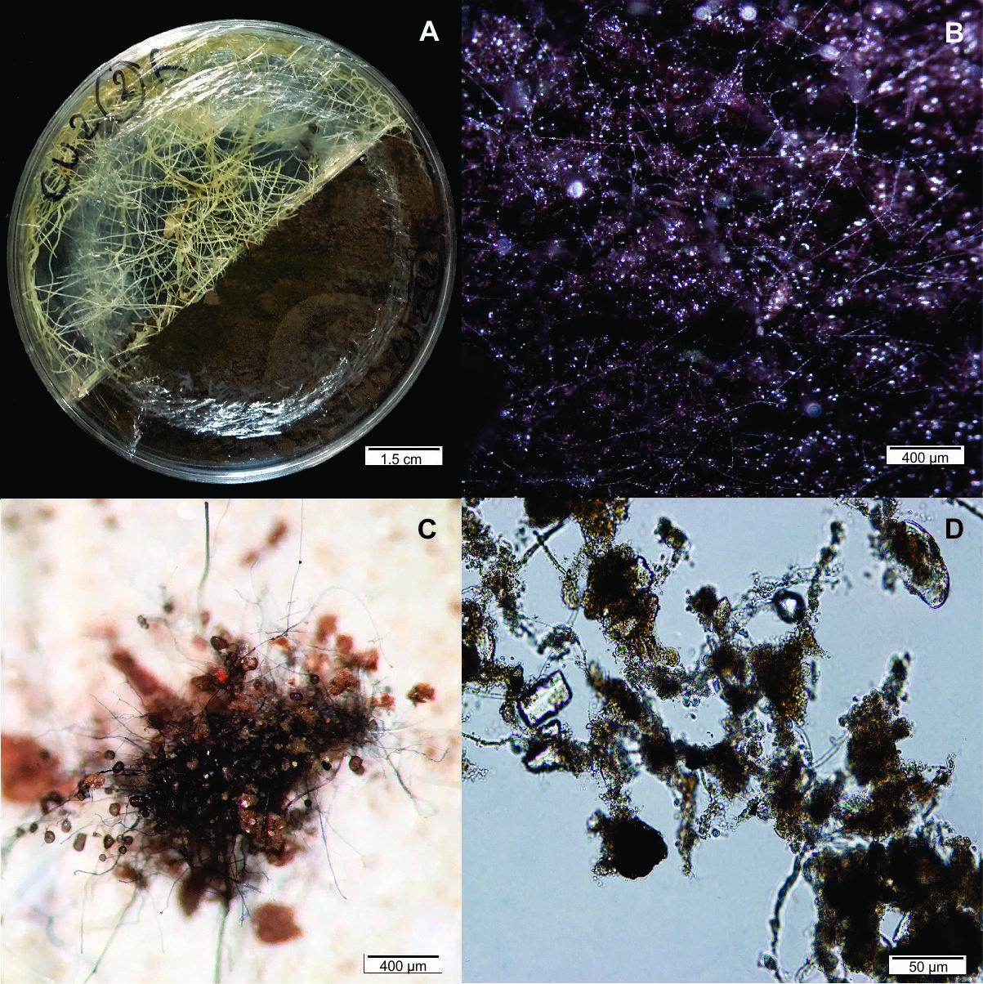
Figure 2. Hyphal length and spore number of Rhizophagus intraradices GC3 in the root compartment (RC; a, c) and in the hyphal compartment with soil (HC; b, d) at three Cu doses. Large symbols, geometric means; bars, 95% CI (n = 2–3); small symbols, individual plates. Note the logarithmic axes. In b and d, non-inoculated plates show background. Labels give the ratio relative to Cu0 in GC3 (log-normal models; ⁎P < 0.05, ⁎⁎⁎P < 0.001).
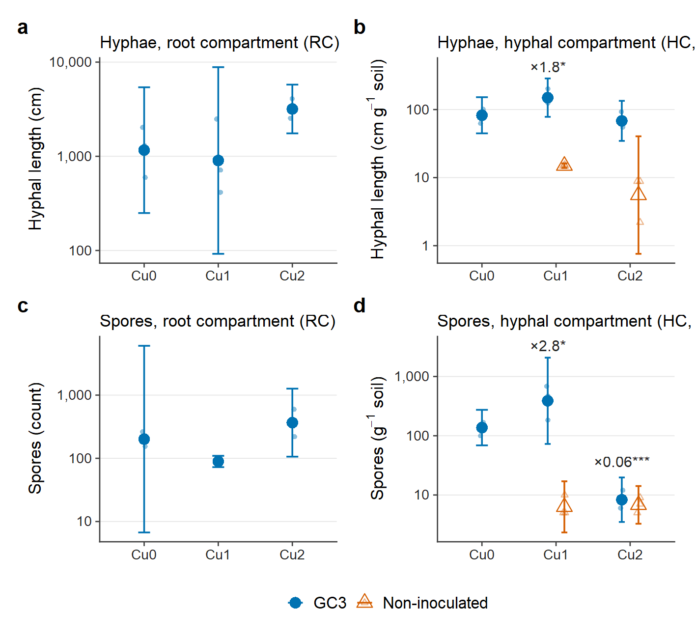
Figure 3. Total (T-GRSP; a, b) and easily extractable (EE-GRSP; c, d) glomalin-related soil protein in the in vitro hyphal compartment (a, c) and in pot soil in vivo (b, d). Large symbols, arithmetic means; bars, 95% CI (n = 2–4); small symbols, individual units. Asterisks mark GC3 vs non-inoculated contrasts within each dose, without multiplicity adjustment (⁎P < 0.05, ⁎⁎P < 0.01, ⁎⁎⁎P < 0.001). Y axes differ among panels, and values cannot be compared between systems.
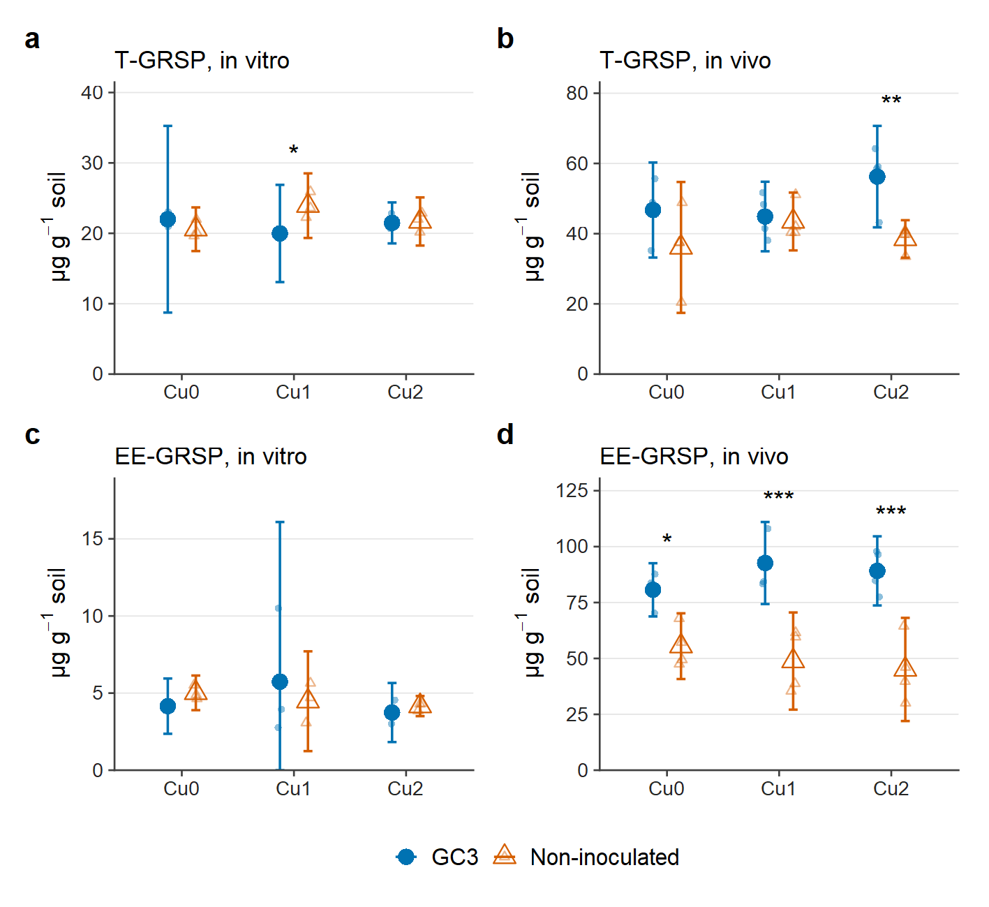
Figure 4. Copper measured by X-ray fluorescence in soil in vitro (a), soil in vivo (b), roots (c) and shoots (d). Large symbols, arithmetic means; bars, 95% CI (n = 3–4; only the mean value is shown where n < 2); small symbols, individual units. Y axes differ among panels.
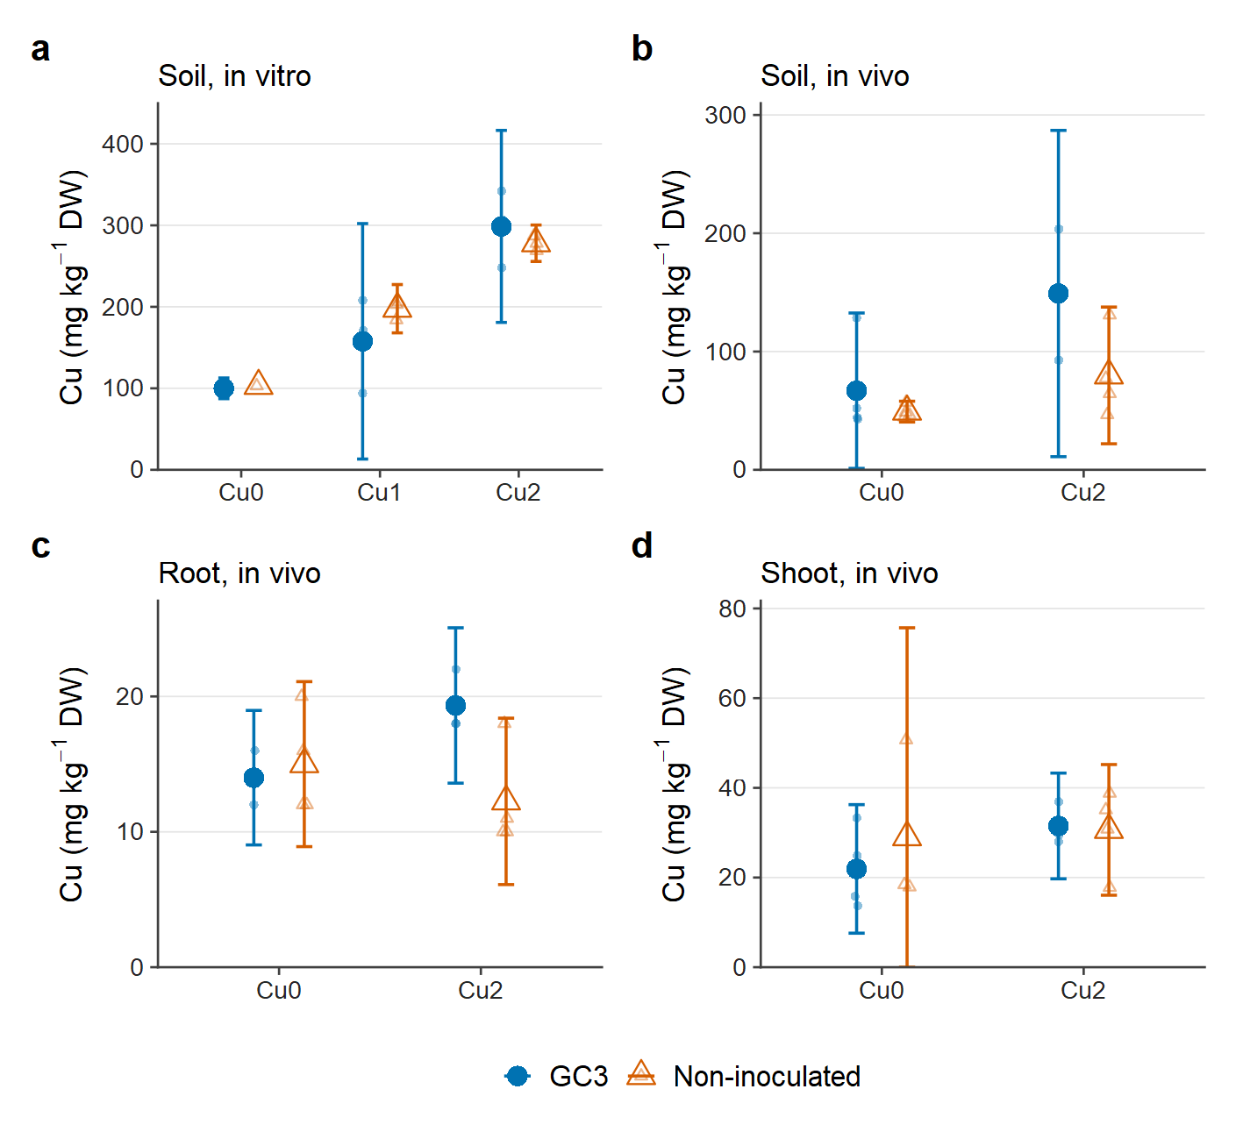
Figure 5. Unit-free comparison of the in vitro and in vivo systems. a Effect of Cu (Cu2/Cu0) in inoculated cultures. b Effect of inoculation (GC3/non-inoculated) on GRSP within each dose. Symbols, ratios of means; bars, 95% CI; note the logarithmic axes. A ratio of 1 indicates no effect.
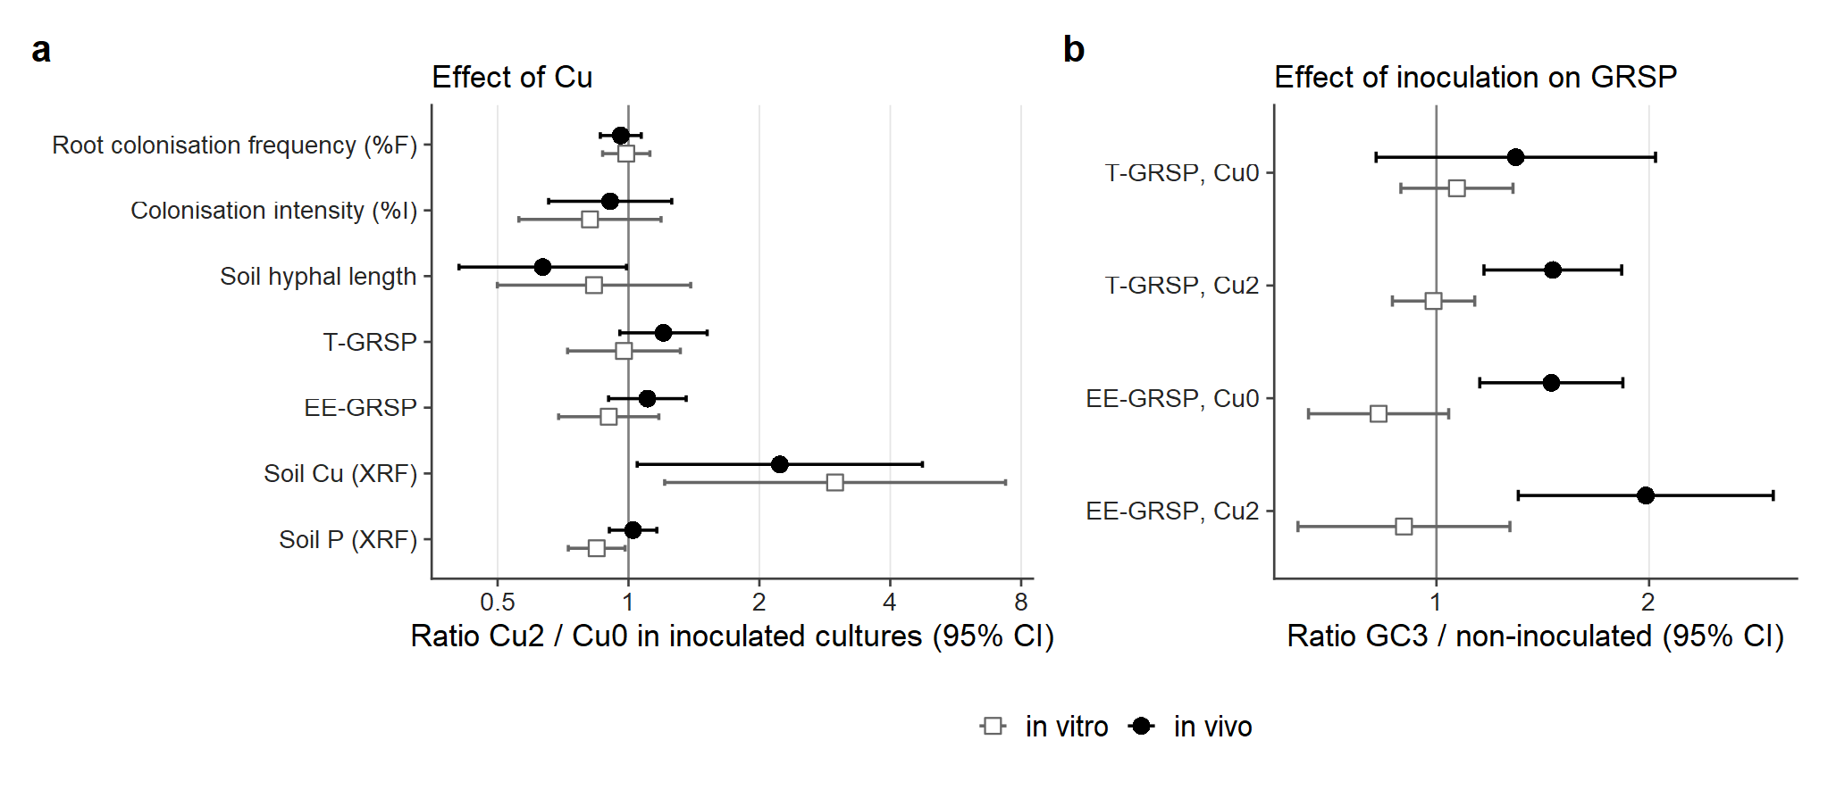
Supplementary material
Table S1. DRAFT, NOT FOR SUBMISSION. Mean tissue P (mg kg⁻¹) as recorded in the spreadsheet and under the hypothesis, to be verified, that values below 200 lost one order of magnitude during transcription.
Treatment | Shoot, recorded | Shoot, hypothesis | Root, recorded | Root, hypothesis | n (shoot/root)
NI-Cu0 | 502 | 814 | 242 | 1144 | 3/4
NI-Cu2 | 554 | 849 | 632 | 924 | 4/4
GC3-Cu0 | 307 | 1078 | 147 | 1467 | 4/3
GC3-Cu2 | 405 | 1074 | 714 | 714 | 3/3
Delete this table once the original XRF values have been verified.

