Understanding the role of arbuscular mycorrhizal fungi in copper immobilization: a multi-methodological approach
[Authors]
¹Laboratorio de Microbiología del Suelo, Instituto de Biodiversidad y Biología Experimental y Aplicada, CONICET-UBA, Facultad de Ciencias Exactas y Naturales, Universidad de Buenos Aires, Ciudad Universitaria, 4to piso, Pabellón 2, 1428 Buenos Aires, Argentina.
²Gerencia Investigación y Aplicaciones, Centro Atómico Constituyentes, Comisión Nacional de Energía Atómica, Av. Gral. Paz 1499, B1650KNA San Martín, Buenos Aires, Argentina.
³Gerencia Química, Laboratorio de Fluorescencia de Rayos X, Centro Atómico Constituyentes, Comisión Nacional de Energía Atómica, Av. Gral. Paz 1499, B1650KNA San Martín, Buenos Aires, Argentina.
⁴International Center for Earth Sciences, Comisión Nacional de Energía Atómica, Complejo Minero Fabril San Rafael, San Rafael, Mendoza, Argentina.
Corresponding author: vanesasilvani@gmail.com; Tel. +54 11 5285 8598

Abstract
Copper is a trace element, considered an inorganic contaminant when found at high concentrations. This work aimed to study the role of the arbuscular mycorrhizal (AM) fungus Rhizophagus intraradices (GC3 strain) in the immobilization of Cu, through in vitro (bi-compartmental Petri plates with root organ culture) and in vivo (sunflower greenhouse experiment) assays. We used X-ray fluorescence (XRF) and micro-particle-induced X-ray emission (microPIXE) to understand Cu distribution in fungal structures, and we measured glomalin-related soil protein (GRSP) production and its relation with soil aggregation at different Cu concentrations. GRSP production by GC3 increased with the Cu concentration. This response to the presence of the pollutant makes R. intraradices strain GC3 a good candidate for future bioremediation projects.
Keywords: trace element; copper; Rhizophagus intraradices; soil aggregation; glomalin

Introduction
Copper (Cu) is a trace element (TE) essential for humans, animals, plants and microorganisms; it participates in various morphological, physiological and biochemical processes. Usually, 5–30 mg kg⁻¹ of Cu in crop tissues is regarded as adequate (Adriano 2001). Cu also meets the definition of a heavy metal (HM) according to its density (8.96 g cm⁻³) and atomic number (29) (Linder and Hazegh-Azam 1996). The edaphic content of Cu depends on complex interactions among parent material, physico-chemical properties and exogenous inputs from agriculture or industry (Ballabio et al. 2018). Excess Cu in soil can be toxic for plants; however, soil P availability seems to insolubilize Cu, improve plant nutrition and mitigate the negative effects of Cu toxicity (Baldi et al. 2018). Soil contamination by Cu arises from multiple sources, including fertilizer production, mining, excessive application of pesticides and fungicides, industrial processes and irrigation with wastewater, among others (Bremner 1998; Liu and Beckerman 2022). Because HMs are non-biodegradable and extensively used, they tend to accumulate in the environment, posing significant toxic and carcinogenic risks to human health (Collins et al. 2014; Wang 2023; Jeremias et al. 2023; Alshammari et al. 2023).
Unlike organic compounds, they require techniques that involve the immobilization, transformation and/or removal of the contaminant to ensure successful soil restoration and remediation. Many of the existing engineering technologies are highly expensive, and soil-disturbing practices hinder the treatment of large areas (Lasat 2002). Phytoremediation is an alternative that overcomes these limitations by taking advantage of plant responses to inorganic pollutants. Plants used for phytoextraction of HMs are hyperaccumulators and have large biomass, such as sunflower (Helianthus annuus) (Sytar et al. 2021). It is an indicator plant, and its morphological characteristics depend on various ecological factors, including HM exposure (Murillo et al. 1999; Khalilvand-Behrouzyar et al. 2007). The hyperaccumulating capacity of these plant species can be enhanced by mutualistic association with AM fungi (phylum Glomeromycota) (Schüßler et al. 2001). These root symbionts improve nutritional status and promote growth through an extensive extraradical mycelium (ERM). The ERM acts as a prolongation of roots, allowing better exploration of soil and increasing uptake of water and nutrients, mainly phosphates and micronutrients (Parniske 2008); it also contributes to the formation and stabilization of soil aggregates (Rillig and Mummey 2006).
AM fungi can capture and adsorb HMs in soil within fungal structures and alleviate the toxicity of these elements for plants (Hildebrandt et al. 2007; Janeeshma and Puthur 2020; Son et al. 2024). They synthesize glomalin-related soil protein (GRSP), a recalcitrant glycoprotein related to long-term carbon sequestration, soil aggregation, soil remediation and soil fertility. Their hyphal walls form complexes with potentially toxic elements and inactivate them in the mycorrhizosphere (Rillig 2004; Nichols and Wright 2006; González-Chávez et al. 2004). Statello et al. (2024) have demonstrated that GRSP from polluted soils sequesters and stabilizes HM ions, thus reducing their bioavailability and toxicity for microorganisms and plants. Cornejo et al. (2013) suggested that a fungal strategy to survive in Cu-polluted environments is to compartmentalize excess Cu in spores, and Statello et al. (2024), using microPIXE in structures of the Rhizophagus intraradices GC3 strain associated with Ri T-DNA carrot roots, showed significant Cu accumulation, suggesting a potential mechanism of toxicity alleviation in the host plant.
Nowadays, various HM detection techniques allow a better understanding of the uptake, translocation and localization of HMs in biological matrices, including mycorrhizal roots and fungal structures. In particular, microPIXE and XRF are adequate technologies for the qualitative and quantitative analysis of material composition (Custo et al. 2005; de la Fournière et al. 2019). Thus, the aim of this work was to investigate the uptake, translocation and localization of Cu and P in mycorrhizal sunflower plants and fungal structures under different culture conditions using both detection technologies, and how copper stress affects GRSP production by the studied strain.

Materials and methods

Arbuscular mycorrhizal inoculum and plant material
The AM fungus Rhizophagus intraradices (N.C. Schenck & G.S. Sm.) C. Walker & A. Schüßler (GC3 strain) was studied using different growing systems: in vivo, using sunflower (Helianthus annuus L. var. Mammoth Russian; [seed size]) as host because it is considered a model plant (Castañón-Silva et al. 2013; Francis and Ndukwn 2019; Scotti et al. 2019), and in vitro, an axenic system using Ri T-DNA transformed carrot roots (TCR; Silvani et al. 2019). The R. intraradices strain was provided by the Banco de Glomeromycota In Vitro (BGIV, www.bgiv.com.ar) and replicated in association with TCR in solid Minimal Medium (MM; Bécard and Fortin 1988).

In vivo assay
Sunflower seeds were surface-sterilized with 70% (v/v) ethanol for 20 min and 20% (v/v) sodium hypochlorite plus Tween 20 (0.1%) for 30 min, rinsed with sterile distilled water and placed on moist filter paper (Whatman #1, Maidstone, UK) at 25 °C in the dark for 4 days. Three germinated seeds were sown in 1.5-L pots with tyndallized soil (see Annex 1). Three days after emergence, two of the three seedlings were removed, selecting a homogeneous set of plants, and inoculation with GC3 (where appropriate) was immediately carried out by placing a 1-cm³ plug of 4-month-old monoxenic culture (containing mycelium, spores and fragments of colonized roots). Non-mycorrhizal control plants received a 1-cm³ plug of MM with TCR only.
Pots were watered by capillarity with deionized water and fertilized every 15 days with 100 mL of Hewitt solution without phosphorus (Hewitt 1952). After thirty days, the soil in each pot was amended with 420 mL of CuSO₄ solution (Cu1: 150 mg L⁻¹; Cu2: 300 mg L⁻¹) or 420 mL of sterile deionized water (Cu0). The experiment used a randomized design in a greenhouse with natural light and temperature for three months. Twenty-four experimental units were divided into six treatments (n = 4): GC3-Cu0, GC3-Cu1, GC3-Cu2, W/I-Cu0, W/I-Cu1 and W/I-Cu2, where W/I denotes plants without AM fungal inoculation.

In vitro assay using transformed carrot roots as a model
The in vitro assay was performed as described in Silvani et al. (2019), using two-segmented plates to separate a root compartment (RC) from a hyphal compartment (HC; St-Arnaud et al. 1996). The RC was filled with 30 mL of MM and a non-mycorrhizal TCR fragment (5 cm long) and was inoculated with a plug of 4-month-old monoxenic culture containing approximately 200 spores, mycelium and colonized roots of R. intraradices GC3. The HC was filled with 30 mL of sterile dry soil (the same as above) and homogeneously amended with 4 mL of filter-sterilized (Millipore, 0.2 µm pore size) CuSO₄ solution (Cu1: 150 mg L⁻¹; Cu2: 300 mg L⁻¹) or 4 mL of sterile deionized water (Cu0). The Cu1 concentration corresponded to values recorded in soil samples from the Riachuelo basin (Avellaneda, Buenos Aires, 34° 39′ 27.36″ S, 58° 22′ 34.37″ W; Colombo et al. 2020). Non-mycorrhizal cultures (W/I) [were inoculated? prepared?] with a root fragment (5 cm long) placed in the RC. Three replicates were prepared for each treatment and incubated in the dark at 25 °C. To assess growth of carrot roots in the RC, root length was measured in five randomly selected 1-cm² squares using the formula of Newman (1966).

Harvest
At the end of the in vivo experiment (130 days), shoots and roots were harvested separately. Dry weight of shoots and roots was recorded after 48 h of oven-drying at 70 °C. Subsamples of air-dried roots were stained to determine AM fungal root colonization, and Cu concentrations were quantified in shoot and root dry mass. [In vitro harvest: complete.]

Estimation of soil aggregation by AM inoculation
At harvest, a portion of the root system was dried for 48 h at 25 °C. The quantity of soil adhering to roots after inoculation was assessed according to Graham et al. (1982). Roots were vigorously shaken to remove soil not firmly attached, and the remaining particles were removed by soaking in distilled water. Washed roots were weighed fresh and dry, and the soil suspension was decanted and dried to constant weight [temperature]. The amount of soil was expressed as grams of dry soil per gram of fresh root.

ERM length and spore number
One gram of dry rhizospheric soil was sampled from each pot and from the HC. Samples were placed in Erlenmeyer flasks with 100 mL of 0.002% trypan blue and vigorously shaken for 10 min. Aliquots of the soil suspension were poured into a 9-cm Petri dish with a 1-cm² counting grid. Intersections of blue-stained AM fungal hyphae with grid lines were quantified using the formula of Newman (1966) to determine centimetres of ERM per gram of dry soil. ERM length in the RC was assessed by counting five randomly selected 1-cm² squares and applying the same calculation. Spore production in the RC was estimated by adding the spores counted in five randomly located 1-cm² squares in each plate.

AM root colonization
Roots from in vivo (130 days) and in vitro (120 days) assays were collected to measure AM colonization. Samples were cleared (10% w/v KOH, 90 °C, 15 min), acidified with 0.1 N HCl (5 min) and stained with trypan blue in lactic acid (0.02% w/v; 90 °C, 10 min; modified from Phillips and Hayman 1970). The frequency (%F) and intensity (%I) of colonization were measured according to Declerck et al. (2004). Fifty randomly selected root pieces were mounted on microscope slides in groups of 10 and examined under a Nikon Optiphot-2 microscope at 400×; arbuscules (%A), vesicles (%V) and intraradical spores (%IS) were recorded. The number of newly formed spores per gram of dry soil was counted under a stereomicroscope (Olympus SZ61) at 4.5×.

Glomalin-related soil protein (GRSP) analysis
GRSP was determined according to Cornejo et al. (2008). Easily extractable GRSP (EE-GRSP) was extracted from 1 g of dry soil with 8 mL of 20 mM citrate (pH 7.0) and autoclaved at 121 °C for 30 min. Total GRSP (T-GRSP) was obtained by repeated extractions from 1 g of dry soil with 8 mL of 50 mM citrate buffer (pH 8.0) and autoclaved at 121 °C for 60 min. In both cases, after cooling to 4 °C, the supernatant was separated by centrifugation (3000 rpm, 15 min). For T-GRSP, extractions were repeated five times on the same sample until the reddish-brown colour disappeared from the supernatants. Extracts from each cycle were pooled, centrifuged at 10,000 rpm for 10 min and analysed. Protein content in the supernatant was determined by the Bradford method (Sigma-Aldrich Inc.) with bovine serum albumin as the standard.

Chemical element localization and quantification
MicroPIXE was employed to analyse the elemental composition of TCR and AM fungal structures in the in vitro assay. Analyses were conducted at CAC-CNEA following de la Fournière et al. (2019). Transverse root sections, 10 µm thick, were prepared using a cryo-microtome at −20 °C and transferred onto ultrapure polypropylene films with acrylic-glass target frames, where they were preserved until irradiation. To identify AM fungal colonization and relate it to elemental distributions, contiguous sections were stained with trypan blue (0.02% v/v) and observed at 400×. External spores and hyphae from the HC were isolated under a microscope and rinsed with Milli-Q water to remove soil particles; fungal vesicles were extracted from the TCR. All AM fungal structures were maintained in Milli-Q water, transferred to ultrapure polypropylene with acrylic-glass frames, dried and preserved until irradiation with a 50 MeV ¹⁶O⁵⁺ ion beam focused to a spot size below 5 µm, scanning over a 256 × 256 pixel matrix. Spectra were analysed with OMDAQ-2007 by calculating the peak area using a Gaussian fit or the sum of counts per channel under the peak.
P and Cu concentrations in sunflower plants and soil samples from both assays were determined by XRF. Soil samples were dried at 70 °C for 48 h, milled and sieved through an 850-µm mesh to obtain a fine, homogeneous powder. Plant material (shoots and roots) was ground and sieved through the same mesh. The powder was pressed into pellets using a die and hydraulic press and immediately analysed according to the protocol of the Laboratorio de Fluorescencia de Rayos X, CAC-CNEA (Custo et al. 2005). The bioconcentration factor was calculated as the element concentration in shoot or root divided by its concentration in the substrate (BCF > 1 indicates potential bioaccumulation), and the translocation factor as the concentration in shoot divided by the concentration in root (TF > 1 indicates an ability to translocate the element from roots to shoots, primarily responsible for phytoextraction; Scotti et al. 2019).

Data analysis
Analyses were performed in R 4.6.1 (R Core Team 2026). Responses were analysed with generalized linear models (Gamma distribution, log link). Variables measured in inoculated and W/I units were analysed with inoculation, Cu level and their interaction as factors, using type II F tests (Fox and Weisberg 2019); GC3 and W/I were compared within each Cu level from estimated marginal means (Lenth 2025). Variables measured only in inoculated units were analysed with Cu level as the factor, followed by pairwise Tukey comparisons. Model fit was checked with simulated residuals (Hartig 2025). Correlations among variables were calculated as Pearson coefficients on complete cases. Significance was set at P < 0.05. Values are shown as mean ± standard error (SE).

Results

In vitro assay
The AM fungus R. intraradices strain GC3 developed in both RC and HC when exposed to Cu-contaminated soil (Figs. 1, 2). Hyphal length in the HC ranged from 70.0 ± 11.6 to 153.3 ± 24.5 cm g⁻¹ and was higher in Cu1 than in Cu2 (P = 0.026), whereas Cu did not significantly affect hyphal length in the RC (P = 0.173; Fig. 2A, B). Spores in the HC differed among all Cu levels (141 ± 21, 445 ± 145 and 9 ± 2 g⁻¹ in Cu0, Cu1 and Cu2; P < 0.001), and spores in the RC were more numerous in Cu2 than in Cu1 (397 ± 109 vs 89 ± 4; P = 0.008; Fig. 2C, D; Table S1). Cu2 mycelium showed particle agglomeration, unlike mycelium without Cu (Fig. 1D). Transformed root length ranged from 402 to 688 cm, with no significant differences among Cu levels (P = 0.536; Table S1).
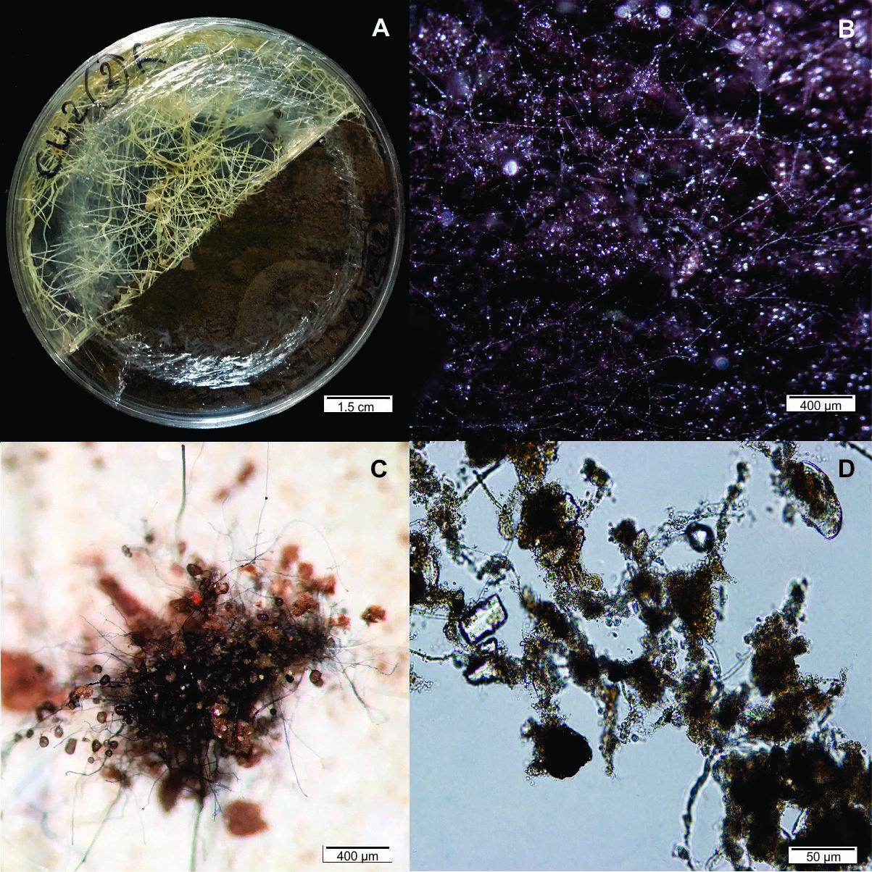
Figure 1. In vitro system with Rhizophagus intraradices GC3 and Ri T-DNA carrot roots. A Bi-compartmental Petri plate. B Mycelium growing in Cu1-treated soil. C Spores from Cu1. D Soil attached to the mycelium in Cu2. Scale bars: A, 1.5 cm; B and C, 400 µm; D, 50 µm.
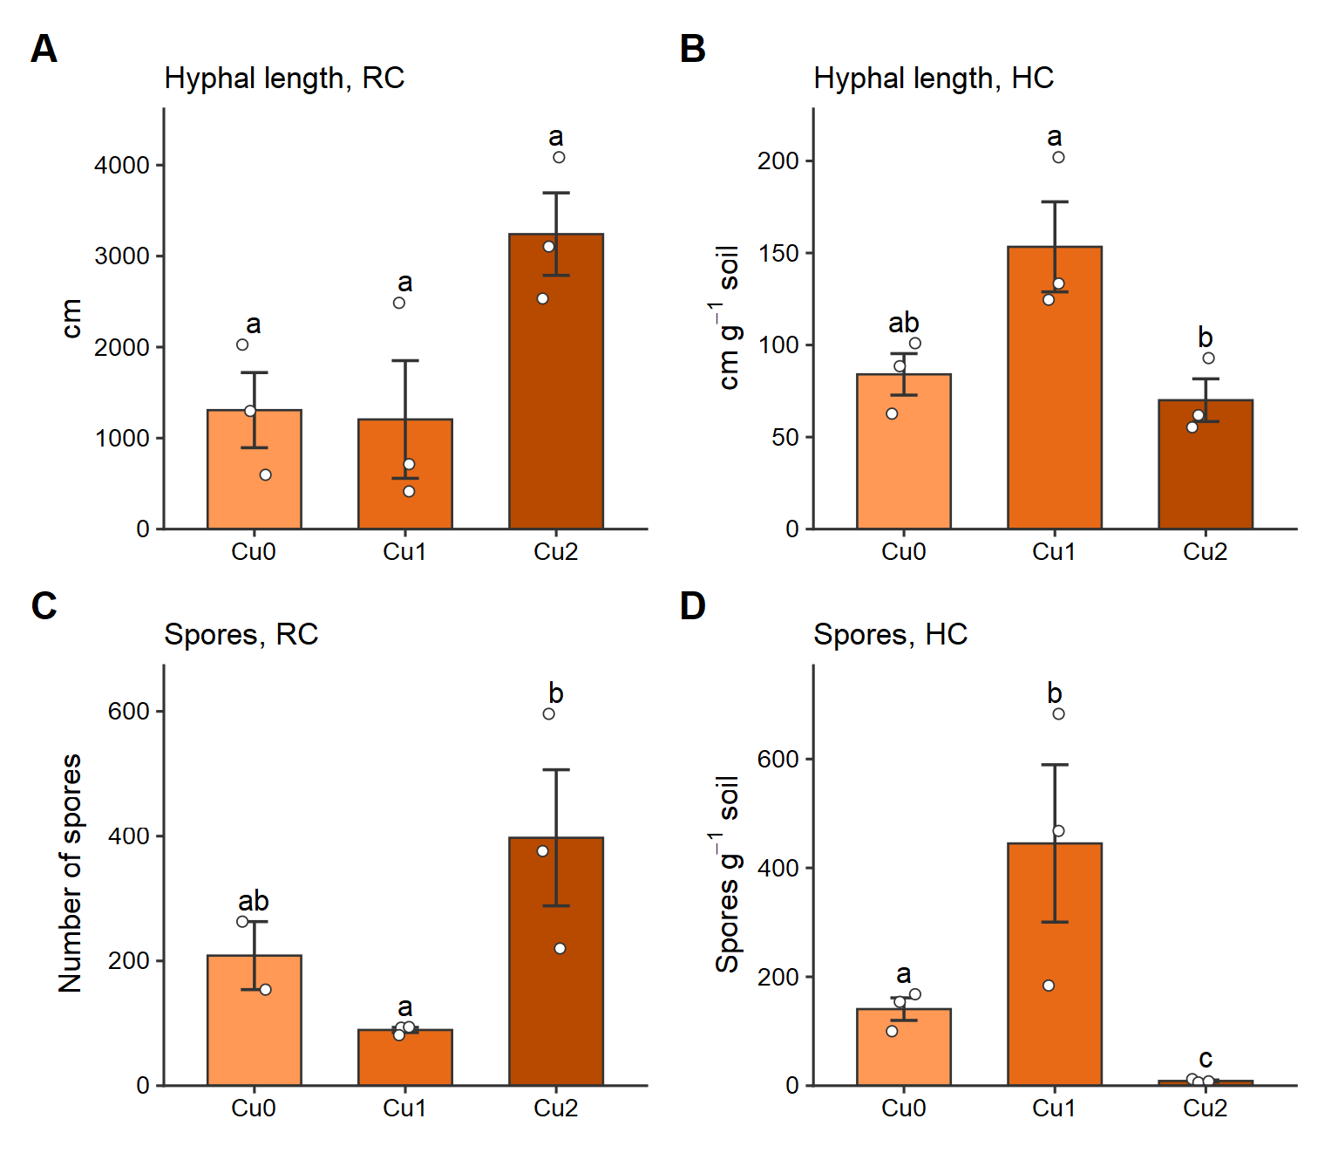
Figure 2. Hyphal length (A, B) and spore number (C, D) of Rhizophagus intraradices GC3 in the root compartment (RC) and the hyphal compartment with soil (HC) of the in vitro system after three months. Bars are means ± SE; circles are individual replicates. Orange, GC3 in vitro; grey, W/I; darker shades indicate higher Cu levels. Different letters indicate significant differences among Cu levels (Tukey, P < 0.05). Cu0: no added Cu; Cu1: 150 mg L⁻¹ CuSO₄ solution; Cu2: 300 mg L⁻¹ CuSO₄ solution.
Colonization of transformed carrot roots ranged between 83.7 ± 1.6 and 91.1 ± 2.2% (%F) and between 40.5 ± 4.2 and 49.6 ± 4.7% (%I), with arbuscules between 59.5 ± 26.6 and 74.2 ± 3.7%. There were no significant differences among Cu levels in any colonization parameter, although vesicles (59.1, 28.2 and 36.3%) and intraradical spores (80.7, 34.4 and 57.1%) tended to be less abundant with Cu (Fig. 3).
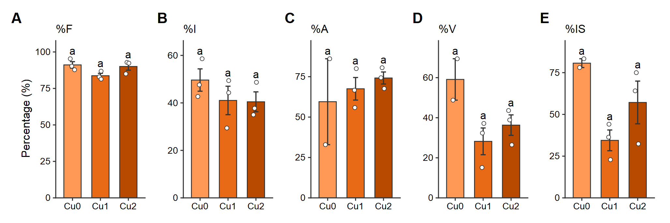
Figure 3. Arbuscular mycorrhizal colonization of transformed carrot roots by Rhizophagus intraradices GC3 in the in vitro system after three months. %F, frequency (A); %I, intensity (B); %A, arbuscules (C); %V, vesicles (D); %IS, intraradical spores (E). Bars are means ± SE; circles are individual replicates. Orange, GC3 in vitro; grey, W/I; darker shades indicate higher Cu levels. Different letters indicate significant differences among Cu levels (Tukey, P < 0.05). Cu0: no added Cu; Cu1: 150 mg L⁻¹ CuSO₄ solution; Cu2: 300 mg L⁻¹ CuSO₄ solution.

In vivo assay
[State why elemental analyses were not performed for the intermediate Cu level.] Growth of sunflower plants was not affected by the Cu solution: there were no significant differences in dry weight of shoots and roots (Table 1) or in stem length (data not shown). Nor were there differences between inoculated and non-inoculated plants in dry biomass. Soil aggregation values are shown in Table 1.
Table 1. Shoot, root and total dry weight (DW), shoot:root ratio, root colonization and soil aggregation of sunflower plants after three months, with and without Cu.
Treatment | Root DW (g) | Shoot DW (g) | Total DW (g) | Shoot:root | %F | %I | Soil aggregation (g g⁻¹)
GC3-Cu0 | 0.75 ± 0.08 | 9.37 ± 1.04 | 10.12 ± 1.10 | 12.5 ± 1.0 | 79.8 ± 3.6 | 22.0 ± 3.1 | 330 ± 69
W/I-Cu0 | 0.99 ± 0.05 | 11.15 ± 0.71 | 12.14 ± 0.76 | 11.2 ± 0.3 | — | — | 332 ± 62
GC3-Cu1 | 0.76 ± 0.12 | 10.69 ± 0.61 | 11.44 ± 0.60 | 15.3 ± 2.9 | 77.8 ± 10.8 | 17.6 ± 5.4 | 355 ± 103
W/I-Cu1 | 0.56 ± 0.10 | 8.89 ± 1.48 | 9.46 ± 1.53 | 16.3 ± 2.4 | — | — | 473 ± 109
GC3-Cu2 | 0.67 ± 0.04 | 11.44 ± 0.26 | 12.11 ± 0.26 | 17.4 ± 1.1 | 76.6 ± 2.7 | 20.0 ± 1.5 | 550 ± 45
W/I-Cu2 | 0.80 ± 0.14 | 10.55 ± 1.36 | 11.36 ± 1.49 | 13.6 ± 1.3 | — | — | 369 ± 76
P Inoculation | 0.607 | 0.727 | 0.775 | 0.308 | — | — | 0.843
P Cu | 0.146 | 0.536 | 0.532 | 0.040 | 0.945 | 0.742 | 0.319
P Inoc. × Cu | 0.087 | 0.234 | 0.205 | 0.428 | — | — | 0.289
Values are means ± SE (n = 4). W/I, plants without AM fungal inoculation. Soil aggregation, g dry soil g⁻¹ fresh root. P values from Gamma models; for %F and %I, effect of Cu in GC3. Cu0: no added Cu; Cu1: 150 mg L⁻¹ CuSO₄ solution; Cu2: 300 mg L⁻¹ CuSO₄ solution.
Cu concentration did not significantly affect hyphal length (P = 0.308; Fig. 4C), although there was a tendency to decrease with Cu: 80.3 ± 11.1 cm g⁻¹ without Cu and 51.0 ± 7.9 cm g⁻¹ with the highest dose. No AM fungal hyphae were detected in the controls. No sporulation occurred in the in vivo assay after three months of growth; extraradical spores were not detected in any treatment. The level of Cu did not affect root colonization: frequency ranged from 76.6 ± 2.7 to 79.8 ± 3.6%, and intensity from 17.6 ± 5.4 to 22.0 ± 3.1% (Table 1, Fig. 4).
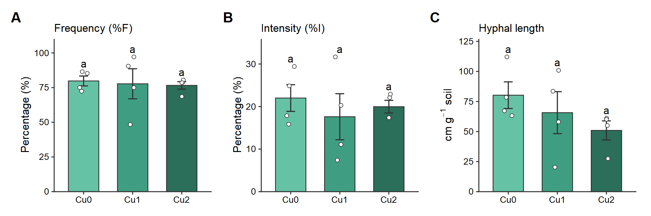
Figure 4. Frequency (A) and intensity (B) of root colonization and hyphal length in soil (C) of sunflower inoculated with Rhizophagus intraradices GC3 after three months. Bars are means ± SE; circles are individual replicates. Green, GC3 in vivo; grey, W/I; darker shades indicate higher Cu levels. Different letters indicate significant differences among Cu levels (Tukey, P < 0.05). Cu0: no added Cu; Cu1: 150 mg L⁻¹ CuSO₄ solution; Cu2: 300 mg L⁻¹ CuSO₄ solution.

GRSP production
A higher concentration of EE-GRSP was recorded in plants inoculated with GC3 than in non-inoculated plants at all Cu levels, whereas Cu did not significantly affect EE-GRSP values (inoculation: P < 0.001; Cu: P = 0.809; Fig. 5B). Means ranged from 80.7 ± 3.7 to 92.7 ± 5.8 µg g⁻¹ soil in inoculated plants and from 45.1 ± 7.2 to 55.5 ± 4.6 µg g⁻¹ in non-inoculated plants. T-GRSP was also higher in inoculated plants (P = 0.009), but the comparison within Cu levels was significant only at the highest dose (56.3 ± 4.5 vs 38.5 ± 1.7 µg g⁻¹; P = 0.010; Fig. 5A). T-GRSP means varied between 44.9 ± 3.1 and 56.3 ± 4.5 µg g⁻¹ in inoculated plants and between 36.1 ± 5.9 and 43.5 ± 2.6 µg g⁻¹ in non-inoculated plants.
In the Cu-free in vitro culture after 10 months, T-GRSP was 58.4 ± 3.1 µg g⁻¹ in GC3 and 65.3 ± 3.7 µg g⁻¹ in W/I, and EE-GRSP was 74.5 ± 1.9 and 88.2 ± 6.6 µg g⁻¹, with no significant differences (P = 0.198 and 0.077; insets in Fig. 5A, B). In the in vitro assay with Cu, T-GRSP (20–24 µg g⁻¹) and EE-GRSP (4–6 µg g⁻¹ as means) did not differ with inoculation (P = 0.265 and 0.990) or Cu (P = 0.438 and 0.465), although T-GRSP was lower in GC3 than in W/I in Cu1 (P = 0.010; Fig. 5C, D).
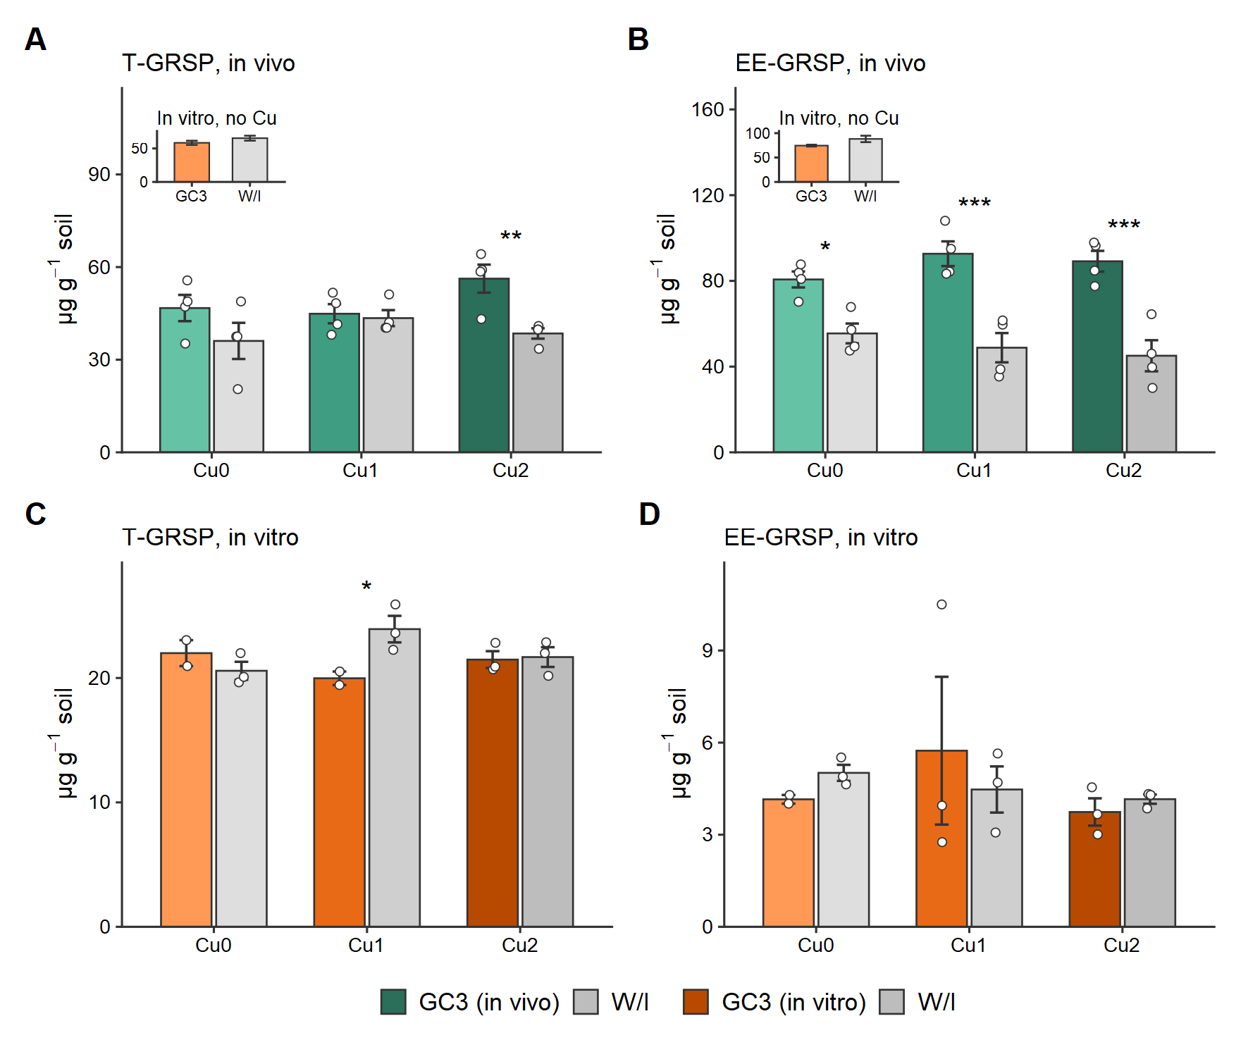
Figure 5. Total (T-GRSP; A, C) and easily extractable (EE-GRSP; B, D) glomalin-related soil protein in vivo (A, B) and in the in vitro assay with Cu (C, D). Insets in A and B: in vitro culture without Cu after 10 months. Bars are means ± SE; circles are individual replicates. Green, GC3 in vivo; orange, GC3 in vitro; grey, W/I; darker shades indicate higher Cu levels. Asterisks mark differences between GC3 and W/I within each Cu level (P < 0.05 ⁎, < 0.01 ⁎⁎, < 0.001 ⁎⁎⁎); no mark, not significant. Cu0: no added Cu; Cu1: 150 mg L⁻¹ CuSO₄ solution; Cu2: 300 mg L⁻¹ CuSO₄ solution. W/I, without AM fungal inoculation.
Soil adhered to roots did not vary significantly among treatments (P ≥ 0.289; Table 1, Fig. 6).
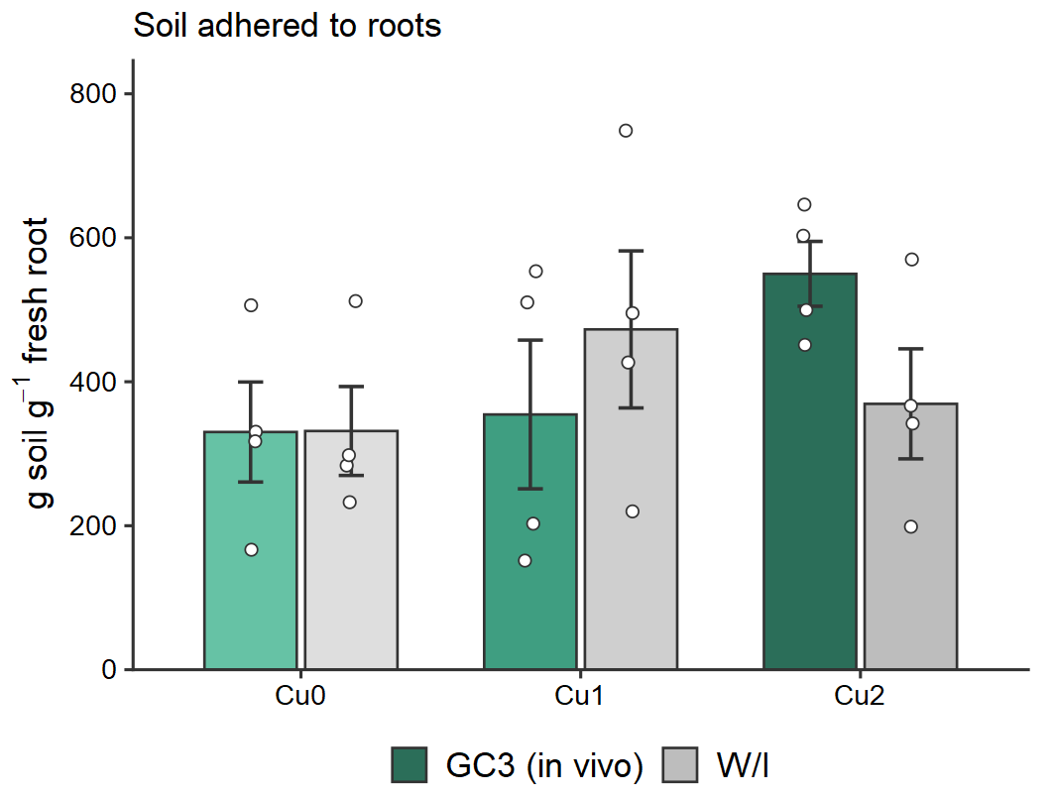
Figure 6. Soil adhered to sunflower roots inoculated with Rhizophagus intraradices GC3 or not inoculated (W/I). Bars are means ± SE; circles are individual replicates. Green, GC3 in vivo; grey, W/I; darker shades indicate higher Cu levels. No significant differences between GC3 and W/I within Cu levels. Cu0: no added Cu; Cu1: 150 mg L⁻¹ CuSO₄ solution; Cu2: 300 mg L⁻¹ CuSO₄ solution.

Element detection
In the in vitro assay, soil Cu increased with Cu dose (P < 0.001), with no effect of inoculation, and total P was lower in inoculated soil (P = 0.044; Table 2). Figure 7 shows the spectra and Figure 8 the 2D X-ray maps. Copper values in the observed ERM and intraradical vesicle sections were 26.64 and 33.75 mg kg⁻¹, respectively, in Cu2. In non-colonized Cu2 roots the value was 128.53 mg kg⁻¹, and no Cu was recorded in mycorrhizal Cu2 roots (Table S2). The 2D maps (Fig. 8) show P distributed in ERM, roots and intraradical vesicles of colonized roots, whereas Cu was located only in the area of the vesicles. Some higher-concentration points were distributed in the area that would delimit the vesicles, but a cloud of points with no defined distribution was seen in the mycelium area. Correlations among in vitro variables are shown in Fig. 9.
Table 2. Total P and Cu (mg kg⁻¹) in soil from the hyphal compartment of the in vitro system with Rhizophagus intraradices GC3 after three months.
Treatment | Total P | Total Cu
GC3-Cu0 | 430 ± 20 | 100 ± 1
W/I-Cu0 | 410† | 103†
GC3-Cu2 | 363 ± 27 | 299 ± 27
W/I-Cu2 | 413 ± 3 | 278 ± 5
P Inoculation | 0.044 | 0.505
P Cu | 0.065 | <0.001
P Inoc. × Cu | 0.317 | 0.212
Values are means ± SE (n = 2–3). †Single value (n = 1), without SE. W/I, roots not inoculated with AM fungi. P values from Gamma models including Cu1. Cu0: no added Cu; Cu2: 300 mg L⁻¹ CuSO₄ solution.
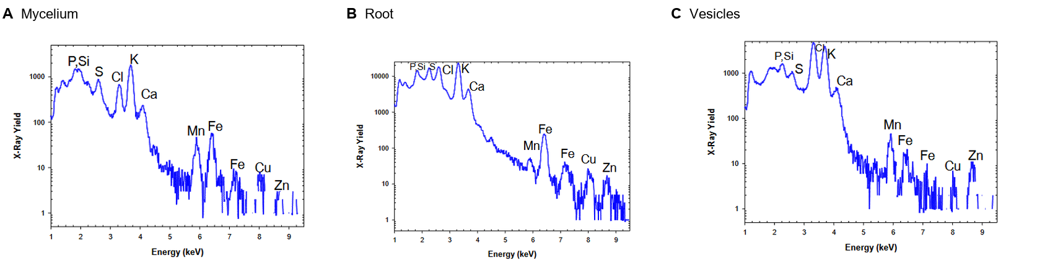
Figure 7. MicroPIXE spectra of irradiated AM fungal mycelium (A), carrot root cross-section (B) and intraradical AM fungal vesicles (C), exposed to Cu2 in the in vitro assay.
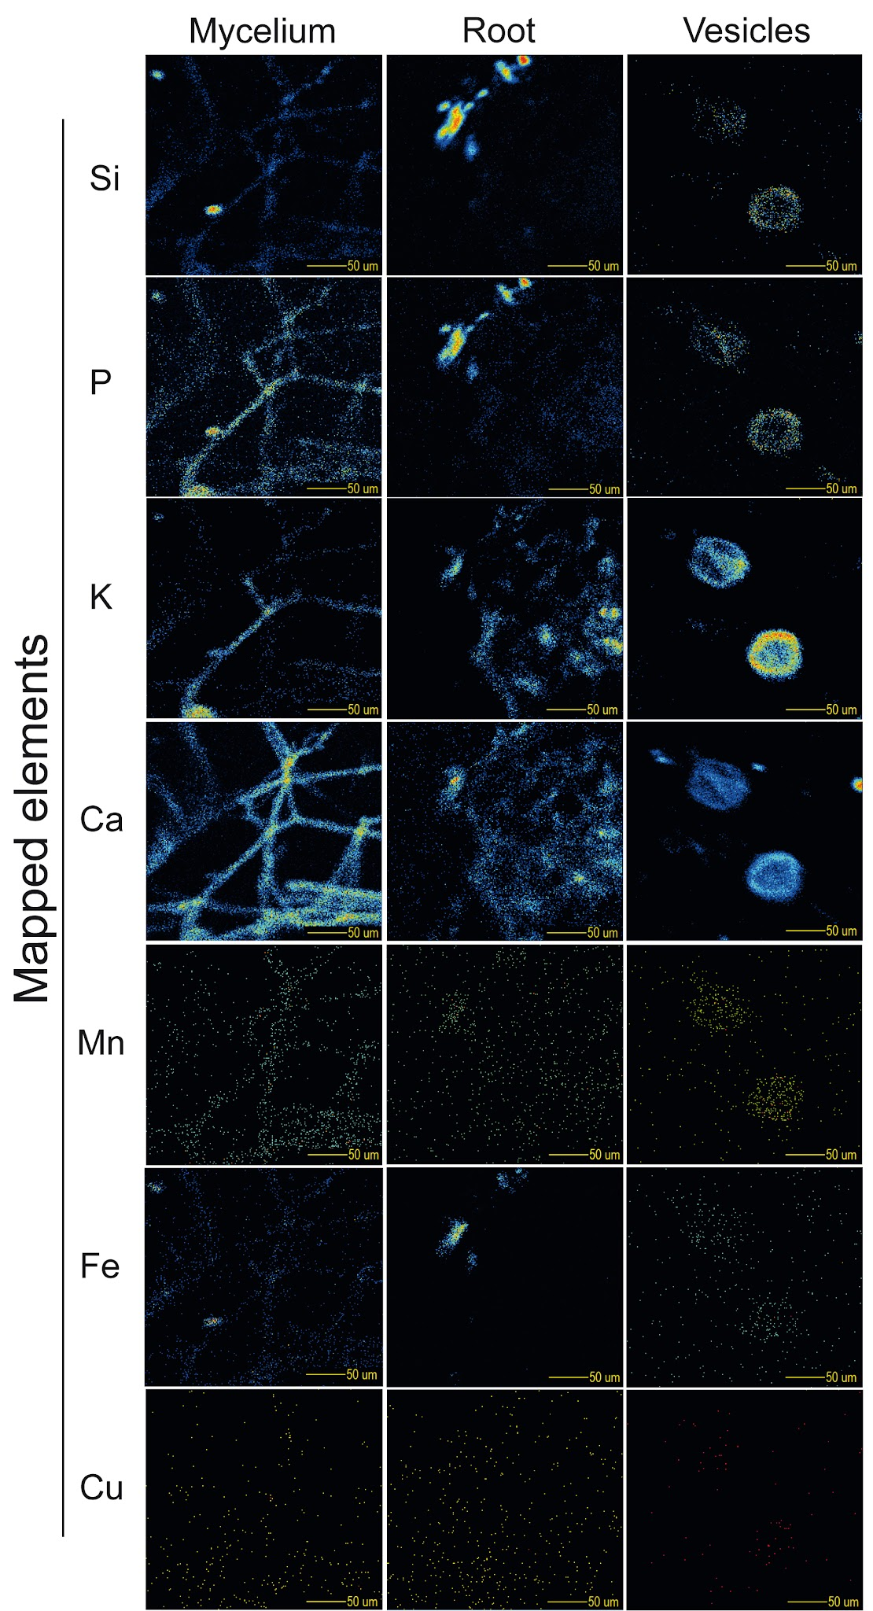
Figure 8. 2D X-ray maps of Si, P, K, Ca, Mn, Fe and Cu in AM fungal mycelium, carrot root cross-section and intraradical AM fungal vesicles exposed to Cu2. Pixels change colour from blue to red with increasing element concentration.
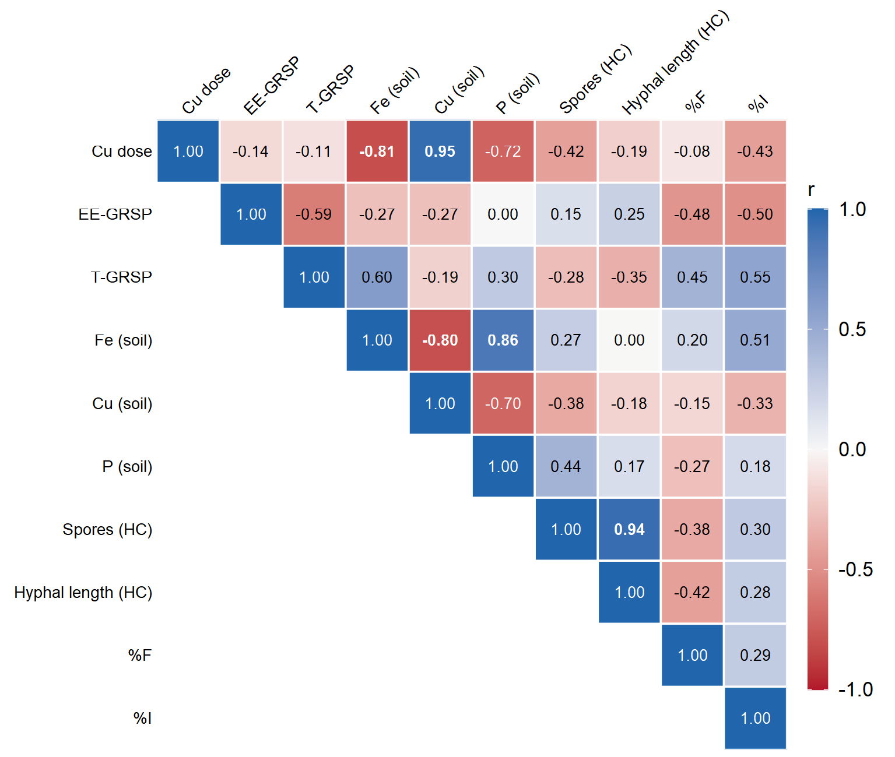
Figure 9. Pearson correlations among variables of the in vitro assay in inoculated plates (n = 7). Blue, positive; red, negative. Bold coefficients, P < 0.05.
In the in vivo assay, root P concentration was higher with Cu (P = 0.004) and was not affected by inoculation (Table 3). The highest individual value was 920 mg kg⁻¹ in a non-mycorrhizal plant with Cu2, and the lowest was 100 mg kg⁻¹ in a non-mycorrhizal plant without Cu. Neither shoot nor soil P differed significantly among treatments (Table 3).
Table 3. Total P and Cu (mg kg⁻¹) in shoots, roots and rhizosphere soil of sunflower plants inoculated or not with Rhizophagus intraradices GC3 after three months, with Cu0 and Cu2.
Treatment | P shoot | P root | P soil | Cu shoot | Cu root | Cu soil
GC3-Cu0 | 306 ± 192 | 147 ± 15 | 635 ± 10 | 21.9 ± 4.5 | 14.0 ± 1.2 | 66.9 ± 20.6
W/I-Cu0 | 502 ± 208 | 242 ± 110 | 671 ± 15 | 29.0 ± 10.9 | 15.0 ± 1.9 | 49.2 ± 2.8
GC3-Cu2 | 405 ± 294 | 714 ± 73 | 651 ± 10 | 31.5 ± 2.7 | 19.3 ± 1.3 | 149.0 ± 32.1
W/I-Cu2 | 554 ± 143 | 632 ± 175 | 665 ± 20 | 30.6 ± 4.6 | 12.2 ± 1.9 | 79.8 ± 18.2
P Inoculation | 0.465 | 0.590 | 0.114 | 0.577 | 0.154 | 0.068
P Cu | 0.729 | 0.004 | 0.799 | 0.362 | 0.866 | 0.017
P Inoc. × Cu | 0.867 | 0.356 | 0.473 | 0.499 | 0.068 | 0.497
Values are means ± SE (n = 3–4). W/I, plants without AM fungal inoculation. P values from Gamma models. Cu0: no added Cu; Cu2: 300 mg L⁻¹ CuSO₄ solution.
Shoot Cu did not differ significantly among treatments. Root Cu ranged from 10 to 22 mg kg⁻¹ among individual plants; the lowest mean was recorded in non-mycorrhizal plants with Cu (12.2 ± 1.9 mg kg⁻¹) and the highest in mycorrhizal plants with Cu (19.3 ± 1.3 mg kg⁻¹; P = 0.031; Table 3, Fig. 10B). Soil Cu increased with Cu dose (P = 0.017), with higher means in inoculated soil that were not significant (Cu2: 149.0 ± 32.1 vs 79.8 ± 18.2 mg kg⁻¹; P = 0.087; Fig. 10A).
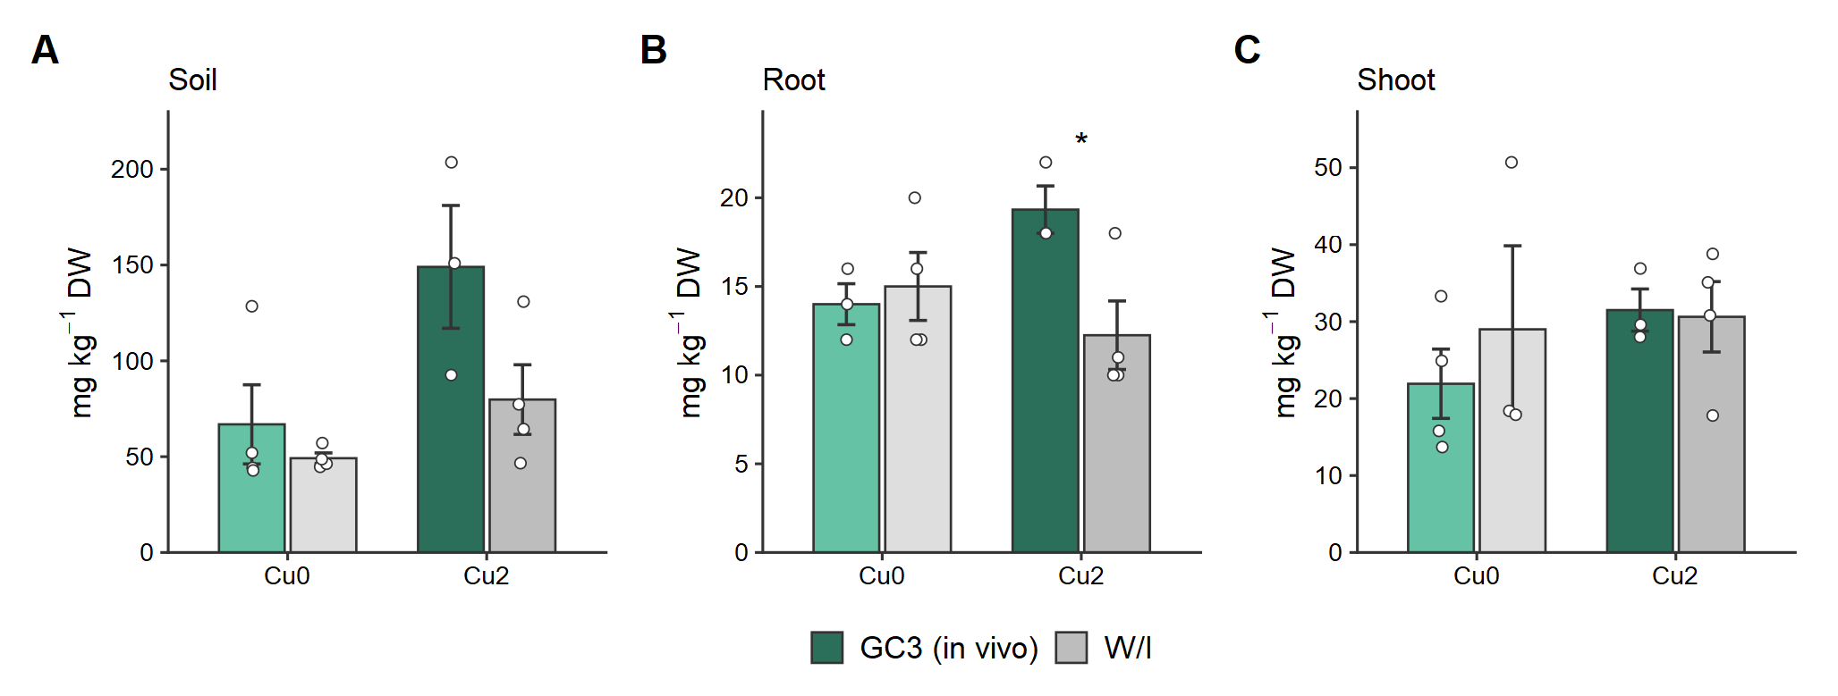
Figure 10. Copper in soil (A), roots (B) and shoots (C) of sunflower plants inoculated with Rhizophagus intraradices GC3 or not inoculated (W/I). Bars are means ± SE; circles are individual replicates. Green, GC3 in vivo; grey, W/I; darker shades indicate higher Cu levels. Asterisks mark differences between GC3 and W/I within each Cu level (P < 0.05 ⁎, < 0.01 ⁎⁎, < 0.001 ⁎⁎⁎); no mark, not significant. Cu0: no added Cu; Cu2: 300 mg L⁻¹ CuSO₄ solution.
Bioaccumulation factors for Cu were below 1 in all treatments (Fig. 11, Table S3). TF values for Cu were above 1 in all treatments, indicating that shoots accumulated more Cu than roots (Fig. 12B). TF values for P differed between Cu levels (P = 0.013): without Cu, TF was above 1 (2.5–3.7), indicating translocation of P to the shoot, whereas with Cu it was below 1 (0.5–0.9), with P retained in roots (Fig. 12A). Correlations among in vivo variables are shown in Fig. 13.
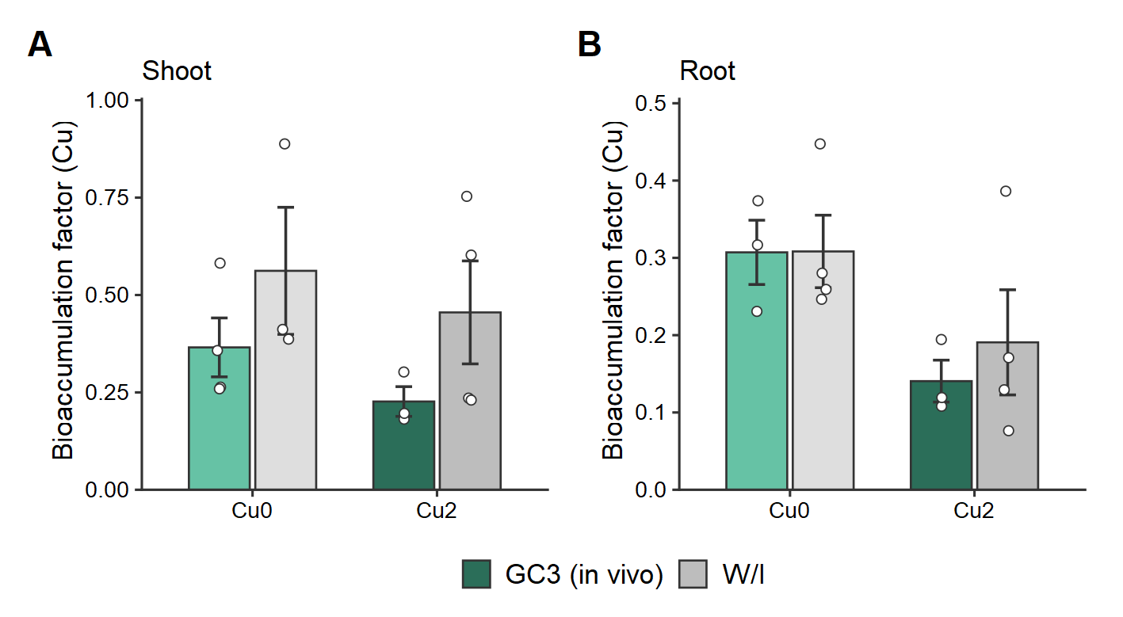
Figure 11. Bioaccumulation factors of Cu in shoots (A) and roots (B) of sunflower plants inoculated with Rhizophagus intraradices GC3 or not inoculated (W/I). Bars are means ± SE; circles are individual replicates. Green, GC3 in vivo; grey, W/I; darker shades indicate higher Cu levels. No significant differences between GC3 and W/I within Cu levels. Cu0: no added Cu; Cu2: 300 mg L⁻¹ CuSO₄ solution.
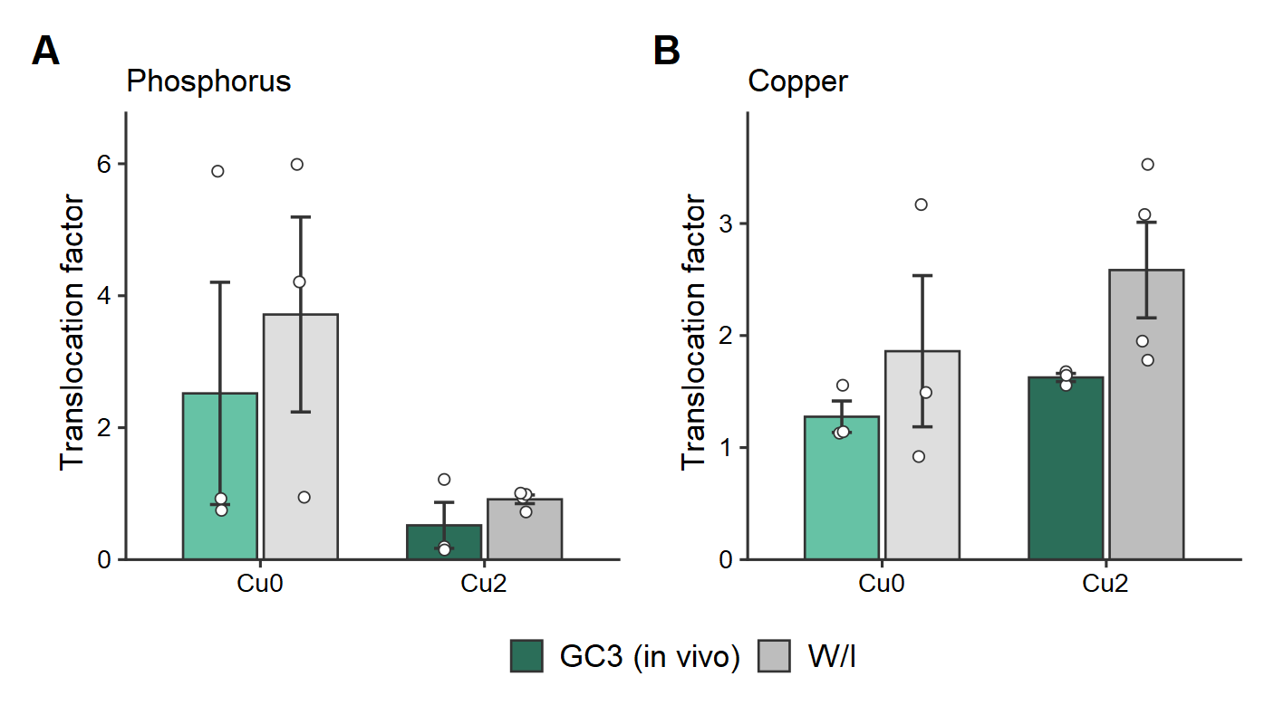
Figure 12. Translocation factors of P (A) and Cu (B) in sunflower plants after three months, inoculated with Rhizophagus intraradices GC3 or not inoculated (W/I). Bars are means ± SE; circles are individual replicates. Green, GC3 in vivo; grey, W/I; darker shades indicate higher Cu levels. No significant differences between GC3 and W/I within Cu levels. Cu0: no added Cu; Cu2: 300 mg L⁻¹ CuSO₄ solution.
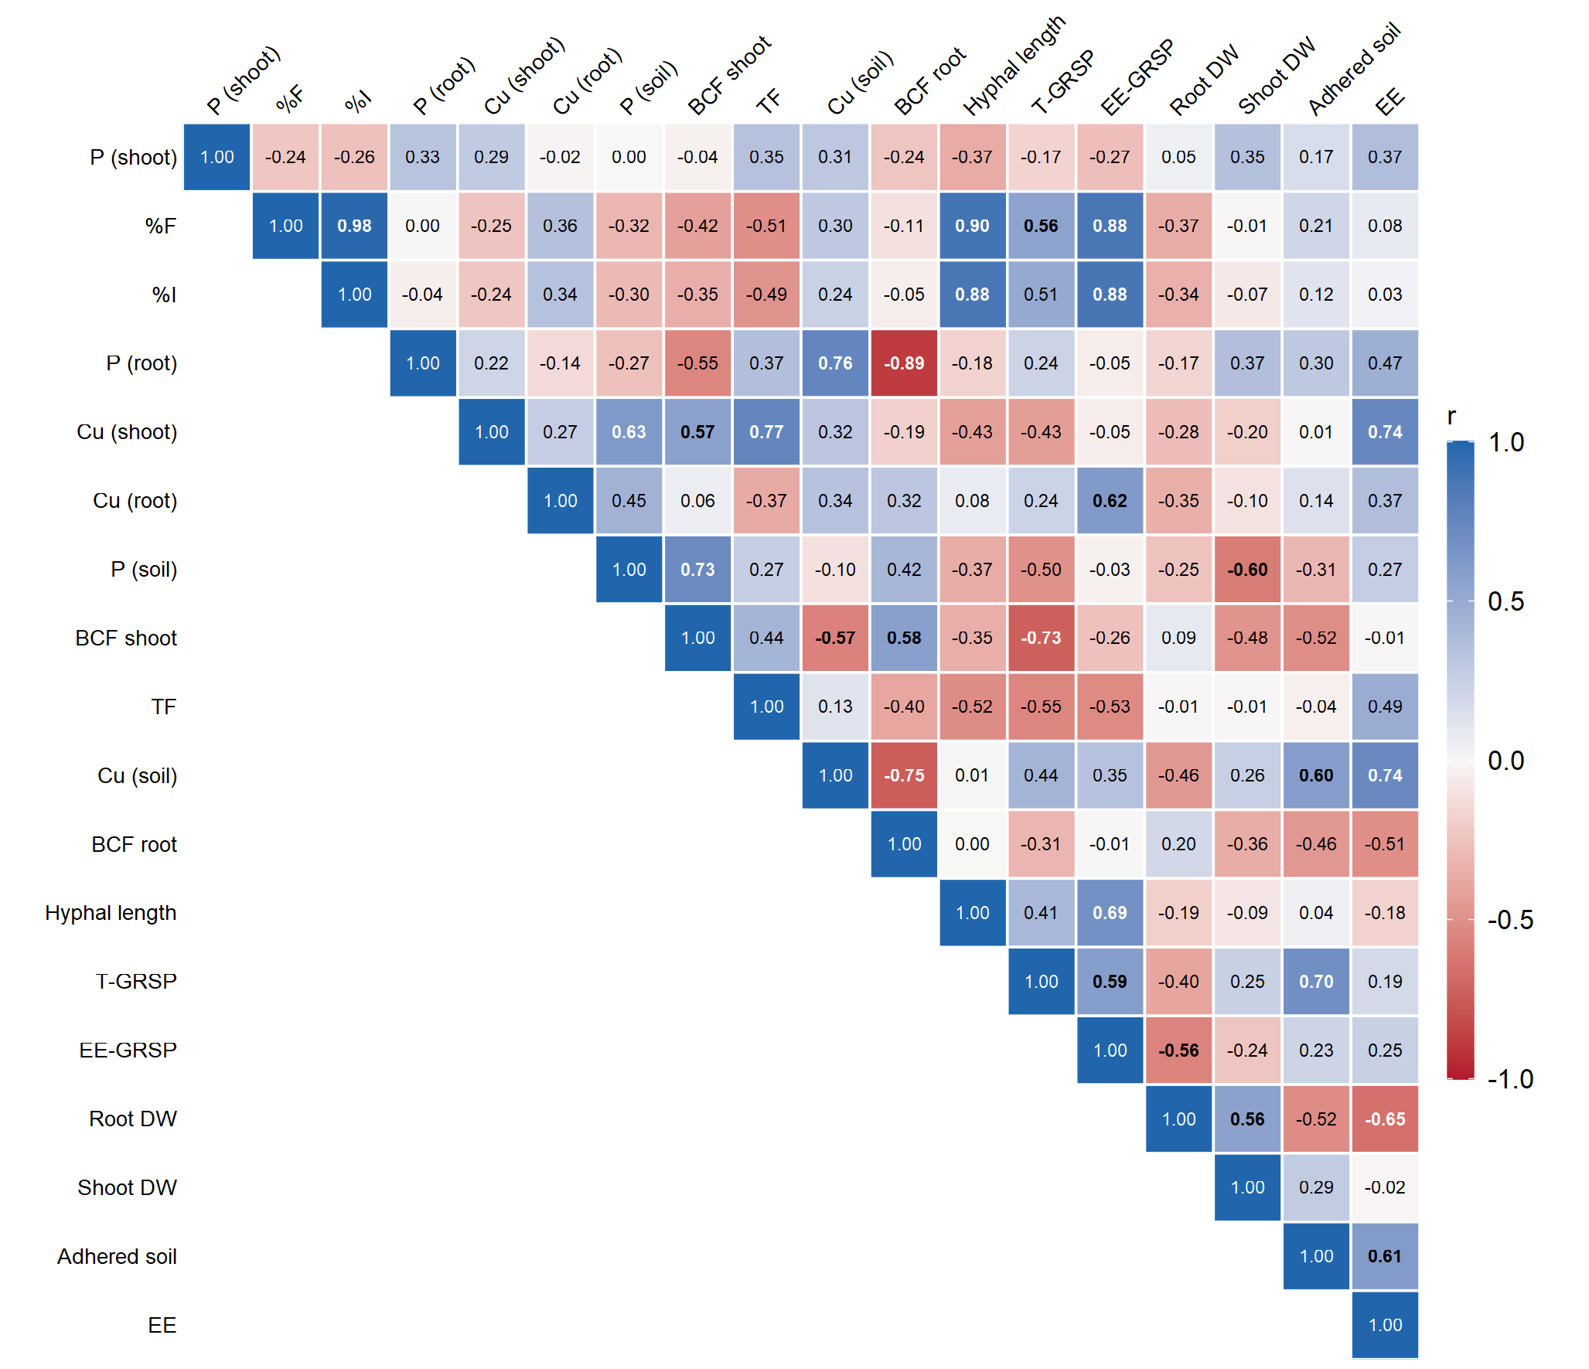
Figure 13. Pearson correlations among variables of the in vivo assay, in Cu0 and Cu2 (n = 13). Blue, positive; red, negative. Bold coefficients, P < 0.05. BCF, bioconcentration factor; TF, translocation factor; DW, dry weight; EE, extraction efficiency.

Discussion
The present study evaluated the effect of fungal strain GC3 on plants treated with a heavy metal, using techniques such as microPIXE to locate the distribution of elements in fungal structures and roots.
In our study, the R. intraradices GC3 strain, isolated from an uncontaminated grassland, did not affect the growth of inoculated plants under the conditions studied. After adding high concentrations of Cu, sunflower plants tolerated the stress without negative effects on growth and biomass, demonstrating their potential use in restoration projects as a phytoremediation plant.
The addition of Cu did not affect the intensity of colonization by GC3 in sunflower, showing high tolerance to this contaminant. The ERM developed in the rhizosphere was not affected either, although a tendency to decrease with increasing Cu was observed.
In the treatments representing stress due to high Cu concentrations, GRSP detection was greater in cultures inoculated with GC3 than in controls. The highest T-GRSP concentration was recorded with the highest Cu dose. Therefore, it can be inferred that the increase in GRSP detection could be due to an AM fungal response to environmental stress. AM fungi have been found in environments with very high levels of heavy metals, so they are thought to have developed strategies to avoid metal damage (Ferrol et al. 2009). GRSP, due to its binding capacity, can capture metals by fixing them in its complex structure and preventing damage to cellular metabolism (González-Chávez et al. 2004; Cornejo et al. 2008).
Previous studies agree that under adverse conditions GRSP production by AM fungi increases while mycelial growth decreases (Rillig and Steinberg 2002; Hammer and Rillig 2011). Enkhtuya et al. (2000) found ERM growth to be a highly sensitive indicator of stress effects in their experiment.
Regarding the distribution of Cu and P, the in vivo results show that plants translocated P to the shoot in the absence of Cu, whereas they retained P in the root in the presence of the metal. Feil et al. (2020) showed in Cucumis sativus that, at high Cu concentrations (above 25 µM), shoot and root growth were stunted and the P influx rate diminished. Abd_Allah et al. (2015) found that cadmium-stressed sunflower plants showed reduced P uptake, whereas plants inoculated with AM fungi not only increased P uptake but also ameliorated the deleterious effect of cadmium. This did not occur in our case.
To discern whether P was distributed in the root or in fungal structures in the in vitro assay, the microPIXE technique was used. Calcium and potassium were efficient choices to delimit each compartment evaluated: mycelium, roots and vesicles. P was distributed mainly in the ERM and vesicles, whereas Cu was located in the vesicles.

Conclusion
[To be written.]

Acknowledgments
We acknowledge Universidad de Buenos Aires, Consejo Nacional de Investigaciones Científicas y Técnicas and Agencia Nacional de Promoción Científica y Tecnológica for financial support. We also thank Dr Pablo Pomata (IBYME-CONICET) for technical assistance.

References
Abd_Allah EF, Hashem A, Alqarawi AA, et al (2015) Alleviation of adverse impact of cadmium stress in sunflower (Helianthus annuus L.) by arbuscular mycorrhizal fungi. Pak J Bot 47:785–795 [verify authors]
Adriano DC (2001) Trace elements in terrestrial environments: biogeochemistry, bioavailability, and risks of metals, 2nd edn. Springer, New York. https://doi.org/10.1007/978-0-387-21510-5
Alshammari et al. (2023) [not identified]
Baldi E, Miotto A, Ceretta CA, Quartieri M, Sorrenti G, Brunetto G, Toselli M (2018) Soil-applied phosphorous is an effective tool to mitigate the toxicity of copper excess on grapevine grown in rhizobox. Sci Hortic 227:102–111. https://doi.org/10.1016/j.scienta.2017.09.010
Ballabio C, Panagos P, Lugato E, Huang JH, Orgiazzi A, Jones A, Fernández-Ugalde O, Borrelli P, Montanarella L (2018) Copper distribution in European topsoils: an assessment based on LUCAS soil survey. Sci Total Environ 636:282–298. https://doi.org/10.1016/j.scitotenv.2018.04.268
Bécard G, Fortin JA (1988) Early events of vesicular–arbuscular mycorrhiza formation on Ri T-DNA transformed roots. New Phytol 108:211–218. https://doi.org/10.1111/j.1469-8137.1988.tb03698.x
Bremner I (1998) Manifestations of copper excess. Am J Clin Nutr 67:1069S–1073S. https://doi.org/10.1093/ajcn/67.5.1069S
Castañón-Silva PA, Venegas-Urrutia MA, Lobos-Valenzuela MG, Gaete-Olivares HJ (2013) Influencia de micorrizas arbusculares Glomus spp. en el crecimiento y acumulación de cobre en girasol Helianthus annuus L. Agrociencia 47:309–317
Collins et al. (2014) [not identified]
Colombo RP, Benavidez ME, Fernandez Bidondo L, Silvani VA, Bompadre MJ, Statello M, Scorza MV, Scotti A, Godeas AM (2020) Arbuscular mycorrhizal fungi in heavy metal highly polluted soil in the Riachuelo river basin. Rev Argent Microbiol 52:145–149. https://doi.org/10.1016/j.ram.2019.05.001
Cornejo P, Meier S, Borie G, Rillig MC, Borie F (2008) Glomalin-related soil protein in a Mediterranean ecosystem affected by a copper smelter and its contribution to Cu and Zn sequestration. Sci Total Environ 406:154–160. https://doi.org/10.1016/j.scitotenv.2008.07.045
Cornejo P, Pérez-Tienda J, Meier S, Valderas A, Borie F, Azcón-Aguilar C, Ferrol N (2013) Copper compartmentalization in spores as a survival strategy of arbuscular mycorrhizal fungi in Cu-polluted environments. Soil Biol Biochem 57:925–928. https://doi.org/10.1016/j.soilbio.2012.10.031
Custo G, Boeykens S, Dawidowski L, Fox L, Gómez D, Luna F, Vázquez C (2005) Soil characterization by energy dispersive X-ray fluorescence: sampling strategy for in situ analysis. Anal Sci 21:751–756. https://doi.org/10.2116/analsci.21.751
de la Fournière EM, Vega NA, Müller NA, Pizarro RA, Debray ME (2019) Determinación del mercurio en tejidos vegetales por microPIXE: aplicación al estudio de la hiperacumulación por Spirodela intermedia (Lemnaceae). Bol Soc Argent Bot 54:263–275. https://doi.org/10.31055/1851.2372.v54.n2.24373
Declerck S, D'Or D, Bivort C, de Souza FA (2004) Development of extraradical mycelium of Scutellospora reticulata under root-organ culture: spore production and function of auxiliary cells. Mycol Res 108:84–92. https://doi.org/10.1017/S0953756203008761
Enkhtuya B, Rydlová J, Vosátka M (2000) Effectiveness of indigenous and non-indigenous isolates of arbuscular mycorrhizal fungi in soils from degraded ecosystems and man-made habitats. Appl Soil Ecol 14:201–211. https://doi.org/10.1016/S0929-1393(00)00057-3
Feil SB, Pii Y, Valentinuzzi F, Tiziani R, Mimmo T, Cesco S (2020) Copper toxicity affects phosphorus uptake mechanisms at molecular and physiological levels in Cucumis sativus plants. Plant Physiol Biochem 157:138–147. https://doi.org/10.1016/j.plaphy.2020.10.023
Ferrol N, González-Guerrero M, Valderas A, Benabdellah K, Azcón-Aguilar C (2009) Survival strategies of arbuscular mycorrhizal fungi in Cu-polluted environments. Phytochem Rev 8:551–559. https://doi.org/10.1007/s11101-009-9133-9
Fox J, Weisberg S (2019) An R companion to applied regression, 3rd edn. Sage, Thousand Oaks
Francis and Ndukwn (2019) [not identified]
González-Chávez MC, Carrillo-González R, Wright SF, Nichols KA (2004) The role of glomalin, a protein produced by arbuscular mycorrhizal fungi, in sequestering potentially toxic elements. Environ Pollut 130:317–323. https://doi.org/10.1016/j.envpol.2004.01.004
Graham JH, Linderman RG, Menge JA (1982) Development of external hyphae by different isolates of mycorrhizal Glomus spp. in relation to root colonization and growth of Troyer citrange. New Phytol 91:183–189. https://doi.org/10.1111/j.1469-8137.1982.tb03304.x
Hammer EC, Rillig MC (2011) The influence of different stresses on glomalin levels in an arbuscular mycorrhizal fungus—salinity increases glomalin content. PLoS ONE 6:e28426. https://doi.org/10.1371/journal.pone.0028426
Hartig F (2025) DHARMa: residual diagnostics for hierarchical (multi-level/mixed) regression models. R package version 0.5.0
Hewitt EJ (1952) Sand and water culture methods used in the study of plant nutrition. Technical Communication 22. Commonwealth Bureau of Horticulture and Plantation Crops, Farnham Royal
Hildebrandt U, Regvar M, Bothe H (2007) Arbuscular mycorrhiza and heavy metal tolerance. Phytochemistry 68:139–146. https://doi.org/10.1016/j.phytochem.2006.09.023
Janeeshma E, Puthur JT (2020) Direct and indirect influence of arbuscular mycorrhizae on enhancing metal tolerance of plants. Arch Microbiol 202:1–16. https://doi.org/10.1007/s00203-019-01730-z
Jeremias et al. (2023) [not identified]
Khalilvand-Behrouzyar et al. (2007) [not identified]
Lasat MM (2002) Phytoextraction of toxic metals: a review of biological mechanisms. J Environ Qual 31:109–120. https://doi.org/10.2134/jeq2002.1090
Lenth RV (2025) emmeans: estimated marginal means, aka least-squares means. R package version 2.0.4
Linder MC, Hazegh-Azam M (1996) Copper biochemistry and molecular biology. Am J Clin Nutr 63:797S–811S. https://doi.org/10.1093/ajcn/63.5.797
Liu J, Beckerman J (2022) Application of sustainable biosorbents from hemp for remediation copper(II)-containing wastewater. J Environ Chem Eng 10:107494. https://doi.org/10.1016/j.jece.2022.107494
Murillo JM, Marañón T, Cabrera F, López R (1999) Accumulation of heavy metals in sunflower and sorghum plants affected by the Guadiamar spill. Sci Total Environ 242:281–292. https://doi.org/10.1016/S0048-9697(99)00396-4
Newman EI (1966) A method of estimating the total length of root in a sample. J Appl Ecol 3:139–145. https://doi.org/10.2307/2401670
Nichols KA, Wright SF (2006) Carbon and nitrogen in operationally defined soil organic matter pools. Biol Fertil Soils 43:215–220. https://doi.org/10.1007/s00374-006-0097-2
Parniske M (2008) Arbuscular mycorrhiza: the mother of plant root endosymbioses. Nat Rev Microbiol 6:763–775. https://doi.org/10.1038/nrmicro1987
Phillips JM, Hayman DS (1970) Improved procedures for clearing roots and staining parasitic and vesicular-arbuscular mycorrhizal fungi for rapid assessment of infection. Trans Br Mycol Soc 55:158–161. https://doi.org/10.1016/S0007-1536(70)80110-3
R Core Team (2026) R: a language and environment for statistical computing. R Foundation for Statistical Computing, Vienna
Rillig MC (2004) Arbuscular mycorrhizae, glomalin, and soil aggregation. Can J Soil Sci 84:355–363. https://doi.org/10.4141/S04-003
Rillig MC, Mummey DL (2006) Mycorrhizas and soil structure. New Phytol 171:41–53. https://doi.org/10.1111/j.1469-8137.2006.01750.x
Rillig MC, Steinberg PD (2002) Glomalin production by an arbuscular mycorrhizal fungus: a mechanism of habitat modification? Soil Biol Biochem 34:1371–1374. https://doi.org/10.1016/S0038-0717(02)00060-3
Schüßler A, Schwarzott D, Walker C (2001) A new fungal phylum, the Glomeromycota: phylogeny and evolution. Mycol Res 105:1413–1421. https://doi.org/10.1017/S0953756201005196
Scotti A, Silvani VA, Cerioni J, Visciglia M, Benavidez M, Godeas A (2019) Pilot testing of a bioremediation system for water and soils contaminated with heavy metals: vegetable depuration module. Int J Phytoremediation 21:899–907. https://doi.org/10.1080/15226514.2019.1583634
Silvani VA, Statello M, Scorza MV, Pérgola M, Colombo RP, Godeas AM (2019) A novel in vitro methodology to cultivate arbuscular mycorrhizal fungi combining soil and synthetic media. Symbiosis 79:163–170. https://doi.org/10.1007/s13199-019-00637-z
Son Y, Martínez CE, Kao-Kniffin J (2024) Three important roles and chemical properties of glomalin-related soil protein. Front Soil Sci 4:1418072. https://doi.org/10.3389/fsoil.2024.1418072
St-Arnaud M, Hamel C, Vimard B, Caron M, Fortin JA (1996) Enhanced hyphal growth and spore production of the arbuscular mycorrhizal fungus Glomus intraradices in an in vitro system in the absence of host roots. Mycol Res 100:328–332. https://doi.org/10.1016/S0953-7562(96)80164-X
Statello M, Colombo R, de la Fournière E, Debray M, Godeas A, Silvani V (2024) The microPIXE technique to understand the distribution of heavy metals in arbuscular mycorrhizal symbiosis. Rev Argent Microbiol 56:198–199. https://doi.org/10.1016/j.ram.2023.12.006
Sytar et al. (2021) [not identified]
Wang (2023) [not identified]
Supplementary material
Table S1. Hyphal length, spore number, root length and root colonization in the in vitro system with Rhizophagus intraradices GC3 (W/I: not inoculated).
Treatment | Hyphal length RC (cm) | Hyphal length HC (cm g⁻¹) | Spores RC | Spores HC (g⁻¹) | Root length (cm) | %F | %I | %A | %V | %IS
GC3-Cu0 | 1307.1 ± 412.9 | 84.1 ± 11.3 | 208 ± 54 | 141 ± 21 | 687.6 ± 6.2 | 91.1 ± 2.2 | 49.6 ± 4.7 | 59.5 ± 26.6 | 59.1 ± 10.3 | 80.7 ± 2.6
W/I-Cu0 | — | 10.8 ± 3.0‡ | — | 7 ± 1‡ | 498.0 ± 38.7 | — | — | — | — | —
GC3-Cu1 | 1204.7 ± 646.4 | 153.3 ± 24.5 | 89 ± 4 | 445 ± 145 | 488.4 ± 21.6 | 83.7 ± 1.6 | 41.0 ± 6.0 | 67.5 ± 7.0 | 28.2 ± 6.7 | 34.4 ± 6.2
W/I-Cu1 | — | 15.0 ± 0.3 | — | 7 ± 2 | 479.2 ± 33.1 | — | — | — | — | —
GC3-Cu2 | 3241.5 ± 453.4 | 70.0 ± 11.6 | 397 ± 109 | 9 ± 2 | 655.6 ± 161.4 | 90.1 ± 2.5 | 40.5 ± 4.2 | 74.2 ± 3.7 | 36.3 ± 5.1 | 57.1 ± 12.8
W/I-Cu2 | — | 6.6 ± 2.2 | — | 7 ± 1 | 401.9 ± 73.8 | — | — | — | — | —
P Inoculation | — | — | — | — | 0.055 | — | — | — | — | —
P Cu | 0.173 | 0.024 | 0.011 | <0.001 | 0.536 | 0.096 | 0.431 | 0.753 | 0.118 | 0.075
P Inoc. × Cu | — | — | — | — | 0.299 | — | — | — | — | —
Values are means ± SE (n = 2–3). RC, root compartment; HC, hyphal compartment with soil. ‡From an earlier table of the draft. P values from Gamma models; for variables measured only in GC3, effect of Cu. Cu0: no added Cu; Cu1: 150 mg L⁻¹ CuSO₄ solution; Cu2: 300 mg L⁻¹ CuSO₄ solution.
Table S2. Calculated element concentrations (mg kg⁻¹) in AM fungal mycelium, intraradical vesicles and carrot root cross-sections in vitro.
Sample | Treatment | Si | P | Cu | Fe | Mn | Zn | K | Ca | Cl | Ti
ERM | Cu2 | 479.83 | 959.65 | 26.64 | 188.03 | 40.92 | ≈23 | 838.61 | 127.56 | 920.03 | 0
 | Cu0 | 465.21 | 475.08 | 0 | 341.71 | 54.08 | <DL | 552.18 | 259.98 | 1610.52 | 0
Vesicles | Cu2 | 12099.80 | 9202.55 | 33.75 | 110 | 260.06 | 88.15 | 17627.50 | 2477.38 | 13244.50 | 0
 | Cu0 | 44420.63 | 39655.92 | 18 | 232.77 | 121.50 | 14.44 | 38998.12 | 7999.61 | 6554.99 | 0
Carrot roots | GC3-Cu2 | 253848 | 0 | 0 | 3286.7 | 162.16 | 0 | 57097.20 | 16073.00 | 19646.50 | 1054.06
 | W/I-Cu2 | 0 | 0 | 128.53 | 195.42 | 101.94 | 54.66 | 242054 | 34060.89 | 145844.50 | 0
 | GC3-Cu0 | — | — | 63.33 | 244.47 | 265.02 | 16.45 | 66179.70 | 18614 | 10475.70 | 0
 | W/I-Cu0 | 0 | 6524 | 0 | 152 | 125 | 12 | 18465 | 35326 | 27060 | 0
<DL, below detection limit; —, not available. Cu0: control; Cu2: 300 mg L⁻¹ CuSO₄ solution; W/I: roots without AM fungal inoculation.
Table S3. Bioconcentration (BCF) and translocation (TF) factors of Cu and P in sunflower plants after three months, with and without Cu and with or without AM fungal inoculation.
Treatment | BCF Cu shoot | BCF Cu root | TF Cu | BCF P shoot | BCF P root | TF P
GC3-Cu0 | 0.37 ± 0.08 | 0.31 ± 0.04 | 1.28 ± 0.14 | 0.48 ± 0.30 | 0.23 ± 0.02 | 2.52 ± 1.68
W/I-Cu0 | 0.56 ± 0.16 | 0.31 ± 0.05 | 1.86 ± 0.67 | 0.74 ± 0.30 | 0.35 ± 0.16 | 3.71 ± 1.48
GC3-Cu2 | 0.23 ± 0.04 | 0.14 ± 0.03 | 1.63 ± 0.04 | 0.61 ± 0.44 | 1.09 ± 0.10 | 0.52 ± 0.35
W/I-Cu2 | 0.46 ± 0.13 | 0.19 ± 0.07 | 2.58 ± 0.43 | 0.85 ± 0.23 | 0.98 ± 0.28 | 0.91 ± 0.07
P Inoculation | 0.053 | 0.557 | 0.069 | 0.489 | 0.639 | 0.338
P Cu | 0.210 | 0.035 | 0.192 | 0.725 | 0.003 | 0.013
P Inoc. × Cu | 0.610 | 0.560 | 0.837 | 0.923 | 0.404 | 0.855
Values are means ± SE (n = 3–4). P values from Gamma models. P-based factors depend on tissue P values pending verification. Cu0: no added Cu; Cu2: 300 mg L⁻¹ CuSO₄ solution.
Annex 1. Soil characteristics
Texture: sand 12%, silt 65.5%, clay 22.5%. pH 5.1. Total C: 14.90 g kg⁻¹. P: 13.90 mg kg⁻¹ [method]. Total N: 1.53 g kg⁻¹.

