**Jorge_Perez_CPRG200_Lab3**

1. Error Exc while pressing the save button with a negative value in Unit Price:

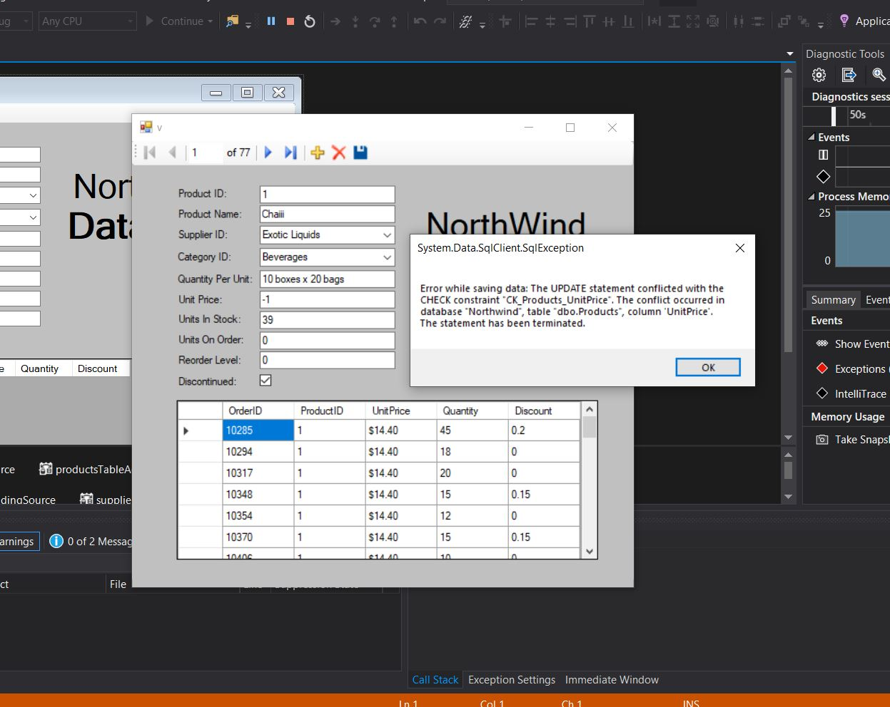

1. Error Exc while pressing the save button with a crazy value amount in Quantity Per Unit.

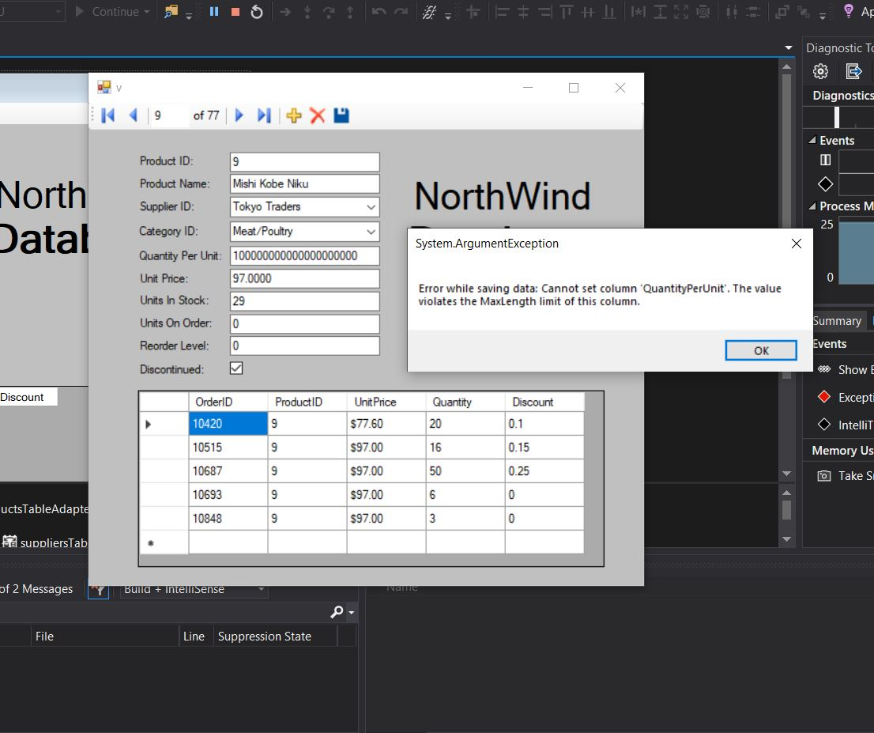

1. Added a new “Test” productid (78) when save clicked.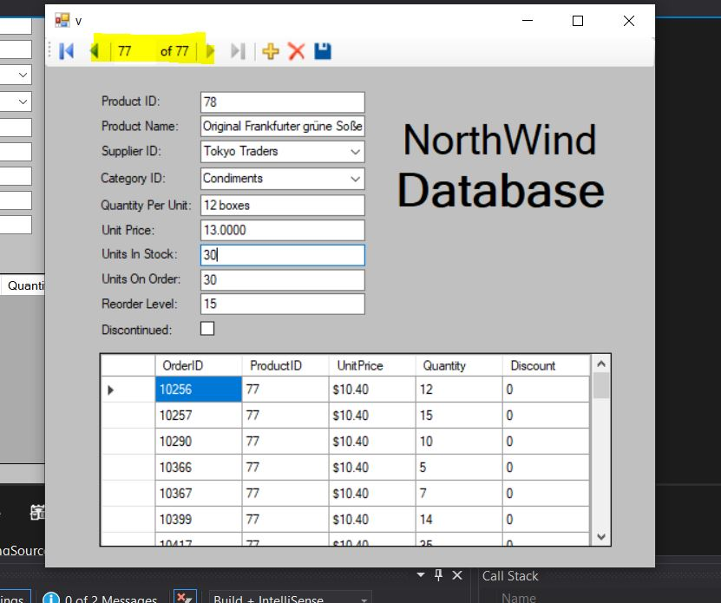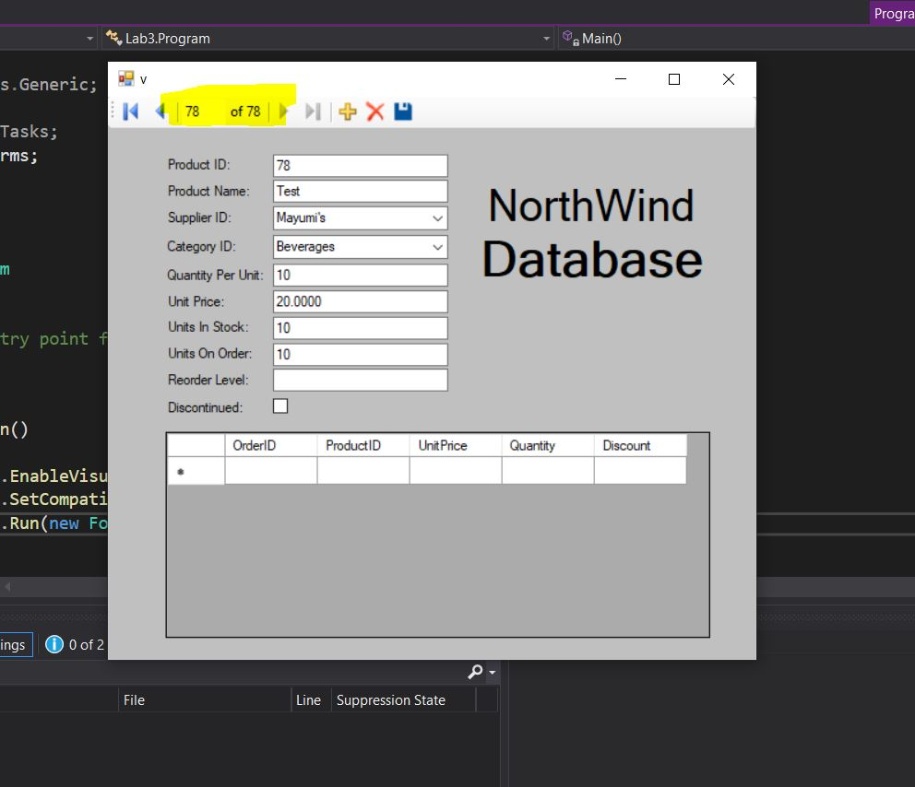
2. Deleting “Test ProductID” 78.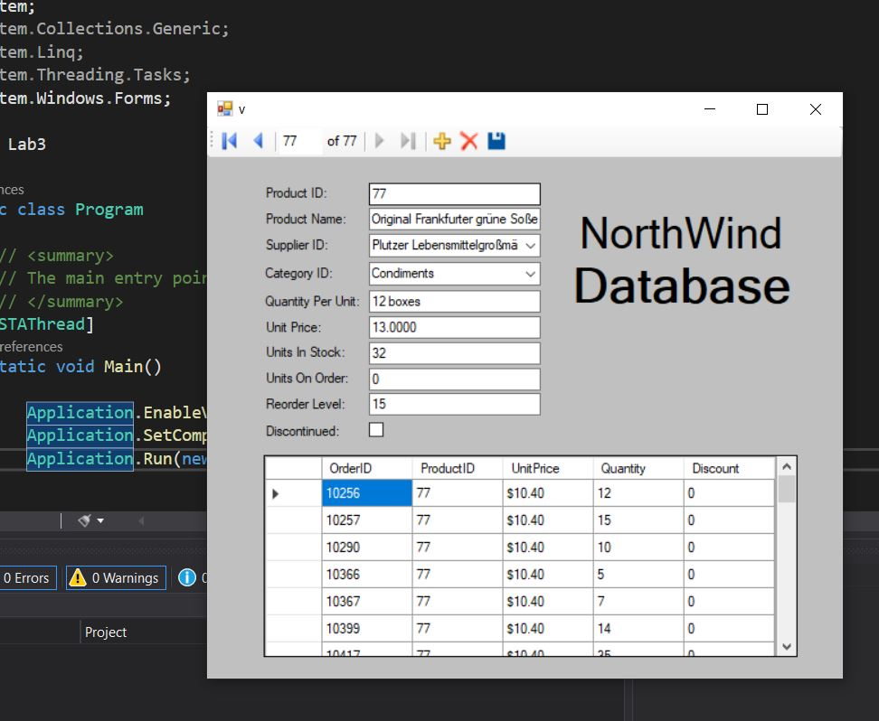
3. Error Exc while pressing the save button with Empty Reorder level/Discontinued on:

