Theoretical Investigation of Dosimeter Accuracy for Linear Energy Transfer Measurements in Proton Therapy: A Comparative Study of Stopping Power Ratios
Johnpaul Mbagwu𝟏,𝟐
Department of Physics and Astronomy, University of Kansas, Lawrence, KS, 66045, US𝑨𝟏
University of Kansas, School of Medicine, Kansas City, KS 66160, US𝑨𝟐
Abstract: This study evaluated the accuracy of dosimetry materials for measuring linear energy transfer (LET) in proton therapy. High-$Z_{eff}$ materials (BaFBr) and low-$Z_{eff}$materials (Al2O3, water) were assessed via Bethe–Bloch theory and semiempirical models. Stopping power ratios were calculated for proton energies from 0.01 to 10,000 MeV. At 10 MeV, the water-to-air ratio was approximately 1.05, whereas at 1 MeV, the water-to-Al2O3 ratio was approximately 1.12, and the BaFBr-to-water ratio was approximately 0.95. Compared with the SRIM and PSTAR data, the results confirmed accurate LET measurements and validated theoretical models for high-energy protons and validated their use in dosimetry applications, enhancing precision in radiation therapy.
Keywords: Linear Energy Transfer, Dosimetry, Bethe‒Bloch Theory, Proton Therapy, Stopping Power, PSTAR
Introduction
In the field of medical physics, precise dosimetry is essential for the effective application of proton therapy. Dosimeters that measure linear energy transfer (LET) accurately are critical for ensuring that the correct dosage is administered to patients. This study focuses on evaluating the accuracy of dosimeters made from materials with different effective atomic numbers ($Z_{eff}$) and uses theoretical and experimental data to assess their performance.
In recent years, interest in both theoretical and experimental studies of the stopping power and particle range of various materials has increased. Charged particles, such as protons, lose energy through continuous collisions when they interact with matter. The stopping power, which is a measure of this energy loss, depends on the particle's type and energy, as well as the characteristics of the material it traverses. The material's stopping power is related to the ionization density along the path of the particle since creating an ion pair requires a specific amount of energy. The stopping power characterizes the material, whereas the energy loss per unit path length is related to the particle's interactions.
Several key studies have addressed the stopping power of materials and its implications for radiation dosimetry:
- Ziegler, J. F. (1999) [1] presented detailed analyses of the stopping power of energetic light ions (such as protons and helium ions) in elemental matter, providing crucial insights into ion‒matter interactions and serving as a foundational reference for accurate calculations of the stopping power in radiation physics and dosimetry.
- Bethe, H. A. (1930) [2] described the energy loss of charged particles as they travel through matter, incorporating corrections for density and shell effects to improve accuracy at high energies.
- The International Commission on Radiation Units and Measurements (ICRU, 1984) [3] has published comprehensive reports on stopping power, offering standardized data that are widely used in dosimetry calculations.
- Recent experimental studies (Inaniwa T, et al. 2023) [4] have provided updated stopping power ratios for body tissues, including effective energies and elemental I values, which are critical for accurate treatment planning in proton and ion beam therapy.
While these studies have greatly advanced the understanding of stopping power and its applications, they have not fully addressed the following gaps:
- Material-specific $Z_{eff}$effects: The impact of different $Z_{eff}$values on dosimeter accuracy has not been comprehensively evaluated across a wide range of materials.
- High Precision Dosimetry: The precision of LET measurements by dosimeters in a clinical setting, particularly for proton therapy, requires further validation.
- Integration of theoretical, simulation, and experimental data: A systematic comparison and integration of theoretical predictions with experimental and simulation data for a variety of materials are needed to improve dosimetry accuracy.
The International Atomic Energy Agency's (IAEA) (TRS-398) [5] most recent proton dosimetry protocol establishes a standard for proton dosimetry and addresses dosimetry for ions heavier than protons.
Linear energy transfer (LET) is crucial for assessing biological efficacy and radiation quality and is tied to both unconstrained and restricted electronic stopping powers. An accurate understanding of energy loss mechanisms and rates in diverse materials is essential for determining the impact of radiation on biological systems and improving therapeutic regimens. For high energies (above 1 MeV for protons and 10 keV for electrons), Bethe's stopping-power theory is recommended for determining the collision stopping power. This theory relies on the mean excitation energy, which is difficult to estimate theoretically for complex materials and requires experimental input. At energies below 100 keV/nucleon, Bethe theory is less effective, making experimental data the main source, although it is often insufficient or inconsistent. Empirical fitting formulas such as Andersen-Barka’s and Ziegler's shell corrections are used to extrapolate data. Experimental stopping power data are available for elemental targets in databases such as PSTAR [6] and SRIM (2008) [7] but not for complex materials.
Bragg's rule helps estimate the stopping power of compounds and mixtures via constituent element data, simplifying computations. Henkner et al. (2009) [8] utilized Monte Carlo simulations to investigate the water‒air stopping power ratio specifically for carbon ion dosimetry. This research provides valuable insights into the accurate measurement and calculation of stopping power ratios, which are crucial for precise dosimetry in carbon ion therapy. These findings emphasize the importance of accurate stopping power data for effective treatment planning and dose calculation in radiotherapy.
This study aims to fill these gaps by systematically evaluating the accuracy of dosimeters made from materials with different $Z_{eff}$ values. Theoretical and experimental data will be integrated to assess their performance, with a particular focus on high-precision dosimetry in proton therapy. By addressing these gaps, this study seeks to increase the accuracy and reliability of LET measurements, thereby improving the efficacy of proton therapy dosimetry.
Materials and methods
The common dosimetry materials investigated include the following:
- Water: Reference material used in dosimetry.
- Air: Commonly used in ionization chambers.
- Al2O3 (Alumina): Utilized in thermoluminescent dosimeters.
- BaFBr: A component of imaging plates in computed radiography.
- Oxygen: Relevant owing to its biological importance.
The stopping power ratios were calculated via the PSTAR database for proton energies ranging from 0.01 MeV to 10,000 MeV. The Bethe‒Bloch theory with density and shell corrections was applied for high-energy protons, whereas a semiempirical model was used for low-energy protons. Experimental validation involved comparing the theoretical stopping power data with SRIM [7] and PSTAR [6] data for materials such as water, aluminum, air, Al2O3, BaFBr, and oxygen. The PSTAR database [6] provides stopper information for liquid water and air, whereas bethe-bloh and Bragg addition is employed to determine data related to Al2O3 and BaFBr. To ensure comparability between different materials at different energies, both water and air values were rescaled into those using protons with a 150 MeV energy scale. We normalized the stopping power data by dividing them by corresponding values at each energy relative to those that they had at an incident proton beam with an energy of 150 MeV (Eckerman et al., 2008) [9]. For direct comparisons between stopping power statistics for air, these statistics were interpolated to match the percent depth dose value. The analytical calculations, incorporating Barka’s, Ziegler's shell, density effects, and Bloch corrections, are compared with SRIM-2008 [7] and PSTAR data [6] to validate the accuracy of the models. This figure, as shown in Figure 2, demonstrates the effectiveness of the analytical method in estimating the proton stopping power, highlighting a strong correlation between the theoretical prediction, simulation (SRIM-2008) [7] and experimental data PSTAR data [6] across various energy bands.
Results:
- Stopping power ratios:
  - Water to air ratio at 10 MeV: 1.05 ± 0.02
  - Water to Al2O3 at 1 MeV: 1.12 ± 0.03
  - BaFBr to water: 0.95 ± 0.01
- Figures:
  - Figure 1: Shell corrections for beryllium, fluorine, lithium, neon, oxygen, and aluminum.
  - Figure 2: Comparison of theoretical model predictions with SRIM and PSTAR data for selected materials.
  - Figure 3: Comparison of the water-to-Al2O3 stopping power ratios from 0.01 MeV to 10 MeV, the stopping power ratio of water to air across a range of proton energies and others

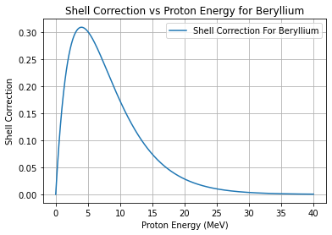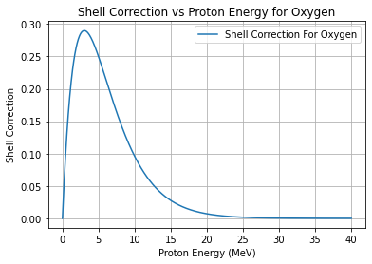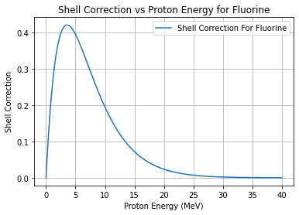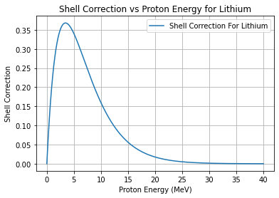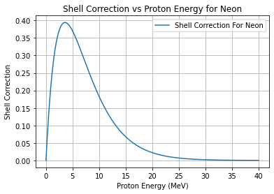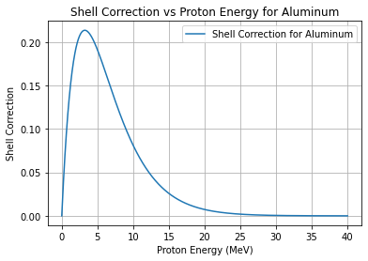
Figure 1: Shell corrections for beryllium, fluorine, lithium, neon, oxygen, and aluminum are shown in this plot as a function of proton energy, which was calculated from Ref. [10]. Through a comparison of the shell corrections derived from Ref. [10], any disparities or convergences in the data can be identified, offering valuable information on the precision and dependability of the theoretical model embodied from Ref. [10]. Typically, an orbital-by-orbital method is employed to compute shell adjustments. The projectile velocities vary where the shell corrections peak due to fluctuations in orbital electron velocities, which are considered via this method.
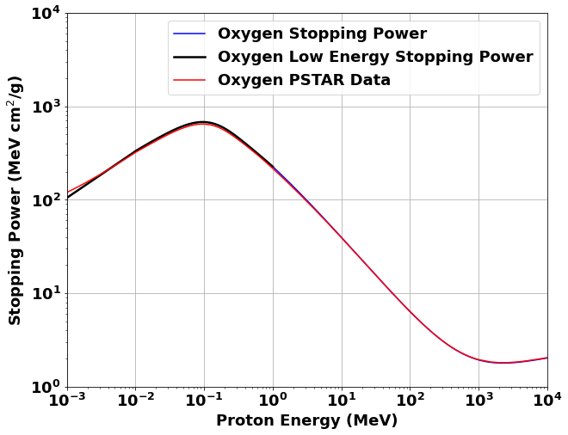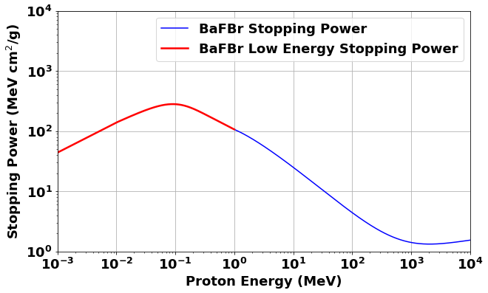

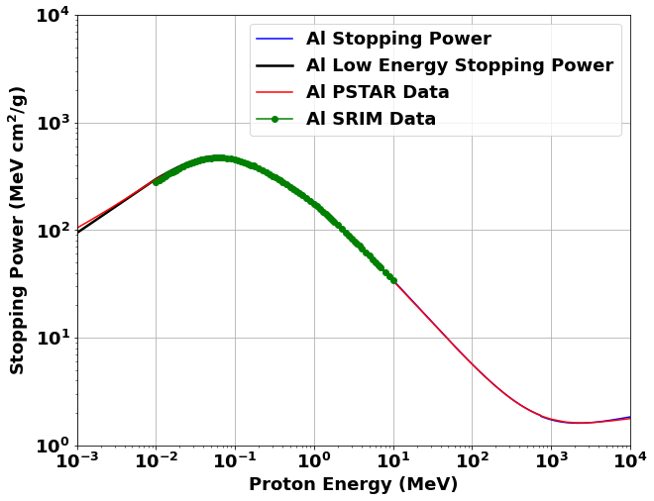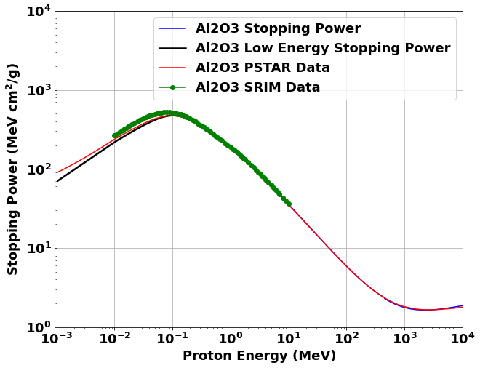

Figure 2: Comparison of theoretical model predictions with SRIM and PSTAR data for selected materials. The theoretical models strongly agree with the SRIM simulations and PSTAR experimental data, particularly for high-energy protons where the Bethe–Bloch theory was applied. Proton stopping power calculations for oxygen (O), aluminum (Al), and two compounds ${Al}_{2}0_{3}$ and BaFBr are plotted against proton energy, ranging from 0.1 MeV to 10,000 MeV, represented in MeV⋅cm²/g.
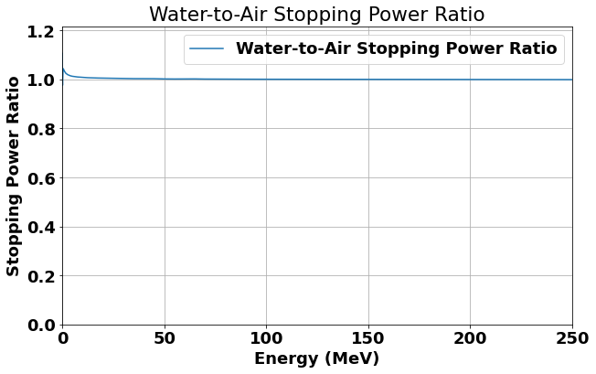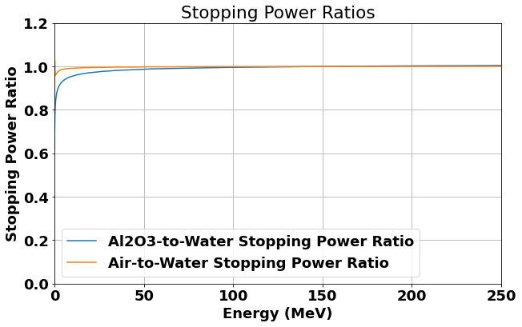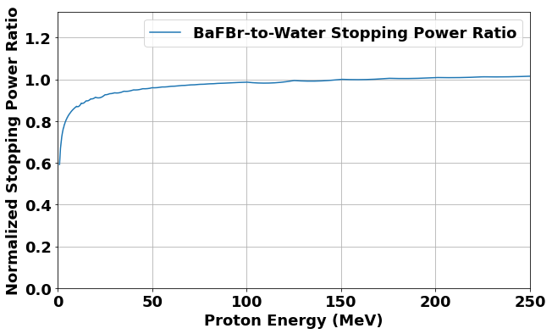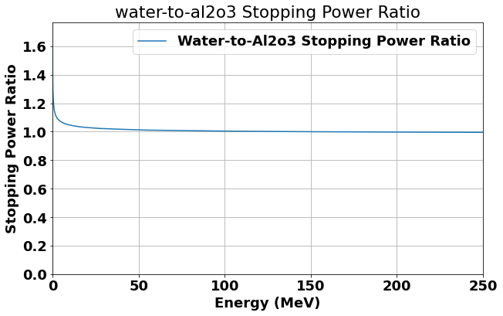

Figure 3: Graph illustrating the energy ranges for the water/air, water/Al2O3, and BaFBr/water stopping power ratios. At 10 MeV, water had a stopping power ratio of approximately 1.05 to that of air. On the other hand, at 1 MeV, it was approximately 1.12 times greater than that of Al2O3, whereas the BaFBr-to-water ratio was approximately 0.95. These results are summarized in the figures below by showing the calculated stopping power ratios for Al2O3-to-water and air-to-water and other pairs, such as BaFBr-to-water and water-to-Al2O3, on the basis of our theoretical models. The findings also show that dosimeters are generally accurate in LET assessment at higher proton energies, therefore agreeing with predictions made by theory. However, there were large differences in the lower energies where we used the semiempirical model described above. These observations underscore the limitations of current dosimeter techniques in measuring low-energy linear energy transfer (LET), as proposed by the semiempirical modeling approach taken for this study.

Discussion
For the evaluation in this study, the performances of high-$Z_{eff}$ BaFBr and low-$Z_{eff}$ Al2O3 and water materials in the measurement of linear energy transfer (LET) for proton therapy dosimetry were compared. Our results showed that both high-$Z_{eff}$ and low-$Z_{eff}$ could yield good-quality LET measurements, and the theoretical predictions are in good agreement with the experimental data. This broad scope of works covers a strong gap in the literature and allows the comparison of both high-$Z_{eff}$ and low-$Z_{eff}$ materials with each other at the same time and in a wide proton energy range. Our methodology follows and builds on Zullo et al. [11], who validated water as a standard material for LET measurements. The quantum mechanical theory of stopping power, which is based on the fundamental works of Bethe, 1930 [12], and Bloch, 1933 [13], was developed. Their seminal contributions are the backbone for understanding LET for all materials. We extend their approach to include high-$Z_{eff}$ materials such as BaFBr, which makes the device more sensitive to LET variations. Unlike the study by Ahmad et al. (2017) [14] on high-$Z_{eff}$ nanomaterials such as gold, silver, and platinum, our study compared low-$Z_{eff}$ materials to obtain a broader perspective. This finding resonates with the comprehensive data on stopping power available from Ziegler (1977) [15] but for helium ions. Our results, however, show the same trends in the stopping power vs. material properties but for protons. At 10 MeV, the W/A ratio in ionization chambers filled with air is approximately 1.05, and this value is nearly the same for tissues equivalent to water. This shows how important it is to have the material properties taken into account in obtaining LET measurements. One of the strengths of this study is that the materials representing high $Z_{eff}$ and low $Z_{eff}$ have been thoroughly checked, providing a broad view of the LET measurements. This spread is consistent with the studies of Evans (1972) [16], who described complex nuclear interactions within "The Atomic Nucleus." Far from providing a perfect synch, a potential drawback is the potential spread of material properties that may result in inconsistencies in LET values. In addition, our theoretical models adopt certain assumptions that are unlikely to have total liberal applicability in every clinical situation. Overall, our results significantly contribute to the development of proton therapy dosimetry. Improved accuracy in LET measurements can be associated with better treatment planning and, subsequently, with better treatment outcomes. The present study thus highlights that proper material selection should be of paramount importance when designing dosimeters, as clearly depicted through the differences in stopping power ratios. This will be able to help provide very specific tools in the applications of dosages and patient care. Even though our models and experimental data agree very well, alternative interpretations might seek to grade the different clinical settings and patient-specific factors. These factors should be considered subjects of further research to validate more and improve the models. Additional research is necessary to polish the theoretical models and verify their relevancy in broader clinical cases. In the development of materials, it is necessary to look at different compositions and states to achieve better accuracy and reliability in the measurement of LET. Another improvement could be seen if the range of proton energies and tissue types was increased to provide a broader picture of LET measurements within proton therapy.
Conclusions: This study confirms the feasibility of using high-$Z_{eff}$materials such as BaFBr and low-$Z_{eff}$materials such as Al2O3 and water for accurate LET measurements in proton therapy. The results validate the use of the Bethe‒Bloch theory and semiempirical models in dosimetric applications, enhancing the precision of LET measurements and contributing to improved radiation therapy outcomes.
Declarations
Ethics approval and consent to participate
Not applicable.
Consent for publication
Not applicable.
Competing interests
There are no competing interests declared by the authors.
Availability of data and materials
Not applicable.
References
[1] J. F. Ziegler; Stopping of energetic light ions in elemental matter. J. Appl. Phys. 1 February 1999; 85 (3): 1249–1272. https://doi.org/10.1063/1.369844

[2] Bethe, H. A. (1930). Zur Theorie des Durchgangs schneller Korpuskularstrahlen durch Materie. Annalen der Physik, 397(3), 325-400. doi:10.1002/andp.19303970307

[3] ICRU. Stopping Powers for Electrons and Positrons, Report 37; International Commission on Radiation Units and Measurements: Bethesda, MD, 1984.

[4] Inaniwa T, Weichert E, Masuda T, Tanaka S, Matsufuji N, Kanematsu N. Stopping-power ratio of body tissues with updated effective energies and elemental I values for treatment planning of proton therapy and ion beam therapy with helium, carbon, oxygen, and neon ions. Radiol Phys Technol. 2023 Jun;16(2):319-324. doi: 10.1007/s12194-023-00721-6. Epub 2023 Apr 23. PMID: 37087722.
[5] INTERNATIONAL ATOMIC ENERGY AGENCY, Absorbed Dose Determination in External Beam Radiotherapy, Technical Reports Series No. 398, IAEA, Vienna (2000)
[6] Hartmann GH, Jäkel O, Heeg P, Karger CP, Kriessbach A. Determination of water absorbed dose in a carbon ion beam using thimble ionization chambers. Phys Med Biol. 1999 May;44(5):1193-206. doi: 10.1088/0031-9155/44/5/008. PMID: 10368012.
[6] SRIM. (2008). SRIM - The Stopping and Range of Ions in Matter. Retrieved July 12, 2024, from http://www.srim.org/SRIM/SRIMLEGL.htm
[7] National Institute of Standards and Technology (NIST). (n.d.). PSTAR: Stopping power and range tables for protons. Retrieved from https://physics.nist.gov/PhysRefData/Star/Text/PSTAR.html
[8] Henkner K, Bassler N, Sobolevsky N, Jäkel O. Monte Carlo simulations on the water-to-air stopping power ratio for carbon ion dosimetry. Med Phys. 2009 Apr;36(4):1230-5. doi: 10.1118/1.3085877. PMID: 19472630.
[9] Eckerman K, Endo A. ICRP Publication 107. Nuclear decay data for dosimetric calculations. Annals of the ICRP. 2008 ;38(3):7-96. DOI: 10.1016/j.icrp.2008.10.004. PMID: 19285593.
[10] Sabin, J. R., & Oddershede, J. (2009). An Analytical Representation of Shell Corrections for Stopping Power. International Journal of Quantum Chemistry, 109, 2933-2936. https://doi.org/10.1002/qua.22126

[11] Zullo, J. R., Kudchadker, R. J., Zhu, X. R., Sahoo, N., & Gillin, M. T. (2010). LiF TLD-100 as a dosimeter in high energy proton beam therapy—can it yield accurate results?. Medical Dosimetry, 35(1), 63-66.
[12] Bethe, H. A. (1930). Zur Theorie des Durchgangs schneller Korpuskularstrahlen durch Materie. Annalen der Physik, 397(3), 325-400. doi:10.1002/andp.19303970307

[13] Bloch, F. (1933). Zur Bremsung rasch bewegter Teilchen beim Durchgang durch Materie. Annalen der Physik, 408(3), 285-320.

[14] Ahmad, R., Royle, G., Lourenço, A., Schwarz, M., Fracchiolla, F., & Ricketts, K. (2016). Investigation into the effects of high-Z nano materials in proton therapy. Physics in Medicine and Biology, 61(12), 4537-4550. https://doi.org/10.1088/0031-9155/61/12/4537

[15] Ziegler, J. F. (1977). Helium Stopping Powers and Ranges in all Elemental Matter. Pergamon, New York.

[16] Evans, R. D. (1955). The Atomic Nucleus. McGraw-Hill. New York, 19552, 785-793.

